3GPP TSG-RAN WG4 Meeting # 104-e R4-21xxxxx
Electronic Meeting, 15– 26 August, 2022

Agenda item: 4.3.3
Source: Moderator (Huawei)
Title: Email discussion summary for [104-e][302] NR_Conformance_Maintenance
Document for: Information

0 Introduction
The scope of this email discussion is to discuss the contributions submitted at agenda 4.3 on NR BS conformance maintenance.
- Topic #1: Clarification on RMS detection mode
- Topic #2: Additional BS conformance to other standards
- Topic #3: Clarifications of BS type for band n46 and n102
- Topic #4: Correction of the OBUE frequency range definition for FR2
- Topic #5: Corrections for the NB-IoT requirements in NR in-band

Topic #1: Clarification on RMS detection mode

Companies’ contributions summary
(Category A CRs are not listed)
T-doc number | Company | Proposal summary
R4-2212503 | Huawei, HiSilicon | Draft CR to 38.141-1: Clarification on RMS detection mode  Reason for change: RMS detection mode is defined for ACLR while the required measurement duration is not clarified. The corresponding changes for other requirements using RMS detection were agreed in RAN4#102-e meeting

Companies views’ collection for 1st round

1.2.1 CRs/TPs comments collection
CR/TP number | Comments collection
R4-2212503 | Ericsson: good but maybe also good time to clarify if “True RMS voltage” or “true average power” or both of them shall be included for all test procedures. IN some procedures appears only one. Are these terms something necessary to define? Are they settings in the measurement equipment?

Summary for 1st round

1.3.1CRs/TPs
Moderator tries to summarize discussion status for 1st round and provides recommendation on CRs/TPs Status update
Note: The tdoc decisions shall be provided in Section 3 and this table is optional in case moderators would like to provide additional information.
CR/TP number | CRs/TPs Status update recommendation
XXX | Based on 1st round of comments collection, moderator can recommend the next steps such as “agreeable”, “to be revised”

Discussion on 2nd round (if applicable)

2 Topic #2: Additional BS conformance to other standards

2.1 Companies’ contributions summary
(Category A CRs are not listed)
T-doc number | Company | Proposal summary
R4-2212506 | Huawei, HiSilicon | Draft CR to 38.141-1: Additional BS conformance to other standards  Reason for change: In the final draft of EN 301 908-24, additional BS conformance to other standards was defined. The conformance with the requirements in ETSI EN 301 908-24 can also equally be demonstrated through MSR standards such as ETSI EN 301 908-18 for BS type 1-C, ETSI EN 301 908-23 for BS type 1-H and 1-O. But in current 38.141-1 and 38.141-2 such equal demonstration is missing.
R4-2212509 | Huawei, HiSilicon | Draft CR to 38.141-2: Additional BS conformance to other standards  Reason for change: In the final draft of EN 301 908-24, additional BS conformance to other standards was defined. The conformance with the requirements in ETSI EN 301 908-24 can also equally be demonstrated through MSR standards such as ETSI EN 301 908-18 for BS type 1-C, ETSI EN 301 908-23 for BS type 1-H and 1-O. But in current 38.141-1 and 38.141-2 such equal demonstration is missing.

2.2 Companies views’ collection for 1st round

2.2.1 CRs/TPs comments collection
CR/TP number | Comments collection
R4-2212506 | Nokia: NR (single-RAT) BS is not included in the current scope of 37 series.
 | Qualcomm: To our understanding, 37 series does not deal with single RAT NR. What does the statement in the CR “additional conformance to TS 37.141-1” refers to?
Ericsson: we think it is good to introduce the statements about additional conformance, as we find this in 36.141 as well for the E-UTRA BS. However, the current formulation is not correct.
Instead of "For BS type 1-C that is NR (single-RAT) capable only" we should say "For an MSR BS that is NR (single-RAT) capable only… This means that requirements in the present document (38.141-2) also apply for an MSR BS supporting only NR operation.
Same for the paragraph for BS Type -1H. Correct is to say “ For a Hybrid AAS BS that is NR (single RAT) capable only….
We are interested to contribute to this CR and co-sign it. Ericsson was always supporting these statements of additional compliance, also in EU Harmonised Standard EN 301 908 parts 3, 14 and 18
Huawei2:
To Ericsson,
We are ok to further check on the wording and the formulation. We think the original one is correct which is referring to 36.141, as below. It means conformance to TS 37.141 also applies to NR single RAT.
“For BS that is E-UTRA (single-RAT) capable only, the requirements in the present document are applicable and additional conformance to TS 37.141 [18] is optional.”
Huawei: the capability sets in 37 series includes both single RAT and multi-RAT supported configurations. Hence if the BS pass the tests in 37 series for the declared CS (e.g. CS16), we do not need to repeat the 38.141 test for single RAT NR, which is the intention of this CR. Furthermore, we see it was already done in EN 301 908-24, i.e. the conformance with the requirements in ETSI EN 301 908-24 (baseline is 38.141) can also equally be demonstrated through MSR standards such as ETSI EN 301 908-18 (baseline is 37.141) for BS type 1-C, ETSI EN 301 908-23 (baseline is37.145) for BS type 1-H and 1-O.

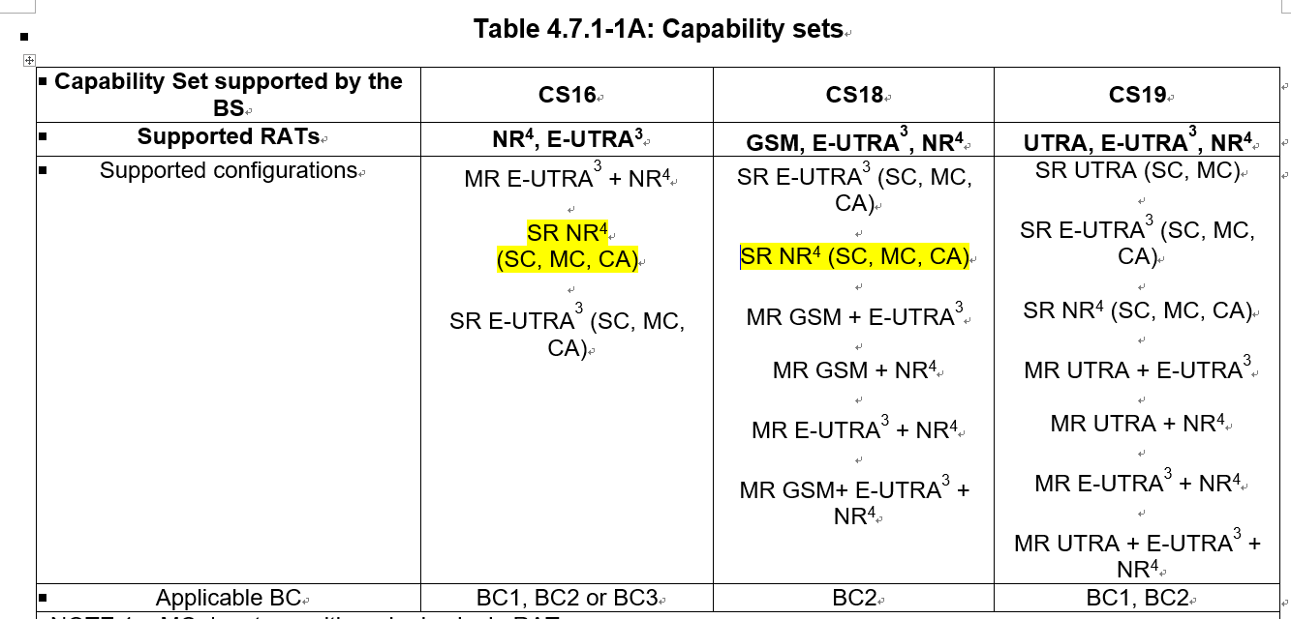

e.g. for BS type 1-C in EN 301 908-24
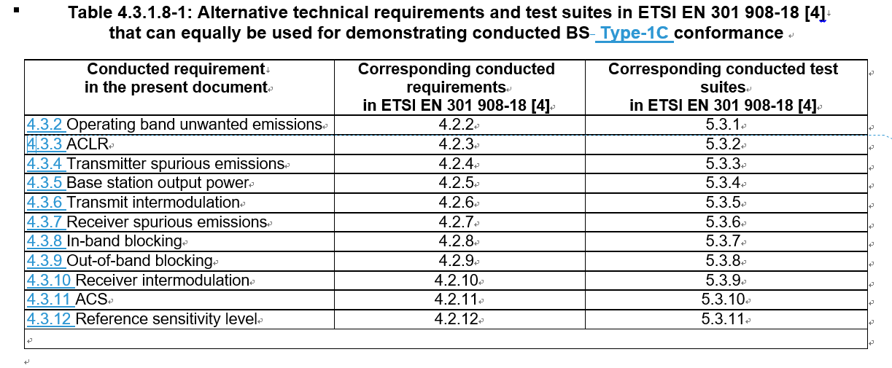
 | Nokia: while single-RAT NR configuration is included in CS16 and CS18, these capability sets were defined for multi-carrier NR/E-UTRA or NR/GSM/E-UTRA operation and are verified by multi-RAT test configurations. How they can be run on a single-RAT NR BS, do you plan changes to 37 series specfications? If so, we prefer to agree on complete CRs as a package.
Qualcomm: we have the same understanding as Nokia. Based on the scope of 37.104/37.141, the requirements listed in that spec are applicable to the highlighted specs for multi-carrier single-RAT BSs.
“The present document establishes the minimum RF characteristics of NR, E-UTRA, UTRA, GSM/EDGE and NB-IoT Multi-Standard Radio (MSR) Base Station (BS). Requirements for multi-RAT and single-RAT operation of MSR BS are covered in the present document. The requirements in the present document for E-UTRA, UTRA and NB-IoT single-RAT operation of MSR BS are also applicable to E-UTRA, UTRA and NB-IoT multi-carrier capable singleRAT BS. Requirements for GSM BS that are only single-RAT capable in all supported operating bands are not covered.”
R4-2212509 | Nokia: NR (single-RAT) BS is not included in the current scope of 37 series.
 | Qualcomm: To our understanding, 37 series does not deal with single RAT NR. What does the statement in the CR “additional conformance to TS 37.141-2” refers to?
Ericsson: see above comment. We suggest to make following modifications:
Instead of “For BS type 1-H that is NR (single-RAT) capable only” use “For a Hybrid AAS BS that is…”
Instead of “For BS type 1-O that is NR (single-RAT) capable only” use “ For an OTA AAS BS that is..”
We also want to co-sign this when the suggested modifications are done
 | Huawei: see our response above for R4-2212506
 | Nokia: see further comments above

2.3 Summary for 1st round

2.3.1CRs/TPs
Moderator tries to summarize discussion status for 1st round and provides recommendation on CRs/TPs Status update
Note: The tdoc decisions shall be provided in Section 3 and this table is optional in case moderators would like to provide additional information.
CR/TP number | CRs/TPs Status update recommendation
XXX | Based on 1st round of comments collection, moderator can recommend the next steps such as “agreeable”, “to be revised”

2.4 Discussion on 2nd round (if applicable)

3 Topic #3: Clarifications of BS type for band n46 and n102

3.1 Companies’ contributions summary
(Category A CRs are not listed)
T-doc number | Company | Proposal summary
R4-2213987 | Nokia, Nokia Shanghai Bell | CR to TS 38.141-2 with clarifications of BS type for band n46  Reason for change:  During RAN4#102-e meeting agreed R4-2205198 that included clarifications for band n46. Also during RAN4#103 CRs were agreed with updates to 38.104 and 38.141-1. However there was missing update for TS 38.141-2 for transmitter and receiver part. This CR introduce this missing sentence. Also update is proposed in in Measurement uncertainty section where band n46 was removed.
R4-2213988 | Nokia, Nokia Shanghai Bell | CR to TS 38.141-2 with clarifications of BS type for band n46 and n102  Reason for change: RAN4#102-e and RAN4#103-e meeting agreed CRs (R4-2205199, R4-2209812, R4-2209813, R4-2209810, R4-2209809) that included clarifications for band n46 and n96 and n102 for TS 38.104 and TS 38.141-1. However there was missing update for TS 38.141-2. This CR introduce missing sentences for transmitter and receiver sections. Also, update is proposed in in Measurement uncertainty section where band n46 and band n102 were removed.

3.2 Companies views’ collection for 1st round

3.2.1 CRs/TPs comments collection
CR/TP number | Comments collection
R4-2213987 | Nokia: CR needs to be updated to remove remaining n46 requirements
R4-2213988 | Nokia: CR needs to be updated to remove remaining n46/n102 requirements

3.3 Summary for 1st round

3.3.1CRs/TPs
Moderator tries to summarize discussion status for 1st round and provides recommendation on CRs/TPs Status update
Note: The tdoc decisions shall be provided in Section 3 and this table is optional in case moderators would like to provide additional information.
CR/TP number | CRs/TPs Status update recommendation
XXX | Based on 1st round of comments collection, moderator can recommend the next steps such as “agreeable”, “to be revised”

3.4 Discussion on 2nd round (if applicable)

4 Topic #4: Correction of the OBUE frequency range definition for FR2

4.1 Companies’ contributions summary
(Category A CRs are not listed)
T-doc number | Company | Proposal summary
R4-2214026 | Huawei, HiSilicon | draft CR to TS 38.141-2: correction of the OBUE frequency range definition for FR2, Rel-15  Reason for change: During the work on the M.2070 updates for the IMT-2020, it was observed that the OBUE text for the FR2 requirements definition and its applicable frequency range is defined in a confusing and unclear way. This CR is correcting this issue.

4.2 Companies views’ collection for 1st round

4.2.1 CRs/TPs comments collection
CR/TP number | Comments collection
R4-2214026

4.3 Summary for 1st round

4.3.1CRs/TPs
Moderator tries to summarize discussion status for 1st round and provides recommendation on CRs/TPs Status update
Note: The tdoc decisions shall be provided in Section 3 and this table is optional in case moderators would like to provide additional information.
CR/TP number | CRs/TPs Status update recommendation
XXX | Based on 1st round of comments collection, moderator can recommend the next steps such as “agreeable”, “to be revised”

4.4 Discussion on 2nd round (if applicable)

5 Topic #5: Corrections for the NB-IoT requirements in NR in-band

5.1 Companies’ contributions summary
(Category A CRs are not listed)
T-doc number | Company | Proposal summary
R4-2214024 | Huawei, HiSilicon | draft CR to TS 38.141-1: corrections for the NB-IoT requirements in NR in-band, Rel-16  Reason for change: It was observed that the specification of the BS RF requirements for the NB-IoT operation in NR in-band is not precise enough in the TS 38.141-1 specification. Related corrections and clarifiactrions are introduced in this CR.

5.2 Companies views’ collection for 1st round

5.2.1 CRs/TPs comments collection
CR/TP number | Comments collection
R4-2214024 | Nokia: NB-IoT in NR guard-band definition was included per operators’ request (ref. R4-1907809 and R4-2000875). Moreover, WI proposal on NB-IoT for AAS was proposed but no agreement was reached in RAN (ref. RP-192828 and RP-193156), hence addition of NB-IoT for BS type 1-H should not be handled as necessary corrections in RAN4.
 | Ericsson: We cannot agree with many of the corrections, as NB-IoT is not supported for BS Type 1-H. We can work offline with Huawei to develop a new version of the CR
Huawei: According to TS 38.141-1 scope, it covers NR and NB-IoT operation in NR in-band Base Station (BS) Type 1-C and Type 1-H. This was the trigger to draft CR for TS 38.104/141-1. However, as commented we have realized that such correction would introduce inconsistency with some of the past agreements in AAS BS specifications, where NB-IoT is not supported by BS type 1-H.
Therefore we suggest to mark this CR as “not pursued” and come-back next meeting with adjusted CRs. The same applies to CR in R4-2214022/23 in thread [301].

5.3 Summary for 1st round

5.3.1CRs/TPs
Moderator tries to summarize discussion status for 1st round and provides recommendation on CRs/TPs Status update
Note: The tdoc decisions shall be provided in Section 3 and this table is optional in case moderators would like to provide additional information.
CR/TP number | CRs/TPs Status update recommendation
XXX | Based on 1st round of comments collection, moderator can recommend the next steps such as “agreeable”, “to be revised”

5.4 Discussion on 2nd round (if applicable)

6 Recommendations for Tdocs

6.1 1st round
New tdocs
Title | Source | Comments
WF on … | YYY
LS on … | ZZZ | To: RAN_X; Cc: RAN_Y

Existing tdocs
Tdoc number | Title | Source | Recommendation | Comments
R4-210xxxx | CR on … | XXX | Agreeable, Revised, Merged, Postponed, Not Pursued

Notes:
- Please include the summary of recommendations for all tdocs across all sub-topics incl. existing and new tdocs.
- For the Recommendation column please include one of the following:
  - CRs/TPs: Agreeable, Revised, Merged, Postponed, Not Pursued
  - Other documents: Agreeable, Revised, Noted
- For new LS documents, please include information on To/Cc WGs in the comments column
- Do not include hyper-links in the documents

6.2 2nd round

Tdoc number | Title | Source | Recommendation | Comments
R4-210xxxx | CR on … | XXX | Agreeable, Revised, Merged, Postponed, Not Pursued
R4-210xxxx | WF on … | YYY | Agreeable, Revised, Noted
R4-210xxxx | LS on … | ZZZ | Agreeable, Revised, Noted

Notes:
- Please include the summary of recommendations for all tdocs across all sub-topics.
- For the Recommendation column please include one of the following:
  - CRs/TPs: Agreeable, Revised, Merged, Postponed, Not Pursued
  - Other documents: Agreeable, Revised, Noted
- Do not include hyper-links in the documents

Annex
Contact information
Company | Name | Email address
Nokia | Man Hung Ng | man_hung.ng@nokia.com
Qualcomm | Mustafa Emara | memara@qti.qualcomm.com
Huawei | Liehai Liu  Michal Szydelko | liuliehai@huawei.com  michal.szydelko@huawei.com
Ericsson | Aurelian Bria | aurelian.bria@gmail.com

Note:
- Please add your contact information in above table once you make comments on this email thread.
- If multiple delegates from the same company make comments on single email thread, please add you name as suffix after company name when make comments i.e. Company A (XX, XX)

