**Agenda item:** 9.14.9

**Source:** Moderator (Qualcomm Inc)

## CCBW >= 400 MHz Power class 3

* Proposals

*Proposals in R4-2111628 and R4-2212372 differ by 3 dB*

* + Discuss between the two proposals

**Recommended WF:**

Adopt Apple compromise scaling 2 dB between 100 and 400 MHz. The table is shown below QCOM2

|  |  |  |  |  |  |  |
| --- | --- | --- | --- | --- | --- | --- |
|  |  | Level | | | | |
| Parameter | Unit | 100 MHz | 400 MHz | 800 MHz | 1600 MHz | 2000 MHz |
| UE EIRP | dBm | [≥ -~~16~~ -13] | [≥ ~~-13~~ -11] | [≥ ~~-10~~ -8] | [≥ ~~-7~~ -5] | [≥ ~~-6~~ -4] |
| UE EIRP for UL 16 QAM | dBm | [≥ -~~13~~ -10] | [≥ ~~-10~~ -8] | [≥ ~~-7~~ -5] | [≥ ~~-4~~ -2] | [≥ ~~-3~~ -1] |
| UE EIRP for UL 64 QAM | dBm | [≥ ~~-9~~ -6] | [≥ ~~-6~~ -4] | [≥ ~~-3~~ -1] | [≥ ~~0~~ 2] | [≥ ~~1~~ 3] |
| Operating conditions | Normal Conditions | | | | | |
| NOTE 1: PTRS is configured for 16 QAM and 64 QAM | | | | | | |

## PTRS IE

In GTW the discussion of whether the EVM test would allow UE to communicate it’s preference indicating whether or not it wouldprefer PTRS to be configured. RAN1/RAN2 have specifically instituted signalling (***PTRS-DensityRecommendationUL)*** to allow the UE to convey its preferred PTRS configuration to accommodate indication.

Recommended WF: Futher discuss the use of ***PTRS-DensityRecommendationUL*** for EVM processing the next meeting.

## MPR power class 1

Recommended WF:

Agree proposal 1 with [] around all the numbers. Proposal 1 is shown below and the [] needs to be added around all of the numbers.

* Table 6.2.2.1-3 MPRWT for power class 1, BWchannel = 100 MHz in FR2-2

|  |  |  |  |  |
| --- | --- | --- | --- | --- |
| Modulation | | MPRWT (dB), BWchannel = 100 MHz | | |
|  | | Outer RB allocations | Inner RB allocations | |
|  | |  | Region 1 | Region 2 |
| DFT-s-OFDM | Pi/2 BPSK | ≤ 5.5 | 0.0 | ≤ 3.5 |
|  | QPSK | ≤ 6.5 | 0.0 | ≤ 3.5 |
|  | 16 QAM | ≤ 7.0 | ≤ 2.5 | ≤ 2.5 |
|  | 64 QAM | ≤ 8.0 | ≤ 8.0 | ≤ 8.0 |
| CP-OFDM | QPSK | ≤ 8.0 | ≤ 1.5 | ≤ 3.5 |
|  | 16 QAM | ≤ 8.0 | ≤ 3.5 | ≤ 4.0 |
|  | 64 QAM | ≤ 9.5 | ≤ 9.5 | ≤ 9.5 |

Table 6.2.2.1-4 MPRWT for power class 1, BWchannel >= 400 MHz in FR2-2

|  |  |  |  |  |
| --- | --- | --- | --- | --- |
| Modulation | | MPRWT (dB), BWchannel = 400, 800, 1600, 2000 MHz | | |
|  | | Outer RB allocations | Inner RB allocations | |
|  | |  | Region 1 | Region 2 |
| DFT-s-OFDM | Pi/2 BPSK | ≤ 6.0 | ≤ 1.0 | ≤ 3.5 |
|  | QPSK | ≤ 6.0 | ≤ 1.0 | ≤ 4.0 |
|  | 16 QAM | ≤ 4.5 | ≤ 3.0 | ≤ 3.0 |
|  | 64 QAM | ≤ 8.0 | ≤ 8.0 | ≤ 8.0 |
| CP-OFDM | QPSK | ≤ 6.0 | ≤ 1.5 | ≤ 3.5 |
|  | 16 QAM | ≤ 6.0 | ≤ 4.0 | ≤ 5.5 |
|  | 64 QAM | ≤ 10.0 | ≤ 10.0 | ≤ 10.0 |

## MPR Power class 3 100 MHz

Recommended WF:

PROP#1 numbers in [], with the 16QAM edge MPR changed to [3.0] to make it consistent with the inner. The table is shown below.

Table 6.2.2.3-1b MPRWT for power class 3, BWchannel = 100 MHz, FR2-2

|  |  |  |  |
| --- | --- | --- | --- |
| Modulation | | MPRWT, BWchannel = 100 MHz | |
|  | | Inner RB allocations,  Region 1 | Edge RB allocations |
| DFT-s-OFDM | Pi/2 BPSK | 0.0 | ≤ [0.5] |
|  | QPSK | 0.0 | ≤ [0.5] |
|  | 16 QAM | ≤ [3.0] | ≤ [3.0] |
|  | 64 QAM | ≤ [8.5] | ≤ [8.5] |
| CP-OFDM | QPSK | ≤ [1.5] | ≤ [1.5] |
|  | 16 QAM | ≤ [4.0] | ≤ [4.0] |
|  | 64 QAM | ≤ [10.0] | ≤ [10.0] |

## MPR Power class 3 > 100 MHz

We can have further discussion or comment on proposals 1, 2, and 3.

Recommended WF:

Agree with the LGE compromise. The tables are shown here.The intention is to end with following tables 6.2.2.3-2b and 6.2.2.3-2c and Void the Tables 6.2.2.3-3, 6.2.2.3-4, and 6.2.2.3-5.

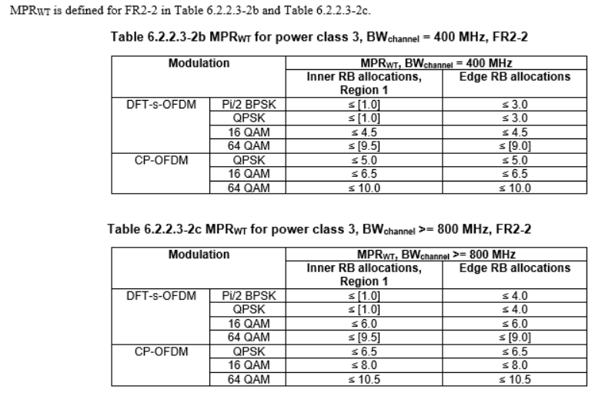

## PC3 max TRP

Further comments and discussion on proposal 1

Proposed WF: Discuss the need for clarification note next meeting

## UL gap for TX power management

We did not conclude on proposal 1 for the UL gap. Further discussion is welcome

Proposed WF: TBA

## MPR for CA

Recommended WF:

Agree proposal 1 with []. The tables are shown below:

Table TBD Maximum power reduction (MPRWT_C_CA) for FR2-2 UE power class 1

|  |  |  |  |  |
| --- | --- | --- | --- | --- |
| **Waveform Type** | **Cumulative aggregated channel bandwidth** | | | |
| **< 400 MHz** | **≥ 400 MHz and < 800 MHz** | **≥ 800 MHz and ≤ 1400 MHz** | **> 1400 MHz and ≤ 2000 MHz** |
| Pi/2 BPSK | ≤ [7.0] | ≤ [5.0] | ≤ [2.0] | ≤ [2.0] |
| QPSK | ≤ [8.0] | ≤ [6.0] | ≤ [3.0] | ≤ [3.0] |
| 16 QAM | ≤ [8.0] | ≤ [6.0] | ≤ [4.0] | ≤ [4.0] |
| 64 QAM | ≤ [10.0] | ≤ [10.0] | ≤ [10.0] | ≤ [10.0] |

Table TBD Maximum power reduction (MPRWT_C_CA) for FR2-2 UE power class 3

|  |  |  |  |  |
| --- | --- | --- | --- | --- |
| **Waveform Type** | **Cumulative aggregated channel bandwidth** | | | |
| **< 400 MHz** | **≥ 400 MHz and < 800 MHz** | **≥ 800 MHz and ≤ 1400 MHz** | **> 1400 MHz and ≤ 2000 MHz** |
| Pi/2 BPSK | ≤ [1.0] | ≤ [1.0] | ≤ [1.0] | ≤ [1.0] |
| QPSK | ≤ [2.0] | ≤ [2.0] | ≤ [2.0] | ≤ [2.0] |
| 16 QAM | ≤ [4.0] | ≤ [4.0] | ≤ [4.0] | ≤ [4.0] |
| 64 QAM | ≤ [10.0] | ≤ [10.0] | ≤ [10.0] | ≤ [10.0] |

## PRACH time mask

Further comments on proposal 1 which adds 480 and 960 SCS values

Recommended WF:

Discuss PRACH time mask proposal 1 next meeting

## Beam correspondence and whether to preclude BC for FR2-2

Recommended WF: Companies are split. Further discuss next meeting.

## ON/ON transient optional UE capability

Further discussion on whether this should be a topic in rel-18.

Chair=> align companies’ view if it needs be discussed in Rel-18.

Recommended WF:

Further discussion in rel-18. Either in existing WI or TEI.

## Uplink configuration for REFSENS

Perhaps we can have a further discussion about the REFSENS proposals 2 and 3

**Proposal 2: Specify the uplink configuration for band n263 as in Table 2.6-1. (R4-2213369)**

Table 2.6-1

|  |  |  |  |  |  |  |  |  |  |
| --- | --- | --- | --- | --- | --- | --- | --- | --- | --- |
| Operating band | NR Band / Channel bandwidth / NRB / SCS / Duplex mode | | | | | | | | |
|  | 50 MHz | 100 MHz | 200 MHz | 400 MHz | 800 MHz | 1600 MHz | 2000 MHz | SCS | Duplex Mode |
| n257 | 32 | 64 | 128 | 256 | N.A | N.A | N.A | 120 kHz | TDD |
| n258 | 32 | 64 | 128 | 256 | N.A | N.A | N.A | 120 kHz | TDD |
| n260 | 32 | 64 | 128 | 256 | N.A | N.A | N.A | 120 kHz | TDD |
| n261 | 32 | 64 | 128 | 256 | N.A | N.A | N.A | 120 kHz | TDD |
| n262 | 32 | 64 | 128 | 256 | N.A | N.A | N.A | 120 kHz | TDD |
| n263 | N.A | 64 | N.A | 256 | N.A | N.A | N.A | 120 kHz | TDD |
| N.A | N.A | N.A | N.A | 120 | 243 | N.A | 480 kHz | TDD |
| N.A | N.A | N.A | N.A | N.A | N.A | 144 | 960 kHz | TDD |

**Proposal 3: vivo in thread**

The NRB number for uplink configuration for band n263 is not the same with what we agreed for.

The numbers for 400M with 480/960k and 800M/1600M with 960k are missing.

Table 5.3.2-1: Maximum transmission bandwidth configuration NRB

|  |  |  |  |  |  |  |  |
| --- | --- | --- | --- | --- | --- | --- | --- |
| SCS (kHz) | 50 MHz | 100 MHz | 200 MHz | 400 MHz | 800 MHz | 1600 MHz | 2000 MHz |
|  | NRB | NRB | NRB | NRB | NRB | NRB | NRB |
| 60 | 66 | 132 | 264 | N/A | N/A | N/A | N/A |
| 120 | 32 | 66 | 132 | 264 | N/A | N/A | N/A |
| 4801 | N/A | N/A | N/A | 66 | [124] | [248] | N/A |
| 9601 | N/A | N/A | N/A | 33 | [62] | [124] | 148 |
| Note 1: This SCS is optional in this release of the specification. | | | | | | | |

Recommended WF: TBA

## RMC CR discussion

Any additional company comments on the RMC CR .

[**R4-2213368**](https://www.3gpp.org/ftp/TSG_RAN/WG4_Radio/TSGR4_104-e/Docs/R4-2213368.zip)Draft CR for n263 RMC

|  |  |
| --- | --- |
| **Company** | **Comments** |
| QCOM | We agree with Anrisu comments 1 and 2. Our view comment 3 is not valid.  If TDD ULDL config for 480 and 960 SCS is not in A.3.3.1 iw needs to be added. |
| Company B |  |

Recommended WF: TBA