3GPP TS 38.161 V0.3.0 (2022-05)
Technical Specification

3rd Generation Partnership Project;
Technical Specification Group Radio Access Network;
NR;
User Equipment (UE) TRP (Total Radiated Power) and TRS (Total Radiated Sensitivity) requirements;
Range 1 Standalone and Range 1 Interworking operation with other radios
(Release 17)

 | 
The present document has been developed within the 3rd Generation Partnership Project (3GPP TM) and may be further elaborated for the purposes of 3GPP.
The present document has not been subject to any approval process by the 3GPP Organizational Partners and shall not be implemented.
This Specification is provided for future development work within 3GPP only. The Organizational Partners accept no liability for any use of this Specification.
Specifications and Reports for implementation of the 3GPP TM system should be obtained via the 3GPP Organizational Partners' Publications Offices.

3GPP
Postal address

3GPP support office address
650 Route des Lucioles - Sophia Antipolis
Valbonne - FRANCE
Tel.: +33 4 92 94 42 00 Fax: +33 4 93 65 47 16
Internet
http://www.3gpp.org

Copyright Notification
No part may be reproduced except as authorized by written permission.
The copyright and the foregoing restriction extend to reproduction in all media.

© 2022, 3GPP Organizational Partners (ARIB, ATIS, CCSA, ETSI, TSDSI, TTA, TTC).
All rights reserved.

UMTS™ is a Trade Mark of ETSI registered for the benefit of its members
3GPP™ is a Trade Mark of ETSI registered for the benefit of its Members and of the 3GPP Organizational Partners
LTE™ is a Trade Mark of ETSI registered for the benefit of its Members and of the 3GPP Organizational Partners
GSM® and the GSM logo are registered and owned by the GSM Association

Contents
Foreword 4
1 Scope 6
2 References 6
3 Definitions of terms, symbols and abbreviations 6
3.1 Terms 6
3.2 Symbols 7
3.3 Abbreviations 7
4 General 7
4.1 Relationship between minimum requirements and test requirements 7
4.2 Applicability of minimum requirements 7
4.2.1 General 7
4.2.2 UE mechanical modes 7
5 Frequency bands 8
5.1 General 8
5.2 Operating bands 8
5.2.1 FR1 Standalone Operating bands 8
5.2.2 FR1 EN-DC band combinations 9
6 FR1 TRP requirements 9
6.1 General 9
6.2 Minimum requirement 9
6.2.1 Minimum requirement for handheld UE 9
6.2.1.1 Hand phantom browsing mode 9
6.2.1.1.1 NR FR1 10
6.2.1.1.2 NR FR1 in EN-DC mode 10
6.2.1.2 Beside the head and hand phantom position 10
6.2.1.2.1 NR FR1 11
6.2.1.2.2 NR FR1 in EN-DC mode 11
7 FR1 TRS requirements 12
7.1 General 12
7.2 Minimum requirement 12
Annex A (normative): <Test methodology> 13
A.1 Test configuration 13
A.1.1 TRP Test configuration 13
A.1.2 TRS Test configuration 13
Annex B (normative): <Phantoms definition and Positioning> 14
Annex C (normative): <Environmental requirements> 16
Annex D (informative): Change history 17

Foreword
This Technical Specification has been produced by the 3rd Generation Partnership Project (3GPP).
The contents of the present document are subject to continuing work within the TSG and may change following formal TSG approval. Should the TSG modify the contents of the present document, it will be re-released by the TSG with an identifying change of release date and an increase in version number as follows:
Version x.y.z
where:
x the first digit:
1 presented to TSG for information;
2 presented to TSG for approval;
3 or greater indicates TSG approved document under change control.
y the second digit is incremented for all changes of substance, i.e. technical enhancements, corrections, updates, etc.
z the third digit is incremented when editorial only changes have been incorporated in the document.
In the present document, modal verbs have the following meanings:
shall indicates a mandatory requirement to do something
shall not indicates an interdiction (prohibition) to do something
The constructions "shall" and "shall not" are confined to the context of normative provisions, and do not appear in Technical Reports.
The constructions "must" and "must not" are not used as substitutes for "shall" and "shall not". Their use is avoided insofar as possible, and they are not used in a normative context except in a direct citation from an external, referenced, non-3GPP document, or so as to maintain continuity of style when extending or modifying the provisions of such a referenced document.
should indicates a recommendation to do something
should not indicates a recommendation not to do something
may indicates permission to do something
need not indicates permission not to do something
The construction "may not" is ambiguous and is not used in normative elements. The unambiguous constructions "might not" or "shall not" are used instead, depending upon the meaning intended.
can indicates that something is possible
cannot indicates that something is impossible
The constructions "can" and "cannot" are not substitutes for "may" and "need not".
will indicates that something is certain or expected to happen as a result of action taken by an agency the behaviour of which is outside the scope of the present document
will not indicates that something is certain or expected not to happen as a result of action taken by an agency the behaviour of which is outside the scope of the present document
might indicates a likelihood that something will happen as a result of action taken by some agency the behaviour of which is outside the scope of the present document
might not indicates a likelihood that something will not happen as a result of action taken by some agency the behaviour of which is outside the scope of the present document
In addition:
is (or any other verb in the indicative mood) indicates a statement of fact
is not (or any other negative verb in the indicative mood) indicates a statement of fact
The constructions "is" and "is not" do not indicate requirements.

1 Scope
The present document establishes the TRP (Total Radiated Power) and TRS (Total Radiated Sensitivity) requirements for NR UEs operating on Range 1 Standalone and Range 1 Interworking operation with other radios.

2 References
The following documents contain provisions which, through reference in this text, constitute provisions of the present document.
- References are either specific (identified by date of publication, edition number, version number, etc.) or non-specific.
- For a specific reference, subsequent revisions do not apply.
- For a non-specific reference, the latest version applies. In the case of a reference to a 3GPP document (including a GSM document), a non-specific reference implicitly refers to the latest version of that document in the same Release as the present document.
[1] 3GPP TR 21.905: "Vocabulary for 3GPP Specifications".
[2] 3GPP TR 38.834: “Measurements of User Equipment (UE) Over-the-Air (OTA) performance for NR FR1; Total Radiated Power (TRP) and Total Radiated Sensitivity (TRS) test methodology”.
[3] 3GPP TS 38.101-1: "NR; User Equipment (UE) radio transmission and reception; Part 1: Range 1 Standalone".
[4] 3GPP TS 38.101-3: "NR; User Equipment (UE) radio transmission and reception; Part 3: Range 1 and Range 2 Interworking operation with other radios".
[5] 3GPP TS 38.521-1: "NR; User Equipment (UE) conformance specification; Radio transmission and reception; Part 1: Range 1 Standalone".
[6] 3GPP TS 38.521-3: "NR; User Equipment (UE) conformance specification; Radio transmission and reception; Part 3: Range 1 and Range 2 Interworking operation with other radios".
[7] 3GPP TS 38.508-1: "5GS; User Equipment (UE) conformance specification; Part 1: Common test environment ".
[8] 3GPP TS 37.544: “Universal Terrestrial Radio Access (UTRA) and Evolved Universal Terrestrial Radio Access (E-UTRA); User Equipment (UE) Over The Air (OTA) performance; Conformance testing “.

[9] CTIA Certification™ OTA Test Plan: “CTIA Certification Test Plan for Wireless Device Over-the-Air Performance, Version 3.9.4 “, https://ctiacertification.org/test-plans/

3 Definitions of terms, symbols and abbreviations

3.1 Terms
For the purposes of the present document, the terms given in 3GPP TR 21.905 [1] and the following apply. A term defined in the present document takes precedence over the definition of the same term, if any, in 3GPP TR 21.905 [1].
Definition format (Normal)
<defined term>: <definition>.
example: text used to clarify abstract rules by applying them literally.

3.2 Symbols
For the purposes of the present document, the following symbols apply:
Symbol format (EW)
<symbol> <Explanation>

3.3 Abbreviations
For the purposes of the present document, the abbreviations given in 3GPP TR 21.905 [1] and the following apply. An abbreviation defined in the present document takes precedence over the definition of the same abbreviation, if any, in 3GPP TR 21.905 [1].
Abbreviation format (EW)
AC Anechoic Chamber
DUT Device Under Test
EIRP Effective Isotropic Radiated Power
EUT Equipment Under Test
FR1 Frequency Range 1
NSA Non-Standalone, a mode of operation where operation of an other radio is assisted with an other radio
OTA Over The Air
QZ Quiet Zone
SA Standalone
SS System Simulator
TAA Time-Averaging Algorithm
TAS Tx Antenna Switching
TRP Total Radiated Power
TRS Total Radiated Sensitivity
UE User Equipment

4 General

4.1 Relationship between minimum requirements and test requirements
The Minimum Requirements given in this specification make no allowance for measurement uncertainty. The test specification in RAN5 will define test tolerances for FR1 TRP TRS. The test tolerances are used to relax the minimum requirements in this specification to create test requirements.

4.2 Applicability of minimum requirements

4.2.1 General
The minimum requirements apply only to the corresponding primary mechanical mode of UE in the environmental conditions specified in Annex C.4.2.2

4.2.1 UE mechanical modes
The mechanical modes of a device under test (DUT) are declared by the manufacturer. A DUT shall have at least one mechanical mode. If only one mode is supported, then this is defined as the primary. If multiple modes are supported, the manufacturer can declare different primary mechanical modes applicable for different user scenarios, e.g., different primary mechanical mode for Browsing mode usage and Talk mode usage for the same UE.

4.3 Applicability rules for testing of FR1 SA and NSA UEs
(1) The applicability and test coverage rules for Non-Standalone (NSA) only capable devices shall include the following:
a) For each NR band supported by the device, test the UE in EN-DC mode using any one example configuration containing that NR band or configuration declaration decision tree as per recommended TRP/TRS test procedures in this specification.
(2) The applicability and test coverage rules for Standalone (SA) and NSA (EN-DC) capable devices shall include the following:
a) For each NR band in a device, test the UE in Standalone Mode as per the TRP/TRS test procedures in this specification.
b) This shall also fulfils coverage for all EN-DC FR1 minimum performance requirements for that NR band and need not be retested in EN-DC mode.

4.4 Applicability rules for testing of power class capability of UEs
(1) The applicability and test coverage rules for PC2 and PC3 UEs shall include the following:
a) For UEs that support PC2 in a given band: verify the requirement only with PC2 configuration
b) For UEs that only support PC3 in a given band: verify the requirement with PC3 configuration
NOTE 1: The test procedure and requirements in this version of the specification apply only for UEs based on 1 Tx configuration and are not applicable to UEs under TxD and UL MIMO configurations.

5 Frequency bands

5.1 General
<Editor’s note: Detailed structure of the subclause is TBD. >

5.2 Operating bands
<Editor’s note: Detailed structure of the subclause is TBD. >

5.2.1 FR1 Standalone Operating bands
The requirements defined in this specification for FR1 standalone apply to the operating bands defined in Table 5.2.1-1.
Table 5.2.1-1 NR operating bands in FR1 standalone
NR operating band | Uplink (UL) operating band  BS receive / UE transmit  F_{UL_low} – F_{UL_high} | Downlink (DL) operating band  BS transmit / UE receive  F_{DL_low} – F_{DL_high} | Duplex Mode
n1 | 1920 MHz – 1980 MHz | 2110 MHz – 2170 MHz | FDD
n2 | 1850 MHz – 1910 MHz | 1930 MHz – 1990 MHz | FDD
n3 | 1710 MHz – 1785 MHz | 1805 MHz – 1880 MHz | FDD
n5 | 824 MHz – 849 MHz | 869 MHz – 894 MHz | FDD
n7 | 2500 MHz – 2570 MHz | 2620 MHz – 2690 MHz | FDD
n8 | 880 MHz – 915 MHz | 925 MHz – 960 MHz | FDD
n12 | 699 MHz – 716 MHz | 729 MHz – 746 MHz | FDD
n14 | 788 MHz – 798 MHz | 758 MHz – 768 MHz | FDD
n20 | 832 MHz – 862 MHz | 791 MHz – 821 MHz | FDD
n25 | 1850 MHz – 1915 MHz | 1930 MHz – 1995 MHz | FDD
n26 | 814 MHz – 849 MHz | 859 MHz – 894 MHz | FDD
n28 | 703 MHz – 748 MHz | 758 MHz – 803 MHz | FDD
n30 | 2305 MHz – 2315 MHz | 2350 MHz – 2360 MHz | FDD
n34 | 2010 MHz – 2025 MHz | 2010 MHz – 2025 MHz | TDD
n38 | 2570 MHz – 2620 MHz | 2570 MHz – 2620 MHz | TDD
n39 | 1880 MHz – 1920 MHz | 1880 MHz – 1920 MHz | TDD
n40 | 2300 MHz – 2400 MHz | 2300 MHz – 2400 MHz | TDD
n41 | 2496 MHz – 2690 MHz | 2496 MHz – 2690 MHz | TDD
n48 | 3550 MHz – 3700 MHz | 3550 MHz – 3700 MHz | TDD
n50 | 1432 MHz – 1517 MHz | 1432 MHz – 1517 MHz | TDD¹
n51 | 1427 MHz – 1432 MHz | 1427 MHz – 1432 MHz | TDD
n53 | 2483.5 MHz – 2495 MHz | 2483.5 MHz – 2495 MHz | TDD
n65 | 1920 MHz – 2010 MHz | 2110 MHz – 2200 MHz | FDD⁴
n66 | 1710 MHz – 1780 MHz | 2110 MHz – 2200 MHz | FDD
n70 | 1695 MHz – 1710 MHz | 1995 MHz – 2020 MHz | FDD
n71 | 663 MHz – 698 MHz | 617 MHz – 652 MHz | FDD
n74 | 1427 MHz – 1470 MHz | 1475 MHz – 1518 MHz | FDD
n75 | N/A | 1432 MHz – 1517 MHz | SDL
n76 | N/A | 1427 MHz – 1432 MHz | SDL
n77¹² | 3300 MHz – 4200 MHz | 3300 MHz – 4200 MHz | TDD
n78 | 3300 MHz – 3800 MHz | 3300 MHz – 3800 MHz | TDD
n79 | 4400 MHz – 5000 MHz | 4400 MHz – 5000 MHz | TDD
n80 | 1710 MHz – 1785 MHz | N/A | SUL
n81 | 880 MHz – 915 MHz | N/A | SUL
n82 | 832 MHz – 862 MHz | N/A | SUL
n83 | 703 MHz – 748 MHz | N/A | SUL
n84 | 1920 MHz – 1980 MHz | N/A | SUL
n86 | 1710 MHz – 1780 MHz | N/A | SUL
n95 | 2010 MHz – 2025 MHz | N/A | SUL
Other operating bands may be considered in future releases.

5.2.2 FR1 EN-DC band combinations
<Editor’s note: Example EN-DC combinations can be added. >
Principle of EN-DC band combinations selection for FR1 TRP TRS OTA testing:
1) Focus on the performance of the NR carrier and do not consider multiple permutations between different LTE bands and NR band under test, i.e., for each NR band, only select one EN-DC band combination.
2) For UE supporting multiple EN-DC band combinations for the same NR band, consider only those EN-DC configurations which have no MSD impact on either LTE or NR, i.e., the selected EN-DC combination should be no MSD issue identified in TS 38.101-3 Section 7.3B.2.3 (Inter-band EN-DC within FR1).
Table 5.2.2-1 Measurement parameters for example inter-band EN-DC band combinations (two bands)
EN-DC  configuration | E-UTRA configurations | NR configurations
DC_3A_n28A | Note1 | Note2
DC_2A_n41A | Note1 | Note2
DC_1A_n78A | Note1 | Note2
DC_1A_n79A | Note1 | Note2
Note 1: As per TR 37.902 [10], Section 6.4 (Measurement frequencies).
Note 2: As per Table 4.3.3-1 and Table 4.3.3-2 in TR 38.834.

6 FR1 TRP requirements

6.1 General
<Editor’s note: Detailed structure of the subclause is TBD>

6.2 Minimum requirement

6.2.1 Minimum requirement for handheld UE
The average measured total radiated power (TRP) of low, mid and high channel for handheld UE shall be higher than the average TRP requirement specified in subclauses 6.2.1.1 and 6.2.1.2. The averaging shall be done in linear scale for the TRP results of both right and left side of the phantom head in case of beside the head and hand phantom positions. For the hand phantom browsing mode position the averaging shall be done in linear scale for the TRP results of both right and left hand phantom measurements.
$${TRP}_{average}=10log\left[\frac{{10}^{P_{left_low}/10}+{10}^{P_{left_mid}/10}+{10}^{P_{left_high}/10}+{10}^{P_{right_low}/10}+{10}^{P_{right_mid}/10}+{10}^{P_{right_high}/10}}{6}\right]$$
For UEs which do not support NR FR1 in stand-alone mode, EN-DC mode requirements apply. SA and EN-DC test case applicability is defined in Clause 4.3, and test case applicability based on power class capability is defined in Clause 4.4. The relevant test methodology is defined in Annexes A and B of this specification.

6.2.1.1 Hand phantom browsing mode
Hand phantom browsing mode positions are defined in TR38.834 [1] subclause 6.3.

6.2.1.1.1 NR FR1
Handheld UE TRP minimum performance requirement for NR FR1 bands in the hand phantom browsing position and the primary mechanical mode are defined in Tables 6.2.1.1.1-1 and 6.2.1.1.1-2.
Table 6.2.1.1.1-1 Handheld PC3 UE TRP minimum performance requirement for NR FR1 bands in the hand phantom browsing position and the primary mechanical mode
NR Band | Power Class 3
NR Band | Average TRP (dBm)
NR Band | UE width ≤ 72mm | UE width > 72mm
n28
n41
n78
n79

Table 6.2.1.1-2 Handheld PC2 UE TRP minimum performance requirement for NR FR1 bands in the hand phantom browsing position and the primary mechanical mode
NR Band | Power Class 2
NR Band | Average TRP (dBm)
NR Band | UE width ≤ 72mm | UE width > 72mm
n28
n41
n78
n79

6.2.1.1.2 NR FR1 in EN-DC mode
Handheld UE TRP minimum performance requirement for NR FR1 bands (in EN-DC mode) in the hand phantom browsing position and the primary mechanical mode are defined in Tables 6.2.1.1.2-1 and 6.2.1.1.2-2.
Table 6.2.1.1.2-1 Handheld PC3 UE TRP minimum performance requirement for NR FR1 bands (in EN-DC mode) in the hand phantom browsing position and the primary mechanical mode
NR Band | Power Class 3
NR Band | Average TRP (dBm)
NR Band | UE width ≤ 72mm | UE width > 72mm
n28
n41
n78
n79

Table 6.2.1.1.2-2 Handheld PC2 UE TRP minimum performance requirement for NR FR1 bands (in EN-DC mode) in the hand phantom browsing position and the primary mechanical mode
NR Band | Power Class 2
NR Band | Average TRP (dBm)
NR Band | UE width ≤ 72mm | UE width > 72mm
n28
n41
n78
n79

6.2.1.2 Beside the head and hand phantom position
Beside the head and hand phantom mode positions are defined in TR38.834 [1] subclause 6.4.

6.2.1.2.1 NR FR1
Handheld UE TRP minimum performance requirement for NR FR1 bands in the beside head and hand phantom position and the primary mechanical mode are defined in Tables 6.2.1.2.1-1 and 6.2.1.2.1-2.
Table 6.2.1.2.1-1 Handheld PC3 UE TRP minimum performance requirement for NR FR1 bands in the beside head and hand phantom position and the primary mechanical mode
NR Band | Power Class 3
NR Band | Average TRP (dBm)
NR Band | UE width ≤ 72mm | UE width > 72mm
n28
n41
n78
n79

Table 6.2.1.2.1-2 Handheld PC2 UE TRP minimum performance requirement for NR FR1 bands in the beside head and hand phantom position and the primary mechanical mode
NR Band | Power Class 2
NR Band | Average TRP (dBm)
NR Band | UE width ≤ 72mm | UE width > 72mm
n28
n41
n78
n79

6.2.1.2.2 NR FR1 in EN-DC mode
Handheld UE TRP minimum performance requirement for NR FR1 bands (in EN-DC mode) in the beside head and hand phantom position and the primary mechanical mode are defined in Tables 6.2.1.2.2-1 and 6.2.1.2.2-2.
Table 6.2.1.2.2-1 Handheld PC3 UE TRP minimum performance requirement for NR FR1 bands (in EN-DC mode) in the beside head and hand phantom position and the primary mechanical mode
NR Band | Power Class 3
NR Band | Average TRP (dBm)
NR Band | UE width ≤ 72mm | UE width > 72mm
n28
n41
n78
n79

Table 6.2.1.2.2-2 Handheld PC2 UE TRP minimum performance requirement for NR FR1 bands (in EN-DC mode) in the beside head and hand phantom position and the primary mechanical mode
NR Band | Power Class 2
NR Band | Average TRP (dBm)
NR Band | UE width ≤ 72mm | UE width > 72mm
n28
n41
n78
n79

7 FR1 TRS requirements

7.1 General
<Editor’s note: Detailed structure of the subclause is TBD. >

7.2 Minimum requirement
<Editor’s note: Detailed structure of the subclause is TBD. SA and EN-DC>

Annex A (normative):
<Test methodology>

A.1 General
TRP TRS minimum requirement specified in Clause 6 and Clause 7 should be measured with Anechoic Chamber method.

A.2 UE configuration

A.2.1 General
For FR1 TRP and TRS radiated conformance testing, P-MPRc shall be 0 dB.

FR1 TRP and TRS radiated conformance testing shall be performed with the UE consistently operating at maximum power level, e.g., Time-Averaged Algorithm (TAA) and other power back-off functions should be disabled. The above functions OFF should be based on manufacturer declaration, if declared, then the manufacturer is required to provide a mechanism for the test lab to enable/disable the function.
The NR SS should send continuous uplink power control “up” commands to the DUT to ensure the DUT’s transmitter is at maximum output power during the TRP and TRS test.

A.2.2 UE configuration for TRP test
For devices containing multiple Tx antennas, the Tx Antenna Switching (TAS) function should be OFF, and the TRP should be measured for each Tx antenna individually. The antenna with better TRP is identified as the primary antenna, and the corresponding TRP result will be used to determine the pass/fail compliance. Otherwise, the primary antenna should be selected based on manufacturer declaration. To ensure the TAS OFF testing, the manufacture should provide either software/guidance to lab to control which Tx antenna is used, or the pre-configured DUT locked at primary antenna.
For Standalone, the NR System Simulator (SS) and DUT shall be configured per TS 38.521-1 [5], section 6.2.1 (UE maximum output power) using the default settings specified in TS 38.521-1 [5] and TS 38.508-1 [7] as applicable. The measurement should be carried out based on the detailed test parameters for each band, as defined in TR 38.834 Table 4.3.3-1.
For EN-DC, the SS and DUT shall be configured per TS 38.521-3 [6], Section 6.2B.1 (UE Maximum Output Power for EN-DC) using the default settings specified in TS 38.521-3 [6] and TS 38.508 [7] as applicable. The measurement should be carried out based on the detailed test parameters for each band, as defined in TR 38.834 Table 4.3.3-3. The UL output power of LTE carrier should be set as a constant power of 10dBm, while measuring NR at maximum output power, i.e., with fixed p-MaxEUTRA-r15=10 dBm, and p-NR-FR1 not configured.

A.2.3 UE configuration for TRS test
For TRS measurement, no specific setting is needed for Rx antennas. By default, the maximum number of Rx antennas supported at each band should be enabled during the TRS test.
For Standalone, the NR System Simulator (SS) and DUT shall be configured per section 7.3.2 (Reference sensitivity power level) of TS 38.521-1 [5] using the defaults specified in TS 38.521-1 [5] and TS 38.508-1 [7] as applicable. The measurement should be carried out based on the detailed test parameters for each band, as defined in TR 38.834 Table 4.3.3-2.
For EN-DC, the EN-DC SS and DUT shall be configured per section 7.3B.2 (Reference Sensitivity for EN-DC) of TS 38.521-3 [6], using the defaults specified in TS 38.521-3 [6] and TS 38.508 [7], as applicable. The measurement should be carried out based on the detailed test parameters for each band, as defined in TR 38.834 Table 4.3.3-3. The UL power configuration for LTE and NR is 50%-50% power splitting, i.e.,
- For PC3, p-MaxEUTRA-r15=20 dBm, and p-NR-FR1= 20dBm;
- For PC2, p-MaxEUTRA-r15=23 dBm, and p-NR-FR1= 23dBm.

A.3 Test system of Anechoic Chamber method

A.3.1 System setup
For FR1 TRP TRS testing, both Single-antenna and multiple-antennas anechoic chambers can both be applied. In Figure A.3.1-1, an example TRP TRS test system with combined axes system is presented.
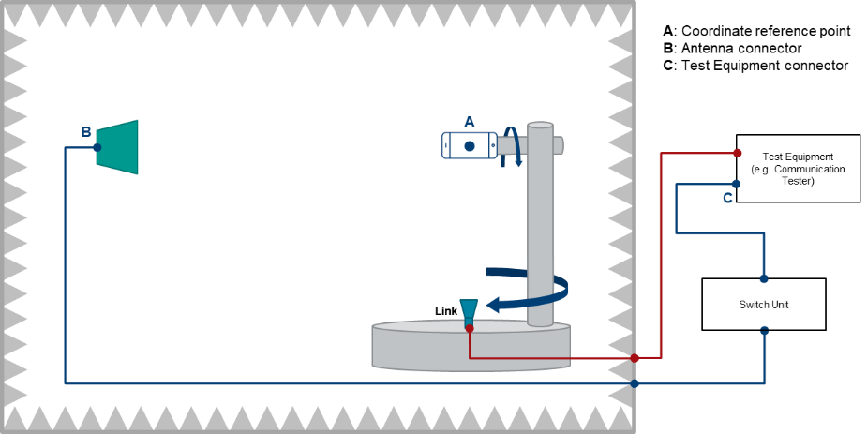
Figure A.3.1-1: Example of a FR1 TRP TRS OTA test system with combined axis
In Figure A.3.1-2, an example TRP TRS test system with distributed axes system is presented.
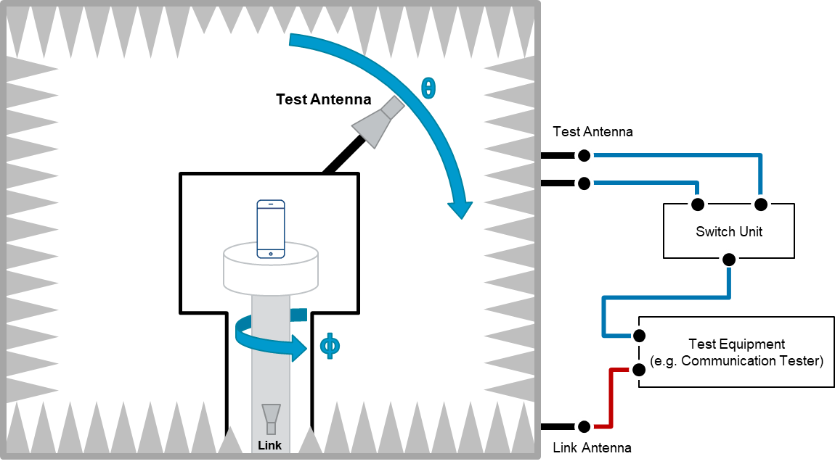
Figure A.3.1-2: Example of a FR1 TRP TRS OTA test system with distributed axis

A.3.2 Calibration procedure
The relative power values of the measurement points will be transformed to absolute radiated power values (in dBm) by performing a range path loss calibration measurement. The system needs to be calibrated by using a reference calibration antenna with known gain values. In the range path loss calibration measurement, the reference antenna is measured in the same place as the DUT, i.e. the center of the QZ, and the attenuation of the complete transmission path (Ltotal) from the DUT to the measurement receiver/BS simulator is calibrated out.
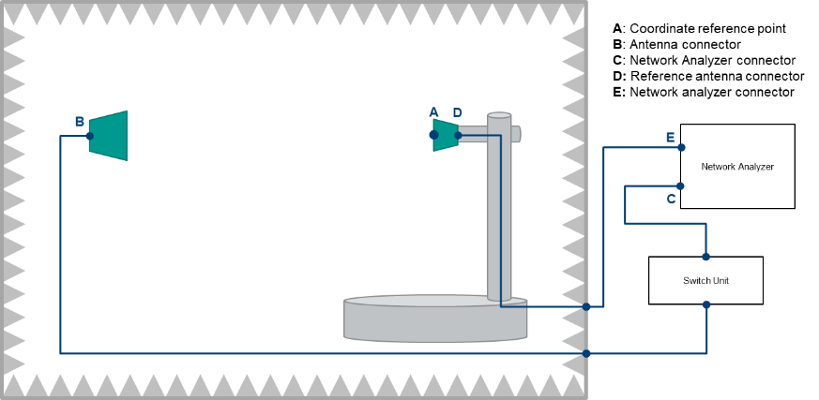
Figure A.3.2-1: Example FR1 TRP TRS calibration setup
The calibration measurement is repeated for each measurement path (two orthogonal polarizations and each signal path). The range path loss calibration measurement is performed in a two-step process including total path loss measurement and cable calibration.
Step 1: Cable calibration: the measurement of path loss L_{DE} LDE, by connecting the cable from D to E to the two ports of VNA, and measure the cable path loss.
Step 2: Total path loss measurement: the measurement of total path loss L_{BC};
1. Place the reference calibration antenna (e.g. reference dipole) in the center of the test zone aligned with θ polarization of the measurement antenna, connected to a VNA port E, with the other VNA port C connected to the input of the Switch box – in Figure A.2.2-1.
2. Configure the proper output power of VNA.
3. Measure the response L_{CE} LCE of each path from each θ polarization of the measurement antenna to the reference antenna in the center of QZ.
4. Repeat the steps 1 to 3 with the reference antenna aligned with the ϕ polarization of the measurement antenna.
Then, the Ltotal=LCE-LDE+Gcal, Where L_{DE} LDE is cable loss from D to E. Gcal is the gain or efficiency of the calibration antenna at the frequency of interest. In TRP and TRS measurements point C is connected to the calibrated input/output port of measurement receiver.
This range path loss calibration procedure is common to both SA and EN-DC measurements.

A.3.3 Test procedure

A.3.3.1 General
For TRP and TRS testing in SA or EN-DC mode, measurements should be only performed at NR carrier. The LTE link antenna in EN-DC mode is used to provide a stable LTE link to the DUT without precise path loss or polarization control.

A.3.3.2 TRP Test procedure
The TRP of the DUT is measured by sampling the radiated transmit power of the DUT with three-dimensional scan at various locations surrounding the device. The measurement is performed with a constant sampling step of 15 degrees in both theta (θ) and phi (φ) axes for TRP measurement. This accounts for a total of 266 measurements for each of two orthogonal polarizations since measurements at theta = 0 and 180 degrees only require one measurement each. For some test system can not measure 180º EIRP, then the extrapolation approach can be adopted when generating the 3D antenna pattern. All of the measured power values will be integrated to TRP, as defined in Clause 5.1 in [2].
For TRP measurement, the evaluations shall be performed at maximum transmit power.
The measurement procedure includes the following steps:
1) Place the DUT inside the QZ following the positioning guideline defined in Clause 6.
2) Connect the SS with the DUT through the link antenna following steps 1 and 2 in section 6.2.1.4.2 of TS 38.521-1 [5] and ensure the DUT transmits with its maximum power.
3) Measure the power at each measurement point, and calculate EIRPθ,ϕ by adding the composite loss of the entire transmission path.
The TRP value is calculated using the TRP integration approaches outlined in Clause 5.1 in [2].
This TRP test procedure is common to both SA and EN-DC measurements. The detailed UE configurations for TRP test in SA and EN-DC mode are specified in Clause A.2.

A.3.3.3 TRS Test procedure
The TRS of the DUT is measured by sampling effective isotropic sensitivity (EIS) of the DUT with three-dimensional scan at various locations surrounding the device. The measurement is performed with a constant sampling step of 30 degrees in both theta (θ) and phi (φ) axes for TRS measurement.
EIS, or receiver sensitivity measurements, is defined as the minimum downlink signal power received at the UE antenna input required to provide a data throughput rate greater than or equal to 95% of the maximum throughput of the reference measurement channel (RMC) (the maximum throughput is per Appendix A of TS 38.521-1 [5]).
For TRS measurement, the evaluations shall be performed at maximum transmit power.
The measurement procedure includes the following steps:
1) Place the DUT inside the QZ following the positioning guideline defined in Clause 6.
2) Connect the SS with the DUT through the measurement antenna.
3) Follow steps 1 through 4 in section 7.3.2.4.2 of TS 38.521-1 [5], with the following exception: determine each EIS, i.e., by adjusting the downlink signal level until the minimum power level at which the throughput exceeds or equal to 95% of the maximum throughput of the specified RMC, at each sampling point. The downlink power step size shall be no more than 0.5 dB when the RF power level is near the NR sensitivity level.
The TRS value is calculated using the equation outlined in Clause 5.2 in [2].
This TRS test procedure is common to both SA and EN-DC measurements. The detailed UE configurations for TRS test in SA and EN-DC mode are specified in Clause A.2.

A.3.4 Minimum Range Length
This sub-section specifies the minimum range lengths for Anechoic-Chamber-based FR1 TRP-TRS OTA systems. The range length is defined as the distance from the centre of the quiet zone to the aperture of the measurement probes/antennas, as illustrated in Figure A.3.4-1.
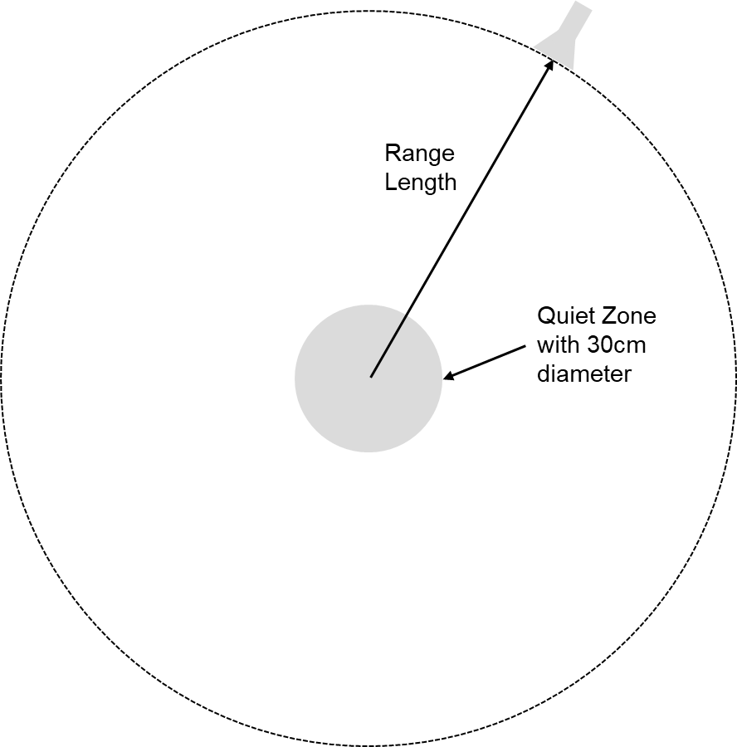
Figure A.3.4-1: Illustration of range length definition
The minimum range length shall be the maximum of the following three limits

- The phase uncertainty limit: R_{QZ}+2D_{rad}²/λ
- The amplitude uncertainty limit: 3D
- The reactive Near-Field limit: R_{QZ}+2λ
where R_{QZ} is defined as the radius of the quiet zone, i.e., R_{QZ}=D/2, and D_{rad} is the diameter of the effective radiating aperture. The minimum range length calculations for D=30cm quiet zone size TRP-TRS OTA test systems shall assume that D_{rad} is 30cm below 1GHz and decrease linearly from 30cm to 5cm from 1GHz to 7.125GHz, respectively. The last column of Table A.3.4-1 shall be considered the minimum range length for NR FR1 TRP-TRS OTA systems with 30cm quiet zone size.
Table A.3.4-1: Minimum Range Length for NR FR1 TRP-TRS OTA systems with 30cm quiet zone size.
F [GHz] | D_{rad} [m] | R_{QZ}+2D_{rad}²/λ | 3D = 6R_{QZ} | R_{QZ}+2λ | max(R_{QZ}+2λ,3D,R_{QZ}+2D²/λ)
0.41 | 0.30 | 0.40 | 0.9 | 1.61 | 1.61
0.6 | 0.30 | 0.51 | 0.9 | 1.15 | 1.15
0.7 | 0.30 | 0.57 | 0.9 | 1.01 | 1.01
0.8 | 0.30 | 0.63 | 0.9 | 0.90 | 0.90
1 | 0.30 | 0.75 | 0.9 | 0.75 | 0.90
1.2 | 0.29 | 0.83 | 0.9 | 0.65 | 0.90
1.4 | 0.28 | 0.90 | 0.9 | 0.58 | 0.90
1.6 | 0.28 | 0.96 | 0.9 | 0.52 | 0.96
1.8 | 0.27 | 1.01 | 0.9 | 0.48 | 1.01
2 | 0.26 | 1.05 | 0.9 | 0.45 | 1.05
2.2 | 0.25 | 1.07 | 0.9 | 0.42 | 1.07
2.4 | 0.24 | 1.09 | 0.9 | 0.40 | 1.09
2.6 | 0.23 | 1.11 | 0.9 | 0.38 | 1.11
2.8 | 0.23 | 1.11 | 0.9 | 0.36 | 1.11
3 | 0.22 | 1.10 | 0.9 | 0.35 | 1.10
4 | 0.18 | 0.99 | 0.9 | 0.30 | 0.99
5 | 0.14 | 0.77 | 0.9 | 0.27 | 0.90
6 | 0.10 | 0.52 | 0.9 | 0.25 | 0.90
7 | 0.06 | 0.29 | 0.9 | 0.24 | 0.90
7.125 | 0.05 | 0.27 | 0.9 | 0.23 | 0.90

A.4 Preliminary example MU budget

A.4.1 General

A.4.2 Test system of Anechoic Chamber method
The uncertainty contributions related to TRP are described in Annex B in [2]. A preliminary example uncertainty budget for TRP hand only test case using Anechoic Chamber test system is presented in Table A.4.2-1.
Table A.4.2-1 Preliminary example of uncertainty budget for TRP hand only (browsing mode) measurement for anechoic chamber method for NR FR1 bands
UID | Uncertainty Source | Comment | Uncertainty Value [dB] | Prob Distr | Div | ci | Standard Uncertainty [dB]
Stage 2: DUT measurement
1 | Mismatch of receiver chain | Г_{power meter} <0.05 Г_{measurement antenna} <0.16 | 0.07 | U-shaped | 1.41 | 1 | 0.05
2 | Insertion loss of receiver chain | Systematic with Stage 1 (=> cancels) | 0 | Rectangular | 1.73 | 1 | 0.00
3 | Influence of the measurement antenna cable | Systematic with Stage 1 (=> cancels) | 0 | Rectangular | 1.73 | 1 | 0.00
4 | Measurement Receiver: uncertainty of the absolute level | Power Meter | 0.06 | Rectangular | 1.73 | 1 | 0.03
5 | Measurement distance | d=1.6m, Δd=0.05m | 0.27 | Rectangular | 1.73 | 1 | 0.16
6 | Quality of quiet zone | Surface standard deviation of power measurements in ripple test | 0.5 | Actual | 1 | 1 | 0.50
7 | DUT Tx-power drift | Drift | 0.2 | Rectangular | 1.73 | 1 | 0.12
8 | Uncertainty related to the use of phantoms | U_{ε} [dB] = 0.20 U_{σ} [dB] = 0.15 | 0.32 | Rectangular | 1.73 | 1 | 0.18
9 | Coarse sampling grid | Negligible 15° sampling grid | 0 | Actual | 1 | 1 | 0.00
10 | Random Uncertainty | Monoblock, clamshell and PDA design used for testing | 0.81 | Rectangular | 1.73 | 1 | 0.47
11 | Frequency Response | Average path loss corrected | 0 | Rectangular | 1.73 | 1 | 0.00
 | Stage 1: Calibration measurement, network analyzer method
12 | Uncertainty of network analyzer | Manufacturer’s uncertainty | 0.5 | Rectangular | 1.73 | 1 | 0.29
13 | Mismatch of receiver chain | Taken into account in VNA uncertainty term | 0 | U-shaped | 1.41 | 1 | 0.00
14 | Insertion loss of receiver chain | Systematic with Stage 2 (=> cancels) | 0 | Rectangular | 1.73 | 1 | 0.00
15 | Mismatch in the connection of calibration antenna | Taken in to account in VNA setup uncertainty | 0 | U-shaped | 1.41 | 1 | 0.00
16 | Influence of the calibration antenna feed cable | Gain calibration with a dipole | 0.3 | Rectangular | 1.73 | 1 | 0.17
17 | Influence of the measurement antenna cable | Systematic with Stage 2 (=> cancels) | 0 | Rectangular | 1.73 | 1 | 0.00
18 | Uncertainty of the absolute gain/ radiation efficiency of the calibration antenna | Calibration certificate | 0.5 | Rectangular | 1.73 | 1 | 0.29
19 | Measurement distance | Dipole: aligned with phase center | 0 | Rectangular | 1.73 | 1 | 0.00
20 | Quality of the Quiet Zone | Peak-to-null ripple | 0.5 | Rectangular | 1.73 | 1 | 0.29
Combined standard uncertainty |  |  |  |  |  |  | 0.91
Expanded uncertainty (Confidence interval of 95 %) |  |  |  |  |  |  | 1.78

The uncertainty contributions related to TRS are described in Annex B in [2]. A preliminary example uncertainty budget TRS hand only test case using Anechoic Chamber test system is presented in Table A.4.2-2.
Table A.4.2-2: Preliminary example of uncertainty budget for TRS hand only (browsing mode) measurement for anechoic chamber method for NR FR1 bands
UID | Uncertainty Source | Comment | Uncertainty Value [dB] | Prob Distr | Div | ci | Standard Uncertainty [dB]
Stage 2: DUT measurement
1 | Mismatch of transmitter chain | Г_{CommTester} <0.13 Г _{antenna connection} <0.03 | 0.07 | U-shaped | 1.41 | 1 | 0.05
2 | Insertion loss of transmitter chain | Systematic with Stage 1 (=> cancels) | 0 | Rectangular | 1.73 | 1 | 0.00
3 | Influence of the measurement antenna cable | Systematic with Stage 1 (=> cancels) | 0 | Rectangular | 1.73 | 1 | 0.00
4 | Communication Tester: uncertainty of the absolute output level | Manufacturer’s data sheet | 1 | Rectangular | 1.73 | 1 | 0.58
5 | Sensitivity measurement: output level step resolution | Step of 0.5 dB | 0.25 | Rectangular | 1.73 | 1 | 0.14
6 | Measurement distance | d=1.6m, Δd=0.05m | 0.27 | Rectangular | 1.73 | 1 | 0.16
7 | Quality of quiet zone | Surface standard deviation of power measurements in ripple test | 0.5 | Actual | 1 | 1 | 0.5
8 | DUT sensitivity drift | Drift measurement | 0.2 | Rectangular | 1.73 | 1 | 0.12
9 | Uncertainty related to the use of phantoms | U_{ε} [dB] = 0.20  U_{σ} [dB] = 0.15 | 0.32 | Rectangular | 1.73 | 1 | 0.18
10 | Coarse sampling grid | 30° sampling grid | 0.15 | Actual | 1 | 1 | 0.15
11 | Random uncertainty | Monoblock, clamshell and PDA used for testing | 0.91 | Rectangular | 1.73 | 1 | 0.53
12 | Frequency Response | Included in the output level step resolution | 0 | Rectangular | 1.73 | 1 | 0.00
Stage 1: Calibration measurement, network analyzer method
13 | Uncertainty of network analyzer | Manufacturer’s uncertainty calculator, covers NA setup | 0.5 | Rectangular | 1.73 | 1 | 0.29
14 | Mismatch of transmitter chain | Taken in to account in VNA setup uncertainty | 0 | U-shaped | 1.41 | 1 | 0.00
15 | Insertion loss of transmitter chain | Systematic with Stage 2 (=> cancels) | 0 | Rectangular | 1.73 | 1 | 0.00
16 | Mismatch in the connection of calibration antenna | Taken in to account in VNA setup uncertainty | 0 | U-shaped | 1.41 | 1 | 0.00
17 | Influence of the calibration antenna feed cable | Gain calibration with dipole | 0.3 | Rectangular | 1.73 | 1 | 0.17
18 | Influence of the measurement antenna cable | Systematic with Stage 2 (=> cancels) | 0 | Rectangular | 1.73 | 1 | 0.00
19 | Uncertainty of the absolute gain/ radiation efficiency of the calibration antenna | Calibration certificate | 0.5 | Rectangular | 1.73 | 1 | 0.29
20 | Measurement distance | Dipole: aligned with phase center | 0 | Rectangular | 1.73 | 1 | 0.00
21 | Quality of quiet zone | Peak-to-null ripple | 0.5 | Rectangular | 1.73 | 1 | 0.29
Combined standard uncertainty |  |  |  |  |  |  | 1.12
Expanded uncertainty (Confidence interval of 95 %) |  |  |  |  |  |  | 2.20

Annex B (normative):
< Phantoms definition and Positioning >

B.1 General
This Clause defines the phantom definition and positioning guidance for TPR TRS requirement measurement.

B.2 Phantom Definition

B.2.1 Head Phantom
The basic head phantom is based on the “SAM” head phantom in IEEE Std 1528-2003, which is also described in TS 37.544 Annex A.2 [8]. For TRP TRS test, the IEEE SAM head model has been extended to the neck region, which is specified in CTIA Certification OTA Test Plan [9].
The Head phantom defined in CTIA Certification OTA Test Plan section C.2 [9], is used for FR1 TRP TRS requirement testing.
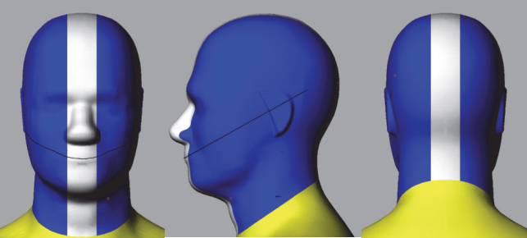
Figure B.2.1-1 Head Phantom (© 2001 – 2022 CTIA Certification. Reproduced with permission.), defined in the CTIA Certification OTA Test Plan

B.2.2 PDA Grip Hand Phantom
The PDA Grip Hand described in TS 37.544 Annex A.2.2 [8], which is identical to that defined in CTIA Certification OTA Test Plan section C.4.8 [9], is adopted for TRP TRS testing for the UE with width ≥56mm and ≤72mm.

B.2.3 Wide Grip Hand Phantom
The Wide Grip hand defined in CTIA Certification OTA Test Plan section C.4.9 [9], is used for FR1 TRP TRS testing for UE with width >72mm and ≤92mm.
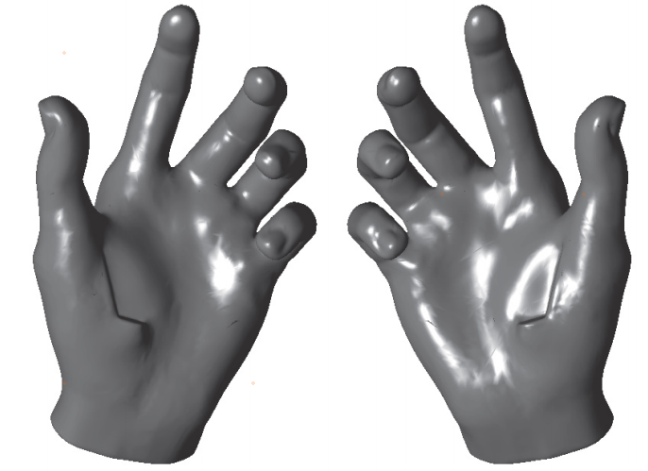
Figure B.2.3-1 Wide Grip hand (© 2001 – 2022 CTIA Certification. Reproduced with permission.), defined in the CTIA Certification OTA Test Plan

B.3 UE positioning guidelines

B.3.1 Hand phantom only (Browsing mode)
The positioning specified in this clause is used for the test cases for Browsing Mode with Hand Phantom. The characteristics of the Hand Phantom are specified in Clause B.3.1. Browsing mode is used to simulate user cases where the DUT is held in hand, but not pressed against ear e.g. web browsing and navigation. The DUT should be set as primary mechanical mode for browsing mode scenario, which is declared by manufacturer if the UE support multiple mechanical modes. Then, the DUT shall be mounted in a suitable hand phantom and oriented such that the DUT’s main display is tilted 45 degrees from vertical:
- Wide Grip Hand for UE with Width >72mm and ≤92mm
- PDA Grip Hand for UE with Width ≥56mm and ≤72mm
Note: the width is the UE width under primary mechanical mode for Browsing mode scenario.

B.3.1.1 Wide Grip Hand
This positioning guideline is suitable for DUTs with width >72mm and ≤92mm.
The positioning guideline defined in CTIA Certification OTA Test Plan section A.1.4.4 [9], is used for FR1 TRP TRS testing for UE with width >72mm and ≤92mm.
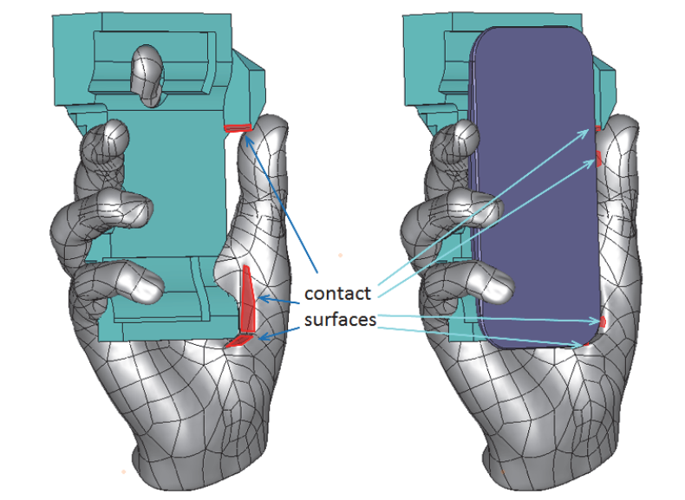
Figure B.3.1.1-1: Positioning guidance for Wide Grip Hand (© 2001 – 2022 CTIA Certification. Reproduced with permission.), defined in the CTIA Certification OTA Test Plan

B.3.1.2 PDA Grip Hand
This positioning guideline is suitable for DUTs with width ≥56mm and ≤72mm.
To help achieve a consistent positioning, the DUT is aligned to a PDA palm spacer. No alignment tool is required. The PDA spacer features side and bottom walls to ensure consistent alignment of DUTs of various sizes.

1. Place the DUT on the PDA spacer between the fingers and align the DUT to the side wall of the PDA.
2. If the DUT is shorter than 135 mm, then align the top of the DUT with the top of the PDA spacer. Otherwise, align the bottom of the DUT with the bottom wall of the PDA spacer.
3. While keeping the DUT in the hand phantom in the position defined in previous steps, place the DUT and the hand phantom against the head phantom in such way that the DUT is in 6°tilt angle as described in Clause B.3.2.1.
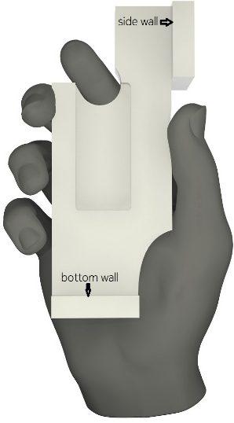
Figure 6.2.2-1: Right-handed PDA Grip hand phantom with a spacer
NOTE: Use left-handed (mirror-imaged) spacers with left-handed phantoms.

B.3.2 Head and Hand phantom (Talk Mode)

B.3.2.1 General
The positioning specified in this clause is used for the test cases for Talk Mode using Head & Hand Phantom. The characteristics of the Hand Phantom and Head Phantom are specified in Clause B.3.1.
Talk mode is used to simulate user cases where the DUT is placed into a hand phantom, which is holding the DUT against the SAM head phantom, presenting a realistic voice call operation of the DUT. The DUT should be set as primary mechanical mode for talk mode scenario, which is declared by manufacturer if the UE support multiple mechanical modes. Same as Browsing mode, the DUT for talk mode shall also be mounted in a suitable hand phantom:
- Wide Grip Hand for UE with Width >72mm and ≤92mm
- PDA Grip Hand for UE with Width ≥56mm and ≤72mm
Note: the width is the UE width under primary mechanical mode for talk mode scenario.
In this section, the procedure provides the guideline on how to place the DUT+hand against the head phantom. The detailed DUT positioning into hand phantom for talk mode is defined in Clause B.3.1.
For talk mode, the DUT is attached to the head phantom in “cheek” position. The DUT performance is measured on both left and right side of the head. Three points as shown in Figure B.3.2.1-1 define the reference plane: centre of the right ear piece (RE), centre of the left ear piece (LE) and centre of mouth (M).
Definition of the ‘Cheek’ position:
1. Align the ear piece of the phone (see Figure B.3.2.1-1) at the line RE-LE. Then, position the DUT beside the phantom so that the vertical line (see Figure B.3.2.1-3) is parallel to the reference plane in Figure B.3.2.1-2 and is aligned with the line M-RE on the reference plane (see Figure B.3.2.1-3).
2. Position the DUT so that the ear piece of the DUT touches the ear piece of the phantom head on the line RE-LE. Tilt the DUT chassis towards the cheek of the phantom having the vertical line aligned with the reference plane until any point on the front side of the DUT is in contact with the cheek or until the contact with the ear is lost.
NOTE: A holder fixture made of e.g. plastic may be used to position the handset against the phantom.
Figure B.3.2.1-1: Reference plane on head phantom, front view
Figure B.3.2.1-2: Reference plane on head phantom, side view
Figure B.3.2.1-3: Reference lines at a mobile handset.
In addition, 6°tilt angle from the cheek is being used instead of having direct contact between the cheek and DUT. A mask may be used to help configuration of cheek + 6° tilt angle. The mask is a 32 mm wide conformal strip, created by sweeping the surface of the head phantom through a 6º rotation about the ear. Direct DUT contact against the mask thus establishes the required 6º spacing away from the cheek, regardless of DUT form factor. The material for the head phantom mask spacer shall have dielectric constant of less than 1.3 and a loss tangent of less than 0.003. Material additions can be used to help fixing of the mask spacer onto the head phantom.

B.3.2.2 Wide Grip Hand and Head
This procedure is suitable for talk mode use with DUTs of width >72mm and ≤92mm. The positioning of the DUT in the Wide Grip hand for talk mode is identical to that for browsing mode described in Clause B.3.1.1.

B.3.2.1 PDA Grip Hand and Head
This procedure is suitable for talk mode use with DUTs of width ≥56mm and ≤72mm. The positioning of the DUT in the PDA Grip hand for talk mode is identical to that for browsing mode described in Clause B.3.1.2.

Annex C (normative):
<Environmental requirements>

E.1 General
This normative annex specifies the environmental requirements of the UE. Within these limits the requirements of the present documents shall be fulfilled.

E.2 Environmental
The requirements in this clause apply to all types of UE(s).

E.2.1 Temperature
All the test cases defined in this technical specification should be measured in room temperature e.g. 25°C.

E.2.2 Voltage
All test cases shall be performed with the DUT operated in stand-alone battery powered mode. It is preferable if the UE is fully charged in the beginning of the test.

Annex D (informative):
Change history
Change history
Date | Meeting | TDoc | CR | Rev | Cat | Subject/Comment | New version
2021-11 | RAN4#101-e | R4-2120687 |  |  |  | Initial Skeleton | 0.0.1
2022-01 | RAN4#101-bis-e | R4-2200971 |  |  |  | R4-2200974 TP to TS 38.161 on requirement applicability | 0.1.0
2022-03 | RAN4#102-e | R4-2204952 |  |  |  | R4-2205174 TP to 38.161 on general aspects  R4-2207315 Text proposal on environmental requirements for 38.161  R4-2207323 TP to 38.161 on TRP aspects  R4-2207316 TP to TS 38.161 on frequency bands  R4-2207322 TP to TS 38.161 on Annex A: Test methodology | 0.2.0
2022-05 | RAN4#103-e | R4-2208626 |  |  |  | R4-2208481 TP to TS 38.161 on primary mechanical mode  R4-2210939 TP to 38.161 on EN-DC and PC2 test case applicability rules  R4-2210940 TP to 38.161 on TRP aspects  R4-2210942 TP to TS 38.161 on test method  R4-2210944 TP to TS 38.161 on Phantoms | 0.3.0

