3GPP TR 38.849 V0.4.0 (2021-08)
Technical Report
3rd Generation Partnership Project;
Technical Specification Group Radio Access Networks;
Introduction of lower 6GHz NR unlicensed operation for Europe
(Release 17)
The present document has been developed within the 3rd Generation Partnership Project (3GPP TM) and may be further elaborated for the purposes of 3GPP.
The present document has not been subject to any approval process by the 3GPP Organizational Partners and shall not be implemented.
This Specification is provided for future development work within 3GPP only. The Organizational Partners accept no liability for any use of this Specification.
Specifications and Reports for implementation of the 3GPP TM system should be obtained via the 3GPP Organizational Partners' Publications Offices.

3GPP
Postal address

3GPP support office address
650 Route des Lucioles - Sophia Antipolis
Valbonne - FRANCE
Tel.: +33 4 92 94 42 00 Fax: +33 4 93 65 47 16
Internet
http://www.3gpp.org

Copyright Notification
No part may be reproduced except as authorized by written permission.
The copyright and the foregoing restriction extend to reproduction in all media.

© 2021, 3GPP Organizational Partners (ARIB, ATIS, CCSA, ETSI, TSDSI, TTA, TTC).
All rights reserved.

UMTS™ is a Trade Mark of ETSI registered for the benefit of its members
3GPP™ is a Trade Mark of ETSI registered for the benefit of its Members and of the 3GPP Organizational Partners
LTE™ is a Trade Mark of ETSI registered for the benefit of its Members and of the 3GPP Organizational Partners
GSM® and the GSM logo are registered and owned by the GSM Association

Contents
Foreword 4
1 Scope 6
2 References 6
3 Definitions of terms, symbols and abbreviations 6
3.1 Terms 6
3.2 Symbols 6
3.3 Abbreviations 7
4 Background 7
5 NR Frequency band definition 7
6 RF requirements 8
6.1 UE specific 8
6.2 BS specific 8
7 RRM 8
7.1 Frequency bands grouping 8
Annex [A]: Change history 9

Foreword
This Technical Report has been produced by the 3rd Generation Partnership Project (3GPP).
The contents of the present document are subject to continuing work within the TSG and may change following formal TSG approval. Should the TSG modify the contents of the present document, it will be re-released by the TSG with an identifying change of release date and an increase in version number as follows:
Version x.y.z
where:
x the first digit:
1 presented to TSG for information;
2 presented to TSG for approval;
3 or greater indicates TSG approved document under change control.
y the second digit is incremented for all changes of substance, i.e. technical enhancements, corrections, updates, etc.
z the third digit is incremented when editorial only changes have been incorporated in the document.
In the present document, modal verbs have the following meanings:
shall indicates a mandatory requirement to do something
shall not indicates an interdiction (prohibition) to do something
The constructions "shall" and "shall not" are confined to the context of normative provisions, and do not appear in Technical Reports.
The constructions "must" and "must not" are not used as substitutes for "shall" and "shall not". Their use is avoided insofar as possible, and they are not used in a normative context except in a direct citation from an external, referenced, non-3GPP document, or so as to maintain continuity of style when extending or modifying the provisions of such a referenced document.
should indicates a recommendation to do something
should not indicates a recommendation not to do something
may indicates permission to do something
need not indicates permission not to do something
The construction "may not" is ambiguous and is not used in normative elements. The unambiguous constructions "might not" or "shall not" are used instead, depending upon the meaning intended.
can indicates that something is possible
cannot indicates that something is impossible
The constructions "can" and "cannot" are not substitutes for "may" and "need not".
will indicates that something is certain or expected to happen as a result of action taken by an agency the behaviour of which is outside the scope of the present document
will not indicates that something is certain or expected not to happen as a result of action taken by an agency the behaviour of which is outside the scope of the present document
might indicates a likelihood that something will happen as a result of action taken by some agency the behaviour of which is outside the scope of the present document
might not indicates a likelihood that something will not happen as a result of action taken by some agency the behaviour of which is outside the scope of the present document
In addition:
is (or any other verb in the indicative mood) indicates a statement of fact
is not (or any other negative verb in the indicative mood) indicates a statement of fact
The constructions "is" and "is not" do not indicate requirements.

1 Scope
The present document is a technical report for Work Item on New Radio (NR) Access Technology, covering introduction of lower 6GHz NR unlicensed operation for Europe (NR_6GHz_unlic_EU).

2 References
The following documents contain provisions which, through reference in this text, constitute provisions of the present document.
- References are either specific (identified by date of publication, edition number, version number, etc.) or non-specific.
- For a specific reference, subsequent revisions do not apply.
- For a non-specific reference, the latest version applies. In the case of a reference to a 3GPP document (including a GSM document), a non-specific reference implicitly refers to the latest version of that document in the same Release as the present document.
[1] 3GPP TR 21.905: "Vocabulary for 3GPP Specifications".
[2] 3GPP TR 37.890: Feasibility Study on 6 GHz for LTE and NR in Licensed and Unlicensed Operations
…
[x] <doctype> <#>[ ([up to and including]{yyyy[-mm]|V<a[.b[.c]]>}[onwards])]: "<Title>".
It is preferred that the reference to 21.905 be the first in the list.

3 Definitions of terms, symbols and abbreviations
This clause and its three subclauses are mandatory. The contents shall be shown as "void" if the TS/TR does not define any terms, symbols, or abbreviations.

3.1 Terms
For the purposes of the present document, the terms given in 3GPP TR 21.905 [1] and the following apply. A term defined in the present document takes precedence over the definition of the same term, if any, in 3GPP TR 21.905 [1].
Definition format (Normal)
<defined term>: <definition>.
example: text used to clarify abstract rules by applying them literally.

3.2 Symbols
For the purposes of the present document, the following symbols apply:
Symbol format (EW)
<symbol> <Explanation>

3.3 Abbreviations
For the purposes of the present document, the abbreviations given in 3GPP TR 21.905 [1] and the following apply. An abbreviation defined in the present document takes precedence over the definition of the same abbreviation, if any, in 3GPP TR 21.905 [1].
Abbreviation format (EW)
<ABBREVIATION> <Expansion>
ACLR Adjacent Channel Leakage Ratio
ACS Adjacent Channel Selectivity
BS Base Station
BW Bandwidth
EIRP Effective Isotropic Radiated Power
FR Frequency Range
GSCN Global Synchronization Channel Number
ICS In-Channel Selectivity
ITU-R Radiocommunication Sector of the International Telecommunication Union
NR New Radio
NR-ARFCN NR Absolute Radio Frequency Channel Number
OTA Over The Air
RF Radio Frequency
RX Receiver
SCS Sub-Carrier Spacing
TDD Time division Duplex

4 Background
Administrations in Europe have had unlicensed operation in the range 5925 to 6425 MHz for consultation. The result of this consultation is that at the November 2020 meeting the ECC with ECC Decision (20)01 “on the harmonised use of the frequency bands 5945 to 6425 MHz for the implementation of Wireless Access Systems including Radio Local Area Networks (WAS/RLANs)” approved unlicensed operation in the range 5945 to 6425 MHz.
NR-Unlicensed is standardized in Rel-16 with the definition of band n96 covering the spectrum range 5925-7125 MHz which is currently applicable in the USA only subject to FCC Report and Order FCC 20-51. For Rel-17 3GPP WG4 is tasked to also enable unlicensed operation in the range 5945 to 6425 MHz for European deployments.
Regulatory information is maintained in [2].

5 NR Frequency band definition

5.1 Band definition

5.2 NR-ARFCN and GSCN
Operation in the 6GHz EU band is to be aligned with other technologies operation in the same shared spectrum restricted to the following NR-ARFCN and GSCN points.
Applicable GSCN in Europe:
- GSCN = {9548, 9562, 9576, 9590, 9603, 9617,9631, 9645, 9659, 9673, 9687, 9701, 9714, 9728, 9742, 9756, 9770, 9784, 9798, 9812, 9826, 9840, 9853, 9867}
Applicable NR-ARFCN in Europe:
- For 20 MHz channel bandwidth, NREF = {797000, 798332, 799668, 801000, 802332, 803668, 805000, 806332, 807668, 809000, 810332, 811668, 813000, 814332, 815668, 817000, 818332, 819668, 821000, 822332, 823668, 825000, 826332, 827668}
- For 40 MHz channel bandwidth, NREF = {797668, 800332, 803000, 805668, 808332, 811000, 813668, 816332, 819000, 821668, 824332, 827000}
- For 60 MHz channel bandwidth, NREF = {798332, 799668, 803668, 805000, 809000, 810332, 814332, 815668, 819668, 821000, 825000, 826332}
- For 80 MHz channel bandwidth, NREF = {799000, 804332, 809668, 815000, 820332, 825668, 831000}

6 RF requirements

6.1 UE specific

6.1.1 Transmitter characteristics
This section details specific transmitter characteristics for a UE operating in the lower 6 GHz NR unlicensed range in Europe.

6.1.1.1 A-MPR for a NS(s) for lower 6GHz NR unlicensed operation in Europe.
Additional emission requirements can be signalled by the network. Each additional emission requirement is associated with a unique network signalling (NS) value indicated in RRC signalling by an NR frequency band number of the applicable operating band as detailed in TS 38.101-1.
To meet the additional requirements applicable in EU as given in EN 303 687, additional maximum power reduction (A-MPR) is allowed for the maximum output power as specified in Table 6.1.1.1-1 for low power indoor (LPI).

Table 6.1.1.1-1: A-MPR for PC5 LPI
Pre-coding | Modulation | RB Allocation
 |  | Full² (dB) | Partial³ (dB)
DFT-s-ODFM | Pi/2 BPSK⁴ | ≤ 1.5 | ≤ 2.5
 | QPSK | ≤ 2.0 | ≤ 3.5
 | 16 QAM | ≤ 2.5 | ≤ 4.0
 | 64 QAM | ≤ 3.5 | ≤ 4.5
 | 256 QAM | ≤ 5.0 | ≤ 5.5
CP-OFDM | QPSK | ≤ 3.5 | ≤ 4.5
 | 16 QAM | ≤ 4.0 | ≤ 4.5
 | 64 QAM | ≤ 5.5 | ≤ 5.5
 | 256 QAM | ≤ 7.0 | ≤ 7.0
NOTE 1: The A-MPR shall apply to all SCS in all active 20 MHz sub-bands contiguously allocated in the channel. The MPR applies to interlaced allocations with uplink resource allocation type 2 as specified in TS 38.214 [10].
NOTE 2: Full RB allocation A-MPR applies when all RB’s in a 20 MHz channel or all RB’s in all sub-bands for wideband operation are fully allocated and sub-bands are transmitted according to configuration A in Table 6.2F.2-2.
NOTE 3: Partial RB allocation A-MPR applies when one or more RB’s in one or more sub-bands are not allocated or when the transmitted sub-bands for wideband operation are transmitted according to configuration B in Table 6.2F.2-2.
NOTE 4: Applicable to Pi/2-BPSK modulation when IE powerBoostPi2BPSK is set to 0.
NOTE 5: The A-MPR applies instead of MPR for 20 MHz channel centered at the nearest NR-ARFCN corresponding to 5955 MHz, 40 MHz channel at the nearest NR-ARFCN corresponding to 5965 MHz, 60 MHz channel at the nearest NR-ARFCN corresponding to 5975 MHz, and 80 MHz channel at the nearest NR-ARFCN corresponding to 5985 MHz. For all other channels, A-MPR is zero and MPR as specified in Table 6.2F.2-1 applies.

For very low power (VLP) operation the out-of-band emissions and in-band power spectral density requirements are much more restrictive than for LPI. For PC5 VLP, a comprehensive set of A-MPR simulation results is provided below for 20, 40, 60, and 80 MHz channels. In Figure 6.1.1.1-1 all channels in the band are represented while in Figure 6.1.1.1-2 lower edge channels are not illustrated since those are most impacted by the additional spurious emission requirement of -45 dBm/MHz. The lower edge channels found to be impacted were the ones centered at 5955 MHz for 20 MHz channels, 5965 MHz for 40 MHz channels, 5975 MHz and 5995 MHz for 60 MHz channels, and 5985 MHz for 80 MHz channels.
Table 6.1.1.1-2. Simulation scenarios for all CBW/SCS
Scenario | Modulation | DFT/CP | Allocation
1 | QPSK | CP | Interlace_0
2 | QPSK | DFT-S | Interlace_0
3 | QPSK | CP | Full
4 | QPSK | DFT-S | Full
5 | 16QAM | CP | Interlace_0
6 | 16QAM | DFT-S | Interlace_0
7 | 16QAM | CP | Full
8 | 16QAM | DFT-S | Full
9 | 64QAM | CP | Interlace_0
10 | 64QAM | DFT-S | Interlace_0
11 | 64QAM | CP | Full
12 | 64QAM | DFT-S | Full
13 | 256QAM | CP | Interlace_0
14 | 256QAM | DFT-S | Interlace_0
15 | 256QAM | CP | Full
16 | 256QAM | DFT-S | Full

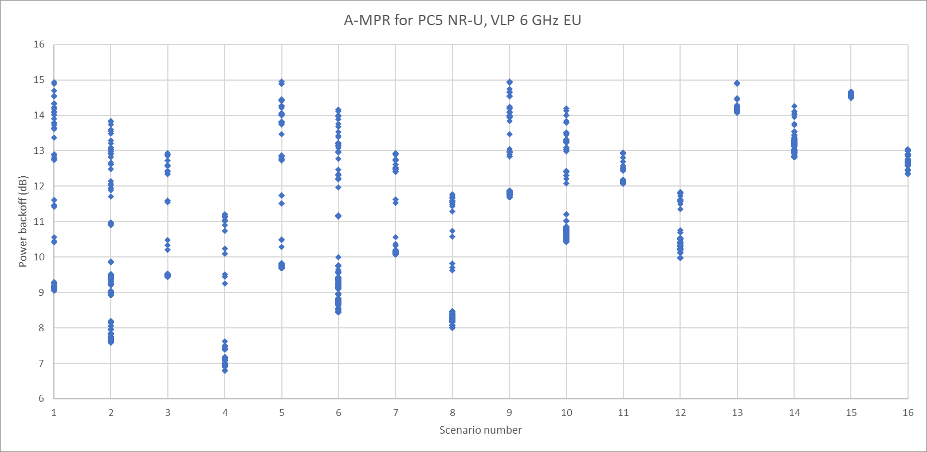
Figure 6.1.1.1-1. Power backoff for 20, 40, 60, and 80 MHz channels

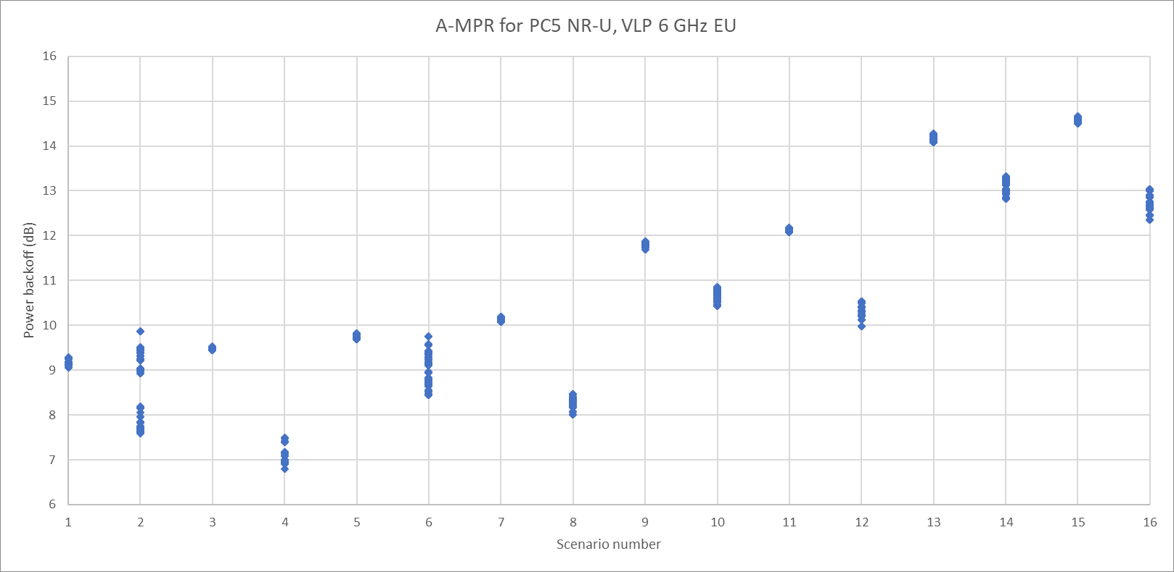
Figure 6.1.1.1-2. Power backoff with lower edge channels excluded
Based on these simulation results, the A-MPR table for VLP is provided below in Table 6.1.1.1-3.
Table 6.1.1.1-3. PC5 A-MPR table for VLP
Pre-coding | Modulation | RB Allocation (Note 2) |  | RB Allocation (Note 3)
 |  | Full (dB) | Partial (dB) | Full (dB) | Partial (dB)
DFT-s-ODFM | QPSK | ≤ 12 | ≤ 14 | ≤ 8 | ≤ 10
 | 16 QAM | ≤ 12 | ≤ 15 | ≤ 9 | ≤ 10
 | 64 QAM | ≤ 12 | ≤ 15 | ≤ 11 | ≤ 11
 | 256 QAM | ≤ 13 | ≤ 15 | ≤ 13 | ≤ 14
CP-OFDM | QPSK | ≤ 13 | ≤ 15 | ≤ 10 | ≤ 10
 | 16 QAM | ≤ 13 | ≤ 15 | ≤ 11 | ≤ 10
 | 64 QAM | ≤ 13 | ≤ 15 | ≤ 13 | ≤ 12
 | 256 QAM | ≤ 15 | ≤ 15 | ≤ 15 | ≤ 15
NOTE 1: Full allocation A-MPR applies when all RB’s in a 20 MHz channel or all RB’s in all sub-bands for wideband operation are fully allocated and all sub-bands are transmitted. Partial allocation A-MPR applies when one or more RB’s in one or more sub-bands are not allocated or when not all transmitted sub-bands for wideband operation are transmitted.
NOTE 2: Applicable for 20 MHz channels centered at the nearest NR-ARFCN corresponding to 5955 MHz, 40 MHz channels centered at the nearest NR-ARFCN corresponding to 5965 MHz, 60 MHz channels centered at the nearest NR-ARFCN corresponding to 5975 and 5995 MHz and 80 MHz channels centered at the nearest NR-ARFCN corresponding to 5985 MHz.
NOTE 3: Applicable for all valid channels other than those enumerated under NOTE 2.

6.1.2 Receiver characteristics

6.2 BS specific

6.2.1 Transmitter characteristics

6.2.2 Receiver characteristics

7 RRM

7.1 Frequency bands grouping

Annex [A]:
Change history
Change history
Date | Meeting | TDoc | CR | Rev | Cat | Subject/Comment | New version
2021-01 | RAN4-98e | R4-2101927 |  |  |  | TR Skeleton | 0.0.0
2021-02 | RAN4-98e | R4-2101928 |  |  |  | draft TR after RAN4-98e | 0.1.0
2021-04 | RAN4-98bis-e | R4-2107196 |  |  |  | draft TR after RAN4-98bis-e  Inclusion of:  R4-2105384 - TP to TR 38.849 on NR-ARFCN and GSCN points | 0.2.0
2021-05 | RAN4-99e | R4-2110691 |  |  |  | draft TR after RAN4-99-e  Inclusion of:  R4-2107789 - TP to TR 38.849 on MPR values for LPI deployments  Removal of automatic bullets | 0.3.0
2021-08 | RAN4-100e | R4-2113692 |  |  |  | draft TR after RAN4-100-e  Inclusion of:  R4-2114883 - TP to TR 38.849 on A-MPR for VLP | 0.4.0

