Invitation to
3GPP RAN1#89 / RAN2#98 / RAN3#96 / RAN4#83 /
RAN5#75 / RAN6#4 / SA2#121
May 15 – 19, 2017
Hangzhou, P. R. China

Dear 3GPP colleagues,

On behalf of Huawei Technologies, we are pleased to invite you to the 3GPP RAN1#89 / RAN2#98 / RAN3#96 / RAN4#83 / RAN5#75 / RAN6#4 / SA2#121 meeting in Hangzhou, P. R. China.

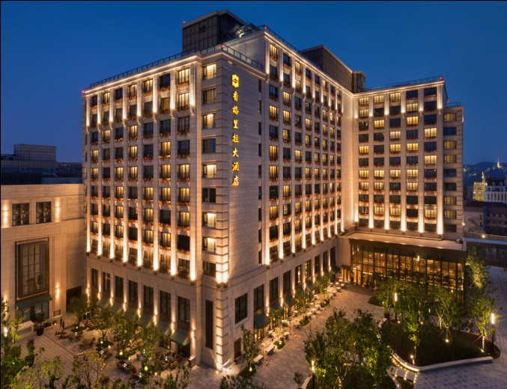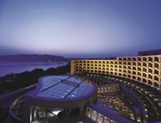

The meetings will be held at the Midtown Shangri-La, Hangzhou and Hyatt Regency Hangzhou. A block of rooms has been reserved at each hotel under a specific block code. An additional small block of rooms has been reserved for 3GPP delegates at the Wyndham Grand Plaza Royale Hangzhou. Please be sure to check the meeting list below to see where your meeting will be held. Please note, the Midtown Shangri-La and Hyatt Regency hotels are located 1.1 km away from one another. This is a six-minute ride or ten-minute walk. Please read the hotel reservation information in the following pages for more on group rates. Delegates are responsible for their own hotel reservations. Please book your room before the cutoff date, 14 April 2017. (Note that reservation beyond this point may be considerably expensive and subject to availability.)

Please make your reservations with and stay at the contracted meeting hotels, booking your room with the appropriate group code to ensure that the hotels know that you are with our group.

In addition to making your hotel reservation, it is also very important to register for the meeting on the 3GPP website. This provides the MCC and meeting planners with important planning information. Please visit www.3gpp.org to register on line. Please be sure to print your name badge prior to the meeting. Name badges will no longer be provided at meetings.

Should you require a personal letter of invitation for your business visa application, please contact the host listed in Appendix A via email. Your email should attach the form in Appendix A filled with all necessary information and be sent out before 21 April 2017. For Chinese Embassy or Consulate information, please visit website http://www.fmprc.gov.cn/eng/.

Meeting directions and general information are provided in the following pages.

We are looking forward to seeing you in Hangzhou, China.

Sincerely yours,
Wan, Lei
On behalf of Huawei Technologies Co., Ltd.

General Meeting Information

Meeting & Date:
Midtown Shangri-La, Hangzhou
RAN1#89 May 15 – 19, 2017
RAN2#98 May 15 – 19, 2017
RAN3#96 May 15 – 19, 2017
RAN5#75 May 15 – 19, 2017

Hyatt Regency Hangzhou
RAN4#83 May 15 – 19, 2017
RAN6#4 May 15 – 19, 2017
SA2#121 May 15 – 19, 2017

Location:
Hangzhou, Zhejiang

Contact from the Host:
Ms. Katherine Wu Ms. Cici Xie
Tel: +86 10 82829060 Tel: +86 18506836066
Email: kathy.wu@huawei.com Email: xiewei.xie.xiewei@huawei.com

Hotel Information:
Midtown Shangri-La, Hangzhou
Address: No.6 Changshou Road, Kerry Central, Yan’an Road, Hangzhou, Zhejiang 310006, P. R. China
Phone: +86 517 8733 8888
Website: www.shangri-la.com/hangzhou/midtownshangrila/about/
Kind Reminder: There are two Shangri-La hotels in Hangzhou. We are in the Midtown Shangri-La, not the Shangri-La on Beishan road.

Hyatt Regency Hangzhou
Address: No.28 Hu Bin Road, Hangzhou, Zhejiang 310006, P. R. China
Phone: + 86 571 8779 1234
Website: hangzhou.regency.hyatt.com

Wireless LAN:
This will be a paperless meeting.
MCC will provide and administer a WLAN during the meeting.

Hotel Reservation Information

Please note:
If you encounter any problems, when attempting to reserve a room online, e.g. that there are no rooms available under the group code, please contact the hotel staff (listed in the below sections) who can assist you with your reservation in the group block, at the reduced rate, at the meeting hotel. Please contact the meeting host (listed in the above sections) if your issue cannot be resolved by the hotel staff. We cannot help with problems of any reservations made outside the block/group code.

Midtown Shangri-La, Hangzhou
Group Rates (apply from 13th to 21st May 2017):
- Deluxe room
￥1029 + tax and service charge for single occupancy, including one buffet breakfast and WIFI access
￥1115 + tax and service charge for double occupancy, including two buffet breakfasts and WIFI access
Tax and Service Charge
10% Service Charge and an additional 6% VAT

Reservations Link
http://www.shangri-la.com/hangzhou/midtownshangrila/reservations/;
- Enter group code “HUA140517” (case sensitive), arrival and departure date;
- Select rate;
- Select room;
- Confirm booking information;
- Provide guest information and receive confirmation letter.
Contact for Hotel Reservations
Mr. Fox Wu: +86-18157181363; email: fox.wu@shangri-la.com
Ms. Shine Zhang: +86 18157181378; email: shine.zhang@shangri-la.com
If you have any question concerning hotel reservations, please contact them.

Cancellations
- Reservations will be held until 4 pm on day of arrival (local hotel time) unless guaranteed by a credit card or deposit.
- Guaranteed reservations cancelled less than 24 hours prior to 4pm on day of arrival (local hotel time) will be subject to a one-night charge.

Hyatt Regency Hangzhou

Group Rates (apply from 13th to 21st May 2017):
- Standard room
￥1044 + tax and service charge for single occupancy, including one buffet breakfast and WIFI access
￥1131 + tax and service charge for double occupancy, including two buffet breakfasts and WIFI access
- Lake View Room
￥1479 + tax and service charge for single occupancy, including one buffet breakfast and WIFI access
￥1566 + tax and service charge for double occupancy, including two buffet breakfasts and WIFI access
Tax and Service Charge
15%

Reservations Link
https://hangzhou.regency.hyatt.com/en/hotel/home.html
- Enter group code “G-HWHW” (case sensitive) , arrival and departure date;
- Confirm room type, room rate and cancellation policy;
- Complete detail booking information;
- Complete booking and receive confirmation letter.

Contact for Hotel Reservations
Ms. Rose Wu: +86 571 87791234; email: rose.wu3@hyatt.com
If you have any question concerning hotel reservations, please contact her.

Cancellations
- Reservations will be held until 6 pm on day of arrival (local hotel time) unless guaranteed by a credit card or deposit.
- Guaranteed reservations cancelled after 8th May 2017 (local hotel time) or no show will be subject to a one-night charge.

Wyndham Grand Plaza Royale Hangzhou
Address: No.555 Fengqi Road, Hangzhou, Zhejiang 310006, P. R. China
Phone: +86 571 8761 6888
Website: www.wyndhamhotels.com/wyndham-grand/hangzhou-china/wyndham-grand-plaza-royale-hangzhou/overview

This property is located 0.9 km from the Midtown Shangri-La, a five-minute ride or ten-minute walk, and it is located 1.2 km from the Hyatt Regency, a ten-minute ride or fifteen-minute walk.
Please note: No meetings will take place at the Wyndham Grand Plaza Royale Hangzhou. This hotel is for overflow sleeping rooms only.

Group Rates (apply from 13th to 21st May 2017):
￥1110 for deluxe king room, including one buffet breakfast, taxes and fees
Internet access is complimentary in guest rooms.

Booking Information
Please fill out the form in Appendix B and email the completed form to the hotel.

Cancellations
- Reservations will be held until 6 pm on day of arrival (local hotel time) unless guaranteed by a credit card or deposit.
- Guaranteed reservations cancelled after 5th May 2017 (local hotel time) will be subject to a one-night charge.

Check-in/Check-out Times (All hotels):
Check in after 02:00 PM
Check out before 12:00 PM

Cut-off Date (All hotels): 14 April 2017
Please make your reservation before the cutoff date to ensure the reduced group rate. Reservation beyond this point may be considerably expensive and subject to availability.

Please Note:
The host is not responsible for reservation confirmations, cancelled or changed reservations, or no-shows. Please contact the hotel directly to make any changes.

Transportation Information

Those who want to fly to Hangzhou can transfer via Beijing Capital International Airport, Hongkong International Airport or Guangzhou Baiyun International Airport.

Those who choose to fly to Shanghai (Pudong International Airport & Hongqiao International Airport) can go to Hangzhou by long distance coaches or train. The airport websites provide information about coaches. Information about train connections may be found here: http://trains.china.org.cn/.

It takes about 3 hours by long distance coach from Shanghai Pudong International Airport to Hangzhou and costs ￥ 100.

It takes about one hour by train from Shanghai Hongqiao Railway Station to Hangzhou East Railway Station and costs about ￥ 100. The distance between Hongqiao International Airport and Hongqiao Railway Station is about 7 km, a fifteen-minute ride. The distance between Pudong International Airport and Hongqiao Railway Station is about 60 km, a one-hour ride.

Airport: Hangzhou Xiaoshan International Airport
http://www.hzairport.com/en/
IATA: HGH
ICAO: ZSHC
Taxi
Around ￥ 100 (one way)

Directions

Midtown Shangri-La, Hangzhou
http://www.shangri-la.com/hangzhou/midtownshangrila/about/map-directions/

Distance to the hotel
Hyatt Regency Hangzhou 10 minutes by foot
Wyndham Grand Plaza Royale Hangzhou 10 minutes by foot
West Lake 5 minutes by foot
Hangzhou Xiaoshan International Airport 1 hour by car
Hangzhou East Railway Station 20 minutes by car

Taxi Card
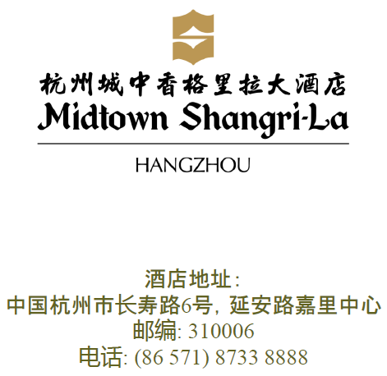

Hyatt Regency Hangzhou
https://hangzhou.regency.hyatt.com/en/hotel/our-hotel/map-and-directions.html

Distance to the hotel
Wyndham Grand Plaza Royale Hangzhou 15 minutes by foot
West Lake 5 minutes by foot
Hangzhou Xiaoshan International Airport 1 hour by car
Hangzhou East Railway Station 20 minutes by car

Taxi Card
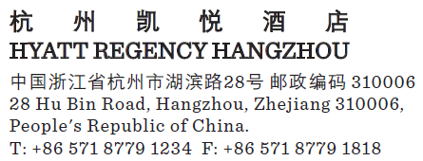

Wyndham Grand Plaza Royale Hangzhou
https://www.wyndhamhotels.com/wyndham-grand/hangzhou-china/wyndham-grand-plaza-royale-hangzhou/local-area

Distance to the hotel
West Lake 5 minutes by foot
Hangzhou Xiaoshan International Airport 1 hour by car
Hangzhou East Railway Station 30 minutes by car

Taxi Card
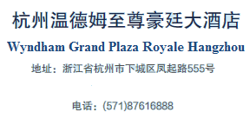

Airport shuttle
Wanghu Line (http://www.hzairport.com/en/bus.aspx)
Ticket Price: ￥ 20
Travel time: 1 hour under normal road and weather conditions
Bus stop: Lake View Hotel Hangzhou (No.2 West Huancheng Road, Hangzhou 310006, P. R. China)
Distance to the hotels
Midtown Shangri-La, Hangzhou 10 minutes by car
Hyatt Regency Hangzhou 10 minutes by foot
Wyndham Grand Plaza Royale Hangzhou 5 minutes by foot
Inquiry Phone Number: +86-571-96299

General Information for Stay in Hangzhou

GSM/UMTS/LTE Coverage:
There is GSM/UMTS/LTE coverage in Hangzhou.

Currency:
Until January 2017, 1 U.S. dollar was worth ￥ 6.87 CNY and 1 Euro was worth ￥ 7.28 CNY. Most foreign currencies are easily changed at banks or hotels. Local banks are typically open from 9am to 5pm from Monday to Friday, while weekend working hours may vary by institution. You will be required to present your identification card or passport in order to access foreign exchange services.
Several ATMs are conveniently located in the vicinity of the hotel.

Time Zone:
GMT +8 hours

Voltage:
Commercial power in China is 220V. Please be sure you have the correct adapter. Voltage converters will not be provided at the meeting.

City Profile/ Area Attractions:
http://en.gotohz.com/
Please don’t hesitate to direct any questions regarding the logistical arrangements of this meeting to the Meeting Coordinators:

Ms. Katherine Wu
Or
Ms. Cici Xie

Have a successful meeting and enjoy your stay in Hangzhou!
Appendix A
3GPP RAN1#89 / RAN2#98 / RAN3#96 / RAN4#83 / RAN5#75 / RAN6#4 / SA2#121
Hangzhou, China
May 15-19, 2017
INVITATION LETTER REQUEST FORM

To enter China for the meetings indicated above, you may need a letter of invitation from the Chinese host, which you will need to present to the Chinese Embassy/Consulate in your area in order to obtain your visa. In order to obtain the invitation letter, please:
- fill out the form below
- a scanned copy of your passport (the name, date of birth, nationality, passport number, passport validity date, etc. must be seen clearly; to ensure readability; a scanned photograph page is preferred.)
- a scanned copy of the latest Chinese visa (one or two records) if your entry is not the first time
- send all of the above via email before 21 April 2017
to visa_ran_wgs@huawei.com (for RAN WGs meeting)
to visa_sa2@huawei.com (for SA2#121 meeting)

NOTE: please send your application form in WORD file.

Full Name of Company
Surname |  | Given Name
Gender | □ Male □ Female
Birthday (YYYY-MM-DD) |  | Nationality
Tel No. |  | Job Title
Passport No. |  | Place of Issue Passport
Expired Date of Passport (YYYY-MM-DD)
Destination Country/Area & City/ Places to visit after entry (In this case, it is Hangzhou by default; if you want to visit other places than Hangzhou, please indicate here)
Country |  | City
Visa Issued Country/Area & City (If the country in which you'll obtain your visa is different from your nationality, please indicate it here:[ Country to obtain your visa])
Country |  | City
Duration (YYYY-MM-DD)
From |  | To
Applicant Information
Applicant Address
Applicant Fax No.
Applicant Email Address
End of form
(Please do not forget to attach a copy of your passport photograph page before sending.)

Appendix B
3GPP Hotel Reservation Form

Please email the completed form to alice.chen@wyndhamgpr.com or Leon.cao@wyndhamgpr.com. Contact Alice Chen (+86 134 5678 2848) or Leon Cao (+86 159 2560 7671) if you have not received a confirmation letter in 72 hours of sending the form.

New
Guest Name | Arrival Date | Departure Date | Room Type  (Twin or King room) | No. Of Rooms | Room Rate | Breakfast
 |  |  |  |  | CNY1,100net | Including 1 breakfast

Payment
By Guest Individual, Need to provide the credit card guarantee

Credit Card Type: VISA American Express Diners Master JCB
Credit Card Number: _____________________________________________________
Expiration Date: _________________________________________________________
Billing Address of Credit Card Holder: _______________________________________
_____________________________________

Remarks
I hereby agree that The Wyndham Grand Plaza Royale Hangzhou shall charge CNY1,100, the one night room booking expenditure on this credit card
(No._________________________________ MM/YY______) as the deposit for total one room on , 2016 to guarantee the booking. If guaranteed reservation was cancelled after 5th May 2017 (local hotel time) or no show, it would be charged one room revenue.
Credit card holder signature:

Confirmed by/Date:

