**3GPP TSG-RAN WG3 #128 R3-253780**

**St. Julien, Malta, 19th – 23rd May 2025**

**Agenda Item: 17.2**

**Source: Ericsson (Moderator)**

**Title: Network Energy Saving Summary of offline discussion**

**Document for: Discussion and Approval**

# Introduction

**Early RAN3 agreements (from RAN3#127bis)**

In the new Class 1 message (Direction NES gNB to Cell A gNB), RAN3 has agreed that:

* One Choice “Start with UL WUS Configuration”;
* One Choice “Stop” meaning the Cell A gNB will remove/release/discard the UL WUS Configuration and stop the broadcasting, it also means that next time the NES gNB should use “Start with UL WUS Configuration”.

# For Online discussion

2.1 Objective 1: Support on-demand SSB Scell

**Continue from the discussion we had from RAN3#127bis:**

Introduce a New list: ZTE, Samsung, Nokia

Reuse the list (May revise the procedural text): Rakuten, Huawei, CATT, Ericsson, DT

Nothing: Nokia, Ericsson

2.2 Objective 2: Support on-demand SIB1 for UEs

**Working Assumption:**

We are sending “Cell A list” from NES gNB to Cell-A gNB in the “WUS Configuration Provision Request” message, and send Cell A list from the Cell-A gNB to NES gNB in the response/failure

**The below list of the essential issues should be discussed for the closing of the WID:**

2.2.1 Related to the WUS Configuration Provision Request, choice of “Start”, Direction: NES gNB -> Cell-A gNB

* Should one “UL WUS Configuration Provision Request” message contain **one** UL WUS Configuration or **multiple different** UL WUS Configurations (i.e. a loop of the “single UL WUS Configuration”?
* Should the UL WUS Configuration in the request contain:
  + One NES Cell ID or a list of NES Cell IDs what share the same UL WUS Configuration?
  + the “octet string” that we can refer to TS 38.331 (OD-SIB1-Config-r19, refer to Annex)
  + It is a working assumption that a Cell-A list will be included. It is indicating to Cell A gNB that the UL WUS Configuration /OD-SIB1-Config-r19 should be broadcasted in the indicated Cell As.

2.2.2 Related to the UL WUS Configuration Provision Response/Failure, Direction: Cell-A gNB -> NES gNB

* For the “UL WUS Configuration provision”, what is considered as “successful” thus Cell-A gNB confirm to the NES Cell the broadcasting for the given UL WUS Configuration is successful?

Option 1: All the Cell-A cells have successfully broadcast UL WUS Configuration

Option 2: At least one Cell-A cell can broadcast the UL WUS Configuration

* It is a working assumption that a Cell-A list will be included. It is indicating to NES gNB that the UL WUS Configuration /OD-SIB1-Config-r19 cannot be broadcasted in the indicated Cell As.

2.2.3 Related to the WUS Configuration Provision Request, choice of “Stop”, Direction NES gNB -> Cell-A gNB

* Can we agree that “Stop” is always successful?
* If NES Cell IDs are included, the Cell A will stop the UL WUS Configuration for the given NES Cell IDs, if provision ID ( assuming it is signalled in the request) is included, the broadcasting for all the NES Cell associated to the provision ID will be stopped?

2.2.4 Related to Cell-A gNB, if it is gNB-CU or gNB-DU to encode the new SIBxx

* Most of the company proposed that it is gNB-CU in the Cell-A gNB encode the new SIBxx. Can we make this agreement?

# 3 Offline Discussion on Support on-demand SIB1 for UEs

3.1 Related to the WUS Configuration Provision Request, choice of “Start” NES Cell -> Cell A

* Should **one “WUS Configuration Provision Request” message** contain one WUS Configuration or **multiple different WUS Configurations?**

NEC: do we know RAN2’s design. -🡪 we do not need to have dependency on RAN2 on this aspect ( common understanding), **Prefer the single UL WUS Configuration**

QC: Provide a list, which means possible to contain multiple “**Different UL WUS Configuration**”

Huawei: Prefer multiple different WUS configuration in one message

Rakuten: Prefer single UL WUS Configuration, it is easy to handle with associated to a single provision ID

DT: If two requests at different times, NES gNB has to send twice the request.

Lenovo /ZTE/Samsung/CATT/Nokia : Prefer: multiple “**Different UL WUS Configuration**”

Ericsson: Prefer single **UL WUS Configuration**, to avoid the complexity for example how Cell A provide the response/failure.

**We will revisit this part when we see how the response message will look like.**

* Should each UL WUS Configuration instance contain:
  + the “octet string” format “WUS Config” that we can refer to TS 38.331 (OD-SIB1-Config-r19, refer to Annex).
  + One NES Cell ID or a list of NES Cell IDs what share the same UL WUS Configuration?

Option 1: Loop on the “UL WUS Configuration “: Huawei/CATT/DT/Ericsson/ZTE/Lenovo/NEC: multiple NES Cells shared the same UL WUS Config with the loop on “UL WUS Configuration”

Option 2: Loop on the “NES Cell”: Nokia/Rakuten: one NES cell associated with one UL WUS Configuration, “loop on the NES cells and each loop associates to a UL WUS Configuration”

* + One Cell-A ID or a list of Cell-A IDs that should broadcast the UL WUS Configuration?

**Samsung /DT/Nokia/CATT/ZTE/Lenovo/Ericsson/**: support list of Cell A ID, Configuration will be on NES.

**Huawei/Rakuten/**: prefer not to add Cell A ID;.

Nokia: Not to use CCO. Support to have Cell A ID

NEC: exchange the Cell A capability between to NES Cell

**Working Assumption:**

We do not send Cell A from NES to Cell A gNB in the request, and not Cell A in the response?

Rakuten, Huawei, NEC, CATT

We are sending Cell A list from NES to Cell A in the request, and send Cell A in the response?

DT, Ericsson, Samsung, ZTE, Lenovo, Nokia, QC

3.2 Related to the “WUS Configuration Provision Response/Failure”

The discussion should be based on the decisions we are going to make for 3.1.

* What is considered to be a “sucessful”, i.e. Cell A gNB will send “WUS Configuration Provision Response”
  + when all the indicated Cell A Cells have broadcasted the UL WUS?
  + When at least one indicated Cell A Cells has broadcasted the UL WUS ( but not all)?

**Rakuten**

**DT/ Ericsson/CATT:** do not support partical sucessful, as the NES would not know in this case if there is enough coverage.

**NEC:** thus prefer to have one UL WUS Config in the request and in the response we have response to the one UL WUS Configuration.

**DT:** all Cell A can broadcast UL WUS Configuration, then it is sucessufly.

**Rakuten:** if Cell A is not sent from NES Cell in the Request, it is up to Cell A to decide what is sucessful, blindly.

* What is considered to be a “failure”, i.e. Cell A gNB will send “WUS Configuration Provision Failure”
  + At least one indicated Cell A Cells cannot perfrom broadcasting WUS Configuration
    - The list of the failled Cell As are included in the failure message or not?
  + All the indicated Cell A Cells cannot perfrom broadcasting WUS Configuration

3.3 Related to the WUS Configuration Provision Request, choice of “Stop”

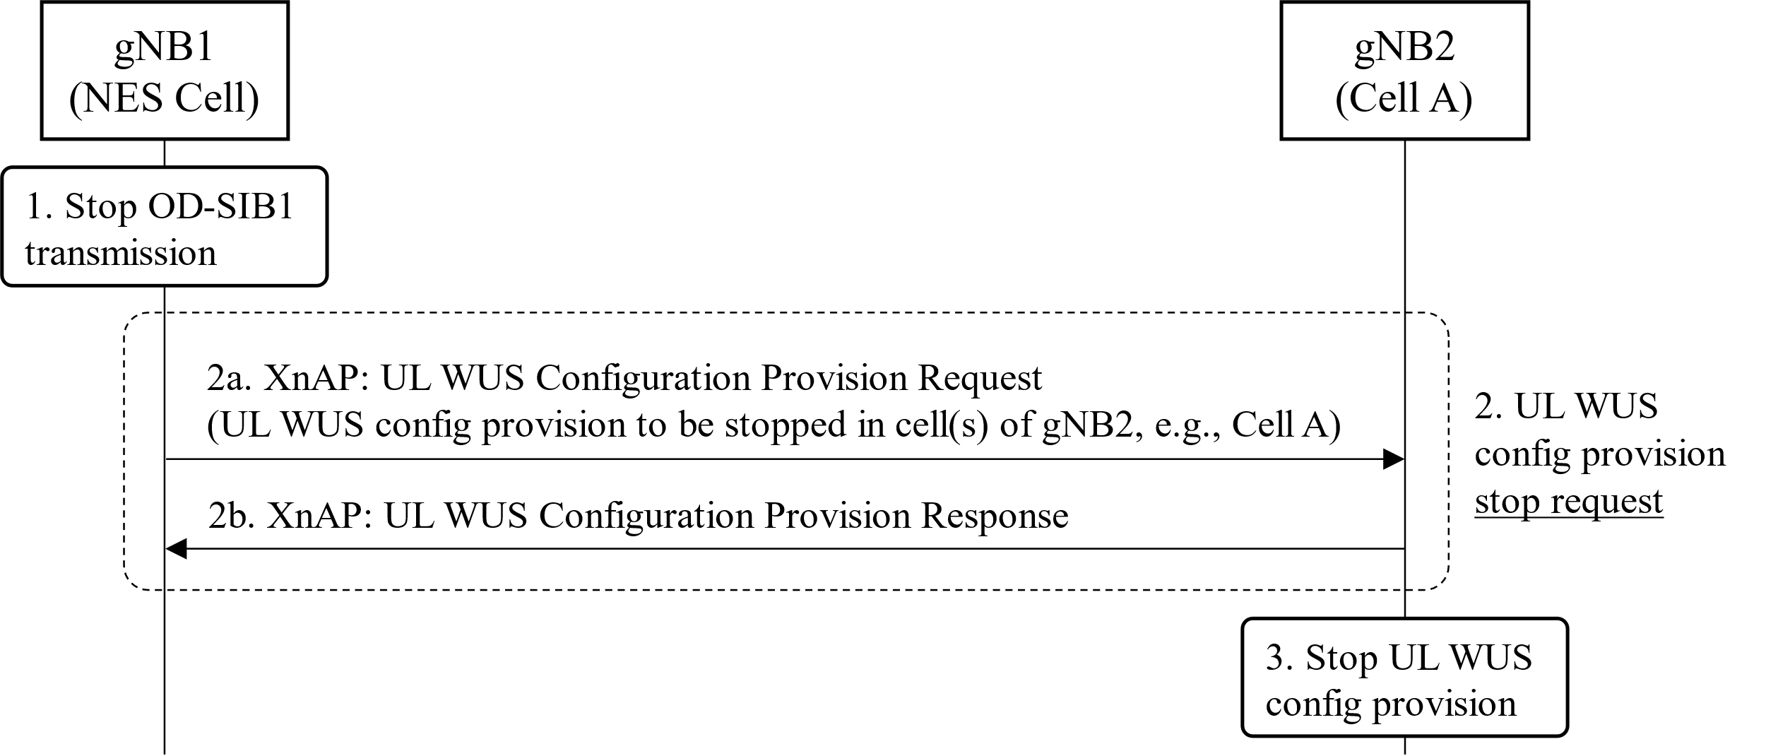

* The “Priovision ID” is included in the “Request”, in the “Stop” message, the “given Provision ID” associated UL WUS Configuration is remove/release/discard and the broadcast of UL WUS Configuraiton is stopped.
* The NES Cell list is included, all the indicated NES Cells UL WUS Configuration broadcasting is stopped ( and the configuration is removed/released/discarded).
* The “Stop” operation is always sucessful.

3.3 Related to the NES Cell CU and NES Cell DU

* Before the gNB-DU can determine if it can send the “on-demand SIB1 IE” to gNB-CU, receive a permission list from gNB-CU?
* After gNB-DU has sent the on-demand SIB1 IE” to gNB-CU, it will receive “confirmation” from gNB-CU that the UL WUS Configuration is broadcasoed, so that it can enter the OD-SIB1 operation.

3.4 Related to the Cell-A CU and Cell-A DU

* Should the UL WUS Configuration SIBx be encoded by Cell-A CU or Cell-A DU?

3.5 Related to the WUS Configuration Provision Request, we have already start and stop, if we need to have more choice option?

3.6 The following is up to implemenation or by OAM or need update the specification

* NES Cell goes to OD-SIB1 operation after it has received the suceesful response from the Cell A is up to implemenation
* Which gNB works as “Cell A gNB” for the other gNB.

3.7 Discussion on class 2 message (sending from Cell A -> NES Cell)



# 4 Discussion on Support on-demand SSB Scell

New list? ZTE, Samsung, Nokia

Reuse the list (may revise the text )? Rakuten, Huawei, CATT, Ericsson, DT

# 5 Discussion on Support adaptive

**Anything?**

# 6 Moderator Summary

# 7 Annex

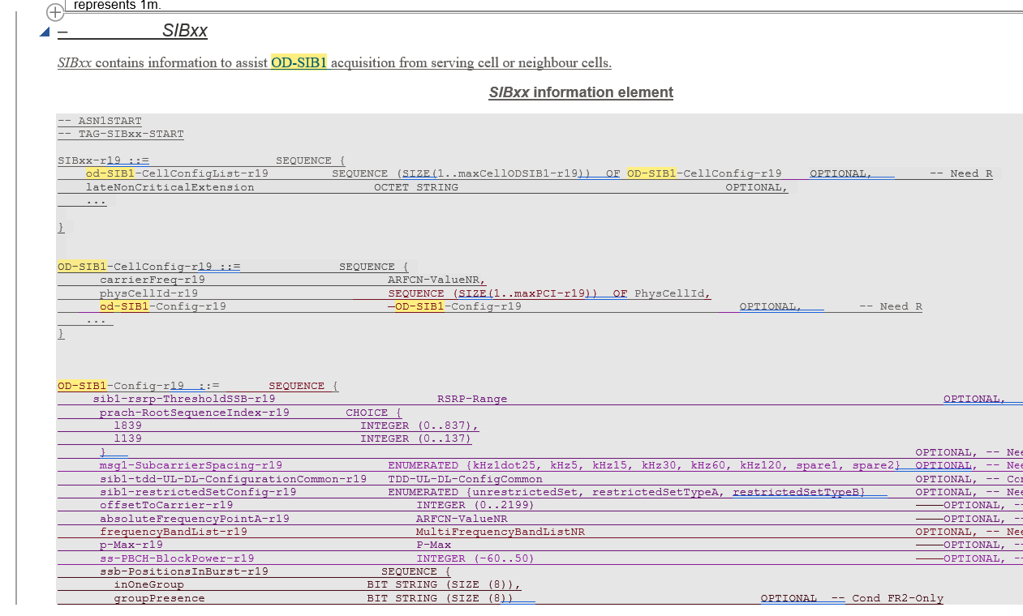

# 8 Reference