3GPP TSG-RAN WG3 #128 DRAFT_ R3-253757

Malta, 19-23 May 2025
Agenda Item: 9.2
Source: Vodafone (moderator)
Title: CB: # 5_L3MeasurementsLTM

Introduction:
Agreements during main online:

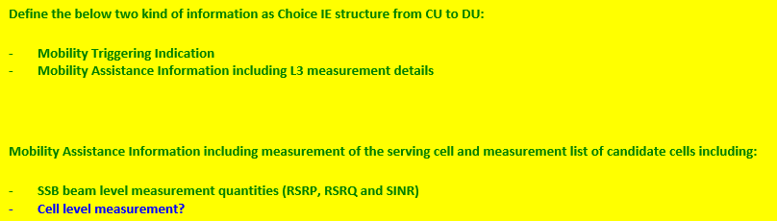

- Comments to the description as in 8.2.x CU-DU Mobility Initiation
- The word “LTM” will not introduced into procedural name

8.2.x CU-DU Mobility Initiation

8.2.x.1 General
The purpose of the CU-DU Mobility Initiation procedure is to trigger cell switch command and/or early synchronization for the UE. The procedure uses UE-associated signalling.
Procedural Text:
The procedure is initiated with the CU-DU MOBILITY INITIATION REQUEST message sent from the gNB-CU to the gNB-DU. Upon receipt of this message,
- if the CU-DU MOBILITY INITIATION REQUEST message indicates Mobility Triggering, the gNB-DU shall trigger LTM procedure(s) accordingly.
- if the CU-DU MOBILITY INITIATION REQUEST message indicates Assistance Information, the gNB-DU shall take this information into account for triggering LTM procedure(s).

8.2.x.4 Abnormal Conditions
If the Triggering Indication IE bitmap is set to "0" (all bits are set to "0") in the CU-DU MOBILITY INITIATION REQUEST message, the gNB-DU shall initiate an ERROR INDICATION message with an appropriate cause value.

- Comments to structure and IEs in 9.2.2.x “CU-DU MOBILITY INITIATION REQUEST”.

9.2.2.x CU-DU MOBILITY INITIATION REQUEST
This message is sent by the gNB-CU to the gNB-DU to trigger cell switch command and/or early synchronization for the UE.
For Message structure we agree that Serving and candidate Cell Measurements are mandatory provided if DU takes a decision.

- Inclusion of Measurements on the cell level in addition to SSB Level
QCM:If the DU gets only SSB level measurements only, it is hard (DU cannot track from SSB measurements the cell based measurements) to rank them in a good way and the first step the ranking should be performed on the cell level first. QCM also agrees that for synchronization SSB index is needed. Also the cell based measurements are anyway available by the CU, so just pass it to DU, there is no additional effort associated with that.
LG: If the LTM is based on L1 measurements, the information provided to the DU from the UE does not include Cell level measurements and LTM functionality is based on SSB level measurements.
QCM: In case of L1 measurement, the UE does not provide cell level measurements and DU can derive the cell level measurements for ranking based on implementation where in case of L3 measurements, the UE is already configured to rank the cells and the DU does not need have the same filter as used by the UE which may lead to different rankng between the UE and DU in case of L3 measurements. Cell Level and beam level filters are different
Huawei: Believes that L1 and L3 way of operation explained by QCM is controversial as in case of L1, cell based measurements can be derived from SSB and in case of L3, it is not possible.
QCM: If the cell level measurements are not provided to the DU by CU, then the DU would need to be configured exactly in the same way as CU configured to the UE in order to come to the same results during the filtering and that would require corresponding configuration alignment between CU and DU.
E///: We do not want to provide Cell ID based measurements as we have to take care about protocol split… It is a fundamental thing.
NTTdocmo: We have a neutral position. The benefit from the Qualcomm is recognized…Functional split is ambiguous thing… With choice there is nothing wrong to include cell based measurements.
Conclusion: No conclusion on cell level/SSB level measurements

