3GPP TSG-RAN WG3 Meeting #127 R3-250850

**Athens, Greece, 17 – 21 Feb, 2025**

**Agenda item: 10.4**

**Source: Samsung**

**Title: (TP for SON BLCR for 38.423) MRO for MR-DC SCG failure**

**Document for: Discussion and Decision**

# **1 Introduction**

The contribution provided a TP for SON BLCR for TS38.423 on MRO for MR-DC SCG failure.

# **TP for TS38.423 on MR-DC SCG failure**

8.3.17.2 Successful Operation

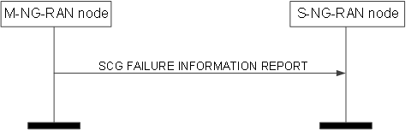

**Figure 8.3.17.2-1: SCG Failure Information Report, successful operation**

The M-NG-RAN node initiates the procedure by sending the SCG FAILURE INFORMATION REPORT message to the S-NG-RAN node. Upon receiving the message, the S-NG-RAN node shall assume that a PSCell change failure event was detected.

The SCG FAILURE INFORMATION REPORT message may include:

- the *SN Mobility Information* IE, if the *SN Mobility Information* IE was sent for the PSCell change procedure from the S-NG-RAN node;

- the *Source PSCell* *CGI* IE, if the *Source PSCell* *CGI* IE was sent for the PSCell change procedure from the S-NG-RAN node.

If the SCG FAILURE INFORMATION REPORT message includes the *Source PSCell* *CGI* IE, the S-NG-RAN node shall, if supported, store the information.

If the SCG FAILURE INFORMATION REPORT message includes the *Failed PSCell* *CGI* IE, the S-NG-RAN node shall, if supported, store the information and act as specified in TS 38.300 [9].

If the SCG FAILURE INFORMATION REPORT message includes the *Time SCG Failure* IE, the S-NG-RAN node shall, if supported, store the information and act as specified in TS 37.340 [8].

If received, the S-NG-RAN node uses the above information for SCG failure reason detection and optimisation.