3GPP TSG-RAN3 Meeting #127 R3-250825
Athens, Greece, Feb 17th – 21nd, 2025

Agenda Item: 10.3.1
Source: Huawei (moderator)
Title: SoD of SON for intra-NTN mobility
Document for: Approval

Introduction
This is the offline discussion document for SON for intra-NTN mobility.

For the Chairman’s Notes

Time based CHO:
Check the following observation before online discussion:
Observation: For single time-based trigger condition, the UE shall initiate the conditional reconfiguration execution at the time of T1, there will be no RLF after T1.
If the observation is correct, the following issue and FFS is no longer valid.
Existing timers can be reused to identify whether RLF happens before or after T1 with 100ms accuracy, FFS if the accuracy is a problem to be solved.
Then, proposal for agreement:
No need to identify whether RLF happens before or after T1 for time-based CHO.
Otherwise, the blue sentence retains.

Location based CHO:
Revert the WA: There is no need to report any other info in the RLF report for the location based CHO.
For earth moving case, the accuracy and complexity issue of the network-based solution is acknowledged.
- Option 1: to introduce the absolute UTC time of when RLF/HOF happens in the RLF report.
- Option 2: to introduce measured distance from UE to moving reference location of serving cell, and measured distance from UE to moving reference location of candidate cell (when RLF occurred).
FFS on option 1 or option 2.

Online discuss R3-250077 if time allows.

Discussion

MRO for NTN
Time based trigger condition
Existing timers can be reused to identify whether RLF happens before or after T1 with 100ms accuracy, FFS if the accuracy is a problem to be solved.
In R3-250099, it thinks that detection error within 100ms of T1 threshould can be ignored and no need to report any absolute timestamp. R3-250271 does not think that the absolute time is needed either.
In R3-250180, it thinks that Existing timers do not have a sufficient duration or granularity compared to T1-threshold and propose to report the absolute time in the RLF report.
R3-250326 thinks that the judging error is acceptable therefore, no need any flag or absolute time.
In R3-250499, it thinks that the absolute time is needed.
In R3-250408, it observes that
In Rel-17, there was no single time-based trigger condition, the time-based trigger condition is always configured together with one of the measurement-based trigger conditions, therefore, the time when the conditional reconfiguration is initiated is spread within the time window [T1, T1+ Duration] depending on when the measurement-based trigger condition is fulfilled. Later in Rel-18, when single time-based trigger condition was supported, the time when the conditional reconfiguration is initiated only depends on T1.
Observation: For single time-based trigger condition, the UE shall initiate the conditional reconfiguration execution at the time of T1, there will be no RLF after T1.

ZTE: accuracy is still a problem even the observation is correct.
Do we need to know how long before T1?
Check the observation offline.
Proposal: Existing timers are sufficient to identify whether RLF happens before or after T1. No additional information is needed.

Location based trigger condition:
WA: There is no need to report any other info in the RLF report for the location based CHO.
For the network based solution, the following accuracy and complexity issues are identified in R3-250408, R3-250300, and R3-250666.
- the location information logged in the RLF report may not be the location at the time of connection failure, it is the available measured location information when RLF or HOF happens.
- The location info in RLF report is subject to user consent which may be not available in case of no user consent.
- the UE measured location update frequency can vary
- The timeSinceCHO-Reconfig is on the level of 100ms accuracy. The satellite speed is around 7.56km/s for earth moving cells, the accuracy of the moving reference location of CondEvent D2 may change as much as 756m during 100ms.
- The granularity of the distance threshold defined in the location-based CHO is 50m
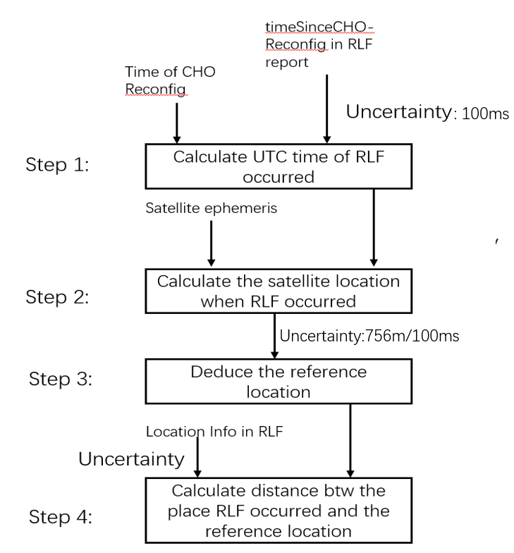
Furthermore, R3-250666 emphasizes that the propagation delay in NTN cell is not negligible, and may bring further errors on the accuracy of the timeSinceCHORecofig.
While, in R3-250099, R3-250499 and R3-250271, it still thinks there is no need to let the UE to report anything without any new points. In R3-250180, it thinks that the current location info in RLF report is sufficient without any justification.
R3-250326 thinks that the error is acceptable compared to the max cell radius which is up to 65535m.
Observation 5: Using timeSinceCHO-Reconfig will cause up to 756m error for moving reference location but the error can be acceptable because 756m is very small when compared (plus or minus) with distanceThreshFromReference1/2 which is up to 65535m.

Discussion:
Can we agree on the following conclusion?
The accuracy and complexity issue of the network based solution is acknowledged.

Or turn the above WA into agreement?
Conclusion: With the 100ms accuracy of the timeSinceCHO-Reconfig, it will limit the location-based CHO configuration with the granularity of around 756m in 100ms, which is 16 times of the original 50m in 1ms granularity. And the complexity is also huge.
Possible solutions:
- Option 1: to introduce the absolute UTC time of when RLF/HOF happens in the RLF report together with the location information. R3-250408.
- Option 2: To introduce measured distance from the configured/current reference location. Plus the configured/current reference location.
Discussion:
ZTE: prefer option 1.

Revert the following WA:
The accuracy and complexity issue of the network based solution is acknowledged.
FFS on option 1 or option 2

Temporary propagation change:

MRO is designed originally for non-moving cells.
But for earth moving satellite, the cells will move along with the time.

Discussion: Further clarification and confirmation on the scenario and the issue?
Discuss it online tomorrow.

MDT for NTN
RAN3 assumes both geographical area and the mapped cell ID as Area Scope of logged MDT for NTN over NGAP are feasible and confirm with RAN2 whether the geographical area defined for MBS NTN can be reused for MDT NTN.
R3-250408 and R3-250735 propose to support only geographical area for logged MDT Area Scope.R3-250408 further proposes that the same MDT Area Scope enhancement applies to both logged and immediate MDT over NGAP.
R3-250738 thinks that the Mapped Cell ID and geographical area both are needed can be added outside the existing Area Scope IE. It is also proposed to send LS to SA5.
R3-250300 and R3-250326 propose to proceed the TPs related to RAN3 based on the agreement above..
R3-250326 further proposes to:
- Introduce a new use case i.e., add the description of mapped cell ID for NTN MDT configuration in 38.300.
Discussion:
Issue 1: Support both option as the area scope of NTN MDT, or only one of them, which one?
Wait for RAN2 reply LS.
Issue 2: the smaller area scope applies to both logged MDT and immediate MDT?
the smaller area scope applies to both logged MDT and immediate MDT
Issue 3: the new area scope is added within the existing area scope or outside?
Issue 4: LS to SA5?
Issue 4: introduce new use case for mapped cell ID for NTN MDT?

TPs
No TPs need to be proceeded.

Reference
R3-250077 | [TP to BL CR to 38.423, SON] Solution to avoid restarting MRO in NTN deployments (Nokia) | other
R3-250099 | SON MDT for NTN (Qualcomm Incorporated) | discussion
R3-250180 | Discussion on SON/MDT enhancements for NTN (NEC) | discussion
R3-250271 | Discussion on MRO for intra-NTN mobility (Lenovo) | discussion
R3-250300 | (TP for MDT BLCRs for TS38.413, TS38.423, TS37.320): SON for Intra-NTN mobility (Huawei) | other
R3-250326 | (TP for 38.300 and 38.413) Intra-NTN mobility for SONMDT (CATT) | other
R3-250408 | SON-MDT enhancements for NTN (Ericsson) | discussion
R3-250499 | (TP to BL CR for 38.300) Further discussion on SONMDT enhancement for NTN (ZTE Corporation) | other
R3-250666 | Discussion on SONMDT enhancement for NTN (CMCC, Huawei) | discussion
R3-250735 | Discussion on SONMDT enhancements for NTN mobility (China Unicom) | discussion
R3-250736 | draft CR for TS 38.413 MDT enhancement for NTN (China Unicom) | draftCR
R3-250738 | (TP for MDT BLCRs for TS38.413, TS38.423) SON enhancements for NTN (Samsung) | other

