**3GPP TSG-RAN WG3 #127 R3-25xxxx**

**Athens, Greece., 17th-21st February 2025**

**Agenda Item: 17.3**

**Source: Ericsson (Moderator)**

**Title: Summary of offline discussions: Rel-19 Network Energy Saving OD-SIB1**

**Document for: Discussion and Approval**

# Introduction

**CB: # ES2**

**Check the signaling flow for the cases discussed online**

**Capture agreements and open issues**

(moderator - E///)

# For the Chairman’s Notes

It is proposed to capture the following RAN3 agreements in the chairman’s notes**:**

**Proposal 1: It is agreed that “after Cell A gNB has received and accepted the UL WUS Configuration request from the NES Cell gNB, it broadcasts SIB at the first opportunity.**

**Proposal 2: It is agreed from the signalling point of view, in UL WUS Configuration Request (naming FFS) from NES Cell gNB to Cell A gNB, UL WUS Configuration is included to trigger Cell A to start broadcasting UL WUS configuration in SIB as in Proposal 1.**

**Proposal 3: It is agreed that NES Cell gNB can “stop” (naming FFS) Cell A to broadcast UL WUS configuration. But it is not agreed if the class 1 or class 2 procedure is used. For further discussion.**

**The XnTP capture the above agreement is in R3-25xxxx.**

**It implements proposal 1 and proposal 2.**

# 3 Discussion on Support on-demand SIB1 for UEs

**We have reached the below agreements:**

It is agreed that “after Cell A gNB has received and accepted the UL WUS Configuration request from the NES Cell gNB, it broadcasts SIB at the first opportunity, as shown in the below figure:

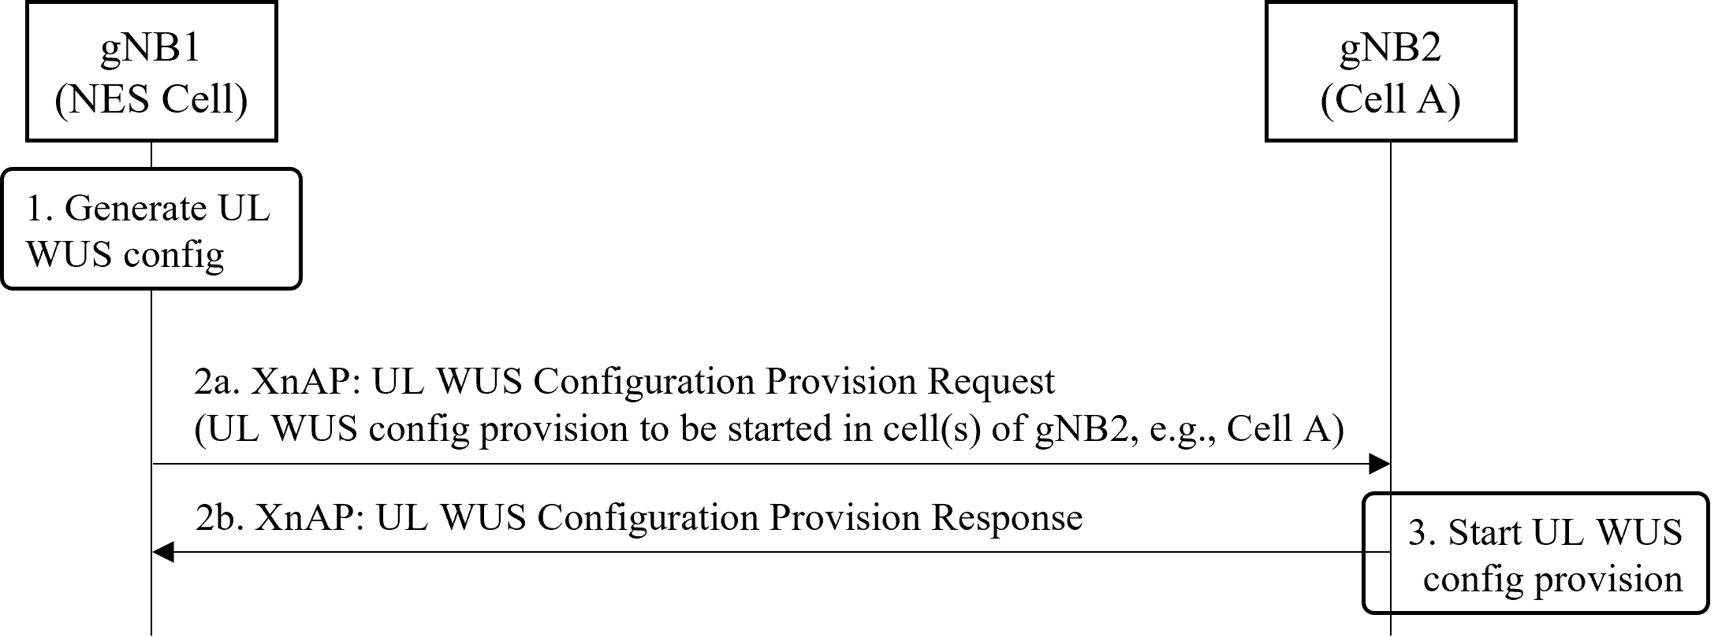

It is agreed from the signalling point of view, in UL WUS Configuration Req (naming FFS) from NES Cell gNB to Cell A gNB, one code point “start” with UL WUS Configraiton. This code point is used to trigger Cell A to broadcast UL WUS configruation in SIB.

It is agreed that NES Cell gNB can “stop” (naming FFS) Cell A to broadcast UL WUS configuration. But it is not agreed if the class 1 procedure or class 2 procedure is used. For further discussion.

**The XnTP capture the above agreement is in R3-25xxxx.**

# 6 Moderator Summary

Capture the agreement in the XnAP TP.