**3GPP TSG-RAN WG3 Meeting #127bisR3-252476**

**Wuhan, China, 7 – 11 April 2025**

**Title: [DRAFT] LS on AI/ML Positioning Case 3b**

**Response to:**

**Release: Release 19**

**Work Item: NR_AIML_air-Core**

**Source: Ericsson [to be RAN3]**

**To:** SA2

**Cc:**

**Contact Person:**

**Name:** Angelo Centonza

**Tel. Number:**

**E-mail Address:** Angelo.Centonza@ericsson.com

**Send any reply LS to: 3GPP Liaisons Coordinator,** [**mailto:3GPPLiaison@etsi.org**](mailto:3GPPLiaison@etsi.org)

**Attachments:**

**1. Overall Description:**

As part of the work on use case 3a for AI/ML assisted positioning, included in the WI NR_AIML_air-Core, RAN3 is working on solutions to retrieve positioning data at the NG-RAN. Such data can be used to manage NG-RAN sided models, e.g. to train or to monitor such models.

RAN3 has identified the following solutions and RAN3 would like to ask SA2 whether they are feasible.

***Solution 1: Positioning Information collection for UEs under positioning***



1. The LMF sends the NRPPa MEASUREMENT REQUEST message to one or more gNBs according to legacy positioning procedures.

2. The gNB(s) determines that data collection is needed for the UE being positioned.

3. The gNB(s) sends the NRPPa MEASUREMENT RESPONSE message to the LMF and indicates that data collection is needed for the UE being positioned.

Note: Steps 1 to 3 may occur while the LMF performs one or more of the positioning procedures described in clauses 6.11.1, 6.11.2 and 6.11.3 of TS 23.273 [35].

4. The LMF sends the new NRPPa POSITIONING DATA COLLECTION REPORT message to the gNB(s) which indicated that positioning data collection is needed for the UE being positioned. The message includes information related to UE location and correlation information that enables the gNB to correlate the information related to UE location with information related to UL measurements (e.g., LMF Measurement ID and RAN Measurement ID).

***Solution 2: Positioning Information collection for UEs served by the NG-RAN which are not being positioned***

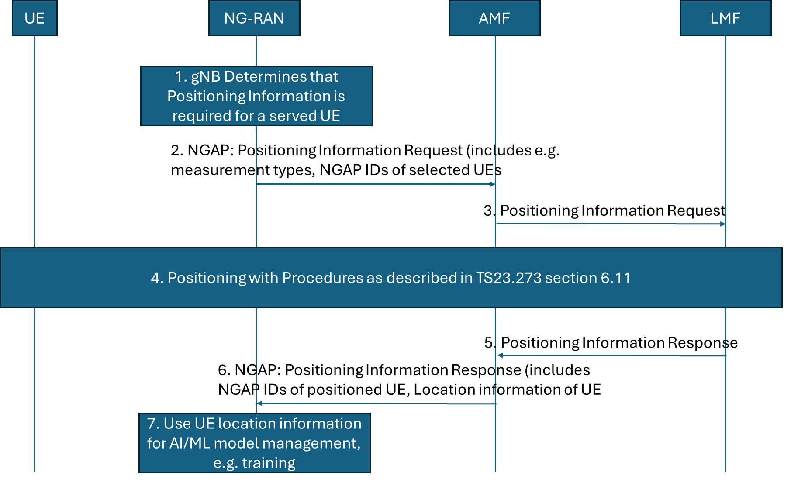

|  |
| --- |
| 1. The gNB is currently serving one or more UE(s) for which positioning measurements (i.e., UL SRS measurements) is available or for which they can be collected via a positioning session. The gNB wishes to receive positioning information, consisting of labels (e.g. UE location information) to form a data set for training. Based on gNB implementation, the gNB decides when/if to trigger a (new) NG: POSITIONING INFORMATION REQUEST message to the serving AMF of the served UE(s). 2. The POSITIONING INFORMATION REQUEST message is an NGAP non-UE associated message containing e.g. the NGAP UE IDs of the UEs for which positioning information is required, type of requested information, e.g. UE position, time stamp. 3. The AMF receives the request message from the NG-RAN node. If the requested information is already available at AMF as part of UE positioning context, the AMF responds directly with the message in step 6. Otherwise, it selects an LMF to request positioning of each UE for Positioning Information collection purposes.  The AMF triggers a Positioning Information Request towards the LMF (it could consist of the (legacy) Nlmf_Location_DetermineLocation service operation) to request the current location of the UE. 4. The LMF performs one or more of the positioning procedures described in clause 6.11.1, 6.11.2 and 6.11.3 of TS 23.273. 5. The LMF returns the requested information towards the AMF. The message Nlmf_Location_DetermineLocation Response might be reused. 6. The AMF returns the requested label(s) to the NG-RAN node in a POSITIONING INFORMATION RESPONSE message. The AMF may return instead a failure message with appropriate cause value if the procedure does not succeed. 7. The gNB combines the received label with the TRP measurements to form the data needed. |

**2. Actions:**

**To SA2**

**ACTION:**  RAN3 asks SA2 to provide feedback on feasibility of the solutions described above.

**3. Date of Next TSG RAN WG3 Meetings:**

TSG-RAN3 Meeting #128 May 19-23, 2025 Malta, MT

TSG-RAN3 Meeting #129 August 25-28, 2025 Bangalore, India