**3GPP TSG-RAN WG3 Meeting #127bisR3-25xxxx**

**Wuhan, China, 7 – 11 April 2025**

**Title: [DRAFT] LS on AI/ML Positioning Case 3b**

**Response to:**

**Release: Release 19**

**Work Item: NR_AIML_air-Core**

**Source: Ericsson [to be RAN3]**

**To:** SA2

**Cc:**

**Contact Person:**

**Name:** Yazid Lyazidi

**Tel. Number:**

**E-mail Address:** Yazid.lyazidi@ericsson.com

**Send any reply LS to: 3GPP Liaisons Coordinator,** [**mailto:3GPPLiaison@etsi.org**](mailto:3GPPLiaison@etsi.org)

**Attachments:**

**1. Overall Description:**

As part of the work on use case 3a for AI/ML assisted positioning, included in the WI NR_AIML_air-Core, RAN3 is working on solutions to retrieve positinong data at the NG-RAN. Such data can be used to manage NG-RAN sided models, e.g. to train or to monitor such models.

RAN3 has identified the following solutions and RAN3 wpould like to ask SA2 whether they are feasible.

***Solution 1: Positioning Information collection for UEs under positioning***

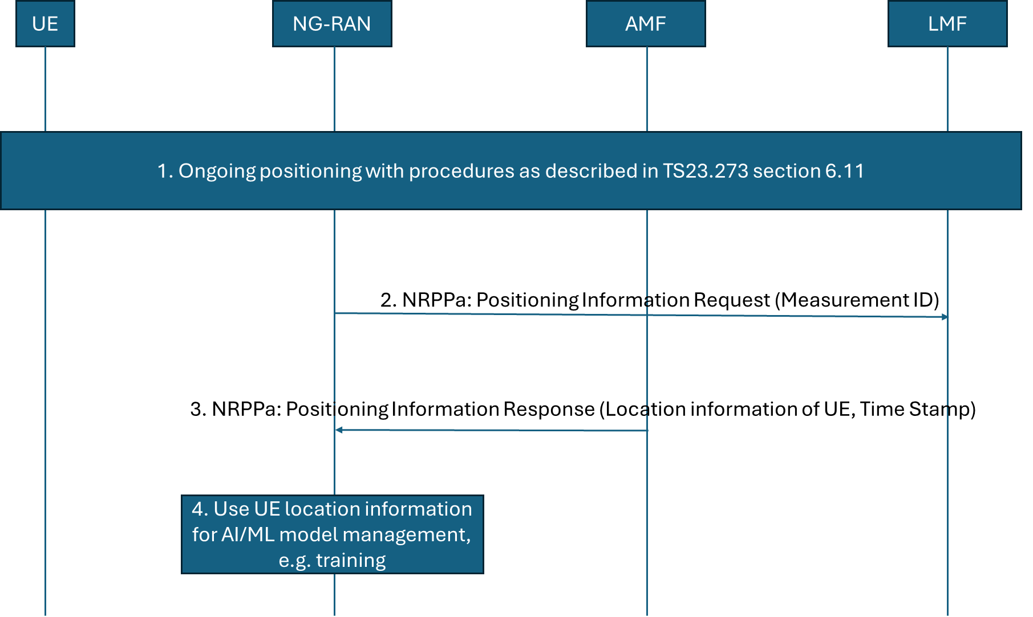

Solution 1: Positioning Information collection for UEs undergoing positioning that involves the gNB

Step 1. A positioning process is ongoing for a UE. The gNB involved in the positioning process determines that positioning information, e.g. UE location information, is needed for the UE under positioning.

2. gNB sends the Positioning Information Required message to the LMF over NRPPa, including the NRPPa Step Measurement ID associated to the UE for which positioning data is requested.

Step 3. LMF sends the Positioning Information Update message to the gNB, includingthe requested positioning data.

***Solution 2: Positioning Information collection for UEs served by the NG-RAN which are not being positioned***

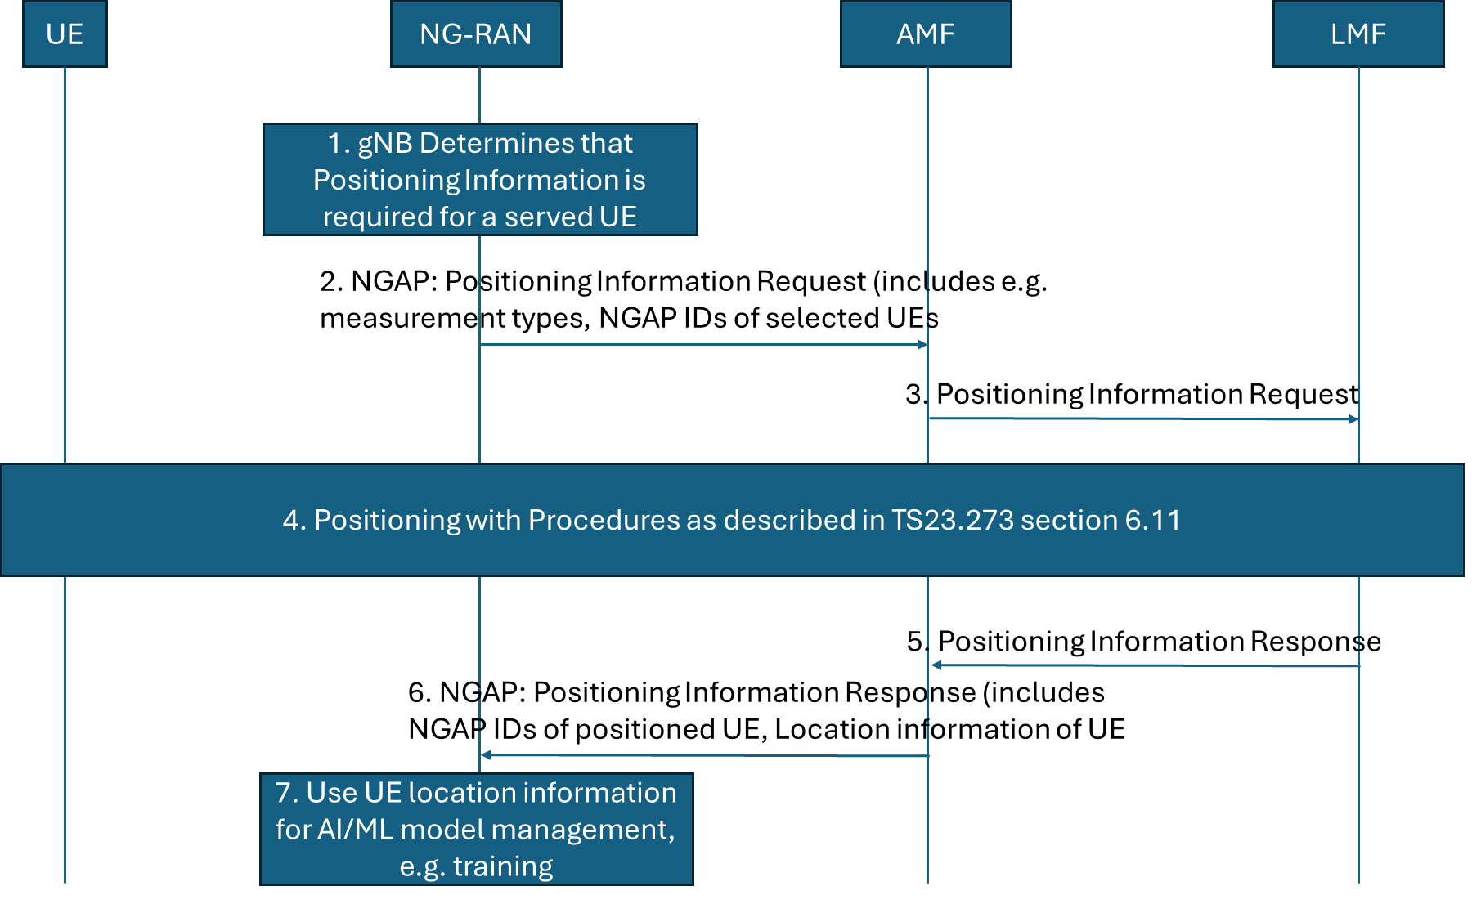

|  |
| --- |
| 1. The gNB is currently serving a UE for which part A information (i.e., UL SRS measurements) is available or for which it can be collected via a positioning session. The gNB wishes to receive the part B information, consisting of labels to form a data set for training. Based on gNB implementation, the gNB decides when/if to trigger a (new) NG: POSITIONING INFORMATION REQUEST message to the serving AMF of the served UE. 2. The POSITIONING INFORMATION REQUEST message is an NGAP non UE associated message containing e.g. the NGAP UE IDs of the UEs for which positioning information is required,type of requested information, e.g. UE position, time stamp. 3. The AMF receives the request message from the NG-RAN node. If the requested information is already available at AMF as part of UE positioning context, the AMF responds directly with the message in step 6. Otherwise, it selects an LMF to request positioning of the UE for Positioning Informaiton collection purposes.  The AMF triggers a Positinoing Informaiton Request towards the LMF (it could consist of the (legacy) Nlmf_Location_DetermineLocation service operation) to request the current location of the UE. 4. The LMF performs one or more of the positioning procedures described in clause 6.11.1, 6.11.2 and 6.11.3 of TS 23.273. 5. The LMF returns the requested information towards the AMF. The message Nlmf_Location_DetermineLocation Response might be reused. 6. The AMF returns the requested label to the NG-RAN node in a POSITIONING INFORMATION RESPONSE message.The AMF may returns instead a failure message with appropriate cause value if the procedure does not succeed. 7. The gNB combines the received label with the TRP measurements to form the data needed. |

**2. Actions:**

**To SA2**

**ACTION:**  RAN3 asks SA2 to provide feedback on the solutions described above.

**3. Date of Next TSG RAN WG3 Meetings:**

TSG-RAN3 Meeting #128 May 19-23, 2025 Malta, MT

TSG-RAN3 Meeting #129 August 25-28, 2025 Bangalore, India