3GPP TSG-RAN WG3 Meeting #127bis R3-252306  
Wuhan, China, 7 – 11 April, 2025

Agenda Item: 20.2

Source: CATT (moderator)

Title: Summary of Offline Discussion on AIPHY

Document for: Approval

# Introduction

The following CB is discussed in this document:

**CB: # AIPHY**

* **For Case3a, start with the solution signaling flow in 1720 based on common understanding on whether LMF or gNB selects the UE**
* **Check the TP for Case3b in [R3-251770](F:\\会议文件\\RAN3\\2025年\\RAN3#127bis武汉\\Inbox\\Drafts\\CB # AIPHY\\Inbox\\R3-251770.zip)**
* **Capture agreements and open issues**

(moderator - CATT)

Summary of offline disc [R3-252306](F:\\会议文件\\RAN3\\2025年\\RAN3#127bis武汉\\Inbox\\Drafts\\CB # AIPHY\\Inbox\\R3-252306.zip)

# For the Chairman’s Notes

Propose the following:

**Case 3a data collection:**

An NRPPA based solution could be used to collect UE location information in an opportunistic way, i.e. from UEs that are being positioned.

* Agree the TP to BL CR for TS 38.305 in R3-252420.

FFS on Whether to introduce an NGAP based procedure to collect UE location information in a proactive way, i.e. from UEs that are being served by the NG-RAN. (Updated Option 3 as in the LS)

Send the LS to SA2 in R3-252443.

**Case 3b:**

**On support of sample based measurement**

* Focus on NRPPa TP at this meeting, work on F1AP TP later when NRPPa TP is stable.
* Agree the NRPPa TP in R3-252427 (revised from 1770)
* Send the LS to RAN1 in R3-252418 (revised from 2026)

# Discussion

## Case 3a

For Case 3a, we mainly discussed how the data collection is performed during online discussion, especially for the issue “**Which entity to perform the UE selection? LMF or gNB?”.**

The call flow in 1720 is taken as start point to further discuss the signalling flow of data collection.

* **For Case3a, start with the solution signaling flow in 1720 based on common understanding on whether LMF or gNB selects the UE.**

The call flow in 1720 is copied here for reference:



**Figure 7.x.2-1 Data Collection Information Transfer Procedures**

1. LMF initiates the Data Collection Notification procedure towards the gNBs which holds the AI/ML positioning model to establish the NRPPa transaction.

Note: This step could be ignored if NRPPa transaction(s) has already been established between the gNB and LMF for other purposes.

2. When gNB decides to train the model for AI/ML based positioning, it may request for the training data from LMF.

3. The gNB sends the Data Collection Request towards the LMF, with some assistance information, e.g. expected amount of UE labels, expected data type.

4. LMF confirms the requirements of the gNB and replies with the response message.

5. LMF decides the UE labels and initiates proper positioning procedures to collect the training data via the Positioning Information Transfer and Measurement procedures.

6. When the training data is collected, LMF provides the training data to the gNB via the Data Collection Update.

**The Call flow of 1720 is revised a little bit to the option 1 and option 2 as below, and Option 3**



**Figure x Data Collection Information Transfer Procedures (option 1)**

1. LMF initiates the Data Collection Notification procedure towards the gNBs which holds the AI/ML positioning model to establish the NRPPa transaction.

2. When gNB decides to train the model for AI/ML based positioning, it may request for the training data from LMF.

3. The gNB sends the Data Collection Required towards the LMF.

4. LMF indicates gNB the UE is selected for data collection and gNB indicates LMF the Part B is needed for the UE when performing Measurement procedures for a UE.

5. LMF provides the requested training data to the gNB via the Data Collection Update. gNB associate Part A and Part B and use them as the collected data for AI/ML model training.



**Figure x Data Collection Information Transfer Procedures (Option 2)**

Option 2 is similar to Option 1, difference is step 1 and 2 are a pair of class 1 procedure.

**Data Collection Request via NGAP (Option 3)**

0. The gNB decides to train the AI/ML positioning model and may request for the training data from the LMF.

1. The gNB sends a non-UE associated class 2 NGAP Data Collection Trigger towards the AMF, with some assistance information. FFS content of assistance information e.g. UE NGAP ID list, number of measurements etc.

2. The AMF finds a suitable LMF and forwards the data collection trigger to the LMF using Nlmf_DataExposure, or Nlmf_Location_DetermineLocation Request if UE(s) is provided by step 1 service.

3. If the list of UE(s) is not provided, the LMF may subscribe to the AMF serving the subscribed NG-RAN to retrieve the list of SUPIs located in an area of interest and the UE Positioning Capability for each UE, using the Namf_EventExposure_Subscriber_Request operation. The LMF may also check the user privacy requirements and the model training consent from each UE.

*Note 1: Step 3 to be confirmed with SA2.*

4. The LMF may perform any of the UE positioning procedures defined in TS 23.273 and 38.305 to obtain the UE location (to determine/calculate the ground truth label information).

*NOTE 2: Step 4 may also be triggered by an external LCS client. In that case, the LMF may opt for considering the UE to be positioned as part of the data collection triggered in Step 2, if the UE list is not provided in Step 2.*

5. If the UE is served by the gNB, the LMF shall provide the UE/PRU location (ground truth label/Part B information) to the gNB using

Option 1: a Nlmf_Location_DetermineLocation response followed by a new class 2 non-UE-associated NGAP message.

Option 2: a new UE-associated NRPPa Data Collection Report/Update message.

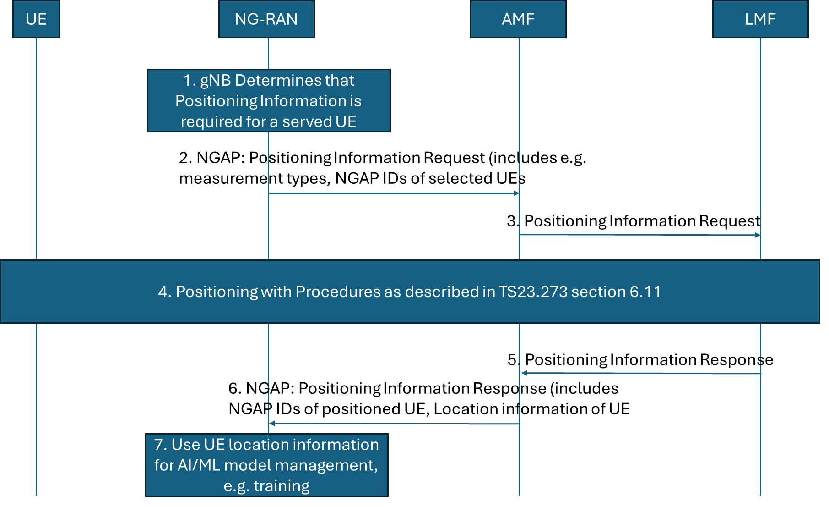

Updated Option 3

1. The gNB is currently serving one or many UE(s) for which part A information (i.e., UL SRS measurements) is available or for which it can be collected via a positioning session. The gNB wishes to receive part B information, consisting of labels to form a data set for training. Based on gNB implementation, the gNB decides when/if to trigger a (new) NG: POSITIONING INFORMATION REQUEST message to the serving AMF of the served UE(s).
2. The POSITIONING INFORMATION REQUEST message is an NGAP non-UE associated message containing e.g. the NGAP UE IDs of the UEs for which positioning information is required, type of requested information, e.g. UE position, time stamp.
3. The AMF receives the request message from the NG-RAN node. If the requested information is already available at AMF as part of UE positioning context, the AMF responds directly with the message in step 6. Otherwise, it selects an LMF to request positioning of the UE for Positioning Information collection purposes.   
   The AMF triggers a Positioning Information Request towards the LMF (it could consist of the (legacy) Nlmf_Location_DetermineLocation service operation) to request the current location of the UE.
4. The LMF performs one or more of the positioning procedures described in clause 6.11.1, 6.11.2 and 6.11.3 of TS 23.273.
5. The LMF returns the requested information towards the AMF. The message Nlmf_Location_DetermineLocation Response might be reused.
6. The AMF returns the requested label(s) to the NG-RAN node in a POSITIONING INFORMATION RESPONSE message. The AMF may return instead a failure message with appropriate cause value if the procedure does not succeed.
7. The gNB combines the received label with the TRP measurements to form the data needed.

## Case 3b

Check stage 3 TPs for 38.455 and 38.473 in R3-251770 to make support of Sample-Based Measurement as agreed by RAN1.

* Focus on NRPPa TP at this meeting, work on F1AP TP later when NRPPa TP is stable.
* Measurement type should be added, with FFS.

Discuss the potential LS out on behalf of R3-252026, if the TP(s) are agreed.

# Conclusion, Recommendations [if needed]

See section 2.

# References

1. R3-251509 Reply LS on LMF-based AI/ML Positioning for Case 3b (RAN1(Ericsson)) LS in
2. R3-251510 LS on AI/ML Positioning Case 3b (RAN1(Ericsson)) LS in
3. R3-252026 [DRAFT] LS reply on AI/ML Positioning Case 3b (Ericsson) LS out To: RAN1, RAN2 CC:
4. R3-251720 (TP to BL CRs) Support of gNB-based AI positioning (CATT) other
5. R3-251769 (TP for TS 38.455) Support of gNB-side model (case 3a) (Xiaomi) other
6. R3-252027 Discussion on data collection procedures to support gNB-sided model (case 3a) (Ericsson) discussion
7. R3-251617 [TP to 38.455 & 38.401] Support of AI/ML assisted Positioning (case 3a) (ZTE Corporation) other
8. R3-251618 (TP to BLCR to TS 38.455 & TS38.473) Discussion on AI/ML assisted positioning (case 3b) (ZTE Corporation) other
9. R3-251692 Discussion on AIML based Positioning Accuracy Enhancements (NEC) discussion
10. R3-251719 (TP to BL CR for TS38.455) Support of LMF-based AI positioning (CATT) other
11. R3-251770 (TP for 38.455 and TS 38.473) Support of Sample-based measurement for LMF-side model (case 3b) (Xiaomi, Ericsson) other
12. R3-251800 Discussion on Case 3a in AI/ML for positioning (Samsung, JIO Platforms) discussion
13. R3-251801 Discussion on Case 3b in AI/ML for positioning (Samsung, JIO Platforms) discussion
14. R3-251867 Discussion on support of direct AI/ML positioning (Case 3b) (China Telecom) discussion
15. R3-251868 Discussion on support of AI/ML assisted positioning (Case 3a) (China Telecom) discussion
16. R3-251953 AIML for gNB assisted positioning (Lenovo) discussion
17. R3-251957 AI/ML based positioning accuracy enhancements (Qualcomm Incorporated) discussion
18. R3-252001 (TP for AI/ML BLCR to TS 38.455) Discussion on RAN3 impacts for Direct AI/ML positioning (Case 3b) (Huawei) other
19. R3-252002 (TP for AI/ML BLCR to TS 38.455) Discussion on RAN3 impacts for NG-RAN node-assisted AI/ML positioning (Case 3a) (Huawei) other
20. R3-252028 (TPs to NRPPa and NGAP BL CRs to support case 3a) (Ericsson) other
21. R3-252034 (TPs To BL CRs) Support Direct AI ML Positioning (CMCC) other
22. R3-252035 Support Assisted AI ML Positioning (CMCC) discussion
23. R3-252084 (TP to TS 38.305) Model training at gNB for Case 3a (Nokia) other
24. R3-252085 (TP to TS 38.300) Intermediate feature reporting and general principles for case 3a (Nokia) other
25. R3-252154 AI/ML-Enhanced Positioning Enhancements for NRPPa (Jio Platforms Ltd (JPL)) discussion
26. R3-252163 Model training/monitoring at gNB for Case 3a (CEWiT) discussion

# TP to BL CR for TS 38.305 data collection procedures for Case 3a (opportunistic solution)

7.x Procedures for Data Collection Information Transfer

7.x.1 General

To support AI/ML based positioning with gNB-side model, data collection information is used to enable the data training in gNB-side AI model.

7.x.2 Data Collection Information Transfer Procedures

Figure 7.x.2-1 shows the Data Collection Information Transfer Procedure.



**Figure x Data Collection Information Transfer Procedures**

1. LMF initiates the Data Collection Notification procedure towards the gNB to establish the NRPPa transaction for data collection.

2. gNB determines to take the on-going UL positioning measurement(s) into account for data collection.

Editor’s Note: gNB generate and keep the Part A internally according to the UL positioning measurement, and request for corresponding Part B in the Step 3.

3. gNB sends Data Collection Required to the LMF with NRPPa Measurement ID to request for corresponding Part B.

Editor’s Note: Whether use “Part B” could be further checked and refined.

Editor’s Note: It’s assumed NRPPa Measurement ID is used to associate Part A and Part B.

4. LMF sends Data Collection Update to the gNB with the requested data (Part B).

Editor’s Note: FFS on the detail design of the signallings above.