### **3GPP TSG-RAN WG3 #127-bis DRAFT_****R3-252265**

**Wuhan, China, 7-11 April 2025**

Agenda Item: 9.2

Source: Vodafone (moderator)

**Title: CB: # 4_L3MeasurementsLTM**

Introduction:

Agreements during online:

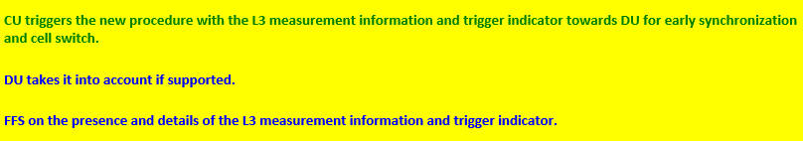

Discussion:

### The presence document is aimed to find agreements on the following points:

* Procedural text
* IEs within the message
* Presence of these IEs (Mandatory vs Optional)

**Moderator would like to propose the following text for agreement**

### 8.2.x CU-DU Mobility Initiation

#### 8.2.x.1 General

The purpose of the CU-DU Mobility Initiation procedure is to enable DU to trigger cell switch command and/or early synchronization to the UE. . The procedure uses UE-associated signalling.

#### 8.2.x.2 Successful Operation

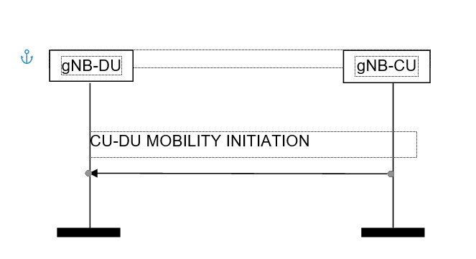

Figure 8.3.x.2-1: CU-DU Mobility Initiation procedure. Successful operation.

The gNB-CU initiates the procedure by sending a CU-DU MOBILITY INITIATION message.

Upon reception of the CU-DU MOBILITY INITIATION message, the gNB-DU is enabled to take provided information into account once triggering a cell switch command and/or early synchronization to the UE as in 38.401.

**Question 1: Do you agree with the text above- If not, please provide your exact wording and justification**

|  |  |  |
| --- | --- | --- |
| Company Name | Agree/Not Agree | Comments |
| Qualcomm | Agree but with some suggestion. | Prefer to change name of message to “LTM Assistance Information”.  Since the purpose of this message is provide assistance info to DU and DU will have freedom whether and for which candidate cells to trigger pre-sync and CSC even though CU provides its own assessment as assistance info.  Suggest to update text as below:  *Upon reception of the LTM Assistance Information message, the gNB-DU is enabled to take provided information into account for triggering a cell switch command and/or early synchronization to the UE as specified in 38.401.*  The term “enabled” used by moderator is compromise to avoid additional controversy. |
|  |  |  |
|  |  |  |
|  |  |  |
|  |  |  |

**Which IEs are included into the message:**

Question 2: Do you agree, that “Triggering Indication” is sent?

|  |  |  |
| --- | --- | --- |
| Company Name | Agree/Not Agree | Comments |
| Qualcomm | Ok as compromise but it shall NOT mandate DU to follow CU provided code points always but they are mere assistance info to DU for its own decision making purpose. | Note that L1 based LTM is baseline in R18 and L3 based LTM was added as additional support to take some initial product development delays into account without L1 measurements.  LTM is L1/L2 based mobility and all pre-sync and CSC decisions are made by an implementation algorithm either by taking L1 and/or L3 measurements taken into account. This purely an implementation algorithm and 3GPP only provides signalling info but does not specify how algorithm is designed. DU LTM algorithms implementations shall not be restricted by having restricted signalling design.  CU provided code points are optional IE. If provided as mandatory IE then it shall not enforce DU to follow in all cases and DU must have freedom to make its own decisions by taking both L1 measurements (intra-freq case) and CU provided assistance info for L3 measurements (inter-freq case). This is for the case of mixed deployment case where some UEs support L1 measurement for Intra-freq FR1 and L3 measurements for inter-freq FR1 case based on UE capabilities. Specification shall not restrict to configure only L3 measurement based LTM for all cases even if we indicates it is capable of supporting L1 measurements for intra or inter-frequency LTM. |
|  |  |  |
|  |  |  |
|  |  |  |

Question 2a: Do you agree that Early DL, Early UL and Switch command are the values “Triggering Indication” can take?

|  |  |  |
| --- | --- | --- |
| Company Name | Agree/Not Agree | Comments |
| Qualcomm | Ok but as compromise | See above comments for Q2.  But DL TCI state activation and deactivation have to be separate bits in encoding. |
|  |  |  |
|  |  |  |
|  |  |  |

Question 2b: Do you agree the values of Early DL, Early UL and Switch command are the values “Triggering Indication” and can be sent in combination, e.g. Synch and Command:

|  |  |  |
| --- | --- | --- |
| Company Name | Agree/Not Agree | Comments |
| Qualcomm | May be OK | See above comments for Q2. |
|  |  |  |
|  |  |  |
|  |  |  |

Question 3: Do you agree that Candidate Cell ID list is included

|  |  |  |
| --- | --- | --- |
| Company Name | Agree/Not Agree | Comments |
| Qualcomm | Yes | It is mandatory and coding has to allow upto max of 8 candidate cells and serving cell as well. |
|  |  |  |
|  |  |  |
|  |  |  |
|  |  |  |

Question 4: Do you agree that SSB Index List is included

|  |  |  |
| --- | --- | --- |
| Company Name | Agree/Not Agree | Comments |
| Qualcomm | Yes | It is mandatory and coding has to allow upto max of 8 SSB IDs for FR1 case. |
|  |  |  |
|  |  |  |
|  |  |  |
|  |  |  |

Question 4a: Do you agree that CSI-RS Index List is included

|  |  |  |
| --- | --- | --- |
| Company Name | Agree/Not Agree | Comments |
| Qualcomm | Yes | It is mandatory and coding has to allow upto max of 192 CSI-RS Resource IDs.  Note that L3 measurements can be either based on SSB or CSI-RS based. |
|  |  |  |
|  |  |  |
|  |  |  |

Question 5: Do you agree that RSRP, RSRQ, SINR measurements quantities are included? Please indicate if the measurements are provided, if they are provided on the cell level, beam level or both and if for SSB and CSI-RS based

|  |  |  |
| --- | --- | --- |
| Company Name | Agree/Not Agree | Comments |
| Qualcomm | Yes | It should be allowed to report per cell level, SSB beam and CSI-RS Resource ID level.  This can be provided as RRC OCTET String “*MeasQuantityResults IE”, which includes RSRP, RSRQ, SINR.* |
|  |  |  |
|  |  |  |
|  |  |  |

Question 6: Mandatory IEs vs optional IEs? Taking into account that according to the section 10.3.3 of 38.413 the mandatory presence of the IEs does not require the receiving node, to execute any follow up actions, do you agree to have IEs as mandatory. Please indicate which one and why?

* “Triggering Indication”
* Candidate Cell ID list
* SSB Index List and CSI-RS list
  + RSRP, RSRQ, SINR for cell level and beam level

|  |  |  |
| --- | --- | --- |
| Company Name | Agree/Not Agree | Comments |
| Qualcomm | Ok but all measurements are mandatory IEs. | * “Triggering Indication” -> Optional * Candidate Cell ID list -> Mandatory * SSB Index List and CSI-RS list -> Mandatory   + RSRP, RSRQ, SINR for cell level and beam level |
|  |  |  |
|  |  |  |
|  |  |  |

Conclusion:

#### 8.2.x.1 General

The purpose of the CU-DU Mobility Initiation procedure is to enable DU to trigger cell switch command and/or early synchronization to the UE. The procedure uses UE-associated signalling.

#### 8.2.x.2 Successful Operation



Figure 8.3.x.2-1: CU-DU Mobility Initiation procedure. Successful operation.

The gNB-CU initiates the procedure by sending a CU-DU MOBILITY INITIATION message.

Upon reception of the CU-DU MOBILITY INITIATION message, the gNB-DU is enabled to take provided information into account once triggering a cell switch command and/or early synchronization to the UE as in 38.401 based on L3 measurements.

Question 2: Do you agree, that “Triggering Indication” is sent?

Question 2a: Do you agree that Early DL, Early UL and Switch command are the values “Triggering Indication” can take?

Question 2b: Do you agree the values of Early DL, Early UL and Switch command are the values “Triggering Indication” and can be sent in combination, e.g. Synch and Command:

Question 3: Do you agree that Candidate Cell ID list is included

Question 4: Do you agree that SSB Index List is included

Question 4a: Do you agree that CSI-RS Index List is included

Question 5: Do you agree that RSRP, RSRQ, SINR are included?