### **3GPP TSG-RAN WG3 #127-bis DRAFT_****R3-252265**

**Wuhan, China, 7-11 April 2025**

Agenda Item: 9.2

Source: Vodafone (moderator)

**Title: CB: # 4_L3MeasurementsLTM**

Introduction:

Agreements during online:

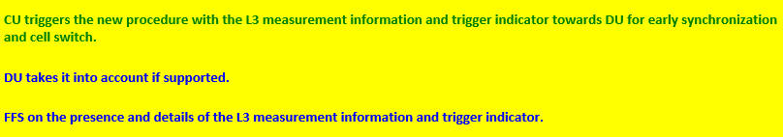

Discussion:

### The presence document is aimed to find agreements on the following points:

* Procedural text
* IEs within the message
* Presence of these IEs (Mandatory vs Optional)

**Moderator would like to propose the following text for agreement**

### 8.2.x CU-DU Mobility Initiation

#### 8.2.x.1 General

The purpose of the CU-DU Mobility Initiation procedure is to enable DU to trigger cell switch command and/or early synchronization to the UE. . The procedure uses UE-associated signalling.

#### 8.2.x.2 Successful Operation

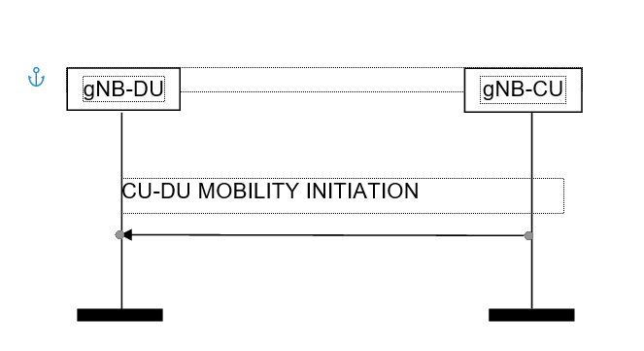

Figure 8.3.x.2-1: CU-DU Mobility Initiation procedure. Successful operation.

The gNB-CU initiates the procedure by sending a CU-DU MOBILITY INITIATION message.

Upon reception of the CU-DU MOBILITY INITIATION message, the gNB-DU is enabled to take provided information into account once triggering a cell switch command and/or early synchronization to the UE as in 38.401.

**Question 1: Do you agree with the text above- If not, please provide your exact wording and justification**

|  |  |  |
| --- | --- | --- |
| Company Name | Agree/Not Agree | Comments |
|  |  |  |

**Which IEs are included into the message:**

Question 2: Do you agree, that “Triggering Indication” is sent?

|  |  |  |
| --- | --- | --- |
| Company Name | Agree/Not Agree | Comments |
|  |  |  |

Question 2a: Do you agree that Early DL, Early UL and Switch command are the values “Triggering Indication” can take?

|  |  |  |
| --- | --- | --- |
| Company Name | Agree/Not Agree | Comments |
|  |  |  |

Question 2b: Do you agree the values of Early DL, Early UL and Switch command are the values “Triggering Indication” and can be sent in combination, e.g. Synch and Command:

|  |  |  |
| --- | --- | --- |
| Company Name | Agree/Not Agree | Comments |
|  |  |  |

Question 3: Do you agree that Candidate Cell ID list is included

|  |  |  |
| --- | --- | --- |
| Company Name | Agree/Not Agree | Comments |
|  |  |  |

Question 4: Do you agree that SSB Index List is included

|  |  |  |
| --- | --- | --- |
| Company Name | Agree/Not Agree | Comments |
|  |  |  |

Question 4a: Do you agree that CSI-RS Index List is included

|  |  |  |
| --- | --- | --- |
| Company Name | Agree/Not Agree | Comments |
|  |  |  |

Question 5: Do you agree that RSRP, RSRQ, SINR measurements quantities are included? Please indicate if the measurements are provided, if they are provided on the cell level, beam level or both and if for SSB and CSI-RS based

|  |  |  |
| --- | --- | --- |
| Company Name | Agree/Not Agree | Comments |
|  |  |  |

Question 6: Mandatory IEs vs optional IEs? Taking into account that according to the section 10.3.3 of 38.413 the mandatory presence of the IEs does not require the receiving node, to execute any follow up actions, do you agree to have IEs as mandatory. Please indicate which one and why?

* “Triggering Indication”
* Candidate Cell ID list
* SSB Index List and CSI-RS list
  + RSRP, RSRQ, SINR for cell level and beam level

|  |  |  |
| --- | --- | --- |
| Company Name | Agree/Not Agree | Comments |
|  |  |  |

Conclusion:

#### 8.2.x.1 General

The purpose of the CU-DU Mobility Initiation procedure is to enable DU to trigger cell switch command and/or early synchronization to the UE. The procedure uses UE-associated signalling.

#### 8.2.x.2 Successful Operation



Figure 8.3.x.2-1: CU-DU Mobility Initiation procedure. Successful operation.

The gNB-CU initiates the procedure by sending a CU-DU MOBILITY INITIATION message.

Upon reception of the CU-DU MOBILITY INITIATION message, the gNB-DU is enabled to take provided information into account once triggering a cell switch command and/or early synchronization to the UE as in 38.401 based on L3 measurements.

Question 2: Do you agree, that “Triggering Indication” is sent?

Question 2a: Do you agree that Early DL, Early UL and Switch command are the values “Triggering Indication” can take?

Question 2b: Do you agree the values of Early DL, Early UL and Switch command are the values “Triggering Indication” and can be sent in combination, e.g. Synch and Command:

Question 3: Do you agree that Candidate Cell ID list is included

Question 4: Do you agree that SSB Index List is included

Question 4a: Do you agree that CSI-RS Index List is included

Question 5: Do you agree that RSRP, RSRQ, SINR are included?