3GPP TSG-RAN WG3 Meeting #125bis R3-245737
Hefei, China, 14th – 18th October, 2024

Agenda Item: 17
Source: Ericsson (Moderator)
Title: Summary of offline discussions: Rel-19 Network Energy Saving
Document for: Discussion and Approval

Introduction
The CB is related to AI 17.3.
CB: # R19ES
- Discuss the open issues above
(moderator - E///)
Summary of offline disc R3-245737

For the Chairman’s Notes

It is proposed to capture the following RAN3 agreements in the chairman’s notes.
********************************* Start ************************************
For “Support on-demand SIB1 for UEs”, RAN3 has agreed that:
New Agreement:
- Cell A gNB can decide and signal to NES Cell gNB that it stops the UL WUS configuration broadcast in its SIB.

********************************* The End ************************************

To be continued….
Which option for the UL WUS configuration provision? Some companies have already indicated their views in below.
Cell A can start the UL WUS configuration broadcast in its SIB?
Cell A can restart the UL WUS configuration broadcast in its SIB?
Xn Aspect: Details of the new Class 1?
Xn Aspect: Details of the new Class 2?
F1 aspect?
Other aspects not discussed at this meeting?

3 Discussion
The UL WUS configuration will be transferred over Xn via a new class1 defined procedure.
Introduce the start/stop mechanism from NES cell to Cell A for UL WUS configuration broadcast. Further check on first activation of UL WUS configuration broadcast in Cell A.

Let us assume call the new procedure “UL WUS Configuration Provision”, there is a request from NES Cell to Cell A and there is a response from Cell A to NES Cell.

A few options are collected in below: (Successful Operation)
Option 1: After the UL WUS Configuration Provision request and Positive Response (confirm), NES Cell gNB goes to OD-SIB1 Mode. Cell A gNB broadcasts UL WUS configuration via its SIB.
XnAP: Cell A gNB “confirm” means that it will broadcast received UL WUS configuration via its SIB right away ( i.e. not wait for 2 days)
Cell A gNB “reject” means it will not perform the request.

Request Parameters (FFS): WUS configuration, Cell Lists, Start, Stop, Remove, Cancel….
Response parameters (FFS)
- Confirm with a Timer meaning when Cell A has broadcasted UL WUS in its SIB1;
- Alternatively, no need for a timer, instead by implementation, NES waits a certain time before it goes to OD-SIB1;

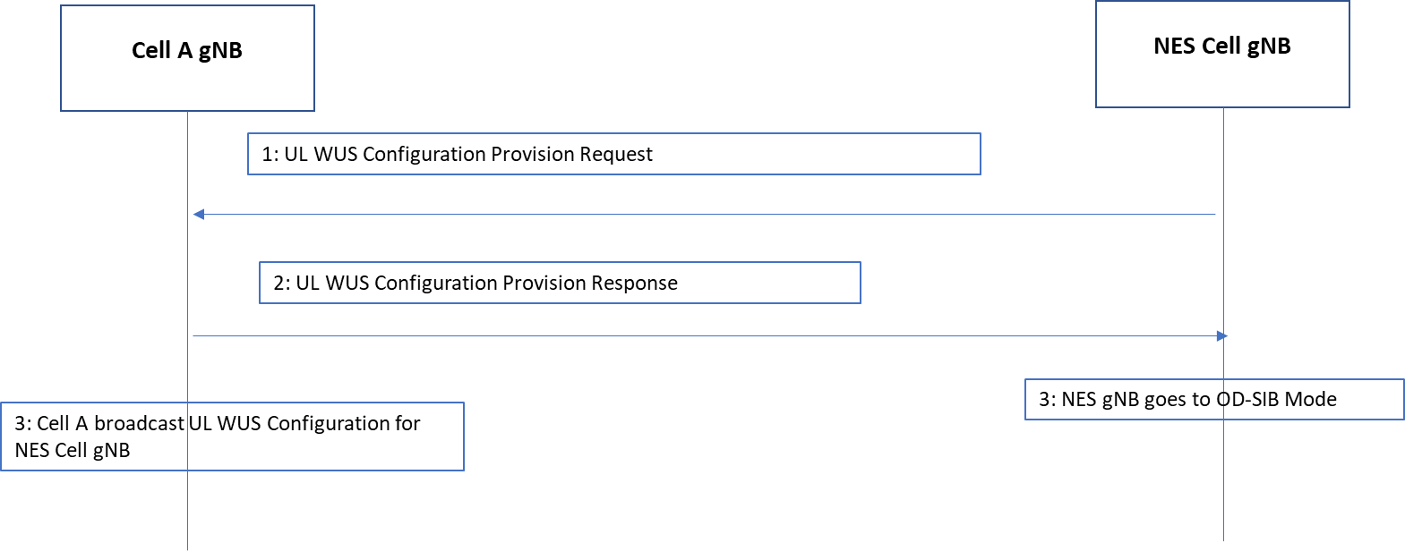

Option 2: After the UL WUS Configuration Provision request and positive response (confirm), Cell A gNB broadcast received UL WUS configuration via its SIB. NES cell goes to OD-SIB Mode upon reception of the explicit “UL config provided” message from Cell A gNB.
The reason is, it may take up to 41 seconds to broadcast UL WUS even Cell A broadcast immediately, NES cell can stay as legacy until it knows that Cell A has broadcast its UL WUS.

XnAP: Cell A gNB Confirm means that it has the intention to broadcast UL WUS config in SIB.
Reject: means it will not perform the request.

The addition message indicates when Cell A has broadcasted UL WUS Config in its SIB

Request Parameters (FFS): WUS configuration, Cell Lists, Start, Stop, Remove, Cancel….

This additional message from Cell A to NES cell (Class 2, FFS) can be used to indicate:
- Cell A has broadcasted UL WUS config in its SIB for NES cell;
- Cell A has stopped UL WUS config in its SIB for NES cell; ( in the later phase) (FFS) (Maybe Cell A is busy, is planned to shut down);
- Cell A has restart the UL WUS Config in the SIB (FFS) (in this case, Cell A stores the UL WUS configuration and reuses it). Else NES has to request UL WUS configuration from scatch.

The companies have agreed that Cell A should be able to send a message to NES cell to indicate it stops broadcasting UL WUS Configuration for the NES Cell.

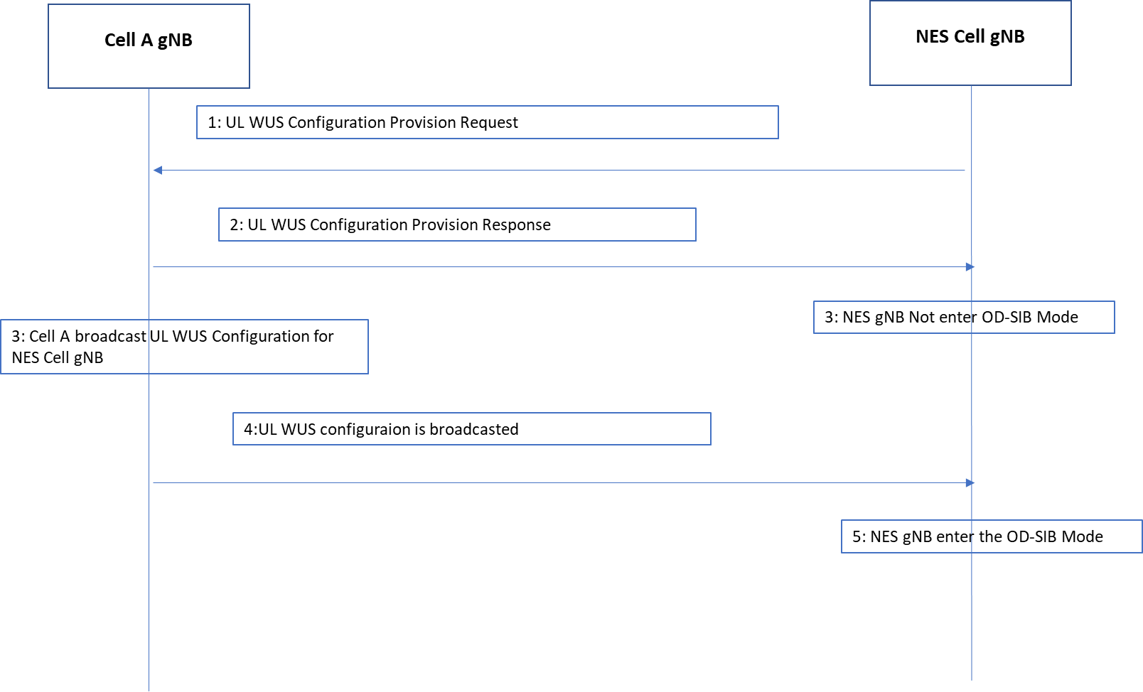

Option 3: After the UL WUS Configuration Provision request and positive response (confirm), no change in NES Cell or Cell A gNBs.
The Request message is to send the UL WUS Configuration;
The positive Response is to indicate that Cell A has received the UL WUS configuration and has intension to broadcast it ( but it will not do it yet.)
The second message is sent from NES Cell gNB to Cell A gNB to indicate it is time to broadcast UL WUS configuration. And NES cell goes to OD-SIB Mode.

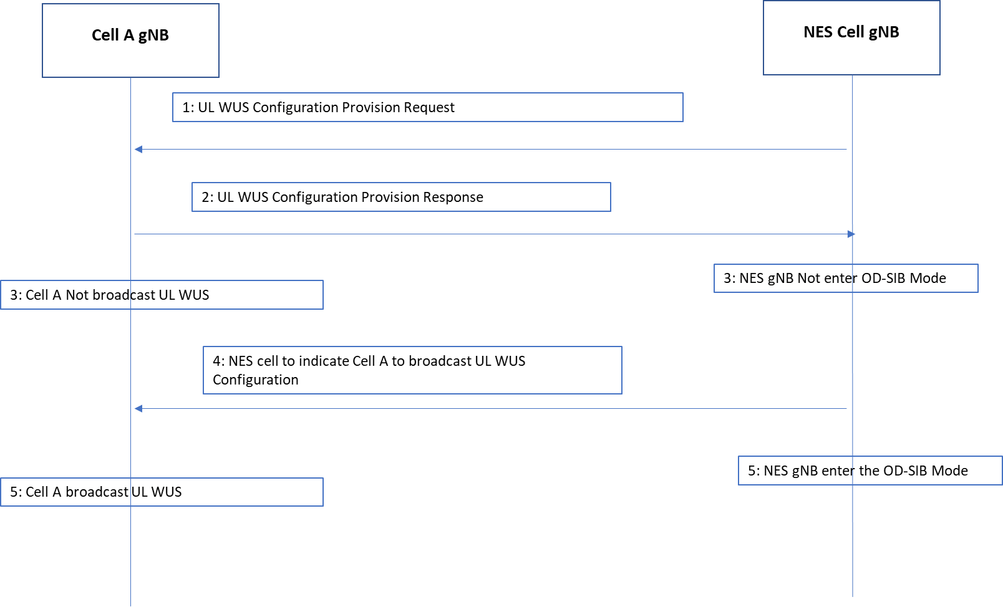

Q1: Which is your view of how UL WUS configuration works according to the above Options?

Company Name | Company View
Rakuten | Option 1;
NEC | Option 1;
Ericsson | Prefer Option 2, Can also be open for Option 1,
Huawei | Prefer Option 1. But can also open for the other options;
Samsung | Prefer Option 1. But can also open for the other options;
Nokia | Option 2 + Option 3 (i.e. both solutions in one)
CATT | Option 1 and Option 2
CT | Open for all the Options
Lenovo | Option 1
ZTE | Prefer OP3, but open for other options if majority agrees.

Q2: For the new UL WUS Configuration provision procedure, should we produce XnAP Text Proposal at this meeting?
Not discussed

Q3: Should we produce F1AP Text Proposal at this meeting?
Not discussed

4 References
R3-245498 | Xn impact of On-demand SIB1 for UEs in idle/inactive mode (Ericsson) | other
R3-245517 | F1 impact of On-demand SIB1 for UEs in idle/inactive mode (Ericsson) | discussion
R3-245107 | Support On-Demand SIB1 for UEs (CMCC) | discussion
R3-245120 | Discussion on on-demand SIB1 in low-carbon green network (Samsung) | discussion
R3-245219 | (TP for TS 38.473) Discussion on on-demand SIB1 for UEs in idle or inactive mode (Huawei) | other
R3-245249 | Aspects of on-demand SIB1 for NES enhancements (Qualcomm Inc.) | discussion
R3-245257 | On support on-demand SIB1 for idle UE (CATT) | discussion
R3-245300 | Support on-demand SIB1 (NEC) | discussion
R3-245456 | Discussion on On-demand SIB1 for Idle/Inactive UE (Lenovo) | discussion
R3-245561 | Further thoughts on open Issues in support of On-Demand SIB1 (Nokia) | discussion
R3-245647 | Discussion on OD-SIB1 (Rakuten Mobile, Inc) | discussion
R3-245668 | Further discussion on on-demand SIB1 (ZTE Corporation) | discussion

