3GPP TSG-RAN WG3 Meeting #125bis R3-245737
Hefei, China, 14th – 18th October, 2024

Agenda Item: 17
Source: Ericsson (Moderator)
Title: Summary of offline discussions: Rel-19 Network Energy Saving
Document for: Discussion and Approval

Introduction
The CB is related to AI 17.3.
CB: # R19ES
- Discuss the open issues above
(moderator - E///)
Summary of offline disc R3-245737

For the Chairman’s Notes

It is proposed to capture the following RAN3 agreements in the chairman’s notes.

********************************* Start ************************************
For “Support on-demand SIB1 for UEs”, RAN3 has agreed that:
TBD:
- BLABLA
********************************* The End ************************************

3 Discussion
The UL WUS configuration will be transferred over Xn via a new class1 defined procedure.
Introduce the start/stop mechanism from NES cell to Cell A for UL WUS configuration broadcast. Further check on first activation of UL WUS configuration broadcast in Cell A.

Let us assume call the new procedure “UL WUS Configuration Provision”, there is a request from NES Cell to Cell A and there is a response from Cell A to NES Cell.
A few options are collected in below:
Option 1: After the UL WUS Configuration Provision request and Response (confirm), NES Cell gNB can go to OD-SIB Mode. Cell A broadcast UL WUS via SIB.
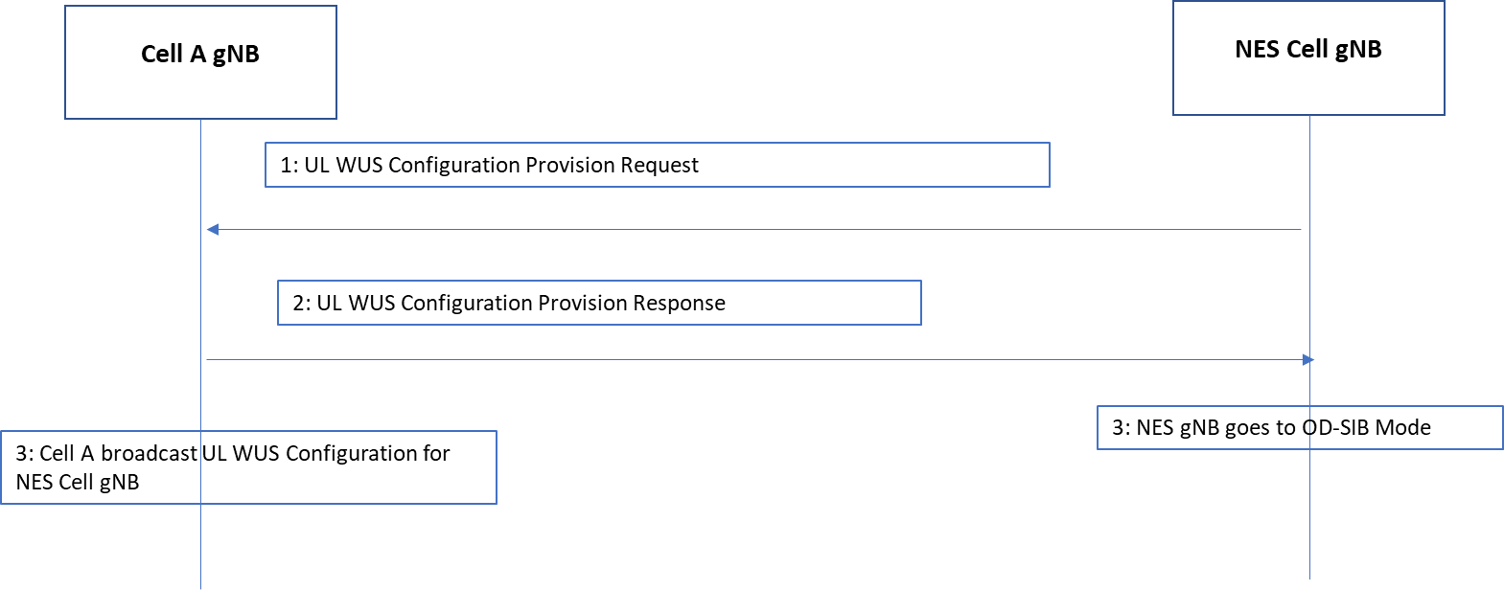

Option 2: After the UL WUS Configuration Provision request and Response (confirm), Cell A broadcast UL WUS via SIB. NES cell goes to OD-SIB Mode upon reception of “UL config provided” message from Cell A.
The reason is, it may take up to 41 seconds to broadcast UL WUS, NES cell can stay as legacy until it knows that Cell A has broadcast it’s UL WUS.
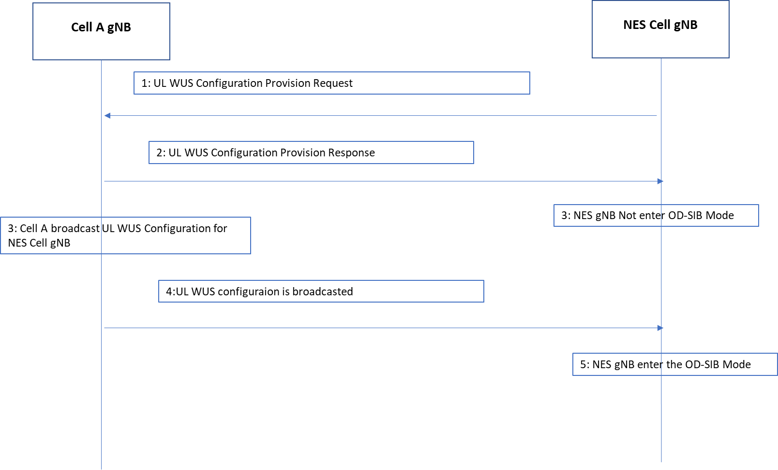

Option 3: After the UL WUS Configuration Provision request and Response (confirm), Nothing is changed.
The second message is sent from NES Cell gNB to Cell A gNB to indicate it is time to broadcast UL WUS. And NES cell goes to OD-SIB Mode.

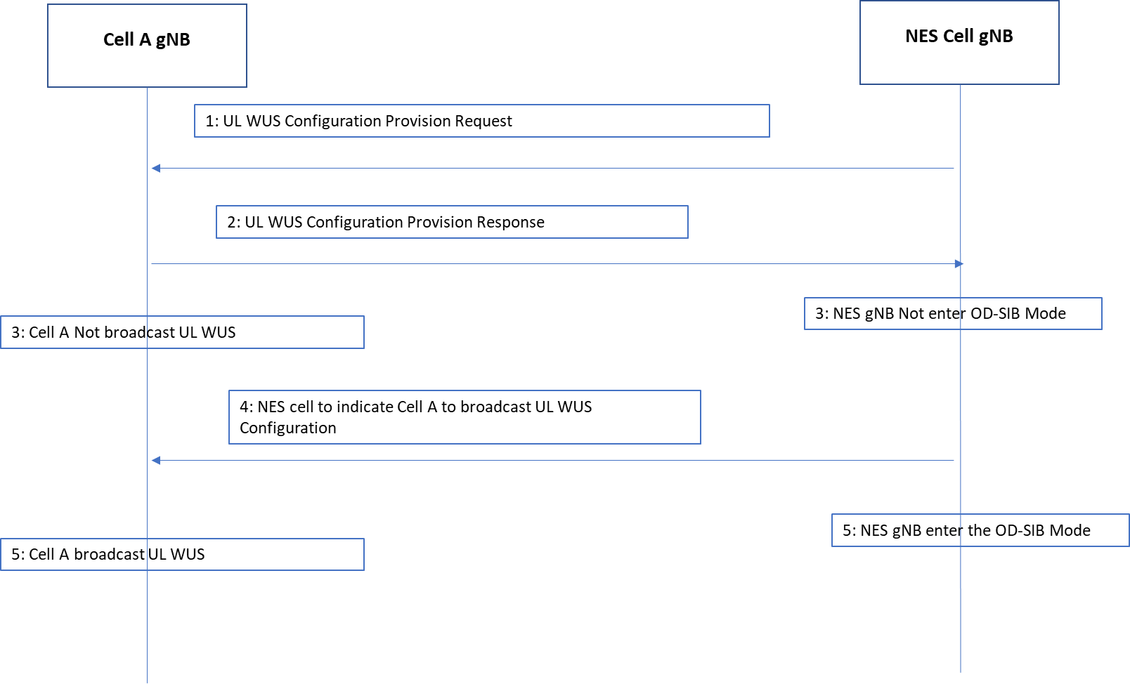

Q1: Which is your view of how UL WUS configuration works according to the above Options?

Q2: For the new UL WUS Configuration provision procedure, should we produce XnAP Text Proposal at this meeting?

Q3: Should we produce F1AP Text Proposal at this meeting?

4 References
R3-245498 | Xn impact of On-demand SIB1 for UEs in idle/inactive mode (Ericsson) | other
R3-245517 | F1 impact of On-demand SIB1 for UEs in idle/inactive mode (Ericsson) | discussion
R3-245107 | Support On-Demand SIB1 for UEs (CMCC) | discussion
R3-245120 | Discussion on on-demand SIB1 in low-carbon green network (Samsung) | discussion
R3-245219 | (TP for TS 38.473) Discussion on on-demand SIB1 for UEs in idle or inactive mode (Huawei) | other
R3-245249 | Aspects of on-demand SIB1 for NES enhancements (Qualcomm Inc.) | discussion
R3-245257 | On support on-demand SIB1 for idle UE (CATT) | discussion
R3-245300 | Support on-demand SIB1 (NEC) | discussion
R3-245456 | Discussion on On-demand SIB1 for Idle/Inactive UE (Lenovo) | discussion
R3-245561 | Further thoughts on open Issues in support of On-Demand SIB1 (Nokia) | discussion
R3-245647 | Discussion on OD-SIB1 (Rakuten Mobile, Inc) | discussion
R3-245668 | Further discussion on on-demand SIB1 (ZTE Corporation) | discussion

