QoE in NR-DC

Basic configuration and reporting
If the MN receives the request from the SN about configuring an m-based QoE, the MN can only decide to configure the m-based QoE to UE by itself instead of SN when the MN has received the same QoE configuration. (ZTE)
Conclusion: The QoE configuration container should not be included in SN to MN QMC Coordination Request List, because the MN can only decide to configure the m-based QoE to UE by itself instead of SN when the MN has received the same QoE configuration.

Stage 3 details

RRC Transfer message:
Editor’s Note: The use of this message is to be confirmed.
Proposals:
- RRC Transfer message is used to transfer RVQoE reports between MN and SN.
- Remove RRC id and container for QoE report in the RRC transfer message?
- Before the radio bearer information is determined, the RVQoE reports should be sent to the RVQoE-configuring node, via Uu interface directly or RRC Transfer message over Xn, depends on the reporting leg.
Conclusion: implement the corresponding changes on the XnAP BLCR below.
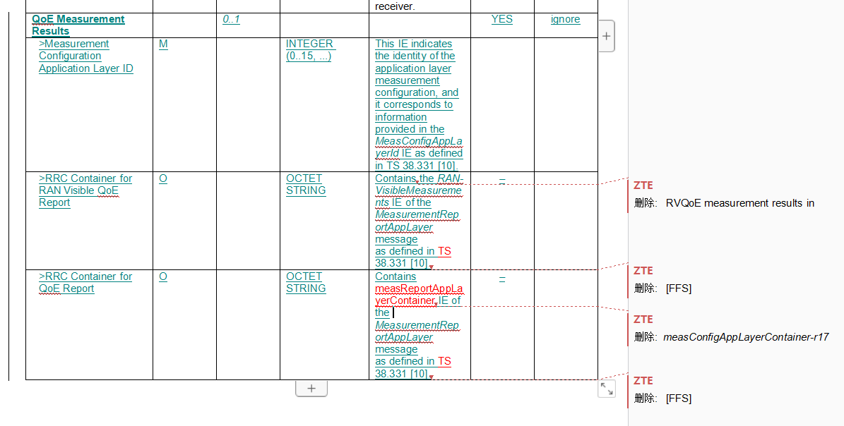

- MCE IP Address:
Proposal: Add MCE IP Address in the SN to MN QMC Coordination Request List of QMC Coordination Request IE (E///, ZTE)
Conclusion: turn the above into agreement.

- Mobility
To support inter MN HO scenarios, the new MN needs to be provided with all the information that the old MN has about the SN configured QoE measurements exchanged during co-ordination procedure.
To support SN change scenario, the co-ordination procedure can be used to deliver the necessary information about SN configured QoE measurements in old SN to MN, and MN can transfer this information to new SN.
#1: SN -> MN: During the QMC coordination, the SN provides SN-received configuration to the MN.
Option 1: Reuse the existing IE for QoE configuration, which is called ‘SN-related QMC configuration IE’.
Option 2: define a new IE named e.g. SN-Received QMC Configuration Information
The content in the IE:
- QoE Reference (?)
- Measurement Configuration Application Layer ID;
- Service Type;
- QoE Measurement Status;
- Container for Application Layer Measurement Configuration (?)
- MDT Alignment Information (?)
- Measurement Collection Entity IP Address;
- Area Scope; and
- Available RAN Visible QoE Metrics.
Conclusion:
Include the SN-related QMC configuration IE in the following messages:
- Handover Request
- SN Addition Request
- SN Change Required
- SN Modification Required

#2: MN -> target SN: During SN change, the MN provides all the SN related QMC configuration information to the new SN
- How to deal with the reporting path?
Option 1: MN coordinate with the SN about the reporting path during SN change (MN -> SN: SN addition).
(SS: MN becomes the new QoE-configuring node of the QoE configured by the source SN.)
Option 2: MN informs the current reporting path to the SN during SN change. After SN change, SN modification can be triggered to change the reporting path.
- the placement of the SN-related configuration?
Option 1: in parallel with the QMC Coordination Request IE in SN Addition Request message. (E///)
Option 2: inside the MN to SN QMC Coordination Request List in the QMC Coordination Request IE of SN Addition Request msg.
Conclusion:
Not discussed yet.

#3: source MN -> target MN: During the MN change (HO), the MN provides all the SN related QMC configuration information to the new MN.
Proposal: Inform the reporting path to the target MN?
Conclusion:
Not discussed yet.

RAN overload:
CATT: both MN and SN can indicate the UE to switch the reporting leg based on its overload status
Lenovo: when setting ‘pause’ or ‘resume’, both MN and SN overload should be taken into account.
ZTE: capture stage 2 description on RAN overload
Conclusion:
Not discussed yet.

