3GPP TSG-RAN WG3 #119 R3-230858
Athens, GR, 27th Feb - 3rd Mar 2023

Agenda Item: 12.2.2.3
Source: Verizon (moderator)
Title: Summary of Offline Discussion on CB: # 19_AIRAN3_ES
Document for: Approval

Introduction
CB: # 19_AIRAN3_ES
-Continue solution down-selection
(Verizon - moderator)
Summary of offline disc R3-230858

Please provide the comments before Thursday, March 2nd, 6pm (Athens Time); 8am (PST); 11:59pm (Beijing Time)

For the Chairman’s Notes
To be captured in the Chairman notes:
1) How to calculate this EE, solution down-selection
Option 1: Indicating the value of the ratio of data volume over energy consumption directly
Option 2: Define the EE metric in a more abstract way using a quantitative encoding, e.g., using EE values on a linear scale from 0 to 100.
Option 3: The metric of Energy Efficiency exchanged between NG-RAN nodes is an Energy Consumption related to an additional load. And exchanged EE metric between neighboring NG-RAN nodes is defined in the interval [0, 100].
Option 4: Deliver both data volume and energy consumption over RAN interfaces to let the requesting node calculate the overall DV and over EC of the specific area and thereby drive the overall EE.

Discussion

Adoption of SA5 defined Energy Efficiency metric in NG-RAN
In specification TS 28.310, SA5 defined Energy Efficiency (EE) metric as a number of bits sent per joule of consumed energy,
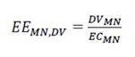, where DV is the Data Volume and EC is the Energy Consumption of the respective network elements.
“Besides the parameters required to calculate the energy efficiency, e.g. DV and EC, other parameters may be used to interpret variations in energy efficiency KPI values from different networks. These parameters can be classified into demography, topography and climate classes (see ETSI ES 203 228 [2] – section 4.3), which describe the network characteristics with regard to population density, geographical conditions and climate zones. For each class of parameters, there can be subclasses, e.g. demography can be further classified into dense urban, urban, sub-urban, rural or unpopulated scenarios. For each class / subclass, the energy efficiency KPI values may be interpreted differently.” [3]
In the last RAN3 meeting #118, RAN3 made a working assumption that EE defined in SA5 was adopted as a baseline for EE of a gNB. The EE of a gNB tends to fluctuate from peak to trough as the network traffic volume rises and falls on a daily basis.
However, over the longer term, this EE metric will be able to provide a network-level energy efficiency big picture view for the operators to monitor the trend of energy consumption and efficiency, and to make strategic decisions on OPEX savings.[1]
We think that a gNB is able to measure its EE according to the SA5 definition by implementation and report it to the OMA.

Introduce the metric of Incremental Energy Cost (IEC) to be exchanged between nodes
AI/ML based Energy Saving at a gNB essentially is for a trained AI model to make real-time decisions to either deactivate or activate a cell to save network energy consumption. These decisions involve traffic migration from a source node (gNB0) to its neighboring target nodes (gNBi, where i is 1, 2, or 3). Please see Figure 1 for illustration [2] below.
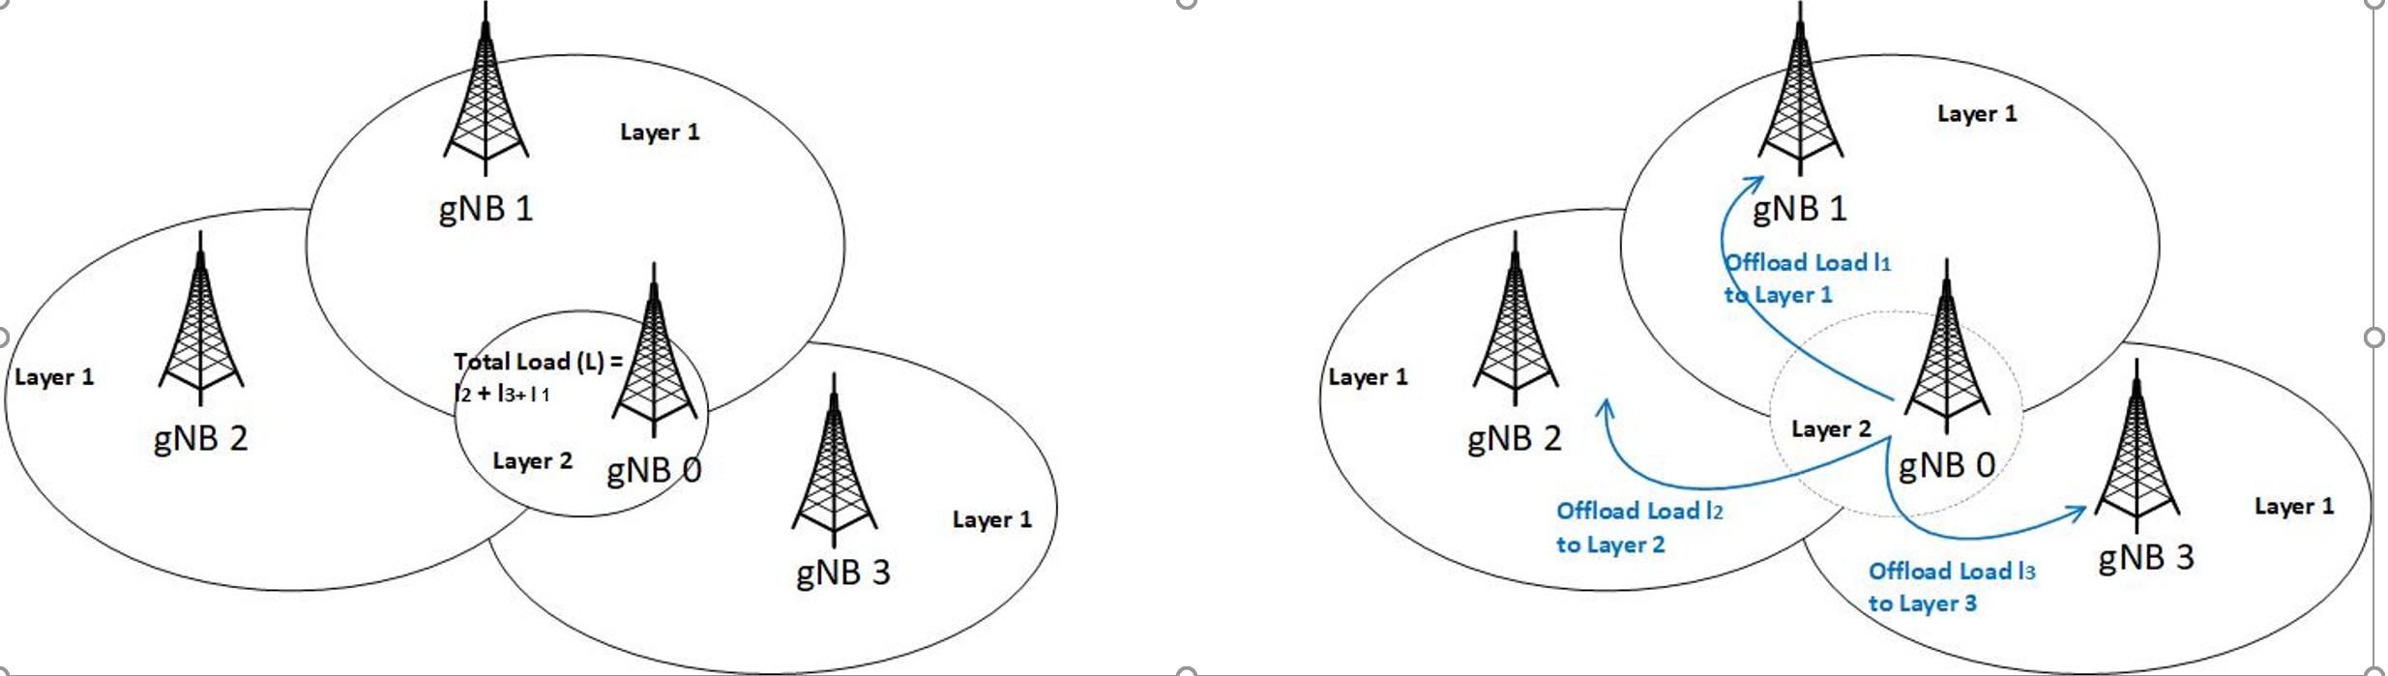
Figure 1 Energy Saving scenario – cell deactivation and traffic offloading
To make an intelligent energy saving decision, an AI/ML model needs to see the triggering condition that the estimated combined amount of energy consumed at the target nodes for the additional offloading traffic from the source node is less than, the amount of energy consumed at the source node for the same traffic volume.
Incremental Energy Cost (IEC) is defined as the estimated energy consumption at a gNB related to an additional load if such traffic load is migrated from a neighboring source node. To make the energy saving decision stand, the total IECs from gNB1, gNB2, and gNB3 shall be less than the current energy consumption at gNB0. In short, the IEC is the key EE metric that needs to be shared over the Xn interface to facilitate this AI/ML based Energy Saving use case.

Proposal 1: Based on recent offline discussion, most companies support this concept of IEC. Would propose to introduce "Incremental Energy Cost" as one of the AI/ML metrics shared between nodes.
Q1: Would you support above proposal? Any comments?
Companies | Support or not? | Comments
Verizon | Yes | AI/ML based Energy saving decisions are more small local cluster based, and real time or near real time in nature. IEC is useful to facilitate such use case.

The Metric to be transferred in the Xn interface
To continue solution down selections, several options are listed as below:
Option 1: Indicating the value of the ratio of data volume over energy consumption directly.
Option 2: Define the EE metric in a more abstract way using a quantitative encoding, e.g., using EE values on a linear scale from 0 to 100.
Option 3: The metric of Energy Efficiency exchanged between NG-RAN nodes is an Energy Consumption related to an additional load. And exchanged EE metric between neighbouring NG-RAN nodes is defined in the interval [0, 100].
Option 3a: The metric of Incremental Energy Cost (IEC) exchanged between NG-RAN nodes is an estimated Energy Consumption value related to an additional load from a neighboring node. Whether and/or how this IEC metric be normalized, for example in the interval [0, 100], is FFS.
Option 4: Deliver both its current and its predicted energy efficiency metrics (i.e. data volume + energy consumption) over RAN interfaces.
Proposal 2: Based on recent offline discussion, most companies support this concept of IEC. So would propose to adopt Option 3a and exchange "Incremental Energy Cost" upon request over the Xn interface.
Q2: Would you support above proposal? Any comments?

Companies | Support or not? | Comments
Verizon | Yes | AI/ML based Energy saving decisions are more local cluster based, and real time or near real time in nature. IEC is useful to facilitate such decisions.

How to transfer the EE-related Metric over the Xn interface
The last open point is to discuss how to transfer this much discussed EE-related metric over the Xn interface. We think there are 3 options as follows.
Option-1: modify the existing Resource Status procedure to transfer this information,
Option-2: use the new procedure being defined to transfer the AI/ML related information
Option-3: develop a new procedure just for this particular objective.

Q3: Which transfer option would you prefer? Any comments?
Companies | Which option to Support? | Comments
Verizon | 3 | It can be customized, so it could be flexible and sent on request.

References
[1] R3-230456 - Network Energy Efficiency Metric, Ericsson.
[2] R3-230553 AIML Energy Saving, Nokia.
[3] TS 28.310, 3GPP SA5

