3GPP TSG-RAN WG3 Meeting #116-e R3-223934
May.9th ~May.19th, 2022
Online
CR-Form-v12.2
CHANGE REQUEST
 | 38.401 | CR | 0209 | rev | 1 | Current version: | 17.0.0
For HELP on using this form: comprehensive instructions can be found at
http://www.3gpp.org/Change-Requests.

Proposed change affects: | UICC apps |  | ME |  | Radio Access Network | X | Core Network

Title: | CR on TS38.401 for Rel-17 Sidelink Relay
Source to WG: | CATT, Nokia
Source to TSG: | R3
Work item code: | NR_SL_relay-Core |  |  |  |  |  |  | Date: |  | 2022-04-25
Category: | F |  |  |  |  |  |  | Release: |  | Rel-17
 | Use one of the following categories:  F (correction)  A (mirror corresponding to a change in an earlier release)  B (addition of feature),  C (functional modification of feature)  D (editorial modification)  Detailed explanations of the above categories can  be found in 3GPP TR 21.900. |  |  |  |  |  |  |  | Use one of the following releases:  Rel-8 (Release 8)  Rel-9 (Release 9)  Rel-10 (Release 10)  Rel-11 (Release 11)  …  Rel-15 (Release 15)  Rel-16 (Release 16)  Rel-17 (Release 17)  Rel-18 (Release 18)  Rel-19 (Release 19)
Reason for change: |  | - Remote UE initial access/ RRC Reestablishment/ RRC Inactive to other states  1. GNB establishes Uu RLC channel for remote UE only after receives SUI.  2. DU should be configured with bearer mapping (RB to Uu RLC channel) for relaying e.g., RRCsetup/RRCsetupcomplete of remote UE.  3. Align with current TS38.401 about SecurityModeCommand.  4. Step 30 is for relay UE only.  - Inter-DU/intra-DU switch from direct to indirect path  1. Lack of “bearer mapping” in RRCReconfiguration message
Summary of change: |  | - Remote UE initial access/ RRC Reestablishment/ RRC Inactive to other states  1. Remove “During RRC connection establishment procedure of the U2N Relay. UE, gNB may configure the U2N Relay UE with Uu RLC channel(s) for relaying of U2N Remote UE’s SRB0/1” in step 3. .  2. Add “may include bearer mapping and” in step 5.  3. Add “may also encapsulate the SecurityModeCommand message” in step 20.  4. Remove remote UE related description.  - Inter-DU/intra-DU switch from direct to indirect path  1. Introduce “bearer mapping” in RRCReconfiguration message  Impact assessment towards the previous version (same release) of the specification:  This CR has isolated impact with the previous version of the specification (same release).  This CR has no backward compatibility issue.  The impact can be considered isolated because the change is limited to SL relay.
Consequences if not approved: |  | Cannot support Rel-17 Sidelink Relay well
Clauses affected: |  | 8.19.1, 8.19.2, 8.19.3, 8.19.4.1, 8.19.4.2
 |  | Y | N
Other specs |  | X |  | Other core specifications |  |  | TS 38.473 CRxxxx
affected: |  |  | x | Test specifications
(show related CRs) |  |  | x | O&M Specifications
Other comments:

This CR's revision history: | Rev.1 reflect the agreements in RAN3#116-e

8.19.1 Remote UE initial access
The signalling flow for remote UE Initial access is shown in Figure 8.19.1-1.
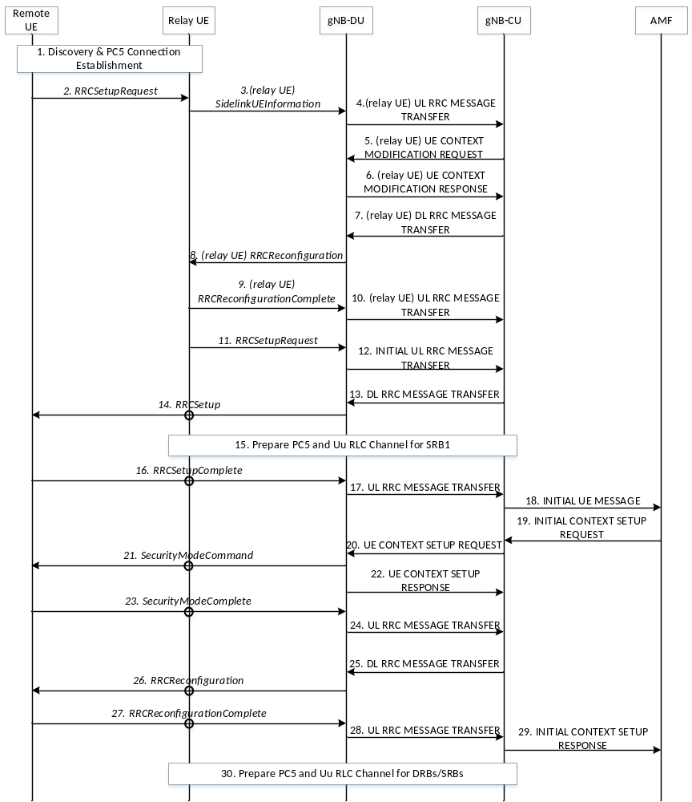

Figure 8.19.1-1: Remote UE Initial Access procedure
1. The U2N Remote UE and the U2N Relay UE perform discovery procedure, and establish PC5 connection using NR ProSe procedure.
2. The U2N Remote UE sends an RRCSetupRequest message to the U2N Relay UE via PC5 RLC Channel.
3. The U2N Relay UE withholds the received RRC message and sends the SidelinkUEInformation message to the gNB-DU. Before that, if the U2N Relay UE is in RRC_IDLE/RRC_INACTIVE status, it should trigger the RRC establishment/resume procedure to enter RRC_CONNECTED status.
4. The gNB-DU sends the UL RRC MESSAGE TRANSFER message of the U2N Relay UE by encapsulating the SidelinkUEInformation message to gNB-CU, and gNB-CU allocates the local ID of U2N Remote UE.
5. The gNB-CU sends the UE CONTEXT MODIFICATION REQUEST message of the U2N Relay UE to gNB-DU. Such message may include bearer mapping and may request the establishment of Uu RLC channel(s) for the transmission of U2N Remote UE’s SRB0/1 if not configured yet.
6. The gNB-DU sends the UE CONTEXT MODIFICATION RESPONSE message of the U2N Relay UE to gNB-CU.
7. The gNB-CU sends the DL RRC MESSAGE TRANSFER message of the U2N Relay UE to gNB-DU by encapsulating the RRCReconfiguration message, which contains the local ID allocated to the U2N Remote UE. The RRCReconfiguration message shall also contain the Uu RLC channel(s) configuration if not configured and bearer mapping for relaying of U2N Remote UE’s SRB0/1.
8. The gNB-DU sends the RRCReconfiguration message to the U2N Relay UE to configure the local ID of the U2N Remote UE, the Uu RLC channel configuration and bearer mapping for relaying of U2N Remote UE’s SRB0/1.
9. The U2N Relay UE sends the RRCReconfigurationComplete message to gNB-DU.
10. The gNB-DU sends the UL RRC MESSAGE TRANSFER message of the U2N Relay UE by encapsulating the RRCReconfigurationComplete message to gNB-CU.
11. After receiving the local ID of the U2N Remote UE, the U2N Relay UE sends the RRCSetupRequest message of the U2N Remote UE to gNB-DU. The local ID of the U2N Remote UE and RB ID are conveyed in the SRAP header
12. The gNB-DU allocates a C-RNTI and a gNB-DU UE F1AP ID for the U2N Remote UE and sends the INITIAL UL RRC MESSAGE TRANSFER message to gNB-CU by encapsulating the RRCSetupRequest message of the U2N Remote UE. In addition, the local ID of the U2N Remote UE , the gNB-DU UE F1AP ID of the U2N Relay UE and the container of SL-PHY-MAC-RLC-Config for at least the PC5 RLC channel configuration for relaying of U2N Remote UE’s SRB1 are included in the INITIAL UL RRC MESSAGE TRANSFER message .
13. The gNB-CU allocates a gNB-CU UE F1AP ID for the U2N Remote UE and generates a RRCSetup message towards the U2N Remote UE. The RRC message is encapsulated in the DL RRC MESSAGE TRANSFER message, and includes the configurations of PC5 RLC channel and bearer mapping at least for the transmission of U2N Remote UE’s SRB1.
14. The gNB-DU sends the RRCSetup message to the U2N Remote UE via the U2N Relay UE.
15. The gNB-CU configures the U2N Relay UE with PC5 RLC channel, Uu RLC channel and bearer mapping for relaying of U2N Remote UE’s SRB1. According to the configuration from gNB-CU, the U2N Relay UE establishes a PC5 RLC channel for relaying of SRB1 over PC5 and establishes a Uu RLC channel for relaying of SRB1 towards gNB-DU if not configured yet.
NOTE 1: This step may be performed earlier, e.g., via steps 5~8.
16. The U2N Remote UE sends the RRCSetupComplete message to the gNB-DU via the U2N Relay UE.
17. The gNB-DU encapsulates the RRC message in the UL RRC MESSAGE TRANSFER message and sends it to the gNB-CU.
18. Upon receiving the RRCSetupComplete message of U2N Remote UE, the gNB-CU sends the INITIAL UE MESSAGE message to the AMF.
19. The AMF sends the INITIAL CONTEXT SETUP REQUEST message to the gNB-CU.
20. The gNB-CU sends the UE CONTEXT SETUP REQUEST message to establish the U2N Remote UE context in the gNB-DU. Such message may request the configuration of PC5 RLC channels for the transmission of U2N Remote UE’s SRB2 and DRBs, and may also encapsulate the SecurityModeCommand message.
21. The gNB-DU sends the SecurityModeCommand message to the U2N Remote UE via U2N Relay UE.
22. The gNB-DU sends the UE CONTEXT SETUP RESPONSE message of the U2N Remote UE to the gNB-CU, which contains the configuration of PC5 RLC channels for the transmission of U2N Remote UE’s SRB2 and DRBs.
23. The U2N Remote UE responds with the SecurityModeComplete message.
24. The gNB-DU encapsulates the RRC message in the UL RRC MESSAGE TRANSFER message and sends it to the gNB-CU.
25. The gNB-CU generates the RRCReconfiguration message for U2N Remote UE and encapsulates it in the DL RRC MESSAGE TRANSFER message. The RRCReconfiguration message contains the configuration of PC5 RLC channels and bearer mapping for the transmission of U2N Remote UE’s SRB2 and DRBs.
26. The gNB-DU sends RRCReconfiguration message to the U2N Remote UE via the U2N Relay UE.
27. The U2N Remote UE sends RRCReconfigurationComplete message to the gNB-DU via the U2N Relay UE.
28. The gNB-DU encapsulates the RRC message in the UL RRC MESSAGE TRANSFER message and send it to the gNB-CU.
29. The gNB-CU sends the INITIAL CONTEXT SETUP RESPONSE message to the AMF.
30. The gNB-CU configures additional Uu RLC channels between the gNB-DU and the U2N Relay UE, and additional PC5 RLC channels for the U2N Relay UE for the relaying of U2N Remote UE’s DRBs and SRBs. Also, such step may configure the bearer mapping between U2N Remote UE’s DRB/SRB and PC5/Uu RLC channel at the U2N Relay UE.
NOTE 2: This step may be performed earlier.

8.19.2 Remote UE RRC Reestablishment
The signalling flow for remote UE RRC Reestablishment is shown in Figure 8.19.2-1.

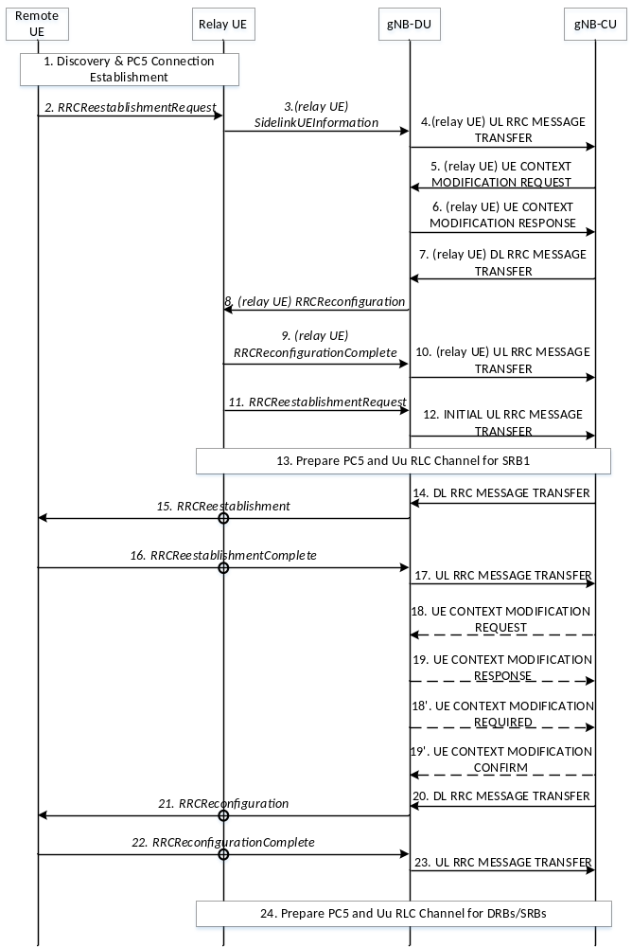
<< Unchanged part is omitted>>
24. The gNB-CU configures additional Uu RLC channels between the gNB-DU and the U2N Relay UE, and additional PC5 RLC channels for the U2N Relay UE for relaying of U2N Remote UE’s DRBs and SRBs. Also, such step may configure the bearer mapping between U2N Remote UE’s DRB/SRB and PC5/Uu RLC channel at the U2N Relay UE.
NOTE 2: This step may be performed earlier.

8.19.3 Remote UE RRC Inactive to other states
The signalling flow for remote UE from RRC Inactive to other states is shown in Figure 8.19.3-1.

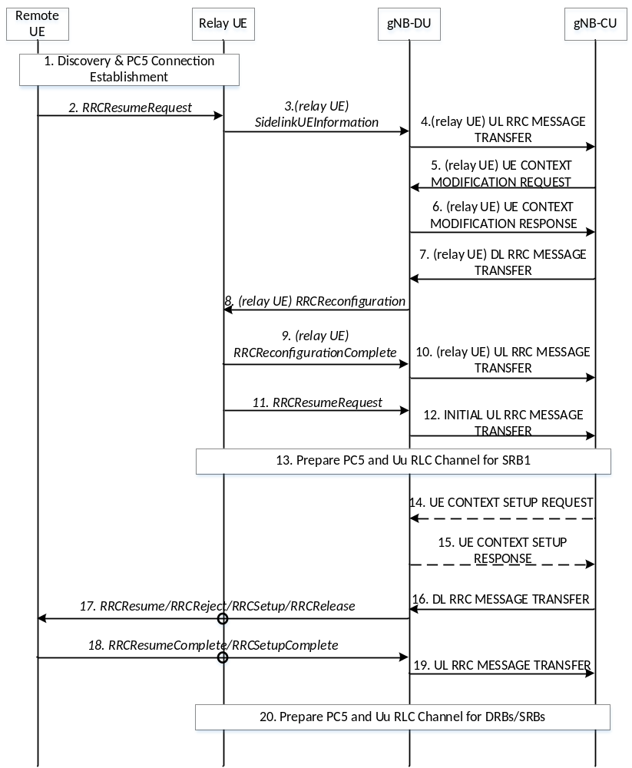
<< Unchanged part is omitted>>
20. The gNB-CU establishes additional Uu RLC channels between the gNB-DU and the U2N Relay UE, and additional PC5 RLC channels for the U2N Relay UE for relaying of U2N Remote UE’s DRBs and SRBs. Also, such step may configure the bearer mapping between U2N Remote UE’s DRB/SRB and PC5/Uu RLC channel at the U2N Relay UE.
NOTE 2: This step may be performed earlier.

8.19.4 Service Continuity for L2 U2N relay

8.19.4.1 Inter-gNB-DU switch from direct to indirect path
The signalling flow for U2N remote UE switch from direct to indirect path with gNB-DU change is shown in Figure 8.19.4.1-1.
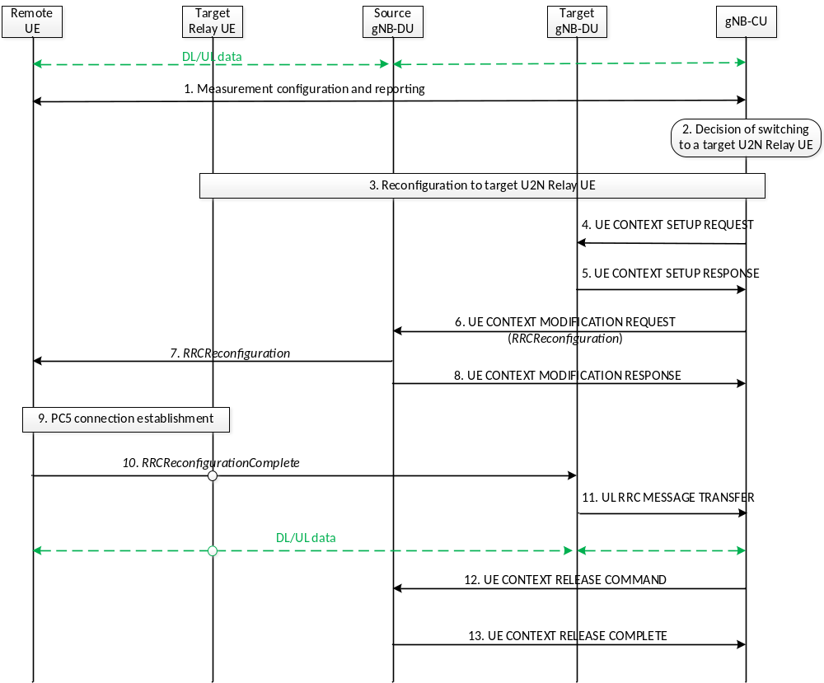
Figure 8.19.4.1-1: U2N Remote UE Direct-to-indirect Path Switch with gNB-DU change procedure
1. The Uu measurement configuration and measurement report signalling is performed between U2N Remote UE and gNB-CU to evaluate both relay link measurement and Uu link measurement. The U2N Remote UE may report one or multiple candidate U2N Relay UE(s) and Uu measurement results after it measures/discovers the candidate U2N Relay UE(s).
2. The gNB-CU decides to switch the U2N Remote UE to a target U2N Relay UE under a different gNB-DU (i.e., target gNB-DU).
3. The reconfiguration to target U2N Relay UE is performed among U2N Relay UE, the target gNB-DU and gNB-CU, if the U2N Relay UE is in RRC_CONNECTED state. The gNB-CU sends an RRCReconfiguration message to the target U2N Relay UE. If the target relay UE is in RRC_IDLE/INACTIVE state, this step is skipped and the configuration to the target U2N Relay UE is performed in Step 10.
4. gNB-CU sends the UE CONTEXT SETUP REQUEST message for the U2N Remote UE to the target gNB-DU, which contains the path switch configuration at least.
5. gNB-DU responds with the UE CONTEXT SETUP RESPONSE message to gNB-CU.
6. gNB-CU sends the UE CONTEXT MODIFICATION REQUEST message by including the RRCReconfiguration message to the source gNB-DU. The contents in the RRCReconfiguration message may include at least the path switch configuration, PC5 RLC channel configuration for relay traffic, bearer mapping and the associated radio bearer(s).
7. The source gNB-DU sends the RRCReconfiguration message to the U2N Remote UE. The U2N Remote UE stops UP and CP transmission over Uu after reception of RRCReconfiguration message from the gNB.
8. The source gNB-DU sends the UE CONTEXT MODIFICATION RESPONSE message to the gNB-CU.
9. The U2N Remote UE establishes PC5 connection with target U2N Relay UE.
10. The U2N Remote UE completes the path switch procedure by sending the RRCReconfigurationComplete message to the target gNB-DU via the target U2N Relay UE. In case the U2N relay UE is in RRC_IDLE/ INACTIVE state when receiving the RRCReconfigurationComplete message, the reception of the RRCReconfigurationComplete message will first trigger RRC setup/resume procedure for the U2N relay UE to enter RRC_CONNECTED state.
11. The target gNB-DU sends the UL RRC MESSAGE TRANSFER message to gNB-CU by including the RRCReconfigurationComplete message.
12. The gNB-CU sends an UE CONTEXT RELEASE COMMAND message to the source gNB-DU.
13. The source gNB-DU releases the UE context and responds the gNB-CU with an UE CONTEXT RELEASE COMPLETE message.

8.19.4.2 Intra-gNB-DU switch from direct to indirect path
The signalling flow for U2N remote UE switch from direct to indirect path without gNB-DU change is shown in Figure 8.19.4.2-1.
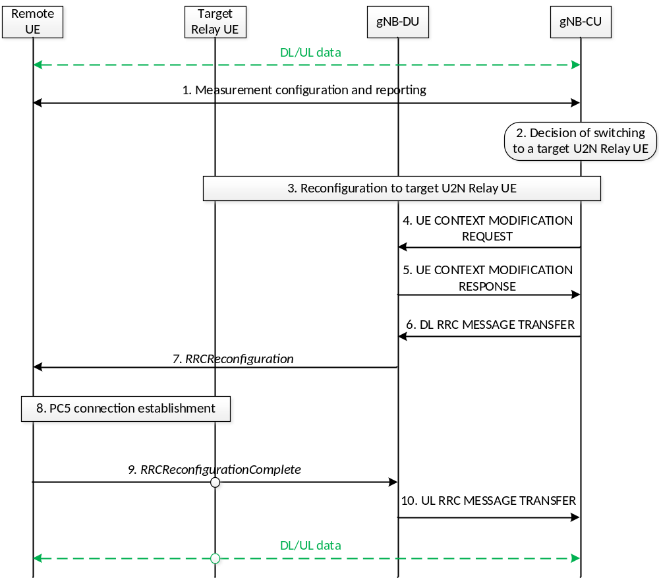
Figure 8.19.4.2-1: U2N Remote UE Direct-to-indirect Path Switch without gNB-DU change procedure
1. The Uu measurement configuration and measurement report signalling is performed between U2N Remote UE and gNB-CU to evaluate both relay link measurement and Uu link measurement. The U2N Remote UE may report one or multiple candidate U2N Relay UE(s) and Uu measurement results after it measures/discovers the candidate U2N Relay UE(s).
2. The gNB-CU decides to switch the U2N Remote UE to a target U2N Relay UE under the same gNB-DU.
3. The reconfiguration to target U2N Relay UE is performed among U2N Relay UE, gNB-DU and gNB-CU if U2N Relay UE is in RRC_CONNECTED state. The gNB-CU sends an RRCReconfiguration message to the target U2N Relay UE. If the target relay UE is in RRC_IDLE/INACTIVE state, this step is skipped and the configuration to the target U2N Relay UE is performed in Step 9.
4. gNB-CU sends the UE CONTEXT MODIFICATION REQUEST message for the U2N Remote UE to gNB-DU, which contains the path switch configuration at least. The F1-U packets of the U2N Remote UE can be continuously transmitted via previous tunnels if there is no tunnel update in this step.
5. gNB-DU responds with the UE CONTEXT MODIFICATION RESPONSE message to gNB-CU.
6. gNB-CU sends the DL RRC MESSAGE TRANSFER message by including the RRCReconfiguration message to gNB-DU. The contents in the RRCReconfiguration message may include at least path switch configuration, PC5 RLC channel configuration for relay traffic, bearer mapping and the associated radio bearer(s).
7. gNB-DU sends the RRCReconfiguration message to the U2N Remote UE. The U2N Remote UE stops UP and CP transmission over Uu after reception of RRCReconfiguration message from the gNB.
8. The U2N Remote UE establishes PC5 connection with target U2N Relay UE.
9. The U2N Remote UE completes the path switch procedure by sending the RRCReconfigurationComplete message to the gNB-DU via the target U2N Relay UE. In case the U2N relay UE is in RRC_IDLE/INACTIVE state when receiving the RRCReconfigurationComplete message, the reception of the RRCReconfigurationComplete message will first trigger RRC setup/resume procedure for the U2N relay UE to enter RRC_CONNECTED state.
10. The gNB-DU sends the UL RRC MESSAGE TRANSFER message to gNB-CU by including the RRCReconfigurationComplete message.

