3GPP TSG-RAN WG3 Meeting #116-e R3-223712
Electronic Meeting, May 9th – 19th, 2022

Agenda item: 9.1.5.1
Source: Intel Corporation
Title: Summary of CB: # Positioning_04_RRC_INACTIVEandLS
Document for: Discussion and Decision

Introduction
R3-223012 | LS on Positioning in RRC_INACTIVE State (RAN2) | LS in
R3-223032 | Reply LS on Positioning in RRC_INACTIVE State (SA2) | LS in
R3-223497 | Correction for positioning measurement during INACTIVE (Intel Corporation) | discussion
R3-223498 | Rel-17 ePos correction on positioning measurement during INACTIVE for SRS-PosRRC-InactiveConfig-r17 (Intel Corporation) | CR0933r, TS 38.473 v17.0.0, Rel-17, Cat. F
R3-223499 | Correction on IE name mismatch in Rel-17 ePos Positioning Context Reservation Indication IE (Intel Corporation) | CR0934r, TS 38.473 v17.0.0, Rel-17, Cat. F
R3-223505 | SRS for positioning measurement (Google Inc.) | CR0936r, TS 38.473 v17.0.0, Rel-17, Cat. F
R3-223276 | Discussion on Positioning support in Inactive (CATT) | discussion
R3-223346 | Support of inactive positioning without anchor relocation (Huawei) | discussion
R3-223587 | Correction on Misalignment with Rel-17 changes in NRPPa (ZTE) | CR0836r, TS 38.413 v17.0.0, Rel-17, Cat. F  withdrawn
CB: # Positioning_04_RRC_INACTIVEandLS
- Agree on needed corrections for Inactive positioning
- Converge on Single CR per Spec
(Intel - moderator)
Summary of offline disc R3-223712
For the first round, companies are encouraged to provide comments until May 13th (Fri) UTC 1300.

For the Chairman’s Notes
The following tdocs are up for agreement: TBD

Discussion (Round 1)
R3-223499 | Correction on IE name mismatch in Rel-17 ePos Positioning Context Reservation Indication IE (Intel Corporation) | CR0934r, TS 38.473 v17.0.0, Rel-17, Cat. F
Intel proposed to fix the IE name mismatch on Positioning Context Reservation Indication IE in F1AP.

Q1) Any objection? Please share your view.
Company | Preference | Comment
Google |  | We are fine with the CR.
CATT |  | We are fine with the CR.
HW |  | We are fine with the CR.
Samsung |  | Fine to align.
Ericsson | Disagree | The change is editorial. It should be added to the F1AP Rapporteur’s CR.
Xiaomi |  | Agree with E///
////////////////////////////////////////////////////////////////////////////////////////////////////////////////////////////////////////////////////////////////////////////////////////////////

Summary
////////////////////////////////////////////////////////////////////////////////////////////////////////////////////////////////////////////////////////////////////////////////////////////////

Regarding the SRS-PosRRC-InactiveConfig-r17 from DU:
R3-223497 | Correction for positioning measurement during INACTIVE (Intel Corporation) | discussion
R3-223498 | Rel-17 ePos correction on positioning measurement during INACTIVE for SRS-PosRRC-InactiveConfig-r17 (Intel Corporation) | CR0933r, TS 38.473 v17.0.0, Rel-17, Cat. F
R3-223505 | SRS for positioning measurement (Google Inc.) | CR0936r, TS 38.473 v17.0.0, Rel-17, Cat. F
Intel and Google are talking about the same issue that the SRS-PosRRC-InactiveConfig-r17 that RAN2 defined for positioning measurements during INACTIVE is generated by DU, but this IE is configured as part of suspend configuration in the RRCRelease message for a UE that is generated by CU.
So, the IE should be able to be transported to CU (via DU to CU RRC Information IE), and Intel further proposed a query for CU to retrieve this configuration from DU since CU is the one who decides to move the UE to INACTIVE state and also decides INACTIVE positioning measurements.

Q2) Any objection? Please share your view.
Company | Preference | Comment
Google |  | As described in section 8.13.9 Positioning Information Exchange procedure, the Positioning Information Request message triggers the DU to initiate a UE Context Modification Required procedure.  The following is from 38.473 v17.0.0 for information.  8.13.9.2 Successful Operation  <unrelated part omitted>  Interaction with the UE Context Modification Required (gNB-DU initiated) procedure:  The UE Context Modification Required (gNB-DU initiated) procedure may be performed before the POSITIONING INFORMATION RESPONSE message.  In Intel’s proposal, we think the Positioning INACTIVE Query Indication IE should be added in the Positioning Information Request message instead of the UE Context Modification Request message. Based on the Positioning INACTIVE Query Indication IE, the DU includes the SRS-PosRRC-InactiveConfig-r17 in the DU to CU RRC Information IE in the UE Context Modification Required message.
CATT |  | Yes, the SRS-PosRRC-InactiveConfig-r17 should be provided from gNB-DU for generation of the RRC Configuration for the UE.  And we understand the Positioning INACTIVE Query Indication IE is needed to obtain the info from gNB-DU. On which message to include the query indication, maybe it should be included in both UE Context Modification Request and Positioning Information Request messages.
HW | Yes with comments | It may be better to include the function within the Positioning procedure, ie, using positioning information exchange procedure. So that gNB-CU can make suggestion for the configuration of SRS resource.
Samsung |  | Agree that SRS-PosRRC-InactiveConfig-r17 should be included in DU to CU RRC Information IE.  For the question on whether to include query indication in POSITIONING INFORMATION REQUEST or UE CONTEXT MODIFICATION REQUEST, our understanding is that both can work so we only need to choose one of them. And we slightly prefer to introduce Positioning INACTIVE Query Indication IE in POSITIONING INFORMATION REQUEST message which makes the whole procedure more natural.
Ericsson | Yes with comments | Agree on the comments made by Google. Nested call flows over F1 is supported for positioning procedures. No need for any query mechanism, as this information can be already included by the gNB-DU upon the UE context modification response. Also, it creates an inconsistent habit of adding query IEs for all the Octet Strings we have in 9.3.1.26 DU to CU RRC Information IE…  So, Google’s approach in R3-223505 is preferable.
Xiaomi | See comments | We think query indication is not needed and the inactive SRS related configuration i.e. SRS-PosRRC-InactiveConfig-r17 should be included positioning related message, e.g. positioning information response.  As the SRS-PosRRC-InactiveConfig-r17 is for inactive UEs, and the Inactive UL positioning relies on SDT, we believe DU is aware of SDT, which means if DU received positioning information request from CU and there’s on-going SDT, DU can know the positioning information request is for the Inactive UE, with that, DU can generate the inactive SRS related configuration and include it in positioning information response message.  There’s no need to involve UE context modification procedure, which introduce additional latency, signaling exchange and signaling overhead, as there is mandatory IE (i.e. CellGroupConfig) in the DU to CU information which is not needed for positioning.  Besides, if CU obtains the SRS-PosRRC-InactiveConfig-r17(which includes SRS configuration) via UE context modification required message, the SRS configuration are duplicated transmitted, as the SRS configuration is also transmitted in positioning information exchange message.  Since there’s already SRS configuration IE in positioning information response message, we think there’re two ways to include the Inactive SRS related configuration.  Option 1, include SRS-PosRRC-InactiveConfig-r17 in positioning information response message  Option 2, reuse SRS configuration IE and include the IEs except SRS configuration in SRS-PosRRC-InactiveConfig-r17 in positioning information response message
////////////////////////////////////////////////////////////////////////////////////////////////////////////////////////////////////////////////////////////////////////////////////////////////

Summary
////////////////////////////////////////////////////////////////////////////////////////////////////////////////////////////////////////////////////////////////////////////////////////////////

Regarding LSes between RAN2 and SA2:
R3-223012 | LS on Positioning in RRC_INACTIVE State (RAN2) | LS in
R3-223032 | Reply LS on Positioning in RRC_INACTIVE State (SA2) | LS in
R3-223276 | Discussion on Positioning support in Inactive (CATT) | discussion
From LSes communicated between RAN2 and SA2 (RAN3 is cc-ed), there are no particular actions that RAN3 should take care of.
But regarding the CR S2-2203251 that SA2 has been working on, CATT found some mismatch between the CR and our design for SDT and proposed to reply the LS to clarify their CR:
////////////////////////////////////////////////////////////////////////////////////////////////////////////////////////////////////////////////////////////////////////////////////////////////
Observation 1: For SDT with anchor relocation case, the UL/DL NAS PDU are exchanged between the receiving gNB (i.e. the new serving gNB) and AMF after path switch.
Observation 2: For SDT with anchor relocation, the corresponding texts for UL/DL signalling transmission in SA2 CR [3] could be aligned with our RAN designs.
Observation 3: For SDT without anchor relocation case, the UL/DL NAS PDU is included in the RRC message and encapsulated in PDCP PDU, then be transferred between the last serving gNB and the receiving gNB via the (Xn) RRC TRANSFER message.
Observation 4: From SA2 CR [3], the UL/DL NAS TRANSPORT message (NAS PDU) may be forwarded between the receiving gNB and the anchor gNB in case of receiving gNB is different with the anchor gNB.
Proposal 1: Reply the LS to SA2 to clarify the RAN behaviours over Xn for SDT transmission.

RAN3 thanks RAN2 and SA2 for the LS on Positioning in RRC_INACTIVE State.
From the CR attached in the LS, the NOTEs (Note 3 and Note 5) in section 6.7.x/6.7.y/6.7.z indicate the UL/DL NAS TRANSPORT message may be forwarded between the receiving gNB and the anchor gNB in case of receiving gNB is not the anchor gNB.
6. The receiving gNB node forwards the UL NAS TRANSPORT message to the serving AMF in an N2 Uplink NAS Transport message.
NOTE 3: If the receiving gNB node is not the anchor gNB node for the UE, the UL NAS TRANSPORT message may be forwarded to the serving AMF via the anchor gNB node.
……
9. The AMF forwards the acknowledgment to the receiving gNB node in a DL NAS TRANSPORT message which is encapsulated in an N2 Downlink NAS Transport message.
NOTE 5: If the receiving gNB node is not the anchor gNB node for the UE, the DL NAS TRANSPORT message may be forwarded to the receiving gNB node via the anchor gNB node.

This is not quite clear from RAN3 point of view, RAN3 would like to clarify the inter-RAN node behaviours for SDT transmission, where the receiving node is different with the anchor node.
- In case of SDT with anchor relocation, the UL/DL NAS PDU, if any, is directly exchanged between the receiving gNB (i.e. the new serving gNB) and AMF after N2 Path Switch procedure.
- In case of SDT without anchor relocation, the UL/DL NAS PDU, if any, is (not may be) forwarded between receiving gNB and the anchor gNB.
  - Directly forwarding of the NAS PDU between RAN nodes is not allowed/specified.
  - NAS PDU, if any, is included in the RRC message and then encapsued in PDCP PDU before been forwarded between RAN nodes by using RRC TRANSFER message over Xn.
We kindly request SA2 to take above into consideration, and do corresponding specification changes if needed.
////////////////////////////////////////////////////////////////////////////////////////////////////////////////////////////////////////////////////////////////////////////////////////////////

Q3) Any objection to reply LS to let SA2 be aligned? Comments on the content of the reply LS? Please share your view.
Company | Preference | Comment
Google |  | OK to send the LS.
CATT |  | Prefer to reply the LS, to indicate the progress in RAN3:  - For positioning support in Inactive, SDT without anchor relocation is not supported in Rel-17.  - In case of SDT with anchor relocation, the NAS PDU is not forwarded between new gNB and the last serving gNB.  Therefore, we understand SA2 may need to adjust the wording of their spec accordingly.
HW | No | We don’t agree with CATT. The SDT procedure support the NAS PDU transfer over Xn in the case of without anchor relocation. So we don’t see any issue with the NOTE. The LS is not needed.
Samsung |  | We share view with CATT.
Ericsson |  | Share the view with Huawei
Xiaomi |  | We understand the intension of CATT, i.e. in case of without anchor relocation, it’s PDCP PDU (with NAS PDU encapsued) instead of NAS PDU transmitted over Xn, so the NOTE in SA2’s spec is incorrect.  We’re fine to send the LS, just wondering whether SA2 needs to know the details in NG-RAN, maybe the text of LS can be further discussed.
////////////////////////////////////////////////////////////////////////////////////////////////////////////////////////////////////////////////////////////////////////////////////////////////

Summary
////////////////////////////////////////////////////////////////////////////////////////////////////////////////////////////////////////////////////////////////////////////////////////////////

INACTIVE positioning without anchor relocation:
R3-223346 | Support of inactive positioning without anchor relocation (Huawei) | discussion
Huawei proposed to support INACTIVE positioning in the scenarios of "without anchor relocation" in Rel-17 that we have discussed before (deferred positioning and normal positioning):
////////////////////////////////////////////////////////////////////////////////////////////////////////////////////////////////////////////////////////////////////////////////////////////////
Proposal 1: Support the scenario of without anchor relocation for Rel-17.
Proposal 2: Reuse the PARTIAL UE CONTEXT TRANSFER procedures to transfer positioning related information between the anchor gNB and the serving gNB.
Proposal 3: Agree the CR in the annex.
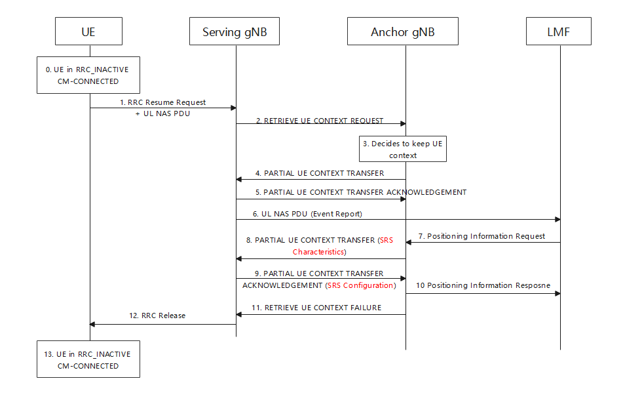
Figure 1, Deferred Postioning in SDT without anchor relocation
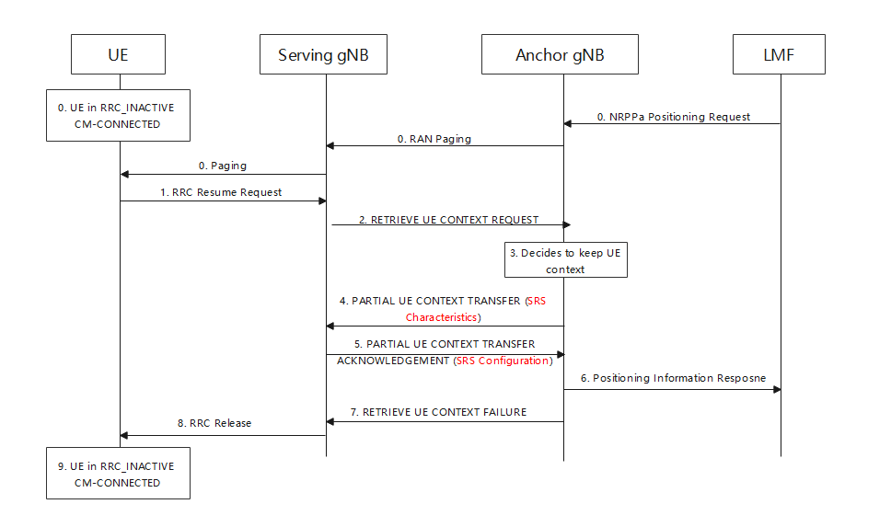
Figure 2, normal positioning in SDT without anchor relocation
////////////////////////////////////////////////////////////////////////////////////////////////////////////////////////////////////////////////////////////////////////////////////////////////

Q4) Please share your view on the proposals and the CR provided in the Annex.
Company | Preference | Comment
CATT | Prefer to further work on this in Rel-18 | In RAN3#115e, we discussed and agreed that:  In case of without anchor relocation  The RRC_INACTIVE positioning in case of SDT without anchor relocation is not supported in R17.  Fully support of SDT without anchor relocation for positioning need more discussion, prefer to further work on it in Rel-18, not now.
HW | Yes | Since SDT has finished the discussion, we can complete the scenarios for inactive positioning in R17.
Samsung | Prefer to discuss further in R18 | We acknowledge the issue that the anchor gNB is agnostic to the content of the UL NAS PDU when it makes the without anchor relocation decision. However, since it is the last meeting and we do not have enough time to have thorough discussion on this topic, we would like to not to revert the agreement we achieved in RAN3#115-e and propose to postpone the discussion to R18.
Ericsson |  | We acknowledge the enhancement points proposed by Huawei, which can be taken as a basis for discussion. However, we must respect the agreement of last e-meeting mentioned by CATT above, otherwise we will not be consistent in our work. The right way to do this is either as part of the R18 positioning package or in TEI18.
Xiaomi | Prefer to discuss further in R18 | We ack the scenario and the impact, but we prefer to discuss this in R18.
////////////////////////////////////////////////////////////////////////////////////////////////////////////////////////////////////////////////////////////////////////////////////////////////

Summary
////////////////////////////////////////////////////////////////////////////////////////////////////////////////////////////////////////////////////////////////////////////////////////////////

Conclusion
TBD

