**3GPP TSG-RAN3 #114-e R3-215958**

**Online, 1st November – 11th November 2021**

**Title:** **LS on RRM Policy utilisation monitoring and reconfiguration**

**Response to:**

**Release: Rel-17**

**Work Item: NR_Slice**

**Source: RAN3**

**To: SA5**

**Cc: -**

**Contact person: Angelo Centonza**

**Angelo.Centonza@Ericsson.com**

**Send any reply LS to: 3GPP Liaisons Coordinator,** [**mailto:3GPPLiaison@etsi.org**](mailto:3GPPLiaison@etsi.org)

# 1 Overall description

As part of the work on Enhancements of RAN Slicing RAN3 is discussing solutions to address the following scenario (see TR38.832):

***Scenario 1: Slice resource shortage in case of Intra-RA mobility and Inter-RA mobility***

**

***Figure 6.1-1: Service interruption due to slice resource shortage***

*As shown by Figure 6.1-1, the UE’s ongoing slice(s) is/are supported by both the source and the target NG-RAN node. At the time of handover, the target node fails to accept the UE with at least one of the ongoing S-NSSAIs due to e.g. high slice-related load at the target node. Under such circumstance, the service(s) for failed ongoing slice(s) is/are interrupted for the UE.*

*It should be noted that remapping of traffic into the resource pool used by other slices requires a pre-configured policy allowing such action. The remapping should avoid overloading the resource pool of the target slice. Any solution to this issue should comply with the RRM policy model defined in TS 28.541 and be validated by SA5.*

*How to support the slice recovery (i.e., re-mapping of remapped slice to on-going slice) when the NG-RAN node recovers enough resources to serve the on-going slice(s) will be discussed in normative phase.*

As a possible solution to address the scenario above, RAN3 has identified that the OAM may monitor the utilisation of RRM Policies (e.g. by means of measurements defined in TS28.552 such as *Mean UL PRB used for data traffic, Mean DL PRB used for data traffic, Peak UL PRB used for data traffic, Peak DL PRB used for data traffic*) in order to identify possible resource share overloads or consistent resource share portions remaining unused. The OAM may therefore dynamically re-adjust the RAN resources allocated to each RRM Policy Ratios or change their slice member list. This would ensure that any unused resources in the configured resource shares are made accessible to slices that consistently request more resources than planned. The figure below shows a graphical representation of the solution.

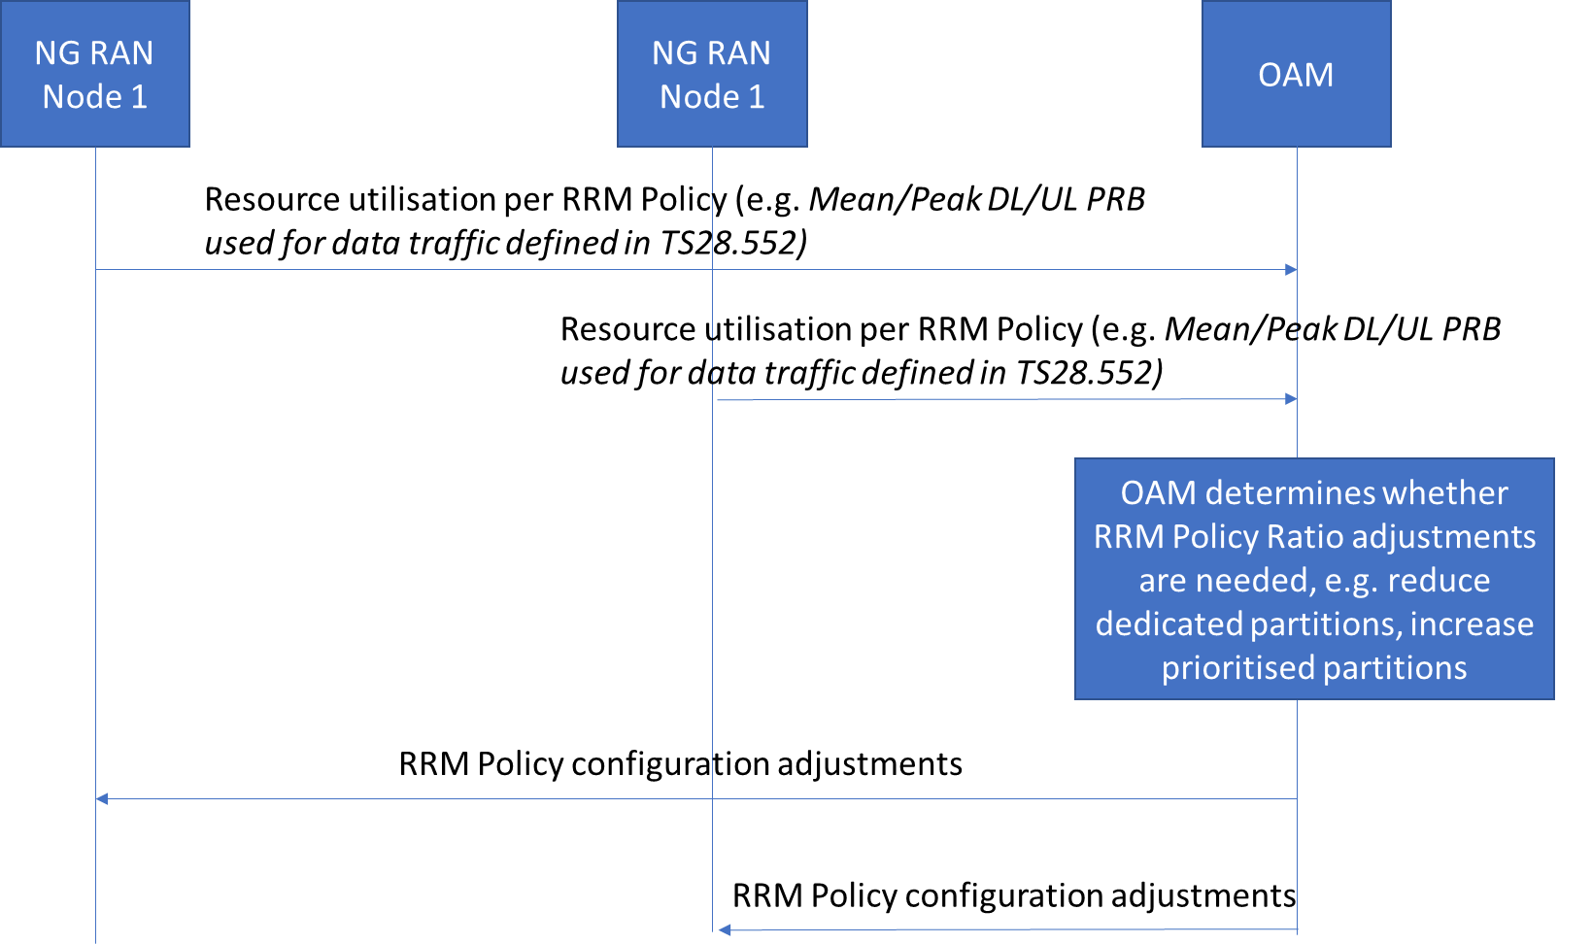

# 2 Actions

**To SA5:**

**ACTION:** RAN3 respectfully asks SA5 to determine whether the solution described above is feasible and whether it requires modifications to SA5 specifications.

# 3 Dates of next TSG SA WG 2 meetings

the upcoming SA2 meetings can be found in the [RAN3 Meetings calendar](https://portal.3gpp.org/Home.aspx?tbid=381&SubTB=381#/)