3GPP TSG-RAN WG3 #112-e R3-212649
17-27 May 2021
Online

Agenda Item: 17.3
Source: ZTE (moderator)
Title: Summary of Offline Discussion on RANSlicing2-Slice_Conclusion
Document for: Approval

Introduction
# RANSlicing2-Slice_Conclusion
- TR updates:
- update the description of section 6.2.3.1 and 6.2.3.2 of the TR with the response from SA5 in R3-211633? Nok
- Modify the evaluation table according to the feedback received from SA2 and SA5, as per text in R3-211624 and R3-211902? Qualcomm, HW
- Update the editor notes part in section 6.2 either removing it or changing it to be note in R3-211902? HW
- Capture agreements as TP for TR updates, revise/merge and check details, split work, if needed

- Remapping solution evaluation and conclusion:
- The Slice Resource Re-partitioning solution analysis based on SA5 LSin (section 6.2.3.1 and 6.2.3.2) ? LS reply to SA5? E///
- RAN3 concluded that scenarios 2 and 4 in TR38.832 concern a situation of sub-optimal slice coverage planning, that can be resolved by slice coverage optimisation hence these scenarios should not be pursued in normative work? RAN3 concluded that the solutions addressing scenarios 2 and 4 are not deemed feasible due to their impact on CN and UE? E///
- Develop details of solutions in 6.2.3 (including OAM requirements if applicable) to the remaining scenarios (e.g. resource shortage in case of Intra-RA mobility, slice resource shortage for MR-DC and slice overload in RAN node in absence of mobility)? Qualcomm
- Update the conclusion of the TR to select one of the solutions described in 6.2.1 i.e. where re-mapping decision would be in the NG-RAN? Nok
- Only resource management solution is used to solve the resource shortage case? only slice remapping solutions are used to solve the not supported slice cases? CATT
- For solutions addressing scenario 1/3/5/6, continue to refine these solutions at the normative phase, which are already captured in the conclusion in TR 38.832. And the “after feedback from SA2 and SA5” in the conclusion part in Section 7.2 can be removed?For solutions addressing scenario 2/4, the 6.2.1.1.1 (Policy configured by OAM) may be further refined at the normative phase. And the conclusion part in section 7.2 can be updated accordingly? HW
- The solutions to support Scenarios 2 and 4 should be specified in normative phase? Solution 6.2.2, Solution 6.2.1.2.1.4, Solutions 6.2.1.1.1 and 6.2.1.1.2 should be ruled out? Solutions 6.2.1.1.3 and 6.2.4 should be selected for normative work to support Scenarios 2 and 4 with the enhancement to change the slice of the on-going PDU session in CN and UE? LG
- RAN3 recommends all solutions in section 6.2.3 to normative phase? Send LS to SA5 to inform that RAN3 decides to implement solutions in section 6.2.3, and clearly indicate RAN3 requirements regarding each solution? RAN3 recommends solution 6.2.1.1.1 (Policy configured by OAM) to normative phase? Send LS to SA2 to inform RAN3’s recommendation on CN/UE impacting solution? CMCC
- Solution 6.2.1 is recommended in normative phase? Samsung
- From SA5 and SA2 point of views, solutions in section 6.2.3.1, 6.2.3.2, 6.2.3.3 are feasible. It is propose to let SA5 decide whether to takes these candidate solutions in normative stage? For policy generation in section 6.2.1.1.4, it is proposed to specify it in normative phase? Providing slice remapping/fallback information to CN should be removed from figure 6.2.2.1-1,figure 6.2.2.2-1, figure 6.2.2.6-1 and figure 6.2.2.7-1, the corresponding descriptions are also need to be removed. With this change, the message sequences in these figures can be candidate for slice remapping solutions in intra-RA scenario 1,3,5,6? Slice remapping solutions for inter-RA scenario 1,3,5,6 may need further evaluation in WI stage or postpone to later releases? ZTE
- Capture TP for conclusion
(ZTE - moderator)
Summary of offline disc R3-212649

Note:
Two rounds of discussion.
The first round email discussion plan to be end .(Wednesday; before on-line session 13:00 UTC, 2021-5-19)
The second round email discussion plan to be end before the email deadline at second week(Thursday 12:00 UTC).

For the Chairman’s Notes
Propose the following:

Conclusion: The following solutions are recommended by RAN3 to be specified in normative phase for scenario 1,3,5,6:
- Configuration based Solution
- Slice resource re-partitioning
- Multi-carrier radio resource sharing

Conclusion: The following solution is expected to be refined during normative phase, involvement of SA2 is necessary:
- Re-mapping decision in NG-RAN node

Conclusion: The LS in R3-211654 depends whether solution 6.2.1 Re-mapping decision in NG-RAN node can be adopted for normative stage.

Conclusion: Update of TP can be found in R3-212773.

Discussion

Update suggestions for solution part of TR38.832

Views on section 6.2 Solutions

Views on section 6.2.1 Re-mapping decision in NG-RAN node
One contribution [10] provide tow type modification proposals below
The first one is remove the editor note from section 6.2.1:
6.2.1 Re-mapping decision in NG-RAN node

In solutions where the target NG-RAN node decides the re-mapping at incoming handover, the target NG-RAN node should be aware of the re-mapping policy for the involved PDU session. The following options are available:
Q1: Please provide your view on the update suggestion.
Company | Yes/No/Other view | Comment
Nokia | OK
Huawei | OK
LGE | OK
CMCC | Agree
CATT | OK
Qualcomm | Clarify | Why is there a difference in the handling of this editor’s note (deletion) with respect to the others? It seems they are all the same, the issue of 6.2.1 (requiring feasibility at system level) still applies.  Suggest instead “Note: Support for system level remapping is a prerequisite for this solution(s)”
Samsung | OK
ZTE | Ok | To my understanding, this editor note is redundant and covered by note in each solutions. That is why [10] suggest to remove it.
Ericsson | NOK | Removing the note may be interpreted as if further checks from SA2 are not needed. Indeed SA2 confirmed that these solutions have an impact o nCN and on the UE, that they are discouraged and that a study is needed to check their feasibility. Hence at best we can make this a simple “note” instead of an “Editor’s note”

The other one is change “Editor note ” to “Note” and remove FFS from TR in section 6.2.1, 6.2.2, 6.2.3.
One update example is shown below:
Note: Whether and how the UE is aware of slice remapping needs the involvement with SA2 if necessary.
Q2: Please provide your view on the update suggestion.
Company | Yes/No/Other view | Comment
Nokia | OK
Huawei | OK
LGE | OK
CMCC | Agree
CATT | OK
Qualcomm | Partially | It is obvious that any UE involvement needs SA2. But this makes it look like an unfinished study. Suggest instead “Support for system level remapping is a prerequisite for this solution”, this could be used throughout.
Samsung | OK
ZTE | OK
Ericsson | Partially | Along the same line as QC, we suggest the following: Support for system level remapping is a prerequisite for this solution. Feasibility of how the UE is aware of slice remapping needs to be studied and confirmed

Conclusion: Based on majorities view, the above update can be merged into TP. A draft TP is prepared in R3-212773.
One contribution [14] provide modification proposal for this section, the detail is shown as below

6.2.1.1.4 Slice Re-mapping policy reuse information provide by CN (during Initial Context Setup)
Signaling in INITIAL CONTEXT SETUP REQUEST
During initial context setup, the CN includes in the INITIAL CONTEXT SETUP REQUEST message the Allowed NSSAI IE,which can be used for NG-RAN to for decision which Slice(s) can can be re-mapped for a PDU session or for UE.
In this option the granularity of the re-mapping policy is Per UE.
Example of per UE policy:
UE 1, any PDU session of S-NSSAI 1 <> re-mapped list (only one S-NSSAI in allowed NSSAI IE,which decided by NG-RAN node )
Signaling from Source NG-RAN node
At the time of handover, the source NG-RAN node includes in the Xn Handover Request message the current PDU Session, the associated S-NSSAI and also the Allowed NSSAI to which this PDU session can be mapped. The target NG-RAN node can decides which S-NSSAI can be selected from Allowed NSSAI and mapped the original S-NSSAI to an appropriate S-NSSAI.
In this option the granularity of the re-mapping policy is Per UE.
Example of per UE policy:
UE 1, any PDU session of S-NSSAI 1 <> re-mapped list (only one S-NSSAI in allowed NSSAI IE,which decided by NG-RAN node )
The above slice-remapping principle are applicable to intra-RA handover scenario, MR-DC scenario and intra NG-RAN node scenario.

Q3: Please provide your view on the modification.
Company | Yes/NO/Other view | Comment
Nokia | NOK | We prefer not to add new solution at this stage. We prefer slice remapping by O&M to make it simple in release 17 as a first step.
Huawei | NO | Agree with Nokia.  Also this solution (UE specific remapping) seems to be covered/updated by the 6.2.1.1.2 (only considering non-UE specific remapping)
LGE | NO | We also prefer not to add new solution at this stage.
CMCC |  | From our understanding, this proposed method can be merged with 6.2.1.1.3, since both solutions describe how to configure remapping policy per PDU session/per UE by CN, and discuss how to transfer remapping list/allowed NSSAI during mobility.  In our opinion, the majority of the descriptions for two solutions seem overlapping, and the main difference is whether to configure the remapping policy by means of remapping list or allowed NSSAI.
CATT | NO | Agree with above. No need to introduce the overlapping solution with the existing one
Qualcomm | No | This is really a new solution and probably should not be added now. But the real issue is that this does not solve any existing problem. The problem is not how the RAN finds out which slices can be used as remapping targets, it is how the remapping can be performed at system level.  What this solution does is to highlight that the problem to be solved is not clear. The motivation seems to be to use slices that are allowed by the CN and the UE is aware of these – but what is the procedure to tell the UE of the change? If the UE is not made aware, then what is the point?
Samsung |  | Technically, we think allowed NSSAI is not designed for slice re-mapping, it may have issues on performance after re-mapping without considering QoS requirement, but we’re fine to capture new policy solutions, and we propose to further evaluate each policy.
zte | Yes | The intention is to try find update in order to limited impact on CN and UE as SA2 required.
Ericsson | NO | The extension of the SI was granted to conclude the study and not to add new solutions for evaluation.

Conclusion: Based on majorities view, the above update NOT accepted.

Views on section 6.2.1.2 Slice Re-mapping Message Sequence Charts

One contribution [14] provide modification proposal for this section, the detail is shown as below:

6.2.1.2.1 Slice Remapping decision in target gNB at Xn based handover
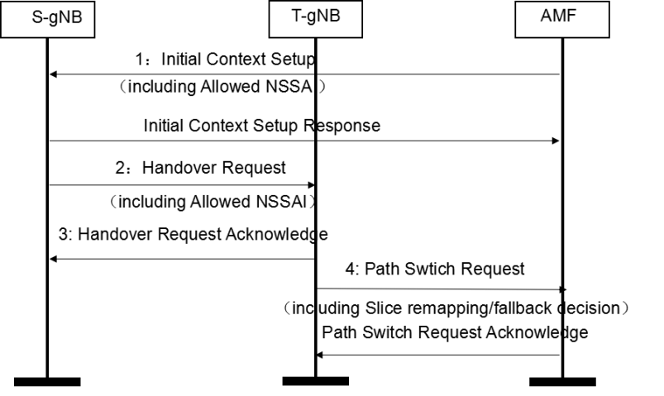
Figure 6.2.1.2.1.1-1: Slice re-mapping/fallback determined by the T-gNB
- The AMF sends the Initial context setup message to the S-gNB including the Allowed NSSAI. Here the Allowed NSSAI is used for slice re-mapping.
- The S-gNB sends the HANDOVER REQUEST message to the T-gNB including the Allowed NSSAI.
- If the UE’s ongoing slice(s) is rejected in the target gNB, the target gNB takes the local slice load and the Allowed NSSAI into account and makes the slice re-mapping/fallback decision. .
- The T-gNB send the PATH SWITCH REQUEST message to the AMF which may include the slice remapping/fallback decision.
- The AMF responds the PATH SWITCH REQUEST ACKNOWLEDGE message.
Note: The slice remapping/fallback decision contained in Path Switch Request message provides information for Core network, e.g. for Billing.

6.2.1.2.2 Slice Remapping decision in target gNB at NG based handover
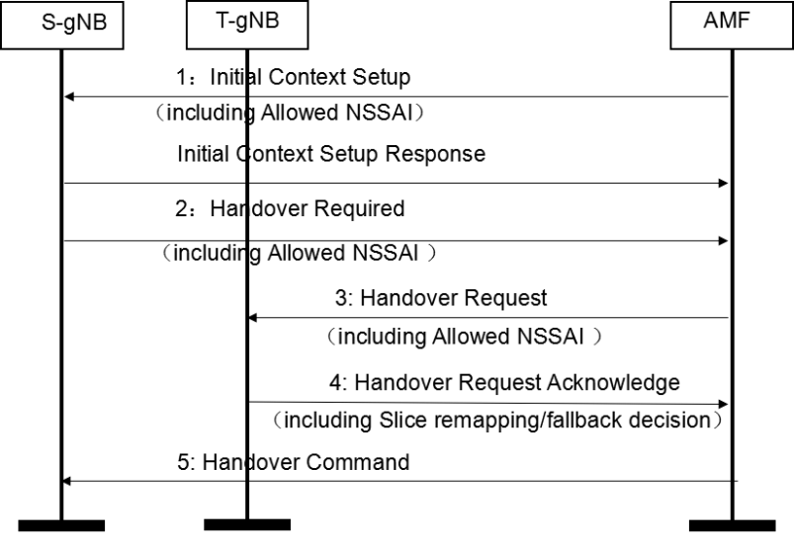
Figure 6.2.1.2.1.2-1: Slice re-mapping/fallback determined by the T-gNB
- The AMF sends the Initial context setup message to the S-gNB including the Allowed NSSAI. Here the Allowed NSSAI is used for slice re-mapping.
- The S-gNB sends the HANDOVER REQUIRED message to the AMF including the Allowed NSSAI.
- The AMF sends the HANDOVER REQUEST message to the T-gNB including the Allowed NSSAI.
- If the UE’s ongoing slice(s) is rejected in the target gNB, the target gNB takes the local slice load and the Allowed NSSAI into account and makes the slice re-mapping/fallback decision. The T-gNB may include the re-mapped/fallback decision in the HANDOVER REQUEST ACKNOWLEDGE message to the AMF.
- The AMF sends the HANDOVER COMMAND message to the S-gNB.
Note: The slice remapping/fallback decision contained in Path Switch Request message provides information for Core network, e.g. for Billing.
.

6.2.1.2.2.1 Slice Remapping decision in SN for MR-DC case
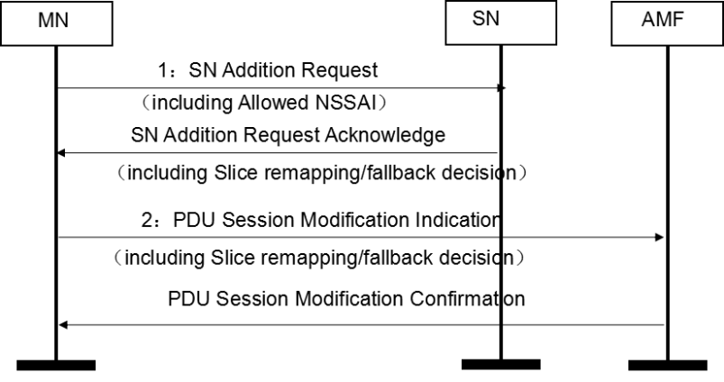
Figure 6.2.1.2.2.1-1: Slice re-mapping/fallback determined by the SN
- The MN sends the SN Addition Request message to the SN with the Allowed NSSAI. Here the Allowed NSSAI list is used for slice re-mapping.
- If the UE’s ongoing slice(s) is rejected by the SN, the SN takes the local slice load and the Allowed NSSAI into account and makes the slice re-mapping/fallback decision. The SN shall include the slice re-mapping/fallback decision in the SN Addition Request Acknowledge message to the MN.
- The MN may send the slice re-mapping/fallback decision to the AMF through the PDU Session Modification Indication message.
- The AMF responds the PDU Session Modification Confirmation message.
Note: The slice remapping/fallback decision contained in Path Switch Request message provides information for Core network, e.g. for Billing.

6.2.1.2.2.2 Slice Remapping decision in MN for MR-DC case
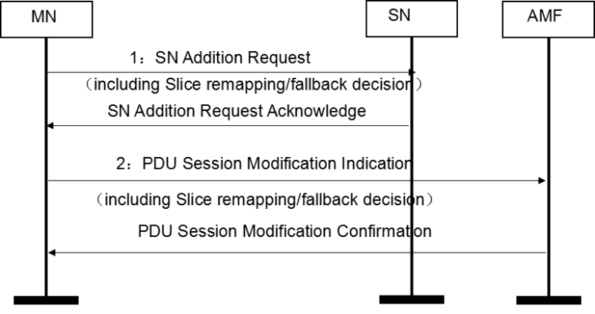
Figure 6.2.1.2.2.2-1: Slice re-mapping/fallback determined by the MN
- The MN makes the slice re-mapping/fallback decision and include the decision in the SN Addition Request message to the SN.
- The SN confirms the slice re-mapping/fallback decision made by the MN with the SN Addition Request Acknowledge message.
- The MN may send the slice re-mapping/fallback decision to the AMF through the PDU Session Modification Indication message.
- The AMF responds the PDU Session Modification Confirmation message.
Note: The slice remapping/fallback decision contained in Path Switch Request message provides information for Core network, e.g. for Billing.

6.2.1.2.5 Slice Remapping Solution for Scenario 6
At the same time the NG-RAN node may notice that another slice 2 which is not overloaded has resources available and is still compatible with the SLA of slice 1.
In short, there is a potential that some unloaded but "good enough or better" alternative slices in the RAN could be used for the subscriber to continue to receive service.
NG-RAN node may send the slice re-mapping/fallback decision to the AMF for e.g. billing.

Q4: Please provide your view on the update.
Company | YES/NO/other view | Comment
Nokia | NOK. | We prefer slice remapping by O&M to make it simple in release 17 as a first step. Prefer not to add new solution at this stage.
Huawei | No | See answer to Q3.
LGE | NO | See answer to Q3
CMCC |  | OK to delete the Editor’s Notes or change to Notes if necessary.  Prefer to keep the original text since it can cover both solutions (already captured 6.2.1.1.3 and the proposed 6.2.1.1.4).
CATT | NO | See answer to Q3
Qualcomm | No | See answer to Q3.
Samsung |  | Prefer to keep the original text.
ZTE | Yes | The intention is to try find update in order to limited impact on CN and UE as SA2 required.
Ericsson | NO | The extension of the SI was granted to conclude the study and not to add new solutions for evaluation.

Conclusion: Based on majorities view, the above update NOT accepted.

Views on section 6.2.3 Resource management in NG-RAN node

Views on section 6.2.3.1 Configuration Based Solution
One contribution [3] provide modification proposal for this section, the detail is shown as below:
6.2.3.1 Configuration Based Solution
The solution builds on the resource modelling described in TS 28.541. The following analysis is provided for the scenario 1 and scenario 2 respectively:
- Scenario 1: Slice resource shortage in case of Intra-RA mobility and Inter-RA mobility
As specified in TS 28.541, the slice re-mapping between different S-NSSAIs can be achieved via the prioritized resource modeling. For example, suppose UE’s ongoing slice is S-NSSAI 1 configured with rRMPolicyMaxRatio policy, which can use at least one of the shared resources, prioritized resources and dedicated resources. If the dedicated resources are not available, it can use other un-used prioritized and shared resources according to TS 28.541 as follows:

- it can explicitly use resources belonging to other S-NSSAIs;
- it cannot use the dedicated but not used resources of other S-NSSAIs;
- it can preempt the used shared resources from other S-NSSAIs.

Q5: Please provide your view on the update.
Company | YES/NO/other view | Comment
Nokia | OK
Huawei | No | The initial intention of this part is to give some gap with respect to the TS 28.541. There is no need to update this, and specify the current behavior in TS 28.541.
LGE | NO | Same view with Huawei
CMCC | No | Agree with HW. Note that the text captured here is a potential solution which may be different in behavior from the current spec in SA5.
CATT | No | Agree with HW
Qualcomm | Could be ok | At least the section for scenario 2 should be deleted as it is not a complete solution, just an aspiration.  For the rest, it is strange that we state there could be some gaps, but actually at the end of the study we cannot state what the gaps are. The existing text wants to “have its cake and eat it”, mentioning 28.541, but then avoiding to analyze the gaps. Maybe what we need is a statement that the existing SA5 toolset provides a baseline although some enhancements (in RAN3 or SA5) could be considered if needed
Samsung | No | Agree with HW
ZTE | No | Share the view with Huawei.
Ericsson | Yes with modifications | We propose to use the following text :  - it can explicitly use shared/prioritised resources if free;  - it cannot use the dedicated but not used resources of other S-NSSAIs, unless it is a member of the ddicated RRMPolicyRatio;  - it can preempt the used prioritized and/or shared resources from other S-NSSAIs if priority allows.

Conclusion: Based on majorities view, the above update NOT accepted.

Views on section 6.3 of Solution evaluation
Three contributions [7][10][15] provide modification proposal for this section, the detail is shown as below:
Table 6.3-1: Evaluation of the solutions
Criteria  Solution |  | RAN impact | Core impact | OAM impact | UE impact | Effectiveness | Applicable scenarios
6.2.1: Re-mapping decision in NG-RAN node | 6.2.1.1.1: Policy configured by OAM | Option 2:  RAN is configured with re-mapping policy from the OAM.  RAN may signal the slice remapping decision to CN. | Option 1:  CN is configured with re-mapping policy from the OAM.  FFS if the CN needs to be notified in case of any slice-remapping, e.g. for charging purpose.  CN performs slice remapping.  CN reconfigures UE with NAS signalling to associate an ongoing PDU Session to a new S-NSSAI. Feasibility would require SA2 study.  Option 2:  CN is configured with re-mapping policy from the OAM.  CN may be notified in case of any slice-remapping, e.g. for charging purpose.  CN reconfigures UE with NAS signalling to associate an ongoing PDU Session to a new S-NSSAI. Involvement with SA2 may be needed for scenario 2/4.  How the slice remapping is done in 5GC needs involvement with SA2 for scenario 2/4. | OAM configures slice re-mapping policy to the NG-RAN, CN (if verification is needed). | Option 1:  UE needs to be reconfigured at NAS level to associate an ongoing PDU Session to a new S-NSSAI. Feasibility would require SA2 study.  Option 2:  UE needs to be reconfigured at NAS level to associate an ongoing PDU Session to a new S-NSSAI. Involvement with SA2 may be needed for scenario 2/4. | Option 1:  Solution at the cost of CN, OAM, RAN and UE impact  Required procedures in UE and CN are not supported. Feasibility would require SA2 study. | 1, 2, 3, 4, 5, 6
6.2.1: Re-mapping decision in NG-RAN node | 6.2.1.1.2/6.2.1.1.3: Policy configured by CN | Option 2;  RAN is signalled with the remapping policy from CN/the source RAN node.  RAN may signal the slice remapping decision to CN. | Option 1:  CN is configured with remapping policy from the OAM, and signals the re-mapping policy to the NG-RAN.  FFS if the CN needs to be notified in case of any slice-remapping, e.g. for charging purpose.  CN performs slice remapping.  CN reconfigures UE with NAS signalling to associate an ongoing PDU Session to a new S-NSSAI. Feasibility would require SA2 study.  Option 2;  CN is configured with remapping policy from the OAM, and signals the re-mapping policy to the NG-RAN.  CN may be notified in case of any slice-remapping, e.g. for charging purpose.  CN reconfigures UE with NAS signalling to associate an ongoing PDU Session to a new S-NSSAI. Involvement with SA2 may be needed for scenario 2/4.  How the slice remapping is done in 5GC needs involvement with SA2 for scenario 2/4. | OAM configures slice re-mapping policy to the CN. | Option 1:  UE needs to be reconfigured at NAS level to associate an ongoing PDU Session to a new S-NSSAI. Feasibility would require SA2 study.  Option 2:  UE needs to be reconfigured at NAS level to associate an ongoing PDU Session to a new S-NSSAI. Involvement with SA2 may be needed for scenario 2/4. | Solution at the cost of CN, OAM, RAN and UE impact  Required procedures in UE and CN are not supported. Feasibility would require SA2 study. | 1, 2, 3, 4, 5, 6
6.2.1: Re-mapping decision in NG-RAN node | 6.2.1.1.4: Slice Re-mapping policy reuse information provide by CN | RAN leverage legacy information (e.g. Allowed NSSAI) provide by CN as input for re-mapping policy.  If RAN decide to signal the slice remapping decision to CN,the usage of decision in CN is for billing. | No impact | No impact | No impact | Solution with RAN impact. | Intra-RA of 1,3,5,6
6.2.1: Re-mapping decision in NG-RAN node | 6.2.1.2.1.4: 5GC Solution based on SSC-mode 3 | RAN is signalled with the remapping policy from CN/the source RAN node if this option is used.  It requires support of updated “SSC-mode 3”, e.g., the target node needs to temporarily accept the PDU session even if slice is not supported in the cell. | CN is configured with remapping policy from the OAM, and signals the re-mapping policy to the NG-RAN if this option is used. It requires modification of the “SSC mode 3” procedure in CN.  Feasibility would require SA2 study.  . | OAM configures slice re-mapping policy to the RAN if this option is used. | The update of “SSC-mode 3”.  Feasibility would require SA2 study. | Solution with OAM, CN, RAN and UE impact  Required procedures in UE and CN are not supported. Feasibility would require SA2 study. | 2, 4
6.2.2: Partially slice re-mapping in NG-RAN | Solution with CN involvement | Same as 6.2.1.1.2/6.2.1.1.3: Policy configured by CN | Same as 6.2.1.1.2/6.2.1.1.3: Policy configured by CN | Same as 6.2.1.1.2/6.2.1.1.3: Policy configured by CN | Same as 6.2.1.1.2/6.2.1.1.3: Policy configured by CN | Same as 6.2.1.1.2/6.2.1.1.3: Policy configured by CN | Same as 6.2.1.1.2/6.2.1.1.3: Policy configured by CN
6.2.2: Partially slice re-mapping in NG-RAN | Solution without CN involvement | RAN is configured with re-mapping policy from the OAM.  New functionality to support semi-handover case.  New behaviour in new gNB (allow usage by non-supported slice even though gNB does not support slice).  Requires Xn support from inside old RA to any node inside new RA (unless continuity is broken later) | New functionality to support the new handover case, where the UE is connected to target but source maintains UE signalling connection with CN.  It is FFS how the CN handles RA update from UE. | OAM configures slice re-mapping policy to the NG-RAN. | New functionality to support the new handover case, where the UE is connected to target but source maintains UE signalling connection with CN. RA procedure and consistency between allowed S-NSSAI in new RA are FFS.  Involvement with SA2 may be needed. | Solution at the cost of CN, OAM, RAN and UE impact.  Feasibility would require SA2 study. | 2, 4
6.2.3: Resource management in NG-RAN node | 6.2.3.1: Configuration based Solution | RAN is configured with re-mapping policy from the OAM.  RAN may possibly signal the RAN-internal slice resource change to CN. | CN may be notified in case of any RAN-internal slice resource change e.g., for charging purpose. | OAM configures slice resource policy to the NG-RAN.  A study in SA5 may be needed if further capabilities are deemed required by RAN beyond those already supported. | No impact | Simple and effective solution at the main cost of the OAM impact. | 1, 3, 5, 6.
6.2.3: Resource management in NG-RAN node | 6.2.3.2: Slice resource re-partitioning | RAN is configured with re-mapping policy from the OAM.  RAN may possibly signal the RAN-internal slice resource change to CN | CN may be notified in case of any RAN-internal slice resource change e.g., for charging purpose. | OAM configures slice resource re-mapping policy to the NG-RAN.  A study in SA5 may be needed if further capabilities are deemed required by RAN beyond those already supported. | No impact | Simple and effective solution at the main cost of the OAM impact | 1, 3, 5, 6
6.2.3: Resource management in NG-RAN node | 6.2.3.3: Multi-carrier radio resource sharing | No impact. | No impact | No impact  SA5 noted that the concept of RRMPolicyRatio is configurable per cell, but not per frequency. | No impact | Simple and effective solution.  It requires the same slice coverage across different frequencies. | 1, 3, 5, 6
6.2.4: Slice Remapping decision in 5GC |  | No impact | CN is configured with remapping policy from the OAM.  New intra-CN procedure is needed to change the slice for an ongoing PDU session.  Feasibility would require SA2 study | OAM configures slice re-mapping policy to the CN. | UE needs to be reconfigured at NAS level to associate an ongoing PDU Session to a new S-NSSAI.  Feasibility would require SA2 study . | Solution with OAM, CN and UE impact  .  Feasibility would require SA2 study Required procedures in UE and CN are not supported. | 2, 4

There are two different interprets on solution 6.2.1 Re-mapping decision in NG-RAN nod in the table.
Option 1: For Scenario 1,2,3,4,5,6, CN performs slice remapping.CN reconfigures UE with NAS signalling to associate an ongoing PDU Session to a new S-NSSAI. Feasibility would require SA2 study.
Option 2: CN may be notified in case of any slice-remapping, e.g. for charging purpose. For Scenario 2,4, CN reconfigures UE with NAS signalling to associate an ongoing PDU Session to a new S-NSSAI. Involvement with SA2 may be needed for scenario 2/4.

Q6: Please provide your view on the options.
Company | Option 1, 2, other view | Comment
Nokia | Option 2 | Not 100% sure to grasp the interpretations. We think to apply Slice remapping to scenarios 2,4.
Huawei | Option 2 | Several issues related to option 1 is that:  - For 6.2.1.1.1: Policy configured by OAM, it is added “CN performs slice remapping”. This seems not correct.  - for 6.2.1.1.2/6.2.1.1.3: Policy configured by CN, the addition seems redundant given the descriptions above.  We can take option 2 as baseline to further polish  Also the reference to Solution with CN involvement is not fully correct.
LGE | Option 2 | Solution 6.2.1 is only applied to Scenario 2, 4.
CMCC | Other view | As captured in the evaluation table in current 38832, solutions 6.2.1.1.1-3 are applicable to all scenarios 1-6. Also as indicated in the evaluation table, no matter which node (OAM or CN) configures the remapping policy, the remapping policy is generated by OAM.
CATT |  | Either OAM or CN provide the remapping policy. In all the scenarios, if the slice remapping is performed, the CN should be involved. But we support the remapping solution only for scenario 2 and 4.
Qualcomm | Option 1 | There seems to be an obfuscation.  For example solutions 6.2.1 are called “Remapping” solutions and as stated by CMCC, are applicable to all scenarios. So the question is not answered, what constitutes remapping in these solutions, even in scenario 1? Is the CN aware of the remapping? Is the UE aware of the remapping? Since slice is an end-to-end concept, is there an end-to-end procedure for the remapping? If these questions are not clearly answered, we cannot take option 2.  On the other hand if the so-called remapping is basically for RAN consumption only, then there is very little difference between solutions 6.2.1 and 6.2.3. In this case all we are doing is borrowing resources, and it is just the mechanism that may be slightly different. But then the terminology is extremely confusing (and we need to find a new term and clarify this as this will be a published document….).  For example in scenario 1, it is very difficult to see a major difference between RAN only remapping, and resource re-partitioning triggered by handover preparation into a congested slice.
Samsung | Other view | Agree with CMCC, Solution 6.2.1 can be applied to all scenarios.  For option 2, we think it’s not only for scenario 2/4, but also for scenario 1, 3, 5,6.  solution 6.2.1 is needed to address scenario 2/4, and the involvement with SA2 cannot be avoided.
ZTE | Option 2 | In our understanding, option 1 think CN need to be impact for scenario 1,3,5,6 While option 2 thinks CN has limited impacted for scenario 1,3,5,6. Because in option 2, RAN node may or may not send remapping decision to CN. And for scenario 2,4, Option 2 also think the CN impact is necessary. This can be seen as following description:  Limited or no impact CN for scenario 1,3,5,6: Option 2  Impact CN for 1,3,5,6: Option 1  Impact CN for 2,4: Option 1 & 2.  Since in LS, SA2 is going to evaluate solution with no and limited impact to CN/UE. We prefer option 2’s view.
Ericsson | Option 1 | There seems to be no doubt about the fact that when a slice remapping takes place, the CN needs to be fully involved. Each slice is served by specific CN functions that the CN needs to select, hence it is simply not possible to assign a QoS flow to a new S-NSSAI without CN involvement. The UE also needs to be notified of such changes, as per current protocols. We however do not understand the purpose of this question. We are not trying to detail solutions at this meeting but only draw conclusions.

The main different for the table relate to 6.2.1.1.1-3.
The understanding of the solutions described in 6.2.1 can actually be divided into two types.
One is that the solutions should be end to end solution. After RAN slice remapping at the RAN side, slicing at the CN side also requires remapping. This will bring impact on CN/UE.
Another understanding is that the solution can only support the slice remapping at the RAN side, and does not require the slice remapping at the CN side. If SA2 think the impact is acceptable, the solution can also support end to end slice remapping.
Due to the limited time, SA2 has not made a detailed analysis of the impact of the solution. Optimization solution to reduce the impact on the core network can be continue in normative stage.
Therefore, moderator recommends retaining the current description of the 6.2.1.1.1,6.2.1.1.2,6.2.1.1.3 in the table. Perhaps it is better to add a note to understand the solution.
Note: Refine solutions in 6.2.1.1, 6.2.1.2,6.2.1.3 in normative stage. Involvement of SA2 is necessary.
For the rest of the part, the update from companies can be converge. Please see the draft TP in R3-212773.

Ericsson comment: we believe it is not viable to agree to normative work for solutions that SA2 has clearly discouraged and for which SA2 has declared there would need to be a study to check their feasibility. The remit of this work is not that of a normative phase, but rather that of a study (as confirmed by SA2). We therefore cannot agree to the conclusion to bring slice remapping solutions to normative work.

One contribution [15] provide a new item for the table, the detail is shown as below:
6.2.1.1.4: Slice] Re-mapping policy reuse information provide by CN

Q7: Please provide your view on the update.
Company | Yes/No, other view | Comment
Nokia | NOK | Prefer to not add new options at this stage.
Huawei | No | See the answers above (to Q3/Q4).
LGE | NO | See the answer to Q3
CMCC |  | See Q3. Prefer to merge with 6.2.1.1.3.
CATT | NO | See the answers to Q3/Q4.
Qualcomm | No | See above answers, let’s fully clarify the solutions on the table first
Samsung |  | See the answer to Q3
Ericsson | NOT | As stated above, no new solutions to be added

Conclusion: Based on majorities view, the above update NOT accepted.

Update suggestions for conclusion part of TR38.832

Views on Conclusions on Solutions for Scenarios 1, 3, 5, 6
One contribution [3] provide modification proposal for this section, the detail is shown as below:
Conclusions on Solutions for Scenarios 1, 3, 5, 6:
The solutions 6.2.3.1 and 6.2.3.2 to support following RAN slicing scenarios are recommended by RAN3 to be specified in normative phase:
- Resource shortage in case of Intra-RA mobility
- Slice resource shortage for MR-DC
- Slice overload in RAN node in absence of mobility
The solutions 6.2.3.1 and 6.2.3.2 are expected to be refined during normative phase

One contribution [7] provide modification proposal for this section, the detail is shown as below:
For release 17, it is recommended that normative work is based on solutions that address the above without PDU session slice remapping in order to avoid CN and UE impacts (i.e., solutions described in 6.2.3, with details adapted as needed for application to the above scenarios).
In future releases, solutions that include slice remapping may be considered if supported by SA2..

One contribution [9] provide modification proposal for this section, the detail is shown as below:
The solutions to support scenarios 1,3,5,6 are recommended by RAN3 to be specified in normative phase:
- The existing SA5 specification can be reused or enhanced for Resource management solution
- Slice remapping not specified for these scenarios

One contribution [10] provide modification proposal for this section, the detail is shown as below:
The involvement with other groups is expected and can be continued during the normative phase.

One contribution [11] provide modification proposal for this section, the detail is shown as below
The following solutions were concluded to be feasible after receiving SA2 and SA5 feedback:
- Configuration based Solution (section 6.2.3.1 of TR38.832)
- Slice resource re-partitioning (section 6.2.3.2 of TR38.832)
- Multi-carrier radio resource sharing (section 6.2.3.3 of TR38.832)
One contribution [13] provide modification proposal for this section, the detail is shown as below
For non CN/UE impacting solutions which address scenarios 1, 3, 5, 6, RAN3 recommends all solutions in section 6.2.3 to normative phase.

For CN/UE impacting solutions which address all scenarios, RAN3 recommends solution 6.2.1.1.1 (Policy configured by OAM) to normative phase.
One contribution [14] provide modification proposal for this section, the detail is shown as below
The corresponding solutions need to be specified during normative phase in R17.
The standard impact are listed as below:
- Reusing/enhancing the Allowed NSSAI from CN as re-mapping policy used by NG-RAN node;
- For Xn and NG based handover, the Allowed NSSAI used for re-mapping needs to be transferred in the handover request message. Slice
- For MR-DC case, the slice re-mapping decision is allowed to be made in MN or SN, the corresponding signalling procedure needs to be supported.
- For all case in scenario 1,3,5,6, the slice remapping/fallback decision allowed to be send to CN for billing usage.

One contribution [16] provide a proposal :
solution 6.2.1 is recommended in normative phase.

Based on above analysis:
For solutions without including CN slice remapping:
5 companies [3][7][9][11][13] think solution 6.2.3.1 and 6.2.3.2 are feasible and 4 companies [3][7][9][11][13]propose the two solutions into normative phase.
4 companies[7][9][11][13] think solution 6.2.3.3 is feasible and 3 companies propose it into normative phase.
1 company [14] provide update solution 6.2.1.1.4 based on 6.2.1 and propose it into normative phase.
Q8: For scenario 1,3,5,6 and solution without including CN slice remapping, Please provide your view that which solutions recommended in normative phase.
Company | solution | Comment
Nokia | Solutions in 6.2.3
Huawei | Solutions in 6.2.3  Solution in 6.2.1.1.1 | For solution 6.2.1.1, Policy is configured by OAM, so this is not CN slice remapping, in our understanding.
LGE | Solutions in 6.2.3
CMCC | Solutions in 6.2.3 and Solution 6.2.1.1.1 | For Solution 6.2.1.1.1, if CN only needs to be notified of any slice remapping for charging purpose, then in our opinion it is not CN slice remapping.  For Solution 6.2.1.1.1, if CN also needs to modify the PDU session with the remapped slice and reconfigures UE with NAS signaling, then in our opinion it is CN slice remapping.
CATT | Solutions in 6.2.3 | The slice is E2E feature. If the remapping performed, the CN should be involved. We may use the configuration solution for the resource shortage scenarios.  To HW and CMCC, I don’t think the 6.2.1.1.1 is one completed solution. It just mentioned how to provide the remapping policy. The target RAN remapping the slice according the policy. Then after remapping, the new mapping between slice and PDU should be updated in the E2E system. Otherwise the packet cannot be delivery correctly.
Qualcomm | Solutions in 6.2.3 | Solutions in 6.2.1.1.1 should only be considered if indeed they have only RAN impact. As already commented, this is still unclear. If solutions in 6.2.1.1.1 can be claimed to have no CN impact, then by definition they are actually more or less the same as 6.2.3, or can be considered as variants of 6.2.3 based on different resource management handling at the congested target (e.g. the target can move resource partition globally pro-actively, or reactively on a handover request basis, treat some PDU sessions as if they were of a different slice or use non-dedicated resource)
Samsung | Solutions in 6.2.3 | If CN slice re-mapping means the slice re-mapping have CN involvement, we think all the solutions in 6.2.1 is CN involved slice re-mapping
ZTE | Solutions in 6.2.3
Ericson | Solutions in 6.2.3 (6.2.3.1, 6.2.3.2, 6.2.3.3)

Conclusion: Based on majorities view, the following solutions are recommended by RAN3 to be specified in normative phase:
- Configuration based Solution
- Slice resource re-partitioning
- Multi-carrier radio resource sharing

For solutions with CN slice remapping:
4 company [16][13][10] think solution 6.2.1.1 is recommended in normative phase.
2 company [13] think rest of 6.2.1 are also recommended in normative phase.
1 company [7] thinks solutions that include slice remapping can be consider in future release.

Q9: For scenario 1,3,5,6 and solution with CN slice remapping, Please provide your view that which solutions recommended in normative phase.
Company | solution | Comment
Nokia | No solution | Scenarios 1,3,5,6 can be handled with solutions 6.2.3.
Huawei | solution 6.2.1.1 | For solution 6.2.1.1, the RAN may signal the remapping results to the 5GC. RAN makes the re-mapping decision. CN may be informed of the re-mapping for charging purposes. Is this still CN slice remapping?
LGE | No solution | Same view with Nokia
CMCC | Solutions in 6.2.1 | Our observation is that solutions in 6.2.1 can also be applied to scenarios 1,3,5,6.  For Solution 6.2.1.1.1, if CN also needs to modify the PDU session with the remapped slice and reconfigures UE with NAS signaling, then in our opinion it is CN slice remapping.
CATT | No solution | Same view with Nokia. The configuration solution can solve the issues in 1,3,5,6
Qualcomm | No solution | Unfortunately this has never been clarified by the proponents.  If these solutions change the end-to-end slice, then they are basically not feasible in rel-17, see option 1 in the evaluation discussion. If they don’t, they are just variants of slice resource management.
Samsung | Solutions in 6.2.1 | Agree with CMCC
ZTE | Solution in 6.2.1 ( need be update to have no or limited impact on CN in normative stage) | Answer the question to Huawei, actually solution 6.1 can be no impact to CN or can have impact on CN.  If solution 6.3.1 allow RAN node not inform remapping decision to CN, and policy provide by OAM, then no or limited impact to CN.  If RAN node have to inform CN of remapping decision and CN have to do the remapping of CN part, and policy need to be provided by CN, then the impact is unavoidable.
Ericsson | No solution | Solutions in 6.2.3 are sufficient

4 companies support solution in 6.2.1 into normative stage. However, SA2 does not acknowledge whether or not to accept the CN/UE impact of solutions in 6.2.1. The refine work can be continue in normative stage.
Conclusion: The following solution is expected to be refined during normative phase, involvement of SA2 is necessary:
- Re-mapping decision in NG-RAN node

Ericsson Comment: as explained above, we believe it is not viable to agree to normative work for solutions that SA2 has clearly discouraged and for which SA2 has declared there would need to be a study to check their feasibility. The remit of this work is not that of a normative phase, but rather that of a study (as confirmed by SA2). We therefore cannot agree to the conclusion to bring the Re-mapping decision in NG-RAN node to normative work.

Q10: For scenario 1,3,5,6 , Please provide other view for solution recommended in normative phase, if any.
Company | solution | Comment
Nokia | Solutions in 6.2.3.
CATT | Solutions in 6.2.3. | Not introduce the remapping solution for these scenarios

Already cover by other conclusion.

Views on Conclusions on Solutions for Scenarios 2, 4
One contribution [7] provide modification proposal for this section, the detail is shown as below:
Conclusions on Solutions for Scenarios 2, 4:
RAN3 is not able to make any recommendations on solutions to support scenario 2 and 4 during the Study Item. All solutions addressing these scenarios have been found to have both UE and CN impacts that would require future study by SA2..

One contribution [8] provide modification proposal for this section, the detail is shown as below:
Conclusions on Solutions for Scenarios 2, 4:
RAN3 is not able to make any recommendations on solutions to support scenario 2 and 4 during the Study Item. RAN3 would like to postpone the feasibility of addressing scenario 2 and 4, including potential solution selection, until SA2’s feedback.
RAN3 makes the recommendation to select one of the solutions of section 6.2.1 where the re-mapping decision is done in the NG-RAN. Final selection among the solutions in 6.2.1 can take place in the work item phase.
And provide a solution to limit impact of CN/UE of scenario 2,4:
Proposal 1: define a re-mapping “supporting UE” as a UE which will NOT locally tear down the PDU session when receiving an Allowed NSSAI not including the slice of the PDU session in the Register Update following the handover.
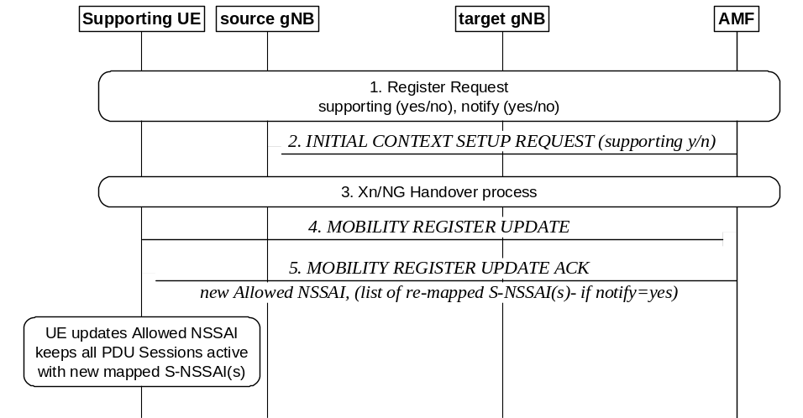

One contribution [9] provide modification proposal for this section, the detail is shown as below
The solutions to support scenarios 2, 4 are recommended by RAN3 to be specified in normative phase:
- Slice level slice remapping is specified
- Slice remapping policy is provided by CN
- Slice remapping decision in target gNB at Xn based handover
- Slice remapping decision in 5GC at NG based handover
One contribution [10] provide modification proposal for this section, the detail is shown as below
Conclusions on Solutions for Scenarios 2, 4:
For solutions addressing scenario 2/4, the 6.2.1.1.1 (Policy configured by OAM) may be further refined at the normative phase.
For the rest solutions, RAN3 is not able to make any recommendations during the Study Item.

One contribution [11] provide modification proposal for this section, the detail is shown as below
RAN3 has analysed solutions to Scenarios 2 and 4 after receiving feedback from SA2.
RAN3 concludes that scenarios 2 and 4 concern a situation of sub-optimal slice coverage planning, that can be resolved by slice coverage optimisation hence these scenarios should not be pursued in normative work.
RAN3 concluded that the solutions addressing scenarios 2 and 4 are not deemed feasible due to their impact on CN and UE.

One contribution [12] provide modification proposal for this section, the detail is shown as below
The following solutions to support Scenario 2 and 4 are recommended by RAN3 to be specified in normative phase:
- Solution 6.2.1.1.3 (Slice Re-mapping policy configured by CN (during PDU session setup)),
- Solution 6.2.4 (Slice Remapping decision in 5GC).
The following enhancements will be also progressed in the normative phase based on feedback from SA2 and CT1:
- New intra-CN procedure to change the slice for an ongoing PDU session,
- New NAS signaling with the UE in order to associate an ongoing PDU Session to a new S-NSSAI.
One contribution [15] provide a proposal :
solution 6.2.1 is recommended in normative phase.

Based on above analysis:
For solutions without including CN slice remapping:
1 company [3] thinks no recommendations on solutions to support scenario 2 and 4.
6 company [8] [9] [10] [12] [15] think to select one or all of the solutions of section 6.2.1 (e.g 6.2.1.1.1, 6.2.1.1.3 ) into normative stage. Final selection among the solutions in 6.2.1 can take place in the work item phase.
1 companies [11] thinks the scenario is not feasible.

Q11: For scenario 2,4 , Please provide other view for solution recommended in normative phase.
Company | solutions | Comment
Nokia | Solution 6.2.1.1.1 | If not agreeable, we can decide 6.2.1 only now and refine among 6.2.1 during WID phase.
Huawei | 6.2.1.1.1 (Policy configured by OAM) | It can be further refined during the normative phase.
LGE | Solution 6.2.1.1.3 and Solution 6.2.4 | As in R3-212402, we think that the re-mapping policy needs to be related to UE-specific information. In Solutions 6.2.1.1.3 and 6.2.4, the CN can take into account the UE subscription information (e.g., Subscribed S-NSSAIs) to properly determine the re-mapping policy
CMCC | Solutions in 6.2.1 | Our observation is that solutions in 6.2.1 can cover all scenarios 1-6, and we prefer to recommend a solution which can solve all valid scenarios. Note that SA2 LS has clearly indicated that scenarios 1-6 are all valid scenarios.
CATT | Selected Solution in 6.2.1.1.1/2 | We don’t need specify all the solutions in 6.2.1. We may select the basic and simple slice remapping solution  Such as 6.2.1.1.1/2 slice remapping policy provided by CN or OAM in slice level.
Qualcomm | none | If we apply 6.2.1, we now have to interpret it (see discussion on scenario1,3 etc) as actually impacting the CN (i.e. contradicting statements in the previous items). Then to be consistent, we have to admit that this is not feasible in rel-17. Note validity of scenarios is completely different from validity of solutions. There are no solutions for scenarios 2,4 that do not require end-to-end solution impacting SA2, CT1 etc etc.
Samsung | Solution in 6.2.1.1.3 or solution 6.2.1 | Scenario 2 and 4 is the initial reason why we need RAN slicing enhancement to support service continuity, it’s the real network problem that operators need to solve (as I remember the use cases brought by operators from the first RAN slicing meeting)  So we propose RAN3 should address scenario 2 and 4 in R17.  To address scenario 2 and 4, it seems that slice re-mapping is the only way. Considering slice is an end to end logical network, the impact on CN/UE cannot be avoided to address scenario 2 and 4. On the other hand, slice re-mapping decision should be made by RAN, so that the RAN can consider both the load and policy to make the best decision.  So we propose at least solution 6.2.1 is recommended in normative phase.  Regarding the different policies in 6.2.1, at least we need to evaluate which one is better, which one have the real less impact on CN/UE. We don't think RAN can perform slice re-mapping without CN involvement, and we don’t think policy configured by OAM (6.2.1.1.1) has less CN/UE impact than policy provided by CN (6.2.1.1.3). On face of the policy configured by OAM, it seems no impact on CN as the policy generation has no CN involvement, however, that’s also the drawbacks of policy configured by OAM 6.2.1.1.1 as follows:  - The selected re-mapped slice may be not aligned with UE subscription information  - The selected re-mapped slice may not provide the best performance without knowing the QoS requirement  - The selected re-mapped slice has not the same slice instances as the original one in CN, which may lead to more implementation effort in CN.  Conversely, 6.2.1.1.3 policy provided by CN will have the best re-mapped slice decision, the best performance and less implementation impact on CN/UE with considering the UE subscription information, QoS requirement and the instance configuration in CN, etc.  So we propose RAN3 to further evaluate the policies in solution 6.2.1 in normative phase.
ZTE | Solutions in 6.2.1 | Actually , due to limited time, SA2 does not provide detail evaluate on any solution in 6.2.1. In the LS, SA2 clearly say “RAN3 is encouraged to find alternative solutions without or limiting such impacts. Any further progress in RAN3 for CN and UE impacting solutions would need to be coordinated with SA2”. Which means SA2 is going to evaluate the impact to CN and UE if receive confirmed solution. Therefore, solution in 6.2.1 can be good start to be updated in normative stage.
Ericsson | None | Agree with Qualcomm. SA2 has NOT stated that solutions to scenarios 2 and 4 are feasible. SA2 has stated that these solutions incur in considerable UE and CN impacts, that they should be discouraged and that a study is needed to check their feasibility. Hence RAN3 shall not move these solutions to normative phase because there are no aspects of these solutions that can be confirmed to be added in our specs.

7 companies support one or all solution(s) in 6.2.1 into normative stage. However, SA2 does not acknowledge whether or not to accept the CN/UE impact of any solutions in 6.2.1. The refine work can be continue in normative stage.
Conclusion: The following solution is expected to be refined during normative phase, involvement of SA2 is necessary:
- Re-mapping decision in NG-RAN node

Ericsson Comment: please consider our sustained objection above. We cannot agree to this conclusion

Views on LS ( Comments can be provided at 2nd round discussion )

Response to SA5
An draft LS[5] was prepared for SA5 ,
RAN3 thanks SA2 for the LS reply on enhancement of RAN slicing.
RAN3 took the replies from SA5 into account and concluded that the existing SA5 specifications are sufficient to support the “Configuration Based Solution” in section 6.2.3.1 of TR 38.832 v1.0.0 and the “Slice resource re-partitioning” solution in section 6.2.3.2 of TR38.832 v1.0.0.
RAN3 will inform SA5 of any OAM requirements that may result from the work on Enhancements of RAN slicing.

Q1: Please provide your view on the LS.
Company | Approach | Comment
Nokia | No LS | There seems no need to liaise again SA5 at this stage before the WID phase. We can contact SA5 further in WID phase.
Huawei |  | No need. We can contact them during WI phase
LGE |  | Same view with Nokia, Huawei
CMCC |  | We can decide whether to send LS after we achieve the final conclusion for this SI.
CATT |  | Same view with Nokia, Huawei
Qualcomm | No LS | As other companies
ZTE |  | Share the view with majority.
Ericsson | OK | We support sending this LS to clarify to SA5 that for the time being new work is not needed.

Conclusion: Based on majorities view, the LS is not needed for this meeting.

Response to SA2
An draft LS[6] was prepared for SA2,
RAN3 thanks SA2 for their reply LS on LS Enhancement of RAN Slicing.
RAN3 has taken SA2’s evaluations into account and it has drawn the following conclusions with respect to solutions developed during the SI on Enhancements of RAN Slicing.
The following solutions were concluded to be feasible after receiving SA2 and SA5 feedback:
- Configuration based Solution (section 6.2.3.1 of TR38.832)
- Slice resource re-partitioning (section 6.2.3.2 of TR38.832)
- Multi-carrier radio resource sharing (section 6.2.3.3 of TR38.832)
RAN3 concluded that scenarios 2 and 4 in TR38.832 concern a situation of sub-optimal slice coverage planning, that can be resolved by slice coverage optimisation hence these scenarios should not be pursued in normative work.
RAN3 concluded that the solutions addressing scenarios 2 and 4 are not deemed feasible due to their impact on CN and UE.
Full conclusions and solutions details are captured in TR38.832

Q1: Please provide your view on the LS.
Company | Approach | Comment
Nokia | NOK | Solutions 6.2.1.1.1 need to be further investigated in normative phase before drawing any conclusion.
Huawei |  | No need. We can contact them during WI phase.
LGE |  | Same view with Huawei
CMCC |  | We can decide whether to send LS after we achieve the final conclusion for this SI.
CATT |  | Same view with Huawei
Qualcomm | Could be ok | Agree with CMCC, this might be considered as SA2 indicated already several times they want to know what we are going to do.
ZTE |  | Share the view as Nokia.
Ericsson | OK | SA2 requested RAN3 to report progress. We should at least inform SA2 of the outcomes of the solutions evaluation and selection

Conclusion: Based on majorities view, the LS is not needed for this meeting.

Any other stuff?
Please provide your view on the Proposal.
Company | Yes/no/other view | Comment
Nokia | LS in 1654 | We have prepared an LS in annex of 1654 to inform SA2 that we will continue with their support to investigate solutions in 6.2.1 during normative phase and we need as minimum impact for prerequisite that UE can signal their “remapping supporting” capability.
Qualcomm | No for the LS in 1654 | We can consider an LS to SA2 as discussed above, the contents can be discussed. This particular aspect however may not be part of it (depends on discussions) and already assumes too much, and it misses out an elephant in the room: that the procedures for “supporting UEs” would change, and such change propagates around several CN functions.
ZTE | Probably needed | We notice SA2 also have meeting this week, a quick interactive between may benefit the solution decision of scenario 2/4>

Conclusion: The LS in R3-211654 depends whether solution 6.2.1 can be adopted for normative stage.

Conclusion, Recommendations [if needed]
If needed

References
- R3-211452 Reply LS on feedback on RAN WG3 service continuity solutions (SA2)
- R3-211469 Response to LS Reply LS on Enhancement of RAN Slicing (3GPP SA5)
- R3-211633 Impact of SA5 feedback on Enhancement of RAN Slicing Slice Shortage solution (Nokia, Nokia Shanghai Bell)
- R3-212302 Discussion on Slice Resource Remapping solutions (Ericsson)
- R3-212303 Response to LS Reply on Enhancement of RAN Slicing (Ericsson)
- R3-212317 Reply LS on feedback on RAN WG3 service continuity solutions (Ericsson)
- R3-211624 (TP for TR38.832) Revised evaluation and conclusions (Qualcomm Incorporated)
- R3-211654 Down-selection of Solutions for Slice not supported at target (Nokia, Nokia Shanghai Bell)
- R3-211842 Discussion on Solutions Evaluation and Conclusions (CATT)
- R3-211902 Final evaluation and conclusions of slicing service continuity (Huawei)
- R3-212070 Conclusions on Enhancements for RAN Slicing (Ericsson)
- R3-212402 Conclusion update on solutions for Scenarios 2 and 4 (LG Electronics Inc.)
- R3-212501 Solution down-selection and conclusion for service continuity (CMCC)
- R3-212574 Further consideration on RAN slicing (ZTE, China Telecom ,Lenovo, Motorola Mobility,China Unicom)
- R3-212575 (TP for BL CR for TR 38.832) RAN Slicing (ZTE, China Telecom,Lenovo, Motorola Mobility,China Unicom)
- R3-212420 Discussion on down-selection for RAN slicing enhancement (Samsung, ZTE)

