3GPP TSG-RAN WG3#112-e R3-21xxxx
E-Meeting, 17 – 27 May 2021

Title: [DRAFT] LS on IAB resource multiplexing
Response to:
Release: Release 17
Work Item: NR_IAB_enh-Core

Source: RAN3
To: RAN1
Cc:

Contact person: Yuanping Zhu
zhuyuanping@huawei.com

Send any reply LS to: 3GPP Liaisons Coordinator, mailto:3GPPLiaison@etsi.org

Attachments: None

1. Overall Description
RAN3 discussed the inter-donor resource multiplexing, and agreed to consider the following two scenarios for Rel-17 IAB:
- Scenario 1: Inter-donor migration/RLF recovery for single connected IAB-node
- Scenario 2: Inter-donor topology redundancy for dual-connected IAB-node

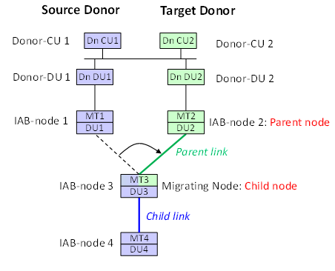
- Scenario 1
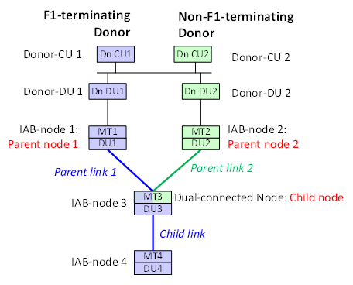
- Scenario 2

In scenario 1, for the resource multiplexing of IAB-node 3 (i.e. the boundary node), some kinds of coordination may be needed between the resource for its parent link and the child link. Similarly, in scenario 2, resource coordination may be necessary among the parent link 1, parent link 2, and child link for the IAB-node 3 (i.e. the boundary node).
For scenario 1, RAN3 considers the following solutions (other solutions are not precluded) for the resource coordination between the parent link and the child link:
- Option 1: The child node’s gNB-DU cell resource configuration is matched to the parent node’s gNB-DU’s resource configuration.
- Option 2: The parent node’s gNB-DU resource configuration is matched to the child node’s gNB-DU’s resource configuration.
- Option 3: A boundary node should connect only to a new parent with which it has a non-conflicting TDD and H/S/NA pattern beforehand.
For Scenario 2, RAN3 considers the following solutions (other solutions are not precluded) for the coordination between two parent links:
- Option 1: The gNB-DU cell resource configuration of the parent node controlled by the F1-terminating donor of the boundary node, is matched to another parent’s gNB-DU’s resource configuration.
- Option 2: The gNB-DU cell resource configuration of the parent node controlled by the non-F1-terminating donor of the boundary node, is matched to another parent’s gNB-DU’s resource configuration.
- Option 3: The secondary leg of a boundary node is established only towards a secondary parent whose H/S/NA configuration is compatible with the H/S/NA configuration of the master parent beforehand.
Furthermore, RAN3 has the following related agreements:
- The IAB-DU’s resource configuration can be provided by the F1-terminating donor. This also applies if child and parent DUs connect to different donors.
- The non-F1-terminating donor of the boundary node should be aware of the boundary node’s multiplexing info and the boundary IAB-DU’s activated cell list.
- The F1-terminating donor of the boundary node forwards the boundary IAB node’s multiplexing info and the boundary IAB-DU’s activated cell list to the non-F1-terminating donor.
- The parent node, which is controlled by the non-F1 terminating donor of the boundary IAB node, should also be aware of the boundary IAB-DU’s cell configurations.
- The content of the boundary IAB-DU’s cell configurations to be sent to its parent node should include: H/S/NA resource configurations, DL/UL resource configurations, the multiplexing info, and cell specific signal/channel configurations of boundary IAB-DU’s cells.
RAN3 assumes that the inter-donor resource multiplexing should be handled by RAN1 first, and then RAN3 design some signalling to achieve such coordination accordingly. So RAN3 would like to ask RAN1 to discuss solutions for such issue first, and inform RAN3 about the outcome.

2. Actions
To RAN1 group:
ACTION: RAN3 respectfully asks RAN1 to take the above into account and to inform RAN3 about the outcome of the discussion on inter-donor resource multiplexing.

3. Dates of Next TSG-RAN3 Meetings
3GPP RAN3#113-e 16 – 26 August 2021 Electronic Meeting
3GPP RAN3#114-e 2 – 12 November 2021 Electronic Meeting

