3GPP TSG-RAN WG3 Meeting #112e R3-212960
Online, 17 - 28 May 2021

Agenda item: 10.2.6
Source: Lenovo, Motorola Mobility
Title: Update of Way forward on Scenarios for SON enhancements for CHO and DAPS HO
Document for: Discussion and Decision

1 Introduction
This paper tries to capture the scenarios for SON enhancements for CHO and DAPS handover according to contributions and discussion [3] [4].

2 Scenarios for MRO of CHO

2.1 Potential scenarios for too late CHO
Figure 1 Potential cases for too late CHO [1]
As shown in the Fig 1 [1], the potential scenarios for too late CHO may include the following cases:
Case 1: the UE receives CHO configuration; an RLF occurs in the cell before CHO execution; the UE attempts to re-establish the radio link connection in a cell other than the source cell.
Case 2: the UE receives CHO configuration; an RLF occurs in the cell before CHO execution; the UE attempts to CHO recovery in a CHO candidate cell.
Case 3: the UE receives CHO configuration; an RLF occurs in the cell before CHO execution; the UE attempts to CHO recovery to a CHO candidate cell but fails; the UE attempts to re-establish the radio link connection in a cell other than the source cell.
Case 4: the UE receives CHO configuration; an RLF occurs in the cell before CHO execution; the UE attempts to CHO recovery to a CHO candidate cell but fails; the UE attempts to re-establish the radio link connection in the source cell.
Case 5: the UE receives CHO configuration; an RLF occurs in the cell before CHO execution; the UE attempts to CHO recovery to a CHO candidate cell and successes; the UE occurs an RLF in a short period after CHO recovery; the UE attempts to re-establish the radio link connection in a cell other than the source cell.
Case 6: the UE receives CHO configuration; an RLF occurs in the cell before CHO execution; the UE attempts to CHO recovery to a CHO candidate cell and successes; the UE occurs an RLF in a short period after CHO recovery; the UE attempts to re-establish the radio link connection in the source cell
Conclusion until RAN3#111e:
- For too late CHO, case 1, 2 and 3 will be considered, and case 4 and 6 will not be considered. FFS on case 5.

2.2 Potential scenarios for too early CHO
Figure 2 Potential scenarios for too early CHO
In a summary, the potential scenarios for too early CHO may include the following cases:
Case 1: the UE receives CHO configuration; the CHO execution fails; the UE attempts to re-establish the radio link connection in the source cell.
Case 2: the UE receives CHO configuration; the CHO execution successes; an RLF occurs shortly after the successful CHO; the UE attempts to re-establish the radio link connection in the source cell.
Case 3: the UE receives CHO configuration; an legacy handover is performed but fails; the UE attempts to re-establish the radio link connection in source cell.
Case 4: the UE receives CHO configuration; a legacy handover is performed and successes; an RLF occurs shortly after the successful legacy handover; the UE attempts to re-establish the radio link connection in the source cell.
Conclusion until RAN3#111e:
- For too early CHO, case 1 and 2 will be considered. FFS on case 3 and 4.
Conclusion in RAN3#112e:
- For too early CHO, case 3 and case 4 will not be considered.

2.3 Potential scenarios for CHO to wrong cell
Figure 3 Potential scenarios for CHO to wrong cell
In a summary, the potential scenarios for CHO to wrong cell may include the following cases:
Case 1: the UE receives CHO configuration; the CHO execution fails; the UE attempts to re-establish the radio link connection in a cell other than the source cell and the previously selected target cells.
Case 2: the UE receives CHO configuration; the CHO execution fails; the UE successfully performs CHO recovery in another CHO candidate cell.
Case 3: the UE receives CHO configuration; the CHO execution fails; the UE attempts to CHO recovery to a CHO candidate cell but fails; the UE attempts to re-establish the radio link connection in a cell other than the source cell and the previously selected target cells.
Case 4: the UE receives CHO configuration; the CHO execution fails; the UE attempts to CHO recovery to a CHO candidate cell and successes; a RLF occurs shortly after CHO recovery; the UE attempts to re-establish the radio link connection in a cell other than the source cell and the previously selected target cells.
Case 5: the UE receives CHO configuration; the CHO execution successes; a RLF occurs shortly after the successful CHO; the UE attempts to re-establish the radio link connection in a cell other than the source cell and the previously selected target cells.
Conclusion until RAN3#111e:
- For CHO to wrong cell, case 1-5 will be considered.

2.4 Potential scenarios for mixed HO/CHO to wrong cell
Figure 4 Potential scenarios for mixed HO/CHO to wrong cell
Considering the mixed scenarios of legacy HO and CHO, there are another potential 5 cases in figure 4, which may also be considered as CHO/HO to wrong cell failure type and included in stage2 definition and detection mechanisms.
Case 6: the UE receives CHO configuration; a legacy handover is performed but fails; the UE attempts to re-establish the radio link connection in a cell other than the source cell and the CHO candidate cells.
Case 7: the UE receives CHO configuration; a legacy handover is performed but fails; the UE successfully performs CHO recovery in a CHO candidate cell.
Case 8: the UE receives CHO configuration; a legacy handover is performed but fails; the UE attempts to CHO recovery to a CHO candidate cell but fails; the UE attempts to re-establish the radio link connection in a cell other than the source cell and the previously selected target cells..
Case 9: the UE receives CHO configuration; a legacy handover is performed but fails; the UE attempts to CHO recovery to a CHO candidate cell and successes; a RLF occurs shortly after CHO recovery; the UE attempts to re-establish the radio link connection in a cell other than the source cell and the previously selected target cells.
Case 10: the UE receives CHO configuration; a legacy handover is performed and successes;; a RLF occurs shortly after the successful legacy HO; the UE attempts to re-establish the radio link connection in a cell other than the source cell and the previously selected target cells.
Conclusion until RAN3#111e:
- It is FFS whether the cases for mixed HO/CHO to wrong cell should be deprioritized.
Conclusion in RAN3#112e:
- For mixed HO/CHO to wrong cell, case 6-10 are deprioritized.

3 Scenarios for SON of DAPS HO
In [2], Fig. 5 gives the possible failure events during the DAPS handover procedure.
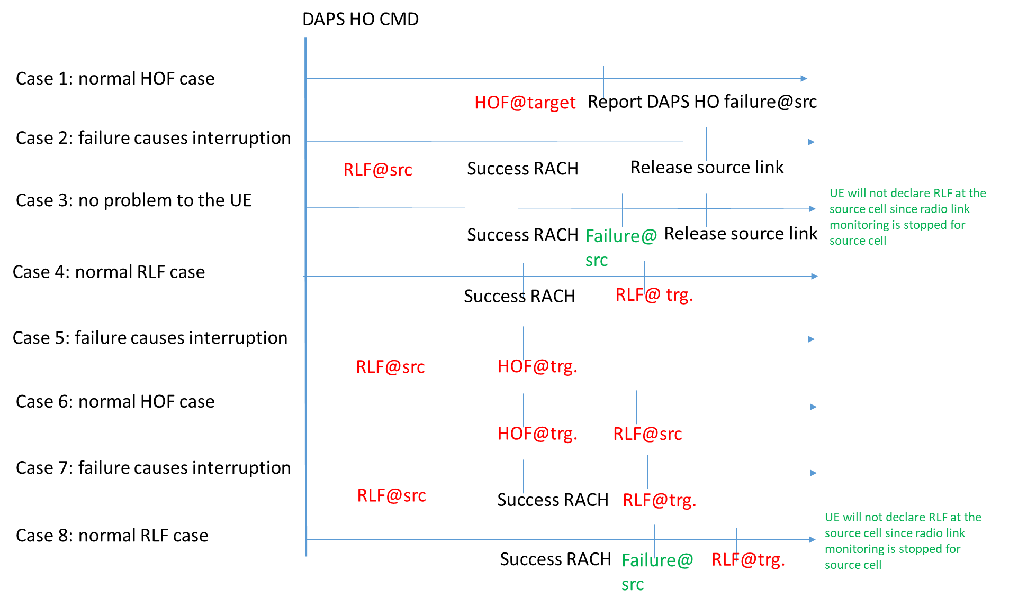
Figure 5. Potential cases for SON of DAPS HO
Besides the above eight cases, two additional cases are proposed:
Case 9: Mixed scenario of case 1 and case 6, i.e. HOF@Target->report DAPS HO failure@src->RLF@src;
Case 10: RLF@src before/after successful RACH in a DASP HO procedure after a successful normal HO.
Case 11: Successful DAPS handover without source RLF.
Conclusion until RAN3#111e:
- Consider DAPS handover failure cases 1, 2, 4, 5, 6, and 7 for further study.
- It is FFS whether case 3 and case 8 are deprioritized.
- It is FFS on whether case 9, case 10, case 11 should be considered in MRO for DAPS handover.
Conclusion in RAN3#112e:
- For failure cases in DAPS HO, case 10 will not be considered.
- For failure cases in DAPS HO, case 11 will not be considered as a failure case, but a case of successful HO.
- The case of ‘a legacy HO is executed though the UE is configured with DAPS HO configuration’ will not be considered in the scope of MRO.

Reference
- R3-210291 Discussion on MRO for CHO mobility enhance (CATT)
- R3-205998 Discussion on SON enhancements for DAPS handover (Samsung)
- R3-212158, SON Enhancements for CHO, Lenovo, Motorola Mobility
- R3-212160, SON Enhancements for DAPS Handover, Lenovo, Motorola Mobility

Annex
Agreements in RAN3#111e
- For too late CHO, case 1, 2 and 3 will be considered, and case 4 and 6 will not be considered. FFS on case 5.
- For too early CHO, case 1 and 2 will be considered. FFS on case 3 and 4.
- For CHO to wrong cell, case 1-5 will be considered.
- Resource optimization for CHO is deprioritized.
- Data forwarding enhancements for CHO is deprioritized.

Agreements in RAN3#110e
- Cover CHO failure scenarios; whether to define CHO specific failure types or reuse the existing failure types with some necessary update is FFS.
- Consider DAPS handover failure cases 1, 2, 4, 5, 6, and 7 for further study. It is FFS on case 3 and case 8.
- UE reports DAPS HO Failure Indication to Network (LS to RAN2).
- Data forwarding enhancements on HO to wrong cell is de-prioritized in this WI
- Resource optimization for Conditional Handover is FFS
- CHO recovery procedure is considered in the definition of failure types and/or failure types detection.
- At least the following CHO failure scenarios need to be considered: Too Late CHO Execution, Too early CHO Execution, and CHO to Wrong Cell. FFS on how CHO recovery applies to legacy HOs. FFS on other failure scenarios.
- UE reports the time elapsed since CHO execution until connection failure to network (LS to RAN2).
- the source node needs to know the candidate cell list and CHO execution condition(s). It is FFS on how the source node knows these information
- if UE has experienced failure twice, UE reports information related with the two failures (LS to RAN2 for confirmation).
- Try to capture DAPS handover failure cases as part of current definitions of handover failure types first. If not feasible, define a set of specific DAPS handover failure types.

Agreements in RAN3#109e

Scope:
- SON Enhancements for CHO (i.e MRO for CHO) will be supported.
- SON Enhancements for DAPS handover will be supported.
- Postpone SON Enhancements for CPC with waiting for the progress of R17 CPC enhancements and SON enhancements for CHO. It is FFS whether SON enhancements for conditional PSCell change should be supported.
- Study resource optimization for CHO, based on contributions
- Decide if the problem of data forwarding in case of a HO to wrong cell is part of the SON WI (SON for Mobility Enhancements) or is to be treated as TEI-17.

MRO for CHO:
- FFS whether CHO specific failure types are needed. The existing definitions of too late handover /too early handover/ handover to wrong cell are the starting point for further study.
- From RAN3 point of view, in order to support MRO for CHO, more information is needed from UE. (FFS on the details).
- Study the contents of the RLF INDICATION or HANDOVER REPORT message to support MRO enhancements for CHO. In order to progress in this area it is necessary to converge on the CHO failure case definition.

SON Enhancements for DAPS handover:
- Reporting of failure information of the source link from UE may be needed for DAPS handover (FFS: Need further discussion).
- From RAN3 point of view, in order to support SON enhancements for DAPS handover, more information is needed from UE. (FFS on the details).
- Study the contents of the RLF INDICATION or HANDOVER REPORT message for the failure scenarios in DAPS HO. In order to progress in this area it is necessary to converge on the DAPS failure case definition.

