3GPP TSG-RAN WG3 Meeting #110-e R3-211055
Online, 25th January – 5th February 2020

Agenda Item: 9.2.2
Source: ZTE
Title: Summary of Discussion for DRXinfo_delivery_inactive
Document for: Discussion, Decision

Introduction
CB: # 85_DRXinfo_delivery_inactive
- further check usage
- RAN node should make calculation itself?
- all options should be supported by signaling
- check details
(ZTE - moderator)

For the Chairman’s Notes
[To be added]

Discussion
Based on the TS 36.304[1] description, for UE in RRC_INACTIVE:
- if extended DRX is not configured, the DRX cycle(T) is determined by the shortest of the RAN paging cycle, the UE specific paging cycle, if allocated by upper layers and the default paging cycle.
- if the extended DRX is configured: DRX cycle (T) is determined by the shortest of the RAN paging cycle, the UE specific paging cycle, if allocated by upper layers and the default paging cycle during the PTW, and DRX cycle (T) is determined by the RAN paging cycle outside the PTW.
7.1 Discontinuous Reception for paging
//SKIP THE UNRELATED PART//
The following Parameters are used for the calculation of the PF, i_s, PNB, and the NB-IoT paging carrier:
- T: DRX cycle of the UE.
Except for NB-IoT: If a UE specific extended DRX value of 512 radio frames is configured by upper layers according to 7.3, T =512. Otherwise, T is determined by the shortest of the UE specific DRX value, if allocated by upper layers, and a default DRX value broadcast in system information. If UE specific DRX is not configured by upper layers, the default value is applied. In RRC_INACTIVE state, if extended DRX is not configured by upper layers as defined in 7.3, T is determined by the shortest of the RAN paging cycle, the UE specific paging cycle, if allocated by upper layers and the default paging cycle. Otherwise, in RRC_INACTIVE state when extended DRX is configured by upper layers, T is determined by the shortest of the RAN paging cycle, the UE specific paging cycle, if allocated by upper layers and the default paging cycle during the PTW as defined in 7.3, and by the RAN paging cycle outside the PTW.
//SKIP THE UNRELATED PART//

Thus, for UE in RRC_INACTIVE:
- Case 1: if extended DRX is not configured, UE monitors paging with a same DRX cycle (T). e.g. the DRX cycle(T) = the shortest of (the RAN paging cycle, the UE specific DRX value, if allocated by upper layers, and the default paging cycle), as is shown in Fig 1, in which, RAN paging cycle = rf512; UE specific paging cycle= rf128; default paging cycle=rf256, so, the DRX cycle (T) = rf128.
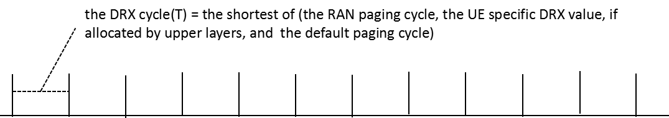
Fig 1. DRX cycle (T) for case 1

- Case 2: if extended DRX is configured, and the RAN paging cycle is less than or equal to the UE specific paging cycle, or the UE specific paging cycle is not allocated by upper layers, the UE will monitor paging with different DRX cycle(T) value during the PTW or outside the PTW. e.g. in Fig 2, the RAN paging cycle =rf512, the default paging cycle=rf256:
  - during the PTW, DRX cycle(T) =the minimum of (the RAN paging cycle, the default paging cycle)=rf256.
  - outside the PTW, DRX cycle(T) =the RAN paging cycle=rf512.
And since the value range of RAN paging cycle is [rf32, rf64, rf128, rf256, rf512, rf1024], the value range of the default paging cycle are is [rf32, rf64, rf128, rf256], it is possible that the RAN paging cycle is larger than the default paging cycle.
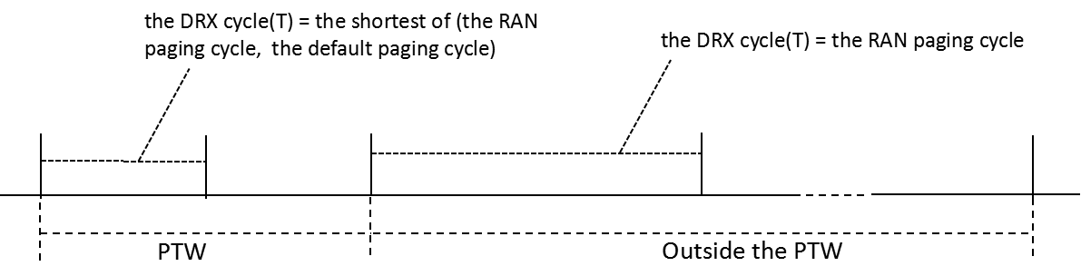
Fig 2. DRX cycle (T) for case 2
- Case 3:if extended DRX is configured, the UE specific paging cycle is allocated by upper layers and the RAN paging cycle is larger than the minimum of (the UE specific paging cycle, the default paging cycle), the UE will monitor paging with different DRX cycle(T) value during the PTW or outside the PTW. e.g. in Fig 3, the RAN paging cycle =rf512, the default paging cycle=rf256, the UE specific paging cycle=rf128:
  - during the PTW, DRX cycle(T) =the minimum of (the RAN paging cycle, the UE specific paging cycle, the default paging cycle) =rf128.
  - outside the PTW, DRX cycle(T) =the RAN paging cycle= rf512.
And since the value range of RAN paging cycle is [rf32, rf64, rf128, rf256, rf512, rf1024], the value range of UE specific paging cycle and the default paging cycle are is [rf32, rf64, rf128, rf256], it is possible that the RAN paging cycle is larger than the minimum of (the UE specific paging cycle, and the default pagingycle).
- 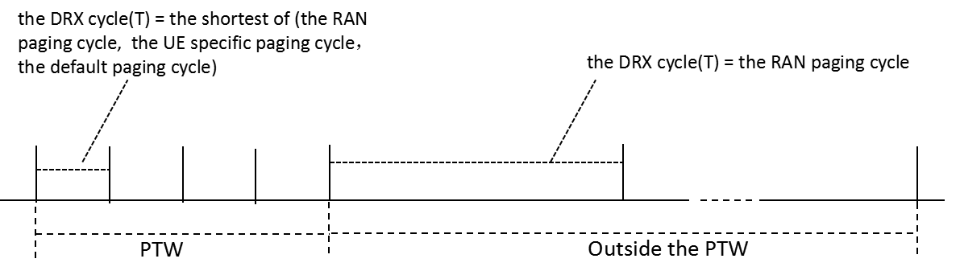
Fig 3. DRX cycle (T) for case 3
Since UE in RRC_INACTIVE can always obtain the Paging eDRX Information, the RAN paging cycle, the UE specific paging cycle, if allocated by upper layers and the default paging cycle, UE can always follows the specification for all the cases above.
In RAN2 specification, only UE behavior is described, eNB should follow the same behavior by default.
Since Paging eDRX Information and UE specific paging cycle can be included in Core Network Assistance Information for RRC INACTIVE IE [2], the anchor ng-eNB can always follows the specification for all the cases above.
But for ng-eNB in the RAN paging area, except the anchor ng-eNB, since only one DRX parameter(e.g. Paging DRX IE) is included in RAN PAGING message[3], it can follow the UE behavior in case 3, e.g. it cannot obtain different DRX cycle(T) value for the UE during the PTW and outside the PTW.
Based on these information[4][5], it is proposed that the RAN paging cycle and Paging eDRX Information IEs are included in the RAN PAGING message of XnAP specification.

Q1: Companies are invited to confirm whether the ng-eNB should follow the same DRX cycle (T) determination rules as UEs for UE in RRC_INACTIVE.
Company | Yes/No | Comments
ZTE | Yes | Since Paging eDRX Information and UE specific paging cycle have already be introduced in Core Network Assistance Information for RRC INACTIVE IE, and they are only used for ng-eNB to determine the DRX cycle(T), the ng-eNB should follow the same DRX cycle(T) determination rules as UEs.  Furthermore, the consistent behavior between UE and ng-eNB can avoid both paging lost and paging delay.  Last, in RAN2 specification, only UE behavior is described, ng-eNB should follow the same behavior by default.
Qualcomm | Yes | Very helpful analysis.

For the case 1 above, companies are invited to confirm how the PAGING DRX IE in RAN PAGING message of XnAP should be set, and if additional information should be provided in the RAN PAGING message.
In this case, the DRX cycle (T) = the shortest of (the RAN paging cycle, the UE specific DRX value, if allocated by upper layers, and the default paging cycle).
Since only a single DRX cycle (T) is used for the UE in RRC_INACTIVE, and only the ng-eNB in the RAN paging area knows its own default paging cycle, the PAGING DRX IE in RAN PAGING message of XnAP should be set to the shortest of (the RAN paging cycle, the UE specific DRX value, if allocated by upper layers).
Q2a: In case of Case 1 above, does company agree that the PAGING DRX IE in RAN PAGING message of XnAP should be set to the shortest of (the RAN paging cycle, the UE specific DRX value, if allocated by upper layers)?
Company | Comment
ZTE | Yes
Qualcomm | Yes – this equates to the legacy behaviour which we should not change

Q2b: In case of Case 1 above, does company agree that additional information should be provided in the RAN PAGING message?
Company | Comment
ZTE | No
Qualcomm | Agree, the existing information is enough

For the case 2 above, companies are invited to confirm how the PAGING DRX IE in RAN PAGING message of XnAP should be set, and if additional information should be provided in the RAN PAGING message.
In this case, although different DRX cycle(T) is used during the PTW and outside the PTW:
- during the PTW, DRX cycle(T) =the minimum of (the RAN paging cycle, the default paging cycle).
- outside the PTW, DRX cycle(T) =the RAN paging cycle.
But only the ng-eNB in the RAN paging area knows its own default paging cycle, the PAGING DRX IE in RAN PAGING message of XnAP should be set to the the RAN paging cycle, and ng-eNB in the RAN paging area can determine the DRX cycle(T) used.
Q3a: In case of Case 2 above, does company agree that the PAGING DRX IE in RAN PAGING message of XnAP should be set to the RAN paging cycle?
Company | Comment
ZTE | Yes.
Qualcomm | Yes – if the RAN paging cycle is less than or equal to the UE specific paging cycle, this is legacy behaviour

Q3b: In case of Case 2 above, does company agree that additional information should be provided in the RAN PAGING message?
Company | Comment
ZTE | Yes.  To determine the PTW position (e.g. during the PTW or outside the PTW) in the ng-eNB in RAN paging area, the paging eDRX information should be provided in the RAN PAGING message.
Qualcomm | Yes, for sure the eDRX information is needed in case there is a default DRX at the target that is lower than the RAN paging cycle etc

For the case 3 above, companies are invited to confirm how the PAGING DRX IE in RAN PAGING message of XnAP should be set, and if additional information should be provided in the RAN PAGING message.
In this case, different DRX cycle(T) are used for UE during the PTW and outside the PTW as follows:
- during the PTW, DRX cycle(T) =the minimum of (the RAN paging cycle, the UE specific paging cycle, the default paging cycle).
- outside the PTW, DRX cycle(T) =the RAN paging cycle.
But only the ng-eNB in the RAN paging area knows its own default paging cycle, the following two DRX related values are necessary for the ng-eNB in the RAN paging area to determine the DRX cycle(T):
- the minimum of (the RAN paging cycle, the UE specific paging cycle), which is used for DRX cycle(T) determination during the PTW.
- the RAN paging cycle, which is used for DRX cycle(T) outside the PTW.
But since only one DRX parameter (e.g. Paging DRX IE) is included in RAN PAGING message.
If the Paging DRX IE in RAN PAGING message is set to the minimum of (the RAN paging cycle, the UE specific paging cycle), and no additional DRX parameters is introduced, the DRX cycle(T) used in ng-NB in RAN paging area will be smaller than that the UE used outside the PTW, thus the RAN PAGING may be lost.
It is shown in the Fig 4, in which:
The RAN paging cycle =rf512, the default paging cycle=rf256, the UE specific paging cycle=rf128. Thus, outside the PTW, the ng-eNB DRX cycle (T)= rf128, the UE DRX cycle (T)= rf512, the the ng-eNB DRX cycle (T) is less than that the UE used outside the PTW, and the RAN PAGING may be lost in some paging occasion(e.g. if ng-eNB paging the UE in the POs marked with red line, the RAN PAGING will be lost).
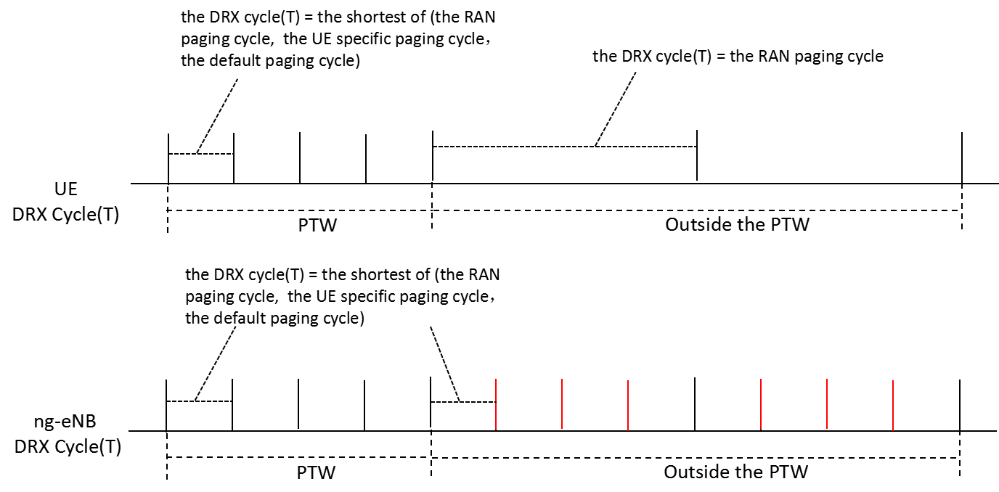
Fig 4
If the Paging DRX IE in RAN PAGING message is set to the the RAN paging cycle, and no additional DRX parameters is introduced, the DRX cycle(T) used in ng-NB in RAN paging area will be larger than that the UE used during the PTW, thus the RAN PAGING may be delayed unnecessary.
It is shown in the Fig 5, in which:
The RAN paging cycle =rf512, the default paging cycle=rf256, the UE specific paging cycle=rf128.
Thus, during the PTW, the ng-eNB DRX cycle (T)= rf512, the UE DRX cycle (T)= rf128, the ng-eNB DRX cycle (T) is larger than that the UE used during the PTW, and the RAN PAGING may be delayed unnecessary(e.g. although UE is monitoring the PAGING in the POs marked with green line, the ng-eNB cannot send RAN PAGING in these POs).
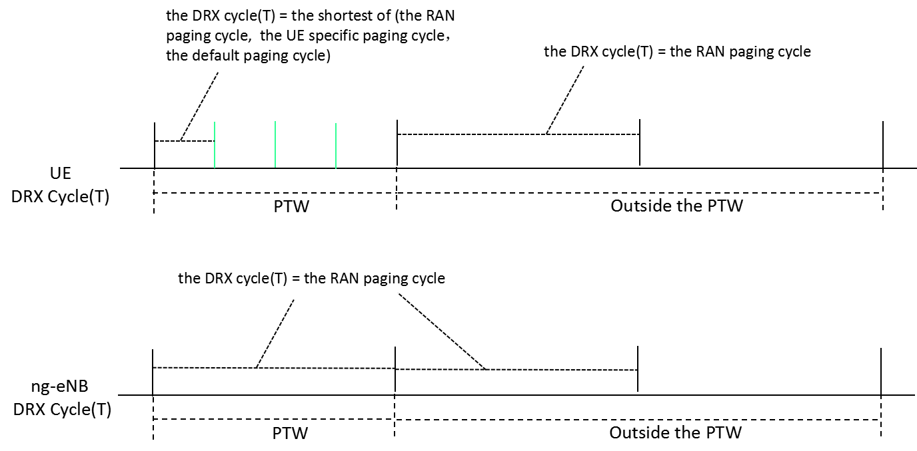
Fig 5.
Q4a: In case of Case 3 above, companies are invited to confirm how the PAGING DRX IE in RAN PAGING message of XnAP should be set.
Company | Comment
ZTE | To keep the same understanding as that for case 1, the PAGING DRX IE in RAN PAGING message of XnAP in this case should be set to the shortest of (the RAN paging cycle, the UE specific DRX value).
Qualcomm | In general for this case information is missing.  The legacy IE however should be interpreted as in legacy i.e. minimum of RAN paging cycle and UE specific DRX. This IE should not change depending on the values, whether eDRX is used etc

Q4b: In case of Case 3 above, does company confirm that the PAGING DRX IE in RAN PAGING message of XnAP should be set to the RAN paging cycle?
Company | Comment
ZTE | Yes.  To determine the PTW position (e.g. during the PTW or outside the PTW) in the ng-eNB in RAN paging area, the paging eDRX information should be provided in the RAN PAGING message.  To align the DRX cycle (T) between UE and ng-eNB in RAN paging area both during the PTW and outside the PTW, one additional DRX parameter (e.g. the RAN paging cycle) should be provided in the RAN PAGING message.  Otherwise, from UE point of view, the RAN PAGING may be missing or delayed
Qualcomm | Yes  With that, we believe a general logical implementation would be to always send the RAN paging cycle with eDRX parameters, and leave the legacy IE as it is (at most we might want to clarify semantics)

Q5: If companies agree that additional information should be provided in the RAN PAGING message, please provide comments for the CR, if any
Company | Comments
ZTE | No comments
Nokia | CR is ok but eDRX is an optional feature. We would like to add a few words to say if supported. With this change we can cosign the CR. I dropped the proposed revision draft_1056 in CB folder.
Qualcomm | No further comments. Would like to thank the moderator for the nice analysis.

Conclusion, Recommendations

References
- 3GPP, TS 36.304, V16.3.0 (2020-12), Evolved Universal Terrestrial Radio Access (E-UTRA); User Equipment (UE) procedures in idle mode
- 3GPP, TS 38.413, V16.4.0 (2020-12), NG-RAN; NG Application Protocol (NGAP)
- 3GPP, TS 38.423, V16.4.0 (2020-12), NG-RAN; Xn application protocol (XnAP)
- R3-210205 Discussion on the UE information delivery for RRC_INACTIVE UE (ZTE, Qualcomm)
- R3-211041 Correction on the DRX information delivery for RRC_INACTIVE UE (ZTE, Qualcomm Incorporated, Ericsson)

