3GPP TSG-RAN WG3 Meeting #110-e R3-211055
Online, 25th January – 5th February 2020

Agenda Item: 9.2.2
Source: ZTE
Title: Summary of Discussion for DRXinfo_delivery_inactive
Document for: Discussion, Decision

Introduction
CB: # 85_DRXinfo_delivery_inactive
- further check usage
- RAN node should make calculation itself?
- all options should be supported by signaling
- check details
(ZTE - moderator)

For the Chairman’s Notes
No consensus on whether the paging node should be (optionally) aware of the eDRX configuration i.e. of the additional POs in the PTW and the understanding of existing IE “Paging DRX IE” in the RAN PAGING message, i.e., either the shortest of (the RAN paging cycle, the UE specific DRX value), or RAN paging cycle. Need to further check. To be continued…

Discussion

First round
Based on the TS 36.304[1] description, for UE in RRC_INACTIVE:
- if extended DRX is not configured, the DRX cycle(T) is determined by the shortest of the RAN paging cycle, the UE specific paging cycle, if allocated by upper layers and the default paging cycle.
- if the extended DRX is configured: DRX cycle (T) is determined by the shortest of the RAN paging cycle, the UE specific paging cycle, if allocated by upper layers and the default paging cycle during the PTW, and DRX cycle (T) is determined by the RAN paging cycle outside the PTW.
7.1 Discontinuous Reception for paging
//SKIP THE UNRELATED PART//
The following Parameters are used for the calculation of the PF, i_s, PNB, and the NB-IoT paging carrier:
- T: DRX cycle of the UE.
Except for NB-IoT: If a UE specific extended DRX value of 512 radio frames is configured by upper layers according to 7.3, T =512. Otherwise, T is determined by the shortest of the UE specific DRX value, if allocated by upper layers, and a default DRX value broadcast in system information. If UE specific DRX is not configured by upper layers, the default value is applied. In RRC_INACTIVE state, if extended DRX is not configured by upper layers as defined in 7.3, T is determined by the shortest of the RAN paging cycle, the UE specific paging cycle, if allocated by upper layers and the default paging cycle. Otherwise, in RRC_INACTIVE state when extended DRX is configured by upper layers, T is determined by the shortest of the RAN paging cycle, the UE specific paging cycle, if allocated by upper layers and the default paging cycle during the PTW as defined in 7.3, and by the RAN paging cycle outside the PTW.
//SKIP THE UNRELATED PART//

Thus, for UE in RRC_INACTIVE:
- Case 1: if extended DRX is not configured, UE monitors paging with a same DRX cycle (T). e.g. the DRX cycle(T) = the shortest of (the RAN paging cycle, the UE specific DRX value, if allocated by upper layers, and the default paging cycle), as is shown in Fig 1, in which, RAN paging cycle = rf512; UE specific paging cycle= rf128; default paging cycle=rf256, so, the DRX cycle (T) = rf128.
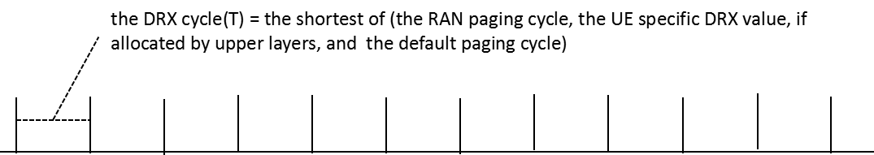
Fig 1. DRX cycle (T) for case 1

- Case 2: if extended DRX is configured, and the RAN paging cycle is less than or equal to the UE specific paging cycle, or the UE specific paging cycle is not allocated by upper layers, the UE will monitor paging with different DRX cycle(T) value during the PTW or outside the PTW. e.g. in Fig 2, the RAN paging cycle =rf512, the default paging cycle=rf256:
  - during the PTW, DRX cycle(T) =the minimum of (the RAN paging cycle, the default paging cycle)=rf256.
  - outside the PTW, DRX cycle(T) =the RAN paging cycle=rf512.
And since the value range of RAN paging cycle is [rf32, rf64, rf128, rf256, rf512, rf1024], the value range of the default paging cycle are is [rf32, rf64, rf128, rf256], it is possible that the RAN paging cycle is larger than the default paging cycle.
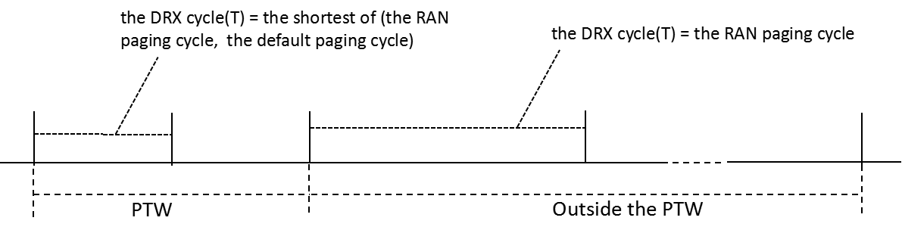
Fig 2. DRX cycle (T) for case 2
- Case 3:if extended DRX is configured, the UE specific paging cycle is allocated by upper layers and the RAN paging cycle is larger than the minimum of (the UE specific paging cycle, the default paging cycle), the UE will monitor paging with different DRX cycle(T) value during the PTW or outside the PTW. e.g. in Fig 3, the RAN paging cycle =rf512, the default paging cycle=rf256, the UE specific paging cycle=rf128:
  - during the PTW, DRX cycle(T) =the minimum of (the RAN paging cycle, the UE specific paging cycle, the default paging cycle) =rf128.
  - outside the PTW, DRX cycle(T) =the RAN paging cycle= rf512.
And since the value range of RAN paging cycle is [rf32, rf64, rf128, rf256, rf512, rf1024], the value range of UE specific paging cycle and the default paging cycle are is [rf32, rf64, rf128, rf256], it is possible that the RAN paging cycle is larger than the minimum of (the UE specific paging cycle, and the default pagingycle).
- 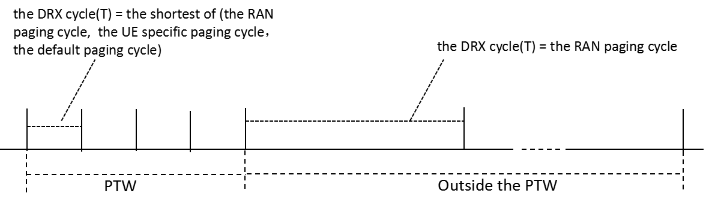
Fig 3. DRX cycle (T) for case 3
Since UE in RRC_INACTIVE can always obtain the Paging eDRX Information, the RAN paging cycle, the UE specific paging cycle, if allocated by upper layers and the default paging cycle, UE can always follows the specification for all the cases above.
In RAN2 specification, only UE behavior is described, eNB should follow the same behavior by default.
Since Paging eDRX Information and UE specific paging cycle can be included in Core Network Assistance Information for RRC INACTIVE IE [2], the anchor ng-eNB can always follows the specification for all the cases above.
But for ng-eNB in the RAN paging area, except the anchor ng-eNB, since only one DRX parameter(e.g. Paging DRX IE) is included in RAN PAGING message[3], it can follow the UE behavior in case 3, e.g. it cannot obtain different DRX cycle(T) value for the UE during the PTW and outside the PTW.
Based on these information[4][5], it is proposed that the RAN paging cycle and Paging eDRX Information IEs are included in the RAN PAGING message of XnAP specification.

Q1: Companies are invited to confirm whether the ng-eNB should follow the same DRX cycle (T) determination rules as UEs for UE in RRC_INACTIVE.
Company | Yes/No | Comments
ZTE | Yes | Since Paging eDRX Information and UE specific paging cycle have already be introduced in Core Network Assistance Information for RRC INACTIVE IE, and they are only used for ng-eNB to determine the DRX cycle(T), the ng-eNB should follow the same DRX cycle(T) determination rules as UEs.  Furthermore, the consistent behavior between UE and ng-eNB can avoid both paging lost and paging delay.  Last, in RAN2 specification, only UE behavior is described, ng-eNB should follow the same behavior by default.
Qualcomm | Yes | Very helpful analysis.
Huawei | No | For ng-eNB, in case CN paging is received, ng-eNBs will page the UE based on CN paging formula, in case of RAN paging, ng-eNB will page the UE based on RAN paging formula. CN paging and RAN paging are never triggered together by the network. RAN nodes do not need to consider CN paging and RAN paging together.  The reason for TS 36.304, is because the UE needs to monitor both CN paging and RAN paging, because in some cases, the UE consider itself as inactive mode, but network actually considered it as idle, e.g. after RAN paging failure the UE is considered as unreachable by the network and the UE context is release in RAN node.  Using your example case 2 and case 3:  For case 1:  - UE monitors paging by using the shortest one, i.e. 128 in this example.  - For CN paging, ng-eNB uses 128, for RAN paging, ng-eNB uses 512, the UE can receive both CN paging and RAN paging.  - For this case, there is no paging missing.  For case 2:  - In case of CN paging, the ng-eNB will only page the UE during the PTW, and use the DRX cycle(T) = 256, UE can receive the paging during the PTW for sure, note that although UE uses 512 outside of the PTW, there is no CN paging outside of the PTW.  - In case of RAN paging, the ng-eNB will page the UE by using RAN paging cycle = 512 and the ng-eNB do not need to take care of the PTW, in such case, UE monitors 512 outside of the PTW, and 256 inside of the PTW, the UE can receive the RAN paging for sure.  - For this case, there is no paging missing.  For case 3:  - In case of CN paging, the ng-eNB will only page the UE during the PTW, and use the DRX cycle(T) = 128, UE can receive the paging during the PTW for sure.  - In case of RAN paging, the ng-eNB will page the UE by using RAN paging cycle = 512 and the ng-eNB do not need to take care of the PTW, in such case, UE monitors 512 outside of the PTW, and 128 inside of the PTW, the UE can receive the RAN paging for sure.  - For this case, there is no paging missing as well.  All in all, CN paging is treated as CN paging by RAN, RAN paging is treated as RAN paging by RAN, RAN node no not need to mix the CN paging and RAN paging handling.
ZTE1 |  | For HW’ comments:  In TS 36.304, only paging DRX cycle(T) is defined, which does not differentiate CN paging DRX cycle(T) and RAN paging DRX cycle(T). So, there is not CN paging formula and RAN paging formula in the specification.  Thus, the main different understanding is: whether the RAN PAGING is always sent with RAN paging cycle configured to UE, or RAN PAGING can be sent with the paging DRX cycle(T) defined in TS36.304.  If RAN PAGING is always sent with RAN paging cycle configured to UE (HW’s opinion), there is no paging missing, but there is paging delay for case 1, case 2 and case 3.  If RAN PAGING can be sent with the paging DRX cycle(T)(majority company’s opinion), there is paging missing for case 3 if the PAGING DRX IE in RAN PAGING is set to the shortest of the RAN paging cycle and the UE specific paging cycle, if UE specific paging cycle is allocated by upper layers.  So, we should firstly confirm whether the RAN PAGING should always be sent with RAN paging cycle configured to UE, or RAN PAGING should be sent with the paging DRX cycle(T).

For the case 1 above, companies are invited to confirm how the PAGING DRX IE in RAN PAGING message of XnAP should be set, and if additional information should be provided in the RAN PAGING message.
In this case, the DRX cycle (T) = the shortest of (the RAN paging cycle, the UE specific DRX value, if allocated by upper layers, and the default paging cycle).
Since only a single DRX cycle (T) is used for the UE in RRC_INACTIVE, and only the ng-eNB in the RAN paging area knows its own default paging cycle, the PAGING DRX IE in RAN PAGING message of XnAP should be set to the shortest of (the RAN paging cycle, the UE specific DRX value, if allocated by upper layers).
Q2a: In case of Case 1 above, does company agree that the PAGING DRX IE in RAN PAGING message of XnAP should be set to the shortest of (the RAN paging cycle, the UE specific DRX value, if allocated by upper layers)?
Company | Comment
ZTE | Yes
Qualcomm | Yes – this equates to the legacy behaviour which we should not change
Huawei | Why? Could be, up to anchor RAN node.  There is no paging missing issue for case 1.  There seems only one requirement in TS23.501:  If the UE supports eDRX in RRC inactive, based on its UE radio capabilities, NG-RAN configures the UE with an eDRX cycle in RRC-INACTIVE up to the value for the UE's idle mode eDRX cycle as provided by the AMF in "RRC Inactive Assistance Information" as defined in clause 5.3.3.2.5 or up to 10.24 seconds (whichever is lower).
ZTE1 | For HW’ comments:  Since there is not usage description for the PAGING DRX IE in RAN PAGING message:  - If it is set to the RAN paging cycle and the UE specific DRX is less than the RAN paging cycle, the RAN PAGING may be delayed unnecessary.  So, it is necessary to clarify the usage for the PAGING DRX IE in the specification.

Q2b: In case of Case 1 above, does company agree that additional information should be provided in the RAN PAGING message?
Company | Comment
ZTE | No
Qualcomm | Agree, the existing information is enough
Huawei | Agree, no additional information needed.

For the case 2 above, companies are invited to confirm how the PAGING DRX IE in RAN PAGING message of XnAP should be set, and if additional information should be provided in the RAN PAGING message.
In this case, although different DRX cycle(T) is used during the PTW and outside the PTW:
- during the PTW, DRX cycle(T) =the minimum of (the RAN paging cycle, the default paging cycle).
- outside the PTW, DRX cycle(T) =the RAN paging cycle.
But only the ng-eNB in the RAN paging area knows its own default paging cycle, the PAGING DRX IE in RAN PAGING message of XnAP should be set to the RAN paging cycle, and ng-eNB in the RAN paging area can determine the DRX cycle(T) used.
Q3a: In case of Case 2 above, does company agree that the PAGING DRX IE in RAN PAGING message of XnAP should be set to the RAN paging cycle?
Company | Comment
ZTE | Yes.
Qualcomm | Yes – if the RAN paging cycle is less than or equal to the UE specific paging cycle, this is legacy behaviour
Huawei | Yes  There is no paging missing issue for case 2, as clarified in Q1.

Q3b: In case of Case 2 above, does company agree that additional information should be provided in the RAN PAGING message?
Company | Comment
ZTE | Yes.  To determine the PTW position (e.g. during the PTW or outside the PTW) in the ng-eNB in RAN paging area, the paging eDRX information should be provided in the RAN PAGING message.
Qualcomm | Yes, for sure the eDRX information is needed in case there is a default DRX at the target that is lower than the RAN paging cycle etc
Huawei | No  There is no paging missing issue for case 2, as clarified in Q1.
ZTE 1 | For HW’ comments:  Yes, there is no paging missing.  But if the paging RAN node sends the RAN PAGING always with RAN paging cycle (e.g. Paging DRX IE) to paging the UE during the PTW, there is paging delay unnecessary.  If paging eDRX information is provided in the RAN PAGING message, the paging RAN node can send the RAN PAGING with the paging DRX cycle(T) during the PTW.

For the case 3 above, companies are invited to confirm how the PAGING DRX IE in RAN PAGING message of XnAP should be set, and if additional information should be provided in the RAN PAGING message.
In this case, different DRX cycle(T) are used for UE during the PTW and outside the PTW as follows:
- during the PTW, DRX cycle(T) =the minimum of (the RAN paging cycle, the UE specific paging cycle, the default paging cycle).
- outside the PTW, DRX cycle(T) =the RAN paging cycle.
But only the ng-eNB in the RAN paging area knows its own default paging cycle, the following two DRX related values are necessary for the ng-eNB in the RAN paging area to determine the DRX cycle(T):
- the minimum of (the RAN paging cycle, the UE specific paging cycle), which is used for DRX cycle(T) determination during the PTW.
- the RAN paging cycle, which is used for DRX cycle(T) outside the PTW.
But since only one DRX parameter (e.g. Paging DRX IE) is included in RAN PAGING message.
If the Paging DRX IE in RAN PAGING message is set to the minimum of (the RAN paging cycle, the UE specific paging cycle), and no additional DRX parameters is introduced, the DRX cycle(T) used in ng-NB in RAN paging area will be smaller than that the UE used outside the PTW, thus the RAN PAGING may be lost.
It is shown in the Fig 4, in which:
The RAN paging cycle =rf512, the default paging cycle=rf256, the UE specific paging cycle=rf128. Thus, outside the PTW, the ng-eNB DRX cycle (T)= rf128, the UE DRX cycle (T)= rf512, the ng-eNB DRX cycle (T) is less than that the UE used outside the PTW, and the RAN PAGING may be lost in some paging occasion(e.g. if ng-eNB paging the UE in the POs marked with red line, the RAN PAGING will be lost).
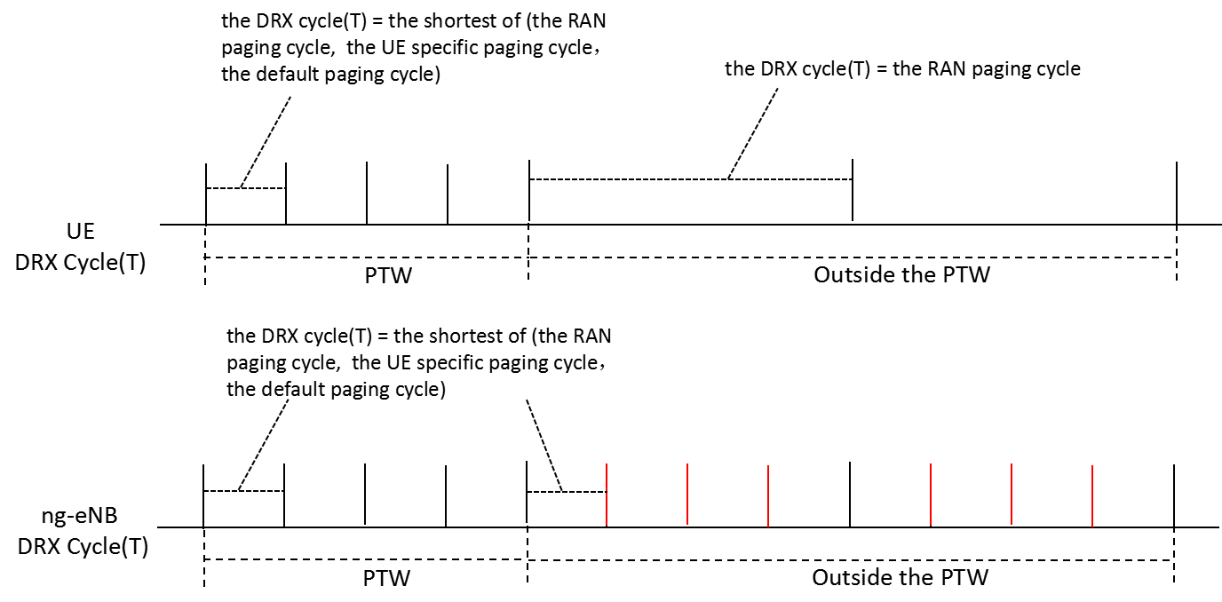
Fig 4
If the Paging DRX IE in RAN PAGING message is set to the RAN paging cycle, and no additional DRX parameters is introduced, the DRX cycle(T) used in ng-NB in RAN paging area will be larger than that the UE used during the PTW, thus the RAN PAGING may be delayed unnecessary.
It is shown in the Fig 5, in which:
The RAN paging cycle =rf512, the default paging cycle=rf256, the UE specific paging cycle=rf128.
Thus, during the PTW, the ng-eNB DRX cycle (T)= rf512, the UE DRX cycle (T)= rf128, the ng-eNB DRX cycle (T) is larger than that the UE used during the PTW, and the RAN PAGING may be delayed unnecessary(e.g. although UE is monitoring the PAGING in the POs marked with green line, the ng-eNB cannot send RAN PAGING in these POs).
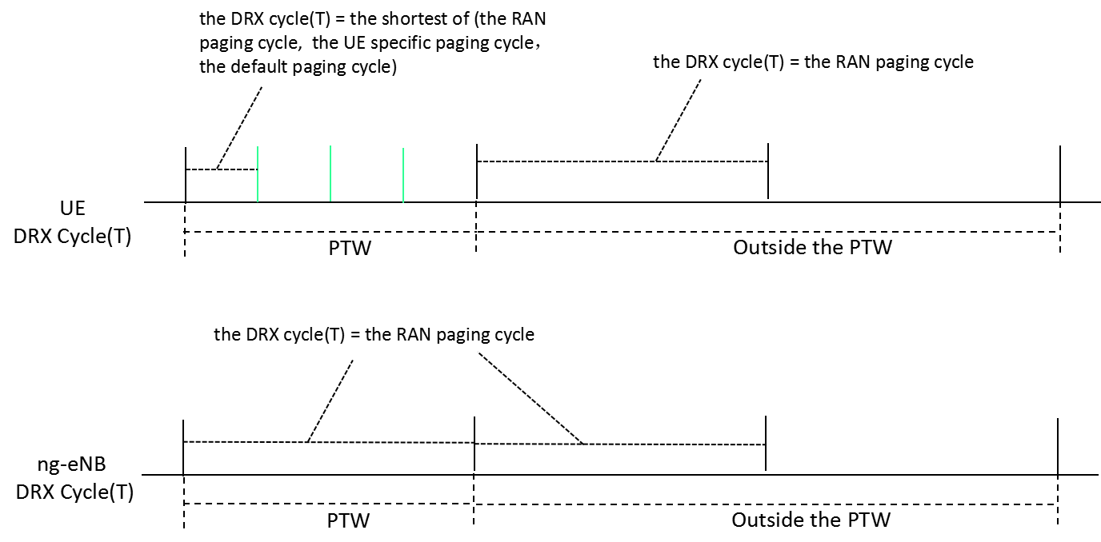
Fig 5.
Q4a: In case of Case 3 above, companies are invited to confirm how the PAGING DRX IE in RAN PAGING message of XnAP should be set.
Company | Comment
ZTE | To keep the same understanding as that for case 1, the PAGING DRX IE in RAN PAGING message of XnAP in this case should be set to the shortest of (the RAN paging cycle, the UE specific DRX value).
Qualcomm | In general for this case information is missing.  The legacy IE however should be interpreted as in legacy i.e. minimum of RAN paging cycle and UE specific DRX. This IE should not change depending on the values, whether eDRX is used etc
Huawei | Disagree with the analyses, outside of the PTW, there is no CN paging, the ng-eNB will follows the RAN paging cycle to page the UE.
ZTE 1 | For HW’ comments:  Since there is not usage description for the Paging DRX IE in RAN PAGING message:  - If it is set to the shortest of the RAN paging cycle and UE specific DRX, and the UE specific DRX is less than the RAN paging cycle, the RAN PAGING may be missing outside the PTW.  - If it is set to the RAN paging cycle, and the UE specific DRX is less than the RAN paging cycle, the RAN PAGING may be delayed unnecessary.  So, it is necessary to clarify the usage for the Paging DRX IE in the specification.

Q4b: In case of Case 3 above, does company confirm that the PAGING DRX IE in RAN PAGING message of XnAP should be set to the RAN paging cycle?
Company | Comment
ZTE | Yes.  To determine the PTW position (e.g. during the PTW or outside the PTW) in the ng-eNB in RAN paging area, the paging eDRX information should be provided in the RAN PAGING message.  To align the DRX cycle (T) between UE and ng-eNB in RAN paging area both during the PTW and outside the PTW, one additional DRX parameter (e.g. the RAN paging cycle) should be provided in the RAN PAGING message.  Otherwise, from UE point of view, the RAN PAGING may be missing or delayed
Qualcomm | Yes  With that, we believe a general logical implementation would be to always send the RAN paging cycle with eDRX parameters, and leave the legacy IE as it is (at most we might want to clarify semantics)
Huawei | The RAN PAGING message carries RAN paging cycle, for sure. How to set the RAN paging cycle is up to RAN node.
ZTE 1 | For HW’ comments:  Yes, if the Paging DRX is set to RAN paging cycle always, there is no paging missing, but the RAN PAGING may be delayed unnecessary during the PTW, if UE specific DRX is less then the RAN paging cycle.

Q5: If companies agree that additional information should be provided in the RAN PAGING message, please provide comments for the CR, if any
Company | Comments
ZTE | No comments
Nokia | CR is ok but eDRX is an optional feature. We would like to add a few words to say if supported. With this change we can cosign the CR. I dropped the proposed revision draft_1056 in CB folder.
Qualcomm | No further comments. Would like to thank the moderator for the nice analysis.
Ericsson | The rapporteur has provided a very detailed explanation and we thank ZTE for their thorough analysis. We agree with all the above technical points.  One comment, as mentioned by Qualcomm, is that semantics clarification is needed to distinguish between the legacy Paging DRX IE and the new RAN Paging Cycle IE, since they have the same IE reference in the RAN PAGING message. We provided a revision on top of Nokia’s version.
Huawei | Do not see the paging missing issue…

Summary:
Four companies think the CR is necessary, and agree to co-sign the CR.
One company thinks the CR is not necessary for no paging issue.

Second round
After first round email discussion, moderator has the following analysis.
The definition of PAGING DRX IE in RAN PAGING message is missing in X2AP specs, so there are two different configuration methods for PAGING DRX IE in RAN PAGING message
Method 1: PAGING DRX IE is always sent with RAN paging cycle configured to UE
Method 2: PAGING DRX IE is allowed to be sent with the shortest of the RAN paging cycle and UE specific DRX,
It is obvious that the method 1 has some drawbacks, e.g.
1) It is possible misaligned between RAN paging transmission by ng-eNB and RAN paging reception by UE during PTW.
2) The anchor ng-eNB and other ng-eNB within RNA may have different behavior when transmitting RAN paging during PTW.
3) It will introduce unnecessary RAN paging latency
But, the method 2 will introduce more normative work than method 1.

Q6: Do you agree with the above analysis?
Company | Yes/No | Comments
ZTE | Yes
Huawei | No | Paging DRX included in the RAN PAGING message, is the RAN Paging cycle, it is obvious, note that this IE is a Mandatory IE does not need to have procedural text.  The different behavior for the UE to monitor paging during and outside of the PTW is intended to do, in order to not miss RAN paging and CN paging.  For this new method 2, with this one, in case RAN paging cycle is 512, UE specific DRX is 256, the neighbor RAN node will page the UE using 256 for RAN paging, but the UE actually monitors 512 outside of the PTW, will lead to paging missing.  For the original proposal, as there is no RAN paging missing, it is not a correction. As an optimization, it seems not worth to do that comparing with the increased RAN node handling complexity.
Qualcomm | Yes | Trying to check the contrary argument, my understanding is that it is thought that in legacy the anchor should set the RAN DRX to be always <= UE specific DRX if it exists, and in that sense the signalled value can be interpreted as the RAN DRX. Therefore, the same interpretation would apply with eDRX, so the DRX outside the PTW would be known (and inside the PTW, if needed, would be the min of this value and default DRX, just like legacy).  So, both methods actually work in all cases, and the key point is whether we can mandate that RAN DRX is always <= UE specific DRX if it exists, else there is interoperability issue.  From an implementation point of view this makes sense, but from a general point of view it does not work because I doubt we can mandate that RAN DRX <= UE specific DRX. So, it seems ok to state that the signalled value is the minimum of the two, even if in practice it is always the RAN DRX.
Ericsson | - | The proposed procedure text in R3-211056 mentions that the NG-RAN node “shall, if supported, use it…” implying, that this feature is mandatory when received and supported by the receiving node.  However, from Huawei’s comments, we guess that if it is indeed an optimization, then there is already an alternative, i.e., NG-RAN can live without such information. We should further check if indeed such information is necessary.

If we can tolerate the drawback in the method 1, then a little normative work is needed, i.e.
The existing IE Paging DRX in RAN PAGING message is defined as “RAN paging cycle configured to UE”.

Q6: Do you accept the method 1 and agree with this change as above?
Company | Yes/No | Comments
ZTE | No/but | We say no to method 1 so far.  But we can follow majority company’s view, then the clarification is necessary.
Huawei | No | Do not see the need to do that.
Qualcomm | ? | This is effectively mandating RAN DRX <= UE specific DRX; otherwise legacy inactive paging is inefficient (POs are missed even in legacy). We acknowledge it could work though, but cannot see how to specify in easy manner (i.e. not the above).
Ericsson | No | If it is the same as legacy functionality, then no need to reinvent the wheel.

If we cannot tolerate the drawback in the method 1 and select method 2, we shall agree with the CR “R3-211056“(revised from R3-211041).
Q7: Do you accept the method 2 and agree with this CR R3-211056?
Company | Yes/No | Comments
ZTE | Yes
Huawei | No | It will lead to RAN paging missing.
Qualcomm | Yes | To Huawei I don’t think there is missing paging outside the PTW with this CR. If eDRX is configured, the RAN paging cycle is mandatorily sent, please check.  The basic difference is that Method 2 makes no assumption on the setting RAN DRX vs UE specific DRX, so things are crystal clear. Drawback is that the IE could be carrying the same value.
Ericsson |  | We would like to further check internally and are taking a neutral position now 😊

Conclusion, Recommendations

References
- 3GPP, TS 36.304, V16.3.0 (2020-12), Evolved Universal Terrestrial Radio Access (E-UTRA); User Equipment (UE) procedures in idle mode
- 3GPP, TS 38.413, V16.4.0 (2020-12), NG-RAN; NG Application Protocol (NGAP)
- 3GPP, TS 38.423, V16.4.0 (2020-12), NG-RAN; Xn application protocol (XnAP)
- R3-210205 Discussion on the UE information delivery for RRC_INACTIVE UE (ZTE, Qualcomm)
- R3-211041 Correction on the DRX information delivery for RRC_INACTIVE UE (ZTE, Qualcomm Incorporated, Ericsson)

