**3GPP TSG-RAN3 Meeting #110-e R3-207108**

**E-meeting, 2 - 12 November 2020**

**Title:** Solutions and Flow charts of network slice service continuity

**Source:** Huawei

**Agenda item:** 17.2

**Document Type:** Discussion and Decision

# Annex 1– TP

## 6.2 Solutions

*Editor Note: Capture the solutions for the scenario and issue.*

<Unchanged Text Omitted>

## 6.2.m Candidate solutions with/without CN involvement

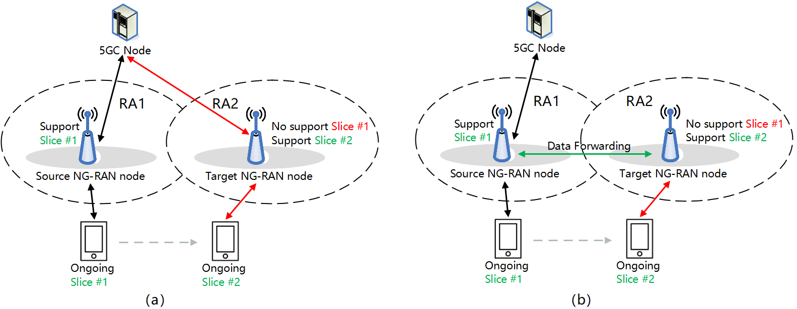

**Fig. 6.2.m.1: Slice re-mapping solutions: (a) with CN impact; (b) without CN impact**

This solution is applicable to scenario 2, where there are two possible slice re-mapping solutions depending on whether the CN is involved.

Fig. 6.2.m.1 (a) shows the re-mapping solution where both the RAN and CN parts are involved. In this case, the CN procedure is involved.

Fig. 6.2.m.1 (b) shows the re-mapping solution where the CN pat of the slice is not changed while the RAN part of the slice is remapped. The UL/DL traffics are relayed between the S-gNB and the T-gNB via the Xn tunnel. In this case, the CN may not be involved.

Editor’s note: The handling of the UE at target node needs to be clarified.

### 6.2.Y Slice Re-mapping Message Sequence Charts

Editor’s note: Feasibility of this solution at system level requires further work including checking with SA2.

.

<Unchanged Text Omitted>

#### 6.2.Y.4 Slice Remapping decision in 5GC and target gNB at NG based handover



**Fig. 4: Slice re-mapping/fallback determined by the AMF and T-gNB**

1. The S-gNB sends the *HANDOVER REQUIRED* message to the AMF.
2. If the UE’s ongoing slice(s) is not supported by the T-gNB, the AMF may make the initial slice re-mapping/fallback decision and include the decision in the *HANDOVER REQUEST* message to the T-gNB.
3. If the UE’s ongoing or re-mapped/fallback slice(s) is rejected in the target gNB, based on the slice re-mapping policy described in section 6.2.1, the T-gNB shall include the further re-mapped/fallback decision in the *HANDOVER REQUEST ACKNOWLEDGE* message to the AMF.
4. The AMF may send the slice re-mapping/fallback decision to the S-gNB through the *HANDOVER COMMAND* message.

Editor’s note: efficiency of the solution needs to be further evaluated.

#### 6.2.Y.5 Slice Remapping decision in SN for MR-DC case



**Fig. 5: Slice re-mapping/fallback determined by the SN**

This flow chart applies to the scenario of resource shortage only.

1. The MN sends the *SN Addition Request* message to the SN.
2. If the UE’s ongoing slice(s) is rejected by the SN, based on the slice re-mapping policy described in section 6.2.1, the SN makes the slice re-mapping/fallback decision. The SN shall include the slice re-mapping/fallback decision in the *SN Addition Request Acknowledge* message sent to the MN.
3. The MN shall send the slice re-mapping/fallback decision to the AMF through the *PDU Session Modification Indication* message.
4. The AMF responds the *PDU Session Modification Confirmation* message.

#### 6.2.Y.6 Slice Remapping decision in MN for MR-DC case



**Fig. 6: Slice re-mapping/fallback determined by the MN**

This flow chart applies to the scenario of resource shortage only.

1. The MN may make the slice re-mapping/fallback decision and include the decision in the *SN Addition Request* message to the SN.
2. The SN may confirm the slice re-mapping/fallback decision made by MN in the *SN Addition Request* *Acknowledge* message.
3. The MN shall send the slice re-mapping/fallback decision to the AMF through the *PDU Session Modification Indication* message.
4. The AMF responds the *PDU Session Modification Confirmation* message.