**3GPP TSG-RAN WG3 Meeting #110-e *R3-206734***

**2 – 12 Nov 2020**

**Title:** TP on potential RAN3 impacts about the QoE measurement configuration, reporting and releasing under SA, NSA and MR-DC operation

**Source:** Huawei, China Unicom

**Agenda item:** 15.2

**Document Type:** Discussion

# 1. Introduction

This TP to 38.890 tries to reflect the following agreements:

**For QoE measurement configuration and Reporting**

* RAN is not allowed to intervene, i.e. pause, activate or de-activate an ongoing QoE measurement unless instructed otherwise by the OAM
* RAN is allowed to release an ongoing QoE measurement, and no need to inform upper layer about the release of a QoE measurement. FFS for the details under EN-DC/NR-DC operation
* RAN is allowed to configure UE to delay/suspend the reporting of a QoE report when it is available at UE side, in case e.g. overload case. The criteria could be e.g. event triggered or time based, FFS for details
* Multiple QoE measurements for a UE could be supported
* Both Management-based and signaling-based QoE measurement could be configured in a certain area and towards an individual specific UE;

# 2. Reference

1. RP-193256, New SID: Study on NR QoE management and optimizations for diverse services
2. R3-206734, Discussions on potential RAN3 impacts about the QoE measurement configuration, reporting and releasing under SA, NSA and MR-DC operation Huawei, China Unicom

# 3. Annex- TPs to be captured in TR

## 6.X General procedure for QoE measurement in NR

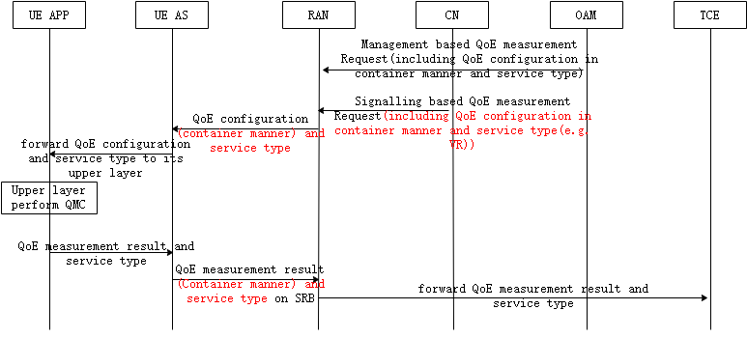

Figure 6.x.1 QoE measurement procedures in NR

According to the Figure 6.x.1 above, the procedure goes as follows:

* NG-RAN receives the QoE measurement configuration from CN (via OAM) or directly from OAM;
* NG-RAN sends the QoE measurement configuration to the UE in an RRC message, in which at least the container of QoE measurement and configuration service type are included;
* UE (AS layer) receives the QoE measurement configuration and forwards container and service type to its application layer;
* UE’s application layer performs the QoE measurement;
* UE application layer incorporates QoE measurement results into a container with service type and sends to UE AS layer;
* UE AS layer sends the QoE measurement results and service type to RAN with RRC message. The QoE measurement results may be partially visible at the RAN (encoding is FFS);
* RAN forwards the received QoE measurement results and service type to TCE/MCE;

Here, both Management-based and signalling-based QoE measurement could be configured in a certain area and towards an individual specific UE. Multiple QoE measurements could be configured for a UE at the same time.

### 6.x1 QoE measurement triggering and stopping

QoE measurement triggering and stopping can be realized using time-based and/or threshold-based criteria, configured by the OAM. Time-based QoE measurement triggering and stopping in NR is achieved by reusing mechanisms specified in LTE for the start and stop of QoE measurements. Threshold-based QoE measurement triggering and stopping allows to start and stop QoE measurement when given thresholds are passed.

Meanwhile, RAN is not allowed to intervene, i.e. pause, activate or de-activate an ongoing QoE measurement unless instructed otherwise by the OAM.

### 6.x2 Release of QoE measurement configuration

An NG-RAN node can issue a release of QoE measurement configuration for UEs previously configured for QoE measurement reporting, provided that the session for which the QoE measurements are reported is completed.

### 6.x3 QoE measurement handling at RAN overload

In case of RAN overload in standalone connectivity, RAN can stop new QoE measurement configurations, release existing QoE measurement configurations and pause QoE measurement reporting. In case of overload in one of the serving RAN nodes in EN-DC or MR-DC, the QoE reports originally sent from the UE via the RAN node that is currently in overload may be sent over the leg served by the RAN node that is not in overload.