3GPP TSG-RAN WG3 Meeting #110-e R3-206933
2-12 November 2020
Online
Agenda Item: 9.2.2
Source: Huawei (moderator)
Title: Summary of Offline Discussion on Immediate Suspension
Document for: Approval

Introduction
CB: # 79_ImmediateSuspension
- clarify usage: reselection vs. suspend/resume
- clarify WUS aspects
- check details
(HW)
Summary of offline disc R3-206933

For the Chairman’s Notes
Agreement: Introduce Information on Recommended Cells and RAN Nodes for Paging IE and Paging Assistance Data for CE Capable UE IE in NGAP: UE CONTEXT RESUME REQUEST message.
R3-206984 (rev of 6111) Agreed, CR to TS 38.413
R3-20xxxx Agreed, draftCR to TS36.300
R3-207071 Agreed, draft LS to SA2

Discussion

Clarification of Paging optimization
In Paging optimization, the RAN node informs the CN about the recommended Cells and eNBs in case of UE Context release and UE Context Suspension, these information needs to up to date because:
- the CN could use it when page the UE, e.g. first page in the last RAN node, then page in a set of RAN nodes around the last RAN node, then page in the TA, which is up to the CN implementation of course.
- and the CN will provide the recommended cells to the RAN node in paging procedure, then the RAN node could use the received information to page the UE, e.g. page first in the last cell, then page in the cells around the last cell, then page in the cells within the TA list of the UE, which is also up to the RAN node implementation of course.
Note that the RAN node also provide the cell id and coverage level to the CN in case of UE Context release and UE Context Suspension, these information needs to up to date because:
- in case of CN paging, the RAN node will take the received coverage level and the cell id into account when page the UE over radio, e.g. to determine the repetition number.

Clarification of WUS
In WUS, last cell solution was agreed in previous meetings among RAN2/SA2/RAN3, in that solution, the RAN node provide the last cell id as the first entry of the recommended cells to the CN, and the CN will provide it to RAN nodes in case of CN paging, the UE will only monitor WUS in case it is still camping in the last used cell, and RAN node will only use WUS in the indicated last cell. This last cell information needs to up to date because:
- If the last cell is not up to date in CN side, the UE monitor WUS in cell1, but the RAN node will not able to get the correct information from CN in paging message, and then the RAN node will not use WUS to page that UE in cell1, the UE will not able to receive paging in cell1, i.e. UE becomes unreachable…

Clarification of the scenario of the Immediate Suspension
As clarified in [R3-206110], in case of immediate suspension, the UE context will be suspended after NG-RAP context resume procedure, the UE context suspension procedure will not be triggered.
When the UE moves to idle_suspended, it may change cells, and the coverage level also may change, when then UE access to the network in another cell of the same RAN node, or access to the network in different coverage level, if immediate suspension is used, the CN node will not able to get the up to date mentioned information above.
Proposal: introduce Information on Recommended Cells and RAN Nodes for Paging IE and Paging Assistance Data for CE Capable UE IE in NGAP: UE CONTEXT RESUME REQUEST message
With the clarifications above, it is proposed to agree the CR provided in [R3-206111], please provide your comments if any.
Company | Comment
Huawei | Ok for the CR.
Ericsson | Thank you Huawei for feedback and detailed explanation. Our assumption was that the suspend procedure towards the AMF can still be executed, even though the RRC connection has been already released. Thus AMF can still receive the Paging optimization IEs in the NG-AP Suspend message. But after checking TS 23.502 (and not TS 38.300, which caused us confusion), it seems indeed that there will be no Suspend procedure once the RRC connection is released after Step 5.  Therefore we no longer object the CR.
Huawei1 | Thank you for your consideration☺
ZTE | Ok. It is necessary for fast connection release procedure (e.g. without UE Context Suspend procedure or UE Context Release procedure).  We support and would like to cosign the CR.  And, once the CR is agreed, we suggest to send an LS to SA2 to update the related SA2 specification.
Huawei 2 | To ZTE, thank you for co-sourcing the CR. And for the LS, so far we do not see the need to send an LS to SA2 on that, if any changes needed in SA2, companies can provide directly to SA2.

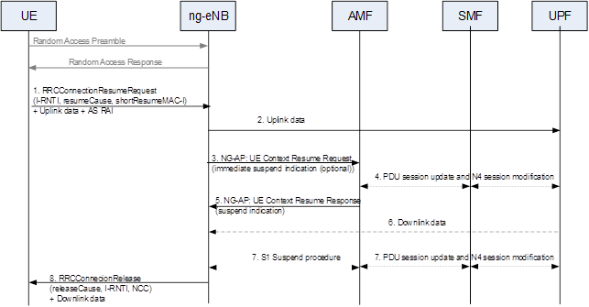

References
- R3-206110 Consideration on immediate suspension (Huawei, China Telecom, Nokia, Nokia Shanghai Bell), Discussion
- R3-206111 Correction on immediate suspension (Huawei, China Telecom, Nokia, Nokia Shanghai Bell) CR0411r1, TS 38.413 v16.3.0, Rel-16, Cat. F

