3GPP TSG-RAN WG3 #109e R3-205703
Electronic meeting, August 17th – 28th 2020

Agenda Item: 17.3
Source: Ericsson
Title: TP on solutions for serving slices on different frequencies
Document for: Discussion, Decision

1 Introduction
Text proposal for TR 38.832

6 Study necessity and mechanisms to support service continuity

6.1 Use case description
Editor Note: capture the use cases description and benefits of the use cases

6.2 Solution description
Editor Note: Capture the solutions for the use case.

Te following solution need another section.

7 Study Other Aspects of Network Slicing Service Continuity

7.1 Solutions for Slice Availability on Different Frequencies

7.1.X1 Signaling of Rejected NSSAI to RAN
UE is always updated with an Allowed NSSAI, sent over NAS signaling, that only includes slices served on the current frequency. If the UE wants to access a slice that is not in the Allowed NSSAI, it will request the slice over NAS.
If the current cell is using a frequency that is dedicated for another slice, CN will reject the access since it is not supported in current cell. The RAN is not aware of rejected S-NSSAIs and is not triggered to move the UE to another frequency. Therefore, slice access will not be possible in this scenario.
The figure below is showing a network level solution that can help optimization of cell/frequency selection for a UE that wants to access a slice not currently available in its Registration Area.

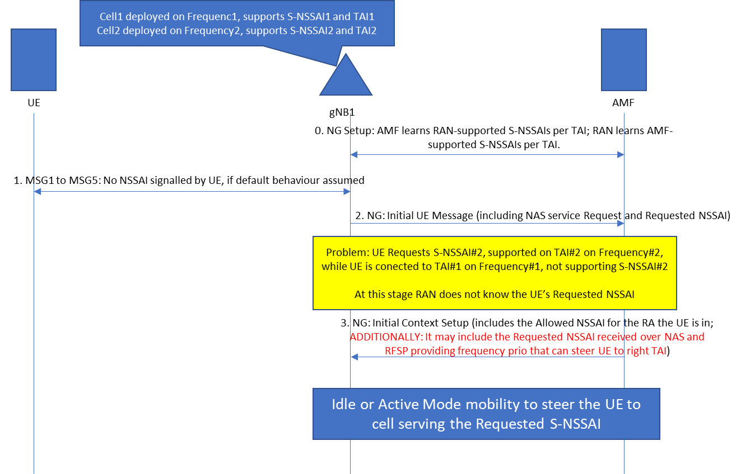
Figure 1: CN assistance allows RAN to know Requested S-NSSAI and RFSP for such S-NSSAI. RAN can steer the UE towards appropriate cell/frequency

In the figure above it can be seen that if the UE requests services for a slice that is not supported in the current Allowed NSSAI, the RAN can learn about such request by means of CN assistance information. The CN may signal to the RAN a Requested NSSAI and an RFSP value for such requested NSSAI. With this information the RAN is able to take actions in moving the UE towards the right cell/frequencies and enable that the requested services are provisioned.

7.1.X2 Slice Access by means of Multi Connectivity

If multiple network slices operating in different frequency bands are to be used in Connected state, the NG-RAN can activate Dual Connectivity or Carrier Aggregation based on local configuration.

7.1.X3 Preferred Frequencies per Slice
The slices are supported on all frequencies within a given Registration Area, but slices are assigned ‘preferred frequencies’ where the slice should be served if possible. RAN nodes could be pre-configured with preferred frequency per slice, and/or the RFSP index could be used to signal preferences from the CN.
The preferred frequency is taken into account at HO, at DRB setup and when setting frequency priorities for idle mode mobility.
If a UE has no coverage at or it does not support the preferred frequency for the requested slice or is using another slice simultaneous that is served at a different preferred frequency, the UE might either be served on the current frequency for all requested slices or it might be handed over to a cell at another frequency that better serves the combination of slices the UE requested. It is FFS how the RAN is informed of the frequency which would best serve any combination of slices which may be requested by the UE.
If a UE is starting a PDU session in a cell that is not at the preferred frequency, the RAN may move the UE to a cell at the preferred frequency or use CA/DC to send the UP data at the preferred frequency. If the UE can’t use the preferred frequency, the RAN should admit the PDU session on the available frequency. In that case, it may use Access Control and/or scheduling priority to ensure that the load from slices not preferred in the cell is properly policed (FFS).
The advantage with this method is that it is very flexible and it maximises spectral efficiency because resources on all frequencies can be used by different slices when available. The method can be used to achieve , e.g. for public safety, a specific frequency could be used as preferred frequency for that slice so that only public safety UE’s camp on that frequency, but CA/DC can be used to spread the UP load evenly on all frequencies.

7.1.X4 Check of UE Frequency Support
Editor’s note: this solution can be studied only in case SA2 informs that the principle of homogeneous slice support in a TA is no longer required.

In case a network slice is only available on certain frequency(ies) the AMF and RAN should ensure that the UE’s radio capabilities support the frequency of the slice before allowing it in the ‘Allowed NSSAI’ list during registration. The UE Radio Capability Check procedure over N2 interface is used by the AMF to request the NG-RAN node to derive and provide an indication to the AMF on whether the UE radio capabilities are compatible with the network configuration for IMS voice. The capability check procedure could be extended to enable the AMF to check if the UE’s radio capabilities are compatible with the RAN configuration for different slices requested by the UE. This requires that every RAN node in a tracking area knows the mapping between frequencies and slices available in that area.

