3GPP TSG-RAN WG3 Meeting #109-e R3-205614
E-meeting, 17 – 27 August, 2020

Agenda item: 31.3.1
Source: Nokia (moderator)
Title: Summary of discussions on CB: # 82_CLImeasEN-DC
Document for: Approval

1 Introduction
This paper provides summary of discussions at RAN#109-e on:
CB: # 82_CLImeasEN-DC
- usage should be about cell-level resources
- Xn impact needed?
- we should follow current CLI agreements w.r.t. signaling neighbor cell resources
- check details
(Nok - moderator)

-

2 For the Chairman’s Notes

Stage 3:
X2AP: R3-204857 revised in R3-205745 (updated CR title). Online discussion needed.
XnAP: R3-205190 noted

Stage 2:
R3-205188: noted

3 Discussion

3.1 Issue 1 - usage should be about cell-level resources
It was commented in the online session that CLI measurements as such were not transferred on the interface. Please provide your company's view:
Company | Comment
Nokia | The CR title of [2] is: "Support for UE CLI measurement for EN-DC". For better clarity, we propose to update the title as follows: "Support for UE CLI measurement configuration transfer for EN-DC"
ZTE | Fine with clarification.
Qualcomm | The proposal is actually to transfer the Intended TDD DL-UL Configuration NR information, instead of CLI measurement configuration. So, I proposed to change the title as: “Support for intended TDD configuration transfer for EN-DC”
Ericsson | Fully agree with QC – we are working on porting the TDD DL-UL Configuration IE to X2, nothing more, nothing less. Sorry for not commenting the title of TBC in June meeting, I simply oversaw it, but it was always clear that this is about porting from Xn what we have *today*.  So, title should be changed to “Support for intended TDD configuration transfer for EN-DC”.
Huawei | Agree to QC’s comment.
LGE | Similar understanding with QC

3.2 Issue 2 - Xn impact needed?
An XnAP CR is submitted in [6]. Is this CR needed?
Company | Comment
Nokia | We believe that NG-RAN nodes operating as SN will be interconnected using Xn interface, and that TDD UL/DL assignment can therefore be transferred between SNs using XnAP Served Cell Information NR IE. Hence [6] is not needed.
ZTE | The scenario is exactly same as in EN-DC when there is no direct Xn interface between SN for MR-DC. At least neighbor cell information update is necessary.
Qualcomm | Agree
Ericsson | Not needed.
ZTE | 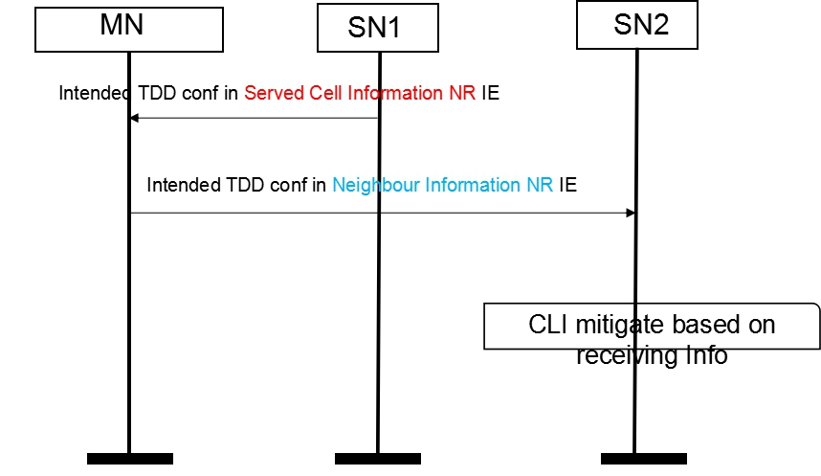  When there is no direct Xn interface between SN in MR-DC case, it is necessary for MN to forward per cell intended UL/DL TDD configuration from one SN to its neighbour SN.  The feature is not supported in current specification (i.e. there is no intended UL/DL TDD configuration IE in neighbour Information NR IE.)
Huawei | Xn impact is not needed. Xn can be setup anyway when there is no Xn between two SNs.
LGE | Same view with Huawei.

3.3 Issue 3 – we should follow current CLI agreements w.r.t. eighbour eighbour cell resources
The TDD UL/DL assignment is not transferred for neighbour cells on Xn. As clarified during the online session, it is proposed in [2] (X2AP CR) to include the TDD UL/DL assignment information for NR neighbour cells, for the purpose of providing this information in the direction eNB -> en-gNB. Please provide your company’s view whether this is OK.
Company | Comment
Nokia | (our proposal) OK
ZTE | OK and also apply for XnAP.
Qualcomm | OK
Ericsson | Disagree, let us do what is done on Xn, as we are tasked.
Huawei | OK
Nokia | Reply to E///: It is not clear to me why we should not use the NR Neighbour Information IE, which would allow us to use EN-DC X2 Setup and EN-DC Configuration Update (to cover the directions eNB->en-gNB and eNB->eNB). Could you please explain why? Still, if there is a real show-stopper for use of the NR Neighbour Information IE, I have drafted an alternative CR introducing a new X2AP procedure for transfer of the Intended TDD DL-UL Configuration NR IE. Please let me know what you think, and I will add ASN.1 if this finally becomes the preferred way forward.
LGE | OK

3.4 Issue 4 - check details: stage 3
Please provide your company's view on whether [2] (X2AP CR) can be agreed, and comments in case a revision is needed.
Company | Comment
Nokia | see proposed revision under issue 1
ZTE | Section 8.3.3 Xn setup , 8.3.5  As shown in the figure below, to confirm whether we agree to support exchange en-gNB’s intended TDD_UL/DL configuration belong to different eNB?  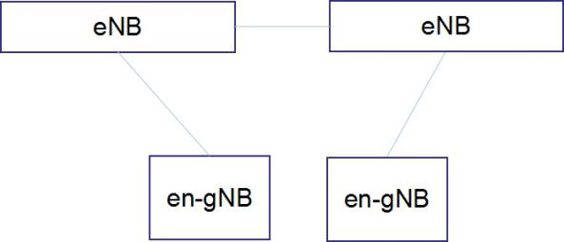  If yes, then  A sending eNB acquired its pertain en-gNB’s “intended TDD UL/DL information” via X2AP EN-DC X2 SETUP REQUEST/ Configuration/update.  The sending eNB forward the information to a receiving eNB via X2AP X2 setup/update procedure in “NR Neighbour Information” IE.  Then receiving eNB forward “intended TDD UL/DL information” to its pertain en-gNB in X2AP EN-DC X2 SETUP REQUEST/ Configuration/update message .  The sending eNB carries the information in “NR Neighbour Information” IE of one “List of Served E-UTRA Cells” IE.  But I am not sure how to input “Served E-UTRA Cell Information” in this case, because the served cell is belong to receiving eNB not belong to sending eNB and receiving eNB may not know cell relationship of en-gNB pertain to different eNBs.
Qualcomm | Looks fine.
Ericsson | Disagree due to at least the following:  - Title – should be as we commented in Q1  - We should repeat what is done on Xn and not add the info about neighbouring cells as well.
Huawei | CR seems OK.
Nokia | Fine to update the title of the CR. And as mentioned above, if there is a real show-stopper for use of the NR Neighbour Information IE, I have drafted an alternative CR introducing a new X2AP procedure for transfer of the Intended TDD DL-UL Configuration NR IE. Please let me know what you think, and I will add ASN.1 if this finally becomes the preferred way forward.
LGE | CR is fine

3.5 Issue 5 - check details: stage 2
Stage 2 support was already introduced by RAN2 in TS 37.340 CR#0182r1 ("Introduction of cross link interference management ", R2-201695). There is also submitted a CR in [4].
Companies are requested to comment on need for additional stage 2 description, and comments on [4] if any.
Company | Comment
Nokia | No strong view on whether additional stage 2 is needed. In [4] is proposed: " MN may coordinate the exchange of intended TDD DL-UL configuration by merging, forwarding and selective forwarding of intended TDD DL-UL configuration(s) between its connected SNs". However we believe this functionality is needed for EN-DC only, and not for the other MR-DC scenarios where we expect that SNs will be inter-connected by Xn interface.
ZTE | As we clarified in issue 2:  Yes, for MR-DC case, SN has a Xn connection with MN, but how does MN only use serving cell IE to forward CLI configuration from one SN to another SN? Therefore, neighbour cell IE update for XN is necessary.  If all MR-DC scenario impact, it is propose to find a better place (e.g. stage 2 specification ) capture behavior of forwarding of MN node.
Qualcomm | No strong view
Ericsson | Disagree with the CR. We are exchanging cell-level resources and it is therefore not correct to use the MN-SN terminology, since these terms refer to UE level. We did not get a task to cover all DC scenarios.
Huawei | The stage 2 CR may be not needed, as we should avoid to add new functionality to the gNB after the WI is closed.
Nokia | Existing stage 2 may be sufficient.
LGE | Additional stage 2 CR is unnecessary because the existing stage 2 covers all DC scenarios.

4 Conclusion, Recommendations [if needed]
If needed

5 References
[1] R3-204856 On X2 support for UE CLI measurement for EN-DC Nokia, Nokia Shanghai Bell, Qualcomm Incorporated discussion
[2] R3-204857 Support for UE CLI measurement for EN-DC Nokia, Nokia Shanghai Bell, Qualcomm Incorporated CR 36.423 Rel-16
[3] R3-205187 Support for UE CLI Measurement for MR-DC ZTE discussion Rel-16
[4] R3-205188 37340 CR to Support for UE CLI Measurement for MR-DC ZTE other Rel-16
[5] R3-205189 X2AP CR to Support for UE CLI Measurement for MR-DC ZTE CR 36.423 Rel-16
[6] R3-205190 XnAP CR to Support for UE CLI Measurement for MR-DC ZTE CR 38.423 Rel-16

