3GPP TSG-RAN WG3 Meeting #109-e R3-205614
E-meeting, 17 – 27 August, 2020

Agenda item: 31.3.1
Source: Nokia (moderator)
Title: Summary of discussions on CB: # 82_CLImeasEN-DC
Document for: Approval

1 Introduction
This paper provides summary of discussions at RAN#109-e on:
CB: # 82_CLImeasEN-DC
- usage should be about cell-level resources
- Xn impact needed?
- we should follow current CLI agreements w.r.t. signaling neighbor cell resources
- check details
(Nok - moderator)

-

2 For the Chairman’s Notes
[To be completed]

3 Discussion

3.1 Issue 1 - usage should be about cell-level resources
It was commented in the online session that CLI measurements as such were not transferred on the interface. Please provide your company's view:
Company | Comment
Nokia | The CR title of [2] is: "Support for UE CLI measurement for EN-DC". For better clarity, we propose to update the title as follows: "Support for UE CLI measurement configuration transfer for EN-DC"
ZTE | Fine with clarification.
Qualcomm | The proposal is actually to transfer the Intended TDD DL-UL Configuration NR information, instead of CLI measurement configuration. So, I proposed to change the title as: “Support for intended TDD configuration transfer for EN-DC”

3.2 Issue 2 - Xn impact needed?
An XnAP CR is submitted in [6]. Is this CR needed?
Company | Comment
Nokia | We believe that NG-RAN nodes operating as SN will be interconnected using Xn interface, and that TDD UL/DL assignment can therefore be transferred between SNs using XnAP Served Cell Information NR IE. Hence [6] is not needed.
ZTE | The scenario is exactly same as in EN-DC when there is no direct Xn interface between SN for MR-DC. At least neighbor cell information update is necessary.
Qualcomm | Agree

3.3 Issue 3 - we should follow current CLI agreements w.r.t. signaling neighbor cell resources
The TDD UL/DL assignment is not transferred for neighbour cells on Xn. As clarified during the online session, it is proposed in [2] (X2AP CR) to include the TDD UL/DL assignment information for NR neighbour cells, for the purpose of providing this information in the direction eNB -> en-gNB. Please provide your company's view whether this is OK.
Company | Comment
Nokia | (our proposal) OK
ZTE | OK and also apply for XnAP.
Qualcomm | OK

3.4 Issue 4 - check details: stage 3
Please provide your company's view on whether [2] (X2AP CR) can be agreed, and comments in case a revision is needed.
Company | Comment
Nokia | see proposed revision under issue 1
ZTE | Section 8.3.3 Xn setup , 8.3.5  As shown in the figure below, to confirm whether we agree to support exchange en-gNB’s intended TDD_UL/DL configuration belong to different eNB?  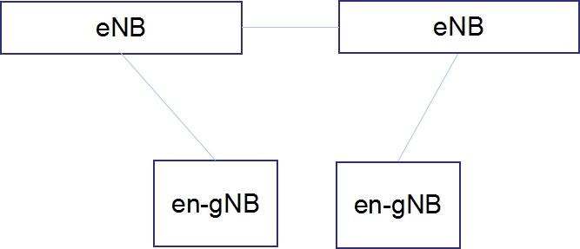  If yes, then  A sending eNB acquired its pertain en-gNB’s “intended TDD UL/DL information” via X2AP EN-DC X2 SETUP REQUEST/ Configuration/update.  The sending eNB forward the information to a receiving eNB via X2AP X2 setup/update procedure in “NR Neighbour Information” IE.  Then receiving eNB forward “intended TDD UL/DL information” to its pertain en-gNB in X2AP EN-DC X2 SETUP REQUEST/ Configuration/update message .  The sending eNB carries the information in “NR Neighbour Information” IE of one “List of Served E-UTRA Cells” IE.  But I am not sure how to input “Served E-UTRA Cell Information” in this case, because the served cell is belong to receiving eNB not belong to sending eNB and receiving eNB may not know cell relationship of en-gNB pertain to different eNBs.
Qualcomm | Looks fine.

3.5 Issue 5 - check details: stage 2
Stage 2 support was already introduced by RAN2 in TS 37.340 CR#0182r1 ("Introduction of cross link interference management ", R2-201695). There is also submitted a CR in [4].
Companies are requested to comment on need for additional stage 2 description, and comments on [4] if any.
Company | Comment
Nokia | No strong view on whether additional stage 2 is needed. In [4] is proposed: " MN may coordinate the exchange of intended TDD DL-UL configuration by merging, forwarding and selective forwarding of intended TDD DL-UL configuration(s) between its connected SNs". However we believe this functionality is needed for EN-DC only, and not for the other MR-DC scenarios where we expect that SNs will be inter-connected by Xn interface.
ZTE | As we clarified in issue 2:  Yes, for MR-DC case, SN has a Xn connection with MN, but how does MN only use serving cell IE to forward CLI configuration from one SN to another SN? Therefore, neighbour cell IE update for XN is necessary.  If all MR-DC scenario impact, it is propose to find a better place (e.g. stage 2 specification ) capture behavior of forwarding of MN node.
Qualcomm | No strong view

4 Conclusion, Recommendations [if needed]
If needed

5 References
[1] R3-204856 On X2 support for UE CLI measurement for EN-DC Nokia, Nokia Shanghai Bell, Qualcomm Incorporated discussion
[2] R3-204857 Support for UE CLI measurement for EN-DC Nokia, Nokia Shanghai Bell, Qualcomm Incorporated CR 36.423 Rel-16
[3] R3-205187 Support for UE CLI Measurement for MR-DC ZTE discussion Rel-16
[4] R3-205188 37340 CR to Support for UE CLI Measurement for MR-DC ZTE other Rel-16
[5] R3-205189 X2AP CR to Support for UE CLI Measurement for MR-DC ZTE CR 36.423 Rel-16
[6] R3-205190 XnAP CR to Support for UE CLI Measurement for MR-DC ZTE CR 38.423 Rel-16

