3GPP TSG-RAN WG3 #109-e R3-205611
Electronic meeting, 17th - 28th August, 2020
Agenda item: 31.2.2
Source: NTT DOCOMO, INC. (moderator)
Title: Summary of discussions on addition of EN-DC connected indication in E-CID measurement response message over LPPa
Document for: Approval

1 Introduction
This paper provides summary of discussions at RAN#109-e on:
CR0112r1, TS 36.455 v16.0.0, Rel-16, Cat. F
QC: need to further discuss applicable scenarios – seems like an optimization for a coverage check (normally not done via positioning functionality); UEs are normally not EN-DC connected all the time; not sure what E-SMLC does with this info
HW: same concerns as QC; E-SMLC should not know about DC. Seems like a deployment problem, which should be detected via e.g. ANR
E///: MDT can already separate EN-DC from non-EN-DC traces; this does not seem needed
CB: # 81_EN-DCinfo_E-CID
- clarify scenario and details
(NTT - moderator)
Summary of offline disc R3-205611

2 Discussion

2.1 Application scenarios

2.1.1 Scenario #1
With the ongoing deployment of EN-DC network, there is a 5G area coverage issue reported by our network engineers in the field. As indicated in the figure below, Area ① is the 5G area where possible for EN-DC transmission and area② is the 5G area where a measurement report of good NR cell is reported by UE, while not possible for EN-DC transmission. The reason for existence of area② is considered as X2 interface between eNB and gNB is not constructed yet, or the concerned NR cell frequency band is not in combination with the LTE PCell frequency band . In order to identify the “Area② like” 5G Area to improve the 5G network quality in a more efficient way, we considered utilizing E-SMLC to identify the geographical location of spot mentioned above based on UE’s measurement report and location Information. In detail, when E-SMLC request eNB to report inter-RAT measurement quantities with E-CID MEASUREMNT INITIATION REQUEST message, and eNB responds E-SMLC with inter-RAT measurement result in E-CID MEASUREMENT INITIATION REPONSE message. We propose to add an “EN-DC connected” indicator in the response message to help E-SMLC identify whether UE is in EN-DC connected. If a 5G area where UEs are always not in EN-DC connected, while the NR measurement results are good, then this 5G area needs to be improved.
Observation 1: With the ongoing deployment of EN-DC network, there is 5G area② indicated in the figure where a measurement report of good NR cell is reported by UE, while not possible for EN-DC transmission.
Observation 2: The reason for existence of area② is considered as X2 interface between eNB and gNB is not constructed yet, or the concerned NR cell frequency band is not in combination with the LTE PCell frequency band.
Observation3: E-SMLC can help identify the “5G Area②” like spot based on UE’s measurement report and location information.
Observation4: Addition of an indication of “EN-DC connected” in E-CID MEASUREMENT INITIATION RESPONSE message could help E-SMLC to identify the spot where UEs are always not in EN-DC connected, while the reported NR measurement results are good.
Proposal1: Add an “EN-DC connected” indication in E-CID MEASUREMENT INITIATION RESPONSE message over LPPa.

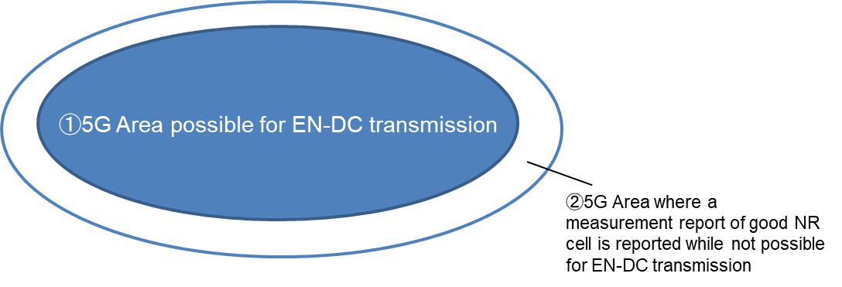
Question 1: Do companies agree with the application scenario#1 described above? Any comments, please provide it below.
Company | Comments
Ericsson | First of all, this doesn’t look like a positioning addition and should therefore not be considered as part of E-CID. Instead, we can investigate whether other tools or existing mechanism(s) could be used instead.
Nokia | This seems like a classical MDT use case, e.g. CCO with possible addition of DC status. We should avoid adding information to LPPa that is not relevant to the positioning of the target UE. The LCS framework is not intended to provide MDT-like services.

2.1.2 Scenario #2
The second applicable scenario is to help build a nationwide 5G service area map like below. This map provides customers with information of the actual radio condition in the area and throughput level where they located. It is built based on statistically averaged UEs’ reported cell measurement results, throughputs and location information (based on LPPa). By adding an “EN-DC connected” indication in E-CID measurement response message could help E-SMLC to identify which spot is not possible for EN-DC transmission and optimize this map from a big amounts of UE’s reported data. The field network engineers could also detect the area network problems (e.g. area with good NR cell measurement result but not possible for EN-DC transmission) based on this map and improve them more conveniently.
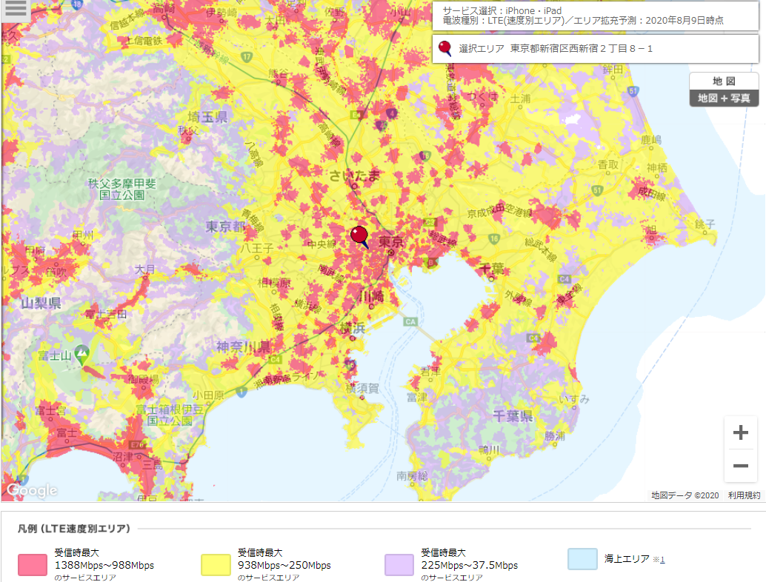
Fgiure1. NTTDOCOMO, INC. Japan nationwide service area map

Question 2: Do companies agree with the application scenario#2 described above? Any comments, please provide it below.
Company | Comments
Ericsson | The purpose of ECID is for location estimation only and not to identify coverage gaps; we should investigate if it isn’t already possible to filter EN-DC traces from non EN-DC ones via existing tools or other mechanism.
Nokia | Please see response to Question 1.

2.1.2 Scenario #3
Another issue is the delayed responding message of E-CID MEASUREMENT INITIATION REPONSE for some UEs. As we statistically analysed in the following graph that 62% of counts(2654683 logs was used in calculation) showed the time required from E-SMLC sending E-CID MEASUREMENT INITIATION message until receiving the response of E-CID MEASUREMENT INITATION RESPONSE message is 500ms, while another 31% showed it required 3500ms. The latter one is considered as an issue due to UE is continuously doing inter-RAT measurement, searching NR cells until measurement gap timer is expired, which cause the delayed response of E-CID MEASUREMENT INITIATION RESPONSE message to E-SMLC. We consider it wasteful to wait the E-CID measurement response even though UE could not find any NR cell until measurement gap expiration, which could severely impact customers’ throughput experiences. To resolve this problem, we propose to add an “EN-DC connected” indicator in E-CID MEASUREMENT INITIATION RESPONSE message. When E-SLMC was notified the UE is not in “EN-DC connected”, the eNB in that area could be set with a shorter measurement gap timer.
Observation5: There exists problem of delayed E-CID MEASUREMENT INITIATION REPONSE message for some UEs, due to doing inter-RAT measurement, searching NR cell until measurement gap timer is expired.
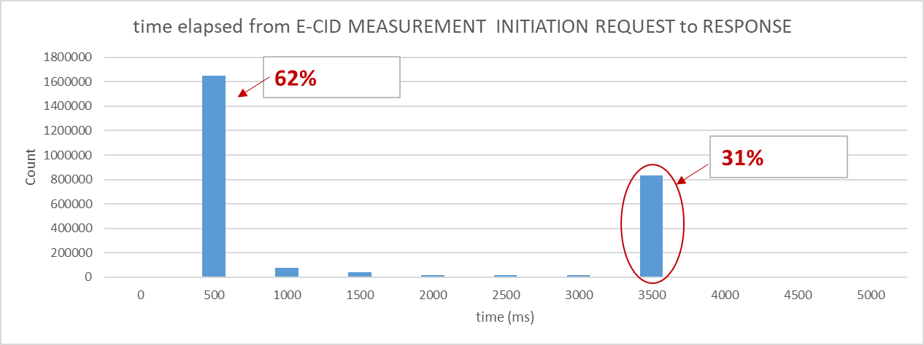

Question 3: Do companies agree with the application scenario#3 described above? Any comments, please provide it below.
Company | Comments
Ericsson | We think that the intention is good, but not the right approach. Please see our answers to questions 2 and 4.
Nokia | In our understanding, the eNB is only expected to provide inter-RAT measurements “if available” (as described in section 8.2.1.2 of TS 36.455). Therefore, the delay described in this scenario appears to be an implementation-related issue.

2.2 Candidate solutions
The possible candidate solutions considered to resolve the issues mentioned above are listed below. The Pros & Cons analysis shows that by adding an “EN-DC connected” indication in E-CID measurement response over LPPa is simplest workable solution.
Candidate Solutions | Pros | Cons
- “EN-DC connected” indication in E-CID measurement response over LPPa | The benefits of this solution are justified in the previous section. By adding a simple flag in E-CID measurement response msg. over LPPa could resolve all the issues mentioned above. | It has LPPa spec impact.
- ANR approach |  | In reality, for most of the EN-DC deployment in the field, SN (gNBs) do not broadcast SIB1 (only broadcast MIB for SFN timing synchronization), so even network configure UEs to do CGI reporting, UE could only reports no-SIB1 in the MeasResult as highlighted in yellow below, thus ANR approach is not workable.
- MDT approach |  | MME could request eNB to trace particular UEs to do signalling based MDT by setting {MDT configuration, MDT configuration NR} in Trace Activation of Trace Start msg., while the MDT measurement result (NR part) is reported in MeasReportNR-r15 as shown below highlighted in green, where only RSRP/RSRQ/SINR information (possibly with LocationInfo associated) could be reported. Based on this, network could only know cell/beam quality of the area, but could have no knowledge whether this area is possible for EN-DC transmission. Thus, MDT approach could not solve this issues mentioned above.

--------------------------------------------------Excerption from 36.331--------------------------------------------------------

MeasResults
The IE MeasResults covers measured results for intra-frequency, inter-frequency and inter- RAT mobility.
MeasResults information element
-- ASN1START

MeasResults ::= SEQUENCE {
measId MeasId,
measResultPCell SEQUENCE {
rsrpResult RSRP-Range,
rsrqResult RSRQ-Range
},
measResultNeighCells CHOICE {
measResultListEUTRA MeasResultListEUTRA,
measResultListUTRA MeasResultListUTRA,
measResultListGERAN MeasResultListGERAN,
measResultsCDMA2000 MeasResultsCDMA2000,
...,
measResultNeighCellListNR-r15 MeasResultCellListNR-r15
} OPTIONAL,
...,
“unrelated part is omitted”

[[ measResultServFreqListNR-r15 MeasResultServFreqListNR-r15 OPTIONAL,
measResultCellListSFTD-r15 MeasResultCellListSFTD-r15 OPTIONAL

“unrelated part is omitted”

MeasResultServFreqListNR-r15 ::= SEQUENCE (SIZE (1..maxServCell-r13)) OF MeasResultServFreqNR-r15

MeasResultServFreqNR-r15 ::= SEQUENCE {
carrierFreq-r15 ARFCN-ValueNR-r15,
measResultSCell-r15 MeasResultCellNR-r15 OPTIONAL,
measResultBestNeighCell-r15 MeasResultCellNR-r15 OPTIONAL,
...
}

MeasResultCellListNR-r15::= SEQUENCE (SIZE (1..maxCellReport)) OF MeasResultCellNR-r15

MeasResultCellNR-r15 ::= SEQUENCE {
pci-r15 PhysCellIdNR-r15,
measResultCell-r15 MeasResultNR-r15,
measResultRS-IndexList-r15 MeasResultSSB-IndexList-r15 OPTIONAL,
...,
[[ cgi-Info-r15 CGI-InfoNR-r15 OPTIONAL
]]
}

MeasResultNR-r15 ::= SEQUENCE {
rsrpResult-r15 RSRP-RangeNR-r15 OPTIONAL,
rsrqResult-r15 RSRQ-RangeNR-r15 OPTIONAL,
rs-sinr-Result-r15 RS-SINR-RangeNR-r15 OPTIONAL,
...
}

MeasResultSSB-IndexList-r15::= SEQUENCE (SIZE (1..maxRS-IndexReport-r15)) OF MeasResultSSB-Index-r15

MeasResultSSB-Index-r15 ::= SEQUENCE {
ssb-Index-r15 RS-IndexNR-r15,
measResultSSB-Index-r15 MeasResultNR-r15 OPTIONAL,
...
}

“unrelated part is omitted”

CGI-InfoNR-r15 ::= SEQUENCE {
plmn-IdentityInfoList-r15 PLMN-IdentityInfoListNR-r15 OPTIONAL,
frequencyBandList-r15 MultiFrequencyBandListNR-r15 OPTIONAL,
noSIB1-r15 SEQUENCE {
ssb-SubcarrierOffset-r15 INTEGER (0..15),
pdcch-ConfigSIB1-r15 INTEGER (0..255)
} OPTIONAL,
...
}

CellIdentityNR-r15 ::= BIT STRING (SIZE (36))

PLMN-IdentityListNR-r15 ::= SEQUENCE (SIZE (1.. maxPLMN-NR-r15)) OF PLMN-Identity

PLMN-IdentityInfoListNR-r15 ::= SEQUENCE (SIZE (1..maxPLMN-NR-r15)) OF PLMN-IdentityInfoNR-r15

PLMN-IdentityInfoNR-r15 ::= SEQUENCE {
plmn-IdentityList-r15 PLMN-IdentityListNR-r15,
trackingAreaCode-r15 TrackingAreaCodeNR-r15 OPTIONAL,
ran-AreaCode-r15 RAN-AreaCode-r15 OPTIONAL,
cellIdentity-r15 CellIdentityNR-r15
}

TrackingAreaCodeNR-r15 ::= BIT STRING (SIZE (24))

-- ASN1STOP
-----------------------------------------------------------End of Excerption--------------------------------------------------------------

Question 4: Do companies agree with the Pros & Cons analysis of three candidate solutions above?
Company | Comments
Ericsson | Thanks Docomo for providing the RRC measurement result.  As stated in our answers to the above questions, E-CID’s purpose is for location estimation only and not for identifying coverage gaps. Instead, MDT can be the working mechanism here as it should already be possible to setup EN-DC traces and non-EN-DC traces. MDT can be triggered while in EN-DC, and the traces can go from each node independently to a Trace Collection Entity in the OAM. The Trace Collection Entity can then analyse the traces in a way to get data separated by the connectivity state. The e-SMLC is not the right entity to transfer these traces to.
Nokia | Regarding the cons of solution 1, it is not simply “spec impact” but also introducing new function to the E-SMLC that is not related to positioning.  An MDT-based solution could be a good candidate, with possible MDT enhancements if the objective is simply to know whether DC is possible or not in a given area.

Question 5: If there are any issues which are not covered in the previous section, please provide your views below.
Company | Comments

3 Conclusion
TBD

References
- TS 36.455 LPPa protocol.
- NTTDOCOMO, INC. Service Area Map. https://www.nttdocomo.co.jp/area/servicearea/?rgcd=03&cmcd=LTE&scale=128000&lat=35.686254&lot=139.694936

