3GPP TSG-RAN WG3 #109-e R3-205471
Online, 17-28 August 2020

Agenda Item: 13.4.1
Source: AT&T (moderator)
Title: Summary of Offline Discussion on CLI Management
Document for: Approval

Introduction
CB: # 11_IAB_CLImgmt
- AT&T
Inter-donor and inter-IAB-node signaling to support the configuration and exchange of MT-MT and DU-DU CLI measurement reports should be considered in Rel-17
- E///
study the enhancement to legacy CLI management signaling to differentiate the TDD resources used for UE access traffic from the slots used for backhaul traffic
++ Suggested guidelines/topics for discussion from Chair (looking at possible consensus):
+ Start from Rel-16 CLI functionality: are any enhancements needed to work with IAB?
+ Possible information to be signaled inter-donor?
+ Attempt st2 and st3 TP?
(AT&T - moderator)

The discussion has two phases:
Phase 1 (Deadline Wednesday, August 19, 24:00 UTC): Discuss scenarios for CLI Management for IAB in Rel-17 and identify potential enhancements to Rel-16 CLI functionality
Phase 2 (Deadline Tuesday, August 25, 1300 UTC): TBD

For the Chairman’s Notes
Propose the following:

Discussion

Scenarios for CLI Management in IAB Rel-17
Support for CLI management was introduced in Rel-16 to enable coordination across neighboring cells in case of different DL/UL resources are configured resulting in performance degradation from CLI as well as support for UE-UE measurements to detect which resources are the most impacted.
For IAB there are several unique aspects related to CLI compared to conventional deployments. In [5226], it is highlighted that since backhaul resources may be associated with many downstream IAB nodes/UEs, protecting those resources may be of higher priority than resources only used for access links.
In [4869], in addition to TDM support in Rel-16 (where only the IAB-MT or IAB-DU were active in a given resource) new scenarios are considered in RAN1 to support more efficient access and backhaul link multiplexing: 1) spatial division multiplexing (SDM) and 2) multi-panel transmission/reception (MPTR), which result in the need for DU-DU as well as MT-MT measurements and reports for IAB nodes as shown in Figure 3.1.1 below.

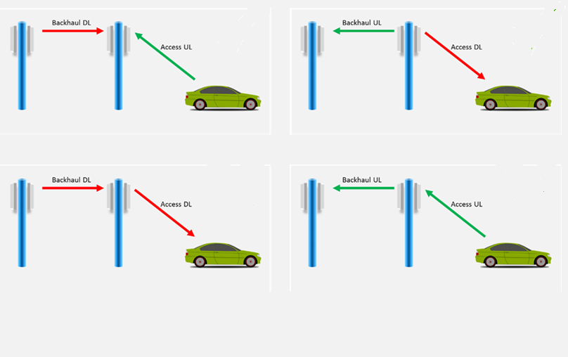
SDM
MPTR
SDM
MPTR
Figure 3.1.1: SDM and MPTR Rel-17 IAB Scenarios
Furthermore, since the IAB network is both multi-hop and relies on the use of “soft” resources configured by the Donor CU, but dynamically determined by a child IAB-DU, more frequent CLI measurements and reports may be needed. In addition, to reduce the overhead and latency of CLI related signaling, [4869] proposes that both inter-donor as well as inter-IAB-node exchange of CLI measurements may be considered in Rel-17.

Question 3.1: What scenarios should be supported in Rel-17 for IAB-specific CLI management?
Company | Comment
AT&T | Given the new multiplexing scenarios and the need for dynamic resource coordination, inter-donor and inter-IAB-node CLI management scenarios should be considered.
Ericsson | We have to see what kind of interference scenarios will be relevant during Rel-17. Interference is not necessarily an IAB specific thing and interference management is not necessarily limited to IAB. We think we need to confirm with RAN Plenary first whether interference related spec(s) should be within IAB scope or more general.  Provided that the above is resolved, we think it would make sense to study inter-donor exchange of CLI measurements.
QC | CLI enhancements are part of the WID, so they need to be addressed. Since this is an IAB WI, we need to address IAB-specific CLI issues.  Deployment of local area IAB-nodes will certainly create more stringent CLI requirements which need to be addressed.
ZTE | We could focus on intra IAB donor CLI management scenario first in Rel-17. And inter-donor CLI measurements could be de-prioritized.
Samsung | CLI is in the scope of Rel17 IAB. The supported scenario should be decided by RAN1.
Nokia | The scenario should be decided by RAN1. Better to wait for RAN1 decision.
Huawei | In case of SDM transmission between adjacent links, the interference for DU-DU as well as MT-MT may need to be measured, however, the interference scenarios need to be discussed by RAN1 firstly and we can wait for the RAN1’s conclusion.
LGE | Because the scenario should be decided by RAN1, it is better to wait for RAN1 decision.

Identify potential enhancements to Rel-16 CLI functionality
As raised in [4869] and [5226], the existing Rel-16 CLI features support the exchange of TDD patterns and the reporting of UE-UE layer 3 CLI measurements. However, given the scenarios discussed in the previous section, this framework may be inadequate for IAB since it does not allow for the prioritization of resources used for backhaul vs. access links by differentiating the TDD resources used for UE access traffic from the slots used for backhaul traffic [5226]. In addition, it does not cover CLI measurements specific to the IAB-nodes (i.e. DU-DU and MT-MT measurements) [4869].
These aspects are proposed as the starting point for discussion to identify potential enhancements to Rel-16 CLI functionality.

Question 3.2 – What enhancements should be considered to the existing Rel-16 CLI functionality?
Company | Comment
AT&T | Existing UE-UE measurements only cover a subset of possible IAB CLI scenarios, and MT-MT/DU-DU measurements are critical to protect backhaul links in some cases. In addition the time scale of the measurement configuration and reports should be considered to support dynamic resource coordination (e.g. usage of “soft” resources) for IAB.  RAN3 should consider enhancements to support the configuration and exchange of MT-MT and DU-DU CLI measurement reports in Rel-17.
Ericsson | As a starting point, we think RAN3 should study how to differentiate the UE access resources from the backhaul resources in the existing CLI management signaling.
QC | We agree that MT-MT and DU-DU CLI measurements need to be considered. RAN1 may want to take the lead and identify the relevant scenarios before RAN3 can discuss signaling.
ZTE | MT-MT and DU-DU CLI measurements need to be considered. And R16 UE-UE CLI measurement scheme could be the starting point. However, the above enhancements should be mainly discussed in RAN1.
Samsung | We may need wait for the progress of RAN1 before discussing this in RAN3.
Nokia | This is related to the scenario asked in Q3.1. Better to wait for RAN1 decision.
Huawei | Same comments as in Q3.1. This should be discussed in RAN1 first.
LGE | This enhancements should be discussed in RAN1 first before RAN3 discussion.

Conclusion, Recommendations
Proposed conclusion: IAB-specific CLI management should be considered in Rel-17. The specific scenarios should be first defined in RAN1 and potential enhancements should take the existing Rel-16 CLI measurements/signaling as the starting point.

References

