3GPP TSG RAN WG2 Meeting #117 R2-220xxxx
Electronic meeting, 21th Feb– 3rd Mar, 2022

Source: Huawei, HiSilicon
Title: [Pre117-e][607][POS] Open issues on positioning latency enhancements (Huawei)
Agenda item: 8.6.5
Document for: Discussion and Decision

Introduction
The following email discussion has been triggered after RAN2#116bie-e:
[Pre117-e][607][POS] Open issues on positioning latency enhancements (Huawei)
Under the scope of the above email discussion, this questionnaire intends to address the open key issues for positioning latency enhancements.

The discussion below is mainly based on the open issues provided by the following contributions:
- R2-2201722 Summary of [Post116bis-e][628][POS] 37.355 running CR (Qualcomm)
- R2-2202005 Report of email discussion [Post116bis-e][634][POS] Positioning open issues list (Intel)
The discussion is also based on the following running CRs for MAC, stage2, RRC and LLP
- R2-2202011 Running draft MAC CR for R17 positioning Huawei, HiSilicon
- R2-2202048 Capturing RRC impacts for RAT dependent Positioning Ericsson
- R2-2201815 Running 38.305 CR for Positioning WI on RAT dependent positioning methods Intel
- R2-2201723 Running LPP CR for NR positioning enhancements Qualcomm
Handling of the open issue list is based on the following guideline from the chairman.
- R2-220xxxx Coordinated Company Input For Rel-17 Open Issues Planning R2 117-e and impacts to R2 116bis-e MediaTek (R2 Chairman)

Contact Information
Company | Contact: Name (E-mail)
Fraunhofer | Birendra Ghimire (birendra.ghimire@iis.fraunhofer.de)
CATT | Jianxiang Li(lijianxiang@catt.cn)
Qualcomm | sfischer@qti.qualcomm.com
ZTE | pan.yu24@zte.com.cn
Apple | Sasha Sirotkin <ssirotkin@apple.com>
Xiaomi | Xiaolong Li (lixiaolong1@xiaomi.com)
Ericsson | Ritesh Shreevastav (ritesh.shreevastav@ericsson.com)
vivo | panxiang@vivo.com
InterDigital | Jaya Rao (jaya.rao@interdigital.com),  Fumihiro Hasegawa (fumihiro.hasegawa@interdigital.com)
Lenovo, Motorola Mobility | Robin Thomas (rthomas7@lenovo.com)
Nokia | Mani Thyagarajan (Mani.Thyagarajan@nokia.com)

Scheduled location time

Issue1: Absolute Time or a Window
The following has been captured in the open issue list
Stage 3 details- FFS if the “Scheduled Location Time” is an absolute time or a window. | Yes | Statue: draft in LPP running CR, check the status of LPP email discussion 116bis-628
While in the current LPP running CR, the schedueled location time is captured as an absolute time, as follows:
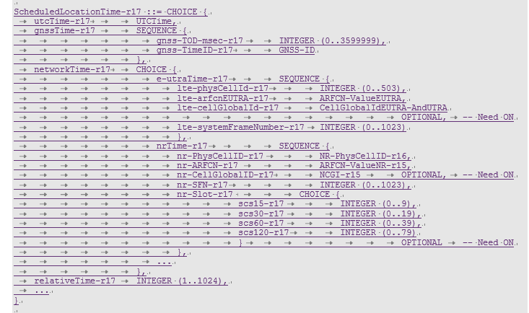
Also with the following field description:
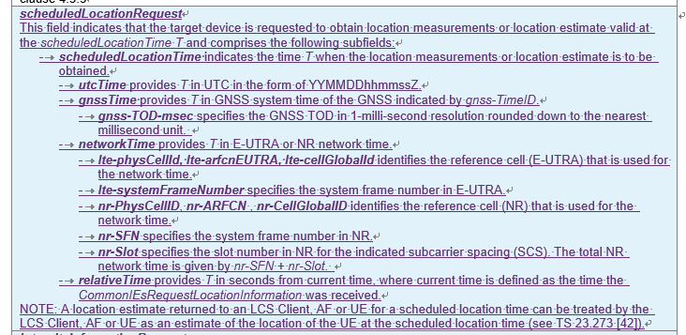

For the current CT4 discussion, the following CRs have been agreed:
- C4-220350 for 24.080 for LCS message
- C4-220368 for 29.515 for GMLC
- C4-220369 for 29.518 for AMF
Within the CRs above, the scheduled location time is defined as DateTime and the DateTime is defined in the IETF spec RFC3339. While in the IETF spec, the following format for the DateTime is defined under the URL
https://xml2rfc.tools.ietf.org/public/rfc/html/rfc3339#anchor14
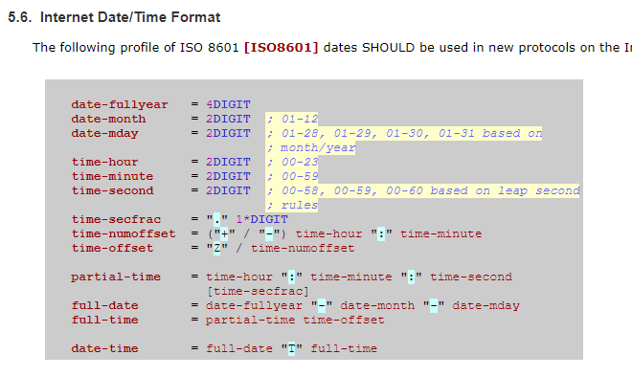
As can be seen above, the scheduled location time is defined as a time instance in the LCS message, AMF service API and GMLC service API.

Question1: Do companies agree that scheduled location time is an absolute time in LPP spec?
Company | Yes/No | Comments
Fraunhofer | Yes
CATT | No | We prefer window, because window seems more flexible than an absolute time in LPP considering the implementation in UE side. BTW, there is no IETF spec RFC3339 in the reference list in TS 37.355, so LPP doesn’t follow the time definition in CT4.
Qualcomm | Yes | Absolute time (e.g., UTC, GNSS) can be one CHOICE. Relative time (in seconds) and network time should also be allowed (i.e., native time bases for the individual positioning methods).
ZTE | Yes | No time window is mentioned and required by SA2
Apple | Yes
Xiaomi | Yes
Ericsson | Yes | However, do we also not need periodic schedule location time T; for example every 10mins from Time T.
vivo | Yes | To align with the following definition in SA2:  Scheduled Location Time: a future global time (e.g. UTC) at which a UE is to be located.
InterDigital | Yes
Lenovo, Motorola Mobility | Yes | To align with SA2 and CT4
Intel | Yes | We think having absolute time works fine.
Huawei, HiSilicon | Yes
Nokia | Yes | Prefer a single time base in 37.355 aligned to that in SA/CT specifications. In the worst case, relative time may also be OK but not sure how practical the LTE or NR network time is.

Summary:

Issue2: UE capability
The following has been included in the summary for LPP spec for the list of open issues for the UE capability of schedueled location time:
R2-B4 | Capability for scheduled location request | Differentiation between UE-based and UE-assisted support and indication of time bases supported. | OTDOA-ProvideCapabilitiesscheduledLocationRequest-r17  A-GNSS-ProvideCapabilitiesscheduledLocationRequest-r17  ECID-ProvideCapabilitiesscheduledLocationRequest-r17  TBS-ProvideCapabilities-r13scheduledLocationRequest-r17  Sensor-ProvideCapabilities-r13scheduledLocationRequest-r17  WLAN-ProvideCapabilities-r13scheduledLocationRequest-r17  BT-ProvideCapabilities-r13scheduledLocationRequest-r17  NR-ECID-ProvideCapabilities-r16scheduledLocationRequest-r17  NR-DL-TDOA-ProvideCapabilities-r16scheduledLocationRequest-r17  NR-DL-AoD-ProvideCapabilities-r16scheduledLocationRequest-r17  NR-Multi-RTT-ProvideCapabilities-r16scheduledLocationRequest-r17 | Huawei, vivo, Nokia
R2-B5 | Time base(s) supported for scheduled location | Is a single time (e.g., UTC) enough for all methods? | OTDOA-ProvideCapabilitiesscheduledLocationRequest-r17  A-GNSS-ProvideCapabilitiesscheduledLocationRequest-r17  ECID-ProvideCapabilitiesscheduledLocationRequest-r17  TBS-ProvideCapabilities-r13scheduledLocationRequest-r17  Sensor-ProvideCapabilities-r13scheduledLocationRequest-r17  WLAN-ProvideCapabilities-r13scheduledLocationRequest-r17  BT-ProvideCapabilities-r13scheduledLocationRequest-r17  NR-ECID-ProvideCapabilities-r16scheduledLocationRequest-r17  NR-DL-TDOA-ProvideCapabilities-r16scheduledLocationRequest-r17  NR-DL-AoD-ProvideCapabilities-r16scheduledLocationRequest-r17  NR-Multi-RTT-ProvideCapabilities-r16scheduledLocationRequest-r17 | vivo, Nokia, ZTE

First, for the differentiation of UE-based and UE-assistaed support for the time base, the following has been captured in the current LPP spec, take DL-TDOA, which supports both UE-based and UE-assistaed positioning, as an example.

It can be seen that for the support of different time bases, e.g., utcTime, networkTime, etc., the capability report is differentiated in terms of positioningModes, in terms of UE-based, UE-assisted, standalone
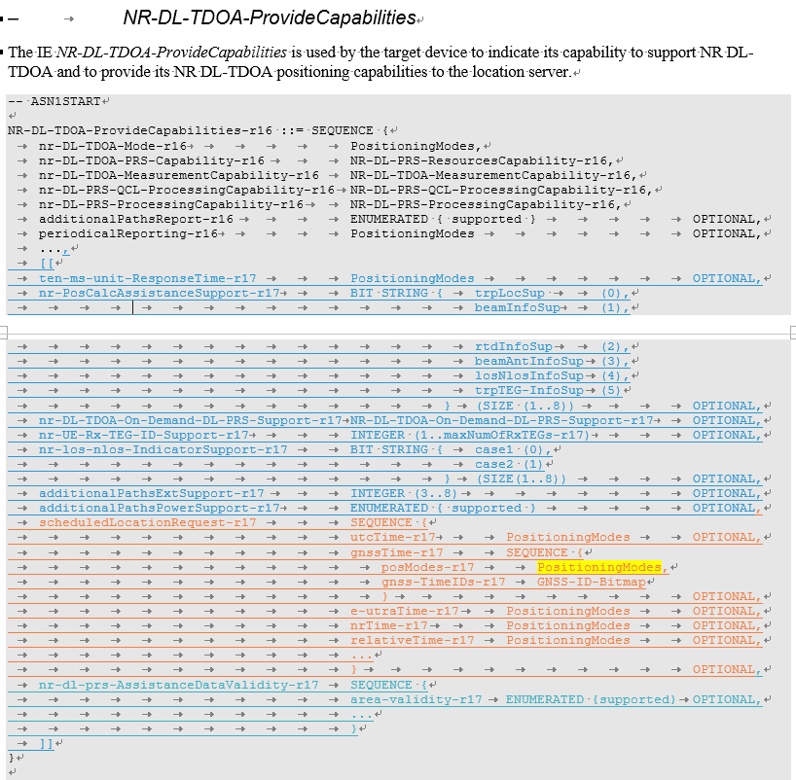
It should be further discussed whether it is necessary for the UE capability reporting for positioning methods that support multiple positioning modes to differentiate its UE capability of time based for different positioning modes.

Question2: Do comapies agree that it is necessary for the UE capability reporting for positioning methods that support multiple positioning modes to differentiate its UE capability of time based for different positioning modes?
Company | Yes/No | Comments
CATT | Yes | We are fine to define the capability for positioning methods considering different UE implementation.
Qualcomm | Yes | The support of time base(s) and positioning modes can be combined (as in similar other capabilities; e.g., periodic reporting).  UE support may be different for UE-based or UE-assisted mode.
ZTE | No | It is not much necessary to differentiate UE capability for different modes. We fail to see the case that UE is supportive of getting measurements+calculates position before scheduled location time in UE-based mode, however the UE is unable to only get measurements before a restrict time in UE-assist mode, and vice versa
Apple | Yes | UE capabilities for this featue may differ in different positioning method.
Xiaomi | Yes | Define UE capabilities for different positioning mode is more flexible for UE.
Ericsson | No | Agree with ZTE. The motivation to have different capability per method is not clear. It is unclear as why UE supporting location Time T feature will have different capability based upon which mode the UE operates in.
vivo | No | Agree with ZTE. Fine with the intention to provide flexibility if essential. However, if a UE can support UE-based positioning and UE-assisted scheduled location, it shall support UE-based scheduled location.
InterDigital | Yes | We share same understanding with QC and Apple
Lenovo, Motorola Mobility | Yes, w/comments | We are also fine to support if the idea is that different positioning methods may vary in measurement time and positioning calculation, which may affect the scheduled location time T. Do not see a clear motivation to differentiate between UE-assisted and UE-based positioning.
Intel | Yes
Nokia | No | Just adds complexity to IOT test efforts. Prefer to minimize the time bases supported and provide the same level of support for both positioning modes.

Summary:

Furthermore, in the current indication of scheduled location time, the indication can be via different format based on different time bases:
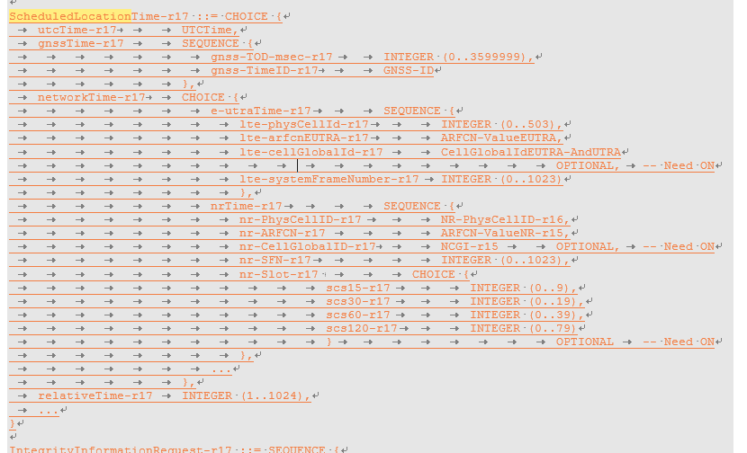

Question3: Do companies agree that the indication of scheduled location time can be based on different time bases?
Company | Yes/No | Comments
CATT | Yes | If the scheduled location time to UE is agreed, the time may be different time bases. Different time bases may be supported by different UE because of different positioning methods/mode supported by UE.
Qualcomm | Yes
ZTE | Yes | If UE is scheduled with A-GNSS positioning, UE should be provided GNSStime and networktime as cheduled location time.
Apple | Yes
Xiaomi | No | We think UTC time is sufficient for all the positioning methods.
Ericsson |  | Not strong view but yes UTC time as such should also work for all positioning methods.
vivo | No | Referring to response time, only be one format is enough for scheduled location time. If UE cannot convert UTC to a suitable time format, then it cannot support the scheduled location.  However, we are fine to compromise if the majority prefer the different time formats to fit in with different positioning methods. In that case, we are wondering whether this could be achieved by a single time format restricted by ‘CHOICE’ if the LMF would the UE to perform measurements of multiple positioning methods in a single location information request.
InterDigital | Yes
Lenovo, Motorola Mobility | Yes | Ok to support different time bases
Intel | Yes | Agree with CATT
Huawei, HiSilicon | Yes
Nokia | No | Prefer a single time base in 37.355 aligned to that in SA/CT specifications. In the worst case, relative time may also be OK but not sure how practical the LTE or NR network time is.

Summary:

Preconfigured Assistance Data
Regarding the preconfigured AD, the following issues have been listed in the open issue list:

Validity condition for pre-configured assistance data-area ID  FFS on details and whether it would be included in RRC broadcast.  FFS if there would be Signaling for multiple area IDs in the same instance. Signalling details can be discussed in the LPP running CR discussion.  FFS on the meaning/ value range of area ID | Yes | Status: check the status of LPP email discussion 116bis-628  check the status of RRC email discussion 116bis-631  RAN2#116bis:  Proposal 3a (modified): Pre-configured DL-PRS assistance data can be associated with a “validity area” at least in LPP. FFS on details and whether it would be included in RRC broadcast.  Pre-configured DL-PRS assistance data can consist of multiple instances, where each instance is applicable to a different area within the network. FFS on additional specification impacts and whether this can already be supported with the agreement made that pre-configured DL-PRS assistance data can be associated with a “validity area”. Single instance of AD is not excluded; FFS if there would be ignaling for multiple area IDs in the same instance. Signalling details can be discussed in the LPP running CR discussion.

Issue3: definition of area ID
Currently in the LPP CR, the Area ID is listed as FFS and it has also been listed in the open issue list above. Since this issue has not been discussed in any detail in the previous meeting, we the issue should be handled by the company input to the next R2 meeting.

Summary:
Thus we propose the following:
Proposal : How to define the area ID for pre-confguerd PRS should be addressed based on the companies’ contribution to the future meetings.

Issue4: Signaling of multiple area ID in the same instance
When multiple area IDs are configured within a single instance of PRS assistance data, the LMF needs to know which set of assistance data the UE is using and this set of AD corresponds to which area. During the last R2 meeting, it has been proposed that the area ID should be sent to the LMF when UE reports the PRS measurements to the LMF.

Question4: Do companies agree that the UE should report area ID along with PRS measurement to the LMF?
Company | Yes/No | Comments
Fraunhofer | Yes | It simplifies if we assume that an instance of an AD contains only one validity area, and multiple instances address different validity areas. Then reporting Area ID uniquely identifies the AD.  Otherwise, we need to report AD instance too, to ensure that the LMF and the UE have the same understanding of the AD used by the UE.
CATT | No | The LMF knows the cell ID which is associated with the area ID in measurement report, according to the existing measurement report data structure. So it seems no need to report the area ID.  NR-DL-TDOA-MeasElement-r16 ::= SEQUENCE {  dl-PRS-ID-r16 INTEGER (0..255),  nr-PhysCellID-r16 NR-PhysCellID-r16 OPTIONAL,  nr-CellGlobalID-r16 NCGI-r15 OPTIONAL,  nr-ARFCN-r16 ARFCN-ValueNR-r15 OPTIONAL,
Qualcomm | No | The LMF needs to know from which TRPs measurements have been reported and not which set of assistance data the UE was using. For identifying TRPs, cell-IDs should be sufficient.
ZTE | No | LMF does not need to know which AD the UE uses, this seems to be no benefit to the latter positioning procedure
Apple | No | Unnecessary complexity
Xiaomi | No
Ericsson |  | In order to lower signaling overhead and also to support schedule location Time T; UE position has to be computed at a future time T; from LMF perspective it may not be clear as where UE will be in future time T. Hence, LMF may need to provide multiple AD.  When Multiple AD has been provided; with tag based upon area IDs; UE should also report as which ID it used to perform the measurement.  However, as suggested by CATT and QC if Cell ID based can uniquely identify then we are fine. UE may not need to report the separate area ID.
vivo |  | Depends on the target range of the valid area of pre-configuration. If the target area is too wide to be identified by an existing ID, then an additional ID is essential. However, currently, we do not see a particularly strong need for this.
InterDigital | No | As indicated by CATT and QC, so long as the cell-IDs are reported there is no need for reporting Area ID
Lenovo, Motorola Mobility | See comments | The main point is to associate validity of a single instance of pre-configured AD with different area IDs is dependent on the mobility of the UE within a large geographic area, where if the reported PRS measurement from the TRPs extends beyond the value range of the PCI IDs {0…1007}. For all the other cases, where the area is smaller we are fine to stick with the existing PCI ID mechanism.
Intel | See comment | As Lenovo mentioned, the key point is some form of association should be supported between AD and area ID in order to meet the validity area criterion as previously agreed. The UE can determine which pre-configured AD is to be used based on this area ID and include this alongside the PRS measurement to identify which AD was used for PRS measurement. However, we do agree that it also depends on how this area ID is defined
Huawei, HiSilicon | No | Within the LPP measurement report, there is already cell identities identify which assistance data the UE has used
Nokia | No | Agree with Qualcomm that LMF only needs to know which TRP was used for measurements. There should be a 1:1 mapping of area ID and a pre-configured assistance data instance.

Summary:

Issue5: RRC broadcast of area ID

PRS assistance data can be broadcasted in the RRC system information by posSIB. Then, whether the area ID can also be included in the posSIB has been raised and listed in the open issue list.

Question5: Do companies agree that the area ID can be broadcasted in the system information?
Company | Yes/No | Comments
Fraunhofer | Yes | In our understanding, the simplest form of area ID can be group of cells where the UE is connected/camped. This allows the AD the UE has acquired in one cell to be used in a group of cells, without having to newly acquire the information.  In case the areaID contains only one cell, this corresponds with the Rel. 16 behaviour.
CATT | Yes | The motivation of area ID is that: when the pre-configured assistance data are larger than the assistance data in ProvideAssistanceData(more DL-PRS), the area ID may help UE improve the efficiency of these assistance data.  The same thing happens when the pre-configured assistance data is broadcast. The area ID in pre-configured assistance data may also help UE improve the efficiency of searching DL-PRS with area ID.  The area ID associated NR-DL-PRS-AssistanceDataPerTRPs show the DL-PRS valid with the same area-ID of the serving cell where UE stays, not only in posSIB of pre-configured assistance data, but also in the pre-configured assistance data in LPP.  Area-ID  This field, if present, specifies the Area ID of the network area to which the TRP for which the NR-DL-PRS-AssistanceDataPerTRP is provided belongs to. The associated NR-DL-PRS-AssistanceDataPerTRPs with the same area-ID are available in the concerned area.
Qualcomm | Yes | This should be “automatically” supported if defined in LPP; similar to the value tag/expiration time (which are also defined in LPP)
ZTE | Yes
Apple | Yes
Xiaomi | Yes
Ericsson | No, however | Maximum posSIB size is 3000 bits and hence there will be need for several SI messages to transfer this. It may not be effective.  As QC mentioned in section 4.4; more than 256 TRPs as such would require 9000 bytes of AD; and that is why we do not see broadcast is good solution  However, the main aim should also be that from NW/Operator perspective; it should not be given for free. Hence, if majority companies want broadcast-based support; we prefer to have a separate posSIB so operator can tie separate subscription to such service; i.e even if UE is capable of receiving AD with maximum area ID; it may not obtain if its subscription is not to that level.
vivo | Yes
InterDigital | Yes
Lenovo, Motorola Mobility | Yes
Intel | Yes | The serving cell needs to broadcast the AreaID as part of system information to allow the UE to determine validity of pre-configured DL-PRS assistance data
Huawei, HiSilicon | Yes
Nokia | Yes

Summary:

Issue6: Support of ultiple AD instance for pre-configured PRS
In the running LPP CR, the following issue has been raised on whether it can already be supported by the current LPP spec. The following observation has been made by the LPP rapporteur in the editor’s note:
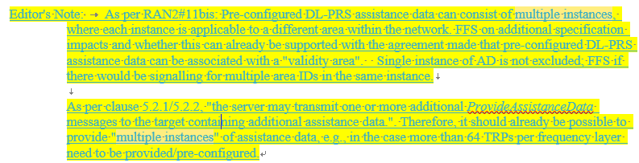
Thus, we ask the following question:

Question6: Do companies agree that multiple AD instances can already be supported by the current LPP spec?
Company | Yes/No | Comments
Fraunhofer | No | In Rel. 16, there was only possibility to provide a single NR-DL-PRS-AssistanceData instance, which was shared among TDOA, AoD and multi-RTT. Therefore, current specifications, as they stand, do not allow multiple assistance data without clarification.  We need to clarify how multiple AD instants are differentiated from single AD instants. One way is to provide different identifiers (e.g. different area ID), other way is to provide them as lists of NR-DL-PRS-Assistance data.  Since the preconfigured assistance data can be reused across multiple positioning sessions, it is important to define how the AD is maintained.  In particular, our opinion is that if the AD in ProvideAssistanceData has the same Area ID as the AssistanceData stored by the UE, then the UE shall discard the old AD instance and use the newly provided instance.  This is similar to Rel. 16 behaviour, where the old AD is replaced by the newly provided AD and used for reporting measurements. Now, the old AD instance with the same validity area as the new AD instance will be replaced. The other instances will be left as they are (stored – depending on UE capability on how many instances it will store).
CATT |  | Disagree Fraunhofer’s comments on area ID. Once there is new assistace data which is the same TRP from network, the stored assistace data of this TRP should be discarded according to the existing protocols. This is irrelative with area ID.
Qualcomm | Yes | If each TRP has an “area id” in addition to the existing Cell-IDs, it does not matter if the assistance data are provided in a single message or in multiple messages. Multiple messages would only be needed in case there are assistance data for more than 256 TRPs provided. But this can be handled with multiple Provide Assistance Data messages, in the same way as it is handled for other rmethods (e.g., GNSS). In addition, more than 256 TRPs would anyhow need segmentation, since it may not fit into a 9000 bytes SDU/PDU.
ZTE | No | We assume the intention of this proposal is to send multiple instances of pre-configured AD at one time to reduce latency, rather than send multiple Ads in sequence
Apple |  | In our understanding multiple AD instances as such may not be supported, but that does not mean they should be introduced.
Xiaomi |  | If the intention of multiple AD instances is to send multiple AD instances at one time, the current LPP spec may not support it.
Ericsson |  | As QC mentioned; more than 256 TRPs as such would require 9000 bytes of AD; and that is why we do not see broadcast is good solution.  However, in terms of LPP; we do not see any issue to provide Multiple AD; yes multiple segments in connected mode can be sent efficiently and UE may then go to inactive mode and perform the measurements.  If NW happens to provide multiple AD using several provideAD; and the AD is associated with an area ID tag (group of cell IDs) and while reporting if UE mentions the cell ID which can uniquely resolve which area ID was used to perform the measurement, then we are fine with how QC suggests.  Only thing required is how many Area IDs can be provided to UE can be based upon UE capability and an operator may tie the provisioning of AD with UE subscription; i.e not every UE should get multiple AD for free.
vivo | No | To support mobility, the pre-configured assistance data may include a list of PRS configurations with the different validity areas. For instance, in the following figure, the pre-configured PRS configuration (i.e. list 1) of TRP 1~3 are valid when UE is camping on TRP 1/2, and the pre-configured PRS configuration (i.e. list 2) of TRP 3~5 are valid when UE is camping on TRP 3/4/5.  Due to the priority rule in RAN1, the same pre-configured PRS resources associated with different validity areas may be in different orders as the priority in different areas can be different. Taking TRP3 as an example, the PRS resources 1&2 are higher priority compared with PRS resources 3&4 in list 1 while are a lower priority in list 2.  Therefore, we think the validity area associated with each pre-configured assistance data can be a list of cells that the target UE may camp on. And the pre-configured PRS resources can be:
  -- ASN1START
  NR-DL-TDOA-ProvideAssistanceData-r16 ::= SEQUENCE {
  nr-DL-PRS-AssistanceData-r16 NR-DL-PRS-AssistanceData-r16 OPTIONAL, -- Need ON
  nr-DL-Preconfigured-PRS-AssistanceData-r17 SEQUENCE (SIZE (1..nrMaxPreconfiguration-r17)) OF NR-DL-Preconfigured-PRS-AssistanceDataPerArea-r17 OPTIONAL, -- Need ON
  nr-SelectedDL-PRS-IndexList-r16 NR-SelectedDL-PRS-IndexList-r16 OPTIONAL, -- Need ON
  nr-PositionCalculationAssistance-r16
  NR-PositionCalculationAssistance-r16
  OPTIONAL, -- Cond UEB
  nr-DL-TDOA-Error-r16 NR-DL-TDOA-Error-r16 OPTIONAL, -- Need ON
  ...
  }
  NR-DL-Preconfigured-PRS-AssistanceDataPerArea-r17 ::= SEQUENCE {
  validityCellList-r17 SEQUENCE (SIZE (1..nrMaxValidCell)) OF NCGI-r15,
  nr-DL-PRS-AssistanceData-r16 NR-DL-PRS-AssistanceData-r16
  }
  -- ASN1STOP
Lenovo, Motorola Mobility | Yes | Our understanding is that multiple instances of AD may in any case need to provided depending on the number of TRPs served by the pre-configured AD e.g, as QC mentioned if TRPs>256, which may be highly probable since the pre-configured can extend across multiple wide geographic areas.
Intel |  | We have similar understanding as Fraunhofer that based on the association between AD and area IDs, the stored AD at the UE for a given area ID can be updated such that the UE shall discard the old AD instance and utilize the new one. In general, this should be true regardless of how area ID is defined relative to TRPs.
Huawei,HiSIlicon | No
Nokia | Yes, can already be supported | With the agreements on pre-configured assistance data, area validity associated with a pre-configured assistance data and with the current LPP signaling ability to send ProvideAssistanceData multiple times to the UE, it does seem like it is possible to already support multiple instances of assistance data to allow UE to store and use it.

Summary:

Issue 7: remaining issues for preconfigured AD
Validity Conditions for DL-PRS Assistance Data  Proposal 1: RAN2 to discuss further whether pre-configured assistance data should be associated with a “validity time” or not.  Proposal 2: RAN2 to discuss further whether pre-configured assistance data could be explicitly modified or released. | ? | Status: No majority see R2-2201875  P1: (9:6)  P2: (8:4 and 2 neutral).  Ericsson commented that Given that we have also agreed that multiple instance of AD can be provided, and UE may store it based upon its memory capacity; UE may discard the last stored AD if it happens to obtain new; it can still however store multiple latest AD.  Suggestion: stop the discussion on them considering RAN2 has discussed this issue several meeting. Then it means the UE shall discard any stored configuration when receiving a new configuration from the network. .  Low priority, company tdoc

As recommended by the moderator of the open issue list, this issue does not have high priority for the current discussion. Thus, companies are invited to propose company tdoc on this.
Proposal: Companies should propose company contributions on (a) whether preconfigured AD can be explicitly modified or released (b) validity time is defined for the pre-configured AD.

MG enhancement
The following has been included in the open issue list for MG enhancement. The issues that need to be addressed in this discussion are highlighted in yellow
Stage 2 text | ? | Status: draft in stage 2, check the status of stage 2 email discussion 116bis-629  Note: need to be updated based on the details of RRC/MAC and NRPPa;
Pre-configuration of MG(s) in RRC (Each MG in the pre-configuration is associated with an ID)  FFS on MG configuration (R2 and R1 to resolve) | Yes | Status: check the status of RRC email discussion 116bis-631  RAN2#116bis:  Proposal 4: The pre-configured Measurement Gap Configurations for Positioning are provided via RRCReconfiguration message. The pre-configured Measurement Gap Configurations for Positioning are included in IE MeasGapConfig.  Proposal 5: The content of the pre-configured Measurement Gap Configurations for Positioning includes at least the existing measurement gap parameters together with an ID identifying each Measurement Gap Configuration for Positioning.  Proposal 6: The existing RRC LocationMeasurementIndication procedure to request the positioning measurement gaps can still be used by a UE, even when pre-configured measurement gaps are provided to the UE.
UL MAC CE for MG activation/deactivation request  Other parameter are FFS.  FFS on Exact format of the UL MAC CE for MG activation/deactivation request and DL MAC CE for MG/PPW activation/deactivation command, e.g., fields, LCIDs, etc (R2 to resolve)  How to trigger the UL MAC CE for MG activation/deactivation request (R2 to resolve) | Yes | Status: check the status of MAC email discussion 116bis-632  RAN2#116bis:  Proposal 5a: A new UL MAC CE for positioning measurement gap activation and deactivation request is introduced.  Proposal 5b: The new UL MAC CE for positioning measurement gap activation and deactivation request includes at least the ID of the pre-configured positioning measurement gap configuration for which the activation/deactivation is requested.  Proposal 5e: The Scheduling Request should be triggered when there is no PUSCH and UL MAC CE for positioning measurement gap activation/deactivation request is triggered.
DL MAC CE for MG activation/deactivation  Other parameter are FFS.  FFS on Exact format of the UL MAC CE for MG activation/deactivation request and DL MAC CE for MG/PPW activation/deactivation command, e.g., fields, LCIDs, etc (R2 to resolve)  How to trigger the UL MAC CE for MG activation/deactivation request (R2 to resolve) | Yes | Status: check the status of MAC email discussion 116bis-632  RAN2#116bis:  Proposal 5c (modified): A new DL MAC CE for positioning measurement gap activation and deactivation command is introduced for positioning latency reduction. LS to RAN1/4 indicating our conclusion, and confirming that DL MAC CE can also be used for positioning measurement gap deactivation as well as activation (to be drafted by email).  Proposal 5d: The new DL MAC CE for positioning measurement gap activation and deactivation command includes at least the ID of the pre-configured positioning measurement gap configuration which has been configured/activated by the gNB.
UE capabilities for MG enhancements | Yes | Status: check the status of RAN1 feature list  RAN2 also needs to discuss how to capture UE capability based on RAN1 feature list R1-2111810R1-2200767  RRC:27-10, 27-11  LPP:27-10a,
NRPPa change | Yes | Status: RAN3 to decide;
QC:  Measurement gap activation via LMF"  The gNB may activate the pre-configurated measurement gap upon receiving the request from a UE or LMF."  Question:  Is the LMF activation of measurement gaps only for pre-configured measurement gaps? It's not clear to me from the RAN1 LS.  [Rapp] Good question, I think the LMF may activate the measurement even if there is no preconfigured MG. But we need to discuss this. Added it as open issue. | Yes | Rapp, this can be a general issue for MG. (from stage 2 discussion)

Issue8: MG preconfiguration
In the last R2 meeting, the following have been agreed for the MG preconfiguration
Proposal 4: The pre-configured Measurement Gap Configurations for Positioning are provided via RRCReconfiguration message. The pre-configured Measurement Gap Configurations for Positioning are included in IE MeasGapConfig.
Proposal 5: The content of the pre-configured Measurement Gap Configurations for Positioning includes at least the existing measurement gap parameters together with an ID identifying each Measurement Gap Configuration for Positioning.
However, in the current running RRC CR, the configuration for MG has not been captured. Since further inputs are needed from R1 on the positioning MGs that can be preconfigured, e.g., maximum number of pre-configured MG for positioning and so on. We think we should wait for the further R1 inputs on the RRC configuration for pre-configured MG. And it can be up to the decision of the RRC rapporteur on how to capture it in the RRC spec and reviewed during the running CR email discussion

Proposal: Wait for R1 inputs on pre-configured positioning MG configuration and up to the RRC rapporteur how to capture in the RRC spec.

Issue9: LCID for DL/UL MAC CE for MG
Another issue to be dicussed is whether to adopt LCID or eLCID for UL/DL MAC CE for MG.

Question7: Whether LCID/eLCID should be adopted for UL MAC CE for MG activation/deactivation request and DL MAC CE for MG activation/deactivation command?
Company | UL MAC CE  (LCID or eLCID) | DL MAC CE  (LCID or eLCID) | Comments
CATT | eLCID | eLCID
Qualcomm | eLCID | eLCID
ZTE | eLCID | eLCID | The R16-introduced functions in MAC spec uses eLCID, and we think R17 functions should use one-octet eLCID, also.
Apple | eLCID | eLCID
Xiaomi | eLCID | eLCID
Ericsson | eLCID | eLCID
vivo | eLCID | eLCID
InterDigital | eLCID | eLCID
Lenovo, Motorola Mobility | eLCID | eLCID
Intel | eLCID | eLCID
Huawei, HiSilicon | eLCID | eLCID
Nokia | eLCID | eLCID

Summary:

Issue10: Applicability of LMF-based MG activation request
In the R1 LSs for preconfiguation of MG/PPW, the following has been included:
R2-2200074 LS on latency improvement for PRS measurement with MG (R1-2112784; contact: Huawei) RAN1 LS in Rel-17 NR_pos_enh To:RAN2, RAN3
RAN1#107-e reached the following agreement on PRS measurement with preconfiguration of MG(s) and MG activation request by UE.

Agreement
Preconfiguration of MG(s) in RRC is supported from RAN1 perspective.
  - Each MG in the preconfiguration is associated with an ID
  - The information in the UL MAC CE for MG activation request by the UE can be one ID associated with the preconfiguration of the MG
  - Send an LS to RAN2 and RAN3

In addition RAN1 understands it is up to RAN2 and/or RAN3 to decide how gNB determines the preconfiguration of MG(s).

RAN1 also agreed MG activation request to the gNB by the LMF in RAN1#106bis-e.

Agreement:
Support the following options (in the agreement made in RAN1#106-e) for a new mechanism of MG activation request for the purpose of positioning.
- Option 2: by UE (via UCI or UL MAC CE)
  - Select only one of UCI and UL MAC CE in RAN1#106bis-e
- Option 1: by LMF (via an NRPPa message)
  - Note: This is transparent to the UE

As the follow-up, RAN1 concluded in RAN1#107-e that it is up to RAN3 to design the necessary information to be transferred in the NRPPa message.

R2-2200089 LS on PRS processing window (R1-2112881; contact: Huawei) RAN1 LS in Rel-17 NR_pos_enh To:RAN2, RAN3
RAN1 discussed the PRS processing window for PRS measurement outside the measurement gap, and reached the following agreements in RAN1#107-e.

Agreement
PRS processing window request to the gNB by the LMF is supported from RAN1 perspective.
  - It is up to RAN3 to design the necessary information to be transferred in the NRPPa message.
  - Note: It is up to gNB to determine the usage of measurement gap or PRS processing window
  - Include it in the LS to RAN2 and RAN3.

Agreement
For PRS processing window configuration and indication, at least the following mechanism is supported
  - RRC (pre-)configuration for PRS processing window configuration and DL MAC CE activation for PRS processing window, respectively.
Include it in the LS to RAN2 and request RAN2 to decide whether DL MAC CE is feasible for this indication.

During the discussuion for open issue list, companies make the comment that whether the activation/deactivation request from LMF can also be used for normal MG configuration instead of being limited to pre-configured MG. The thinking from the moderator is that this depends on how LMF makes the request. If the LMF is aware of the MG preconfiguration and makes the request by MG id, it is obvious that in this case, it can only be applicable for pre-configured MG. But if the LMF makes the request by exact MG configuration, like the LocationMeasurementIndication RRC message, it can be generally applicable for both pre-configured MG and normal MG configuration.
While in the LS from R1, not such information on the request from the LMF given. The moderator thinks that the LMF should not be made aware of the MG configuration since this is related to the scheduling for the gNB.

Question8: Do companies agree that the MG activation/deactivation request from the LMF can also be applicable to pre-R16 MG configuration in addition to positioning MG preconfiguration?
Company | Yes/No | Comments
CATT | No | In principle we share the same understaning with the rapporteur, that the LMF should be aware of the MG configuration. But to note that the R16 MG configuration is always on and only when UE decides that the current MG is not enough, it will trigger the MG request to NG-RAN node. From this perspective, we are wondering why LMF should request activation/deactivation of the R16 MG configuration, since LMF cannot be aware of any information of the current RRM MG.  And further as we know, the activation/deactivation from LMF is specific to R17 newly introduced pre-configured positioning MG, we prefer not to mix the R17 feature with R16 mechanism.
Qualcomm |  | I understand the purpose of LMF MG activation is to pre-empt the UE request (i.e., reduce latency). LMF sends Location Request to the UE and MG request to the gNB at the same time. This should be independent on whether a MG is pre-configured or not. Otherwise, I obviously don't understand the purpose of this feature…
ZTE | Yes | In RAN1’s discussion, one case is that LMF only tells gNB the PRS configuration, and then gNB gives an appropriate MG to LMF, just like LocationMeasurementInfo in R16.  We think it is also feasible to support LMF to pick up MG from pre-configured MGs, but it is RAN3’s business
Apple | No | This should be further discussed, preferably based on contributions. In the absence of such discussion, we are inclined to support the moderator’s view.
Xiaomi | No | Based on RAN1 discussion, we think the MG activation/deactivation request from the LMF is introduced for R17 pre-configured MG.
Ericsson |  | It can be left to NW implementation. LMF may send similar to RRC LocationMeasurementIndication and it is upto gNB whether to invoke Rel-16 or Rel-17 functionality.  One aspect that is needed is that to minimize RRC and MAC interaction all the time; once LMF provides the MG information to gNB; gNB should be able to preconfigure and activate the gap at the same time.
vivo | RAN3 to decide | RAN3 already agreed to include similar information to that in the RRC LocationMeasurementIdication message in the MG activation request message. In our understanding, the decision of gNB to activate the pre-MG or configure a legacy MG is up to gNB implementation.
InterDigital | No | We tend to share the same understanding with the moderator that the LMF may not be made aware of the pre-R16 or R17 MG configurations supported by gNB. In such scenario not mixing the pre-R16 and R17 features, as indicated by CATT, seems reasonable.
Lenovo, Motorola Mobility | No | Our understanding is that the LMF activation request is specifically meant for the pre-configured MG feature. Also agree with CATT that the LMF may not be aware of the R16 MG configuration instances.
Intel |  | While the discussion in RAN1 was mainly just focused on pre-configured MG case, we are fine if companies want this to be applicable to normal MG case as well. But we wonder if this can be left to RAN3 since it also relates to NRPPa signaling.
Huawei, HiSIlicon | Yes
Nokia |  | Check with RAN1 since they agreed the option for LMF activation of MG using NRPPa signaling. Since RAN3 will be working on NRPPa signaling it is worth checking with them also as to how they plan to implement the NRPPa signaling.

Summary:

Issue11: Triggering of the UL MAC CE
As can be seen above, how to trigger the UL MAC CE for MG activation/deactivation request has also been listed in the open issue list. However, there is no previous discussion/proposal on this. Companies are thus welcomed to provide companies tdoc on this for proper solution.

Proposal: Companies are invited for company tdocs on how to trigger the UL MAC CE for MG activation/deactivation request.

PPW
The following has been included in the open issue list for PRS processing window. The issues that need to be addressed in this discussion are highlighted in yellow
Stage 2 text | ? | Status: draft in stage 2, check the status of stage 2 email discussion 116bis-629  Note: need to be updated based on the details of RRC/MAC and NRPPa;
Pre-configuration of PPW  FFS:Whether PRS processing window configuration is provided per BWP or not is up to RAN1 to decide.  FFS: Whether UE can be configured with multiple PRS processing windows should be decided by RAN1.  FFS on PPW configuration (R2 and R1 to resolve)  FFS on the max number of PPW configurations (from Stage 2 discussion) | Yes | Status: check the status of RRC email discussion 116bis-631  RAN2#116bis:  Proposal 7: The PRS processing window configuration is provided via RRCReconfiguration message. Whether PRS processing window configuration is provided per BWP or not is up to RAN1 to decide.
UL MAC CE for PPW activation request  Whether UL MAC CE can also be used for PRS processing window activation/deactivation should be decided by RAN1. | ? | Status: unrelated to RAN2;
DL MAC CE for MG activation/deactivation  FFS on Exact format of the DL MAC CE for MG/PPW activation/deactivation command, e.g., fields, LCIDs, etc (R2 to resolve)  FFS on (R2 to resolve) PDCCH monitoring during RAR window and contention resolution timer | Yes | Status: check the status of MAC email discussion 116bis-632  RAN2#116bis:  Proposal 8: A new DL MAC CE for PRS Processing Window activation and deactivation command is introduced.  Proposal 9: The new DL MAC CE for PRS Processing Window activation and deactivation command includes at least the ID of the pre-configured PRS Processing Window configuration, at least in the case when multiple PRS Processing Windows can be configured.  Proposal 10: The UE ignalin related to the PRS Processing Window feature is captured in the MAC specification.
UE capabilities for MG enhancements | Yes | Status: check the status of RAN1 feature list  RAN2 also needs to discuss how to capture UE capability based on RAN1 feature list R1-2111810R1-2200767  RRC: 27-3-2,  LPP: 27-3-3
NRPPa change | Yes | Status: RAN3 to decide;

Issue12: RAR window/contention resolution timer and PPW
In legacy MAC spec, it has been specified when the RAR window or contention resolution timer is running while the UE is in measurement gap, the UE should continue to monitor PDCCH, aka, the RAR window and contention resolution timer have higher priority than MG.

For PPW, we think the same should be applied that since RACH has already been initiated by the UE, the UE should try to terminate the RACH procedure by monitor PDCCH during RAR window and contention resolution timer.

Question9: Do companies agree that UE should monitor PDCCH during RAR window/msgB window ot contention resolution timer for the affected symbols by PPW?
Company | Yes/No | Comments
CATT | Maybe | Maybe but better to double check with RAN1.
Qualcomm |  | Agree with CATT. This looks more RAN1 centric.
ZTE | Yes | As RAN1’s agreement, in PPW, UE can normally monitor PDCCH when UE capability indicates the reception of PDCCH/PDSCH/CSI-RS is of higher priority.
Apple |  | Agree to leave this to RAN1 to decide.
Xiaomi | Yes | We are also fine to double check with RAN1.
Ericsson |  | Agree to leave this to RAN1 to decide.
vivo |  | Agree to leave this to RAN1 to decide.
InterDigital |  | Up to RAN1 to decide
Lenovo, Motorola Mobility |  | Also fine to leave it up to RAN1.
Intel |  | We assume this is needed but anyway ok to check with RAN1
Huawei, HiSIlicon | Yes | This is R2’s business
Nokia |  | This should be checked with RAN1.

Summary:

Issue13: DL MAC CE for PPW activation/deactivation command
Similar to MG activation/deactivation MAC CEs, for PPW, we have the following question:

Question10: Whether LCID or eLCID should be adopted for DL MAC CE for PPW activation/deactivation command?
Company | LCID/eLCID | Comments
CATT | eLCID
Qualcomm | eLCID
ZTE | eLCID | Same as pre-configured MG design
Apple | eLCID
Xiaomi | eLCID
Ericsson | eLCID
vivo | eLCID
InterDigital | eLCID
Lenovo, Motorola Mobility | eLCID
Intel | eLCID
Huawei, HiSilicon | eLCID
Nokia | eLCID

Summary:

Issue14: Response Time granularity
In the current LPP running CR, the following has been captured for the response time
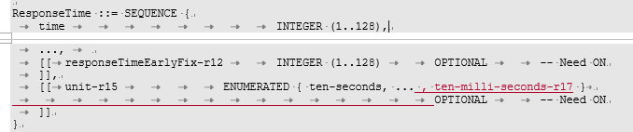
Thus, a unit of ten-milliseconds has been introduced. Within the open issue list, it is proposed to confirm on this granularity of the response time

Question11: Do company agree to have the 10 milliseconds granularity in the responseTime?
Company | Yes/No | Comments
CATT | Yes
Qualcomm | Yes
ZTE | Yes
Apple | Yes
Xiaomi | Yes
Ericsson | Yes
vivo | Yes
InterDigital | Yes
Lenovo, Motorola Mobility | Yes
Intel | Yes
Huawei, HiSilicon | Yes
Nokia | Yes

Final WF:

Other
In this section, companies are invited to provide inputs on the remaining issues that need to be addressed for latency reduction for R17 positioning:
Company | Proposed remaining issues
CATT | Issue 1: The format of the UL/DL MAC CE on MG/PPW activation/deactivation.  Issue 2: FFS on whether we need to capture PPW, MG configuration procedure in stage 2 since we did not do that for posSRS

Conclusions

