3GPP TSG-RAN WG2 Meeting #116-e R2-211xxxx
Electronic, 1st – 12th Nov, 2021

Agenda item: 8.7.1
Source: OPPO
Title: Summary of [621]
Document for: Discussion and decision

Introduction
This is for the discussion of the following:
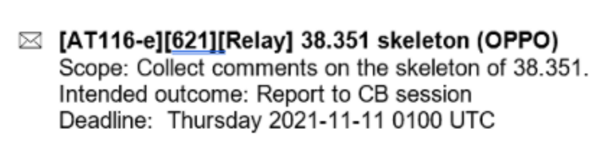
Company | Name | E-mail

Phase-1 Discussion
Based on the submitted Skeleton,
R2-2109400 Running CR for TS 38.351 OPPO draft TS Rel-17 38.351 0.0.0 NR_SL_relay-Core

There is one issue being discussed online, i.e., the naming of TS.
Rapp understand the online output includes the following points:
- “Relay” needs to be included in the name
- “L(ayer)” does not needs to be included in the abbreviation
- Some companies claims that “Sidelink” is somehow mis-leading since the adaptation layer includes Uu hop as well
Rapp would like to suggest to do have a Q in this thread on the following two options which address all the concern(s) above
- Option-1: Relay Adaptation Protocol (RAP)
- Option-2: UE Relay adaption protocol (URAP)
Q0: Which name you prefer?
- Option-1: Relay Adaptation Protocol (RAP)
- Option-2: UE Relay adaption protocol (URAP)
- Others
Company | Option | Comment

Q1: Besides naming issue in Q0, please share your additional comment on the skeleton in the following table.
Company | Comment

Conclusion

Reference
- R2-2109400 Running CR for TS 38.351 OPPO draft TS Rel-17 38.351 0.0.0 NR_SL_relay-Core

