3GPP TSG-RAN WG2 Meeting #116-e R2-211xxxx
Electronic, 1st – 12th Nov, 2021

Agenda item: 8.7.1
Source: OPPO
Title: Summary of [621]
Document for: Discussion and decision

Introduction
This is for the discussion of the following:
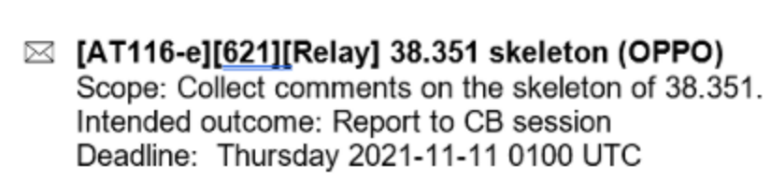
Company | Name | E-mail

Phase-1 Discussion
Based on the submitted Skeleton,
R2-2109400 Running CR for TS 38.351 OPPO draft TS Rel-17 38.351 0.0.0 NR_SL_relay-Core

Q1: please share your comment on the skeleton in the following table.
Company | Comment

Conclusion

Reference
- R2-2109400 Running CR for TS 38.351 OPPO draft TS Rel-17 38.351 0.0.0 NR_SL_relay-Core

