S3GPP TSG-RAN WG2 Meeting #116-e R2-210xxxx

Online, November 1-12, 2021

Agenda Item: 5.4.3
Source: Huawei, HiSilicon
Title: Summary of [AT116-e][003][NR15] UE Capabilities I
Document for: Discussion and decision

Introduction
This document summarizes the following offline discussion.
- [AT116-e][003][NR15] UE Capabilities I (Huawei)
Scope: Determine agreeable parts in a first phase, for agreeable parts agree on CRs. Treat R2-2109310, R2-2110969, R2-2110970, R2-2110971, R2-2110972,
Intended outcome: Report, agreed CRs if applicable
Deadline: Schedule 1

Contact from companies
Company | Email
Ericsson | lian.araujo@ericsson.com
Nokia | amaanat.ali@nokia.com
Apple | naveen.palle@apple.com
OPPO | qianxi.lu@oppo.com, duzhongda@oppo.com
vivo | xiao.xiao@vivo.com
Qualcomm Incorporated | mkitazoe@qti.qualcomm.com
CATT | zhangxiangdong@catt.cn
ZTE | li.wenting@zte.com.cn, liu.jing30@zte.com.cn
Samsung | Sb07.kim@samsung.com
Intel Corporation | seau.s.lim@intel.com
Sequans | omarco@sequans.com

Discussion

Part 1: Intended to determine agreeable parts

Reply LS on the Intra-band and Inter-band (NG)EN-DC/NE-DC Capabilties
R2-2109310 Reply LS on the Intra-band and Inter-band (NG)EN-DC/NE-DC Capabilties (R1-2108378; contact: ZTE) RAN1 LS in Rel-15 NR_newRAT-Core To:RAN2 Cc:RAN4
Rapporteur understands this LS has already been taken into account in the last meeting in [AT115-e][017][NR15] UE Capabilties III (ZTE), so no further discussion is needed in this meeting.

Clarification on intraAndInterF-MeasAndReport capability
R2-2110969 Clarification on intraAndInterF-MeasAndReport capability Huawei, HiSilicon CR Rel-15 38.306 15.15.0 0655 - F NR_newRAT-Core
R2-2110970 Clarification on intraAndInterF-MeasAndReport capability Huawei, HiSilicon CR Rel-16 38.306 16.6.0 0656 - A NR_newRAT-Core
According to current TS 38.306, the capability of intraAndInterF-MeasAndReport is mandatory supported by UE for NR MCG. The network could see this feature as mandatory supported without checking with UE capabilities in NR SA, NR-DC and NE-DC. However, it is also described that this capability applies to NE-DC when configured, which should be interpreted as mandatory with capability signalling. Thus the requirement for intraAndInterF-MeasAndReport capability in NE-DC is not clear in the current 38.306, it should be clarified to avoid possible misunderstanding between the UE and the network.
Q1 Do companies agree with the intention of the CRs above?
Company | Yes or No | Comments
Huawei, HiSilicon | Yes (proponent)
Ericsson | Yes but | We should clarify also the NR-DC case, which does not seem clear at the moment either. Hence we propose the following:  Indicates whether the UE supports NR intra-frequency and inter-frequency measurements and at least periodical reporting. This field only applies to NE-DC and SN configured measurement when (NG)EN-DC is configured. For NR MCG, For NR SA, and MN and SN configured measurement when NR-DC or NE-DC is configured, this feature is mandatory supported.
Nokia | Yes | Agree but the formulation from Ericsson should be corrected as in NE-DC only the NR MCG part is relevant.
Apple | Yes
OPPO (Qianxi) | Yes | Same view as Nokia
vivo | Yes | Share Nokia’s view. So perhaps the original version of the change should be OK instead?
Qualcomm Incorporated | Yes, but | We actually have the same understanding as Ericsson. Currently there is no capability parameter for SCG of NR-DC, which to us indicate it is mandatory today.
CATT | Yes
ZTE (LiuJing) | Yes, but | For NE-DC, we agree this capability is not applicable. But for SN configured measurements in NR-DC, we think this capability is applicable. So we propose the following (based on Ericsson’s version):  Indicates whether the UE supports NR intra-frequency and inter-frequency measurements and at least periodical reporting. This field only applies to NE-DC and SN configured measurement when (NG)EN-DC or NR-DC is configured. For NR MCG, For NR SA, and MN configured measurement when NR-DC or NE-DC is configured, this feature is mandatory supported.  Regarding QC’s comment, we think the field description already says: this field only applies to…”. For the last sentence, it should be interpreted as “this feature is always supported for NR SA and MN configured measurements regardless of the value of this field”.
Samsung | Yes | Since it is already mandatory for NR MCG, need not mention that "This field only applies to NE-DC".
Intel | Yes | NE-DC seems redundant here with NR MCG mentioned.
Sequans | Yes | Agree it is no applicable for NE-DC.
12/12 companies agree with the intention of the CR, but 3 companies among them indicate the further clarification for NR-DC and NE-DC. It seems that it is the consensus that for NR SA, MN configured measurement in NR-DC and NE-DC, the feature is mandatory supported. The controversial part is for SN configured measurement in NR-DC, whether feature is also mandatory supported. This can be further discussed in phase 2. The moderator understands that all companies agree with the intention of the CR, so the CRs R2-2110969 and R2-2110970 can be pursued and the details will be discussed in phase 2.
Proposal 1: The CRs R2-2110969 and R2-2110970 are pursued.

Miscellaneous corrections for Rel-15 UE capabilities
R2-2110971 Miscellaneous corrections for Rel-15 UE capabilities Huawei, HiSilicon CR Rel-15 38.306 15.15.0 0657 - F NR_newRAT-Core
R2-2110972 Miscellaneous corrections for Rel-15 UE capabilities Huawei, HiSilicon CR Rel-16 38.306 16.6.0 0658 - A NR_newRAT-Core
1) pdsch-ProcessingType1-DifferentTB-PerSlot defines the UE supported number of unicast PDSCH TB(s) multiplexed in time domain within the same slot per CC per serving cell for processing time capability 1, in current TS38.306, the counted unicast PDSCH include the PDSCH scrambled with C-RNTI, TC-RNTI or CS-RNTI. However, MCS-C-RNTI, which is also used for unicast should be included as well. Otherwise, the PDSCH TB scrambled with MCS-C-RNTI (if supported by UE) scheduled in a slot may beyond UE capability.
2) timeDurationForQCL defines minimum number of OFDM symbols required by the UE to perform PDCCH reception and applying spatial QCL information received in DCI for PDSCH processing as described in TS 38.214 [12] clause 5.1.5. It is unclear about the starting and ending point for the above highlight time durations and how to count the time durations. For example, whether the last symbol or/and the first symbol are counted in the duration. Therefore, we propose to clarify the boundary of time duration.
beamReportTiming indicates the number of OFDM symbols between the last symbol of SSB/CSI-RS and the first symbol of the transmission channel containing beam report.
beamSwitchTiming indicates the minimum number of OFDM symbols between the DCI triggering of aperiodic CSI-RS and aperiodic CSI-RS transmission. The number of OFDM symbols is measured from the last symbol containing the indication to the first symbol of CSI-RS.
Q2 Do companies agree with the intention of the CRs above?
Company | Yes or No | Comments
Huawei, HiSilicon | Yes (proponent)
Ericsson | Yes
Nokia | Yes | The changes are non-essential and are purely editorial. These are editorial changes so could be merged to the rapporteur’s CR?
Apple | Yes
OPPO (Zhongda) | Yes
vivo | Yes
Qualcomm Incorporated | No | The first proposal looks reasonable.  The second proposal essentially reduces one symbol from the UE reporting delay. Say the last symbol of the indicating is ‘n’ and the first symbol of CSI-RS is ‘m’, the value of beamSwitchTiming should be m-n. But the proposal makes it m-n-1.
CATT | Yes
ZTE | FFS | The first proposal is OK to us, but the modification to the beamReportTiming/beamSwitchTiming, we need to confirm which understanding is right e.g. m-n or m-n-1 in Qualcomm’s example. We think m-n is more aligned with RAN1’s understanding.
Samsung | Yes
Intel | Yes | The first change looks fine.  For the second change to the timeDurationForQCL, these seem to be aligned to the R1 feature list text as ‘Time duration is defined as counting from end of last symbol of PDCCH to beginning of the first symbol of PDSCH.’. Hence, we are fine with this addition. We are also fine to align beamReportTiming and beamSwitchTiming with this.  This can be merged with the previous CR since these changes are not that essential.
10/11 companies agree with the intention of the CR, 2 companies have different understanding on the change 2) the time for beamReportTiming/beamSwitchTiming, i.e. m-n or m-n-1. The moderator understands that the majority of companies agree with the intention of the CR, so the CRs R2-2110971 and R2-2110972 can be pursued, and the issue on value “m-n” or “m-n-1” for beamReportTiming/beamSwitchTiming needs to be discussed in phase 2.
Proposal 2: The CRs R2-2110971 and R2-2110972 are pursued, the issue on value “m-n” or “m-n-1” for beamReportTiming/beamSwitchTiming will be discussed in phase 2.

Part 2: Discussion on details and CRs

Clarification on intraAndInterF-MeasAndReport capability
Based on the phase 2 discussion, regarding capability intraAndInterF-MeasAndReport, companies have consensus on the following aspects:
- For NR SA, MN configured measurement in NR-DC and NE-DC, the feature is mandatory supported
- For SN configured measurement in (NG)EN-DC, the feature is applicable
The controversial part is:
- For SN configured measurement in NR-DC, whether the feature is applicable or mandatory supported?
Q3-1 For SN configured measurement in NR-DC, which option do companies support, capability intraAndInterF-MeasAndReport is applicable or mandatory supported?
Company | Applicable or mandatory supported? | Comments
Intel | Applicable, but no strong view | Can also accept Mandatory for SN configured measurement in NR-DC
Nokia | Mandatory | We don’t see the difference for NR SCG as NR MCG is considered mandatory for support and original intention was also to extend this to NR-DC which is for both MCG and SCG.
Qualcomm Incorporated | Mandatory | The lack of UE capability today means mandatory, at least for legacy NR-DC UEs.
Huawei, HiSilicon | Mandatory | Fine to make it as mandatory.
Ericsson | Mandatory | Agree with Nokia.
ZTE | Applicable | But we are also fine with “mandatory” if majority of companies prefer it.

Q3-2a If “capability intraAndInterF-MeasAndReport is applicable” is supported in Q3-1, do companies agree with the following changes? Besides, do companies think additional capability signalling needs to be introduced for SN configured measurement in NR-DC?
intraAndInterF-MeasAndReport
Indicates whether the UE supports NR intra-frequency and inter-frequency measurements and at least periodical reporting. This field only applies to NE-DC and SN configured measurement when (NG)EN-DC is configured. For NR MCGNR SA, and MN configured measurement when NR-DC or NE-DC is configured, this feature is mandatory supported.

Company | Yes or No for the change? | Comments (including additional capability signalling for SN configured measurement in NR-DC)
Intel | Partially Yes | Should also add NR-DC in this sentence ‘This field only applies to NE-DC and SN configured measurement when (NG)EN-DC or NR-DC is configured’
Nokia | No | If the intent is to introduce separate capability we need additional time for checking until next meeting as this will have impact on implementation.
ZTE | Partially Yes | Agree with Intel’s suggestion.

Q3-2b If “capability intraAndInterF-MeasAndReport is mandatory supported” is supported in Q3-1, do companies agree with the following changes?
intraAndInterF-MeasAndReport
Indicates whether the UE supports NR intra-frequency and inter-frequency measurements and at least periodical reporting. This field only applies to NE-DC and SN configured measurement when (NG)EN-DC is configured. For NR MCGNR SA, MN and SN configured measurement when NR-DC is configured, and MN configured measurement when NE-DC is configured, this feature is mandatory supported.

Company | Yes or No? | Comments
Nokia | Yes | In principle fine.
Qualcomm Incorporated | Yes
Huawei, HiSilicon | Yes
Ericsson | Yes
ZTE | Yes

Q3-3 If “capability intraAndInterF-MeasAndReport is mandatory supported” is supported in Q3-1, do companies agree that the similar changes should applied to capability eventA-MeasAndReport?
eventA-MeasAndReport
Indicates whether the UE supports NR measurements and events A triggered reporting as specified in TS 38.331 [9]. This field only applies to SN configured measurement when (NG)EN-DC is configured. For NR MCGNR SA, MN and SN configured measurement when NR-DC is configured, and MN configured measurement when NE-DC is configured, this feature is mandatory supported.

Company | Yes or No? | Comments
Nokia | Yes
Qualcomm Incorporated | Yes
Huawei, HiSilicon | Yes
Ericsson | Yes
ZTE | Yes

Minimum number of OFDM symbols
timeDurationForQCL
Based on the feedback in phase 1, it seems companies agree with the correction. Companies are invited to confirm it.
Q4-1 Do companies agree with the following changes for timeDurationForQCL, or prefer to send an LS to RAN1 is needed?
timeDurationForQCL
Defines minimum number of OFDM symbols required by the UE to perform PDCCH reception and applying spatial QCL information received in DCI for PDSCH processing as described in TS 38.214 [12] clause 5.1.5. The number of OFDM symbols is measured from the end of the last symbol of the PDCCH reception to the start of the first symbol of the PDSCH reception. UE shall indicate one value of the minimum number of OFDM symbols per each subcarrier spacing of 60kHz and 120kHz.

Company | Yes or No or LS? | Comments
Intel | Yes | This is aligned with R15 R1 feature list
Nokia | Yes | This seems slightly reworded compared to the R15 RAN11 feature list but intent is fine.  From RAN1 feature list the description is as follows “Time duration is defined counting from end of last symbol of PDCCH to beginning of the first symbol of PDSCH. Xi is the number of OFDM symbols”
ZTE | Yes
OPPO (Zhongda) | Yes
Qualcomm Incorporated | Yes
Huawei, HiSilicon | Yes
Ericsson | Yes

beamReportTiming / beamSwitchTiming
Based on the feedback in phase 1, it seems companies have different views on the value “m-n” or “m-n-1”. The understanding for “m-n” or “m-n-1” are illustrated as below
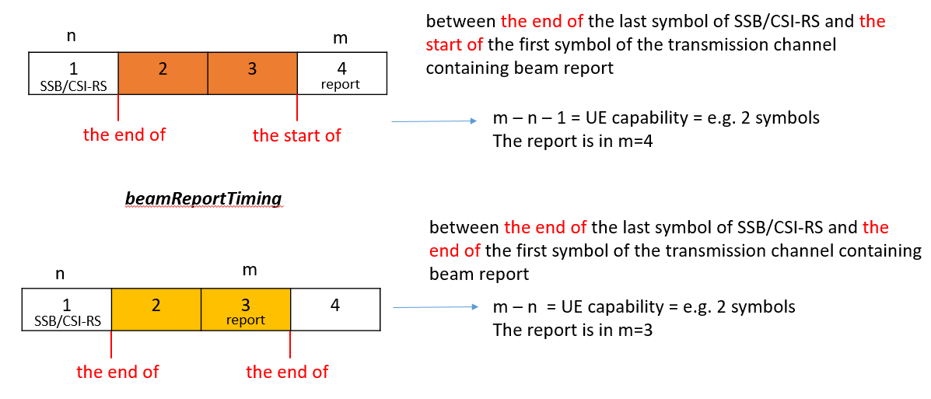
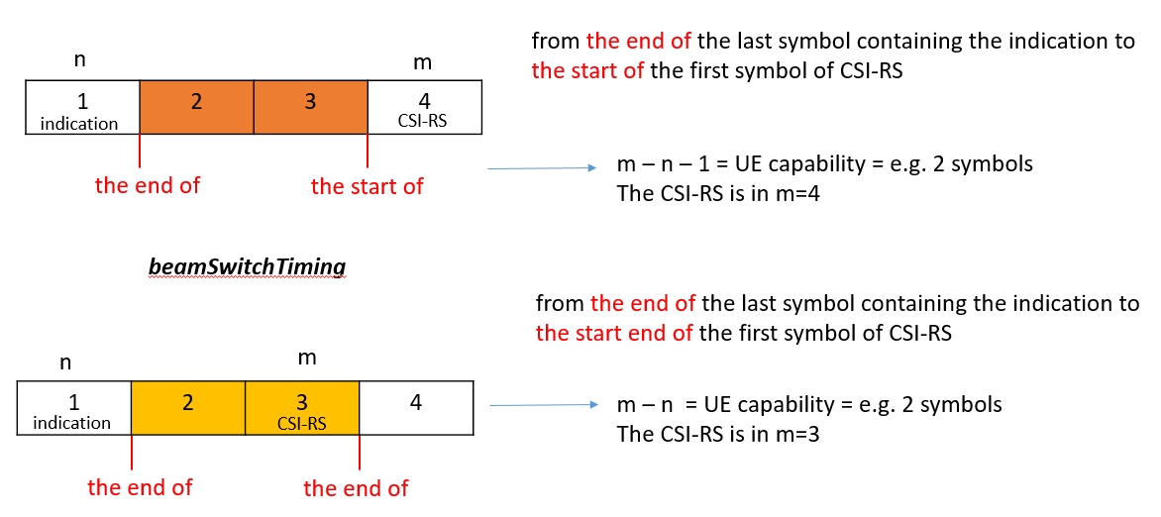
Q4-2 Which option do companies support for beamReportTiming / beamSwitchTiming, value “m-n” or “m-n-1” or sending an LS to RAN1?
Company | “m-n” or “m-n-1” or LS? | Comments
Intel | “m-n-1" or LS | We are also fine to send a LS to RAN1 to confirm
Nokia | LS | If it is super important for RAN2 to clarify this in specs then better to confirm with RAN1 otherwise we risk potential interop issue?
ZTE | LS | Seems companies have different understanding, so we prefer to have a LS.
OPPO (Zhongda) | m-n | We are also fine to send a LS to RAN1 to confirm
Qualcomm Incorporated | LS | LS to RAN1.  We do not see the need of mentioning the end or start or middle of symbol in case of “m-n”. It is simply based on the symbols where indication and report take place and the simple subtraction m-n.
Huawei, HiSilicon | “m-n-1", can be OK with LS | Our understanding is “m-n-1", and the preferred spec clarification is showed in our CRs. If the companies have different view or prefer to get RAN1 confirmation, we are ok with sending LS.
Qualcomm Incorporated | m-n-1 or LS | After further checking with our RAN1 colleagues and reading into RAN1 specifications, we are now fine with “m-n-1” interpretation. Of course we will not object to sending the LS if other companies wanted to be careful.
Ericsson | m-n-1 | After further checking we confirm the understanding that this is the intended interpretation. But if companies prefer to send an LS is also fine by us.

Conclusions

References
- R2-2109310 Reply LS on the Intra-band and Inter-band (NG)EN-DC/NE-DC Capabilties (R1-2108378; contact: ZTE) RAN1 LS in Rel-15 NR_newRAT-Core To:RAN2 Cc:RAN4
- R2-2110969 Clarification on intraAndInterF-MeasAndReport capability Huawei, HiSilicon CR Rel-15 38.306 15.15.0 0655 - F NR_newRAT-Core
- R2-2110970 Clarification on intraAndInterF-MeasAndReport capability Huawei, HiSilicon CR Rel-16 38.306 16.6.0 0656 - A NR_newRAT-Core
- R2-2110971 Miscellaneous corrections for Rel-15 UE capabilities Huawei, HiSilicon CR Rel-15 38.306 15.15.0 0657 - F NR_newRAT-Core
- R2-2110972 Miscellaneous corrections for Rel-15 UE capabilities Huawei, HiSilicon CR Rel-16 38.306 16.6.0 0658 - A NR_newRAT-Core

