3GPP TSG-RAN WG2 Meeting #115 Electronic R2-210xxxx
Elbonia, 16 – 27 August 2021

Agenda item: 8.9.2.1
Source: Nokia (Rapporteur)
Title: [AT115-e][043][ePowSav] Paging Subgrouping (Nokia)
WID/SID: NR_UE_pow_sav_enh-Core - Release 17
Document for: Discussion and Decision

1 Introduction
This document is the report of the following email discussion:
- [AT115-e][043][ePowSav] Paging Subgrouping (Nokia)
Scope: Objective is to arrive at conclusions (CB for confirm) and specify Open issues for non-concluded points.
1) Progress the capabilities discussion and handling of non-support, 2) Progress the architecture. Produce an agreeable generic Message sequence chart. Refine aspects of AMF, gNB and UE role and tasks in more detail (what AMF and gNB shall do and may do, what UE shall do). 3) Outline the options for how to map from CN assigned subgroup to L1-indicated subgroup.
Provision of assistance information is not included for now.
Intended outcome: Report
Deadline: Tuesday W2, for on-line CB.

2 Contact Points
Respondents to the email discussion are kindly asked to fill in the following table.
Company | Name | Email Address
Nokia (Rapporteur) | Chunli Wu | Chunli.wu@nokia-sbell.com
Xiaomi | Yanhua Li | Liyanhua1@xiaomi.com
Huawei, HiSilicon | Yiru Kuang | kuangyiru@huawei.com
Qualcomm | Linhai He | linhaihe@qti.qualcomm.com
Samsung | Anil Agiwal | anilag@samsung.com
MediaTek | Li-Chuan TSENG | li-chuan.tseng@mediatek.com

3 Discussion
The following has been agreed during the online session:
- When AMF has assigned a UE with a Paging subgroup, some NAS signaling should be supported between AMF and UE to convey the related information to the UE. Exact information is FFS. The design and procedure are up to SA2/CT1.
- When AMF has assigned a UE with a Paging subgroup, some signaling should be supported between AMF and gNB(s) to inform gNB(s) about the related subgroup information for paging a UE in RRC_IDLE/RRC_INACTIVE. Exact information is FFS. The message(s) and associated design are up to RAN3.
- It is FFS when a UE in RRC_INACTIVE has been assigned by CN a Paging subgroup, whether some signaling should be introduced between gNBs to inform each other about the UE’s subgroup for RAN paging.
- If RAN2 agrees to support UE assistance information to CN in support of Paging subgroup assignment, RAN2 will focus on the paging probability and power profile attributes.
- UEID-based subgroup method requires, in addition to the already available information for legacy UEID-based grouping in PO, the total number of supported UEID-based subgroups by the network.
- At least for UEID-based subgroup method the total number, N_{sg}, of supported subgroups by the network is decided by RAN and broadcasted in System Information.
- At least for UEID-based subgroup method the total number, N_{sg}, of supported subgroups is controlled on a cell basis and can be different in different cells.

3.1 Architecture – CN/RAN responsibilities and mapping to L1 subgroup indication
The following options has been proposed in the contributions on CN and RAN responsibilities:
Option 1: CN assigns Subgroup ID [2][8][9][10][12][14][17]
- CN assigns subgroup ID to UE and indicates to gNB when the UE is paged
- gNB and the UE apply the assigned subgroup ID
- gNB broadcast subgroup configuration (e.g. number of total subgroups)
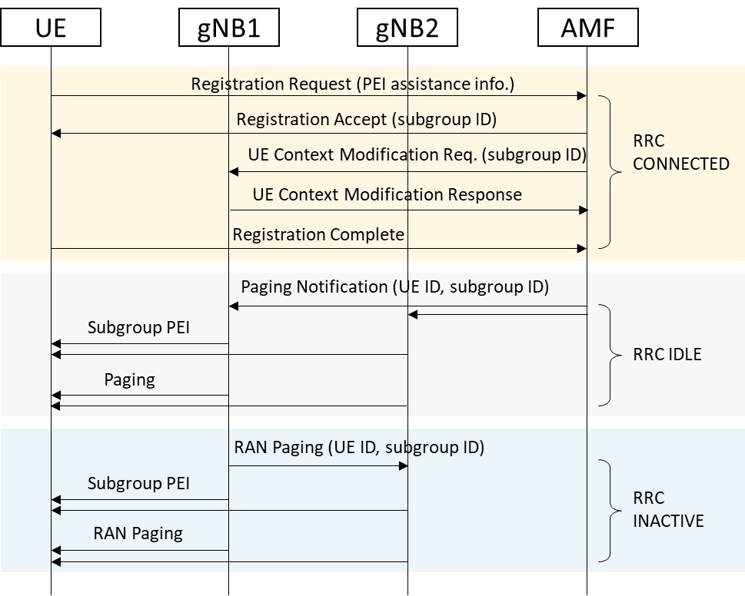
Figure 1: message sequence chart for option 1 [17]
- Pros:
  - The assigned subgroup ID could be directly mapped to L1 indication if it can be ensured RAN can support at least the number of subgroups CN assignment
    - Note that there are also proposals on remapping of CN assigned ID to L1 subgrouping.[2]
- Cons:
  - More complexity for CN and RAN coordination on number of subgroups
    - Further discussions needed if it requires all the cells within the registration area to support same number of subgroups and if they are not how it works, e.g. which node decide the number and how the mapping is done if they do not match
      - Option a1: The total number of subgroups is fixed and specified [2]
      - Option a2: The total number of subgroups is decided by CN and informed to RAN [2]
      - Option a3: The total number of subgroups is decided by RAN with mapping rules from CN subgroup ID to RAN subgroup ID if the ID from CN is larger than RAN [2]
      - Option a4: all the cells within the registration area supports the same number of NW assigned subgroups [8]
  - More complexity w.r.t. co-existence with UE-ID based subgrouping
    - More discussion needed on how it works for subgroup ID determination for a UE with both CN assignment and UE-ID based subgrouping:
      - whether CN assignment is prioritized over UE-ID based if both supported [5][8][10]
      - whether UE-ID based could override NW assignment [14]
    - More discussion needed on how it works for subgroups splitting in RAN for UEs in the cell with NW assignment and UE-ID based:
      - Option b1: Hard split between CN assigned subgroups and UE-ID based subgroups with each broadcasted [6]
      - Option b2: CN assignment and UE-ID based can share the same subgroups [14]
      - Option b3: either NW controlled subgrouping or UE ID based subgrouping is used in a cell without mixing them [13]
      - Option b4: gNB can decide by itself on the number of subgroups it wants to allocate to UE-ID based UEs. It is up to gNB implementation whether there can be any overlap between CN-assigned subgroups and UE-ID based subgroups in its cell. Although hard partition between two types of subgroups is desirable (for avoiding false alarm), we think we can leave that decision to gNB to “keep things simple” [8].
Option 2: CN assigns set of subgroup IDs [1][2]:
- gNB provides subgrouping configurations to CN;
- CN provides subgroup ID or subgroups ID set for different configurations;
- gNB and UEs apply corresponding subgroup ID based on the configuration of the cell
(proponents are welcome to provide message chart here)
Figure 2: message sequence chart for option 2
- Pros:
  - Possible to support different subgrouping configurations for different cells as the assigned ID can be chosen from the assigned set based on RAN configuration
- Cons:
  - More overhead for gNB to CN assistance information on the configurations and the set needs to consider all possilities
  - More overhead for CN to UE subgroup set assignment to consider all possibilities
  - similar discussions are needed as for option 1 on co-existence with UE-ID based approach.
Option 3: Reuse NB-IoT framework [2][3]:
- CN provides subgrouping related information (not limited to paging probability as agreed before) to distinguish the UEs with different characteristics.
- gNB broadcasts subgrouping configurations to split the UEs into different subgroup sets, which enables the aggregation of multiple codepoints from CN into same subgroup set (using probThreshList) as well as it allows to aggregate multiple subgroups within one subgroup set (using groupsForServiceList) if needed.
- UE-ID is used to derive the subgroup ID within the subgroup set.
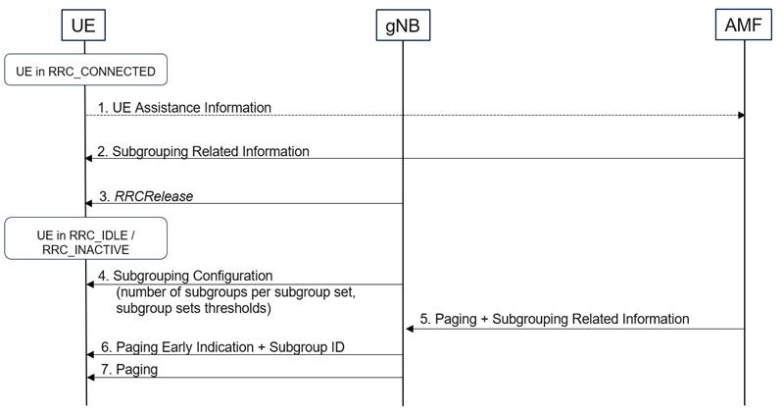
Figure 3: message sequence chart for option 3
- Pros:
  - Re-use NB-IoT framework without redesigning it, thereby with least impact to other working groups, and thus more realistic to complete the WI on time.
  - Full flexibility to allow CN with finer granularity or RAN with finer granularity.
    - If RAN configures same granularity as CN, it becomes equivalent to option 1.
  - RAN can decide number of subgroups based on its own paging configuration without requiring coordination between CN assignment and RAN configuration
  - No further co-existence issue with UE-ID based subgrouping since UE-ID based subgrouping works within the subgroup set
    - In the current NB-IoT mechanism, if a UE is not assigned with a codepoint from CN, it falls into a default subgroup set
    - It is also possible for RAN to implement UE-ID only by configuring all the CN assigned codepoints into the same subgroup set
- Cons:
  - more complexity for gNB configuration
Question 1: Do companies agree with the classification and the analysis of the options and sub-options above?
Answers to Question 1
Company | Yes/No | Clarifications on the options if needed
Xiaomi | Yes | Generally OK.  Some minor comments:  For Option2, “a set of subgroup ID(s)” is more accurate that “subgroups ID set”? Otherwise “subgroups ID set” can be easily confused with “subgroup set” in option3.  For option3: “it allows to aggregate multiple subgroups within one subgroup set (using groupsForServiceList) if needed”, in my understanding, what you mean is this parameters is for aggregate multiple L1 subgrouping resources within one subgroup set?
Huawei, HiSilicon | Yes
Qualcomm | No | We do not agree with the cons listed under Option 1.  - Subgrouping is simply a partition among UEs mapped to the same PO and thus does not involve allocation of any physical resources. Therefore, it is not difficult for gNBs in the same TA support the same number of subgroups decided by CN.  - To “keep things simple”, gNB can decide by itself on the number of subgroups allocated to UE-ID based UEs. It is up to gNB implementation to decide whether there can be any overlap between CN-assigned subgroups and UE-ID based subgroups. Although hard partition between two types of subgroups is desirable (for avoiding false alarm), we think we can leave that decision to gNB to “keep things simple”.  And we’d like to add to the cons of Option 2 and 3 that both schemes require more complexity to UE implementation. For example, in Option 2, UE needs to maintain multiple sets of subgroup assignment and switch its subgroup whenever it changes a serving cell. In Option 3, UE has to perform extra step of hashing to determine its subgroup assignment.
Samsung |  | Do not agree with option 3. This is not inline with agreement made in RAN2#114.  RAN2#114 Agreement: The following is supported:  - CN is responsible for allocating UEs to UE paging subgroups based on UE characteristics  - Use same UE subgroups when in RRC_IDLE and RRC_INACTIVE  Also agree with QC on comments related to Option 1
MediaTek | - | Classification is good, but we do not fully agree with the cons analysis of Option 1:  - It shouldn’t be that hard for CN and RAN to coordinate on the number of subgroups. A reasonable implementation is that all gNBs in a registration area supports at least as many subgroups as CN assigned.  - Then regarding the splitting of CN-assigned and UE-ID based subgroup IDs, one possible way is to have N1 subgroups for CN-assignment (N1 is the same for all gNBs in a registration area), and each gNB additionally assigns N2 subgroup IDs for UE-ID-based subgroups. The subgroup ID calculation in UE is also not hard (a simple hashing plus an offset)  Note that we proposed Option 1 based on our understanding about previous agreements. However if Option 3 was actually not precluded, we are also fine with Option 3.

Summary 1: TBD.
Proposal 1: TBD.
Question 2: Which option for NW assignment do companies prefer out of option 1-3 described above?
Answers to Question 2
Company | Option 1/2/3 | Technical comments
Xiaomi | Option3/1 | Agree the rapporteur that re-using NB-IoT framework saves us a lot of time.  For option3, we wish CN provides subgrouping ID directly. And RAN aggregate multiple subgrouping ID s from CN into same subgroup set. And if RAN configures same granularity as CN, it becomes equivalent to option 1.  Both option3 and option1 can work.  RAN2 is suggested to consider how gNB configures the mapping between subgrouping information to L1 radio resource(s) on Uu interface. If we map each subgroup to L1 resources, it is option1. If we map multiple subgroups (in form of subgroup Set) to L1 resources, it is option3.
Huawei, HiSilicon | 3, can accept 1 | NB-IoT framework is preferred as this is the mechanism already supported in LTE. In this option, UEs can be assigned to different groups based on UE characteristic, and the gNB has the flexibility of determining the subgrouping information, e.g. the total number of supported subgourps.  CN assigned subgroup ID can be supported. However, for this category of solutions, we prefer option 1 since option 2 may provide the unnecessary subgrouping information to the UE, and it is not clear how many subgroup IDs should be assigned by the CN, which in our view also increase the complexity of CN implementation.
Qualcomm | 1 | Option 1.a4 + Option 1.b4 require the least implementation complexity for UE, gNB and AMF
Samsung | 1 | We do not see additional benefits of option 2
MediaTek | 1 or 3 | Configuration for Option2 can be complicated

Summary 2: TBD.
Proposal 2: TBD.
Question 3: Which sub-option out of a1/a2/a3/a4 of option 1 do companies prefer on whether CN or RAN is to decide the number of subgroups for NW assigned subgrouping?
Answers to Question 3
Company | Option a1/a2/a3/a4 | Technical comments
Xiaomi | A3 | Remapping saves the effort of negotiations between CN and RAN.
Huawei, HiSilicon | a3 | In our view sub-option a3 has clear advantages in terms of flexibility of the network configuration  The sub-option a3 is also related to the scenario being discussed in RAN1 on the association between DCI based PEI and POs. We wanted to highlight the the bits that can be used in PEI are limited. These bits may be used to indicate the associated POs and subgroups per PO. If more bits are used to indicate the associated POs, then the bits which can be used to indicate the associated subgroups per PO is reduced.  Considering other sub options, we think that the intention of sub options a2 and a4 is similar but provides lesser flexibility, whereas sub option a1 can be excluded as it seems to impose strict restriction.
Qualcomm | a4 | It requires the least complexity for all entities (UE, gNB and CN)
Samsung | A2, A3 | Do not support A1. A2 is preferred for simplicity. However, if majority view is to have flexibility, A3 can be supported.
MediaTek | A4 or A5 | A5: The number of subgroups is decided by RAN, but it should be no less than the number of subgroups assigned by CN

Summary 3: TBD.
Proposal 3: TBD.
Question 4: For option 1 and 2, do companies think CN assignment should be prioritized over UE-ID based if both are supported?
Answers to Question 4
Company | Yes/No | Technical comments
Xiaomi | Yes | CN assignment is anyway more accurate than the randomization.
Huawei, HiSilicon | Yes | CN assignment subgrouping method provides better power saving gain compared with randomization subgrouping.
Qualcomm | Yes | Presumably CN uses all the available information to assign subgroups so that false alarm is reduced. Its assignment is better than UE-ID based one, which is generated only based on randomization.
Samsung | Yes
MediaTek | Yes

Summary 4: TBD.
Proposal 4: TBD.
Question 5: For option 1 and 2, do companies think UE-ID based subgroup ID could override CN assignment?
Answers to Question 5
Company | Yes/No | Technical comments
Xiaomi | - | What does not mean override?  Will CN assigned group ID still exit or it is overwritten?  Or you mean the UE-ID based subgroup ID will be used if gNB supports UE ID based subgroup only?
Huawei, HiSilicon | No | We do not see the scenario and motivation to support this case.
Qualcomm | No | If UE supports both and have two subgroup IDs, UE and gNB should use only the one assigned by CN.
Samsung | No
MediaTek | No

Summary 5: TBD.
Proposal 4: TBD.
Question 6: For option 1 or 2, which sub-option out of b1/b2/b3 do companies prefer for subgroups splitting in RAN for a cell with both NW assignment and UE-ID based subgrouping UEs?
Answers to Question 6
Company | Option b1/b2/b3 | Technical comments
Xiaomi | B2 | B2 is aligned with LTE. So we think it is the baseline.  Other options can be further considered.
Huawei, HiSilicon | See comments | For “Option 1 CN assigns Subgroup ID”:  Option b3 is simple and seem enough, if both the CN and RAN support CN assigned subgrouping method, CN assigned subgrouping method can be used in a cell; if either the CN or the RAN cannot support CN assigned subgrouping method, RAN can further decided whether UE-ID based subgrouping method can be used in a cell.  If mixed CN assigned subgrouping and UE-ID based subgrouping method can be supported in a cell, we think that b2 should be excluded since the benefits of CN assigned subgrouping is eliminated by UE-ID based subgrouping, b1 can be one of the candidate solution  For “Option 3: Reuse NB-IoT framework”, b2 is preferred.
Qualcomm | b4 | Please see our comment to Q1
Samsung | B2, B3 | B3 is preferred over B2
MediaTek | B1 | Other options are also acceptable, but we think that if CN assigns subgroup IDs to some UEs, it means that CN wants to “protect” these UEs (because they are less frequently paged, or power sensitive). In that sense, other UEs should not share the same groups, otherwise the “false alarm rate” is increased. If extra subgroups can be supported, they can be used by “other” UEs (without CN assignment) to save some power.

Summary 6: TBD.
Proposal 6: TBD.

3.2 UE and NW capabilities
The discussion on capabilities would probably be easier after the functionality is a bit clearer, i.e. after the selection of which option is to be adopted in section 3.1. But we can have a preliminary discussion here.
There are several options proposed for UE capabilities:
Option 1: common capability for subgroup [4][10][13]
- Pros:
  - Fewer cases to address than allowing only one of NW assignment and UE-ID based is supported
  - Single capability communication among CN, UE, and gNB or can be even implicitly based on the configurations/assistance information if supported
- Cons:
  - The UE needs to implement both
Option 2: separate capability for NW assignment and UE-ID based [7][8][9][13][14]
- Pros:
  - More flexibility for UE implementation
- Cons:
  - more complexity for capability indication among CN, UE and gNB
  - more complicated cases to address if CN, UE or gNB only support one of them
Option 3: UE supports only NW controlled subgrouping, or supports both, or supports neither [13]
Option 4: UE supports only UE ID based subgrouping, or supports both, or supports neither [13]
Question 7: Which option do companies prefer on UE capability for subgrouping?
Answers to Question 7
Company | Option 1/2/3/4 | Clarifications on the options if needed
Xiaomi | Option1 | UE’s capability has nothing to do with the subgrouping method the network is using.
Huawei, HiSilicon | Option1 | Agree with the Pros listed by the moderator.
Qualcomm | Option 2 | NW-assigned subgrouping and UE-ID based subgrouping do involve implementation in different layers (NAS vs AS). RAN2 should not mandate UE to signal only one capability for features in two different functional units. For example, that will make product testing and IOTs more challenging. Moreover, we don’t think having separate capabilities would make design more complicated, as long as we try to “keep things simple”.
Samsung | Option 1
MediaTek | Option 1 | A reasonable UE implementation is to support both, or none.

Summary 7: TBD.
Proposal 7: TBD.
For NW capability, it should have full flexibility in principle. For CN, it could choose to provide or not the subgroup ID /subgroup ID set/subgroup related information. If CN provides such information, RAN might still have the possibility to apply either one. For subgroup ID based options there were proposals that RAN can indicate all the subgroups indication bits are for UE-ID based or for CN-assignment based, or it explicitly indicates supporting one of CN-assignment and UE-ID based, or both; for option with NB-IoT mechanism, RAN has the flexibility to put all the UEs within the same subgroup set with configuration of the subgroup set threshold. Details of signalling can be discussed further after the architecture option in section 3.1 to be adopted is clear.
Question 8: Do companies agree the RAN capability could be known based on broadcast information? FFS if explicit indication or implicitly based configuration.
Answers to Question 8
Company | Yes/No | Technical comments
Xiaomi | Yes | gNB broadcasts whether to support CN-assigned subgrouping and/or UE-ID based subgrouping.  FFS the signalling.
Huawei, HiSilicon | Yes
Qualcomm | Yes | gNB certainly can advertise which type(s) of subgrouping it supports, either implicitly (e.g. for UE-ID based) or explicitly (e.g. for CN-assigned).
Samsung | Yes
MediaTek | Yes

The different combinations of UE/gNB/AMF supporting/not supporting subgrouping or certain sub-feature of subgrouping could be for further discussion after the architecture options and capabilities discussions are concluded.

4 Conclusion
TBD.

References
[1] R2-2107549 Further considerations on Network assigned subgrouping Intel Corporation discussion Rel-17 NR_UE_pow_sav_enh-Core
[2] R2-2108027 Further discussion on paging subgrouping Huawei, HiSilicon discussion Rel-17 NR_UE_pow_sav_enh-Core
[3] R2-2108592 CN and RAN responsibility split for paging subgrouping Nokia, Nokia Shanghai Bell discussion Rel-17 NR_UE_pow_sav_enh-Core R2-2108011
[4] R2-2108686 Further Consideration on Paging Subgroup CATT discussion Rel-17 NR_UE_pow_sav_enh-Core
[5] R2-2106998 Further details of UE Subgrouping Samsung Electronics Co., Ltd discussion Rel-17 NR_UE_pow_sav_enh-Core
[6] R2-2107067 Discussion on grouping-based paging OPPO discussion Rel-17 NR_UE_pow_sav_enh-Core
[7] R2-2107068 Discussion on UE paging capabilities OPPO discussion Rel-17 NR_UE_pow_sav_enh-Core
[8] R2-2107222 Paging subgroup assignment Qualcomm Incorporated discussion Rel-17 NR_UE_pow_sav_enh-Core
[9] R2-2107385 The architecture of paging enhancement Xiaomi Communications discussion Rel-17 NR_UE_pow_sav_enh-Core
[10] R2-2107406 Architecture for paging enhancement by UE subgrouping vivo discussion Rel-17 NR_UE_pow_sav_enh-Core
[11] R2-2107721 Further discussion on CN-assigned paging grouping Transsion Holdings discussion
[12] R2-2107902 Consideration on Idle/inactive-mode UE power saving Lenovo, Motorola Mobility discussion Rel-17
[13] R2-2108028 Discussion on paging subgrouping supporting on UE and network Huawei, HiSilicon discussion Rel-17 NR_UE_pow_sav_enh-Core
[14] R2-2107880 UE ID based subgroup LG Electronics Inc. discussion Rel-17
[15] R2-2108237 Grouping methods for Paging Ericsson discussion Rel-17 NR_UE_pow_sav_enh-Core
[16] R2-2108461 Handling network nodes not supporting UE paging subgrouping Futurewei Technologies discussion Rel-17 NR_UE_pow_sav_enh-Core
[17] R2-2108590 UE Paging Subgroup Assignment MediaTek Inc. discussion

