3GPP TSG-RAN WG2 Meeting #115 Electronic R2-21xxxxx
Electronic, 16 – 27 August 2021

Agenda Item: 5.4.1.3
Source: Huawei, HiSilicon
Title: [AT115-e][014][NR15] CP Other (Huawei)-Phase 2
Document for: Discussion, Decision

1 Introduction
This document is to kick off phase 2 of the following email discussion:
[AT115-e][014][NR15] CP Other (Huawei)
Scope: Determine agreeable parts in a first phase, for agreeable parts agree on CRs. Treat R2-2108290, R2-2108644, R2-2108645, R2-2107022, R2-2108646, R2-2108647, R2-2107377, R2-2107378, R2-2107573, R2-2108571
Intended outcome: Report, agreed CRs if applicable
Deadline: A Final round -1 day (Wednesday Aug 25 1200 UTC)

The guidance for deadline is below:
A first round with Deadline for comments Thursday Aug 19 1200 UTC to settle scope what is agreeable etc
A Final round with Final deadline Thursday Aug 26 1200 UTC. to settle details / agree CRs etc. Additional check points etc if needed are defined by the Rapporteur. In case some parts of an email discussion need more time, doesn’t converge, need on-line treatment etc Rapporteur please contact chair.

Contact Information
Company | Email
MediaTek | chun-fan.tsai@mediatek.com
Nokia | amaanat.ali@nokia.com
ZTE | liu.jing30@zte.com.cn
Apple | yuqin_chen@apple.com
Ericsson | hakan.l.palm@ericsson.com
Samsung | anilag@samsung.com
Lenovo | hchoi5@lenovo.com
vivo | panxiang@vivo.com
OPPO | fanjiangsheng@oppo.com
CATT | liangjing@catt.cn
Qualcomm | Mouaffac (mambriss@qti.qualcomm.com)
NEC | hisashi.futaki[at] nec.com
Intel | sudeep.k.palat@intel.com
Docomo | masato.taniguchi.mf@nttdocomo.com
Fujitsu | sanda.takako@fujitsu.com
LGE | stella.choe@lge.com
Huawei, HiSilicon | caozhenzhen@huawei.com
Apple | fangli_xu@apple.com

Discussion
Companies are requested to add their comments on each of the CRs of this email discussion in the questionnaires below.

SearchSpaceSIB1
R2-2108644 Clarification of search space configuration for SIB1 Huawei, HiSilicon CR Rel-15 38.331 15.14.0 2790 - F NR_newRAT-Core
Moved from 5.4.1.1
R2-2108645 Clarification of search space configuration for SIB1 Huawei, HiSilicon CR Rel-16 38.331 16.5.0 2791 - A NR_newRAT-Core
Moved from 5.4.1.1
R2-2107022 Discussion on RMSI and OSI reception based on non-zero search space OPPO discussion Rel-15 NR_newRAT-Core

Summary of phase 1 discussion:
According to the comments, most of companies think we should check with RAN1 first, although it seems that majorities believe that option 1 should be the current situation. Some companies have clarified the scenario of such configuration, i.e. the dedicated BWP not covering the cell-defining SSB and CORESET#0. There is also one company wondering how other SI is received in this case.
It seems that a discussion would be needed in RAN1. To make RAN1 better understand the scenario that RAN2 is discussing (and also to speed up the progress), it would be beneficial to send an LS to RAN1 to clearly clarify the scenario.

The content of the LS:
RAN2 has discussed the issue about SIB1 reception for RRC_CONNECTED UEs. When the UE is configured with a dedicated BWP not covering the cell-defining SSB (i.e. the SSB with an RMSI associated) and CORESET#0, the common search space for SIB1 reception (i.e. searchSpaceSIB1) configured in this BWP has to be a non-zero search space. In this case, there is no mapping correlation defined in RAN2 specifications between PDCCH occasions of the non-zero search space and SSBs.
RAN2 would like to ask RAN1 in the above case when the dedicated BWP does not cover the cell-defining SSB, whether a mapping between PDCCH occasions and SSBs needs to be defined for the non-zero search space configured for reception of SIBs, or SIB reception can be based on other means (e.g. TCI state).

Q1: Companies are invited to provide comments on the LS content if any.
Company | Comments
Nokia | Intent of the LS is okay
Apple | We are fine to reach out to RAN1 to conclude this issue.
NEC | We are also fine to send the LS with this content
OPPO | - The LS should also tell RAN1 that the common search space is not set to zero for OSI/paging, RAN2 spec (38.331 section 5.2.2.3.2 for OSI and TS38.304 section 7 for paging) indicates the mapping between OSI/paging PDCCH monitoring occasions and SSBs for all RRC state UE.  - RAN2 should further ask RAN1:  “ If RAN1 confirm RRC configured TCI state is used to receive RMSI PDCCH, RAN2 wants to confirm whether the RRC configured TCI state can also be used for OSI/paging reception?”

L3 filtering configuration
R2-2107573 Clarification on L3 filtering configuration (filterCoefficient) Apple discussion Rel-16 NR_newRAT-Core

Summary of Phase 1 discussion:
There are 9 companies who agree with the problem identified in R2-2107573, and 5 companies don’t think there is a problem (some companies believe that there is no explicit mapping between the filterCoefficient K and the sample rate X, and the configuration of K can be up to implementation of gNB), and one company thinks more clarifications are needed.
On the other hand, some companies suggest to check with RAN4, but it is unclear what exactly questions that RAN2 can ask RAN4 in this regard. The issue is more like how to understand the current RAN2 specification text and its implications to UE behaviors.
Therefore, moderator would suggest to further discuss in Phase 2 how to understand the existing specification text in TS 38.331.

5.5.3.2 Layer 3 filtering
The UE shall:
1> for each cell measurement quantity and for each beam measurement quantity that the UE performs measurements according to 5.5.3.1:
2> filter the measured result, before using for evaluation of reporting criteria or for measurement reporting, by the following formula:
F_{n} = (1 – a)*F_{n-1} + a*M_{n}
where
M_{n} is the latest received measurement result from the physical layer;
F_{n} is the updated filtered measurement result, that is used for evaluation of reporting criteria or for measurement reporting;
F_{n-1} is the old filtered measurement result, where F₀ is set to M₁ when the first measurement result from the physical layer is received; and for NR, a = 1/2^{(ki/4)}, where k_{i} is the filterCoefficient for the corresponding measurement quantity of the i:th QuantityConfigNR in quantityConfigNR-List, and i is indicated by quantityConfigIndex in MeasObjectNR; for E-UTRA, a = 1/2^{(k/4)}, where k is the filterCoefficient for the corresponding measurement quantity received by quantityConfigEUTRA in the quantityConfig;
2> adapt the filter such that the time characteristics of the filter are preserved at different input rates, observing that the filterCoefficient k assumes a sample rate equal to X ms; The value of X is equivalent to one intra-frequency L1 measurement period as defined in TS 38.133 [14] assuming non-DRX operation, and depends on frequency range.
NOTE 1: If k is set to 0, no layer 3 filtering is applicable.
NOTE 2: The filtering is performed in the same domain as used for evaluation of reporting criteria or for measurement reporting, i.e., logarithmic filtering for logarithmic measurements.
NOTE 3: The filter input rate is implementation dependent, to fulfil the performance requirements set in TS 38.133 [14]. For further details about the physical layer measurements, see TS 38.133 [14].

The text says ” observing that the filterCoefficient k assumes a sample rate equal to X ms; The value of X is equivalent to one intra-frequency L1 measurement period as defined in TS 38.133 [14] assuming non-DRX operation, and depends on frequency range”.
According to the text, companies are asked if they agree that the gNB configuration of k should be based on the assumed sample rate X (as defined in TS 38.133), and this is up to gNB implementation.

Q2a: According the specification text, do you agree that the gNB configuration of k should be based on the assumed sample rate X (as defined in TS 38.133), and it is up to gNB implementation?
Company | Yes/No | Comments
Nokia | Yes | This is a matter of gNB configuration and network should be able to set the k value appropriately
Apple | Yes | gNB configures the K according to the network deployment and performance. But the configuration should be based on the assumed sample rate X which is common understanding between gNB and UE.
Huawei, HiSilicon | Yes
OPPO | Yes
vivo | Yes
ZTE | Yes

The specification text also says that the UE should “adapt the filter such that the time characteristics of the filter are preserved at different input rates, …”.
According to the text, companies are asked if they agree that the UE should adapt the filter to the sample rate equal to X ms (which is defined in TS 38.133) and apply the configured k for filtering, which is up to UE implementation.

Q2b: According the text above, do you agree that the UE should adapt the filter to the sample rate X ms (which is defined in TS 38.133) and apply the configured k for filtering, and it is up to UE implementation?
Company | Yes/No | Comments
Nokia | Don’t know | This is not within the expertise of RAN2 so we cannot give our opinion here. The yellow text above refers to nothing which is up to UE implementation, so we are not sure what we really want to achieve here.
Apple | Yes | NR L3 filter design inherits from LTE, including the sentence ““adapt the filter such that the time characteristics of the filter are preserved at different input rates, …”.”  We donnot think NR has the different design or understanding.  In LTE, the operation was added by the CR (R2-093543) written by Ericsson.  The coversheet and the changes are copied as follows for your reference.  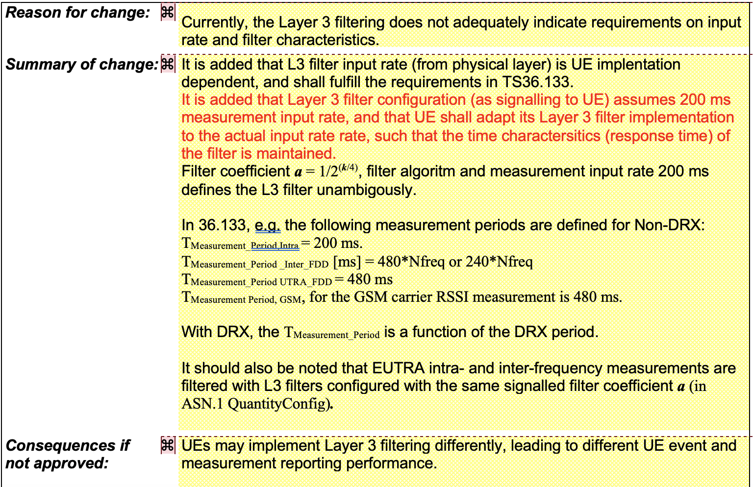  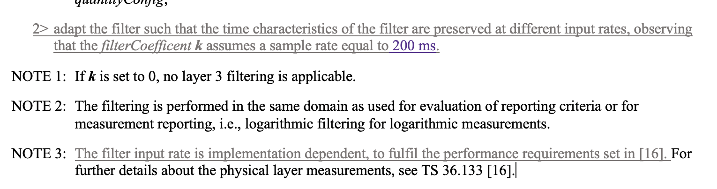
Huawei, HiSilicon | Yes | It seems to be what the text literally says.
OPPO | Yes
vivo | Yes
ZTE | Yes | We agree this is what the spec asks.

Having discussed above, come back to the Proposal 1 in R2-2107573.
Proposal 1: Confirm that UE and NW have the same assumption of the sample rate for the filterCoefficient K configuration.
Companies are asked if they agree that the UE and the gNB have the same understanding on the sample rate X when the gNB configuring k and the UE adapting the filter.
Q2c: According the text above, do you agree that the UE and the gNB have the same understanding on the sample rate X when the gNB configuring k and the UE adapting the filter?
Company | Yes/No | Comments
Nokia | Don’t know | See answer to Q2b
Apple | Yes | As indicated in our answer in Q2b, NW should have the same design as LTE, which is that the NW and UE should have the same understanding on the assumed sample rate for k configuration. And the assumed same rate X cannot be dynamically changed.
Huawei, HiSilicon | Yes | But it is still up to the gNB how to configure k, and different X values may correspond to be a single k value, and the gNB may not need to adjust k when the L1 parameters of the UE change (i.e. value X changes).
OPPO | Yes | As we mentioned in phase 1, we don’t think L1 measurement period is updated that dynamically. We also share the similar view with HW that different X values may correspond to be a single k value.
vivo | Yes | Share the same view with HW.
ZTE | Yes | We tend to agree with Apple. Based on the old agreed CR pointed out by Apple, we think the intention of introducing “assumed sample rate” is trying to align network and UE, so when network provides a filterCoefficient k based on assumed sample rate e.g. 200ms, the UE is expected to adapt the L3 filter using 200ms intervals. So it is not good to dynamically change the value for this assumption.  Of course, network is allowed to configure the same k value for different Xms. But the spec should be clear what the right/expected UE behaviour is.

Overheating assistance
R2-2108571 Clarification for overheating assistance information reporting Huawei, HiSilicon discussion Rel-15 NR_newRAT-Core

Summary of phase 1 discussion:
On Proposal 1,
Proposal 1: If the UE sent the first overheating assistance information with preference on reduced parameter A and the NW already reduced the configuration for parameter A, UE sends the second overheating assistance information without including the preference on reduced parameter A, RAN2 to clarify how to understand UE’s preference:
Alt 1) UE does not have any preference on reducing configuration for parameter A and prefers to restore the configuration for parameter A
Alt 2) the previous preference on reduced parameter A is unchanged and UE prefers to maintain the configuration for parameter A
(The parameter A can be the number of maximum sCC, the number of maximum aggregated bandwidth, the number of maximum MIMO layers).

There are about 9 companies supporting Alt.1 or its revision, and 4 companies supporting Alt.2 or its essence (i.e. the network doesn’t need to remember the previous configuration and indication).
Moderator believe that with the revised Alt.1, i.e. “UE does not have any preference on reducing configuration for parameter A”, Alt.1 would be similar to Alt.2 and the network doesn’t need to remember the previous configuration and indication.

Q3a: Can you compromise to accept the following understanding:
- If the UE sent the first overheating assistance information with preference on reduced parameter A and the NW already reduced the configuration for parameter A, and then the UE sends the second overheating assistance information without including the preference on reduced parameter A, the absence of parameter A means that the UE does not have any preference on reducing configuration for parameter A?
Company | Yes/No | Comments
Nokia | Yes. Our view is that UE sends information that is pertaining to its “current” status | Network should not be expected to remember previous information but process message by message in this case
Huawei, HiSilicon | Yes | The proposal doesn’t require the network remember the previous configuration and indication, which is fine to us.
Apple | Yes | If the sentence “prefers to restore the configuration for parameter A” is removed from Alt 1, then it becomes similar to Alt 2. Would prefer this approach as we do not want the second UAI to be interpreted as a way to restore the previously reduced value (done via the first UAI) back, as this might be counterproductive to the UE.
QCOM | Partially | Irrespective if network complied with the suggested UAI sent by the UE or not, behavior should be the same, hence suggested change:  If the UE sent the first overheating assistance information with preference on reduced parameter A, and then the UE sends the second overheating assistance information without including the preference on reduced parameter A, the absence of parameter A means that the UE does not have any preference on reducing configuration for parameter A
NEC | Yes | Agree with Nokia that network does/should not need to remember the past information after responding it
OPPO | Yes
vivo | Yes | When the parameter is absent, UE has no preference and it’s up to network to maintain the configuration or reconfigure a new one.
ZTE | Yes | We think the modification from QCOM is clearer.  No matter network has or has not reduced the configuration of parameter A, the absence of the field in follow-up UAI means the UE does not have any preference on reducing current configuration of parameter A.

On Proposal 2:
Proposal 2: RAN2 to clarify how to understand the “reduced configuration” for overheating:
Alt 1) the reduced value can range up to the active configuration before UE indicates overheating assistance information
Alt 2) the reduced value can only range up to the current active configuration

There are 6 companies explicitly supporting Alt.1 or its variant (i.e. up to UE capability) and 6 companies supporting Alt.2.
Moderator would like to further check in Phase 2 if companies are ok with the variant of Alt.1 (i.e. up to capability), given that:
1/ From the network’s point of view, it doesn’t harm if the UE signals a value larger than the current active configuration when the overheating problem has been alleviated, and the network can get more information about the UE’s preference. Future, the network doesn’t need to remember the previous configuration.
2/ From the UE’s point of view, it would be more flexible if the UE can signal any value up to its capability.

Q3b: Can you compromise to accept the following understanding:
- For overheating, the reduced value can range up to the UE capability?
Company | Yes/No | Comments
Nokia | Alt 1, up to full UE capability and no memory of past is required in both UE and network | See response to Q3a. When the problem is alleviated the network should be able to configure up to the full UE capability
Huawei, HiSilicon | Yes | The proposal doesn’t require the network remember the previous configuration and indication, which is fine to us.  Further, agree with Nokia, with this proposal, the network is able to configure up to the full UE capability as indicated by the UE, which is up to network implementation.
Apple | Alt 1 | Given the fact that Overheating situation has eased, we would like the UE to be given an opportunity to be restored to the active configuration prior to the initial overheating reporting.
QCOM | Alt1 | Support Apple suggestion
NEC | No | We can simply go for the Alternative with more supports.  But we are wondering if this (Alt1) allows UEs to request upgrade and downgrade (i.e. used for different purpose than original intention = downgrade), which is messy..
OPPO | Yes | Agree with Nokia.
vivo | Yes | Reduced configuration up to UE capability can give the reconfiguration request from UE more flexibility.
ZTE | No | We have two questions to Alt 1).  Does it mean network should not reconfigure the UE to a larger value unless receives the new UAI message (indicating a larger value)?  And how to avoid the case that UE requires a large value even if the UE does not experience overheating problem before.

Conclusion
tbd

References
[1]

