3GPP TSG-RAN WG2 #113e R2-210xxxx
Electronic meeting, 25th January – 5th February 2021

Agenda Item: 6.1.1
Source: Ericsson
Title: Summary of [AT113-e][016][POS V2X NR16] RRC III
Document for: Discussion, Decision

1 Introduction
This document is to handle the following email discussion:
- [AT113-e][016][POS V2X NR16] RRC III (Ericsson)
Scope: Treat R2-2101733, R2-2101825, R2-2100302, R2-2101571, R2-2100887, R2-2100888
Phase 1, determine agreeable parts, Phase 2, for agreeable parts Work on CRs.
Intended outcome: Report and Agreed CRs.
Deadline: See below

Regarding the deadlines, I would like to set the following 2 deadlines:
1) First deadline on Thursday Feb 28 1200 UTC to settle scope what is agreeable.
2) Second deadline on Thursday Feb 4 1200 UTC to agree the CRs, whenever needed.

2 Contact information
Company (Name) | Email

3 Discussion

3.1 System information POS, V2X, On demand

3.1.1 Clarification for SIBs scheduled in posSchedulingInfoList
R2-2101733 Clarification for SIBs scheduled in posSchedulingInfoList Ericsson CR Rel-16 38.331 16.3.0 2433 - F NR_newRAT-Core

Reason for change:
When system information is changed, the UE is notified (systemInfoModification) in the current modification period about the change, and the updated system information is transmitted in the next modification period. However in case of ETWS/CMAS the system information is already changed in the current modification for latency reasons. An ETWS/CMAS capable UE immediately acquires the new scheduling in SIB1 to receive the ETWS/CMAS SIBs when notificed (etwsAndCmasIndication). An ETWS/CMAS capable UE is able to handle this, because it only impacts the ETWS/CMAS SIBs.
However the SIBs scheduled in posSchedulingInfoList are concatenated to the SIBs scheduled in schedulingInfoList. In case the ETWS/CMAS SIBs are transmitted in separate SI-messages from the legacy SIBs (e.g. because they have a different periodicity) then the SIBs scheduled in posSchedulingInfoList will be transmitted in different SI-messages during a modification period where ETWS/CMAS transmission is started (or stopped), as shown in figures below taking posSIBx-y as an example:

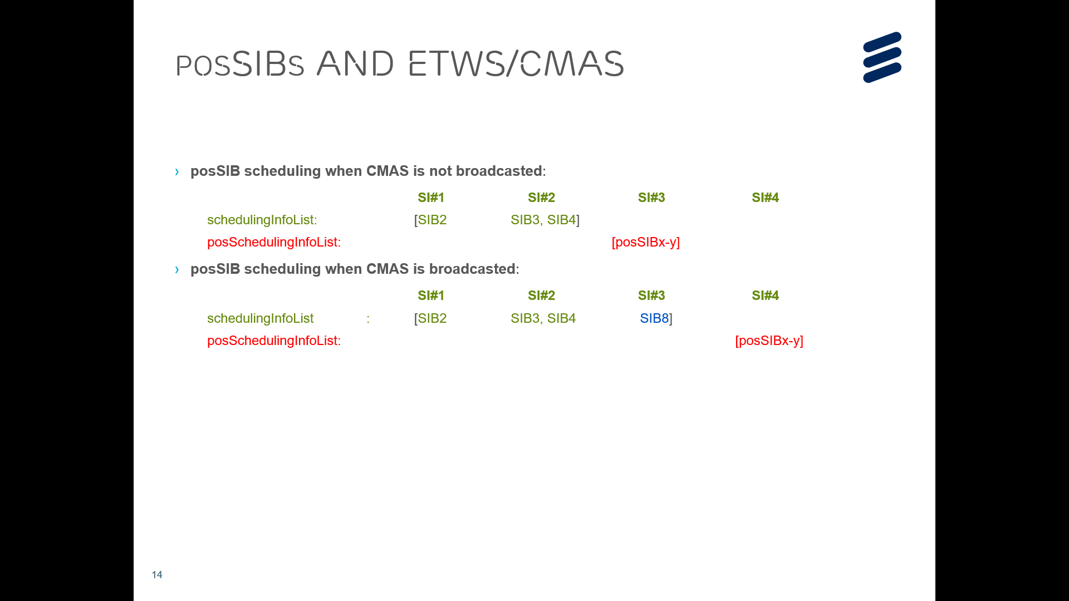

Normally the UE does not expect the SIB scheduling to change during a modification period, other than for ETWS/CMAS SIBs. It should be clarified that SIBs scheduled in posSchedulingInfoList may be transmitted in different SI-message during a modification period where ETWS/CMAS is started or stopped.
Company | Agree (y/n) | Comments

3.1.2 Correction to the UE action upon SIB1 reception
R2-2101825 Correction to the UE action upon SIB1 reception Huawei, HiSilicon, Ericsson CR Rel-16 38.331 16.3.0 2441 - F NR_pos-Core

Reason for change:
In the field description for si-BroadcastStatus, the following has been captured:
si-BroadcastStatus
Indicates if the SI message is being broadcasted or not. Change of si-BroadcastStatus should not result in system information change notifications in Short Message transmitted with P-RNTI over DCI (see clause 6.5). The value of the indication is valid until the end of the BCCH modification period when set to broadcasting.

So, the validity only applies for broadcasting during the current MP. The reason behind this is that, when the SI request is triggered after the initial SI acquisition, UE should re-check SIB1 before sending the SI request - in case another UE already requested and SIB is already being broadcast
In 5.2.2.3.1, there is the following description to check the broadcasting status of UE required SI message (including UE concerned SIBs or posSIBs) in SIB1.
if the UE is in RRC_CONNECTED with an active BWP with common search space configured by searchSpaceSIB1 and pagingSearchSpace and the UE has not stored a valid version of a SIB, in accordance with sub-clause 5.2.2.2.1, of one or several required SIB(s), in accordance with sub-clause 5.2.2.1, and, UE has not acquired SIB1 in current modification period or if requested by upper layers; or
The above text is clearly contradictory with the description for si-BroadcastStatus above. It is possible that the status of broadcastStatus changes from notBroadcast to Broadcast. In this case, even if the UE has already read the field in the MP, the UE should still read the SIB1 to get the most update status of the SIB1.
Company | Agree (y/n) | Comments

3.1.3 Clarifications on the required SIB or posSIB
R2-2100302 Clarficiations on the required SIB or posSIB CATT CR Rel-16 38.331 16.3.1 2317 - F NR_pos-Core, 5G_V2X_NRSL-Core

Reason for change:
Issue 1: Which SIB or posSIB is required to operate within the cell
According to sub-clause 5.2.2.4.2 as follows, when the UE is in RRC_CONNECTED, upon receiving SIB1, the UE will check whether the UE has a stored valid version of a required SIB or posSIB. And which SIB or posSIB is required to operate within the cell is according to sub-clause 5.2.2.1. But in sub-clause 5.2.2.1, which SIB is requred in RRC_CONNECTED and when posSIB is required are missing.
1> if in RRC_CONNECTED while T311 is not running:
2> disregard the frequencyBandList, if received, while in RRC_CONNECTED;
2> forward the cellIdentity to upper layers;
2> forward the trackingAreaCode to upper layers;
2> forward the received posSIB-MappingInfo to upper layers, if included;
2> apply the configuration included in the servingCellConfigCommon;
2> if the UE has a stored valid version of a SIB or posSIB, in accordance with sub-clause 5.2.2.2.1, that the UE requires to operate within the cell in accordance with sub-clause 5.2.2.1:
3> use the stored version of the required SIB or posSIB;
2> else:
3> acquire the required SIB or posSIB requested by upper layer as defined in sub-clause 5.2.2.3.5;

Issue 2: When to perform SI acquisition
According to sub-clause 5.2.2.2.1 as follows (highlighted with yellow), the UE shall apply the SI acquisition procedure upon receiving upper layer request. However, upon receiving upper layer request for positioning, the UE performs posSIB validity check first. If the UE has already had a stored valid version of the request posSIB, the UE doesn’t need to apply SI acquisition procedure, including acquisition of SIB1.
In addition, as highlighted with green, the UE apply the SI acquisition procedure whenever the UE does not have a valid version of a stored posSIB. However, the UE doesn’t need to apply acquisition procedure if the UE does not have a valid version of a stored posSIB but upper layer doesn’t request the posSIB. For example: If the expiration time associated with a stored posSIB expires but the upper layer doesn’t request to acquire it, the UE doesn’t need to apply SI acquisition procedure to obtain a valid posSIB.

5.2.2.2.1 SIB validity
The UE shall apply the SI acquisition procedure as defined in clause 5.2.2.3 upon cell selection (e.g. upon power on), cell-reselection, return from out of coverage, after reconfiguration with sync completion, after entering the network from another RAT, upon receiving an indication that the system information has changed, upon receiving a PWS notification, upon receiving request (e.g., a positioning request) from upper layers; and whenever the UE does not have a valid version of a stored SIB or posSIB or a valid version of a requested SIB.

Company | Agree (y/n) | Comments

3.1.4 Corrections to on-demand SI
R2-2101571 Corrections to on-demand SI ZTE Corporation, Sanechips CR Rel-16 38.331 16.3.1 2423 - F TEI16

Reason for change:
In the current spec, the UE shall store the on-demand SI related configuration (e.g. onDemandSIB-Request) in the UE Inactive AS Context upon entering RRC_INACTIVE state. And the UE does not release the onDemandSIB-Request upon initiation of RRC Resume procedure, which may cause the wrong UE behaviour after the UE successfully resumes in the target node since the UE may request SIB(s) on-demand but the target node does not configure/allow on-demand SI request.
Upon reception of RRCRelease message, the UE shall stop timer T350, if running. However, such behaviour has not been properly reflected in the stop condition of timer T350 in 7.1.1.

Company | Agree (y/n) | Comments

3.2 IIoT Unlicensed
R2-2100887 Co-configuration of NR-IIoT and other features OPPO discussion Rel-16 NR_IIOT-Core, NR_unlic-Core

Proposal 1 Stage-3 spec change is needed to reflect RAN2 agreement on no support of simultaneous configuration of autonomousTX and cg-RetransmissionTimer.
Proposal 2 RAN2 confirms R16 UE is not expected to receive DCI format 0_2/1_2 for unlicensed band.

Company | Agree on P1 and P2 (y/n) | Comments

R2-2100888 CR on co-configuration of NR-IIoT and other features OPPO CR Rel-16 38.331 16.3.1 2363 - F NR_IIOT-Core, NR_unlic-Core

Reason for change:
1. According to latest RAN2 agreement, it depends on the network to assure autonomousTx and cg-RetransmissionTimer are not configured simultaneously per cell, and no CR is needed in R16. However, it is a bit against to RAN2 principle, i.e. configuration restriction should be reflected in normative work, as what we did as usual. Thus, we suggest to reflect such configuration restriction in stage-3 spec.
2. Due to the feature of R16 IIoT designed only for licensed band, the design of DCI format 0_2 and DCI format 1_2 does not include channel access related field, e.g. ChannelAccess-CPext, which is necessary and thus the key field for DG for unlicensed band. Without this field, UE is not sure how to access the channel on unlicensed band.

Company | Agree (y/n) | Comments

Conclusion
Based on the discussion in the previous sections we propose the following:

References

