3GPP TSG-RAN WG2 Meeting #111 Electronic R2-20xxxxx
Elbonia, 17 – 28 August 2020

Agenda item: 6.16
Source: Nokia, Nokia Shanghai Bell
Title: [AT111-e][040][TEI16] SMTC and NeedforGap Corrections (Nokia)
Document for: Discussion and Decision

1 Introduction
This is to provide a summary of TDocs submitted for SMTC and NeedforGap under AI 6.16.
- [AT111-e][040][TEI16] SMTC and NeedforGap Corrections (Nokia)
Scope: Treat R2-2007117, 7118, 7849, 7959
Determine agreeable parts in a first phase, Agree CRs in a second phase
Deadline: Aug 27 0900 UTC, Intermediate deadlines by Rapporteur if needed.

SMTC Configuration for PSCell Addition and SN Change in NR-DC
R2-2007117 SMTC Configuration for PSCell Addition and SN Change in NR-DC Apple, MediaTek Inc., Nokia, Nokia Shanghai Bell, Qualcomm Incorporated, ZTE Corporation, Sanechips, CATT discussion Rel-16 NR_newRAT-Core
R2-2007118 SMTC Configuration for PSCell Addition and SN Change in NR-DC Apple, MediaTek Inc., Nokia, Nokia Shanghai Bell, Qualcomm Incorporated, ZTE Corporation, Sanechips, CATT CR Rel-16 38.331 16.1.0 1787 - F NR_newRAT-Core

NeedForGap
R2-2007849 Correction to gapIndication considering interFrequencyConfig-NoGap Samsung CR Rel-16 38.331 16.1.0 1929 - F TEI16
R2-2007959 CR to 36.300 on support of NeedForGap capability Nokia, Nokia Shanghai Bell CR Rel-16 36.300 16.2.0 1311 - F NR_newRAT-Core
Companies are invited to provide their views for each issue.

2 Discussion

2.1 Issue #1. SMTC Configuration for PSCell Addition and SN Change in NR-DC (R2-2007117 and R2-2007118)
- Option 1: Add the new parameter for SMTC configuration under RRCReconfiguration for PSCell addition and SN change
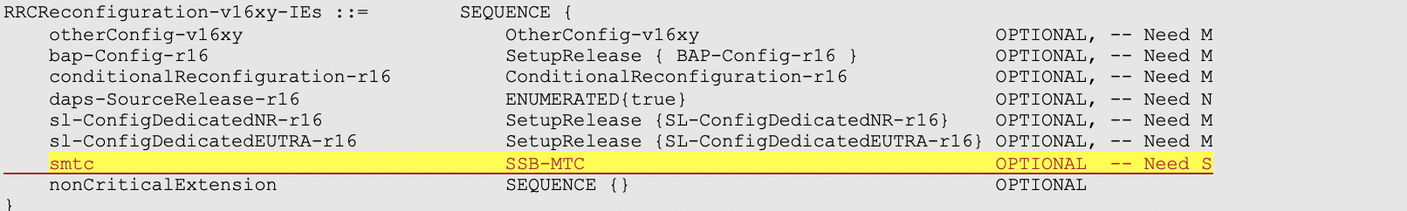

- Option 2: Clarify in the field description of SMTC configuration in secondaryCellGroup -> SpCellConfig -> reconfigurationWithSync, to indicate it can be used for PSCell addition and SN change.
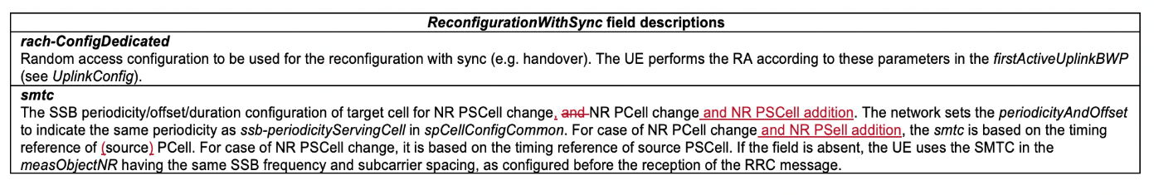

In last RAN2 meeting, Option 2 was adopted for R15 CR in order to avoid the R15 ASN.1 impact while it may introduce the additional network complexity to provide the PSCell SMTC configuration(further details in [1]).
For Option 1, the change is aligned with EN-DC, and MN provides the SMTC configuration. The drawback is that it has ASN.1 impact. In R2-2007117 and R2-2007118, it is proposed to agree Option 1 for SMTC configuration in R16.
Q1) Do companies agree Option 1 for SMTC configuration in R16 for PSCell Addition and SN Change in NR-DC?
Company | Agree/Disagree | Comments (if any)
Huawei | Disagree | We prefer Option 2 for R16.  The smtc is an optimization (UE can use the smtc in measObjectNR to facilitate the synchronization with target SSB or even blindly detecting the SSB on the given frequency), the network optionally carries it when it has the value.  We prefer to re-use the existing smtc in reconfigurationWithSync and update the field description to include the SN change case. The timing is based on source PSCell.  How to fetch the timing is based on network implementation.

Q2) If the answer to Q1 is “Yes”, do you agree with the changes made in R2-2007118?
Company | Agree/Disagree | Comments (if any)

2.2 Issue #2. NeedForGap (R2-2007849, R2-2007959)
When UE reports NeedForGap for a frequency band through gapIndication, UE indicates either gap or no-gap for gapIndication (no way to indicate conditional requirement). In R2-2007849, it is proposed to clarify that, the intended behavior on NeedForGap is to report yes (gap) if at least a single BWP requires measurement gap.
Q3) Do companies agree to add “on at least one DL BWP” in the gapIndication field description (proposed in R2-2007849 )?
Company | Agree/Disagree | Comments (if any)
Huawei | Disagree | We don’t think the change is needed.  For needForGap mechanism, if UE reports “no-gap”, it means gaps are not needed regardless of DL BWP. If UE reports “gap”, then it fallbacks to the inter-f measurement without gaps mechanism and other gapless scenarios defined in R15, which is out of the scope of needForGap and that’s when DL BWP is considered.

In TS 36.300, the sentence in section 10.1.3 "UE may need measurement gaps to perform inter-RAT measurements on NR frequencies depending on the UE capability to support independent FR measurement as specified in TS 38.306." does not cover the new introduced NeedForGap capability. It is noted by the contributing company that this is not correct in the scenario when UE performs FR1 inter-RAT measurement, which the measurement gaps requirement depends on NeedForGap capability instead of UE’s independent FR measurement capability.
Q4) Do companies agree to modify the description in 36.300 section 10.1.3 about measurement gaps requirement for inter-RAT measurements (proposed in R2-2007959) ?
Company | Agree/Disagree | Comments (if any)
Huawei | Disagree | We don’t think the change is needed.  First, the original text uses “may”, which is very soft. Second, the text “Whether a measurement is non gap assisted or gap assisted depends on the UE's capability and the current operating frequency.” has already incorporated the needForGap mechanism, the following texts are based on the assumption that needForGap is reported as “need”.

3 Conclusion
TBD

References
[1] R2-2007117 SMTC Configuration for PSCell Addition and SN Change in NR-DC Apple, MediaTek Inc., Nokia, Nokia Shanghai Bell, Qualcomm Incorporated, ZTE Corporation, Sanechips, CATT
[2] R2-2007118 SMTC Configuration for PSCell Addition and SN Change in NR-DC Apple, MediaTek Inc., Nokia, Nokia Shanghai Bell, Qualcomm Incorporated, ZTE Corporation, Sanechips, CATT
[3] R2-2007849 Correction to gapIndication considering interFrequencyConfig-NoGap Samsung
[4] R2-2007959 CR to 36.300 on support of NeedForGap capability Nokia, Nokia Shanghai Bell

