3GPP TSG-RAN WG2 Meeting #109 electronic R2-2001913
Elbonia, 24th–28th February 2020

Source: CATT
Title: Summary of open issues for PDCCH
Agenda Item: 6.11.2
Document for: Discussion and Decision

Introduction
This contribution provides a summary of the contributions posted in the Agenda Item 6.11.2 PDCCH-based power saving signals/channel Additional stage-3 RAN2 aspects. The addressed issues are classified as:
- New issues not addressed in the email discussions
- Issues already addressed in the email discussions [108#78] (MAC running CR [3][4]) and [108#38] (RRC running CR [1][2]);
For each new issue, companies are invited to provide their answers to the following questions:
- Does the issue need to be solved for rel-16?
- If yes, what are the companies’ opinion(s) on solution(s)?

Discussion
  - New issues not addressed in the email discussions

Issue #1: Capturing CSI reporting when the drx-onDurationTimer is not started due to DCP indication, but the MAC entity is in Active Time during on-duration due to other reasons
Company/Tdoc: CATT [5]
Proposed solution: When evaluating Active Time when drx-onDurationTimer is not started due to DCP, the same triggers, with same ambiguity period (4ms) as in legacy should be taken into account.
Proposed TP (wrt [3]):

------------------------------------------------------------------------------------------------------------------------------
1> if DCP is configured for the active DL BWP:
2> in current symbol n, if the symbol occurs within drx-onDurationTimer duration and drx-onDurationTimer would not be running considering DCP occurrence(s) associated with the current DRX cycle until [x] ms prior to symbol n as specified in this clause; and
2> if the MAC entity would not be in Active Time considering grants/assignments/DRX Command MAC CE/Long DRX Command MAC CE received and Scheduling Request sent until 4 ms prior to symbol n when evaluating all DRX Active Time conditions as specified in this clause:
3> not transmit periodic SRS and semi-persistent SRS defined in TS 38.214 [7];
3> not report semi-persistent CSI;
3> if ps-Periodic_CSI_Transmit is not configured with value true:
4> not report periodic CSI on PUCCH.
------------------------------------------------------------------------------------------------------------------------------

Q1a. Do you think this issue needs to be solved for Rel-16?
Company | Yes/No | Comments (if any)
Qualcomm | Yes | We agree with CATT’s analysis.

Q1b. If the answer to Q1a is Yes, do you agree with the proposed solution (TP)?
Company | Yes/No | Comments and/or other solutions (if any)
Qualcomm | Yes

Issue #2: Impact of DCP associated with a long DRX cycle on the short DRX cycles within this long DRX cycle
Company/Tdoc: vivo [7]
Proposed solution: PDCCH-WUS only locates before onDuration timer for long DRX cycle and such PDCCH-WUS can be also used to control the activation/deactivation of onDuration timer for short DRX cycle in the same long DRX cycle.
Rapporteur: This issue depends on the outcome of the issue of Short DRX support for DCP.

Q2a. Do you think this issue needs to be solved for Rel-16?
Company | Yes/No | Comments (if any)
Qualcomm | No | In our understanding, at any point of time, UE uses either short or long DRX. When short DRX cycle is running, if WUS is not configured (or not supported) for short DRX cycle, then there is no WUS occasions to monitor.

Q2b. If the answer to Q2a is Yes, do you agree with the proposed solution?
Company | Yes/No | Comments and/or other solutions (if any)

Issue #3: UE behaviour when it is configured with multiple DCP monitoring occasions and detects one
Company/Tdoc: OPPO [9]
Proposed solution: If UE detects WUS indicating UE to wake up, UE can skip the left WUS monitoring occasions associated with the next occurrence of drx-onDurationTimer.

Rapporteur: This issue looks more in the RAN1 domain.

Q3a. Do you think this issue needs to be solved by RAN1 or RAN2?
Company | RAN1/RAN2 | Comments (if any)
Qualcomm | RAN1 | How to monitor WUS is a PHY layer issue and hence should be discussed by RAN1.

Q3b. If the answer to Q3a is RAN2, do you think this issue needs to be solved for Rel-16?
Company | Yes/No | Comments (if any)

Q3c. If the answer to Q3b is Yes, do you agree with the proposed solution?
Company | Yes/No | Comments and/or other solutions (if any)

Issue #4: Notification of SI/PWS change and DCP
Company/Tdoc: Intel Corporation [11]
Proposed solution: RAN2 assumes that a UE using WUS can still rely on legacy mechanism to receive notifications of SI or PWS change (as other paging DCI can be received in parallel to PDCCH-WUS).

Rapporteur: As mentioned in [11], “RAN1 is considering that paging DCI could be monitored in parallel to WUS when required by a UE. Therefore, no new solution is required unless RAN1 indicates otherwise”. Given no further work is expected from RAN1, it seems nothing needs to be done and the current situation is already what is proposed.

Q4a. Do you think this issue needs to be solved for Rel-16?
Company | Yes/No | Comments (if any)
Qualcomm | No | We think the current behaviors are fine and no further enhancement is needed.

Q4b. If the answer to Q4a is Yes, do you agree with the proposed solution?
Company | Yes/No | Comments and/or other solutions (if any)

Issue #5: Improving Power Saving when the UE is configured to report L1 RSRP/CSI report irrespective of DCP indications
Company/Tdoc: Apple [12]
Proposed solution: NW configures UE to report CSI/SRS in sparse mode, i.e. report once per N DRX cycles.

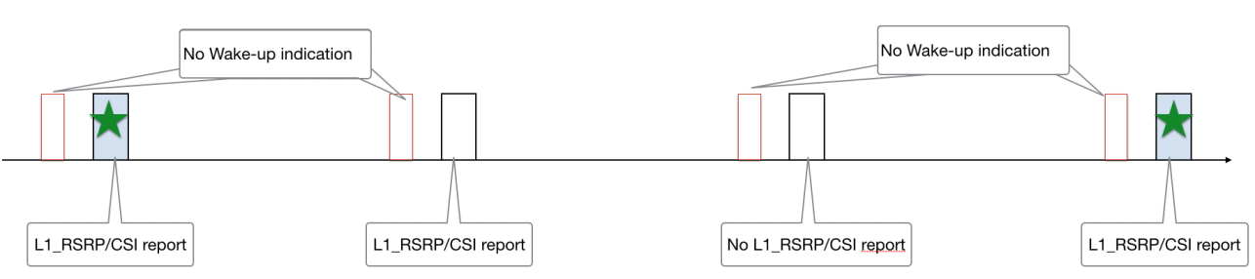

Q5a. Do you think this issue needs to be solved for Rel-16?
Company | Yes/No | Comments (if any)
Qualcomm | Yes | We think this is an important feature to have, given that network now has the option to require UE to report L1-RSRP even if DCP indicates no wakeup. This is because network may configure L1-RSRP with short periodicity during active traffic, in order to continuously refine UE’s serving beams to achieve high throughput. But if DCP indicates no data, then there is no need for UE to report L1-RSRP frequently. Network only needs occasional L1-RSRP report to ensure UE has a working PDCCH beam to receive DCP. This can be done by scaling up the periodicity of L1-RSRP when there is no data, as proposed by [12].

Q5b. If the answer to Q5a is Yes, do you agree with the proposed solution?
Company | Yes/No | Comments and/or other solutions (if any)
Qualcomm | Yes

Issue #6: DCP mis-detection avoidance
Company/Tdoc: Apple [12]
Proposed solution: Support periodical wake up and/or always wake up in poor radio condition mechanism.
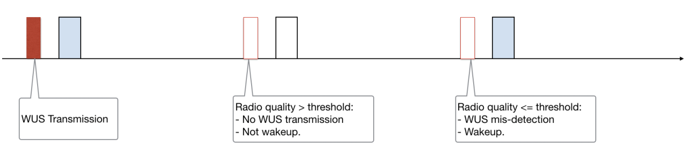

Q6a. Do you think this issue needs to be solved for Rel-16?
Company | Yes/No | Comments (if any)
Qualcomm | No | We think similar effect can already be achieved with the existing behaviors. For example, network can learn about UE’s link quality from UE’s measurement report. If link quality has dropped and mis-detection of DCP may become a concern, NW can configure UE to wake up if WUS is not received. Or alternatively, what is proposed can be just UE implementation, i.e. UE can choose to wake up and monitor PDCCH if it feels that is necessary when its link quality has dropped to a sufficiently low level.

Q6b. If the answer to Q6a is Yes, do you agree with the proposed solution?
Company | Yes/No | Comments and/or other solutions (if any)

Issue #7: ASN.1 options for capturing the search space for the DCP
Company/Tdoc: ZTE Corporation, Sanechips [14]
Proposed solution:
Select one from the following options to introduce DCI format 2_6 in TS38.331.
- Option 1: Introduce a SearchSpace-r16 in which the searchSpaceType-r16 includes all the indications for UE to monitor PDCCH candidates for Rel-15 DCI formats and DCI format 2-6.
- Option 2: Introduce SearchSpaceExt-r16 and searchSpacesToAddModListExt-r16.
- Option 3: Introduce powersavingSearchSpaceList-r16 in PCCCH-Config.
Q7a. Do you think this issue needs to be solved for Rel-16?
Company | Yes/No | Comments (if any)
Qualcomm | Yes

Q7b. If the answer to Q7a is Yes, which of option 1/2/3 do you prefer?
Company | Option | Comments and/or other options (if any)
Qualcomm | Option 1

Issue #8: UE behaviour when it misses DCP during handover
Company/Tdoc: Xiaomi Communications [16]
Proposed solution: UE starts the associated drx-onDurationTimer if UE misses the PDCCH-WUS after handover at a new cell.
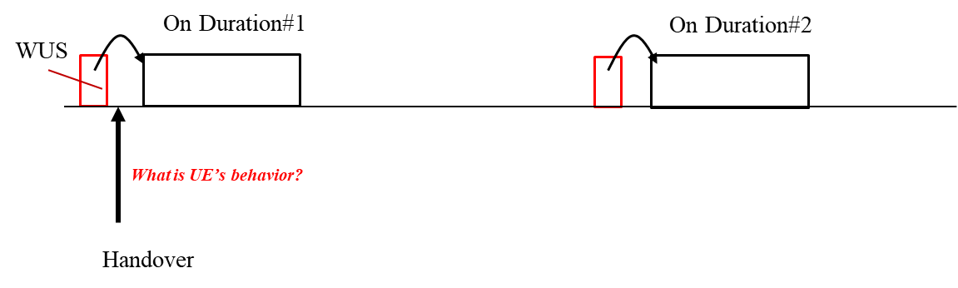
Q8a. Do you think this issue needs to be solved for Rel-16?
Company | Yes/No | Comments (if any)
Qualcomm | No | We do not think there is any critical issue to be solved here.

Q8b. If the answer to Q8a is Yes, do you agree with the proposed solution?
Company | Yes/No | Comments and/or other solutions (if any)

Issue #9: DCP is only monitored outside Active Time, so is there any ambiguity period associated with the DCP monitoring?
Company/Tdoc: Nokia, Nokia Shanghai Bell [17], ZTE Corporation, Sanechips [21]
Proposed solutions:
- Nokia, Nokia Shanghai Bell [17]:
The active time ambiguity period of 4ms applies on whether to UE can monitor the DCP or not (since the UE cannot monitor DCP when in active time).
Proposed TP (wrt [3]):

5.7 Discontinuous Reception (DRX)
…
1> if the Short DRX Cycle is used, and [(SFN × 10) + subframe number] modulo (drx-ShortCycle) = (drx-StartOffset) modulo (drx-ShortCycle):
2> start drx-onDurationTimer after drx-SlotOffset from the beginning of the subframe.
1> if the Long DRX Cycle is used, and [(SFN × 10) + subframe number] modulo (drx-LongCycle) = drx-StartOffset:
2> if DCP is configured for the active DL BWP:
3> if DCP associated with the current DRX Cycle indicated to start drx-onDurationTimer, as specified in TS 38.213 [6]; or:
3> if all DCP occasion(s) in time domain, as specified in TS 38.213 [6], associated with the current DRX Cycle occurred in Active Time considering grants/assignments/DRX Command MAC CE/Long DRX Command MAC CE received and Scheduling Request sent until 4 ms prior to start of the last DCP occasion, or within BWP switching interruption length, or during a measurement gap; or
3> if ps-Wakeup is configured with value true and DCP associated with the current DRX Cycle has not been received:
4> start drx-onDurationTimer after drx-SlotOffset from the beginning of the subframe.
2> else:
3> start drx-onDurationTimer after drx-SlotOffset from the beginning of the subframe.
Editor’s Note: FFS how to progress the support of short DRX cycle for WUS.
Editor’s Note: For DCP overlapping with Active time, it is still FFS in RAN1 whether it refers to all DCP occasions or some DCP occasions.

- ZTE Corporation, Sanechips [21]
[21] specifically addresses the case where DCP occasion occurs right after UE received a DRX Command MAC CE or a Long DRX Command MAC CE:
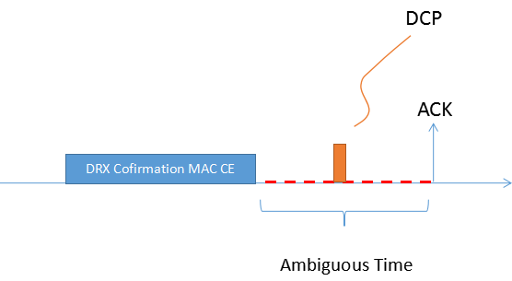

In such case, the proposed solution is to apply the (long) DRX command (i.e. stop the drx-onDurationTimer and drx-InactivityTimer ) only when sending the ACK feedback:
“For the case that DCP is configured and the reception of (long) DRX confirmation MAC CE, stop the drx-onDurationTimer and drx-InactivityTimer in the first symbol after the end of the corresponding transmission carrying the DL feedback of ACK.”
The corresponding TP is:
1> if a drx-HARQ-RTT-TimerUL expires:
2> start the drx-RetransmissionTimerUL for the corresponding HARQ process in the first symbol after the expiry of drx-HARQ-RTT-TimerUL.
1> if a DRX Command MAC CE or a Long DRX Command MAC CE is received:
2> if DCP is configured for the active DL BWP;
3> stop the drx-onDurationTimer and drx-InactivityTimer in the first symbol after the end of the corresponding transmission carrying the DL feedback of ACK.
2>else;
23> stop drx-onDurationTimer;
23> stop drx-InactivityTimer.
1> if drx-InactivityTimer expires or a DRX Command MAC CE is received:
2> if the Short DRX cycle is configured:
3> start or restart drx-ShortCycleTimer in the first symbol after the expiry of drx-InactivityTimer or in the first symbol after the end of DRX Command MAC CE reception;
3> use the Short DRX Cycle.

Q9a. Do you think this issue needs to be solved for Rel-16?
Company | Yes/No | Comments (if any)
Qualcomm | No | We don’t think DRX ambiguity period should include or affect DCP. We analyzed this problem in R2-1916175.

Q9b. If the answer to Q9a is Yes, which of the proposed solutions (TPs) do you prefer:
- Option 1: Nokia, Nokia Shanghai Bell [17]
- Option 2: ZTE Corporation, Sanechips [21]
- Option 3: Both
- Option 4: Other
Company | Option | Comments and/or other solutions (if any)

Issue #10: What should the UE monitor if it misses DCP when configured with SCell dormancy?
Company/Tdoc: Nokia, Nokia Shanghai Bell [18]
Proposed solution: Agree what the UE shall monitor if it misses DCP when configured with SCell dormancy.

Rapporteur: It might be checked first if this is to be discussed in Power Saving WI or in DCCA WI, and in both cases it might rather be a RAN1 issue anyways (since the dormancy state is not visible to MAC).

Q10a. Do you think this issue needs to be discussed in RAN2 Power Saving session instead of DCCA WI or RAN1?
Company | Yes/No | Comments (if any)
Qualcomm | No | We should leave this discussion to RAN1. In fact, RAN1 has already been discussing this issue.

Q10b. If the answer to Q10a is Yes, do you think this issue needs to be solved for Rel-16?
Company | Yes/No | Comments (if any)

Q10c. If the answers to Q10a/b are Yes, what should be the solution?
Company | Solution (if any)

Issue #11: Network is not able to perform beam management actions when WUS has not indicated UE to wake-up but UE has transmitted CSI/SRS
Company/Tdoc: Nokia, Nokia Shanghai Bell [18]
Proposed solution: When UE has reported CSI/transmitted SRS, it would be required to monitor PDCCH for at least part of the on duration. Duration should be configurable by network.

Q11a. Do you think this issue needs to be solved for Rel-16?
Company | Yes/No | Comments (if any)
Qualcomm | No | We do not see it as a critical issue that need to be solved in Rel-16, because if network only needs to perform beam refinement, it can wait until the next DRX cycle and wake up UE to do it. If beam(s) fails, UE can initiate BFR itself.  Moreover, the proposed solution is not power efficient. For example, UE is required to monitor PDCCH regardless of whether CSI indicates good or poor link quality.

Q11b. If the answer to Q11a is Yes, do you agree with the proposed solution?
Company | Yes/No | Comments and/or other solutions (if any)

Issue #12: Can DCP and DRX groups be configured together?
Company/Tdoc: Qualcomm Inc, Samsung [22]
Proposed solution:
RAN2 confirm that the existing RAN1/2 agreements on WUS can still be applied without change when DRX groups are configured. More specifically,
- WUS is configured only on SpCell and UE does not monitor WUS as long as SpCell is in DRX active time;
- If a WUS occasion is not monitored, UE starts DRX on duration timers of both DRX groups at their respective next occurrence;
- Upon a wakeup indication, UE starts DRX on duration timers of both DRX groups at their respective next occurrence
Q12a. Can DCP and DRX groups be configured together in Rel-16?
Company | Yes/No | Comments (if any)
Qualcomm | Yes | We can expect more power saving when both DRX groups and DCP are configured. This is because DCP does not help save power where there is still active traffic. But with DRX groups, once traffic load drops, network can put FR2 cells to sleep first to save power, by using a separate, much shorter DRX inactivity timer for FR2 cells. Therefore, DCP and DRX groups can be configured together to complement each other’s power saving benefits. As analyzed in [22], the existing DCP procedures still can be applied without change, when DRX groups are configured. Therefore, we think DCP and DRX groups should be allowed to be configured together in Rel-16.

Q12b. If the answer to Q12a is Yes, do you agree with the proposed solution?
Company | Yes/No | Comments and/or other solutions (if any)

  - Issues already addressed in the email discussions

MAC-PHY modelling for DCP - Issue #1 of [4]
Company/Tdoc | Related proposal
Ericsson [6] | Indicate in an LS to RAN1 that start of Active Time and drx-OnDurationTimer shall only be captured in 38.321, and ask RAN1 to specify an indication to upper layer when to start PDCCH monitoring during the next DRX cycle.
Intel Corporation [11] | Proposal 1. When a UE is configured with the DCP feature, TS 38.321 captures that UE only starts the drx-onDurationTimer upon indication for lower layer. LS is sent to inform RAN1 on this agreement in case any clarification is required on all the cases described in TS 38.213 when drx-onDurationTimer needs to be started.  Proposal 2. When a UE is configured with the DCP feature, TS 38.321 only reports periodic CSI for next DRX cycle upon indication for lower layer. LS is sent to inform RAN1 on this agreement in case any clarification is required on the cases described in TS 38.213 when drx-onDurationTimer is not started and periodic CSI is required.

Support of Short DRX cycle for DCP - Issue #2 of [4]
Company/Tdoc | Related proposal
Ericsson [6] | Indicate in an LS to RAN1 that DCP with short DRX is supported from RAN2 perspective, unless RAN1 concludes that this is technically not feasible.
vivo [7] | RAN2 to confirm RAN1 decision that PDCCH-WUS is not applicable for Short DRX cycle at least in Rel-16.
Apple [13] | Proposal 1: PDCCH-WUS for short DRX cycles will not be supported in Rel.16  Proposal 2: PDCCH-WUS for short DRX cycles will be taken up for discussion again after Rel.16 is frozen.
Nokia [19] | Proposal 1: DCP is supported for both short and long DRX  Proposal 2: DCP for short and/or long DRX is configurable by the network.
LG Electronics Inc [20] | Proposal 1. As RAN1’s final decision, i.e., the working assumption still stand, RAN2 should not support Short DRX cycle on DCP.

Partial overlapping for DCP monitoring - Issue #3 of [4]
Company/Tdoc | Related proposal
OPPO [9] | Proposal 1 UE does not monitor PDCCH-WUS if the PDCCH-WUS monitoring occasion partially overlaps with DRX Active Time or measurement gap or BWP switching.  Proposal 2 If some of the configured PDCCH-WUS occasions overlap with DRX Active Time or measurement gap or BWP switching, whether UE monitors PDCCH-WUS on other PDCCH-WUS occasions is configured by network.
Nokia [18] | If UE misses one or multiple monitoring occasions before the associated on-duration it monitors the PDCCH i.e. starts the drx-onDuration timer.

DRX ambiguous period in DCP - Issue #4 of [4]
Company/Tdoc | Related proposal
OPPO [10] | Proposal 1 When UE estimates the DRX Active Time status of symbols during period of (4ms-WUSoffset) of drx-ondurationTimer, the legacy events are considered irrespective of actual PDCCH-WUS indication.  Proposal 2 When UE estimates the DRX Active Time status of symbols during period other than the periods of (4ms-WUSoffset) of drx-ondurationTimer, UE should take into account the PDCC-WUS indication besides the legacy events  Proposal 3 RAN2 discusses whether UE does not perform CSI/SRS transmission if PDCCH-WUS does not indicate UE to wake-up for symbols during period of (4ms-WUSoffset) of drx-ondurationTimer.

Conclusion
This contribution summarized the contributions posted in the Agenda Item 6.11.2 at this e-meeting, and extracted some new issues to discuss further.
TBC…

Reference
- R2-2000843 Running CR for 38.331 for Power Savings MediaTek Inc
- R2-2000844 Email discussion summary on running 38.331 CR for Power Saving MediaTek Inc.
- R2-2001615 Running CR for Introduction of Rel-16 NR UE power saving in TS 38.321 Huawei
- R2-2001616 Report of email discussion [108#78][Power Saving] 38.321 open issues Huawei
- R2-2000254 New issue on CSI reporting with DCP; CATT
- R2-2000349 Open issues DCP; Ericsson
- R2-2000367 PDCCH-WUS not applicable for short DRX cycle; vivo
- R2-2000368 WUS impact on CSI reporting; vivo
- R2-2000412 Remaining issues on DCP; OPPO
- R2-2000413 Impacts of power saivng signalling on CSI reporting; OPPO
- R2-2000450 Open issues of DCP feature; Intel Corporation
- R2-2000584 PDCCH-WUS Mechanism; Apple
- R2-2000599 PDCCH-WUS and Short DRX Cycle; Apple
- R2-2000665 Discussion on introduction of search space for the DCP; ZTE Corporation, Sanechips
- R2-2000666 Introduction of search space for the DCP in TS38.331; ZTE Corporation, Sanechips
- R2-2000811 Discussion on PDCCH-WUS missing problems during handover; Xiaomi Communications
- R2-2001037 On DRX ambiguous period; Nokia, Nokia Shanghai Bell
- R2-2001038 On DCP monitoring and CSI/SRS transmission; Nokia, Nokia Shanghai Bell
- R2-2001040 On short DRX cycle applicability for DCP; Nokia, Nokia Shanghai Bell
- R2-2001300 Consideration on Short DRX cycle on DCP; LG Electronics Inc.
- R2-2001463 Remaining issues on WUS signal for Power Saving; ZTE Corporation, Sanechips
- R2-2001482 Wakeup signaling with DRX groups; Qualcomm Inc, Samsung

