3GPP TSG-RAN WG2 Meeting #109e R2-200xxxx

Online, 24 February – 6 March 2020

Agenda item: 5.4.1.4
Source: Nokia, Nokia Shanghai Bell
Title: Summary of email discussion [AT109e][068][NR15] IODT issue in 1-symbol PUCCH configuration with frequency hopping
WID/SID: NR_newRAT-Core
Document for: Discussion and Decision

1 Introduction
Discussion for the following:
R2-2000166 TDoc IODT issue in 1-symbol PUCCH configuration with frequency hopping Nokia, Nokia Shanghai Bell discussion Rel-15 NR_newRAT-Core
- Wrong AI
- Docomo wonder why FH would be configured for 1 symbol
- CATT think R1 is discussing the same issue this week, so maybe we should wait.
- Nokia think the main problem is the RRC reject which is clearly R2.
- Huawei are not sure ..
- ZTE QC: Have to check
- Continue by email, allow for checking.

R2-2000167 TS 38.331 IODT issue in 1-symbol PUCCH configuration with frequency hopping Nokia, Nokia Shanghai Bell CR Rel-15 38.331 15.8.0 1430 - F NR_newRAT-Core

- [AT109e][068][NR15] 1-symbol PUCCH with frequency hopping (Nokia)
Scope: Allow check, Continue treat and discuss the documents R2-2000166, R2-2000167
Intended outcome: Agreed CRs
Deadline: Feb 27 1200 CET

2 Background
The “pucch-F0-2WithoutFH “capability indicates whether the UE supports transmission of a PUCCH format 0 or 2 without frequency hopping, but the relationship between single-symbol PUCCH and intra-slot frequency hopping in general, and this capability in particular is currently ambiguous..
- When included, the UE does not support PUCCH formats 0 and 2 without frequency hopping.
- When not included, the UE supports the PUCCH formats 0 and 2 without frequency hopping.
When the UE is configured with a single-symbol PUCCH, the specification leaves the following room for interpretation that may lead to IoDT issues:
- Case 1: If the network configures the UE with a single symbol PUCCH resource that includes intra-slot frequency hopping, is that a valid configuration or is the UE allowed to reject such an RRC configuration? There is no functional reason to reject the configuration, but it may appear illogical to include FH configuration with 1-symbol PUCCH.
- Case 2: If the network configures the UE with a single symbol PUCCH resource that does not include intra-slot frequency hopping, is that a valid configuration for the UE not supporting PUCCH format 0/2 without frequency hopping, or is such a UE allowed to reject such an RRC configuration? There is no functional reason to reject the configuration, but it may appear illogical NOT to include FH configuration with the PUCCH configuration when the UE does not support PUCCH format 0/2 without FH.
If both cases would be considered as a valid reason to reject the configuration, the UE not supporting PUCCH format 0/2 would always reject the single-symbol PUCCH configuration – something that the UE is not allowed to do, given that the PUCCH format 0/2 (with FH) is a mandatory feature with no capability indication.
In Table 2-1, the cases marked in GREEN indicate the contradictory behavior from the UE.
UE support for F0/2 | RRC config includes FH | UE rejects RRC config?
With and without FH | Yes | Case 1 reject
With and without FH | No | OK
With FH only | Yes | Case 1 reject
With FH only | No | Case 2 reject
Table 2-1: Truth table showing the possible combinations.

Case 1 reject: Network provided the UE with a FH config with 1-symbol PUCCH, but the UE considers receiving the FH configuration with 1-symbol PUCCH illogical.
Case 2 reject: Network did not provide the UE with a FH config but configured 1-symbol PUCCH for UE that does not support F0/F2 w/o FH, but the UE considers not receiving the FH configuration with 1-symbol PUCCH illogical.
Observation 1: Looking at Case 1 and Case 2 reject behaviours, network cannot seem to configure 1-symbol PUCCH (even though the specification supports it).

3 Proposal
A specification change to TS 38.331 is needed and illustrated as follows. Note that there are two different changes needed to the TS 38.331 to ensure both Case 1 and Case 2 are covered.
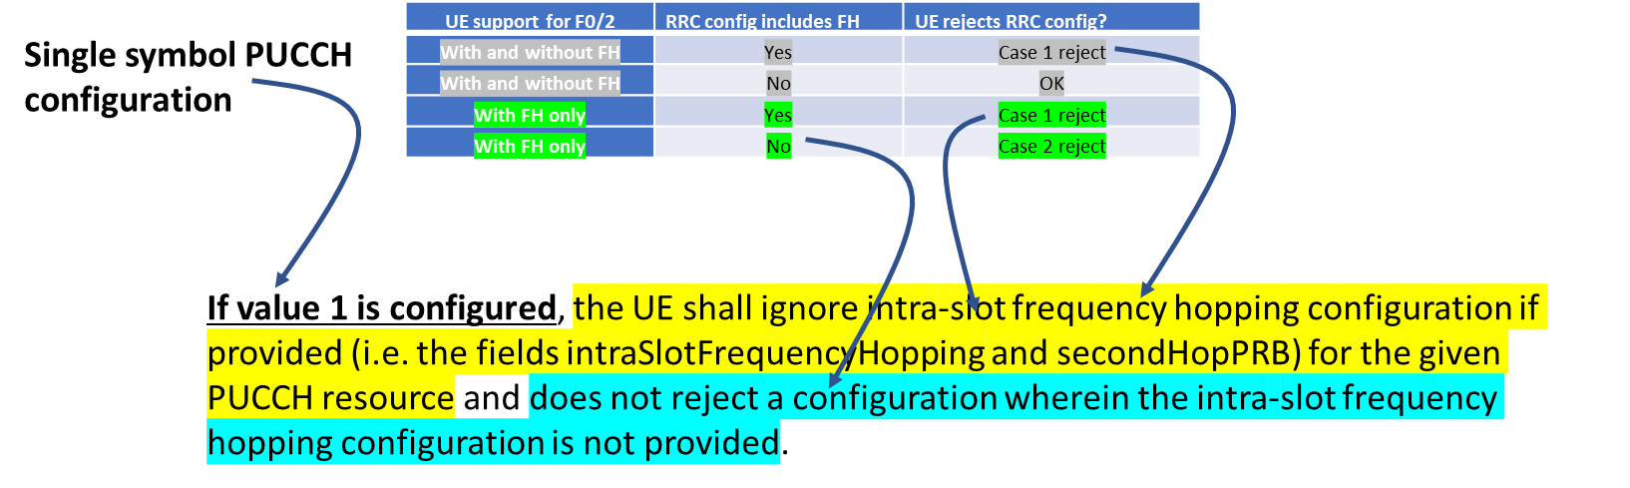

4 Discussion
Companies are invited to give their views on Case 1 and Case 2 reject behavior specifically following the description of the issue listed in section 2:
Company name | View on single symbol PUCCH configuration
Nokia, Nokia Shanghai Bell | Single symbol PUCCH configuration is allowed in Rel-15 and the UE should follow proposal 3 above to ensure that both Case 1 and Case 2 reject behavior is avoided. If both cases would be considered as a valid reason to reject the configuration, the UE not supporting PUCCH format 0/2 would always reject the single-symbol PUCCH configuration – something that the UE is not allowed to do, given that the PUCCH format 0/2 (with FH) is a mandatory feature with no capability indication
Huawei | In our understanding, Case 1 is because the network configures FH for 1-symbol PUCCH; Case 2 is because the network does not configure FH for the UE that only supports FH. Both scenarios seem to be error configuration.  In the 38.331 ASN.1, intraSlotFrequencyHopping and secondHopPRB are configured in the PUCCH-Resource, and each PUCCH-Resource is associated with a PUCCH format, i.e. FH related parameters are format-specific rather than common for all formats. Therefore, the network could easily avoid the wrong configuration mentioned above that leads to Case 1 reject or Case 2 reject.
MediaTek | The following 2 configurations looks like wrong configurations.  • Case 1 - Configure “No FH” for a UE that only supports PUCCH with FH  • Case 2 - Configure “1-symbol” + “FH” to a UE  For case 1, the configuration does not match UE capability. For case 2, it seems that FH is not doable if there is only one-symbol PUCCH duration.  We usually don’t specify the UE behaviour on mis-configuration, it is possible that the UE may reject the configuration.

Company name | Clarification needed in RAN2 (YES/NO)
Nokia, Nokia Shanghai Bell | Yes, reasons as follows  - implementation cannot be expected to read chair notes summarizing RAN2 understanding  - in this case it is clear that RAN2 has had a different understanding of the issue before and even thinking that this is a network issue
Huawei
MediaTek

4 Conclusion
Proposal after the discussion is as follows:

