**RAN1#114b Online Session Schedule**

**RAN1 Breakout1  
(Grand Ballroom C)**

**RAN1 Main**

**(Grand Ballroom B)**

**RAN1 Breakout2**

**(Grand Ballrom A)**

|  |  |  |  |  |  |  |  |  |  |  |  |  |  |  |  |
| --- | --- | --- | --- | --- | --- | --- | --- | --- | --- | --- | --- | --- | --- | --- | --- |
|  | **Monday** | | | **Tuesday** | | | **Wednesday** | | | **Thursday** | | | **Friday** | | |
| **08:30**  **~**  **10:30**  **(120 min)** | **RAN1#114b commences at 09:00 (local time)**  Agenda items 1, 2, 3, 4, 5  Agenda item 9 (election)  Agenda items 6, 7.1 | | | NCR (60)  MC_Enh (60) | UE features (120)  TEI(30)  XR(30)  CovEnh(30)  5MHz(30) | NTN (120) | UE features (120)  MIMO(60)  NES(40)  NCR(20) | eRedCap (45)  <5MHz (30)  AI/ML LS (45) | Pos (120) | 7.1 (80)  7.2 (50) TEI, SL, SDT | eRedCap (45)  <5MHz (30)  AI/ML (45) | UE features (120)  MCE(45)  SL(45)  CovEnh(30) | 6/7.1/7.2 (40)  8.17 (40)  MC-Enh (20)  NCR (20) | UE features (45, 45)  MCE(45)  MIMO(45)  Mobility (30) | SL (60)  Pos (60) |
| **Morning coffee break: 10:30 ~ 11:00** | | | | | | | | | | | | | | | |
| **11:00**  **~**  **13:00**  **(120 min)** | Agenda item 7.1 (60)  MIMO (60) | | | XR (45)  7.2 (75) SL, TR38.901 UE Power, RedCap, SDT, Pos | UE features (60)  MIMO(60Mobility (60) | 7.2 (60)  UE features (60)  SL(60) | MIMO (120) | UE features (60, 60)  POS(45)  BWP(15)  RedCap(30)  DSS(30) | 7.2 (60)  NTN (60) | 7.2 (20) RedCap  NCR (60)  LSs (40) | UE features (90, 30)  MIMO(60),  Mobility(30)  XR(30) | Pos (120) | NES (60)  TBD (60) | Mobility (30)  AI/ML(90) | UE features (60)  POS(55)  [NCR(5)]  Sat Eval (15)  IoT-NTN (45) |
| **Lunch break: 13:00 ~ 14:30** | | | | | | | | | | | | | | | |
| **14:30**  **~**  **16:30**  **(120 min)** | MIMO (120) | Cov (60)  <5MHz (30)  DSS (30) | SL (120) | MIMO (120) | Cov (80)  AI/ML (40) | UE features (120)  NR-NTN(40)  Mobility(40)  POS(40) | MC_Enh (70)  7.2 (50) | Mobility (90)  AI/ML (30) | UE features (120)  SL(70)  MCE(50) | MIMO (120) | UE features (60)  NES(30)  IoT-NTN(30)  CovEnh (60) | SL (120) | Any open issues (150) . Session reports . etc  **RAN1#114b closes at 17:00 (local time)** | | |
| **Afternoon coffee break: 16:30 ~ 17:00** | | | | | | | | | | | | |
| **17:00**  **~**  **19:00**  **(120 min)** | 7.2 (60) NTN, MIMO, URLLC  NES (60) | eRedCap (45)  AI/ML (75) | Pos (120) | NES (100)  Close at 6:40pm | AI/ML (100)  Close at 6:40pm | Pos (100)  Close at 6:40pm | XR (30)  NES (90) | AI/ML (120) | Sat Eval (20)  SL (100) | NES (120) | AI/ML (120) | 7.2 (40)  NR-NTN (80) |
| **All sessions end at 19:15 – no exceptions** | | | | | | | | | | | | | | | |

**RAN1#114b Offline Session Schedule**

**Function Room B (50)**

**Function Room A (50)**

|  |  |  |  |  |  |  |  |  |  |  |
| --- | --- | --- | --- | --- | --- | --- | --- | --- | --- | --- |
|  | **Monday** | | **Tuesday** | | **Wednesday** | | **Thursday** | | **Friday** | |
| **08:30**  **~**  **10:30**  **(120 min)** |  | | 8.1 MIMO (120) | 8.3 Pos (120) | 8.13 NTN (120) | 8.7 Mobility 8.7.1 (60) 8.7.2 (60) | 8.3 Pos (60)  8.5 NES (60) | 8.14 AI/ML 8.14.1(45) LS (30)  8.7 Mobility RRC (45) | 8.7 Mobility 8.7.1 (30) 8.7.2 (30)  8.14.2 AI/ML (60) | 8.3 Pos (60)  8.13 NTN (60) |
| **Morning coffee break: 10:30 ~ 11:00** | | | | | | | | | | |
| **11:00**  **~**  **13:00**  **(120 min)** | 8.5 NES (90)  8.12 MC-Enh (30) | 8.14 AI/ML (120) 8.14.1 8.14.2 | 8.5 NES (60)  8.1 MIMO (60) | 8.14.3 AI.ML (60)  8.4 RedCap (30)  8.10 DSS (30) | 8.5 NES (75)  8.6 XR (45) | 8.14 AI/ML 8.14.1 (60) 8.14.2 (60) | 8.5 NES (120) | 8.2 SL (60)  8.13 NTN (60) |  |  |
| **Lunch break: 13:00 ~ 14:30** | | | | | | | | | | |
| **14:30**  **~**  **16:30**  **(120 min)** | 8.12 MC-Enh (60)  8.11 NCR (60) | 8.3 Pos (120) | 8.9 <5MHz (40)  8.4 RedCap (40)  8.10 DSS (40) | 8.3 Pos (60)  8.15 Sat Eval (60) | 8.1 MIMO (120) | 8.3 Pos (120) | 8.14 AI/ML 8.14.3 (60)  8.7 Mobility 8.7.1 (60) | 8.3 Pos (120) | To be assigned by Xiaodong  To be assigned by David | |
| **Afternoon coffee break: 16:30 ~ 17:00** | | | | | | | | |
| **17:00**  **~**  **19:00**  **(120 min)** | 8.6 XR (45)  8.13 NTN (75) | 8.8 CovEnh 8.8.1 (45) 8.8.3 (45) 8.8.2 (30) | 8.12 MC-Enh (60)  8.11 NCR (40)  **Close at 6:40pm** | 8.2 SL (100)  **Close at 6:40pm** | 8.1 MIMO (120) | 8.4 RedCap (60)  8.9 <5MHz (60) | 8.11 NCR (60)  8.12 MC-Enh (60) | 8.2 SL (120) |
| **All sessions end at 19:15 – no exceptions** | | | | | | | | | | |

**RAN1#114b Detailed Schedule for RAN1 Main Session**

|  |  |  |  |  |  |
| --- | --- | --- | --- | --- | --- |
|  | **Monday** | **Tuesday** | **Wednesday** | **Thursday** | **Friday** |
| **08:30**  **~**  **10:30**  **(120 min)** |  | NCR (60) . Both agenda items  MC_Enh (60) . Both agenda items |  | 7.1 (80) . Any open issues  7.2 (50) . TEI, SL, SDT |  |
| **Morning coffee break: 10:30 ~ 11:00** | | | | | |
| **11:00**  **~**  **13:00**  **(120 min)** | MIMO (60) . DMRS . SRS . Two TA | XR (45)  7.2 (75) SL 🡪 TR38.901 🡪 UE Power 🡪 RedCap 🡪 SDT 🡪 Pos | MIMO (120) . Unified TCI . CSI . DMRS . SRS | 7.2 (20) RedCap  NCR (60) . Any open issues  LSs (40) . Any open issues |  |
| **Lunch break: 13:00 ~ 14:30** | | | | | |
| **14:30**  **~**  **16:30**  **(120 min)** | MIMO (120) . CSI . Unified TCI . UL precoding indication . 8 TX UL SRI/TPMI enhancement | MIMO (120) . Unified TCI . Two TA . UL precoding indication . 8 TX UL SRI/TPMI enhancement | MC_Enh (70)  7.2 (50) . MIMO, . URLLC | MIMO (120) . UL precoding indication . 8 TX UL SRI/TPMI enhancement . CSI . DMRS . SRS . Two TA . Unified TCI |  |
| **Afternoon coffee break: 16:30 ~ 17:00** | | | | |
| **17:00**  **~**  **19:00**  **(120 min)** | 7.2 (60) . NTN 🡪 MIMO 🡪 URLLC  NES (60) . Both agenda items | NES (100) . Both agenda items | XR (30)  NES (90) | NES (100) . Both agenda items |
| **All sessions end at 19:00 – no exceptions** | | | | | |

**Meeting Room Locations (RAN1 meetings have blue borders)**

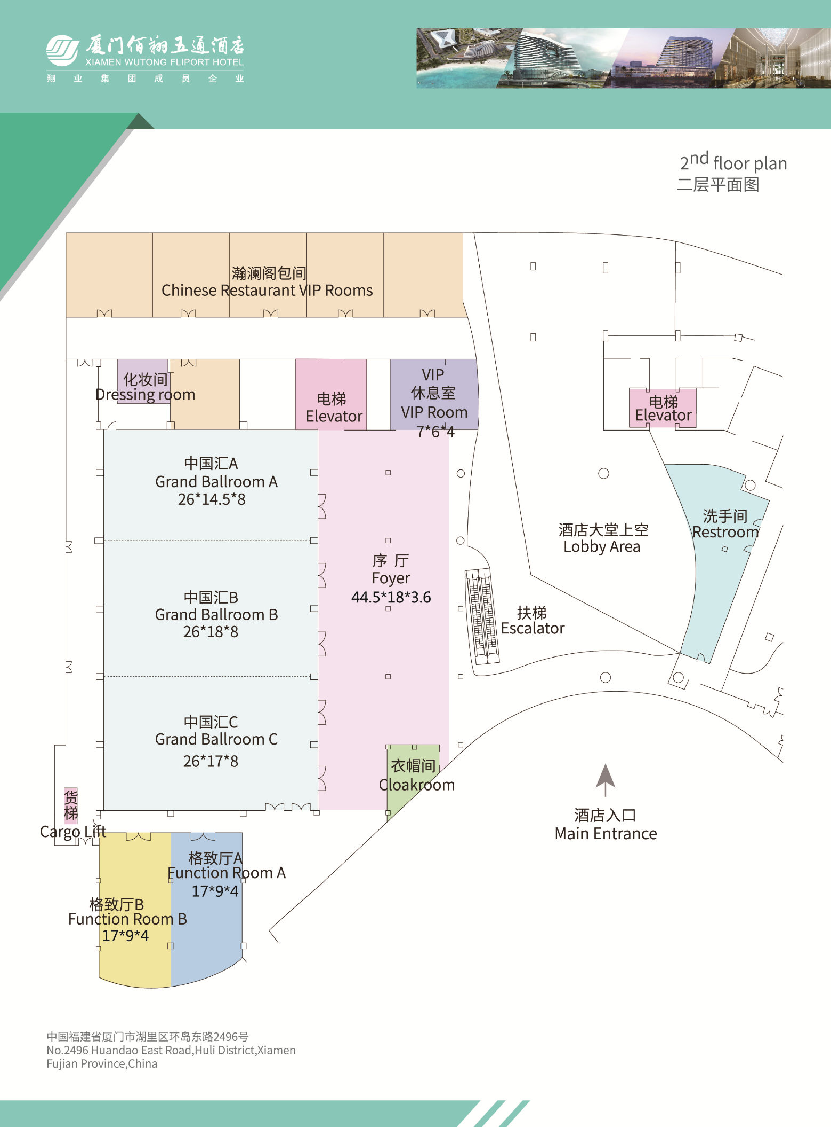

**Monday morning, Friday afternoon:**

**Grand Ballroom A, B, C will be used for main session**

**Monday afternoon ~ Friday morning:**

**Grand Ballroom B: Main Session**

**Grand Ballroom C: Breakout Session 1 (Xiaodong)**

**Grand Ballroom A: Breakout Session 2 (David)**

**Offline sessions**

**Function Room A**

**Function Room B**