3GPP TSG RAN WG1 #109-e R1-22xxxxx
e-Meeting, May 9th – 20th, 2022

Source: Moderator (MediaTek)
Title: [109-e-NR-CRs-11] Maintenance of Rel-15 RSRQ definition
Agenda item: 7.1
Document for: Discussion and Decision

Introduction
In RAN1#109-e meeting, one contribution [1, MTK] is submitted to clarify the NR RSRQ definition in 38.215.
As guided by the Chairman, this contribution provides summary of the submitted contributions (Section 4), discussion points (Section 2), and possible RAN1 consensus during this meeting (Section 3, TBD).
[109-e-NR-CRs-11] Maintenance of Rel-15 RSRQ definition – James (MTK)
- Check point on May 11 to see if there is consensus for spec change or conclusion
- Relevant tdoc: R1-2204681

Discussion points (phase 1 until 10-May)
Based on the submitted contribution [1, MTK], it is mentioned that
  - For LTE system, RSRQ is defined as the ratio of
N×RSRP / (E-UTRA carrier RSSI),
where N is the number of RB's of the E-UTRA carrier RSSI measurement bandwidth.
    - the numerator and denominator will always be measured based on almost the same time span
    - >= -10dB RSRQ corresponds to very good channel quality
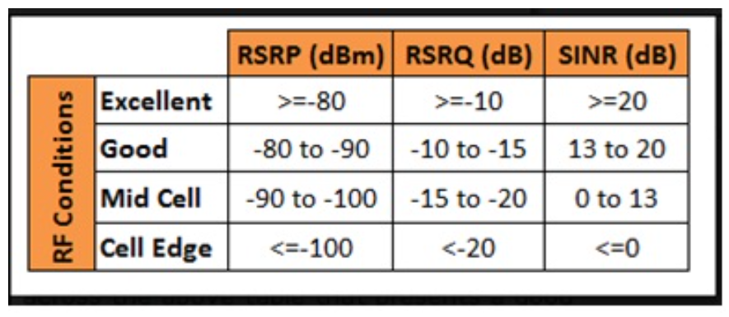
https://www.digi.com/support/knowledge-base/understanding-lte-signal-strength-values
  - For NR system, RSRQ evaluation rules in different scenarios are specified in TS38.215 5.1.3. RSRQ is defined as the ratio of
N×SS-RSRP / (NR carrier RSSI)
    - If the IE measurementSlots is NOT indicated by higher layers:
      - NR Carrier RSSI is measured from OFDM symbols within SMTC window duration
      - In this case, the numerator and denominator might NOT be measured based on the same time span

Take the following Figure 1 where “there is only one SSB inside the SMTC window” for ease of illustration:
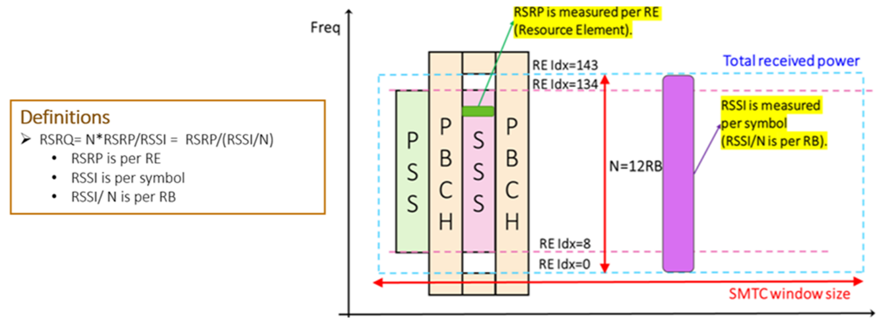
Figure 1. Example of only one SSB inside the SMTC window
For NR FR2, 120kHz SCS with 5ms SMTC duration, and only one SSB detected by UE, when the IE measurementSlots is NOT indicated, there are two possible methods to calculate the RSRQ according to current spec in TS38.215 5.1.3 as shown in Table I below:

Table I. The RSRQ calculation based on two different methods
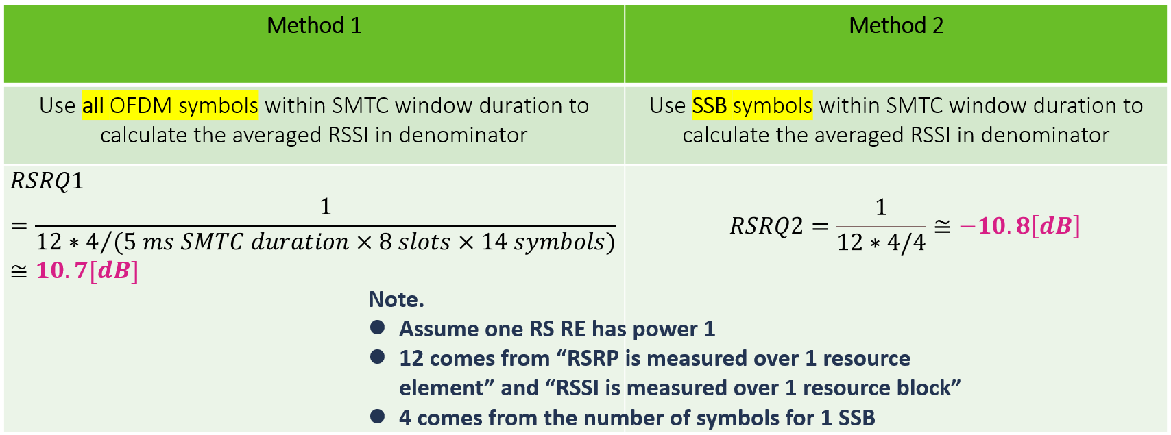

From Table I, it can be seen that, when the cell loading is small, the calculated RSRQ based on the two methods can have up to 20dB value difference.

In the preparation phase summary for AI 7.1 during RAN1 #109e [2],
- vivo states that:
  - We do observe large difference in calculated NR-RSRQ value among different chipset vendors, probably mainly due to the different implementation on the RSSI measurement window. In case "measurementSlots" is not configured by higher layer, the specification says "NR Carrier RSSI is measured from OFDM symbols within SMTC window duration". However, UE implementation could choose to 1) all OFDM symbols in the SMTC window are to be used to calculate the averaged RSSI, or 2) choose a subset of OFDM symbols (how to choose the subset is implementation specific) for the calculation, which would result in different RSRQ. Would be good to have some discussion for better common understanding.
- Qualcomm states that:
  - RSSI measurement is clearly defined in TS 38.215. We don't see the need to align NR RSRQ definition and LTE RSRQ definition. In addition, from our understandings, when measurementSlots is not indicated to the UE, it is up to UE to select resource(s) within the SMTC window for RSSI measurement.
- DOCOMO states that:
  - RAN1 made following conclusion at the RAN1#92 meeting.
Conclusion:
It is RAN1 understanding that the selection of resources within the RSSI measurement window to obtain the RSSI measurement is up to UE implementation. UE is expected to meet the RAN4 RSSI requirements.

Discussion point 1:
For NR RSRQ calculation (N×SS-RSRP / (NR carrier RSSI)), according to 38.215 5.1.3 [3], when the IE measurementSlots is NOT indicated, specification says
- “NR Carrier RSSI is measured from OFDM symbols within SMTC window duration”
What’s your interpretation for the spec sentence above?
- Interpretation 1: UE uses all OFDM symbols in the SMTC window to calculate the averaged RSSI
- Interpretation 2: UE chooses a subset of OFDM symbols (how to choose the subset is up to UE implementation) to calculate the averaged RSSI
- Interpretation 3: UE uses the SSB symbols to calculate the averaged RSSI
Company | Interpretation 1 or 2 or 3 | Comment

Discussion point 2:
RAN1 made following conclusion at the RAN1 #92 meeting [4]:
- Conclusion:
It is RAN1 understanding that the selection of resources within the RSSI measurement window to obtain the RSSI measurement is up to UE implementation. UE is expected to meet the RAN4 RSSI requirements.
What’s your interpretation for the RAN1 conclusion above?
- Interpretation 1: UE uses all OFDM symbols in the SMTC window to calculate the averaged RSSI
- Interpretation 2: UE chooses a subset of OFDM symbols (how to choose the subset is up to UE implementation) to calculate the averaged RSSI
- Interpretation 3: UE uses the SSB symbols to calculate the averaged RSSI
Company | Interpretation 1 or 2 or 3 | Comment

Discussion point 3:
If your interpretations in Discussion point 1 and Discussion point 2 are different, do you see a need to update the following R15/R16 spec text in 38.215 5.1.3:
- “Otherwise not indicated by higher-layers, if measurement gap is not used, NR Carrier RSSI is measured from OFDM symbols within SMTC window duration and, if measurement gap is used, NR Carrier RSSI is measured from OFDM symbols corresponding to overlapped time span between SMTC window duration and the measurement gap.”
If your answer is “Yes”, please suggest a revised spec text for R15/R16 in the comment.
Company | Yes/No | Comment

Discussion point 4:
(This discussion point is only for potential spec change of R17)
Putting current spec text and the RAN1 #92 agreement aside, which interpretation below is most reasonable for you when the IE measurementSlots is NOT indicated by higher layers?
- Interpretation 1: UE uses all OFDM symbols in the SMTC window to calculate the averaged RSSI
- Interpretation 2: UE chooses a subset of OFDM symbols (how to choose the subset is up to UE implementation) to calculate the averaged RSSI
- Interpretation 3: UE uses the SSB symbols to calculate the averaged RSSI
Company | Interpretation 1 or 2 or 3 | Comment

Discussion point 5:
(This discussion point is only for potential spec change of R17)
If your interpretations in Discussion point 1 and Discussion point 4 are different, do you see a need to update the following R17 spec text in 38.215 5.1.3:
- “Otherwise not indicated by higher-layers, if measurement gap is not used, NR Carrier RSSI is measured from OFDM symbols within SMTC window duration and, if measurement gap is used, NR Carrier RSSI is measured from OFDM symbols corresponding to overlapped time span between SMTC window duration and the measurement gap.”
If your answer is “Yes”, please suggest a revised spec text for R17 in the comment.
Company | Yes/No | Comment

Resulted RAN1 conclusion/agreement (phase 2)
TBD based on outcome/situation of phase 1 discussion.

Summary of contribution inputs
Summary for [1, MTK]:
In [1], it is mentioned that
  - For LTE system, RSRQ is defined as the ratio of
N×RSRP / (E-UTRA carrier RSSI),
where N is the number of RB's of the E-UTRA carrier RSSI measurement bandwidth.
    - the numerator and denominator will always be measured based on almost the same time span
    - -10dB RSRQ corresponds to very good channel quality
  - For NR system, RSRQ evaluation rules in different scenarios are specified in TS38.215 5.1.3. RSRQ is defined as the ratio of
N×SS-RSRP / (NR carrier RSSI)
    - If the IE measurementSlots is NOT indicated by higher layers:
      - NR Carrier RSSI is measured from OFDM symbols within SMTC window duration
      - In this case, the numerator and denominator might not be measured based on the same time span

Take one example of NR FR2, 120kHz SCS with 5ms SMTC duration, and only SSB1 can be detected by UE. When the IE measurementSlots is NOT indicated, there are two possible methods to calculate the RSRQ according to current spec in TS38.215 5.1.3:

Observation 1: RSRQ might become abnormally high when RSRP and RSSI are not evaluated based on the same time span
Proposal 1: RAN1 to clarify UE/gNB behavior on RSRQ calculation/comparison between NR and LTE when Network does not indicate the measurementSlots to the NR cell
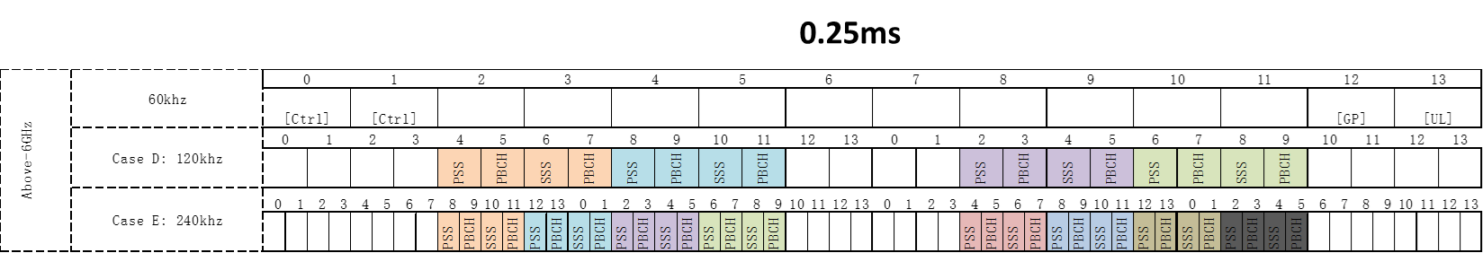
Figure 1: Example of SSB structures in FR2

References
[1] R1-2204681 Discussion on Rel-15 RSRQ definition, MediaTek, RAN1 #109e
[2] R1-22xxxxx RAN1#109-e_NR_CRs_7.1_summary_v24_Samsung_Moderator.xlsx, download link, RAN1, RAN1 #109e
[3] 3GPP TS 38.215 V17.1.0, “NR; Physical layer measurements”
[4] Chairman’s note, RAN1 #92

