3GPP TSG RAN WG1 Meeting #103-e R1-20xxxxx
e-Meeting, October 26th – November 13th, 2020

Agenda Item: 8.8.2
Source: Moderator (China Telecom)
Title: [103-e-NR-CovEnh-EvaluationResults]: Collection of simulation results for enhancements
Document for: Discussion

1. Introduction
This contribution is a summary of email discussion on the collection of simulation results for enhancements.

2. Simulation results for PUSCH enhancements

2.1 Time domain based solutions
Table 2-1 Enhancements on PUSCH repetition type A
Company | Frequency Range | Performance gain |  | Key Assumptions
Company | Frequency Range | eMBB | voice | Key Assumptions
China Telecom | FR1 |  | 3.2 dB | DDDSUDDSUU, O2I, repetitions counted on the basis of available UL slots
China Telecom | FR1 |  | 4.0 dB | DDDSUDDSUU, VoIP, O2O, repetitions counted on the basis of available UL slots
ZTE | FR1 |  | 1~1.5 dB | Rural, O2O, 2 DMRS symbols.  Baseline scheme: 4 repetitions with maximum 1 re-transmission (Max 8 transmissions)  Enhanced scheme: 2 repetitions with maximum 3 re-transmissions (Max 8 transmissions).
Intel | FR1 | ~2.0dB |  | ~2dB performance gain can be observed when doubling the repetition level.  Rural 3km/h, 700MHz, FDD, TBS = 136 bits, MCS 0, 2 DMRS symbols, 12 data symbols
NTT DOCOMO | FR1 | 6.4 dB | 6.8 dB | Comparing w and w/o repetition (number of repetition is 4)  To support repetition for e.g. DDDSU, new mechanism is necessary
Sierra Wireless | FR1 | 0.4 dB |  | Baseline = no repeats,  Rural 3km/h, 700MHz, FDD, TBS=112, 100kbps  Repetitions = 4, TBS = 456
Sierra Wireless | FR1 | 0.2 dB |  | Repetitions = 8, TBS = 888  (same baseline as above)
Sierra Wireless | FR1 | -1.6 dB |  | Repetitions = 16, TBS = 1800  (same baseline as above)
Apple | FR1 | ~2.2dB |  | About 2.2dB gain is observation if the repetition number is doubled. FDD 700MHz MCS=120/1024 4PRB, No frequency hopping, 1DMRS symbol, 3km/h
Apple | FR1 | 0.8dB |  | Keeping the target data rate, with frequency hopping. MCS=120/0124 without repetition; MCS=251/1024with one more repetition. Details are in R1-2008479
Huawei, HiSilicon | FR1 |  | 8.1dB | Compared with no repetition, no retransmission, 8.1dB gain is obtained in TDD (DDDSUDDSUU) with 3 retransmissions combined with 4 actual repetitions.
Huawei, HiSilicon | FR1 | ~2dB |  | By double the actual repetition for eMBB, ~2dB gain can be obtained.

Table 2-2 Enhancement on PUSCH repetition Type B
Company | Frequency Range | Performance gain |  | Key Assumptions
Company | Frequency Range | eMBB | voice | Key Assumptions
China Telecom | FR1 |  | 0.8 dB | DDDSUDDSUU, O2I/O2O, across slot boundary, length > 14 OS
ZTE | FR1 |  | 0.8 dB | 4GHz, ‘DDDSU’ (S: 10D:2G:2U)  Baseline scheme: 14-symbol PUSCH, MCS#5  Enhanced scheme: 16-symbol PUSCH, MSC#4
ZTE | FR1 |  | 0.8 dB | 4GHz, ‘DDDSU’ (S: 10D:2G:2U)  Baseline scheme: PUSCH of 2 repetitions, and the length of each nominal repetition is L=8.  Enhanced scheme: Actual repetition can cross slot boundary. The duration of each actual repetition is L=8.
vivo | FR1 | 2dB |  | For some RV and TDD configuration, especially for RV0 or RV3 are punctured due to limited symbols for actual repetition.
InterDigital | FR1 |  | 2dB | 4GHz, DDDSU, rural, 3km/hr, 3PRBs, 2 DMRS,  Baseline scheme: 14-symbol PUSCH, MCS#7  Enhancement: 16-symbol extended PUSCH, MCS#5,  Reference : Figure 1 in Appendix
InterDigital | FR1 | 0.38dB |  | 4GHz, DDDSU, rural, 120km/hr, 3PRBs, MCS#5  Baseline scheme: 14-symbol PUSCH, 4 DMRS  Enhancement: 16-symbol extended PUSCH, 5 DMRS,  Reference : Figure 2 in Appendix
InterDigital | FR1 |  | 0.36dB | 4GHz, DDDSU, rural 120km/hr, 2PRBs MCS#9  Baseline scheme: 14-symbol PUSCH, 4 DMRS  Enhancement: 16-symbol extended PUSCH, 5 DMRS,  Reference : Figure 3 in Appendix
InterDigital | FR1 |  | 0.2dB | 4GHz, DDDSU, rural 120km/hr, 2PRBs, MCS#8  Baseline scheme: 14-symbol PUSCH, 2 DMRS  Enhancement: 16-symbol extended PUSCH, 3 DMRS,  Reference : Figure 3 in Appendix
InterDigital | FR1 | 0.33dB |  | 4GHz, DDDSU, rural 120km/hr, 5 PRBs, MCS#2  Baseline scheme: 14-symbol PUSCH, 3 DMRS  Enhancement: 16-symbol extended PUSCH, 4 DMRS,  Reference : Figure 2 in Appendix
InterDigital | FR2 | 30PRB$→$26PRB |  | PUSCH, 28GHz, DDDSU, eMBB, 2DMRS, indoor, (Gain in terms of the number of RBs reduced), MCS#5  Baseline scheme: 14-symbol PUSCH Enhancement: 16-symbol extended PUSCH,  Reference : Figure 5 in Appendix
InterDigital | FR1 |  | 38PRB$→$33PRB | PUSCH, 4GHz, DDDSU, VoIP, rural, 2DMRS,pi/2 BPSK (Gain in terms of the number of RBs reduced) , MCS#0  Baseline scheme: 14-symbol PUSCH Enhancement: 16-symbol extended PUSCH,  Reference : Figure 4 in Appendix
InterDigital | FR1 | 1.3dB |  | PUSCH, 4GHz, DDDSU, eMBB, rural, QPSK, 4 PRB, 120km/hr  Baseline scheme: 14-symbol PUSCH, 2DMRS, MCS#3  Enhancement: 16-symbol extended PUSCH, 3DMRS, MCS#2  Reference : Figure 6 in Appendix
Samsung | FR1 |  | 1.75 dB | 4GHz O2I, DDDSUDDDSU, max # of HARQ tx: 4, Latency: 50 ms, TBS: 368, For VoIP, 2% rBLER  Baseline scheme: PUSCH symbol length: {2, 14, 2, 14}  Enhancement: PUSCH symbol length: 16
Samsung | FR2 |  | 1.4 dB | 28GHz O2I, DDDSUDDDSU, max # of HARQ tx: 16, Latency: 50 ms, TBS: 368, For VoIP, 2% rBLER  Baseline scheme: PUSCH symbol length: {2, 14, 2, 14}  Enhancement: PUSCH symbol length: 16

Table 2-3 TB processing at least over multi-slot PUSCH
Company | Frequency Range | Performance gain |  | Key Assumptions
Company | Frequency Range | eMBB | voice | Key Assumptions
China Telecom | FR1 |  | 1.0 dB | DDDSUDDSUU, O2I, TBS based on 4 slots
China Telecom | FR1 |  | 0.6 dB | DDDSUDDSUU, O2O, TBS based on 4 slots
China Telecom | FR1 | 2.7 dB |  | DDDSUDDSUU, rural, O2O, TBS based on 4 slots
IITH, IITM, CEWIT, Reliance Jio, Tejas Networks | FR1 | 0.8 dB |  | 2 slots aggregation, TBS based on 2 slots, DDDSU, rural TDL-D, 30ns
Intel | FR1 |  | ~0.2dB | Baseline scheme 1: 4 PRBs in a slot, 14 symbols.  TB spanning multiple slots: 1 PRB spanning 4 slots  Link level simulation results for these two schemes are similar, but link budget gain of ~6dB for TB spanning 4 slots over baseline scheme can be observed.  Simulation assumption: 3km/h, 4 GHz, TDD with DDDSU
Qualcomm | FR1 | 1-2 dB | 1-2 dB | Baseline: 1 PRB/slot. TB sized per slot.  Proposal: Aggregate PRBs across multiple slots. Size TB for total aggregated resources.  Observation: 2 slot aggregation results in ~1 dB gain, while 4 slot aggregation results in 2 dB gain.  Additional gain due to overhead reduction is not included here.
InterDigital | FR1 | 0~1.0dB |  | TBS determined based on multiple slots and transmitted over multiple slots,  700MHz FDD, TB over 2 or 3 slots, QPSK, 3km/hr,  Compared to the baseline, up to 3dB and 4.7dB power boosting gain is possible for 2 and 3 slot transmission scheme, respectively.  Reference : Figure 8 in Appendix
InterDigital | FR1 | 1.0dB |  | TBS determined based on multiple slots and transmitted over multiple slots,  700MHz FDD, TB over 3 slots, pi/2 BPSK, 3km/hr,  Compared to the baseline, up to 4.7dB power boosting gain is possible  Reference : Figure 8 in Appendix
InterDigital | FR1 | 0.43dB~1.75dB |  | TBS determined based on multiple slots and transmitted over multiple slots,  4GHz, TDD, rural, TB over 2 or 5 slots, QPSK, 3km/hr,  Compared to the baseline, up to 3dB and 4.7 power boosting gain is possible for 2 and 6.98dB slot transmission scheme, respectively  Reference : Figure 7 in Appendix
InterDigital | FR1 |  | 2.0dB | TBS determined based on multiple slots and transmitted over multiple slots,  700MHz, FDD, TB over 6 slots, QPSK, 3km/hr,  Compared to the baseline, up to additional 7.7 dB power boosting gain is possible  Reference : Figure 9 in Appendix
InterDigital | FR1 |  | 0.4dB | TBS determined based on multiple slots and transmitted over multiple slots,  700MHz, FDD, TB over 10 slots, pi/2 BPSK, 3km/hr,  Compared to the baseline, up to 10dB power boosting gain is possible  Reference : Figure 9 in Appendix
Nokia/NSB | FR1 | 1 dB |  | Rural 700MHz, FDD, 15kHz SCS, 2 DMRS symbols per slot, UE speed: 3km/h; Target throughput: 100kbps  Baseline scheme: 4 PRBs, TBS = 432 bits, MCS11 (table 3), 4 repetitions (type A).  Enhanced scheme: 4 PRBs, TBS = 432 bits, MCS5 (table 3), transmitted over time resource of 4 slots, no repetition.
Sierra Wireless | FR1 | 2.5 |  | Gaps between TBs = 7 slots  No FH, Rural, 30km/h, 8 Repetitions, 100kbps
Sierra Wireless | FR1 | 2.0 |  | Gaps between TBs = 7 slots  With FH, Rural, 30km/h, 8 Repetitions, 100kbps

2.2 Frequency domain based solutions
Table 2-4 Enhancements on inter-slot frequency hopping
Company | Frequency Range | Performance gain |  | Key Assumptions
Company | Frequency Range | eMBB | voice | Key Assumptions
ZTE | FR1 | 0.5 dB |  | 4GHz, Rural, MCS#2, one DMRS per hop  Baseline scheme: 2 FH positions  Enhanced scheme: 4 FH positions
Intel | FR1 | 0.3dB |  | Rural 3km/h, 700MHz, FDD, TBS=136 bits, MCS 0, 8 repetitions, 2 DMRS symbols, 12 data symbols  For 4 Rx antennas, ~0.3dB performance gain can be achieved for 4 frequency hops compared to 2 frequency hops.
Intel | FR1 | 1.5dB |  | Same simulation assumptions as above.  For 2 Rx antennas, ~1.5dB performance gain can be achieved for 4 frequency hops compared to 2 frequency hops.
Qualcomm | FR1 | 0 dB |  | Scenario: Urban 4GHz with 64 TXRUs.  Baseline: 4 repetitions with 2 inter-slot frequency hops.  Comparison: 4 repetitions with 4 inter-slot frequency hops.
vivo | FR1 | 1dB |  | More frequency hopping locations, no offsets, from 2 hops to 4.
Ericsson | FR1 | 1.3 dB (LLS) |  | 4 hops vs. 2 hops, no cross-slot est.  1% BLER  For 300ns delay spread, 3kmph, 2 Rx, 2 DMRS  4 PRBs, MCS0, 700 MHz  8 repetitions (no retransmissions)  Details in R1-2008419
Ericsson | FR1 | 0.3 dB (LLS) |  | 4 hops vs. 2 hops, no cross-slot est.  1% BLER  For 30ns delay spread, 3kmph, 2 Rx, 2 DMRS  4 PRBs, MCS0, 700 MHz  8 repetitions (no retransmissions)  Details in R1-2008419
Ericsson | FR1 | 0 dB (LLS) |  | 4 hops vs. 2 hops, with cross-slot est.  1% BLER  For 30ns delay spread, 3kmph, 2 Rx, 2 DMRS  4 PRBs, MCS0, 700 MHz  8 repetitions (no retransmissions)  Details in R1-2008419
Sierra Wireless | FR1 | 1 dB |  | Rural 3km/h, 700MHz, FDD, TBS = 456, Repeats = 4,100kbps, 2 DMRS/slot, 2 Rx Antennas
Huawei, HiSilicon | FR1 | 1.7dB |  | Baseline scheme: no FH positions  Enhanced scheme: 2 FH positions  30RB, MCS3, 300ns, 4GHz, 1T4R
Huawei, HiSilicon | FR1 | 0.8dB |  | Baseline scheme: 2 FH positions  Enhanced scheme: 4 FH positions  30RB, MCS3, 300ns, 4GHz, 1T4R
Huawei, HiSilicon | FR1 |  | 0.75 | Compared with 3 retransmissions combined with 4 actual repetitions for VoIP, 0.75 dB gain is obtained with inter slot frequency hopping at Urban scenario @4GHz DDDSUDDSUU.

Table 2-5 Enhancements on frequency hopping for PUSCH repetition type B
Company | Frequency Range | Performance gain |  | Key Assumptions
Company | Frequency Range | eMBB | voice | Key Assumptions
 | FR1
 | FR2

Table 2-6 Sub-PRB transmission for VoIP
Company | Frequency Range | Performance gain |  | Key Assumptions
Company | Frequency Range | eMBB | voice | Key Assumptions
China Telecom | FR1 |  | 0.8 dB | DDDSUDDSUU, O2O, half PRB and 8 slots
Samsung | FR1 |  | 5.6 dB | DDDSUDDSUU, TBS=80 per 5ms, 2.7 times smaller T-F resource for subPRB (4PRB*1slot vs 0.5PRB*3slots), TDL-A, Delay spread: 30ns, SCS=30KHz, 4Ghz  Note: Required SNR: rel-16 is better with 3.4dB;  Occupied BW (thus noise power): sub-PRB is better as 9dB;
Samsung | FR1 | 8.5dB |  | TBS=50 (per transmission), TDL-C, Delay spread: 300ns, Same T-F resource (4PRB*1slot vs 0.5PRB*8slots), SCS=30KHz, 4Ghz  Note: Required SNR: rel-16 is better with 0.5dB;  Occupied BW (thus noise power): sub-PRB is better as 9dB;
Samsung | FR1 | 1.6dB |  | TBS=50 (per transmission), TDL-A, Delay spread: 30ns, Same T-F resource (1PRB*1slot vs 0.5PRB*2slots), SCS=30KHz, 4Ghz  Note: Required SNR: rel-16 is better with 1.4dB;  Occupied BW (thus noise power): sub-PRB is better as 3dB;
vivo | FR1 |  | 0dB | Sub-PRB with the whole TB transmitted over 2 slots compared to repetition type A with 2 repetitions
Sierra Wireless | FR1 |  | 0~5 dB | No MCL gain. Gain comes from reduction in MPR and A-MPR due to reduction in PAPR/CM.  2 tone Pi/2 BPSK (i.e. LTE-M sub-PRB solution with near zero PAPR)

2.3 DM-RS enhancements
Table 2-7 Joint channel estimation
Company | Frequency Range | Performance gain |  | Key Assumptions
Company | Frequency Range | eMBB | voice | Key Assumptions
China Telecom | FR1 | 0.4 dB |  | DDDSUDDSUU, rural O2I, 2 slots
China Telecom | FR1 | 0.8 dB |  | FDD, rural O2I, 2 slots
ZTE | FR1 | 1.8 dB |  | 4GHz, MCS#5, one DMRS per repetition, 8 repetitions, No FH.  Baseline scheme: No cross-slot channel estimation  Enhanced scheme: Cross-slot channel estimation
Intel | FR1 | ~2.0dB |  | Rural 3km/h, 700MHz, FDD, TBS=136 bits, MCS 0, 8 repetitions, 2 DMRS symbols, 12 data symbols. Cross-slot channel estimation is employed with a fixed window size of 4 slots  For Rel-15 inter-slot FH, cross-slot channel estimation can provide ~2dB performance gain compared to the case without cross-slot channel estimation.
Qualcomm | FR1 | 1-2 dB |  | Baseline: PUSCH 1RB allocation, 4 reps.  Enhancement: PUSCH 1 RB allocation, 0/2/4 reps, with cross-slot channel estimation.
Sharp | FR1 | 1.5 dB |  | Baseline: PUCCH, 1 RB allocation, repetition with 4 slots in FDD  Enhancement: PUCCH, 1 RB allocation, repetition with 4 slots in FDD, cross-slot channel estimation with 4 slots
Panasonic | FR1 | 1.0 dB |  | Rural, 4 GHz, DDDSUDDSUU, 3 km/h  4PRBs, 2 repetitions, w/o HARQ  Baseline: w/o cross-slot channel estimation  Enhancement: w/ cross-slot channel estimation
NTT DOCOMO | FR1 |  | 1 dB | Number of repetition is 2 for consecutive 2 UL slots assuming DDDSUDDSUU for FR1
Samsung | FR1 |  | 1.3 dB | DDDSUDDSUU, 4GHz with O2I, 4PRB, Delay spread: 300 ns, Max # of HARQ tx: 4, Latency: 50 ms, 1 DMRS
Samsung | FR1 |  | 0.9 dB | DDDSUDDSUU, 4GHz with O2I, 4PRB, Delay spread: 300 ns, Max # of HARQ tx: 4, Latency: 50 ms, 2 DMRS
Samsung | FR2 |  | 1.1 dB | DDDSUDDDSU, 28GHz with O2I, 4PRB, Delay spread: 100 ns, Max # of HARQ tx: 16, Latency: 50 ms, 1 DMRS
Samsung | FR2 |  | 0.85 dB | DDDSUDDDSU, 28GHz with O2I, 4PRB, Delay spread: 100 ns, Max # of HARQ tx: 16, Latency: 50 ms, 2 DMRS
CMCC | FR1 | 0.4dB |  | Urban O2I  2.6GHz 7D1S2U (6D:4S:4U for the Special slot)  Baseline：2 uplink slot without cross slot channel estimation, no FH  Enhancement：2 uplink slot with cross slot channel estimation, no FH
vivo | FR1 | 0.8dB |  | 4 repetitions transmission in one slot
vivo | FR1 | 0.3dB |  | 4 repetitions transmission among 4 slots
vivo | FR1 | 1dB |  | DMRS-less in time domain with joint channel estimation for 4 repetitions within one slot.
vivo | FR1 | 1dB |  | DMRS-less in time domain with joint channel estimation for 4 repetitions across 4 slots.
Ericsson | FR1 | 1.1 dB (LLS) |  | With vs. without cross-slot est., no FH  4 DMRS  1% BLER  For 300ns delay spread, 3kmph, 2 Rx  4 PRBs, MCS0, 700 MHz  8 repetitions (no retransmissions)  Details in R1-2008419
Nokia/NSB | FR1 | 0.4 dB |  | Urban 4GHz NLOS, 2DMRS symbols per slot, UE speed: 3km/h  Baseline scheme: no cross-slot channel estimation.  Enhanced scheme: cross-slot channel estimation with 2-slot bundling.
Apple | FR1 | 0.2dB |  | FDD 700MHz MCS=120/1024 4PRB, No frequency hopping, 1DMRS symbol, 3km/h  2 repetitions with or without cross slot channel estimation
Apple | FR1 | 0.4dB |  | FDD 700MHz MCS=120/1024 4PRB, No frequency hopping, 1DMRS symbol, 3km/h  4 repetitions with or without cross slot channel estimation
Apple | FR1 | 0.6dB |  | FDD 700MHz MCS=120/1024 4PRB, No frequency hopping, 1DMRS symbol, 3km/h  8 repetitions with or without cross slot channel estimation
Apple | FR1 | 0.6dB |  | FDD 700MHz MCS=120/1024 4PRB, No frequency hopping, 2 DMRS symbol, 3km/h  4 repetitions with or without cross slot channel estimation
Apple | FR1 | 1dB |  | FDD 700MHz MCS=120/1024 4PRB, No frequency hopping, 2 DMRS symbol, 3km/h  8 repetitions with or without cross slot channel estimation
InterDigital | FR1 |  | 0.3dB | 4GHz TDD Rural, 4 PRBs, DDDSU, 120km/hr, VoIP  Baseline : QPSK, 2 DMRS in uplink slot  Enhancement : 2 DMRS in uplink slot, 1 DMRS in special slot, cross-slot channel estimation assisted by DMRS in special slot  The BLER performance is shown in Figure 10 in the Appendix
Huawei, HiSilicon | FR1 | 1.4dB  2.1dB |  | Compared with single slot channel estimation, 1.4dB and 2.1 dB SNR gain can be obtained by 2 and 3 consecutive slots joint channel estimation at 10% BLER. Other parameter settings:  1T 64R  TDL-C  3 km/h  300ns  Type I, max-length=1, 1 DMRS symbol per slot

Table 2-8 Inter-slot frequency hopping with inter-slot bundling
Company | Frequency Range | Performance gain |  | Key Assumptions
Company | Frequency Range | eMBB | voice | Key Assumptions
China Telecom | FR1 |  | 0.5 dB | FDD, O2I, 2 slots bundling
ZTE | FR1 | 0.5 dB |  | 4GHz, Urban, MCS#3, one DMRS per hop.  Baseline scheme: Inter-slot FH  Enhanced scheme: FH per two repetitions and cross-slot channel estimation among two repetitions per hop.
Intel | FR1 | ~1.0dB |  | Rural 3km/h, 700MHz, FDD, TBS=136 bits, MCS 0, 8 repetitions, 2 DMRS symbols, 12 data symbols  Enhanced inter-slot FH pattern: same frequency resource in 4 consecutive slots. Cross-slot channel estimation is employed with a fixed window size of 4 slots for both Rel-15 inter-slot FH and enhanced inter-slot FH. When employing cross-slot channel estimation, ~1.0dB performance gain can be achieved by enhanced inter-slot FH pattern, compared to Rel-15 inter-slot FH.
Intel | FR1 | ~3.0dB |  | Same simulation assumptions as above. Enhanced inter-slot FH pattern: same frequency resource in 4 consecutive slots.  Compared to Rel-15 inter-slot FH without cross-slot channel estimation, ~3dB can be achieved by enhanced inter-slot frequency hopping with cross-slot channel estimation
Samsung | FR1 |  | 2.5 dB | Residual BLER  DDDSUDDSUU, 4GHz with O2I, 4PRB, Delay spread: 300 ns, Max # of HARQ tx: 4, Latency: 50 ms, Frequency hopping offset: 40RBs, 1 DMRS
Samsung | FR1 |  | 2.1 dB | Residual BLER  DDDSUDDSUU, 4GHz with O2I, 4PRB, Delay spread: 300 ns, Max # of HARQ tx: 4, Latency: 50 ms, Frequency hopping offset: 40RBs, 2 DMRS
Samsung | FR2 |  | 1.55 dB | Residual BLER  DDDSUDDDSU, 28GHz with O2I, 4PRB, Delay spread: 100 ns, Max # of HARQ tx: 16, Latency: 50 ms, Frequency hopping offset: 40RBs, 1 DMRS
Samsung | FR2 |  | 1 dB | Residual BLER  DDDSUDDDSU, 28GHz with O2I, 4PRB, Delay spread: 100 ns, Max # of HARQ tx: 16, Latency: 50 ms, Frequency hopping offset: 40RBs, 2 DMRS
Ericsson | FR1 | 1.3 dB (LLS) |  | With vs. without cross-slot est.  With frequency hopping (2 hops)  1% BLER  For 30ns delay spread, 3kmph, 2 Rx, 2 DMRS  4 PRBs, MCS0, 700 MHz  8 repetitions (no retransmissions)  Details in R1-2008419

Table 2-9 Lower DMRS density
Company | Frequency Range | Performance gain |  | Key Assumptions
Company | Frequency Range | eMBB | voice | Key Assumptions
ZTE | FR1 | 1 dB |  | 2GHz, 14-symbol PUSCH, one DMRS, DMRS type 1, one port transmission.  Baseline scheme: DMRS type 1, one port transmission, 3 dB power boosting on DMRS RE compared to data RE.  Enhanced scheme: Only mapping DMRS type 1 on even PRBs, 6 dB power boosting on DMRS RE compared to data RE.
Intel | FR1 | -0.2dB |  | Baseline scheme: 2 DMRS symbols in each slot  Lower DMRS density scheme: 2 DMRS symbols in even slots and no DMRS in odd slots  Rural 3km/h, 700MHz, FDD, TBS=136 bits, MCS 0, 8 repetitions, 2 DMRS symbols, 12 data symbols
CMCC | FR1 | 1.4 dB |  | Urban O2I  2.6GHz 7D1S2U (6D:4S:4U for  Special slot)  Baseline : MCS #4 2 uplink slot without cross slot channel estimation, 2 DMRS symbol per slot  Enhancement : MCS #3, 4 symbol in special slot+ 2 uplink slot, with single DMRS symbol per slot(including the special slot), with cross slot channel estimation
vivo | FR1 | 1dB |  | DMRS-less in time domain with joint channel estimation for 4 repetitions within one slot.
vivo | FR1 | 1dB |  | DMRS-less in time domain with joint channel estimation for 4 repetitions across 4 slots.

Table 2-10 Higher DMRS density
Company | Frequency Range | Performance gain |  | Key Assumptions
Company | Frequency Range | eMBB | voice | Key Assumptions
China Telecom | FR1 | 0.5 dB |  | DDDSUDDSUU, urban O2I, 1-comb DM-RS
China Telecom | FR1 | 1.5 dB |  | DDDSUDDSUU, rural O2O, 1-comb DM-RS
Intel | FR1 | -0.05dB |  | Baseline scheme: 4 DMRS symbols in each slot  Higher DMRS density: 5 or 6 DMRS symbols in each slot  Rural 3km/h, 700MHz, FDD, TBS=136 bits, MCS 0, 8 transmissions, 2 DMRS symbols, 12 data symbols. Inter-slot FH
NTT DOCOMO | FR1 |  | 1 dB | Symbol duration 1 or 2  Additional DMRS symbol position : pos3

Table 2-11 Adaptive DMRS configuration
Company | Frequency Range | Performance gain |  | Key Assumptions
Company | Frequency Range | eMBB | voice | Key Assumptions
Qualcomm | FR1 | 1.7 dB |  | PUSCH with 14 symbol allocation. 1 Tx, 4 Rx. Channel: TDL-C 300ns, 3 kmph. Performance gap between optimal DMRS and suboptimal DMRS choice is reported as gain.

Table 2-12 DM-RS balancing among frequency hops
Company | Frequency Range | Performance gain |  | Key Assumptions
Company | Frequency Range | eMBB | voice | Key Assumptions
 | FR1
 | FR2

2.4 Other solutions for PUSCH coverage enhancements
Table 2-13 Other Solutions for PUSCH coverage enhancements
Company | Solutions | Performance gain |  |  | Key Assumptions
Company | Solutions | eMBB |  | voice | Key Assumptions
China Telecom | Enhanced intra-slot frequency hopping |  |  | 1.8 dB | DDDSUDDSUU, O2O
China Telecom | Enhanced intra-slot frequency hopping | 0.4 dB |  |  | DDDSUDDSUU, rural O2I
IITH, IITM, CEWIT, Reliance Jio, Tejas Networks | Power boosting for pi/2 BPSK | 3 dB for <50% UL duty cycle
IITH, IITM, CEWIT, Reliance Jio, Tejas Networks | Power boosting for pi/2 BPSK | 6 dB for <25 % UL duty cycle
Qualcomm | Implicit switching between DFT-S-OFDM and CP-OFDM | 2-3dB (due to change in tx power) |  |  | Aimed at avoiding a RRC reconfig to change waveform from CP-OFDM to DFT-S-OFDM.
Qualcomm | Techniques to reduce MPR in uplink transmissions | 1-1.5 dB (due to increase in tx power) |  |  | Aimed at increasing uplink transmit power for DFT-S-OFDM and CP-OFDM waveforms.
Panasonic | Symbol-level repetition | 0.4 dB (3km/h)  -0.3 dB (120km/h) |  |  | Rural, 4 GHz, DDDSUDDSUU, 3 km/h/120km/h  4PRBs, 2 repetitions, w/o HARQ  Baseline: PUSCH repetition Type A w/o cross-slot channel estimation  3 km/h: Type 1, 2 DMRS symbol, no multiplexing with data  120 km/h: Type 1, 3 DMRS symbol, no multiplexing with data
Mitsubishi | Alamouti-based transmit diversity | 2-2.7dB in FR1  2-3dB with QPSK, up to 8.5dB with 16QAM in FR2 |  |  | PAPR preserving SFBC and /or single symbol STBC
Ericsson | Multi-Layer DFT-S-OFDM | ~3 dB cubic metric gain vs. CP-OFDM |  |  | Rank 2 QPSK transmission

3. Simulation results for PUCCH enhancements

3.1 Prioritized solutions
DMRS-less PUCCH
Company | Frequency Range | Performance gain | Key Assumptions
ZTE | FR1 | 2~3 dB | 4GHz, 11 bits UCI, , w/o DTX detection, 1% BLER  Baseline scheme: PUCCH format 3, ML coherent receiver  Enhanced scheme: Sequence based PUCCH with 2^11 sequences, ML noncoherent sequence detector
ZTE | FR1 | 3.8 dB | 4GHz, 11 bits UCI, w/ DTX detection based on DMRS symbols, 1% DTX to ACK error rate, 1% ACK miss detection, and 0.1% NACK to ACK.  Baseline scheme: PUCCH format 3, ML coherent receiver  Enhanced scheme: Sequence based PUCCH with 2^11 sequences, ML noncoherent sequence detector
Qualcomm | FR1 & FR2 | 3 - 4 dB | Results for PUCCH with 2 bits payload:  - Baseline: NR PUCCH Format 1, 14 OFDM symbols  - Enhancement: Orthogonal sequence design for non-coherent PUCCH  - Perf. Target: 1% ACKDTX, 0.1% NACK ACK.  - Lower complexity receiver compared to R15/R16 PF3 receiver.  - Robust to timing and freq errors  Results for PUCCH with 4 bits:  - Baseline: NR PUCCH Format 3, 14 OFDM symbols  - Enhancement: Orthogonal sequence design for non-coherent PUCCH  - Perf. Target: 1% BLER  - Lower complexity receiver compared to R15/R16 PF3 receiver.  - Robust to timing and freq errors  Results for PUCCH with 11 bits:  - Baseline: NR PUCCH Format 3, 4-14 OFDM symbols  - Enhancement: Non-orthogonal sequence design for non-coherent PUCCH  - Perf. Target: 1% BLER  - Lower complexity receiver compared to R15/R16 PF3 receiver.  - Robust to timing and freq errors
Sharp | FR1 | 3 dB | Baseline: Rel-15 PUCCH format 3 with 4 bits, ML detector, 14 symbols, 1 RB allocation  Enhancement: New PUCCH format with 4 bits for sequence selection, correlation detector, 14 symbols, 1 RB allocation
CMCC | FR1 | 1~2.7dB | 4~14 symbol PUCCH format 3 with 11 bits  Payload  Urban 2.6GHz  TDL-C 300ns  1T4R
vivo | FR1 | 1-4 dB (NACK to Ack) | 3bits/4 symbols or 11bits/11 symbols with 2Rx and 4Rx, TDLC-300 11Hz, DTX to ACK rate is limited within 1%.  Gold sequence is assumed for sequence based PUCCH.  Additional DMRS is assumed for legacy PF3.  1% BLER, 1% ACK miss, 0.1% NACK to ACK.
Ericsson | FR1 | 0 to 0.2 dB (LLS) | DMRS-less (Gold code) vs. 2 DMRS  3-11 bits CSI; 1% BLER  For 30ns delay spread, 3kmph, 2 Rx  Format 3, 700 MHz  No repetitions  Details in R1-2008420
Ericsson | FR1 | 0 to 0.2 dB (LLS) | DMRS-less (Gold code) vs. 2 DMRS  3-11 bits CSI; 1% BLER  For 300ns delay spread, 3kmph, 4 Rx  Format 3, 700 MHz  No repetitions  Details in R1-2008420
EURECOM | FR1 | 1.5dB (Coding gain)  4.8 dB (PAPR reduction) | Low-PAPR, DMRS-less (non-orthogonal), 4 bit, 1% BLER,1 PRB, 14 symbols,  For 300ns delay spread, 10 Hz Doppler, 4 Rx  2.6 GHz  No repetitions, Frequency Hopping  Baseline: PUCCH 3 π/2-BPSK, advanced receiver (non-coherent correlator)
EURECOM | FR1 | 0 dB 8 MSBs (Coding gain)  1.8 dB 3 LSBs (Coding gain)  4.8 dB (PAPR reduction) | Low-PAPR, DMRS-less (non-orthogonal, 2 protection levels), 11 bit (8 low protection+3 high protection), 1% BLER,1 PRB, 14 symbols,  For 300ns delay spread, 10 Hz Doppler, 4 Rx  2.6 GHz  No repetitions, Frequency Hopping  Baseline: PUCCH 3 π/2-BPSK, advanced receiver (non-coherent correlator)
EURECOM | FR1 | 2.1dB (Coding gain)  4.8 dB (PAPR reduction) | Low-PAPR, DMRS-less (non-orthogonal, 3GPP Polar + mapping to low-PAPR sequences), 22 bit, 1% BLER,1 PRB, 14 symbols,  For 300ns delay spread, 10 Hz Doppler, 4 Rx  2.6 GHz  No repetitions, Frequency Hopping, simple SC polar decoder  Baseline: PUCCH 3 π/2-BPSK, LS estimator + quasi-coherent receiver for LLR inputs to decoder, simple SC polar decoder
Huawei, HiSilicon | FR1 | 2dB (2dB sequence gain+0dB power back-off gain) | PUCCH 2bits UCI  - Baseline: PUCCH format 1 with ML non-coherent detector  - DMRS-less PUCCH: generated by (2) in R1-2007584 with ML non-coherent detector.  - Metric: 1% DTX->ACK, 1% ACK misdetection, 0.1% NACK->ACK  Other assumptions: 14 OFDM symbols, no repetition, with frequency hopping, power back-off defined in R1-1905837.
Huawei, HiSilicon | FR1 | DMRS-less PUCCH 1 over baseline 1: 2.4dB (0.7dB sequence gain+1.7dB power back-off gain)  DMRS-less PUCCH 1 over baseline 2: 4.5dB (2.8dB sequence gain+1.7dB power back-off gain)  DMRS-less PUCCH 2 over baseline 2: 3dB (1.2dB sequence gain+1.7dB power back-off gain)  PAPR reduction: 4.5 dB (any of DMRS-less PUCCH 1/2 over any of baseline 1/2) | PUCCH 11bits UCI without DTX detection  - Baseline1: PUCCH format 3 with ML non-coherent detector  - Baseline2: PUCCH format 3 with coherent detector (2D-Wiener filter channel estimation, ML demodulation/decoding)  - DMRS-less PUCCH 1: generated by (2) in R1-2007584 with ML non-coherent detector.  - DMRS-less PUCCH 2: generated by (2) in R1-2007584 with low complexity non-coherent detector in R1-2007584.  - Metric: 1% BLER  Other assumptions: 14 OFDM symbols, no repetition, with frequency hopping, power back-off defined in R1-1905837.
Intel | FR1 | 0-0.3dB | 3-10/11 bits UCI, w/ DTX detection, performance metric: 1% false alarm probability, 1% BLER  Receiver for Rel-15/16 PUCCH: PUCCH format 3 with both coherent/non-coherent receiver. Non-coherent receiver can provide better performance than coherent receiver.  Receiver for PUCCH enhancement scheme:  4 schemes were considered in the updated tdoc. 1) Rel-15 PUCCH format 3 with DMRS and removing the 1st column of RM codeword 2) DMRS-less with Gold sequence based 3) DMRS-less with removing the 1st column of RM codeword 4) DMRS-less with enhanced scrambling sequence: note that all 4 schemes have similar performance for all range of 3-10/11 bits. Non-coherent receiver is employed.  Detailed assumption can be found in R1-2009602

PUSCH-repetition-Type-B like PUCCH repetition at least for UCI <=11 bits
Company | Frequency Range | Performance gain | Key Assumptions
vivo | FR1 | 1-1.5dB | For DDDSU frame structure, where S slot with 2 or 4 symbols for PUCCH, U slot is fully used (14 symbols). DMRS bundling is considered for S and U slots.
vivo | FR1 | 0.5 dB | Same as above row, but DMRS bundling is not considered for this case.
vivo | FR2

(Explicit or implicit) Dynamic PUCCH repetition factor indication
Company | Frequency Range | Performance gain | Key Assumptions
ZTE | FR1 | Reducing the number of PUCCH repetitions for more than 70% cases. | Set the SNR at the required SNR for the case with 11bits UCI and 4 PUCCH repetitions. Collect the instantaneous SNR on each PRB.  More than 70% of instantaneous SNR on the RBs can satisfy the required SNR of 2 repetitions.
Qualcomm | FR2 | Helps robust beam switching (L1 beam report reliability increased) | In FR2, incorrect beam switching can lead to link failure. Building robustness around the beam switching procedure is desirable.
Ericsson | FR1 | 3.5 dB MIL  5.0 dB LLS | 8 repetitions vs. no repetition  11 bits CSI; 10% BLER  For 300ns delay spread, 3kmph, 4 Rx  Format 3, 4 GHz  Frequency hopping, 4 DMRS  Details in R1-2008420

DMRS bundling cross PUCCH repetitions
Company | Frequency Range | Performance gain | Key Assumptions
ZTE | FR1 | 1 dB | Urban, 4GHz, 4 PUCCH repetitions.  Baseline scheme: Inter-slot FH for PUCCH repetition.  Enhanced scheme: FH per two repetitions and cross-slot channel estimation among two repetitions per hop.
Intel | FR1 | ~1.2dB | PF3, 1Tx2Rx, FDD 700MHz, 22 UCI bits, 8 repetitions  Enhanced inter-slot FH pattern: same frequency resource in 4 consecutive slots. Cross-slot channel estimation is employed with a fixed window size of 4 slots.  For Rel-15 inter-slot FH, cross-slot channel estimation can provide ~1.2dB performance gain compared to the case without cross-slot channel estimation.
Intel | FR1 | ~2.8dB | PF3, 1Tx2Rx, FDD 700MHz, 22 UCI bits, 8 repetitions  Enhanced inter-slot FH pattern: same frequency resource in 4 consecutive slots.  Compared to Rel-15 inter-slot FH without cross-slot channel estimation, ~2.8dB can be achieved by enhanced inter-slot FH with cross-slot channel estimation.
vivo | FR1 | 0.85dB | For DDDSU frame structure, where S slot with 4 symbols for PUCCH, U slot is fully used (14 symbols). DMRS bundling is considered for S and U slots.  PF3 with 11bits.
vivo | FR1 | 1.3dB | 2 consecutive UL slots with 14 symbols in each slot, PF3 with additional DMRS.  PF3 with 11bits.

3.2 Other solutions for PUCCH coverage enhancements
Company | Solutions | Performance gain | Key Assumptions
CATT | One antenna precoder cycling | 1 dB | Two precoders are applied to consecutive resources in a cycling manner. One antenna port is assumed.
IITH, IITM, CEWIT, Reliance Jio, Tejas Networks | Power boosting for pi/2 BPSK | 3 dB for <50% UL duty cycle
IITH, IITM, CEWIT, Reliance Jio, Tejas Networks | Power boosting for pi/2 BPSK | 6 dB for <25 % UL duty cycle
Qualcomm | UCI payload compression (FR2 L1 beam report) | Helps increase reliability of beam switching procedure | PUCCH carrying larger payloads can be a coverage bottleneck. Payload size reduction helps improve reliability.
NTT DOCOMO | Repetition for PUCCH format 2 | 1.5 dB | Number of repetition : 2
Ericsson | Aperiodic CSI on PUCCH | 3.5 dB MIL  5.0 dB LLS | 8 aperiodic repetitions vs. no repetition  11 bits CSI; 10% BLER  For 300ns delay spread, 3kmph, 4 Rx  Format 3, 4 GHz  Frequency hopping, 4 DMRS  Details in R1-2008420

4. Simulation results for enhancements on other channels / signals
Msg3 PUSCH repetition
Company | Frequency Range | Performance gain | Key Assumptions
ZTE | FR1 | 2.6dB | Rural, 700MHz, O2O, No FH  Baseline scheme: Msg3 PUSCH with one repetition.  Enhanced scheme: Msg3 PUSCH with two repetitions.
ZTE | FR1 | 2.4 dB | Urban, 4GHz, O2I, No FH  Baseline scheme: Msg3 PUSCH with one repetition.  Enhanced scheme: Msg3 PUSCH with two repetitions.
ZTE | FR1 | 5.2 dB | Rural, 700MHz, O2O, No FH  Baseline scheme: Msg3 PUSCH with one repetition.  Enhanced scheme: Msg3 PUSCH with four repetitions.
ZTE | FR1 | 4.7 dB | Urban, 4GHz, O2I, No FH  Baseline scheme: Msg3 PUSCH with one repetition.  Enhanced scheme: Msg3 PUSCH with four repetitions.
ZTE | FR1 | 0.5dB~ 1.07dB | Urban, 4GHz, O2I  Baseline scheme: Msg3 PUSCH with 4 repetitions.  Enhanced scheme: Msg3 PUSCH with 4 repetitions and cross-slot channel estimation.
Intel | FR1 | ~2dB | TBS = 56, MCS = 0, 3 DMRS symbols that are allocated in each slot and UE moving speed of 3km/h  ~2dB performance gain can be observed with doubling the repetition levels for Msg3 PUSCH
NTT DOCOMO | FR1 | 3.46 dB (2 repetition) | Channel: Urban  Center frequency: 2.6 GHz  RV: 0,0
NTT DOCOMO | FR1 | 6.27 dB (4 repetition) | Channel: Urban  Center frequency: 2.6 GHz  RV: 0,0,0,0
CMCC | FR1 | 2.25dB | Urban O2I 2.6GHz  Baseline : Msg 3 PUSCH with no repetition  Enhancements: Msg 3 PUSCH with 2 repetitions (2 slots with no cross slot channel estimation)
vivo | FR1 | 2-3dB | PUSCH repetition Type A and single slot channel estimation is evaluated as shown in R1-2005395. Repetition number is set as 2. Additional gain is achieved via cross slot PUSCH channel estimation.
Ericsson | FR1 | 5.8 dB (LLS) | No vs. 8 repetitions, no frequency hopping  1% BLER  For 30ns delay spread, 3kmph, 2 Rx, 3 DMRS  2 PRBs, MCS0, 700 MHz  no retransmissions  Details in R1-2008421
Nokia/NSB | FR1 | 6.83 dB | Urban 4GHz, NLOS O2I  Baseline scheme: no repetition  Enhanced scheme: 8 repetitions
Nokia/NSB | FR2 | 4.27 dB | Urban 28GHz, NLOS O2I  Baseline scheme: no repetition  Enhanced scheme: 8 repetitions
Huawei, HiSilicon | FR1 | 0.1-0.3dB | Compared with no frequency hopping, intra-slot hopping can obtain 0.1-0.3dB SNR gain.
Huawei, HiSilicon | FR1 | 6 dB | Rural 4GHz, NLOS O2I, no frequency hopping  Baseline scheme: no repetition  Enhanced scheme: 8 repetitions

For evaluation results of other enhancements for Msg3 other than Msg3 repetition or enhancements for other channels/signals including PBCH, unicast/broadcast PDCCH, PDSCH, PRACH, A-CSI and PUCCH with HARQ-ACK for Msg4 etc., please include in the following table:

Company | Channels/Signals | Solutions | Performance gain | Key Assumptions
ZTE | SSB | Increasing the number of SSBs | 1.84 dB | Rural, 700MHz  Baseline scheme: 4 SSBs  Enhanced scheme: 8 SSBs
ZTE | PRACH | PRACH repetition | 3.7 dB | Urban, 4GHz, O2I  Baseline scheme: one PRACH transmission  Enhanced scheme: PRACH with 2 repetitions
ZTE | PRACH | PRACH repetition | 5.2 dB | Urban, 4GHz, O2I  Baseline scheme: one PRACH transmission  Enhanced scheme: PRACH with 4 repetitions
ZTE | PRACH | PRACH repetition | 1.7 dB | Urban, 28GHz, O2I  Baseline scheme: one PRACH transmission  Enhanced scheme: PRACH with 2 repetitions
ZTE | PRACH | PRACH repetition | 3.7 dB | Urban, 28GHz, O2I  Baseline scheme: one PRACH transmission  Enhanced scheme: PRACH with 4 repetitions
ZTE | PRACH | PRACH beam sweeping | 2.5 dB | Rural, 2GHz  Baseline scheme: 1 PRACH transmission  Enhanced scheme: 2 PRACH transmission with different beam
ZTE | PUCCH with Msg4 HARQ-ACK | PUCCH repetition | 3 dB | Rural, 2GHz, 2Rx, PUCCH format 1, 1 bit  Baseline scheme: one PUCCH transmission  Enhanced scheme: PUCCH with 2 repetitions
ZTE | PUCCH with Msg4 HARQ-ACK | PUCCH repetition | 6 dB | Rural, 2GHz, 2Rx, PUCCH format 1, 1 bit  Baseline scheme: one PUCCH transmission  Enhanced scheme: PUCCH with 4 repetitions
ZTE | PDCCH | PDCCH repetition | 2.8~3.1 dB | Rural, 2GHz, 2Tx-2Rx, AL=16  Baseline scheme: one PDCCH transmission  Enhanced scheme: PDCCH with 2 repetitions with separate decoding or joint decoding among 2 repetitions.
ZTE | PDCCH | PDCCH repetition | 4~5.8 dB | Urban, 4GHz, 4Tx-4Rx, AL=16  Baseline scheme: one PDCCH transmission  Enhanced scheme: PDCCH with 4 repetitions with separate decoding or joint decoding among 2 repetitions.
IITH, IITM, CEWIT, Reliance Jio, Tejas Networks | Msg3 | Power boosting using pi/2 BPSK waveform | 3 dB for <50% UL duty cycle
IITH, IITM, CEWIT, Reliance Jio, Tejas Networks | Msg3 | Power boosting using pi/2 BPSK waveform | 6 dB for <25% UL duty cycle
NTT DOCOMO | PDCCH | Aggregation for time domain | 2 dB | Number of PDCCH symbol = 2 and 4
NTT DOCOMO | PDCCH | Compact DCI | 1.5 dB | Payload size = 40 bits and 20 bits
CMCC | Msg3 | Msg 3 repetition with cross slot channel estimation | 4dB | Urban O2I 2.6GHz  Baseline : Msg 3 PUSCH with no repetition  Enhancements: Msg 3 PUSCH with 2 repetitions (2 slots with cross slot channel estimation)
CMCC | Msg3 | Msg 3 repetition with cross slot channel estimation  with reduced DMRS | 3.35~3.75 dB | Urban O2I 2.6GHz  Baseline : Msg 3 PUSCH with no repetition  Enhancements: Msg 3 PUSCH with 2 repetitions (2 slots with cross slot channel estimation) with reduced DMRS
Qualcomm | Broadcast PDCCH | PDCCH repetitions; PDCCH-DMRS bundling | 2-6 dB | Setup: Urban 64 Tx, 4 Rx, TDL-C 300ns, AL 16  Baseline: NR R15/16 PDCCH (no repetitions, no bundling)  Enhancement: 2 or 4 repetitions; with or without DMRS bundling.
Ericsson | CSI on PUSCH | A-CSI on PUSCH | 4.0 dB LLS | 8 aperiodic repetitions vs. no repetition  11 bits CSI; 10% BLER  For 300ns delay spread, 3kmph, 4 Rx  Format 3, 4 GHz  No frequency hopping, 4 DMRS  Details in R1-2008421
Nokia/NSB | PRACH | Multiple PRACH transmission with different beams | 2 dB | Urban, 28GHz, O2I  Baseline scheme: one PRACH transmission  Enhanced scheme: bundle of 2 msg1 transmissions, each transmitted using a different narrow TX beam. Reported gain is the one corresponding to the highest measured RSRP at gNB.
Nokia/NSB | PRACH | Multiple PRACH transmission with different beams | 4.7 | Urban, 28GHz, O2I  Baseline scheme: one PRACH transmission  Enhanced scheme: bundle of 4 msg1 transmissions, each transmitted using a different narrow TX beam. Reported gain is the one corresponding to the highest measured RSRP at gNB.
Apple | Msg3 | 2 repetition with inter-slot hopping comparing with no repetition with intra-slot hopping | 3.2dB | 2.6GHz TDD, TBS=56bits, 2PRB, MCS=157/1024, 3km/h
Apple | Msg3 | 2 repetition with inter-slot hopping comparing with no repetition and no intra-slot hopping | 3.8dB | 2.6GHz TDD, TBS=56bits, 2PRB, MCS=157/1024, 3km/h  Details in R1-2008480

5. Reference
- RAN1 Chairman’s Notes of RAN1#102-e

6. Agreements
Agreements:
- Capture the following updated structure in TR 38.830.
6.1 PUSCH coverage enhancements
6.1.1 Time-domain based solutions
6.1.2 Frequency-domain based solutions
6.1.3 DM-RS enhancements
6.1.4 Power-domain based solutions
6.1.5 Spatial-domain based solutions
6.1.6 Others
Agreements:
- Prioritize the study on the performance and specification impacts on time domain based solutions for PUSCH enhancements, including
  - Increase the number of repetitions for PUSCH repetition type A
    - PUSCH repetition with non-consecutive slots/on the basis of available slots for TDD
    - Note: whether increasing the number of PUSCH repetition for FDD depends on the outcome of AI 8.8.1.1.
  - Enhancement on PUSCH repetition Type B
    - E.g., actual repetition across the slot boundary, or the length of actual repetition larger than 14 symbols, etc.
  - TB processing at least over multi-slot PUSCH
    - e.g., single TB, sized for a single slot, but transmitted in parts over multiple slots; or single TB, sized for multiple slots, transmitted over multiple slots, and in conjunction with repetition, etc.
- FFS
  - OCC spreading based repetition
  - Symbol-level repetition
  - TB interleaving
  - RV repetition
  - Early termination of PUSCH repetitions

Agreements:
- Following solutions are not considered for PUSCH enhancements in this study item in RAN1:
  - Enhancements to improve spherical coverage / beam correspondence
  - Reflective arrays
  - Polarization aspects of the UL and/or DL reference signals

Agreements:
- Prioritize the study on the performance and specification impacts on DM-RS enhancements for PUSCH, including
  - Cross-slot channel estimation
  - With a lower priority compared with cross-slot channel estimation (i.e., companies are encouraged to study it)
    - Lower density
      - E.g., DM-RS sharing among multiple PUSCH transmissions or lower DMRS density in the frequency domain.
    - Higher density
      - E.g., in time or frequency domain, e.g., 1-comb pattern
    - Adaptive configuration
    - DM-RS balancing among frequency hops

Agreements:
- Multiple layer PUSCH transmission with DFT-S-OFDM for PUSCH enhancements can be studied with low priority.
- Study open-loop/closed loop Tx diversity for PUSCH enhancements with low priority.

Agreements:
- Study the performance and specification impacts on frequency domain based solutions for PUSCH, including
  - Inter-slot frequency hopping
    - with more frequency offsets
    - with more frequency hopping positions.
  - Inter-slot frequency hopping with inter-slot bundling to enable cross-slot channel estimation
  - Enhancements on frequency hopping for PUSCH repetition type B
    - Note that the above inter-slot frequency hopping enhancement can apply for PUSCH repetition type B
  - Sub-PRB transmission for VoIP
    - FFS: details, e.g., number of tones, multi-slot aggregation
- FFS
  - Intra-slot frequency hopping
    - with more frequency offsets
    - with more frequency hopping positions.
[Note: Appropriate simulation assumptions are expected.]

Agreements:
- Study following power domain based solution for PUSCH enhancements
  - Waveform design to optimize MPR/A-MPR
  - [FDD high power UE]
  - Power boosting for pi/2 BPSK
Note: if a LS to RAN4 (for the last two bullets) is deemed necessary, target sending the LS in the 1st week of RAN1#103-e

Agreements:
Contingent on all of the outcome of sub-agenda 8.8.1 regarding PUCCH enhancements, prioritize the study of the following schemes for PUCCH coverage enhancement,
- DMRS-less PUCCH
  - FFS: design detail for DMRS-less PUCCH, e.g., sequence based PUCCH transmission, v.s. reuse Rel-15 scheme to transmit UCI without DMRS
- Rel-16 PUSCH-repetition-Type-B like PUCCH repetition at least for UCI <=11 bits.
- (Explicit or implicit) Dynamic PUCCH repetition factor indication
- DMRS bundling cross PUCCH repetitions
  - Including study of transmitting a subset of PUCCH repetitions without DMRS, at least for UCI<=11 bits
Note 1: other schemes are not excluded.
Note 2: the study on DMRS bundling for PUCCH repetition can be a joint study with DMRS bundling for PUSCH repetition studied under 8.8.2.1.
Note 3: Companies are invited to report details of the receivers used in the evaluation. Advanced receiver can be included (not mandatory) in performance evaluations. Performance and receiver complexity are discussed respect to a baseline Rel-15/16 PUCCH scheme.
Note 4: proposed PUCCH repetitions scheme shall account for the resources used by PUSCH to meet the throughput target and should be compared against Rel-15/16 PUCCH repetition framework.
[Note 5: enhancement on one or more PUCCH formats/UCI types may or may not be needed, depends on the outcome of sub-agenda 8.8.1]

Agreements:
Deprioritize the study of the following schemes for PUCCH coverage enhancement
- UE Antenna configuration enhancement for FR2
- Relay (including sidelink relay)
- Reflective arrays

Agreements:
Contingent on all of the outcome of sub-agenda 8.8.1 regarding PUCCH enhancements, the following schemes for PUCCH coverage enhancement can be further studied
- Sequence based PF 0/1 with Pi/2 BPSK
- Pre-DFT data-RS multiplexing for PF2 with Pi/2 BPSK
- UCI size reduction
- Freq hopping enhancement for PUCCH
- Short/mini-slot PUCCH repetition
- Power control enhancement for PUCCH (including power boost for pi/2 BPSK)
- Increase maximum # allowed repetitions for PUCCH
- PUCCH Transmit diversity scheme
- Symbol-level repetition for long PUCCH
- Split UCI payload on short and long PUCCH on adjacent S and U slots
- Potential higher DMRS density for PUCCH with repetitions

Conclusion:
For the performance evaluation of PUCCH coverage enhancement schemes under 8.8.2.2, use PUCCH simulation assumptions agreed under 8.4.1 in RAN1#101e as a baseline. Companies are encouraged to report additional simulation parameters/assumptions particular to their proposed schemes together with the simulations results in RAN1 #103e.

Agreements:
- Study Msg3 PUSCH enhancement in NR coverage enhancement SI
  - Study at least Msg3 PUSCH repetition
    - FFS the aspects to be enhanced, e.g., signaling indication, repetition pattern, interplay between Msg1 and Msg3, DM-RS enhancements related to repetition etc.
  - FFS multiple-antenna techniques.

Agreements:
- Study whether or how to enhance MsgA PUSCH in NR coverage enhancement SI

Agreements:
If PRACH enhancement is needed, study it in NR coverage enhancement SI, e.g. multiple PRACH transmissions.

Agreements:
Study whether/how to enable potential techniques for early CSI and/or beam refinement for physical channels during initial/random access procedure.

Agreements:
- If PDCCH enhancement is needed based on evaluation, study PDCCH enhancement for NR coverage enhancement
  - Study at least for broadcast PDCCH
    - For broadcast PDCCH, it includes a PDCCH monitored in a Type0/0A/1/2-PDCCH CSS set.
  - FFS unicast PDCCH
  - Study the aspects to be enhanced, e.g., PDCCH repetition.

Agreements:
Further discuss the evaluation of PDSCH and discuss whether/how to enhance PDSCH in NR coverage enhancement SI.

Agreements:
Enhancement to PUSCH scheduled by RAR UL grant will not consider the optimization specific for CFRA case in NR coverage SI.

Agreements:
- Capture the following structure in TR 38.830.
6.3 Coverage enhancements for channels other than PUSCH and PUCCH
6.3.1 Enhancements for Msg3 PUSCH
- Note: The above structure can be further updated by adding more sections under section 6.3 for other enhancements if justified.

7. Appendix

7.1 Detailed simulation results for PUSCH enhancements
Companies can provide the detailed simulations results with figures/curves in the appendix.
Company | Solution | Detailed simulation results
China Telecom | Repetitions counted on the basis of available UL slots | Fig.1-1 O2I  Fig.1-2 O2O
China Telecom | Enhanced repetition type B: PUSCH transmission can across the slot boundary and the length of PUSCH transmission can be larger than 14 symbols | Fig.2-1 O2I  Fig.2-2 O2O
China Telecom | TBS is determined based on multiple slots, different segment is transmitted in each slot | Fig.3-1 O2I  Fig.3-2 O2O  Fig.4 eMBB
China Telecom | Enhanced intra-slot frequency hopping | Fig.5-1 eMBB  Fig.5-2 VoIP
China Telecom | Inter-bundle frequency hopping | Fig.6
China Telecom | Sub-PRB transmission | Fig.7
China Telecom | Cross-slot channel estimation | Fig.8-1 TDD (DDDSUDDSUU)  Fig.8-2 FDD
China Telecom | Higher DM-RS density, 1-comb DM-RS | Fig.9-1 Urban scenario  Fig.9-2 Rural scenario
ZTE | Increase the number of repetitions for PUSCH repetition type A | Figure. Simulation results for VoIP with different number of repetitions and HARQ re-transmissions  For PUSCH repetition type A in NR Rel-15/Rel-16, in case of collision with DL slots for TDD or BWP switching, the collided PUSCH transmission shall be canceled. So, the actual number of PUSCH repetitions is less than the nominal indicated number of repetitions. Take TDD configuration ‘DDDDDDDSUU’ for instance, only two repetitions can be transmitted even the number of indicated repetitions is 4 or 8. Therefore, the following two schemes are compared, and 1~1.5 dB gain is observed for the enhanced scheme.  - Baseline scheme: 4 repetitions with maximum 1 re-transmission (Max 8 transmissions)  - Enhanced scheme: 2 repetitions with maximum 3 re-transmissions (Max 8 transmissions).
ZTE | Enhancement on PUSCH repetition Type B | Figure. Cases for PUSCH type B scheduling in frame structure ‘DDDSU’ (S: 10D:2G:2U)  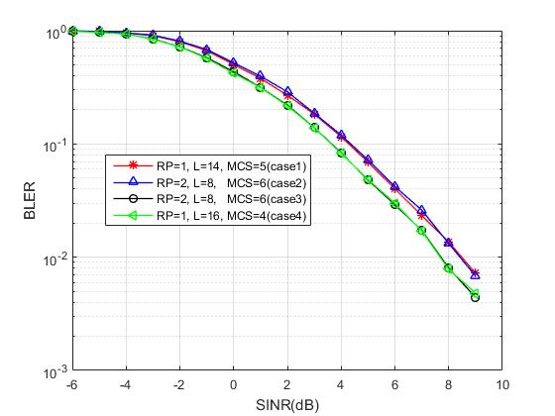  Figure. Simulation results for above four scheduling cases in frame structure ‘DDDSU’ (S: 10D:2G:2U)  The performance of the enhanced Case 3 and Case 4 is similar and both can provide about 0.8 dB gain over the baseline schemes (Case 1 and Case 2).
ZTE | Inter-slot FH | Figure. Simulation results for inter-slot frequency hopping  The case with 4 hopping positions can provide additional 0.5 dB gain over inter-slot hopping in Rel-15 at target BLER 0.1. The performance gain is expected to be larger at a lower BLER target.
ZTE | Inter-slot frequency hopping with inter-slot bundling to enable cross-slot channel estimation | Figure 6. Performance of PUSCH with cross-slot channel estimation and frequency hopping  As can be observed, cross-slot channel estimation could provide about 0.5 dB gain for PUSCH with 4 repetitions in urban 4GHz scenario.
ZTE | Cross-slot channel estimation | Figure. Performance comparison of PUSCH w/ or w/o DMRS sharing in case frequency hopping is disabled  The case with cross-slot channel estimation can provide additional 1.8 dB gain over the baseline case with 8 inter-slot repetitions at target BLER 0.1 in urban scenario.
ZTE | Lower DMRS density | 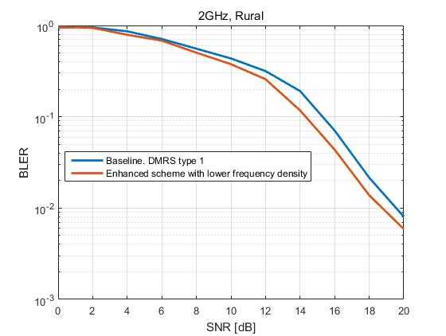  Figure. Performance results for lower DMRS density  About 1 dB gain can be obtained by the enhanced scheme with only mapping DMRS on even PRBs.
Intel | Number of repetitions | From the figure, it can be observed that link level performance for PUSCH can be improved by increasing the number of repetitions. More specifically, ~2dB performance gain can be observed when doubling the repetition levels for PUSCH.
Intel | TB spanning multiple slots | For single slot transmission, 4 PRBs and 14 symbols with 2 DMRS symbols were used. Further, for a TB spanning multiple slots, 4 slots were used with 1 PRB in each slot. From the figure, it can be observed that these two schemes deliver similar link level simulation performance. However, given that only 1 PRB is occupied for TB spanning 4 slots, ~6dB performance gain can be achieved in term of link budget.
Intel | Enhancement on inter-slot frequency hopping and cross-slot channel estimation | 8 repetitions are used for PUSCH transmission with 1) intra-slot FH, 2) inter-slot FH and 3) enhanced inter-slot FH pattern with same frequency resource in 4 consecutive slots. Further, cross-slot channel estimation is employed with a fixed window size of 4 slots. From the figure, it can be observed that  - For Rel-15 inter-slot frequency hopping pattern, cross-slot channel estimation can provide ~2dB performance gain compared to the case without cross-slot channel estimation.  - When employing cross-slot channel estimation, ~1.0dB performance gain can be achieved by enhanced inter-slot frequency hopping pattern, compared to Rel-15 intra-slot and inter-slot frequency hopping pattern.  - Compared to Rel-15 inter-slot frequency hopping without cross-slot channel estimation, substantial performance gain, i.e., ~3dB can be achieved by enhanced inter-slot frequency hopping with cross-slot channel estimation.
Intel | Number of frequency hops | It is assumed TBS = 136, MCS = 0, 2 and 4 Rx antennas, and 2 DMRS symbols are allocated in each slot. From the figure, it can be observed that when 2 Rx antennas are used, ~1.5dB performance gain can be achieved for 4 frequency hops compared to 2 frequency hops. However, when 4 Rx antennas are used, ~0.3dB performance gain can be achieved for 4 frequency hops compared to 2 frequency hops.
Intel | Higher DMRS density | it is assumed TBS = 136, MCS = 0 and inter-slot frequency hopping. From the figure, it can be observed that for 8 repetitions, 4 DMRS symbols can achieve better link level performance than 5 and 6 DMRS symbols.
Intel | lower DMRS density | Two cases were considered for comparison: 1) 2 DMRS symbols are allocated in each slot, 2) 2 DMRS symbols are allocated in even slot while DMRS symbols are not allocated in odd slots. In addition, cross-slot channel estimation is employed with a fixed window size of 4 slots  From the figure, it can be observed that for 8 repetitions with intra-slot frequency hopping, performance difference is small for the cases when DMRS symbols are not allocated in odd slots and when DMRS symbols are allocated in every slot.
Sharp | Cross-slot channel estimation | N means the number of slots for cross-slot channel estimation.
Samsung | 2.2 Inter-slot frequency hopping with inter-slot bundling to enable cross-slot channel estimation  2.3 Cross-slot channel estimation | 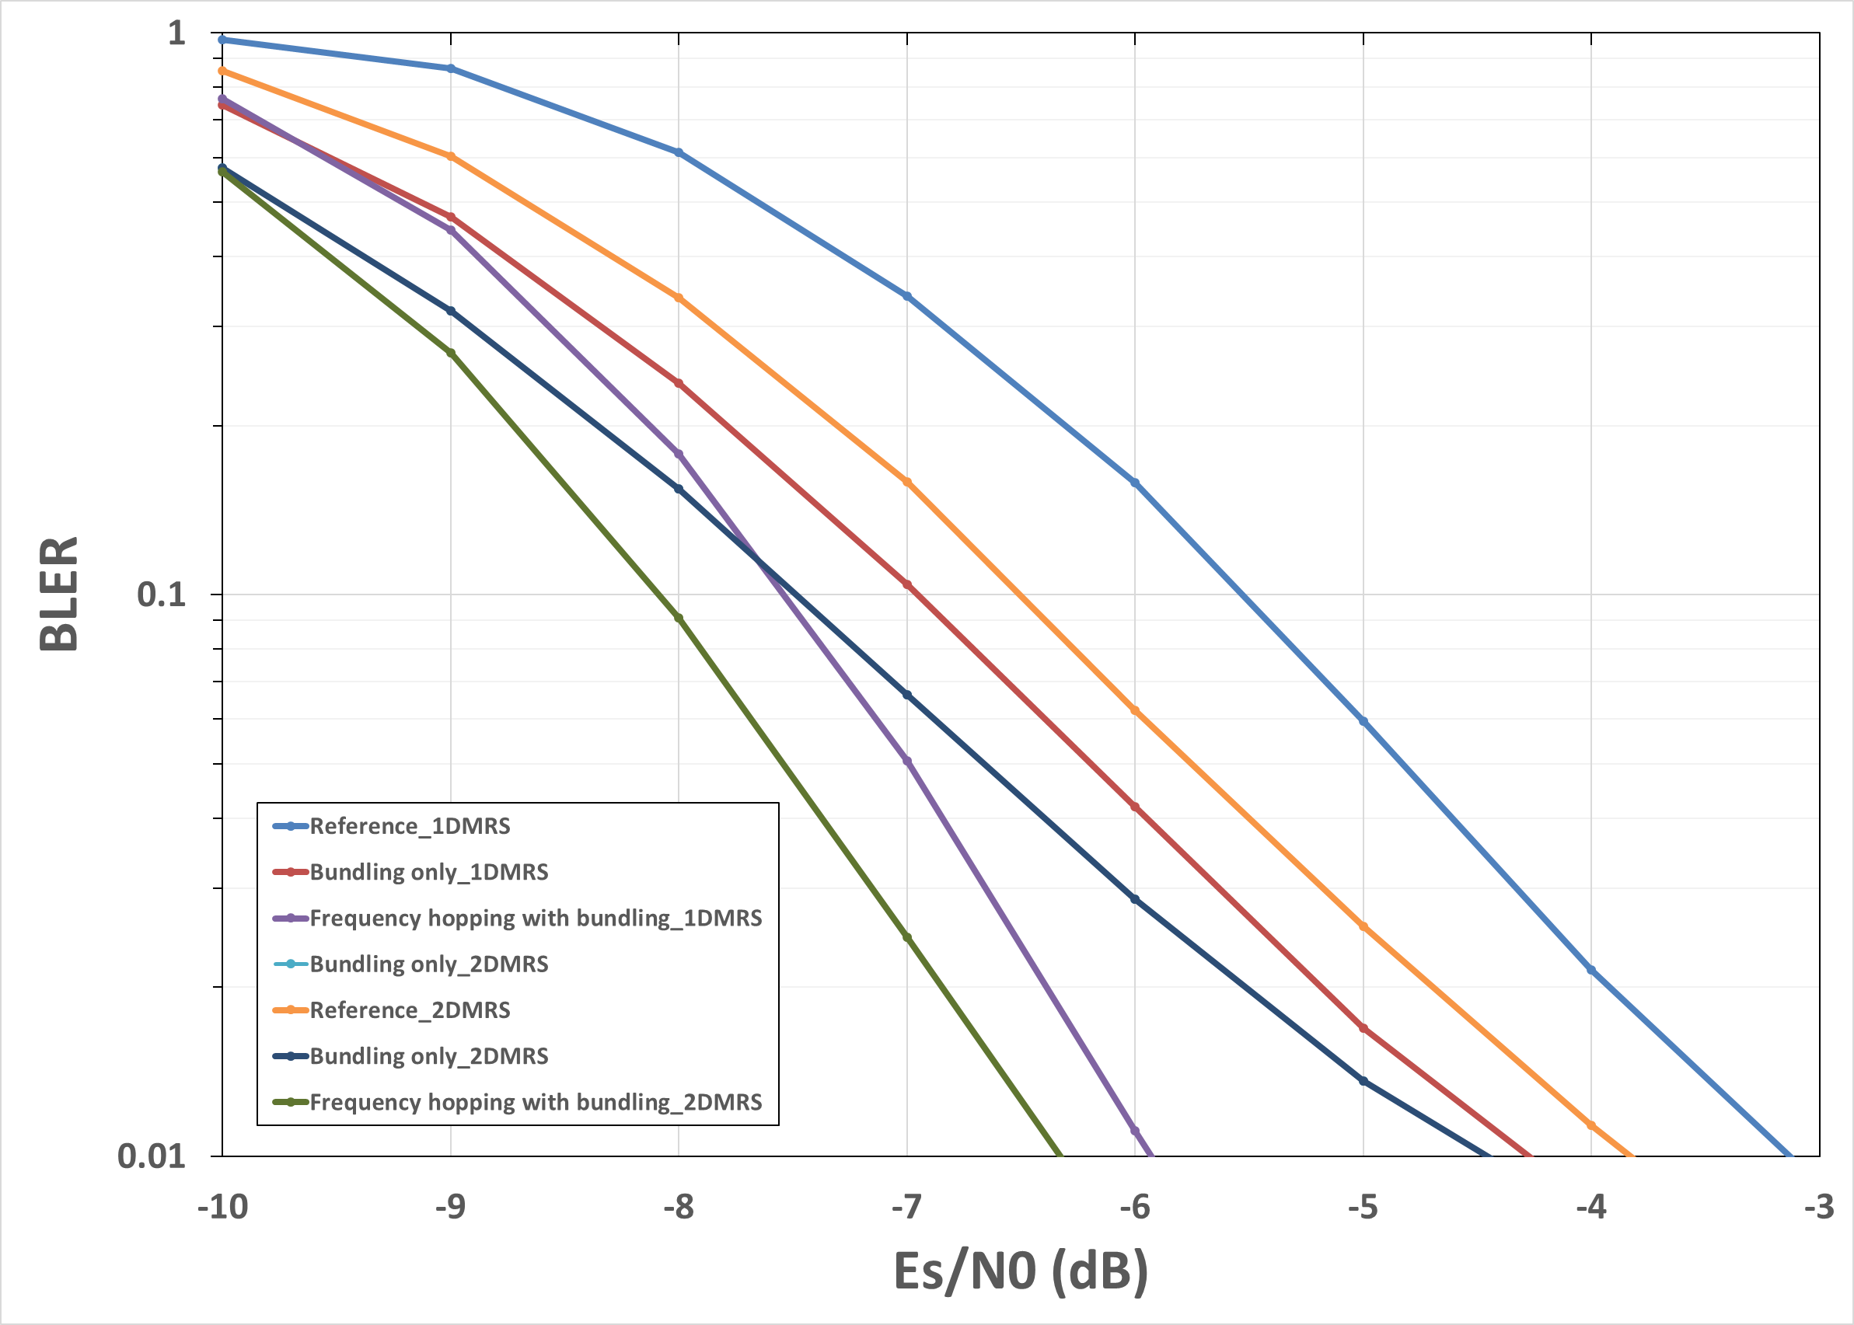  Fig. 1-1 FR1  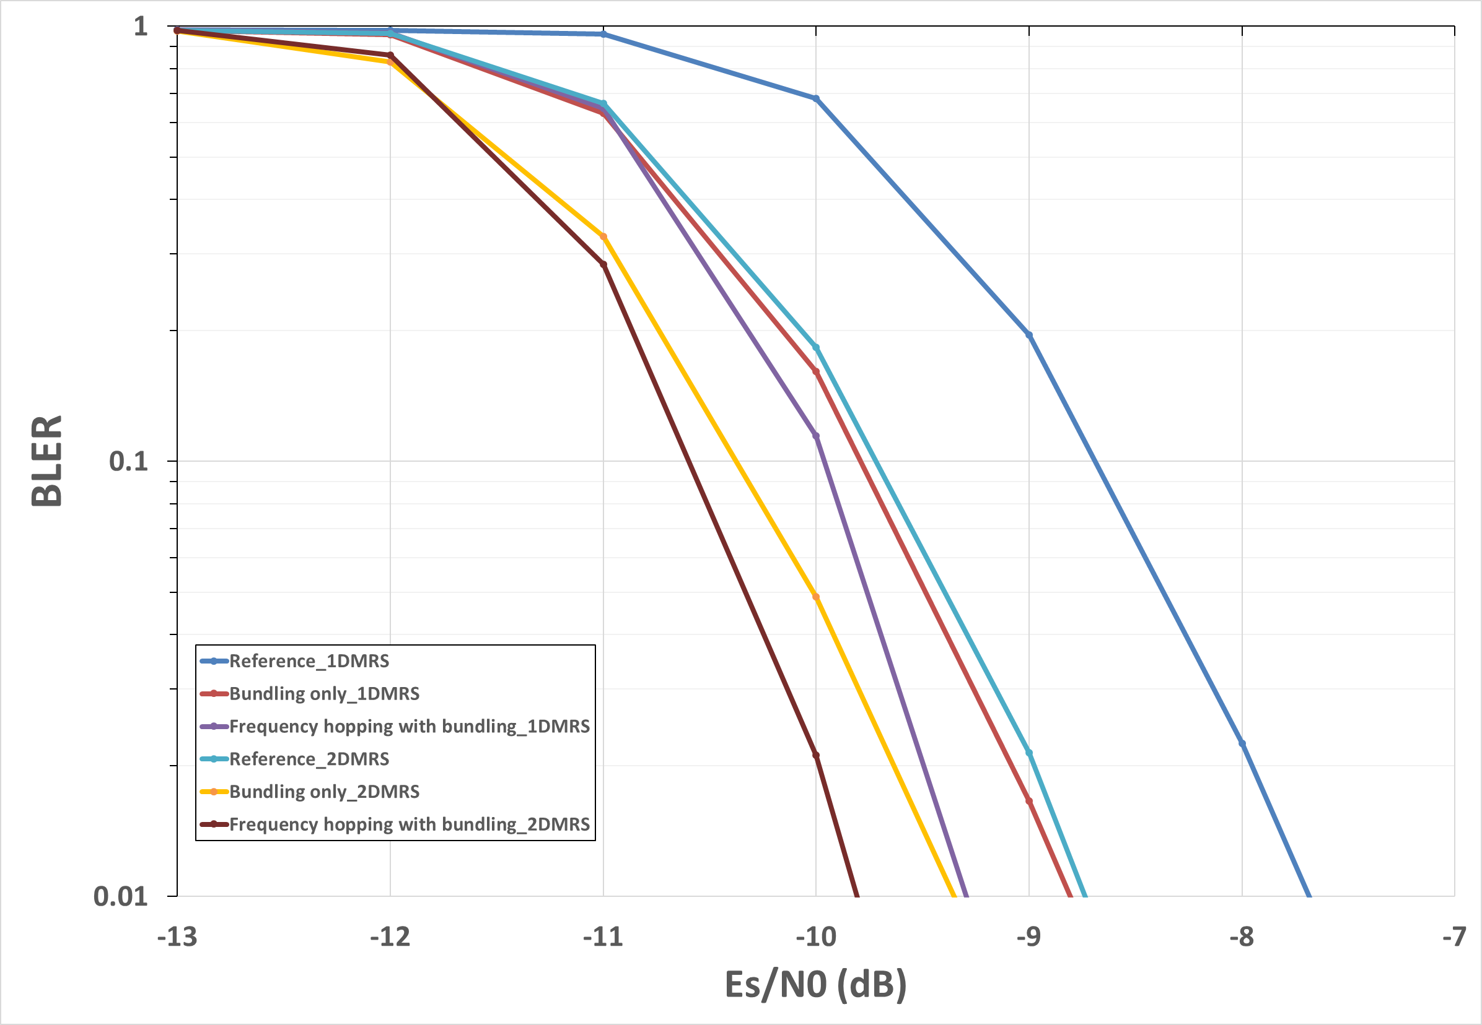  Fig. 1-2 FR2
Samsung | Sub-PRB transmission for eMBB and VoIP | 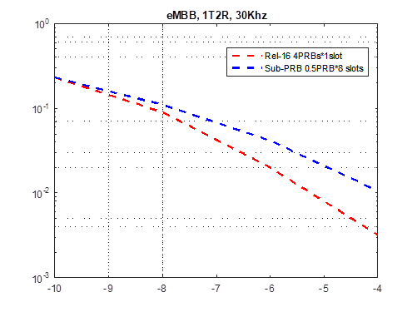  Fig. 2-1 eMBB  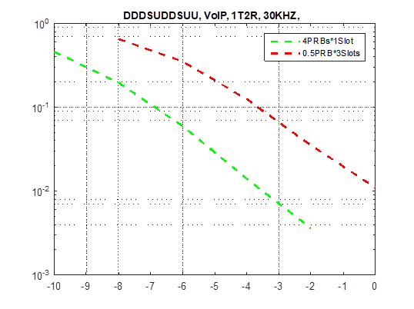  Fig. 2-2 VoIP
Samsung | Enhancement on PUSCH repetition Type B | 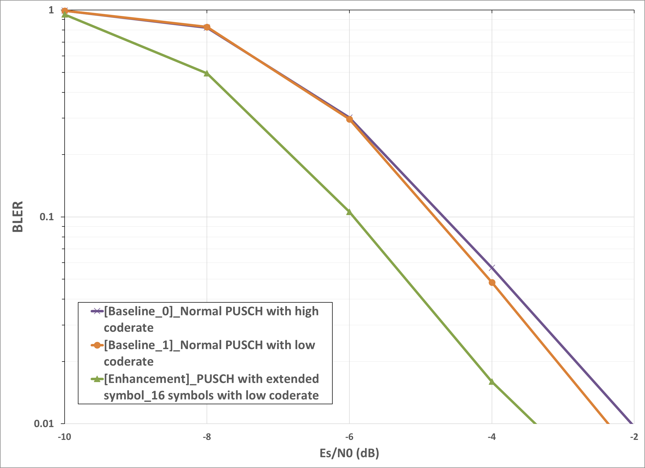  Fig. 1 FR 1  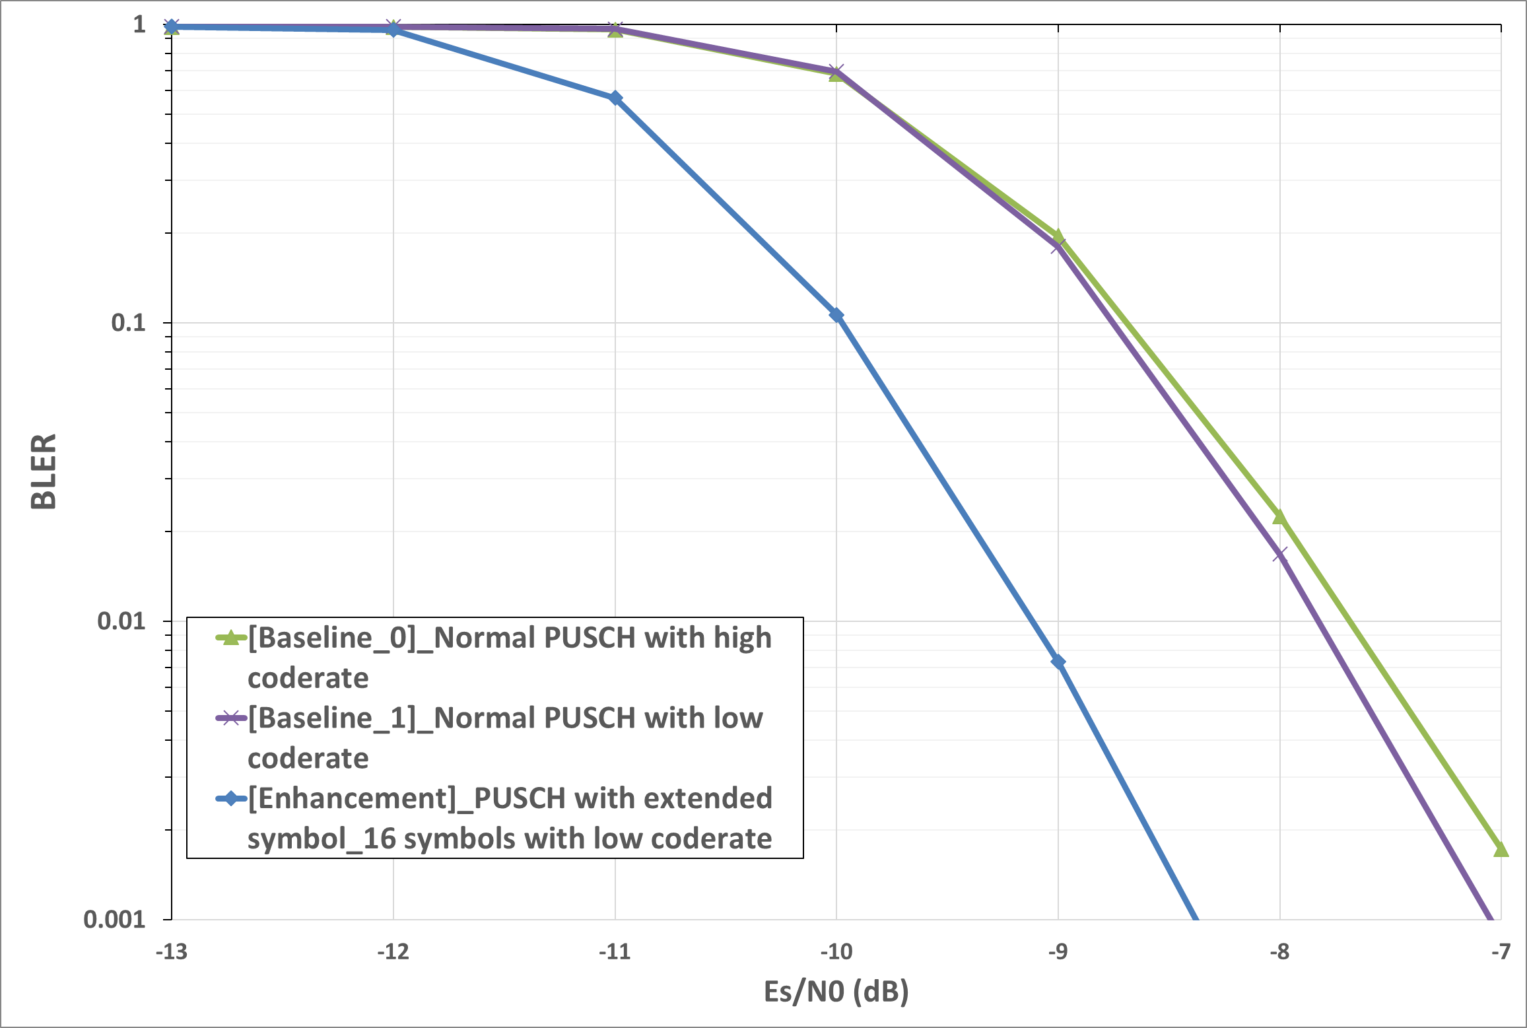  Fig. 2 FR 2  Baseline scheme_0: PUSCH actual repetition with symbol length: {2, 14, 2, 14}, High coderate  Baseline scheme_1: PUSCH actual repetition with symbol length: {2, 14, 2, 14}: 16, Low coderate  Enhancements: PUSCH with extended long symbol: 16, Low coderate
CMCC | Cross-slot channel estimation | Urban O2I  2.6GHz 7D1S2U (6D:4S:4U for Special slot)  Baseline：2 uplink slot without cross slot channel estimation, no FH  Enhancement：2 uplink slot with cross slot channel estimation, no FH  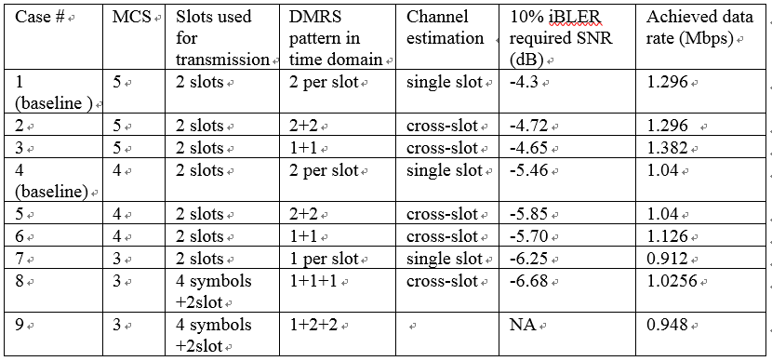  Case #1 vs #2 MCS #5  Case #4 vs #5 MCS #4  Case #7 vs case #8 MCS#3 (for information)
CMCC | Lower DMRS density | Urban O2I  2.6GHz 7D1S2U (6D:4S:4U for  Special slot)  Baseline (Case #5) : MCS #4 2 uplink slot without cross slot channel estimation, 2 DMRS symbol per slot  Enhancement (Case #8) : MCS #3, 4 symbol in special slot+ 2 uplink slot, with single DMRS symbol per slot(including the special slot), with cross slot channel estimation  In Case #8, additional 4 symbols in the special slot is used. And only one DMRS symbol is used for the 3 slots. In this condition, 1 Mbps PUSCH requirement could be satisfied.
vivo | Enhanced solution for PUSCH repetition type B | 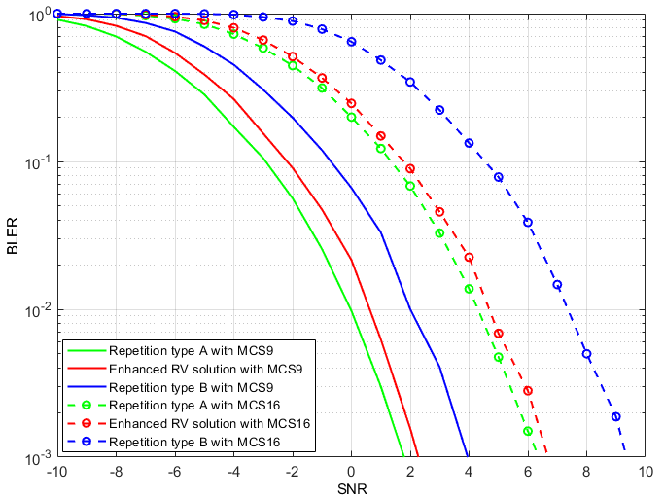  Enhanced RV solution: The same RV would be used for an actual repetition if the last actual repetition occupied few symbols compared with nominal repetition.  It can provide about 2 dB performance gain compared with blind RV cycling in current repetition type B.
vivo | More FH locations for inert-slot FH: (2->4) | 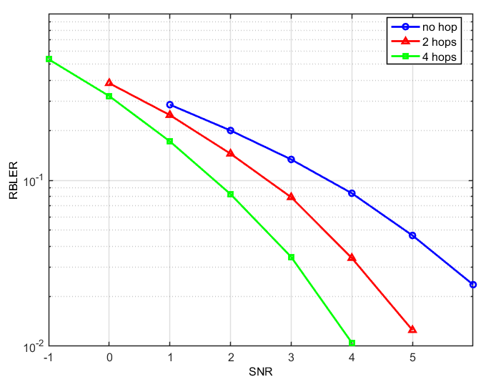  frequency hopping on 4 different frequency locations can provide about 1dB performance gain compared with hopping on 2 frequency locations for inter-slot frequency hopping.
vivo | Joint channel estimation for PUSCH with repetition | 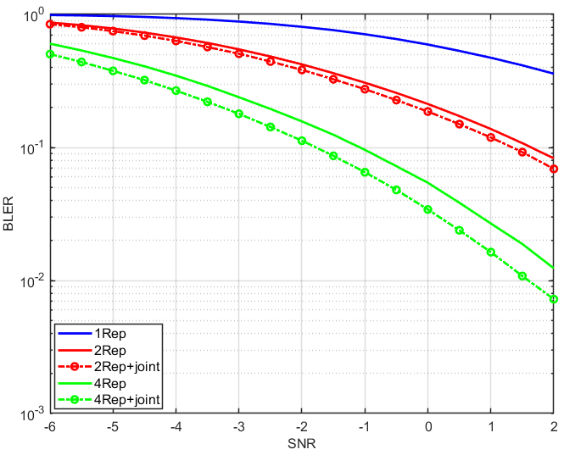  Joint channel estimation for intra-repetition:  About 0.8dB performance gain for 4 repetitions.  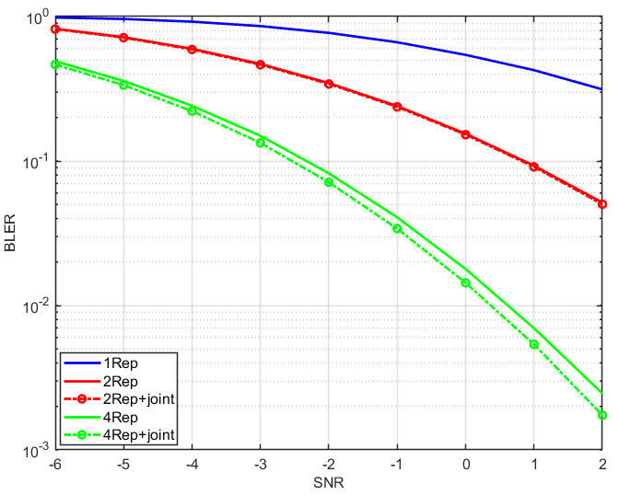  Joint channel estimation for intra-repetition:  About 0.3dB performance gain for 4 repetitions.  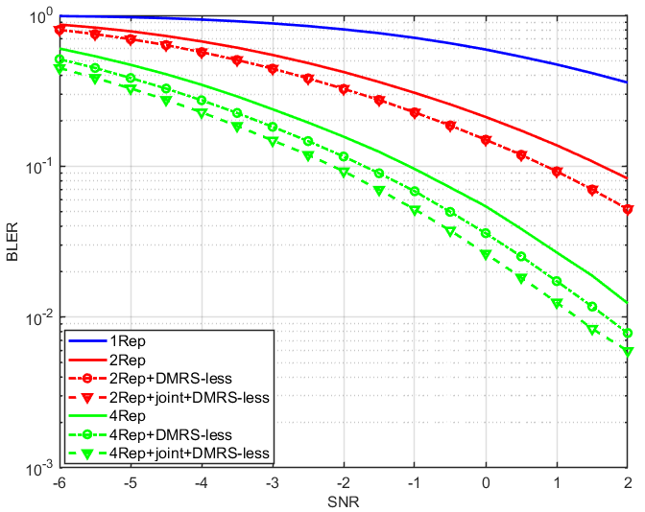  DMRS-less (means less DMRS symbols, reduced from 4->2) and joint channel estimation for intra-slot repetitions:  DMRS-less with joint channel estimation for PUSCH can achieve about 1dB performance gain compared with current PUSCH transmission for 4 repetitions.  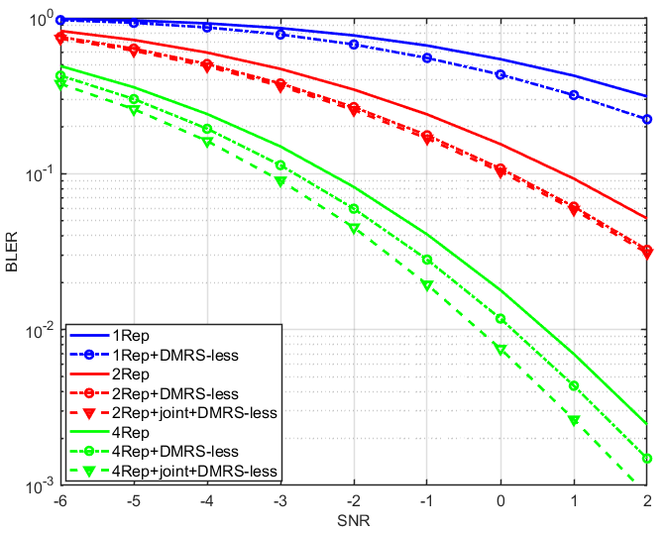  DMRS-less (means less DMRS symbols, reduced from 4->2) and joint channel estimation for inter-slot repetitions:  DMRS-less with joint channel estimation for PUSCH can achieve about 1dB performance gain compared with current PUSCH transmission for 4 repetitions.
vivo | Sub-PRB PUSCH transmission | 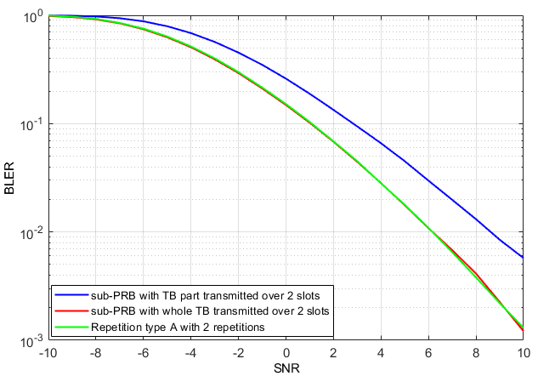  Almost the same performance can be achieved for Sub-PRB with multi-slot PUSCH and full PRB with repetition, the performance gain is 0.
Ericsson | Inter-slot frequency hopping | At 1% BLER with 8 repetitions, without cross slot channel estimation and for 300ns delay spread, there is 1.3 dB gain at the link level from going from 2 to 4 hops. However, 0.3 dB gain is observed if the delay spread goes to 30ns (and cross slot channel estimation is not used).  At 1% BLER with 8 repetitions, cross slot channel estimation, and 30ns delay spread, there is no gain at the link level from going from 2 to 4 hops. Details are in R1-2008419.
Ericsson | Inter-slot frequency hopping with inter-slot bundling to enable cross-slot channel estimation | At 1% BLER with 8 repetitions, 2 frequency hops, and 30ns delay spread, there is 1.3 dB gain at the link level from the use of cross-slot channel estimation.
Ericsson | Cross-slot channel estimation | 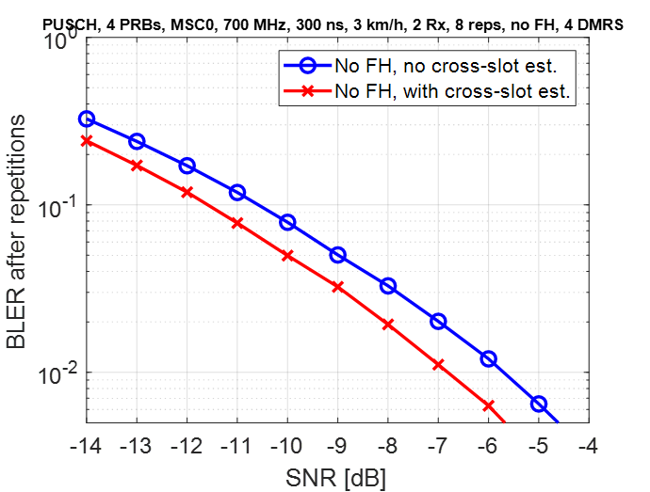  At 1% BLER with 8 repetitions, no frequency hopping, and for 300ns delay spread, there is 1.1 dB gain at the link level from the use of cross-slot channel estimation. Details are in R1-2008419.
Ericsson | Multi-layer DFT-S-OFDM | It is well known that DFT-S-OFDM can reduce PAPR and cubic metric (e.g. by ~ 3dB cubic metric) vs. OFDM. However, the benefit for cell edge / coverage scenarios may be less obvious. In practice it turns out that rank 2 or higher transmission can be quite common in a cell, and that multilayer transmission can be a mechanism to deliver higher power especially for non-coherent UL MIMO UEs.  Figure 1 below shows a histogram of the UL MIMO rank in a cell when the gNB has 4 or 32 Rx antennas. Rel-15 non-coherent UL MIMO transmission is used, and an FTP model 1 traffic is used. Resource utilization is roughly 40%. The detail setup of this simulation is provided in table 1 in Appendix 1. It can be seen that very few UEs transmit only rank 1. In the 4 Rx case, less than 1% of the UEs transmit rank 1, while for 32 gNB Rx antennas, rank 2 is always used. One major reason for the use of high rank is that non-coherent UEs gain 3 dB more power by transmitting two layers.  Therefore, the cubic metric gain from DFT-S-OFDM can be reaped over the vast majority of the cell, instead of being constrained toward the center of the cell.  Details are in R1-2008419.  Figure 1. UL MIMO rank histograms for 4 and 32 Rx gNB
InterDigital | Enhancement on PUSCH repetition Type B | Figure 1 : Optimized MCS with extended slot  Taking advantages of the extra resources in the extended slot, MCS can be optimized in the enhanced scheme. BLER performance is shown in Figure 1. From the figure, nearly 2 dB performance gain can be obtained with the extended slot with optimized MCS.  Figure 2-1 : Comparison between 14-symbol baseline slot and 16-symbol extended slot with additional DMRS in uplink symbols (2 PRBs)  Figure 2-2 : Comparison between 14-symbol baseline slot and 16-symbol extended slot with additional DMRS in uplink symbols (3 PRBs)  Figure 2 eMBB performance with additional DMRS  Figure 3 VoIP performance with additional DMRS  In Figure 2 and Figure 3, BLER performances of the extended slot with additional DMRS are shown. From the figures, it is clear that 0.33dB to 0.38dB gain can be achieved with the additional DMRS in the eMBB scenario. In the VoIP scenario, 0.2 dB to 0.36 dB gain can be obtained. DMRS placement for the scenarios considered in evaluations are shown in Figure 2-1 and Figure 2-2.  Figure 3-1 : Illustration of 14-symbol baseline slot and 16-symbol extended slot (enhancement) with 2 DMRS  Figure 4 Effect of reduced number of RB, VoIP  Figure 5 Effect of reduced number of RB, eMBB  In Figure 4, BLER simulation results are shown. From the figure, it is clear that around iBLER=2%, there is no significant difference in BLER performance between baseline and enhancement for the VoIP scenario. Similarly, as shown in Figure 5, at iBLER=10%, there is no significant difference in BLER performance between baseline and enhancement for the eMBB scenario. DMRS placement considered in the evaluation is shown in Figure 3-1.  Figure 6 eMBB performance comparision between baseline 14-symbol PUSCH and extended 16-symbol PUSCH  Taking advantages of the extra resources in the extended slot, MCS can be optimized in the enhanced scheme. BLER performance for eMBB is shown in Figure 6. From the figure, nearly 1.3 dB performance gain can be obtained at iBLER=10% with the extended slot with optimized MCS.
InterDigital | TB processing at least over multi-slot PUSCH | Figure 7 Multi-slot vs. Baseline performance, 4GHz TDD, eMBB, QPSK  Figure 8 Multi-slot vs. Baseline performance, 700MHz, FDD eMBB, QPSK, pi/2 BPSK  Figure 9 Multi-slot vs. Baseline performance, 700MHz, FDD VoIP, QPSK, pi/2 BPSK  From Figure 7 it is clear that by spreading the TB over 2 or 5 slots, in lower SNR regions up to nearly 1.75 dB gain can be achieved at iBLER=10% by implementing multi-slot PUSCH when the TB is spread over 5 slots. Further gain can be expected by optimizing the number of slots over which the TB is scheduled.  The performance of the multi-slot scheme is also evaluated in the 700MHz FDD eMBB scenario. The BLER performance of the multi-slot scheme is shown in Figure 8. From the figure, the performance gain of nearly 0 dB and 1.0 dB for TB scheduled over 3 or 2 slots can be observed for QPSK, respectively. In addition, when the TB is scheduled over 3 slots, nearly 1dB gain can be observed for pi/2 BPSK.  The performance of the multi-slot scheme is evaluated in the 700 MHz FDD VoIP scenario. The BLER performance of the multi-slot scheme is shown in Figure 7. From the figure the performance gain of nearly 2.0 dB and 0.4 dB can be obtained at iBLER=2% for QPSK and pi/2 BPSK, respectively.  Although it is not included in the link level simulation, up to 10log(N) power boosting gain can be obtained when TBS is determined based on N slots and transmitted over N slots.
InterDigital | Cross-slot channel estimation | Figure 10 Baseline vs. cross-slot channel estimation with DMRS in special slot  From Figure 10, cross-slot channel estimation assisted by DMRS in special slot yields approximately 0.3dB BLER gain at iBLER=10%. DMRS placement of baseline and enhanced scheme is shown in Figure 11.  Figure 11 Baseline vs. cross-slot channel estimation with DMRS in special slot where green and yellow blocks indicate downlink and uplink symbols, respectively. DMRS symblols are indicated by red blocks.
Panasonic | Cross-slot channel estimation  Symbol-level repetition | Figure 2 shows the BLER performance of PUSCH repetition Type A with or without cross-slot channel estimation and symbol-level repetition. The detailed parameters for link level simulation are listed in the Appendix A. The number of repetitions is set to 2. The details of receiver operation for each technique are following.  - PUSCH repetition Type A without cross-slot channel estimation  - 2D MMSE channel estimation is performed in each slot.  - Data modulation is performed in each slot with channel estimate in the corresponding slot.  - LLR in each slot is combined for decoding.  - PUSCH repetition Type A with cross-slot channel estimation  - 2D MMSE channel estimation is performed over multiple slots, i.e., time duration of averaging and interpolation covers multiple slots.  - Data demodulation is performed in each slot with channel estimate of cross-slot channel estimation.  - LLR in each slot is combined for decoding.  - Symbol-level repetition  - Symbol-level coherent combining is performed before channel estimation and data demodulation to improve SINR.  - 2D MMSE channel estimation is applied to the outcome of the symbol-level combining. This operation is also considered as 2D MMSE channel estimation over multiple slots, i.e., time duration of averaging and interpolation covers multiple slots since the DMRS is mapped over multiple slot as shown in Fig.1.  - Data demodulation is also performed to the outcome of the symbol-level repetition and the obtained LLR is the input to decoding.  PUSCH repetition Type A with cross-slot channel estimation can achieve the best performance in both indoor and outdoor scenarios. The gain of cross-slot channel estimation is around 1dB in rural indoor scenario and 0.5dB in rural outdoor scenario. Symbol-level repetition can achieve better performance compared to PUSCH repetition Type A without cross-slot channel estimation in rural indoor scenario, while slight degradation is observed in rural outdoor scenario.  (a) Rural, indoor (UE velocity of 3 km/h)  (b) Rural outdoor (UE velocity of 120 km/h)  Fig.2: Evaluation results on cross-slot channel estimation and symbol-level repetition
Mitsubishi | Different transmit diversity techniques | FR1  Figure 1 - Fc=4GHz, TDL-A 30ns, 3kmph, 4RB  Figure 2 - Fc=4GHz, TDL-A 50ns, 60/120kmph, 4RB  Figure 3 - Fc=4GHz, TDL-A 300ns, 3/60kmph, 4RB,  FR2  Figure 4 - Fc=30GHz, CDL-A 50ns, 3kmph, 50RB  Figure 5 - Fc=30GHz, CDL-A 300ns, 3kmph, 50RB  Figure 6 - Fc=30GHz, CDL-A 50ns, 30kmph, 50RB  Figure 7 - Fc=30GHz, CDL-A 300ns, 30kmph, 50RB  Figure 8 - Fc=30GHz, CDL-A 1000ns, 30kmph, 50RB
  - FER | - Spectral efficiency
  - FER | - Spectral efficiency
  - FER | - Spectral efficiency
  - FER | - Spectral efficiency
  - FER | - Spectral efficiency
  - FER | - Spectral efficiency
  - FER | - Spectral efficiency
  - FER | - Spectral efficiency
Qualcomm | Inter-slot hopping (2 to 4 slots) | 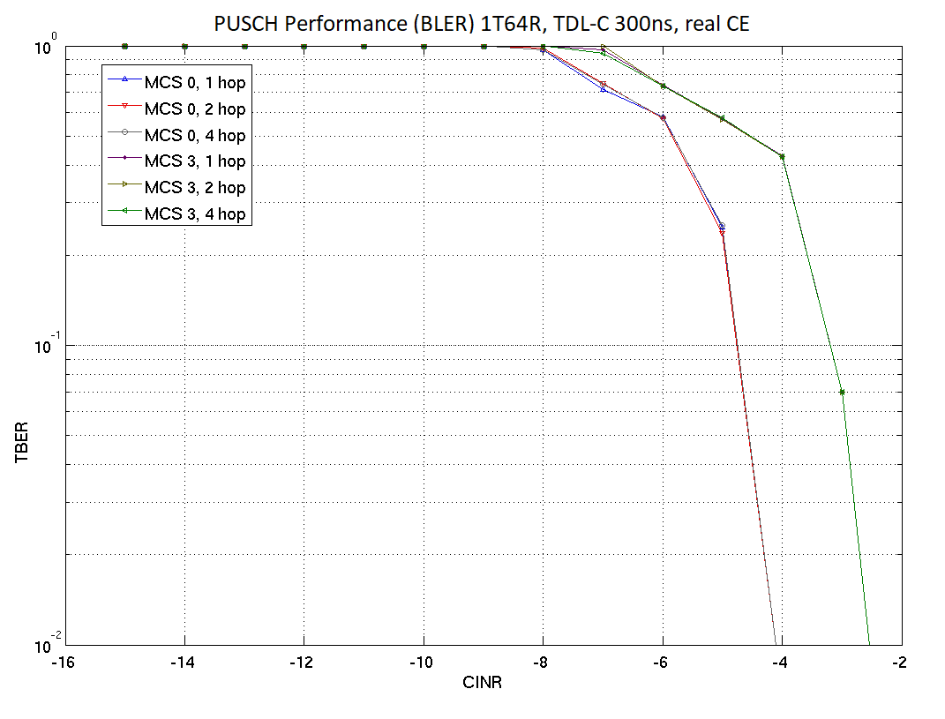  As can be observed above, inter-slot freq hopping enhancements bring no gain in MMIMO systems with a large number of antennas at the base station.
Qualcomm | DMRS bundling | DMRS bundling across multiple slots showing 1-1.5 dB gains in performance.
Qualcomm | MPR optimization/waveform shaping | Simulations results showing PAPR and RCM gains using tone reservation techniques.  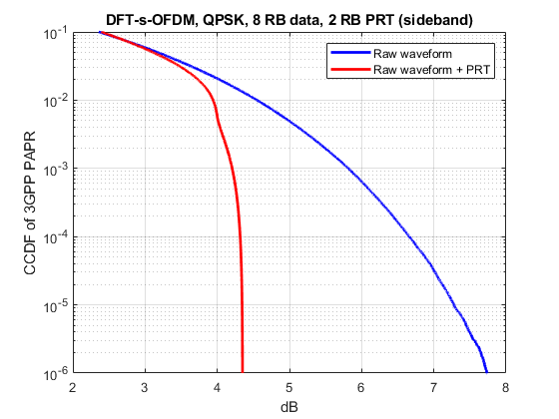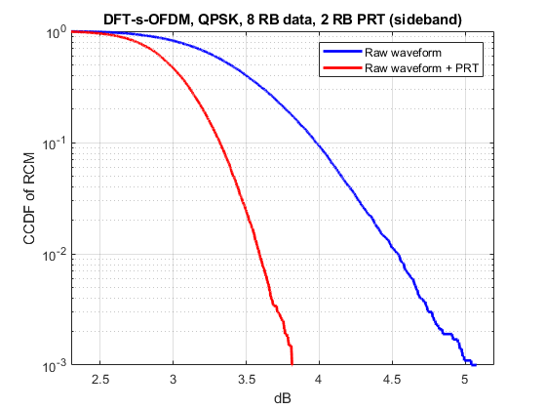  CCDF of PAPR and RCM of the DFT-s-OFDM QPSK waveform before and after PAPR reduction
Qualcomm | Adaptive DMRS | 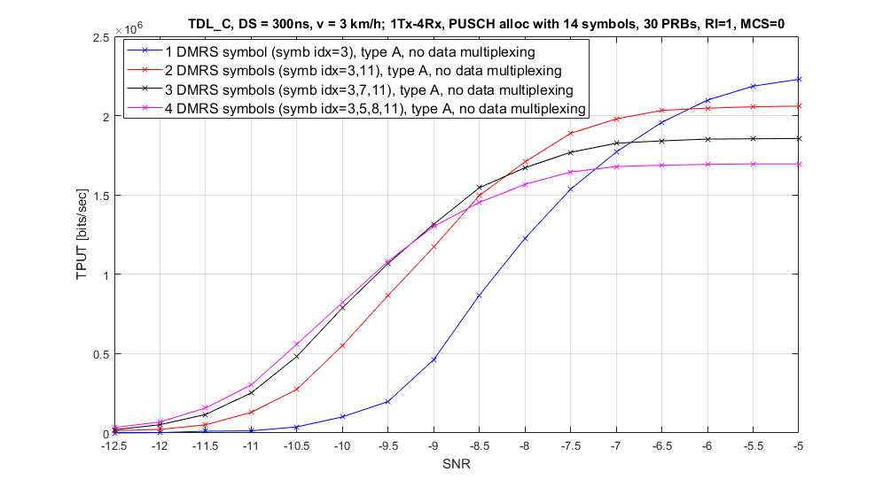  Performance of PUSCH with different DMRS configurations Rank=1, MCS=0  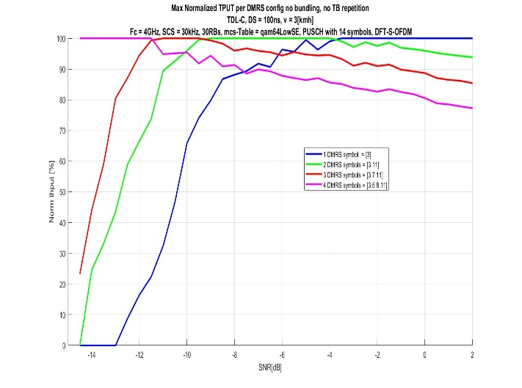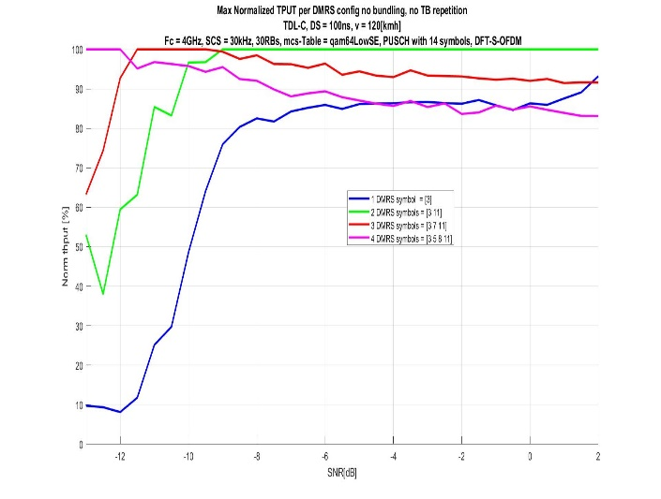  PUSCH performance with adaptive DMRS configuration for cell edge scenario  It can be seen from that, for different scenarios and SNR ranges, a different DMRS configuration option (color) hits 100% of the max relative TPUT (becomes to be the best option among the 4 tested options). Relative degradations of different DMRS configuration options for every SNR point can be also observed for each one of the tested coverage enhancement techniques. This clearly shows a significant value in DMRS adaptation for a wide range of scenarios and employed coverage enhancement techniques.
Qualcomm | TB Scaling/Multi-slot PUSCH | 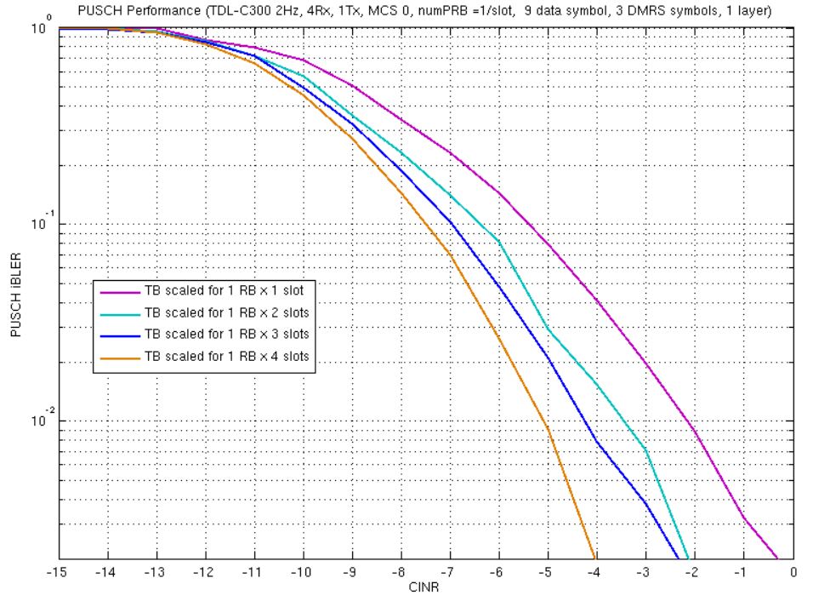  PUSCH Performance enhancement using TB size scaling  Performance gain of 1-2dB observed when TB is transmitted across 2 to 4 slots.
IITH, IITM, CEWIT, Reliance Jio, Tejas Networks | TB Processing over multiple slots | 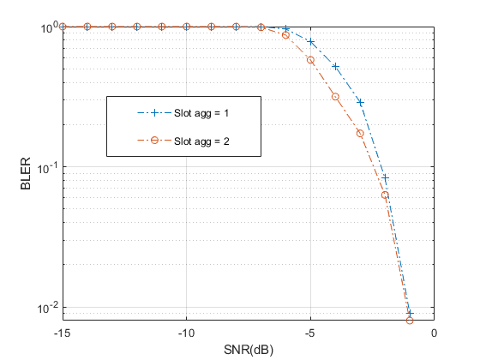  Figure: BLER comparison with (slot agg = 2) and without (slot agg = 1) slot aggregation for 100 kbps (left) and 30 kbps (right)  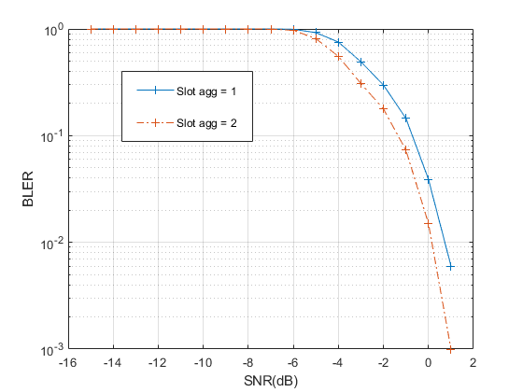  Figure: BLER comparison with (slot agg = 2) and without (slot agg = 1) slot aggregation for 30 kbps  The gains from multi slot TB processing vary with number of PRBs and the TB size. One more result is shown below.  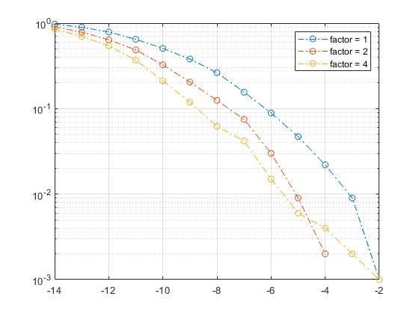  SNR (dB)  BLER  Figure: BLER comparison with (slot agg = 2, 4) and without (slot agg = 1) for TBS 24 bits and 1 PRB.  BLER vs SNR for 1 PRB allocation with TB size of 24 bits is shown above. Gain from slot aggregation factor 2 is around 1.5dB and for slot aggregation factor 4 is around 2-3dB
IITH, IITM, CEWIT, Reliance Jio, Tejas Networks | Power boosting | 3 dB and 6 dB gains are possible when the power is allowed to boost to 26 dBm and 29 dBm. The results are shown in SLS and link budget evaluations in R1-2007905 and R1-2007904.
Apple | Repetition type A | 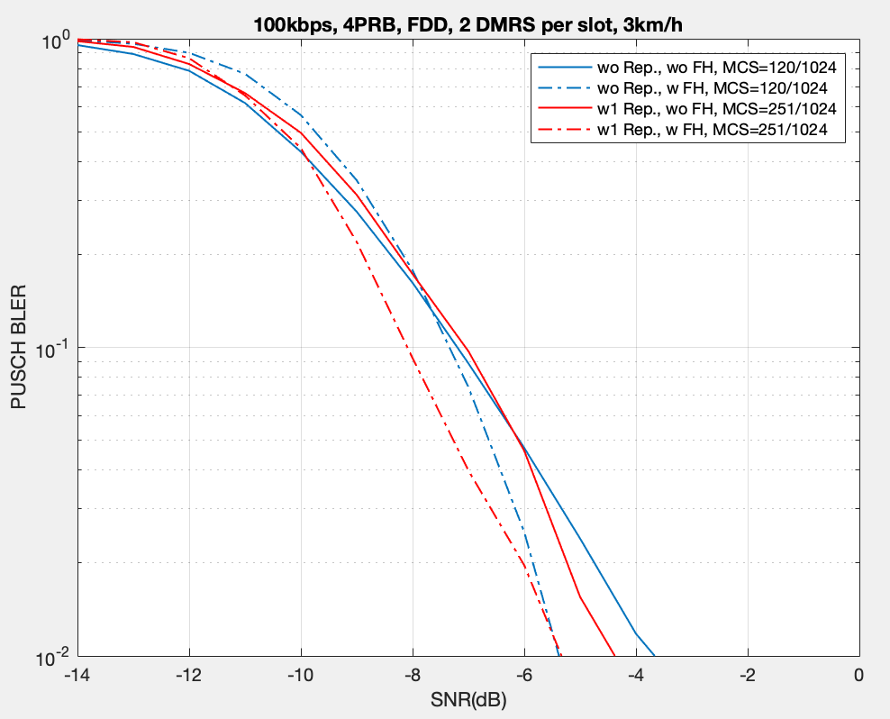  Performance of hopping and repetition with fixed DMRS overhead (2 per slot), the target data rate is maintained for repetition.
Apple | Repetition and cross-slot channel estimation | Rural FDD 700MHz, repetition and enhanced channel estimation, the channel estimation bundle is the same as the repetition number
Apple | Msg3 | 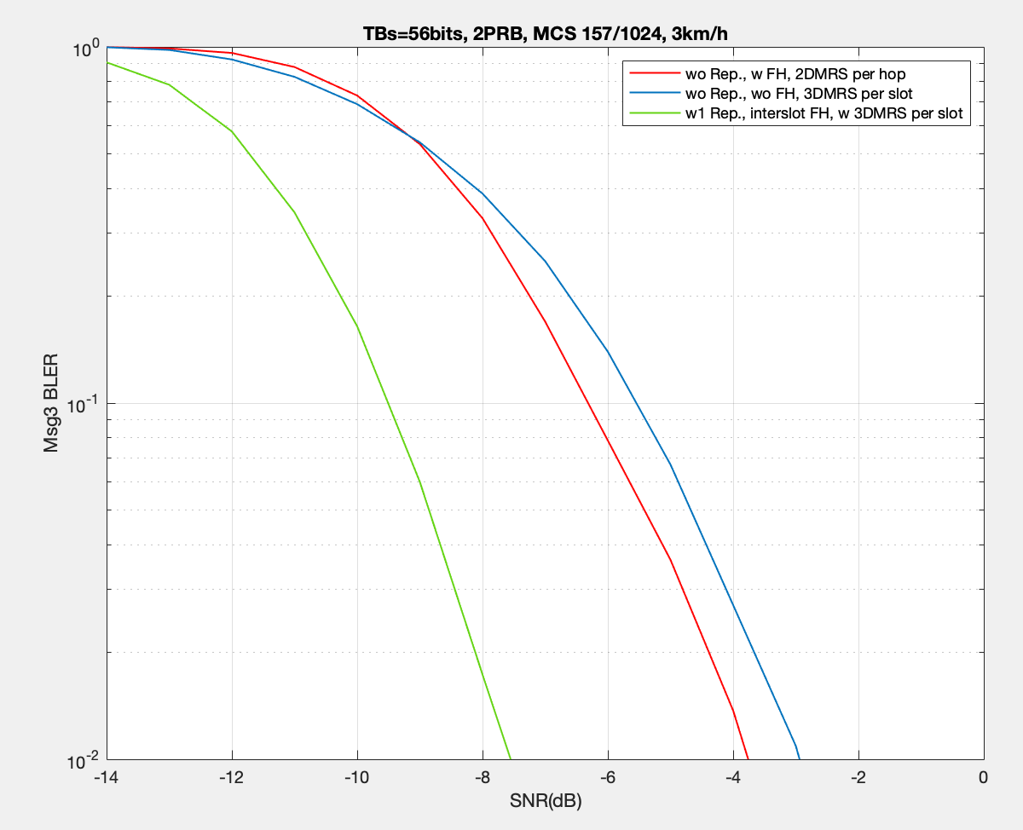  Msg3 performance with repetition and frequency hopping, urban TDD 2.6GHz

7.2 Detailed simulation results for PUCCH enhancements
Companies can provide the detailed simulations results with figures/curves in the appendix.
Company | Solution | Detailed simulation results
ZTE | DMRS-less PUCCH | Figure. Performance comparison of sequence based PUCCH and PUCCH format 3 based on 1% BLER without DTX detection.  For UCI of 11 bits, sequence based PUCCH can provide about 2~3 dB gain over legacy PUCCH format 3 in case DTX detection is not considered.  Figure 2. Performance comparison of sequence based PUCCH and PUCCH format 3 based on {1% DTX to ACK error rate, 1% ACK miss detection, and 0.1% NACK to ACK}  For UCI of 11 bits, sequence based PUCCH can provide about 3.8 dB gain over legacy PUCCH format 3 in case 1% DTX to ACK error rate is applied.
ZTE | Dynamic PUCCH repetition factor indication | 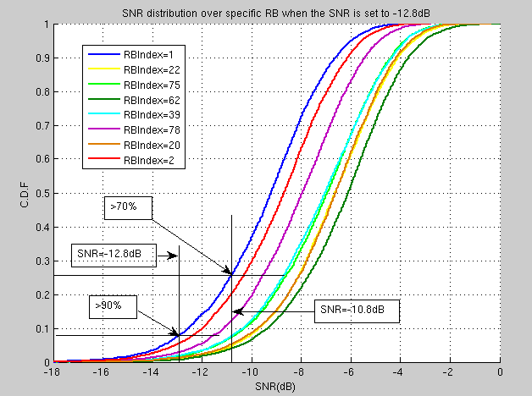  Figure. Distribution of instantaneous SNR on each RB  A simulation is conducted at an SNR of -12.8dB, which is the required SNR for the case with 11bits UCI and RP=4. The simulation is to get the distribution of instantaneous received SNR at certain RBs (which are assumed to be configured for PUCCH transmission) and to see the percentage of instantaneous received SNR higher than the required SNR for RP=4. From Figure-3, we find that at least 90% of the instantaneous SNR on the RBs assumed to be configured for PUCCH transmission exceed the required SNR and more than 70% cases can be indicated to 2 repetitions instead. Therefore, dynamic repetition should be considered if the instantaneous SNR can be obtained by gNB.
ZTE | DMRS bundling cross PUCCH repetitions | Figure. Simulation results for different DMRS patterns with 4 repetitions.  Enhanced scheme: FH per two repetitions and cross-slot channel estimation among two repetitions per DMRS bundle.  For PUCCH with four repetitions, support of both frequency hopping and DMRS bundling can provide 1 dB gain compared with inter-slot frequency hopping only.
Intel | DMRS-less PUCCH design | For DMRS based PUCCH schemes,  - Rel-15 PUCCH format 3: Coherent and non-coherent detection algorithm  - Rel-15 PUCCH format 3 with DMRS and removing the 1st column of RM codeword: non-coherent detection algorithm  For DMRS-less PUCCH schemes,  - Option 1: (sequence based) Gold sequence, where initialization seed is determined based on UCI information. Non-coherent detection based receiver is employed.  - Option 2: (existing RM code with removing 1st column of codeword): non-coherent detection based receiver is employed.  - Option 3: (existing RM code with enhanced scrambling sequence): two scrambling sequences can be introduced which depend on the first bit of UCI payload. Non-coherent detection based receiver is employed.  In the simulations, it was assumed 1% false alarm probability, 14 symbols and intra-slot frequency hopping. Note that in the figure, required SNR is shown based on 1% BLER for different schemes when the number of UCI bits is from 3 to 10 or 11. From the figures, it can be observed that:  - For 1% false alarm probability and 1% BLER, existing PUCCH format 3 with non-coherent detection algorithm can achieve similar performance for UCI payload size of 3-7 bits; and is less than 0.3dB worse than DMRS-less scheme when UCI payload size of 8-11 bits.  - Existing PUCCH format 3 with removing 1st column of RM codeword can achieve similar performance for different UCI payload size compared to DMRS-less scheme.  - All three DMRS-less PUCCH schemes, (Gold sequence based, existing RM code with removing 1st column of codeword and existing RM code with enhanced scrambling sequence) can achieve similar performance for different UCI payload sizes.
Intel | DMRS bundling and enhanced inter-slot frequency hopping | It is assumed 22 bit UCI payload and 8 repetitions for PUCCH transmission with 1) intra-slot FH, 2) inter-slot FH and 3) enhanced inter-slot FH pattern with 4 consecutive slots in a same frequency resource. Further, cross-slot channel estimation is employed with a fixed window size of 4 slots. From the figure, it can be observed that  - For Rel-15 inter-slot frequency hopping, cross-slot channel estimation can provide ~1.2dB performance gain compared to the case without cross-slot channel estimation.  - When employing cross-slot channel estimation, ~1.6dB performance gain can be achieved for enhanced inter-slot frequency hopping pattern, compared to Rel-15 intra-slot and inter-slot frequency hopping pattern.  - Compared to Rel-15 inter-slot frequency hopping without cross-slot channel estimation, substantial performance gain, i.e., ~2.8dB can be achieved by enhanced inter-slot frequency hopping with cross-slot channel estimation.
Intel | Higher DMRS density | In the simulation, it is assumed 22 bit UCI payload and inter-slot frequency hopping. From the figure, it can be observed that for 8 repetitions, 4 DMRS symbols can achieve slightly better link level performance than 5 and 6 DMRS symbols.
Intel | number of repetitions | It is assumed 22 bit UCI payload and intra-slot frequency hopping for PUCCH format 3. In addition, it is assumed 2 DMRS symbols are allocated for each slot. From the figure, it can be observed that link level performance for PUCCH format 3 can be improved by increasing the number of repetitions. Further, ~2dB gain can be observed when doubling the repetition levels for PUCCH format 3.
Sharp | DMRS-less PUCCH design | The above figure shows BLER performance comparison of DMRS-less scheme and Rel-15 PUCCH format 3. As shown, DMRS-less scheme has gain of about 3 dB compared to Rel-15 PUCCH format 3.
CMCC | DMRS-less PUCCH | short sequence combination based PUCCH transmission  The red line is the improved sequence based PUCCH. And the blue line is the baseline, which represents the PUCCH format 3 with 11 bits payload. And 4~ 14 symbols PUCCH are simulated  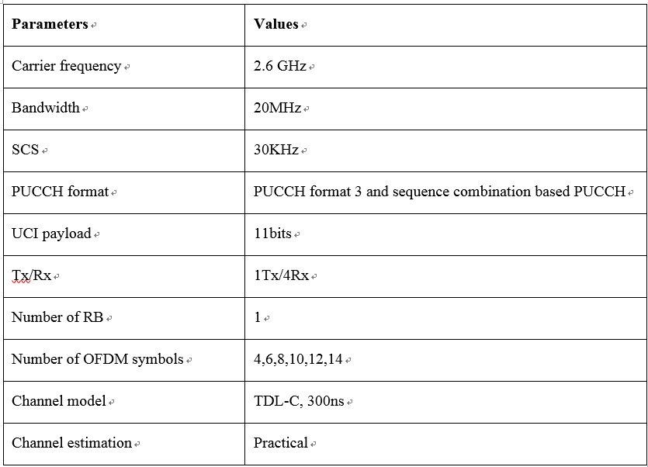
vivo | Sequence based DMRS-less PUCCH | Reference(R1-2009648)  - Detection algorithm for legacy PF3  For legacy PF3 with UCI bits less than 12 bits, RM coding is used with no CRC attachment. Hence, lower false alarm rate (DTX->Ack) can not be guaranteed by CRC check. Hence, DTX detection should be performed based on DMRS and/or UCI symbols. Typically, two DTX detection algorithm can be considered, as illustrated in following figure.  In the DTX detection algorithm (a), the DTX is performed on DMRS only, if DTX is determined at this stage, UE will skip the following detection procedures including channel estimation, equalization and etc. Since, quite limited portion of symbols in a PUCCH, i.e. DMRS symbols, are used for DTX detection, the reliability of DTX cannot be guaranteed, some samples which can be correctly decoded, are discarded due to DTX is determined in advance. While the algorithm (b), the UE performs coherent detection on UCI symbols based on the channel estimation using DMRS, and obtain the decoded bits, and DTX detection is performed afterward. UE re-generates the frequency domain UCI symbols based on the decoded bits, and DTX detection is performed on union of DMRS and regenerated UCI symbols. With more symbols included for DTX detection, the performance loss due to DTX detection is largely reduced. In the following part, the DTX detection based on DMRS+UCI symbols is assumed for legacy PUCCH format 3 in evaluation.  - Simulation Assumptions for Sequence based PUCCH  - Simulation results  - 3 UCI bits, 4symbols (Config 1), 2Rx  - 3 UCI bits, 4symbols (Config 1), 4Rx  - 11 UCI bits, 14symbols (Config 2), 2Rx  - 11 UCI bits, 14symbols (Config 2), 4Rx  As shown in above figures, from BLER perspective, for both 3 and 11 UCI bits. Legacy PF3 out performs sequence based PUCCH if frequency hopping is enabled for legacy PF3 and 2Rx is assumed at gNB. With 4Rx, two schemes have similar performance.  From BER perspective,  - Ack miss: legacy PF3 out performs sequence based PUCCH if configured with 11 UCI bits and frequency hopping, and 2Rx is assumed at gNB. For other combinations, these two schemes have similar performance.  - NACK to Ack:  - For UCI with 3 bits, sequence based PUCCH can obtain 1dB and 2dB performance gain compared with legacy PF3 using 2Rx and 4Rx respectively.  - For UCI with 11bits, sequence based PUCCH can obtain at least 4dB performance gain compared with legacy PF3.
  Property | Value
  Antenna config | 1Tx 2Rx/4Rx
  Channel model | TDL-C 300ns 11Hz
  PUCCH format | PF3 with  - coherent receiver  Sequence based PUCCH format  - long sequence: gold sequence
  Sequence initialization | Gold sequence for DMRS less PUCCH: Cinit = 2^11*(2*seq_idx+1) + 2*seq_idx  where seq_idx belongs to {0,1, …, 2^(bit number)-1}.
  Number of symbols | Config 1: 4 symbols  Config 2: 14 symbols
  Number of UCI bits | Config 1: 3 bits  Config 2: 11 bits
  Frequency Hopping | Enabled or Disabled
  DMRS pattern | - Config 1  1 DMRS symbol for PF3 w/o frequency hopping  1 DMRS symbol in each hop for PF3 w/ frequency hopping  - Config 2  4 DMRS symbols for PF3 w/o frequency hopping  2 DMRS symbols in each hop for PF3 w/ frequency hopping
  Performance metric | UCI BLER  BER including NACK->Ack, Ack->miss
  Note: UCI BLER and BER is considered with the limitation that DTX->Ack is lower than 1%.
vivo | Type-B PUCCH repetition | Compared to single slot with 14 symbols, about 1.5dB performance gain can be achieved for S slot with 4 symbols + 1 slot with 14 symbols for PUCCH repetition, and joint channel estimation is considered for these two slots.
vivo | Joint channel estimation | For joint channel estimation over 2 full slots, 1dB performance gain can be achieved.  For DDDSU frame structure, PUCCH repetition in S and U slot, where S slot with 4 symbols for PUCCH, U slot is fully used (14 symbols). DMRS bundling is considered for S and U slots. 0.85dB gain can be achieved.
Ericsson | DMRS-less PUCCH | At 1% BLER, with 2 Rx antennas and 30ns delay spread, there is 0-0.2 dB gain at the link level from the use of a DMRS-less PUCCH based on a Gold code. An advanced receiver improves performance by roughly 1.5-2.0 dB over the conventional receiver (where 4 DMRS is used for good performance with the conventional receiver).  At 1% BLER, with 4 Rx antennas and 300ns delay spread, there is again 0-0.2 dB gain at the link level from the use of a DMRS-less PUCCH based on a Gold code. Details are in R1-2008420. The advanced receiver has similar gains over the conventional receiver as in the case above.
Ericsson | (Explicit or implicit) Dynamic PUCCH repetition factor indication | At 1% BLER, with 4 Rx antennas and 300ns delay spread, there is a 5 dB gain at the link level and a 3.5 dB gain in maximum isotropic loss in a 4 GHz urban scenario from the use of 8 repetitions vs. no repetition (since dynamic repetition is not supported at present for PUCCH). Details are in R1-2008420.
Qualcomm | DMRS-less PUCCH | Presenting only 1 representative figure. Many more results in our revised Tdoc: R1-2009552.  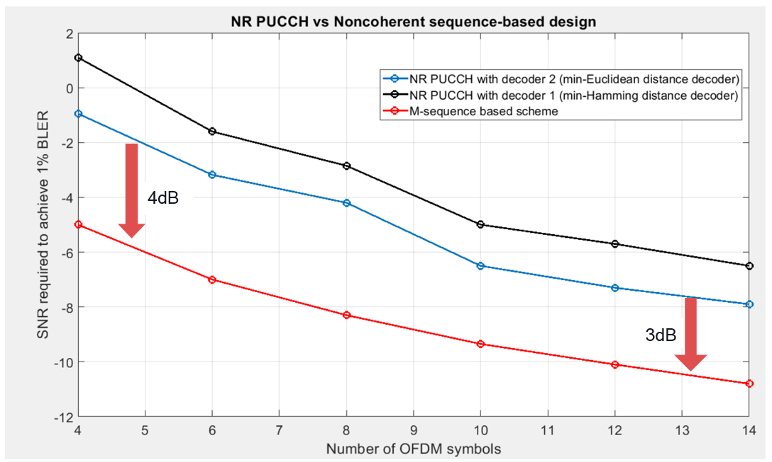  Sequence-based DMRS-less PUCCH transmission vs NR PUCCH with 11 bits UCI payload for FR 1; 1 Tx antenna and 4 Rx antennas; TDL-C channel with 300 ns delay spread and 11 Hz Doppler (30 KHz SCS); the number of DMRS symbols for NR PUCCH is optimized to achieve the best link budget
IITH, IITM, CEWIT, Reliance Jio, Tejas Networks | Power boosting | 3 dB and 6 dB gains are possible when the power is allowed to boost to 26 dBm and 29 dBm. The results are shown in SLS and link budget evaluations in R1-2007905 and R1-2008756.

7.3 Detailed simulation results for enhancements on other channels / signals
Companies can provide the detailed simulations results with figures/curves in the appendix.
Company | Channel | Solution | Detailed simulation results
ZTE | Msg3 | Msg3 repetition | Figure. Performance of Msg3 w/ or w/o repetition.  Msg3 PUSCH with 2 and 4 repetitions can provide about 2.6 and 5.2 dB gain respectively compared to one repetition in rural 700MHz scenario. In urban 4GHz scenario, the respective gain is of Msg3 PUSCH with 2 and 4 repetitions is about 2.4 and 4.7 dB.
ZTE | Msg3 | Msg3 repetition and cross-slot channel estimation | Figure. Performance of Msg3 with cross-slot channel estimation  In case inter-slot frequency hopping is disabled, cross-slot channel estimation can be conducted among all 4 repetitions. As can be observed, cross-slot channel estimation could provide 0.88 dB and 1.07 dB gain for Msg3 PUSCH at target BLER 0.1 and 0.01 respectively.
ZTE | SSB | Increasing the number of SSBs | Figure: Simulation result of beamforming gain for different number of SSBs in 700MHz rural scenario  Beamforming gain under 8 SSBs case has an average 1.84 dB improvement comparing with that 4 SSBs case.
ZTE | PRACH | PRACH repetition | Figure: Simulation results of PRACH repetition  The performance of PRACH with 2 and 4 repetitions is about 3.7dB and 5.2dB better than one PRACH transmission respectively in 4GHz urban O2I scenario. For 28GHz urban O2I scenario, about 1.7dB and 3.7dB gain is observed for PRACH with 2 and 4 repetitions respectively.
ZTE |  | PRACH beam sweeping | Figure: Simulation result of PRACH sweeping  By PRACH sweeping with 2 times, average gain with 2.5dB can be obtained comparing with baseline case (i.e., without sweeping).
ZTE | PUCCH with Msg4 HARQ-ACK | PUCCH repetition | About 3 dB and 6dB gain can be obtained by employing 2 repetitions and 4 repetitions respectively. This could be an effective way for coverage enhancement of PUCCH with Msg4 HARQ-ACK.
ZTE | PDCCH | PDCCH repetition | Figure. Simulation results for PDCCH repetition  For PDCCH repetition with separate decoding, average gains with 2.8 dB for 2 repetitions and 4.0 dB for 4 repetitions can be obtained comparing to the baseline case (i.e., without repetition) in rural and urban scenarios. For PDCCH repetition with joint decoding among multiple repetitions, average gains with 3.1 dB for 2 repetitions and 5.8 dB for 4 repetitions can be obtained comparing with baseline case (i.e., without repetition) in rural and urban scenarios.
Intel | Msg3 PUSCH | Repetitions | It is assumed TBS = 56, MCS = 0, 3 DMRS symbols that are allocated in each slot and UE moving speed of 3km/h. From the figure, it can be observed that link level performance for Msg3 PUSCH can be improved by increasing the number of repetitions. More specifically, ~2dB performance gain can be observed with doubling the repetition levels for Msg3 PUSCH.
CMCC | Msg3 PUSCH | repetition | Urban O2I 2.6GHz  Baseline : Msg 3 PUSCH with no repetition  Enhancements: Msg 3 PUSCH with 2 repetitions (2 slots with cross slot channel estimation)  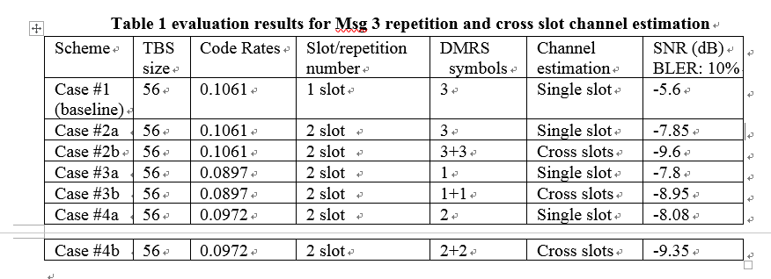  The improvement due to the repetition of Msg 3 could be found when comparing the case #1 and #2a
CMCC | Msg3 PUSCH | Repetition with cross slot channel estimation | Comparing the case #1 and #2b, the performance improvement due to repetition and cross slot channel estimation could be found around 4dB
CMCC | Msg3 PUSCH | Repetition with cross slot channel estimation and reduced DMRS density | Case #3b and #4b represent the performance of Msg 3 with repetition, cross slot channel estimation and various reduced DMRS density. The performance gain could be derived based on the comparison between case #1, #3b and #4b.
Ericsson | CSI on PUCCH | Aperiodic CSI on PUCCH | At 1% BLER, with 4 Rx antennas and 300ns delay spread, there is a 5.0 dB gain at the link level and a 3.5 dB gain in maximum isotropic loss in a 4 GHz urban scenario from the use of 8 repetitions vs. no repetition (since aperiodic triggering, including with repetition, is not supported at present for PUCCH). Details are in R1-2008420.
Ericsson | Msg3 PUSCH | Msg3 PUSCH repetition | 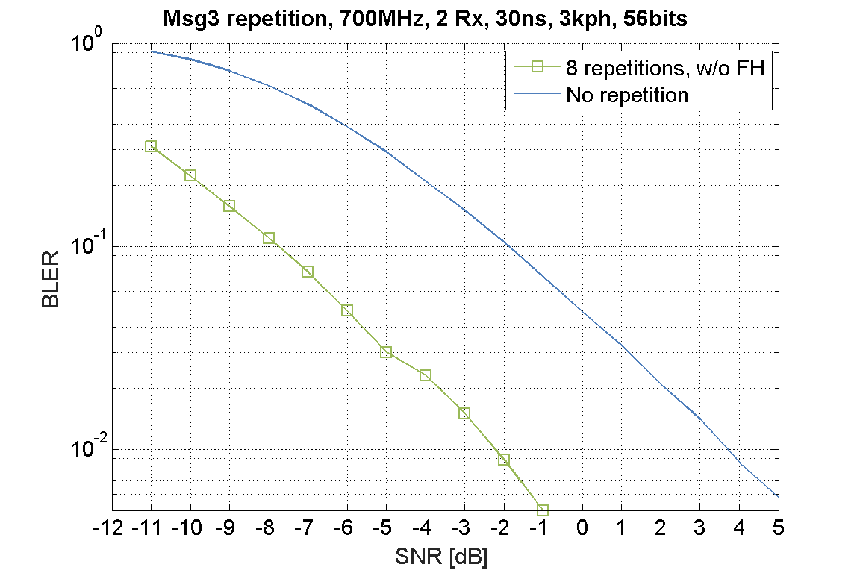  At 1% BLER, without frequency hopping, and for 30ns delay spread, there is 5.8 dB gain at the link level from the use of 8 repetitions vs. 1 repetition of Msg3 (noting that Msg3 retransmission is an alternative that can provide at least this gain, but is more cumbersome than repetition). Details are in R1-2008421.
Ericsson | CSI on PUCCH | A-CSI on PUSCH | At 1% BLER, with 4 Rx antennas and 300ns delay spread, there is a 4.0 dB gain at the link level from the use of 8 repetitions vs. no repetition (since A-CSI with repetition is not supported at present on PUSCH). Details are in R1-2008421.

IITH, IITM, CEWIT, Reliance Jio, Tejas Networks | Msg3 | Power Boosting | 3 dB and 6 dB gains are possible when the power is allowed to boost to 26 dBm and 29 dBm. The results are shown via SLS and link budget evaluations in R1-2007905 and R1-2007904.

