3GPP TSG RAN WG1 e-Meeting #103 R1-2009753
e-Meeting, October 26th – November 13th, 2020

Agenda Item: 8.7.1.1
Source: Moderator (MediaTek)
Title: Summary for Potential Paging Enhancements
Document for: Discussion and Decision

Introduction
This contribution summarizes companies’ views from the technical documents [1] - [22] and aims for characterizing paging enhancements along the agreed performance metrics in RAN1 #102 e-meeting [23]:

Agreements:
For the study on paging enhancements to reduce unnecessary paging reception, the following metrics are considered:
- UE power saving gain (relative to a given feature or overall)
- Impact to UE paging detection probability
  - FFS: Link level simulation assumptions
- System impact, including
  - Additional resource overhead and its implications
  - Impact to Rel-15/Rel-16 idle/inactive-mode UEs and connected-mode UEs
  - Impact to other legacy functionalities, including SI change and ETWS indication
  - [Note: NW energy consumption evaluation is not precluded]

The following Sections are arranged as below:
- Section 2: Characterization of UE synchronization requirements
- Section 3: Characterization of UE power saving gains with paging enhancements
- Section 4: Characterization of paging detection performance with paging early indication
- Section 5: Characterization of system impact and design criteria on paging enhancements

In each section, we will have different phases for achieving agreements.

Characterization of UE Synchronization Requirements
In RAN1#102 e-meeting, the following is agreed for companies to justify UE synchronization requirements:

Agreements:
- For the study of paging enhancement, 1, 2, or 3 SS burst processing is assumed before PO
  - Note: in choosing one or more values (1, 2, or 3) for the evaluations, companies to provide justification

In Table 1, there summarize companies’ evaluation results and views for UE synchronization requirements. There are 8 companies providing inputs, covering:
- Performance characterization with residue frequency error
- Requirement/target for UE synchronization
- Number of synchronization resources required for the requirement/target
Table 1: Companies’ evaluation results s and views for UE synchronization requirement(s)
Company | Results and views
Huawei, HiSilicon | Figure 2 Link level evaluation results for PDCCH with (DCI size 41 bits + CRC 24 bits).  Observation 3: PDCCH performance does not degrade with up to 0.5ppm residual frequency error before the reception of PDCCH.  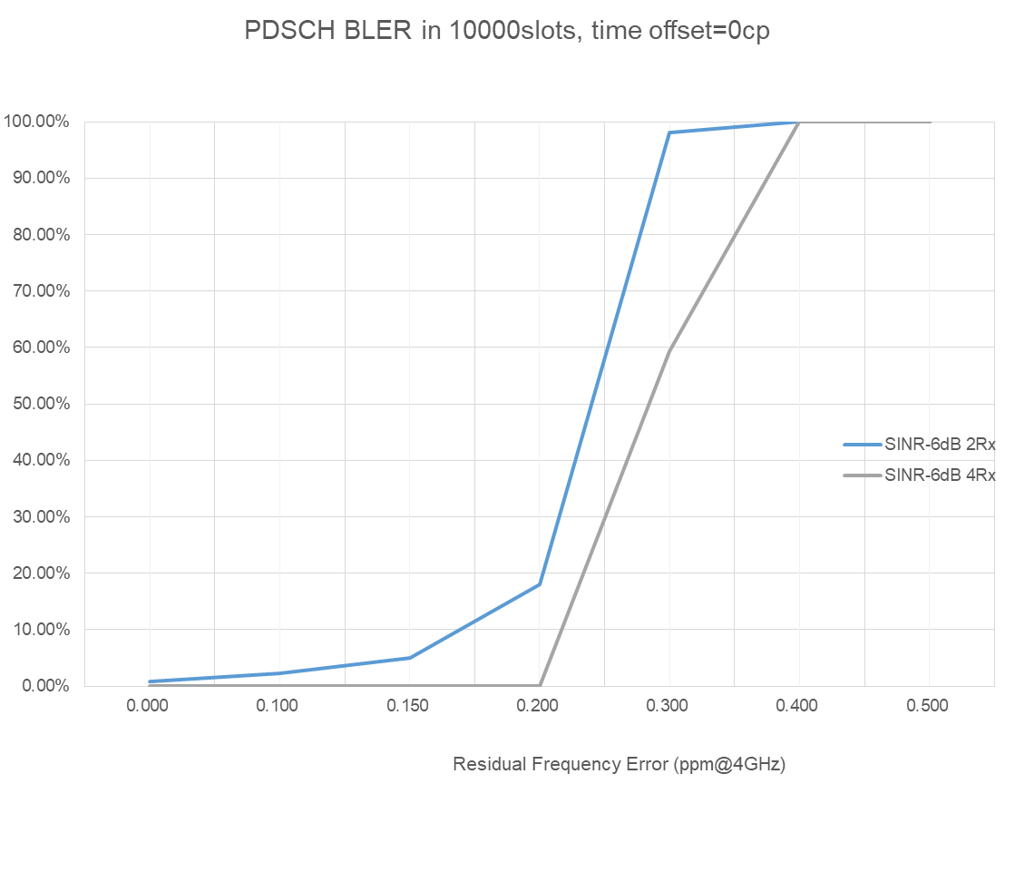  Figure 3 Link level evaluation results for PDSCH based on the agreed evaluation assumptions.  Observation 4: To ensure lower than 10% PDSCH BLER, the residual frequency error is required to be lower than 0.21ppm for UEs using 2T4R and 0.17 ppm for UEs using 2T2R.  Observation 5: UE needs to pre-wake-up for AGC and T/F tracking to receive SS bursts before the corresponding PO, which consumes additional power.  Figure 4 Link level evaluation results for T/F tracking performance.  Observation 6: All paging procedures with 1, 2 and 3 SS bursts reception are relevant UE implementation and should be assumed for evaluation in the study.
  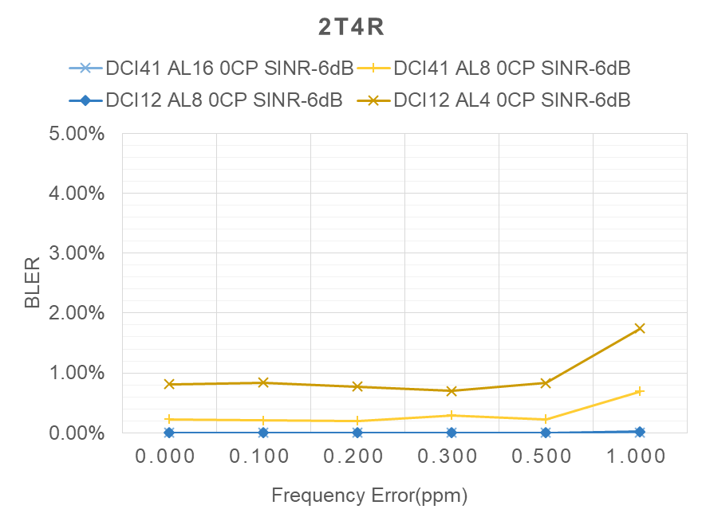  - Results for UEs using 2T4R | 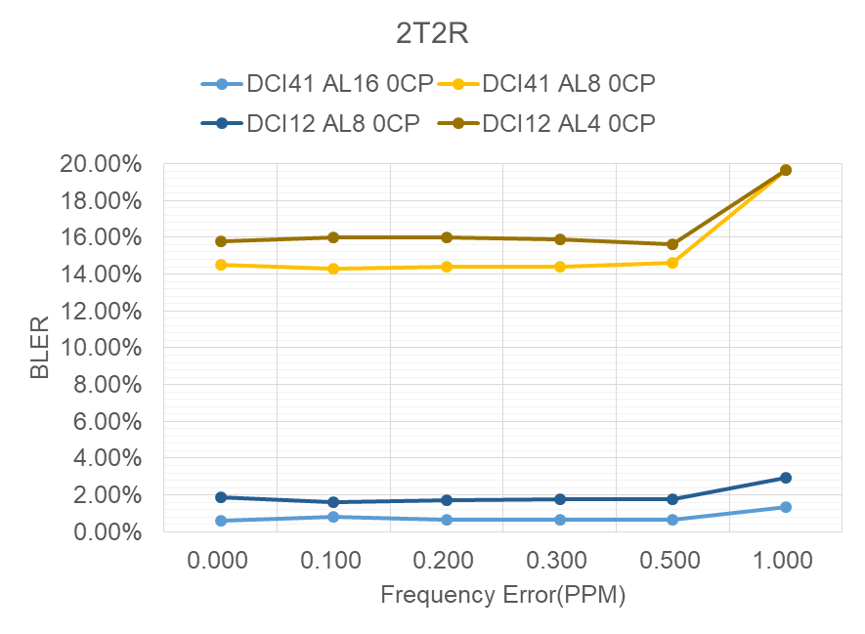  - Results for UEs using 2T2R
  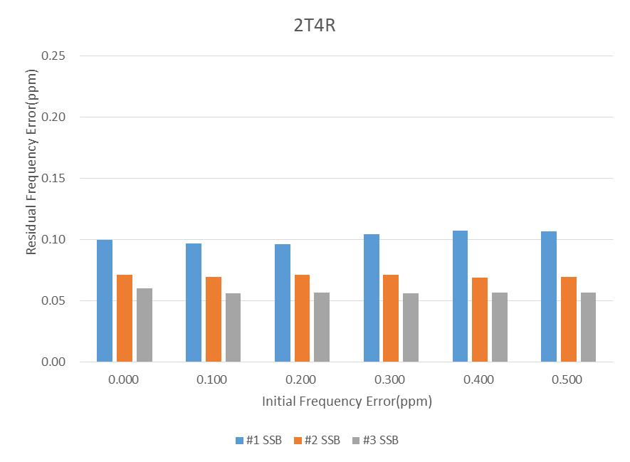  - Results for 2T4R | 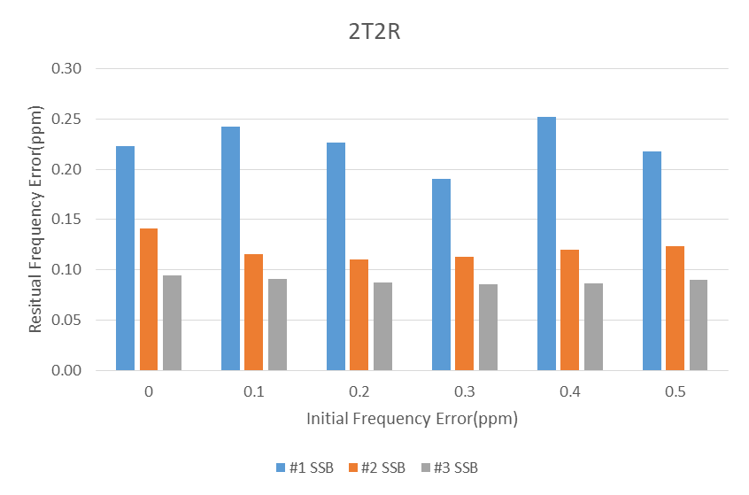  - Results for 2T2R
vivo | (a): Paging PDCCH (b):Paging PDSCH  Figure 1: Performance of paging PDCCH and paging PDSCH with uniformly distributed CFO  Observation 1: To make sure paging PDSCH can be detected with high reliability, UE need to calibrate carrier frequency to limit the residual CFO within about [-0.1ppm 0.1ppm].  Observation 2: In idle and inactive state, UE need to receive 2 or 3 SSBs before PO in Low SNR case, and 1 SSBs before PO in High SNR region.  Proposal 1: The evaluation should assume the number of SSBs for IDLE mode loop convergence / time-frequency tracking can be 1, 2 or 3.
ZTE | Figure 4 Residual frequency error after processing one SSB  Observation 4: When the initial frequency error is +/-0.5 ppm, the residual frequency error is about 0.1 ppm after one SSB processing at -6dB.
Samsung | Observation #8: For max initial CFO = 1ppm or 0.5ppm, 1 or 2 SSB burst is not enough to achieve 0.1 ppm residual error at SNR of -4dB. More RS resources for (re)synchronization are needed.  Observation #9: For max initial CFO = 0.2ppm, 1 SSB burst is enough to achieve 0.1 ppm residual error for SNR > -6dB.  Observation #10: For max initial CFO <=1ppm, TRS can achieve residual error to be less than 0.1ppm for SNR >-6dB.
OPPO | Table 1 PDCCH SNR with residual frequency error  Observation 3: The loss of PDCCH performance with residual frequency error is acceptable.
   | X=0ppm | X=0.1ppm |  | X=0.5ppm |  | X=1ppm
   | X=0ppm | SNR(dB) | gap(dB) | SNR(dB) | gap(dB) | SNR(dB) | gap(dB)
  2T4R | -9.97 | -9.91 | 0.06 | -9.81 | 0.16 | -9.42 | 0.55
  2T2R | -6.15 | -6.13 | 0.02 | -6.04 | 0.11 | -5.70 | 0.45
  1T2R | -6.18 | -6.12 | 0.06 | -6.04 | 0.14 | -5.64 | 0.54
  1T4R | -9.91 | -9.85 | 0.06 | -9.71 | 0.20 | -9.31 | 0.60
MediaTek | 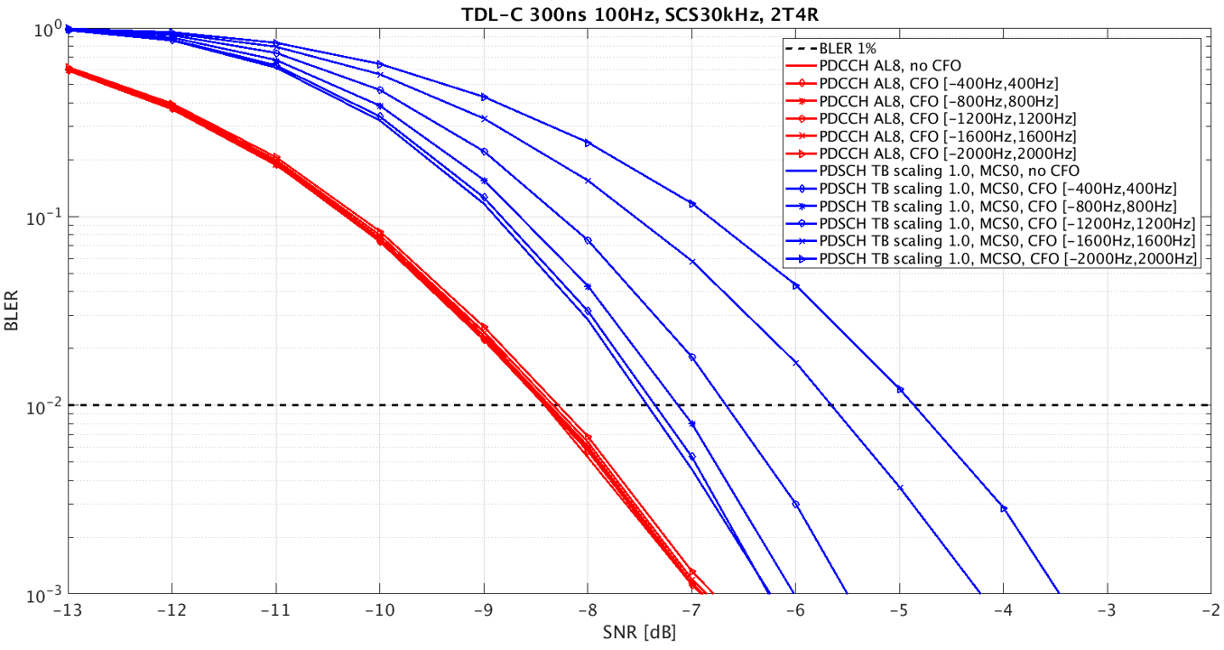  Figure 1: Performances of paging PDCCH and PDSCH with residue frequency offset  Observation 1: Paging performance is dominated by PDSCH sensitivity to residue frequency error after the synchronization.  Observation 2: To confine paging performance loss within 0.2 dB, UE should ensure residue frequency error range is within 0.1 ppm after synchronization.  - The corresponding standard deviation is 230 Hz when modelling the residue frequency error as uniform random variable in the range [-0.1, 0.1] ppm.  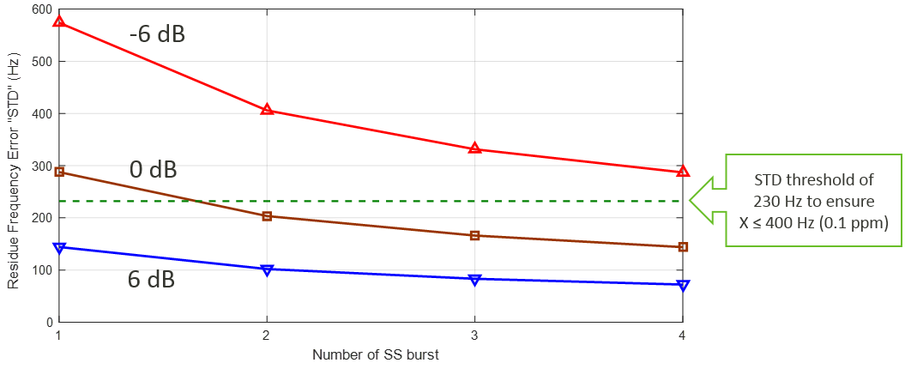  Figure 2: Standard deviation of residue frequency error after synchronization  Observation 3: One SS burst for synchronization is only feasible with good SINR/coverage, e.g., SINR $≥$6 dB. For reduced SINR/coverage, 2 to 4 SSB bursts are generally required.  Proposal 1: For paging enhancement study, consider at least UE processing timelines using 3 SS bursts and 1 SS burst for synchronization.  Proposal 2: For UE processing timelines, it should be assumed that one early SS burst is processed to check channel condition so that sufficient number of SS bursts can be utilized if poor channel condition is identified.  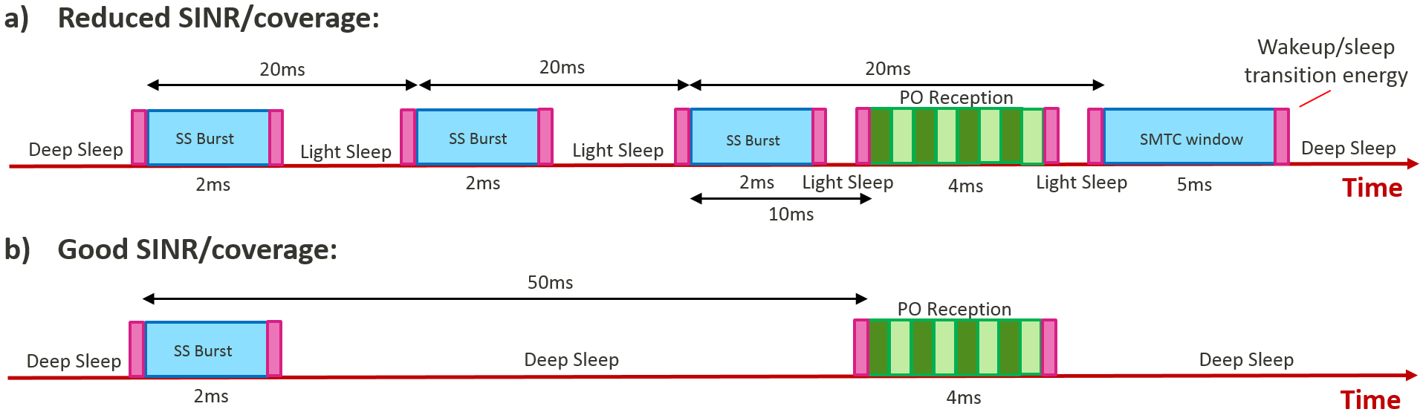  Figure 3: Baseline UE processing timelines for idle/inactive mode
Intel | Observation 2: If frequency drift is 0.16ppm/sec and 0.1ppm is assumed as the residual CFO in last paging cycle, input CFO before next PO can be from 0.292 ppm to 1.73ppm, if paging DRX cycle is increased from 1.2S to 10.24S.  Proposal 2: Design of paging early indication should take RedCap UEs into consideration.  Observation 4: TRS 1-slot and PSS/SSS can achieve similar CFO estimation performance.  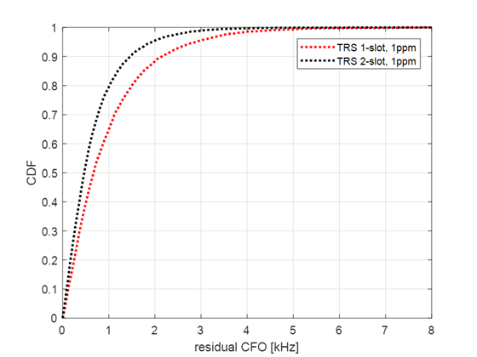  Figure 2: CDF of residual CFO after TRS detection.  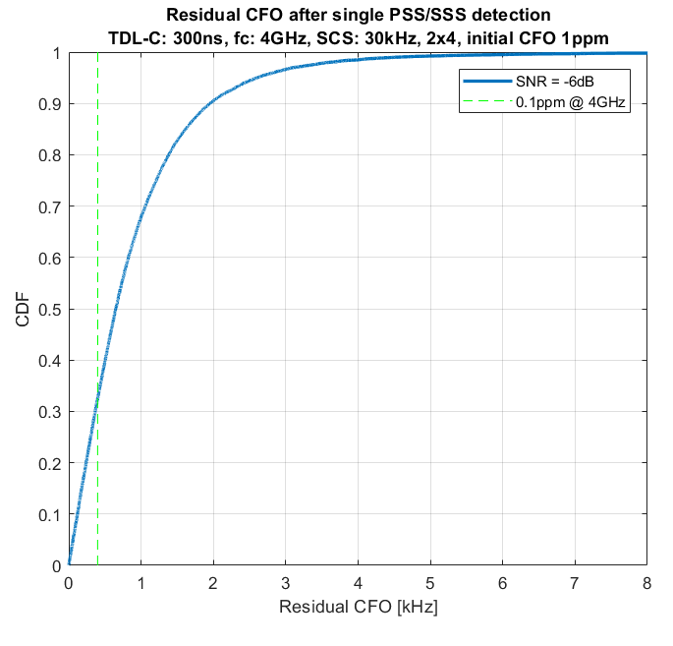  Figure 3: CDF of residual CFO after PSS/SSS detection.  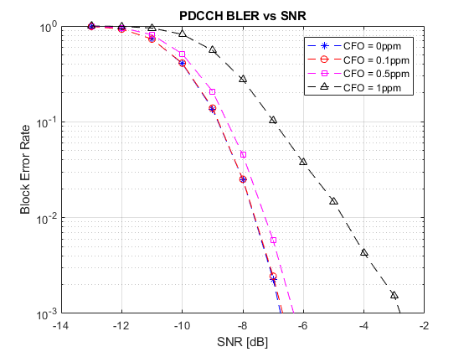  Figure 6: PDCCH BLER for different CFO.  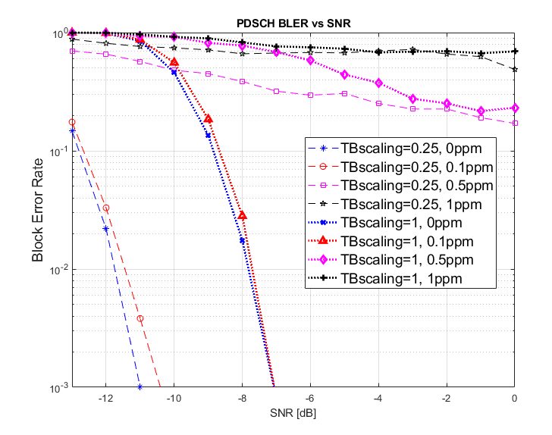  Figure 7: PDSCH BLER for different CFOs and TB scaling.  Observation 8: PDSCH is more vulnerable to CFO values larger than 0.1ppm compared to PDCCH and it is necessary that residual CFO of 0.1ppm or less is maintained when UE decodes PDSCH.
Ericsson | Observation 9: When mechanisms such as TB scaling are used by NW, paging PDSCH performance robustness to frequency error (e.g. due to processing of smaller number of SSBs) is improved.  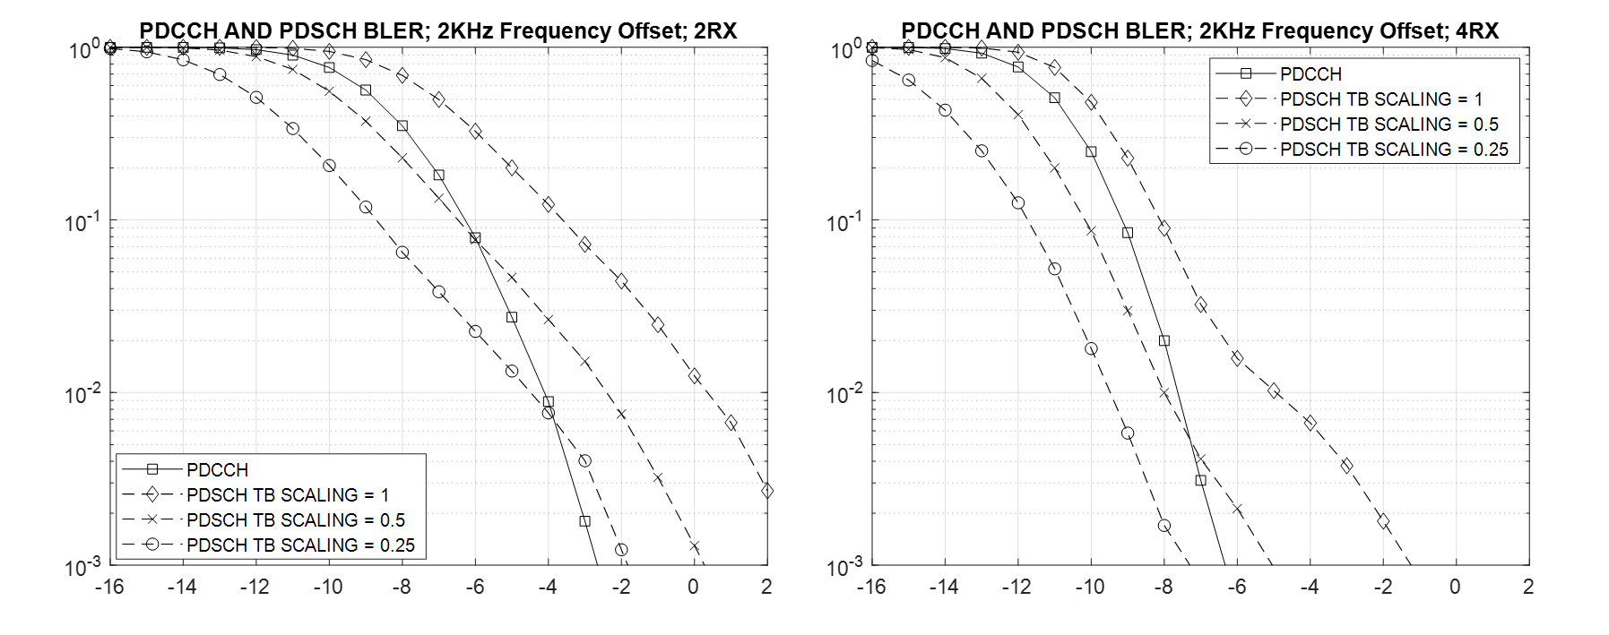  Figure 5: depicts the expected UE PDSCH BLER performance with different TB scaling values in comparison with PDCCH reception performance for the cases 2RX and 4RX. Frequency offset is uniformly randomly distributed between +/- 800kHz, +/-1.6 kHz, +/-2kHz.
CATT  R1-2007869 | 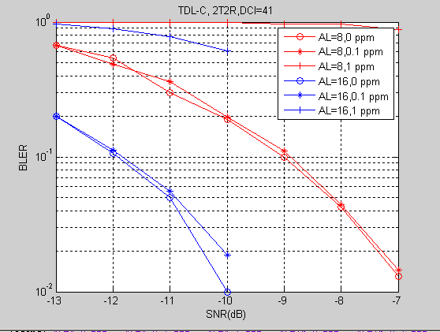  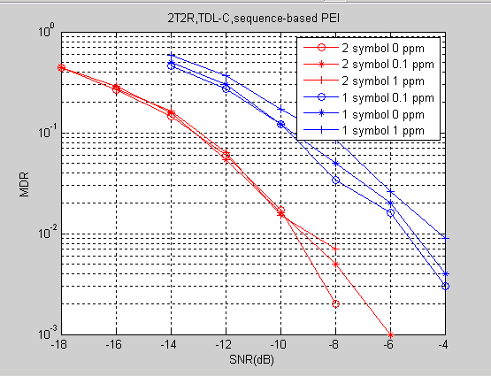  Table 1: Residue frequency error performance with different SSB  Observation 1: PDCCH-based PEI and sequence-based PEI show good performance when there is enough CFO compensation.  Observation 2: sequence-based PEI show better performance gain than PDCH-based when there is no enough CFO compensation.  Observation 3: Three SSBs are required in the evaluation of IDLE mode UE power saving enhancement for coherent detection .
  1SSB | 2SSBs | 3 SSBs
  1ppm | 0.6ppm | 0.1ppm

Phase-1 Discussion
From companies’ inputs, the following topic is suggested for email discussion:

Proposed Topic 1: Capture observations on UE synchronization requirements for paging reception. Potential observations include:
- Paging PDCCH performance loss can be confined within 0.2 dB if the residue frequency error after synchronization is within [-0.5, 0.5] ppm
- Paging PDSCH performance loss can be confined within 0.2 dB if the residue frequency error after synchronization is within [-0.1, 0.1] ppm
- One SS burst or TRS slot is sufficient to confine residue frequency error within [-0.5, 0.5] ppm
- One, two or three SS bursts or TRS slots are possibly needed to confine residue frequency error within [-0.1, 0.1] ppm. The resource requirement is generally higher for larger initial frequency offset, lower channel SINR and/or smaller number of UE receive antennas.
- (TBD)

Please kindly provide your views for including Topic 1 for the email discussion in Table 2. Comments on the potential observations are also encouraged.

Table 2: Companies’ views on including Topic 1 for email discussion
Company name | Include Topic 1? (Y/N) | Comment(s) (including suggestions on the observations)
Spreadtrum | Y | It is related to UE timeline
CATT | Yes | We have included our link level results in R1-2007869 in the table  The potential frequency drift could be more than 1 ppm after long sleep when IDLE UE is out of sync with the network. We should consider frequency error within [-1, 1] ppm
Huawei, HiSilicon | Yes | We are fine with the observations.
LG | Y | Generally fine. One minor comment is that it would be better to use “ X ppm” instead of “[-X, X] ppm”.
Intel | Y, with revision | Agree with CATT that potential frequency drift could make CFO before PO to be more than 1ppm, specially if long DRX cycle is used, such as 10.24 seconds agreed for RedCap UE. Hence, in our view, observations need to be inclusive of 1ppm value as well.  We suggest following revisions:  - Paging PDCCH performance loss can be approximately 0.2 dB and at least 2.5 dB if the frequency error at the time of detection of PDCCH is within [-0.5, 0.5] ppm and [-1,1]ppm, respectively.  - Paging PDSCH performance loss can be confined within 0.2 dB if the frequency error at the time of detection of PDSCH is within [-0.1, 0.1] ppm.  - Paging PDSCH performance is more susceptible to frequency error beyond 0.1ppm than PDCCH.  Regarding number of SSBs needed, our observation is that at -6dB, residual frequency error can be 0.5ppm or lower with 90% chance.  We have the following suggestion:  - One SS burst or TRS slot is sufficient to confine residue frequency error within [-0.5, 0.5] ppm at -6dB  Agree with last observation.  We have added our result on PDCCH and PDSCH MDRs.
DOCOMO | Y
OPPO | Y | We are fine with the observation.
CMCC | Y
Samsung | Y, with modifications. | The study and observations are useful for understanding UE power consumption on (re)synchronization in inactive/idle mode, and also (re)synchronization requirement of PDCCH based or sequence based EPI.  However, we have following concerns about observations c) and d).  - First, it’s necessary to specify the initial frequency offset assumed, for the observations on how much resources of SS burst and TRS are needed to achieve target residual frequency error. The initial frequency offset can be [-1, 1] ppm.  - For TRS based synchronization, it’s necessary to specify both the bandwidth, e.g. 20MHz, slot duration, and number of symbols per slot, e.g. 2.  We don’t agree with observation c). In our evaluation, TRS with 20MHz, 1 slot, 2 symbols per slot, is sufficient to confine residue frequency error within [-0.1, 0.1] ppm with initial frequency offset within [-1, 1] ppm.
Ericsson | Y, with modifications | We updated the table with additional evaluation results from R1-2009200.  - The observations about paging PDCCH and paging PDSCH performance should reflect what is possible with existing mechanisms including TB scaling factors of 1, 0.5 and 0.25.  - Any associated resource requirement to recover coverage for smaller number of UE receive antennas should be discussed in Redcap.  We propose below updates (with change marks in red):  - Paging PDSCH performance loss can be confined within 0.2 dB if the residue frequency error after synchronization is within [-0.1, 0.1] ppm when TB scaling factor =1 is used  - Paging PDSCH performance can be similar/better than Paging PDCCH performance if the residue frequency error after synchronization is within [-0.5, 0.5] ppm when TB scaling factor =0.25 or 0.5 is used  - One, two or three SS bursts or TRS slots are possibly needed to confine residue frequency error within [-0.1, 0.1] ppm. The resource requirement depends on UE implementation, and is generally higher for larger initial frequency offset, lower channel SINR and/or smaller number of UE receive antennas.
Apple | Y | The assumption on initial frequency error should be included as part of the observation.  A general comment to all the proposals for capturing observations: we are not against the discussion on observations. But if the discussion turns out to be difficult, it may not be worthwhile to spend too much effort trying to agree on the observations because this is not a study item.
Qualcomm | Y
ZTE,Sanechips | Yes | We are generally okay with the observations.  Regarding the initial frequency error, it is noted that the frequency drift is assumed to be 0.05ppm/s in NB-IoT/MTC in LTE. We believe that for NR devices, the frequency drift should be much less than that. From this perspective, we think the initial frequency error is no larger than 0.5ppm even when a larger I-DRX cycle, e.g, 10.24s, is considered.  Regarding 1a) and 1b), we agree with the original observation that based on the agreements in the last meeting, we need to capture the performance impact of the residual frequency error after synchronization compensation, instead of the initial frequency error.  A suggestion to 1c) and 1d): As it is pointed out in the last sentence, the number of SSB bursts/residual frequency error depends on lots of factors. It would be better to clarify the corresponding conditions, like SINR, number of UE receive antennas, etc.
vivo | Y | For d), revised as follow,  One, two or three SS bursts or TRS slots are possibly needed to confine residue frequency error within [-0.1, 0.1] ppm. The resource requirement is generally higher for larger dependent on initial frequency offset, lower channel SINR and/or smaller number of UE receive antennas.
MediaTek | Y | We are supportive to include some fundamental observations, particularly reflecting PDSCH sensitivity to residue frequency error. On the other hand, we also agree with Apple, trying to capture too many details may not be beneficial.  Regarding TB scaling, under the condition small TB scaling value, 0.5 or 0.25, is guaranteed and known before UE performs synchronization, we are open to include Ericsson’s observation. But please note that this is equivalent to require 2x or 4x PDSCH overhead per paging data bit, which clearly conflict with the metric of minimized system overhead.
Nokia |  | We would need to clarify what is the intent of the conclusions, are we aiming to align the evaluation assumptions on number of SSBs or placement of the EPI. If so, yes should be discussed, but we may want to clarify the detailed outcome.
InterDigital | Y
Panasonic | Y

There are 18 companies provided inputs for Topic 1. Accordingly the following observation is suggested:
Observation 1: For NR idle/inactive mode UEs,
- Paging PDCCH performance loss can be confined (within around 0.2 dB) w.r.t. that without frequency error if the residue frequency error after synchronization is within 0.5 ppm
- Paging PDSCH performance loss can be confined (within around 0.2 dB) w.r.t. that without frequency error if the residue frequency error after synchronization is within 0.1 ppm
- One company observes that paging PDSCH performance can be similar/better than Paging PDCCH performance if the residue frequency error after synchronization is within 0.5 ppm and if small TB scaling factor of 0.5 or 0.25 is guaranteed by the network and known by the UE before UE performs synchronization.
Observation 2: For NR idle/inactive mode UEs,
- If initial frequency error is no larger than [1] ppm, one SS burst can be utilized to confine the residue frequency error within 0.5 ppm after synchronization.
  - One company observes 1 ppm residue frequency error after synchronization over one SS burst when the initial frequency error is 5 ppm
- To achieve residue frequency error within 0.1 ppm after synchronization, up to three SS bursts are required.
  - Actual number of SS bursts required depends on UE implementation and channel SINR condition.
After the email discussion till 11/06 12 am UTC, Observation 1 is separated into Observations 1 (based on original 1-a) and 1-b)) and 1a (based on original 1-c)) for further discussion. Observation 2 is dropped, since all SS burst settings are already considered in the subsequent observations for candidate paging enhancements. Note that discussion still continues on 11/10 UTC
Observation 1: For NR idle/inactive mode UEs,
- Paging PDCCH performance loss can be confined within 0.2 dB w.r.t. that without frequency error if the residue frequency error before detecting PDCCH is within 0.5 ppm.
  - One source shows the paging PDCCH performance loss can be confined within 0.4 dB w.r.t. that without frequency error if the residue frequency error before detecting PDCCH is within 0.5 ppm.
- Paging PDSCH performance loss can be confined within 0.2 dB w.r.t. that without frequency error if the residue frequency error before detecting PDSCH is within 0.1 ppm
Observation 1a: Paging PDSCH performance can be similar/better than Paging PDCCH performance if the residue frequency error after synchronization is within 0.5 ppm and if small TB scaling factor of 0.5 or 0.25 is guaranteed by the network and known by the UE before UE performs synchronization.

Phase-2 Discussion
Since the intention for Observations 1 and 1a is to ensure minimum paging PDSCH performance impact with Rel-17 paging enhancement. In this regard, we suggest focus on the observation related to synchronization requirement, which will be used as one requirement on paging early indication design:
Observation 1: For NR idle/inactive mode UEs, the residue frequency error after synchronization before paging PDSCH detection should be confined within 0.1 ppm.

Table 3: Companies' views for the updated Observation 1
Company | Support (Y/N)? | Views
CATT | Y | UE is required to support the frequency stability +/- 0.1 ppm in TS38.101. This is a 3GPP requirement and not the observation.
Qualcomm | Y
Intel | Y | Agree with CATT.
Xiaom | Y
Samsung | Partially Y | Not only paging PDSCH, the performance impact to paging PDCCH should be minimized as well. Although PDCCH may be less sensitive to the residual frequency error than PDSCH, we can’t separate the synchronization requirements for them. Because there is no additional RS ensured for synchronization between paging PDCCH and paging PDSCH. So, we think the residual frequency error confined within 0.1ppm is needed before PO rather than paging PDSCH.  Observation 1: For NR idle/inactive mode UEs, the residue frequency error after synchronization before paging PDSCH detection PO should be confined within 0.1 ppm.
InterDigital | Y
LG | Y
DOCOMO | Y
CMCC | Y
Huawei, HiSilicon | Y | Several companies’ link level evaluations show that reliable PDSCH performance needs frequency error within 0.1ppm. PDCCH performance is robust with respective to 0.5ppm frequency error.
Ericsson | N | It needs to be clarified that the observation is “for the purpose of design of paging early indication,”  Is the CATT comment about 3GPP requirement is for a Tx requirement or a Rx requirement? Can it be clarified?  Since this is for the purpose of design, we should consider a range to check the robustness/sensitivity of different PEI designs.  We propose to add following values:  0.1 ppm, 0.2ppm, and [0.3ppm]
ZTE,Sanechips | N | Regarding the 0.1ppm requirement in 38.101, it seems it is the requirement at transmitter side, instead of receiver side.  From companies simulation results, even the residual frequency error is larger than 0.1ppm, the PDSCH performance can still satisfy the target BLER.  It is obvious that the tolerance of residual frequency error is different among companies, which depends on multiple factors in implementation, such as whether DM-RS is used for frequency compensation.  What’s more, when the PEI indicates UE needs to receive the PDSCH, the processing timeline does not change. That is, the frequency error when UE receives the PDSCH is the same as R16, so the decoding performance of the PDSCH can be guaranteed. The residue frequency error does not need to be emphasized.  As there is no consensus on the original observation 1/1a, we think we don’t need to speed too much time to discuss it this meeting.
Spreadtrum | Partially Y | Similar view with Samsung
Apple | N | Even though we are generally fine with using it as a design guideline, it seems dangerous to agree to it because we may not be able to guarantee the residual frequency error is always confined within 0.1ppm.
Mediatek | Y | The requirement in 38.101 is related to UE TX frequency offset. Since there no UE TX in idle-mode, it is ambiguous to say UE is required to achieve 0.1 ppm for paging PDSCH by the spec. On the other hand, companies’ contributions do show the necessity to ensure 0.1 ppm for limiting PDSCH degradation within 0.2 dB. In this regard, capturing the observation is useful for companies to check whether the same sync performance can be ensured for a proposed paging enhancement design.

For the proposed observation, most companies can support, but there is still no consensus. Since the proposed observation provides synchronization requirement in residue frequency error range in order to assist companies’ justification on the impact to UE paging detection probability, companies can directly justify the impact by providing performance results even without this observation. Yet, from companies’ contributions and feedbacks, ensuring 0.1 ppm before paging PDSCH detection is still the majority view that can be referenced.

Characterization of UE Power Saving Gains with Paging Enhancements
After characterizing UE synchronization requirements, UE power saving gain is the first performance metric to check. In Table 3, there summarize the evaluation results and views from 19 companies, considering the following paging enhancements:
- Paging early indication
- UE sub-grouping with additional information carried in paging early indication
- UE sub-grouping with additional information carried in legacy paging PDCCH
- Cross-slot scheduling
Table 4: Companies’ evaluation results s and views for UE power saving gains with paging enhancements
Company | Results and views
Huawei, HiSilicon | Table 1: Analysis on power saving gain for proposed solutions (compared with R16 baseline)  Observation 17: Power saving gain of EPI w/o sub-grouping indication is significantly reduced when the paging load on a PO is increased.  Observation 18: EPI with sub-grouping indication can obtain robust power saving gain which is not impacted by the paging load increment on a PO.  Proposal 1: Support Early paging indication (EPI) in Rel-17 to reduce the power consumption of IDLE more UE.  - FFS: DCI based EPI or RS based EPI
   |  | Power saving gain(10% paging rate) | Power saving gain(40% paging rate)
  EPI w/o sub-grouping | For UEs using 1 SS bursts for T/F tracking; | ~17% | ~11%
  EPI w/o sub-grouping | For UEs using 2 SS bursts for T/F tracking; | 20%~32% | 13%~21%
  EPI w/o sub-grouping | For UEs using 3 SS bursts for T/F tracking; | 29%~41% | 19%~27%
  Sub-grouping indication with EPI | For UEs using 1 SS bursts for T/F tracking; | ~19% | ~19%
  Sub-grouping indication with EPI | For UEs using 2 SS bursts for T/F tracking; | 22%~36% | 21%~34%
  Sub-grouping indication with EPI | For UEs using 3 SS bursts for T/F tracking; | 33%~46% | 30%~42%
vivo | Table 4: Power saving gain by using Option 1  Observation 3: The power saving gain is marginal by configuring the group paging indication in legacy paging PDCCH.  Table 8: Power saving gain by using sequence-based and DCI-based PEI.  Observation 6: By configuring PEI before PO reception, up to 12.63%~29.2% power saving gain in Low SINR case and 0.6%~11.2% gain in High SINR case can be achieved.  Observation 7: For Low SINR UEs, sequence-based PEI could have more benefits than DCI-based PEI, if the sequence itself can be further used for measurement.  Observation 8: There is no power saving benefit by DCI-based PEI for High SINR UEs.  Table 11: The power saving gain comparison of the three paging enhancement schemes  Observation 12: Up to 29.2% and 12.3% power saving gain can be achieved by using sequence-based PEI with sub-grouping indication in Low SINR case and High SINR case with RRM relaxation, which is the most power saving gain compared with other paging enhancement schemes.
  Cases | Average relative power in a slot (sleep / wake up) | Power saving gain (vs the baseline scheme)
  Cases | Average relative power in a slot (sleep / wake up) | PO paging rate: 10% |  |  | PO paging rate: 20% |  |  | PO paging rate: 40%
  Cases | Average relative power in a slot (sleep / wake up) | 4 groups | 8 groups | 16 groups | 4 groups | 8 groups | 16 groups | 4 groups | 8 groups | 16 groups
  Low SINR | Two SSBs before PO:  2.613/2.832 | <0.77% |  |  | <1.53% |  |  | <2.99%
  Low SINR | Three SSBs before PO:  3.035/3.254 | <0.72% |  |  | <1.4% |  |  | <2.58%
  High SINR | 1.663/1.718 | <0.33% |  |  | <0.66% |  |  | <1.2%
  Cases |  | Average relative power in a slot  (sleep / wake up) | Power saving gain  (vs R16 baseline scheme)
   |  | Average relative power in a slot  (sleep / wake up) | PO paging rate: 10% | PO paging rate: 20% | PO paging rate: 40%
  Low SINR | Sequence-based PEI in position 1  or DCI-based PEI in position 3 | 2.164 / 3.420 for 3 SSBs before PO;  2.164/ 2.8164 for 2 SSBs before PO | 25.1%;  19.67% | 21.6%;  17.28% | 14.61%;  12.63%
  Low SINR | Sequence-based PEI in position 2 | 2.039 / 3.284 for 3 SSBs before PO;  2.039 / 2.6914 for 2 SSBs before PO | 29.2%;  23.91% | 25.7%;  21.26% | 18.75%;  16.69%
  High SINR | Sequence-based PEI in position 1 | 1.4914 for rate=10%, 1.535 for rate=20%  1.582 for rate=40% | 10.6%, 4x RRM relax | 8.3%, 4x RRM relax | 4.9%, 4x RRM relax
  High SINR | Sequence-based PEI in position 1 | 1.60/1.87 | 2.5%, no relax | 1.3%, no relax | 0.6%, no relax
  High SINR | Sequence-based PEI in position 2 | 1.48/1.76 | 11.2%, 4x RRM relax | 9.1%, 4x RRM relax | 5.5%, 4x RRM relax
  High SINR | DCI-based PEI in position 3 | - | - | - | -
  Note 5: the result of DCI-based PEI in position 3 is not given because it has no power saving gain.
  Paging enhancement schemes | Power saving gain  (vs Rel 16 baseline paging method)
  Paging enhancement schemes | PO paging rate =10% |  | PO paging rate =20% |  | PO paging rate =40%
  Paging enhancement schemes | Low SINR (with 3 SSBs before PO) | High SINR  (with/without RRM relaxation) | Low SINR (with 3 SSBs before PO) | High SINR  (with/without RRM relaxation) | Low SINR (with 3 SSBs before PO) | High SINR  (with/without RRM relaxation)
  Sub-grouping for paging by using legacy paging DCI | <0.72% | <0.33% | <1.4% | <0.66% | <2.58% | <1.2%
  Sequence-based PEI  in position 1 or 3 | 25.1% | 10.6% / 2.5% | 21.6% | 8.3% / 1.3% | 14.6% | 4.7% / 0.6%
  DCI-based PEI  in position 1 or 3 | 25.1% | - | 21.6% | - | 14.6% | -
  Sequence-based PEI with sub-grouping indication (4 sub-groups) in position 1 or 3 | 29.17% | 12.3%/4.8% | 27.5% | 10.4%/3.6% | 27.34% | 9.33%/3.53%
  Note 1: ‘-’ denotes the power saving gain is smaller than 0.
CATT | Figure 2: Illustration of paging reception with paging indication carried in paging DCI  Figure 6: Power saving gain of sub-grouping with group paging rate 0.1 under different paging cycle  From the evaluation results, it could be observed that,  - There are small power saving gain for the paging sub-grouping power saving scheme to reduce the UE PDSCH decoding, i.e. 0.44%~1.03% power saving gain due to high false alarm for paging reception indication.  Figure 3: Illustration of paging reception with TRS/CSI-RS assisted PDCCH-based paging indication  Figure 7: Power saving gain of DCI-based PEI with group paging rate 0.1 under different paging cycle  From the results in Figure 7, We observe that  - The DCI-based PEI achieves power saving gain, i.e., 4.41%~10.07%. The power saving gain is from reducing unnecessary paging reception and reducing SSB number and light sleep power consumption in the preparation period. Because DCI decoding and demodulation needs high reliability, the number of SSBs in the preparation period is similar to that for decoding of paging DCI to achieve the same PDCCH performance.  Figure 4: Illustration of paging reception with sequence-based PEI and channel tracking, without RRM measurement enhancement  Figure 8: Power saving gain of sequence-based PEI with group paging rate 0.1 under different paging cycle  From the results in Figure 8, we observe that  - The sequence-based PEI achieves power saving gain at 23.11%~51.59% power saving gain for case 4-1 (no RRM relaxation) and 32.33%~67.68% power saving gain for case4-2 (with RRM relaxation). The power saving gain is from reducing unnecessary paging reception and shorten the time in the preparation period since the non-coherent detection of sequence-based PEI has high tolerance in time and frequency error .  Proposal 3: for paging enhancement scheme, PEI could provide obvious power saving gain with DCI-based and sequence-based PEI.
Xiaomi | Observation 3: DCI-based indication won’t be able to save power at all with the assumption that if UE has to monitor N SSBs for AGC and time/frequency tracking before the PO, then UE also need to monitor N SSBs for AGC and time/frequency tracking before the DCI-based paging early indication.  Proposal 2: Power saving effect of DCI-based indication should be reconsidered with a more reasonable assumption, and RS-based or sequence-based paging early indication method is preferred.
ZTE | Table 1. Average power consumption and power saving gain with paging indication  Observation 2: The paging indication before PO can bring about 2.49%-12.45% power saving gain. The higher the group paging rate, the smaller the power saving gain of the paging indication.
  schemes | Group paging rate | Average power consumption | Power saving gain
  Baseline | 0.1 | 2.137 | /
  Paging indication | 0.1 | 1.871 | 12.45%
  Baseline | 0.6 | 2.246 | /
  Paging indication | 0.6 | 2.190 | 2.49%
CMCC | Table 2. Power saving gain evaluation results of PEI  Observation 1: For low SINR, PEI can realize 20.6% power saving gain with paging rate 10% and 17.7% power saving gain with paging rate 25%; for high SINR, PEI can realize 10.7% power saving gain with paging rate 10% and 9.0% power saving gain with paging rate 25%.  Proposal 2. Paging early indication before PO can be supported to indicate whether UE need monitor paging PDCCH.  Table 3. Power saving gain of PEI based UE sub-grouping  Observation 2. PEI based sub-grouping can further improve the UE power saving gain than PEI-only, and the power saving gain will increase with larger sub group number.  Observation 3. The power saving gain of PEI based sub-grouping increases with high paging rate of PO.  Proposal 3. Sub-grouping for paging based on paging early indication can be supported.  Proposal 4. Bitmap in paging early indication DCI can indicate which UE group(s) need to monitor PO and receive paging PDSCH.
  Paging rate | SINR scenario | Power saving gain
  Paging rate 10% | Low SINR | 20.6%
  Paging rate 10% | High SINR | 10.7%
  Paging rate 25% | Low SINR | 17.7%
  Paging rate 25% | High SINR | 9.0%
   | Paging rate of one PO | 10% |  |  | 25%
   | Sub groups number | 2 | 4 | 8 | 2 | 4 | 8
  low SINR | Power saving gain of PEI + sub-grouping | 21.7% | 22.3% | 22.6% | 19.8% | 21.3% | 22.1%
  low SINR | Improvement of power saving gain related to PEI only | 5.3% | 8.3% | 9.7% | 11.9% | 20.3% | 24.9%
  high SINR | Power saving gain of PEI + sub-grouping | 11.4% | 11.7% | 11.9% | 10.3% | 11.1% | 11.6%
  high SINR | Improvement of power saving gain related to PEI only | 6.5% | 9.3% | 11.2% | 14.4% | 23.3% | 25.6%
LG | Table 1 Power saving gain by the PEI  Observation 1: About 14~18% power saving gain can be achieved by the paging early indication when 10% group paging rate is assumed.  Proposal 1: Introduce paging early indication signal/channel which can be used to inform UE(s) of monitoring PO.  Table 2 Power saving gain of UE sub-grouping (compare to the PEI w/o UE sub-grouping)  Observation 2: Additional power saving gain can be achieved when information on UE sub-grouping is conveyed by the paging early indication signal/channel.
  #of SSB processing | 1 | 2 | 3
  Paging rate 10% | 18.37% | 16.6% | 14.84%
  Paging rate 30% | 14.23% | 13.79% | 12.32%
  # of SSB processing | 1 | 2 | 3
  Paging rate 10% | 2.22% | 1.47% | 1.29%
  Paging rate 30% | 6.34% | 4.28% | 3.76%
Spreadtrum | The power consumption can be evaluated as follows.  - Case-1: 3 SSB bursts processing (based on “initial proposal 3”)  - 200 * (1-P) + 480 * P + 3685 = 3913, when P = 10%.  - Case-3: 1 SSB bursts processing + PEI  - 200*(1-P) + 480 * P + 2725 = 2833, when P = 10%.  The power saving is about (3913-2833)/3913=28%, when P = 10%.  Observation 1: PEI with assistance of TRS/CSI-RS can provide the obvious power saving gain by reducing the number of SSB bursts to be processed.  Proposal 1: Consider to specify paging early indication.  Proposal 2: Consider to specify sub-grouping for paging.
Samsung | Table 4: PSG for paging enhancement with I-WUS  ($PSG with r_{sync}=1,$ $PSG with r_{sync}=1/4$)  Observation #5: Paging enhancement of sequence based I-WUS achieves remarkable power saving gain for both cell-center and cell-edge UEs.  Observation #6: Paging enhancement of DCI based I-WUS achieves less power saving gain for cell-edge UEs due to synchronization overhead.  Table 5: PSG for paging enhancement based on UE sub-grouping in frequency domain  ($PSG with r_{sync}=1,$ $PSG with r_{sync}=1/4$)  Observation #7: Paging enhancement of UE sub-grouping achieve about 1% to 5% power saving gain, depending on the number of UEs per sub-group and UE paging rate.
   | Low SINR  (N_SSBs = 3) | Medium SINR  (N_SSBs = 2) | High SINR  (N_SSBs = 1)
  TRS based w/ Config 1  (1 slot duration, 20MHz) | (29.52%, 11.09%) | (18.96%, 7.28%) | (16.30%, 14.70%)
  TRS based w/ Config 2  (2 slot duration, 20MHz) | (28.80%, 10.18%) | (18.13%, 6.33%) | (15.15%, 13.52%)
  DCI based | (-0.29%, -0.37%) | (-0.33%, -0.38%) | (10.35%, 10.54%)
  UE paging rate | N_UEs = 40 | N_UEs = 20 | N_UEs = 10 | N_UEs = 5
  1% | (0%, 0% ) | (1.56%, 1.59%) | (2.46%, 2.51%) | (2.95%, 3.00%)
  2% | (0%, 0% ) | (2.27%, 2.31%) | (3.79%, 3.86) | (4.68%, 4.77%)
OPPO | Observation 5: DCI based paging early indication will have power saving gain if UE is false paged in target PO.
Panasonic | Observation 1: The optimization space to reduce paging monitoring is higher for high SINR case.  Observation 2: To reduce the power consumption for measurement/SSB processing may potentially provide substantial power saving gain due to the large portion it contributes.  Observation 3: Paging early indication can only provide slight power saving gain. Even in the high SINR case and with low group paging rate, which provides the best performance, the gain is still less than 4%.  Observation 6: Except the extreme case that group paging rate can be dramatically reduced, the power saving gain solely provided by sub-grouping is marginal.  Observation 7: To apply both paging early indication and sub-grouping together may provide more justified power saving gain.  Proposal 1: Support of paging early indication with sub-grouping information should be studied.
Sony | 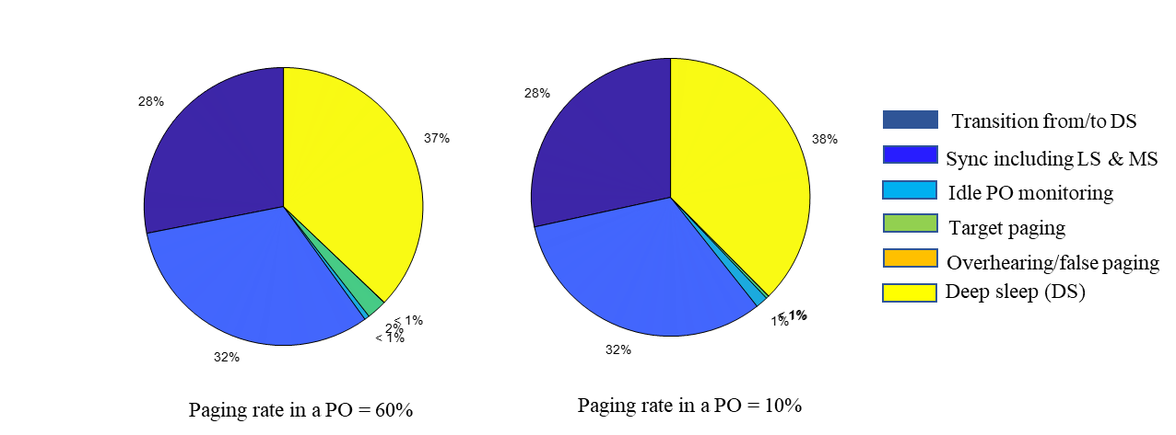  Figure 2a - Power consumption break-down of a UE in good coverage  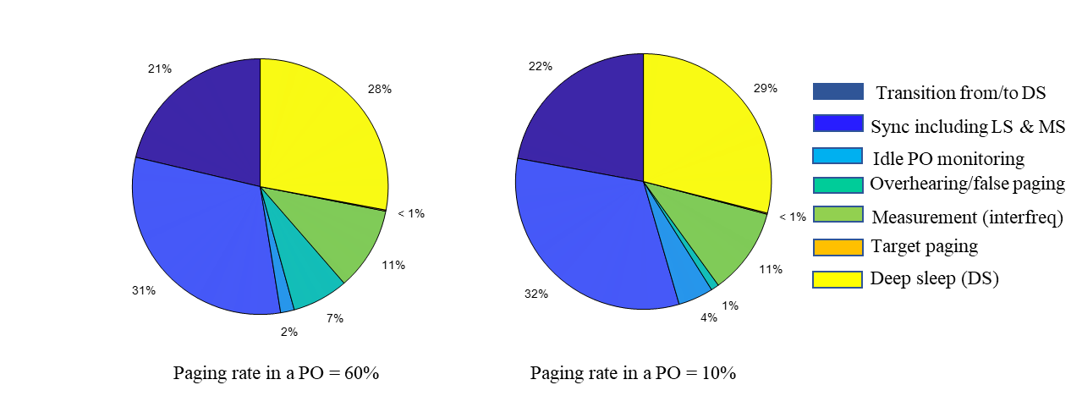  Figure 2b - Power consumption break-down of a UE in bad coverage  Observation 1 – The cost of transition from/to deep sleep as well as synchronization cost are dominant sources of power/energy consumption.  Proposal 1 – Paging enhancement schemes should avoid the UE unnecessarily transitioning from/to deep sleep and from/to synchronization states, when there is no paging for target UE.  Table 1 – Summary of power saving gains for studied paging enhancement schemes  Observation 2 – Early paging indication fulfils the conditions in proposal 1: that Paging enhancement schemes should avoid the UE unnecessarily transitioning from/to deep sleep and from/to synchronization states, when there is no paging for target UE.  Observation 3 – The amount of power saving resulting from UE grouping in a sequence-based early paging indicator is much higher than other UE sub-grouping schemes.
   | Low SINR/bad coverage |  | High SINR/good coverage
   | N=10/paging rate per PO = 10% | N=100/paging rate per PO = 60% | N=10/paging rate per PO = 10% | N=100/paging rate per PO = 60%
  Early paging indicator | 11.9 | 6.51 | 26.06 | 10.65
  UE sub-grouping using legacy paging DCI | 0.32 | 3.0 | 0.1 | 0.99
  UE sub-grouping using early paging indicator + UE sub-grouping | 12.66 | 13.67 | 27.56 | 25.02
  Early paging indicator + UE sub-grouping using legacy paging DCI | 12.58 | 9.93 | 26.28 | 11.77
Apple | Table 1 Power saving gain for different enhancements with group paging rate of 10% and 4 sub-groups  (when applicable)  Observation 1: For the cases evaluated with group paging rate of 10%, WUS provides relative power saving gain up to 32%.  - WUS provides larger relative power saving gain for lower SINR compared to higher SINR due to more savings related to SSB for time/frequency tracking.  - WUS provides more gain when there is less RRM measurement activities.  Observation 2: For the cases evaluated with group paging rate of 10%, sub-grouping only provides negligible (<1%) power saving gain.  Observation 3: For the cases evaluated with group paging rate of 10%, sub-grouping on top of WUS provides additional 2~3% power saving gain.  (a) WUS  (b) Sub-grouping  (c) WUS + sub-grouping  Figure 5 Power saving gain for different enhancements with 10 ms offset between SSB and PO  Observation 4: The power saving gain provided by WUS decreases as the group paging rate increases.  Observation 5: The power saving gain provided by sub-grouping only increases as the group paging rate increases. However, the gain is still <3% with group paging rate of 60% for the cases evaluated.  Observation 6: The power saving gain provided by WUS and sub-grouping together provides a good saving gain (24%-35% for low and medium SINR, ~10% for high SINR) across the range of the group paging rate.  - WUS and sub-grouping complement each other, with WUS providing more power saving for lower group paging rate, and sub-grouping providing more power saving for higher group paging rate.  - The incremental power saving gain provided by sub-grouping on top of WUS is significant for high group paging rate.  Proposal: Introduce wake-up signal for UEs in idle/inactive mode. Further consider the support of sub-grouping.
   |  | Case 1 | Case 2 | Case 3 | Case 4
  WUS | SSB and PO have 10 ms offset | 26.3% | 32.4% | 26.2% | 8.9%
  WUS | SSB and PO are adjacent | 25.5% | 29.6% | 20.3% | -1.9%
  Sub-grouping | SSB and PO have 10 ms offset | 0.3% | 0.3% | 0.4% | 0.5%
  Sub-grouping | SSB and PO are adjacent | 0.3% | 0.3% | 0.5% | 0.6%
  WUS + sub-grouping | SSB and PO have 10 ms offset | 28.9% | 35.5% | 28.5% | 10.6%
  WUS + sub-grouping | SSB and PO are adjacent | 28.0% | 32.5% | 22.2% | 0.1%
InterDigital | Table 2 Power saving gain of paging indication  Observation 2: Significant power saving gain is observed for idle/inactive mode UEs when paging indication is used and the gain becomes more significant when the paging rate goes lower.  Proposal 1: Paging indication is used to indicate to an idle/inactive mode UE the monitoring status of an associated paging occasion.
   |  | Gain over baseline
   |  | 10 % paging rate | 60 % paging rate
  Low SNR |  | 32.8 % | 12.5 %
  High SNR | 1 SSB | 11 % | 3.7 %
  High SNR | No SSB | 22.8 % | 14.8%
Nokia, Nokia Shanghai Bell | Table 3 Energy savings relative to Release 15 baseline.  Observation: DCI-based EPI approach may lead to power savings in order of 19 % - 37 % compared to the Release 15 baseline, depending on the SINR scenario.  Observation: Potential energy savings reduce with increasing group paging rate and SINR.  Observation: In low SINR and high paging rate, subgrouping provides more gain over the other schemes.  Observation: Increasing the number of subgroups, indicated through EPI, beyond 4 does not provide meaningfull increase of the power saving gains.  Observation: Cross-slot scheduling of the paging message does not result in useful energy saving gains.  Observation: Subgrouping through the paging DCI does not result in useful energy saving gains.  Proposal: RAN1 to continue studying further details of the Early Paging Indication for paging power saving enhancement, accounting for the system overhead.
  Group Paging Rate | SINR level | R15 Paging+  EPI | R15 Paging+EPI with subgrouping |  |  | R15 Paging+EPI + additional RS
  Group Paging Rate | SINR level | R15 Paging+  EPI | 4 | 8 | 16
  5 % | Low | 35.4 % | 36.9 % | 37.2 % | 37.3 % | 32.3 %
  5 % | Med | 26.6 % | 27.8 % | 28.0 % | 28.1 % | 22.4 %
  5 % | High | 18 % | 18.8 % | 19.0 % | 19.1 % | 17.1 %
  10 % | Low | 33.5% | 36.5 % | 37.0 % | 37.3 % | 32.0 %
  10 % | Med | 25.2 % | 27.5 % | 27.9 % | 28.0 % | 22.0 %
  10 % | High | 17 % | 18.6 % | 18.9 % | 19.1 % | 16.1 %
  20 % | Low | 29.6 % | 35.7 % | 36.7 % | 37.2 % | 31.2 %
  20 % | Med | 22.2 % | 26.9 % | 27.6 % | 28.0 % | 21.1 %
  20 % | High | 15.0 % | 18.2 % | 18.8 % | 19.1 % | 14.3 %
MediaTek | Table 2: Power saving gains of candidate paging enhancement schemes  Observation 4: (UE-Group) paging early indication can achieve the best power saving gain, up to 25.5% and 17% for reduced SINR/coverage and good SINR/coverage cases, respectively.  Observation 5: UE grouping, if carried in PO, achieves limited power saving gain (up to 2.1%). On the other hand, combining UE grouping and PEI can achieve additional 6.5% power saving gain to PEI-only scheme with 40% group paging rate. The gain is expected to be higher with a higher group paging rate.  Observation 6: Cross-Slot Scheduling achieves limited power saving gain (up to 6.3% in reduced SINR/coverage case), which is due to the limitation of maximum 32 slots on the scheduling offset.  Proposal 3: For Rel-17 paging enhancement study, RAN1 to prioritize (UE-Group) paging early indication scheme, where UE is notified before paging occasion whether UE (sub)group is paged or not.  - LS to RAN2 for inquiring the potential subgroup number if UE grouping is considered
  Channel condition | Reduced SINR/coverage |  |  |  | Good SINR/coverage
  Group paging rate (GPR) | 10% | 20% | 30% | 40% | 10% | 20% | 30% | 40%
  PEI | 23.8% | 21.0% | 18.3% | 15.5% | 15.6% | 13.7% | 11.9% | 10.1%
  UE-Grouping | 0.3% | 0.7% | 1.0% | 1.3% | 0.5% | 1.1% | 1.6% | 2.1%
  UE-Group PEI | 25.5% | 24.3% | 23.2% | 22.1% | 17.0% | 16.5% | 16.0% | 15.5%
  Cross-Slot Scheduling | 6.3% | 5.6% | 4.8% | 4.1% | 0.0% | 0.0% | 0.0% | 0.0%
Intel | Table 1: Configurations for comparison.  Table 2: Power consumption evaluation of paging enhancement schemes  Observation 1: Paging early indication provides most significant power saving gain among the candidate schemes.  - UE sub-grouping can further improve the power saving gains when configured in conjunction with PEI.  Proposal 1: Support paging early indication and UE sub-grouping in Rel-17.  - FFS: Details of UE sub-grouping options with sub-group indication as part of PEI and/or during PO.
  Config Index | Configuration description
  1 | Paging DCI may include sub-grouping information, Cross-slot scheduling for paging PDSCH and PEI are not configured
  2 | Paging DCI may include sub-grouping information and use cross-slot scheduling. PEI is not configured
  3 | PEI is configured and may indicate sub-grouping information. Cross-slot scheduling for paging PDSCH is not configured
  4 | PEI is configured and may indicate sub-grouping information. Cross-slot scheduling for paging PDSCH is configured
  # SSBs monitored | UE sub-grouping used? | Config 1  (avg power/slot) | Config 2  (% gain) | Config 3  (% gain) | Config 4  (%gain)
  1 | No | 1.73 | 1.83 | 17.49 | 17.69
  2 | No | 1.96 | 1.61 | 15.39 | 15.57
  3 | No | 2.19 | 1.44 | 13.75 | 13.91
  1 | Yes (# 5) | 1.72 | 1.82 | 18.22 | 18.26
  2 | Yes (# 5) | 1.96 | 1.60 | 16.04 | 16.08
  3 | Yes (# 5) | 2.19 | 1.43 | 14.32 | 14.36
Ericsson | Observation 6: For UEs in good coverage and only in need of decoding one SSB prior to PO PDSCH reception, due to energy spent on sleep transitions, PEI reception increases UE power consumption when paged and brings negligible savings when not paged.  Observation 8: If ~5..10% of the UEs at cell edge need multiple SSBs, and even if at best ~20..25% savings in idle mode is assumed for such UEs with the PEI solution, considering that idle mode power consumption itself only stands for at most ~27% (see [5]) of total power consumption, the PEI benefits may only be ~0.3..0.7% average overall UE energy saving.  Proposal 1: PEI is not introduced as it brings very low overall saving when compared to system cost.  Proposal 2: Consider cross-slot scheduling (with K0=1) for paging as it has very limited impact on the system and brings the savings for the whole UE population (poor and good coverage).  Observation 10: Grouping information can be added to the reserved bits of P_RNTI scrambled DCI 1_0 scheduled in cross-slot. The expected gains are however quite low, e.g. an even distribution of UEs amongst 4 groups brings 10% rate down to 2,5% (UE just avoids PDSCH sampling in 7,5% of POs).  Proposal 4: Ask RAN2 to provide input on whether grouping is necessary considering the quite low gains.  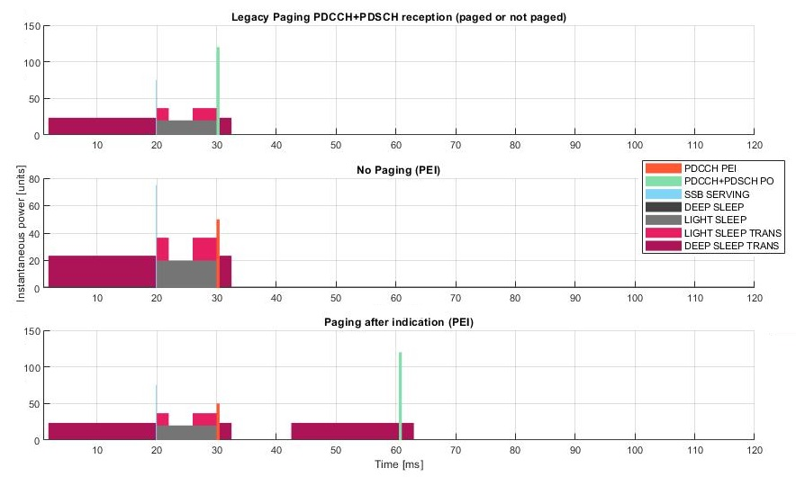  Figure 3 Depicts UE’s paging timelines for a good coverage UE (1 SSB enough prior to PO PDSCH). The upper timeline reflects the legacy case (always PDCCH/PDSCH reception irrespective of being paged or not), whereas the two lower ones show the scenario including a PEI transmission prior to the PO.
  Activity | Relative Energy Cost
  Activity | Legacy Paging | PEI  (not paged) | PEI  (paged)
  PDCCH PEI Rx | 0 | 0.0195 | 0.0195
  PDCCH+PDSCH PO Rx | 0.0468 | 0 | 0.0468
  SSB Rx | 0.0084 | 0.0084 | 0.0084
  Deep Sleep | 0.9917 | 0.9917 | 0.9913
  Light Sleep | 0.1563 | 0.1563 | 0.1563
  Light Sleep Transition | 0.0781 | 0.0781 | 0.0781
  Deep Sleep Transition | 0.3516 | 0.3516 | 0.7031
  SUM | 1.63 | 1.61 | 2.0
Qualcomm | Observation 1: UE sub-grouping alone provides limited power saving gain.  Observation 2: Paging early indication (PEI) can provide essential power saving gain for idle and inactive mode UEs  - Optimal location of PEI transmission can be different for different SINR conditions  - Optimal location of PEI transmission can be different for PDCCH-based and RS/sequence-based due to potential different requirement of time and frequency synchronization and AGC accuracy  - When UE sub-grouping is adopted, it provides another 1% power saving gain in addition to that of PEI.  Observation 3: Additional TRS or CSI-RS can provide power saving gain for idle and inactive mode UEs because the joint periodicity of SSB and TRS/CSI-RS is reduced from 20ms SSB periodicity.
  SINR condition | Low | Medium | High with 4ms PO | High with 1ms PO
  Baseline power | 3.238 | 2.816 | 1.875 | 1.743
  UE subgrouping power (gain) | 3.219 (0.61%) | 2.797 (0.7%) | 1.855 (1.05%) | 1.739 (0.28%)
  SINR condition | Low | Medium | High with 4ms PO | High with 1ms PO
  Baseline power | 3.238 | 2.816 | 1.875 | 1.743
  Early paging indication without UE sub-grouping power (gain) | Location 1: 2.66 (17.8%)  Location 2: 2.728 (15.7%)  Location 3: 3.053 (5.7%)  Location 4: 3.095 (4.4%)  Location 5: 3.095 (4.4%)  Location 6: 3.095 (4.4%) | Location 1: 2.655 (5.7%)  Location 2: 2.651 (5.8%)  Location 3: 2.639 (6.3%)  Location 4: 2.673 (5%)  Location 5: 2.673 (5%)  Location 6: 2.673 (5%) | Location 1: 1.93  (-2.9%)  Location 2: 1.93  (-2.9%)  Location 3: 1.954 (-4.2%)  Location 4: 1.917 (-2.2%)  Location 5: 1.579 (15.7%)  Location 6: 1.578 (15.8%) | Location 1: 1.90 (-9.1%)  Location 2: 1.90 (-9.1%)  Location 3: 1.93 (-10.5%)  Location 4: 1.89 (-8.3%)  Location 5: 1.55 (11.04%)  Location 6: 1.55 (11.09%)
  Early paging indication with UE sub-grouping with 10 groups (gain) | Location 1: 2.581 (20.3%)  Location 2: 2.656 (17.9%)  Location 3: 3.014 (6.9%)  Location 4: 3.06 (5.5%)  Location 5: 3.06 (5.5%)  Location 6: 3.06 (5.5%) | Location 1: 2.58 (8.4%)  Location 2: 2.58 (8.4%)  Location 3: 2.60 (7.7%)  Location 4: 2.64 (6.3%)  Location 5: 2.64 (6.3%)  Location 6: 2.64 (6.3%) | Location 1: 1.88 (-0.26%)  Location 2: 1.88 (-0.26%)  Location 3: 1.90 (-1.5%)  Location 4: 1.87 (0.47%)  Location 5: 1.53 (18.5%)  Location 6: 1.53 (18.5%) | Location 1: 1.88 (-7.6%)  Location 2: 1.88 (-7.6%)  Location 3: 1.90 (-9.0%)  Location 4: 1.86 (-6.8%)  Location 5: 1.52 (12.5%)  Location 6: 1.52 (12.5%)
  SINR condition | Low | Medium | High with 4ms PO | High with 1ms PO
  Baseline power | 3.238 | 2.816 | 1.875 | 1.743
  Power with additional RS without UE sub-grouping (gain) | 2.863 (11.6%) | 2.59 (8%) | 1.875 (0%) | 1.743 (0%)
  Power with RS with UE sub-grouping of 10 groups (gain) | 2.844 (12.2%) | 2.57 (8.7%) | 1.855 (1.05%) | 1.739 (0.28%)

Phase-1 Discussion
From companies’ contributions, the following topics are suggested for the email discussion. In capturing companies’ results, we prioritize the results corresponding to companies recommendations if there are multiple candidate configurations evaluated. Companies’ further check and inputs will be appreciated.
Topic 2: Capture companies’ evaluation results of UE power saving gains for the considered paging enhancements with the following tables
- UE power saving gain results with paging early indication (DCI-based or sequence/RS-based):
Ref sync setting | 3 SS bursts before PO |  |  | 2 SS bursts before PO |  |  | 1 SS burst before PO |  |  | Note
Group paging rate  (GPR) | 10% | 20-35% | 40-60% | 10% | 20-35% | 40-60% | 10% | 20-35% | 40-60% | Note
t-doc# | Estimated power saving gain |  |  |  |  |  |  |  |  | Note
R1-2007600 | 29-41% |  | 19-27% | 20-32% |  | 13-21% | ~17% |  | ~11% | With and w/o inter-freq. RRM
R1-2007673 | 25-29% | 21-25% | 15-19% | 19-23% | 17-21% | 13-17% | 10-11% | 8-9% | ~5% | Case1:Sequence-based/DCI-based PEI with 2 or 3 SS bursts before PO;  Various positions;  Case 2: Sequence-based PEI with 1 SS burst before PO and 4x RRM relax.
R1-2007867 | 23-68% |  |  |  |  |  |  |  |  | TRS-based; various paging cycle sizes; with and w/o RRM relaxation
R1-2007971 |  |  |  |  |  |  | 12.5% |  | 2.5%
R1-2008021 |  |  |  | 20.6% | 17.7% |  | 10.7% | 9.0%
R1-2008053
R1-2008103 | 28% |  |  | 13%
R1-2008175 | 28-30% |  |  | 18-19% |  |  | 15-17% |  |  | TRS-based;  Low quality chipsets (i.e. RedCap)
R1-2008175 | 10-12% |  |  | 6-8% |  |  | 13-15% |  |  | TRS-based;  High quality chipsets (i.e. eMBB)
R1-2008474 | 26.3% | ~23% | ~17% | 26.2% | ~23% | ~18% | 8.9% | ~8% | ~5% | 10 ms gap between SSB and PO, w/o RRM relax
R1-2008474 | 32.4% | ~29% | ~21% |  |  |  |  |  |  | 10 ms gap between SSB and PO, with RRM relax
R1-2008689 | 32.8% |  | 12.5% |  |  |  | 11% |  | 3.7% | DCI-based  WUS
R1-2008689 |  |  |  |  |  |  | 22.8% |  | 14.8% | Sequence based-WUS
R1-2008933 | 33.5% | 29.6% |  | 25.2% | 22.2% |  | 17% | 15.0%
R1-2008964 | 23.8% | 21.0% | 15.5% |  |  |  | 15.6% | 13.7% | 10.1%
R1-2009488 | 13.8% |  |  | 15.4% |  |  | 17.5% |  |  | PEI is monitored after last SSB. 4ms PO duration
R1-2009200 | 0.3-0.7% |  |  |  |  |  |  |  |  | Total UE power consumption reduction  over all UE population needing multiple SSBs in a cell. 5~10% UEs needing multiple SSBs. 20-25% of Idle mode power saved. 27% of overall UE power used in idle mode.
R1-2009266 | 15.7% |  |  | 5% |  |  | 12 - 16% |  |  | DCI-based; 1ms or 4ms PO for 1 SS burst case

- UE sub-grouping with additional information carried in paging early indication:
Sync setting | 3 SS bursts before PO |  |  | 2 SS bursts before PO |  |  | 1 SS burst before PO |  |  | Note
Group paging rate  (GPR) | 10% | 20-35% | 40-60% | 10% | 20-35% | 40-60% | 10% | 20-35% | 40-60% | Note
t-doc# | Estimated total power saving gain |  |  |  |  |  |  |  |  | Note
R1-2007600 | 33-46% |  | 30-42% | 22-36% |  | 21-34% | ~19% |  | ~19% | 4 sub-groups
R1-2007673 | 29% | 28% | 27% |  |  |  | 13% | 11% | 8% | 4 sub-groups;  seq;  PEI at position 1; Sequence-based/DCI-based PEI with 2 or 3 SS bursts before PO; sequence-based PEI with 1 SS burst before PO.
R1-2007673 | 30% | 30% | 31% |  |  |  | 13% | 12% | 10% | 8 sub-groups;  seq; PEI at position 1; Sequence-based/DCI-based PEI with 2 or 3 SS bursts before PO; sequence-based PEI with 1 SS burst before PO.
R1-2008021 |  |  |  | 21.7% | 19.8% |  | 11.4% | 10.3% |  | 2 sub-groups
R1-2008021 |  |  |  | 22.3% | 21.3% |  | 11.7% | 11.1% |  | 4 sub-groups
R1-2008021 |  |  |  | 22.6% | 22.1% |  | 11.9% | 11.6% |  | 8 sub-groups
R1-2008053 | 20.6% | 20.6% |  | 18.1% | 18.1% |  | 16.1% | 16.1% |  | 8 sub-groups
R1-2008474 | 28.9% | ~28% | ~27% | 28.5% | ~28% | ~27% | 10.6% | ~10% | ~10% | 4 sub-groups,  10 ms gap between SSB and PO, w/o RRM relax.
R1-2008474 | 35.5% | ~35% | ~32% |  |  |  |  |  |  | 4 sub-groups,  10 ms gap between SSB and PO, with RRM relax.
R1-2008933 | 36.5% | 35.7% |  | 27.5% | 26.9% |  | 18.6% | 18.2% |  | 4 sub-groups
R1-2008933 | 37.0% | 36.7% |  | 27.9% | 27.6% |  | 18.9% | 18.8% |  | 8 sub-groups
R1-2008933 | 37.3% | 37.2% |  | 28.0% | 28.0% |  | 19.1% | 19.1% |  | 16 sub-groups
R1-2008964 | 25.5% | 24.3% | 22.1% |  |  |  | 17.0% | 16.5% | 15.5%
R1-2009488 | 14.3% |  |  | 16.0% |  |  | 18.2% |  |  | 5 sub-groups. PEI is monitored after last SSB. 4ms PO
R1-2009266 | 17.9% |  |  |  |  |  | 13 - 19% |  |  | 10 sub-groups;  DCI-based;  1ms or 4ms PO for 1 SS burst case

- UE sub-grouping with additional information carried in legacy paging PDCCH:
Sync setting | 3 SS bursts before PO |  |  | 2 SS bursts before PO |  |  | 1 SS burst before PO |  |  | Note
Group paging rate  (GPR) | 10% | 20-35% | 40-60% | 10% | 20-35% | 40-60% | 10% | 20-35% | 40-60% | Note
t-doc# | Estimated power saving gain |  |  |  |  |  |  |  |  | Note
R1-2007673 | <0.72% | <1.4% | <2.58% | <0.77% | <1.53% | <2.99% | <0.33% | <0.66% | <1.2% | 4, 8, 16 sub-groups
R1-2007867 | 0.4-1.0%
R1-2007971 |  |  |  |  |  |  |  |  | 7.6%
R1-2008175 |  | ~1.6% | ~2.3% |  |  |  |  |  |  | 2 sub-groups
R1-2008175 |  | ~2.5% | ~3.8% |  |  |  |  |  |  | 4 sub-groups
R1-2008175 |  | ~3.0% | ~4.7% |  |  |  |  |  |  | 8 sub-groups
R1-2008474 | 0.3% | ~0.5% | ~1% | 0.4% | ~0.8% | ~1.5% | 0.5% | ~1% | ~2% | 4 sub-groups,  10 ms gap between SSB and PO, w/o RRM relax.
R1-2008474 | 0.3% | ~0.6% | ~1.2% |  |  |  |  |  |  | 4 sub-groups,  10 ms gap between SSB and PO, with RRM relax.
R1-2008964 | 0.3% | 0.7% | 1.3% |  |  |  | 0.5% | 1.1% | 2.1%
R1-2009266 | 0.61% |  |  | 0.7% |  |  | 0.3-1.1% |  |  | High SINR, 1ms or 4ms PO for 1 SS burst case

- Cross-slot scheduling:
Sync setting | 3 SS bursts before PO |  |  | 2 SS bursts before PO |  |  | 1 SS burst before PO |  |  | Note
Group paging rate  (GPR) | 10% | 20-35% | 40-60% | 10% | 20-35% | 40-60% | 10% | 20-35% | 40-60% | Note
t-doc# | Estimated power saving gain |  |  |  |  |  |  |  |  | Note
R1-2008933 | <1% |  |  | <1% |  |  | <1%
R1-2008964 | 6.3% | 5.6% | 4.1% |  |  |  | 0.0% | 0.0% | 0.0%
R1-2009488 | 1.44% |  |  | 1.61% |  |  | 1.83%
R1-2009200 |  |  |  |  |  |  | 2.5%

Topic 3: Provide observations and proposal(s) based on UE power saving gain evaluation results. Potential observations include:
- Paging early indication (based on DCI or sequence/RS) can provide the best power saving gain for idle/inactive mode NR UEs
  - Power saving gain is lower with higher group paging rate
  - UE sub-grouping, if carried in paging early indication, can reduce the power saving gain loss due to higher group paging rate
- UE sub-grouping, if utilized alone and conveying grouping information in PO, achieves the worst power saving gain for idle/inactive mode NR UEs
- (TBD if any)
Potential proposal:
- RAN1 to specify paging early indication design capable of carrying UE sub-grouping information.
  - LS to RAN2 to inquire potential information amount of UE sub-grouping
- (TBD if any)

Please kindly provide your views for including Topic 2 and Topic 3 for the email discussion in Table 4. Comments on the observations and proposal are encouraged.

Table 5: Companies’ views on including Topic 2 and Topic 3 for email discussion
Company name | Include  Topic 2?  (Y/N) | Include  Topic 3?  (Y/N) | Comment(s) (including views on observations and proposal)
Xiaomi | Y | Y | For Topic 2,  We get one question that confused us, that is why DCI-based PEI can have so much power gain, and think it should be made clear. We planned to raise it on GTW but with no opportunity, hope can get answers here.  From the contribution in last meeting, a typical use case for DCI-based indication is as Fig.1. Assuming UE need to wake up and monitor 3 SSBs to do synchronization before the PO to receive paging DCI. If UE detect a DCI-based PEI indicating no paging message for itself, then the UE can stop monitoring the next two SSB 2/3 and the PO, so the UE can save power.  But from our view, this use case is based on an unreasonable assumption, that is, UE can achieve synchronization and successfully detect a DCI-based PEI by only monitoring 1 SSB but has to monitor 3 SSBs to achieve synchronization to detect paging DCI. A reasonable assumption is, if UE has to monitor N SSBs for AGC and time/frequency tracking before the PO, then UE also need to monitor N SSBs for AGC and time/frequency tracking before the DCI-based PEI, as shown in Fig.2.  And if this assumption, which we think is reasonable, is adopted, DCI-based PEI won’t be able to save power at all, since no matter how, UE has to monitor N SSBs. And when there is paging DCI in the PO, it even cause more power consumption because UE has to monitor DCI-based PEI besides PO and N SSBs.  Maybe the above thinking is just some misunderstanding, and hope can get corrected.  Fig.1 Use case for paging early indication (with unreasonable assumption)  Fig.2 Synchronization for DCI-based paging early indication  For Topic 3,  Agree to have observations based on evaluations, some may need further clarification (for example, evaluation results for DCI-based PEI).  But for the potential proposal, our view is UE sub grouping can also be done in Paging DCI by some reserved bits, as revealed by many contributions. And when PEI is sequence-based, it will require more resources if it carry UE sub grouping information. So maybe we can separate PEI and sub-grouping, just say,  RAN1 to specify paging early indication and UE sub-grouping indication design
Spreadtrum | Y | Y | In our view, it seems too early to combine PEI and UE sub-grouping. We found that the assumption of UE timeline is different in companies’ evaluations. We may need to have the same understanding for the UE timeline of SSB/PEI/paging reception.
CATT | Y | Y | We include our evaluation results of sub-group paging in paging PDCCH in Table C. We agree that paging early indication provides substantial power saving gain. However, we don’t see the necessary to include the subgrouping.
Huawei, HiSilicon | Y | Y | Some response to Xiaomi’s question: several companies, at least Huawei, MTK, ZTE etc., provided the link level simulations to show that PDCCH performance is robust with respective to up to 0.5 ppm frequency error. But PDSCH performance is more sensitive to the frequency error. The required SS bursts would be up to 3 for paging PDSCH but need only 1 SS burst for DCI. So, there is power saving gain if the PEI DCI indicates UE to sleep earlier. Furthermore, even for the case UE using 1 SS burst for paging PDSCH, regardless DCI based or sequence based, PEI can have power saving gain due to one light sleep transition can be avoided. If we see the power share of different part, the light sleep transition consumes significant part of power consumption for NR IDLE mode UE, which should be reduced to align with IDLE mode LTE power consumption.  Regarding the proposals, we think at least some bits for the sub-grouping should be carried by PEI, which can bring the best power saving gain. But we are open to further consider carry some extended bits for sub-grouping in paging DCI to jointly indicate the sub-grouping considering the payload in PEI may be not sufficient and there are reserved bits in paging DCI.
LG | Y | Y | Please find updated evaluation results in Topic 2. We fill missing values, and update some values based on the format of the tables.  Regarding Topic 3, we are fine with the main bullet of the potential proposal.  Also, as pointed out by the several companies, additional power saving gain can be expected if PEI conveys the additional information such as ETWS/SI change notification and/or cross-slot scheduling. So we would like to capture that additional information for the PEI can be considered further.
Intel | Y | Y | Agree in general. We have the following suggestion for revision  - UE sub-grouping, if utilized alone, indicated in legacy paging DCI and conveying grouping information in PO, achieves the worst power saving gain for idle/inactive mode NR UEs
DOCOMO | Y | Y | For topic 3, it seems related with the PEI type, i.e., DCI-based or sequence/RS-based, whether sub-grouping information is indicated by PEI or not. Although we are fine to have DCI-based PEI which carries sub-grouping information from our perspective, it is not decided to have which PEI between DCI-based or sequence/RS-based. We are not sure how to indicate sub-grouping information in case of sequence/RS-based PEI, and it may need to be further studied if sequenced/RS-based PEI is selected.
OPPO | Y | Y | For the PEI, carrying sub-grouping information can have further power saving gain. We can first decide that PEI carries sub-grouping information. Additional information can be further considered if necessary.  RAN2 group are discussing similar issues with Topic 3. If we have some conclusion or agreements, earlier LS to RAN2 is needed for information.
CMCC | Y | Y | We are fine to capture the evaluation results.  Regarding the proposal, we see the evaluation results that UE sub-groping can provide additional power saving gain both in low paging rate and high paging rate. The current description of UE sub-grouping has some ambiguity, “UE sub-grouping, if carried in paging early indication, can reduce the power saving gain loss due to higher group paging rate  ” it seems the power saving gain of UE sub-grouping carried by PEI in high paging rate may also be smaller than power saving gain of PEI only in low paging rate.  But in our evaluation results R1-2008021, power saving gain of PEI only in low paging rate is 20.6%, but the power saving gain of UE sub-grouping carried by PEI in high paging rate is 21.3%.  Therefore, we suggest modify the description simpler just as  UE sub-grouping, if carried in paging early indication, can provide additional power saving gain than PEI only.
Samsung | Y | Y | For Topic#2, we suggest to capture the power saving gain for PDCCH based EPI and RS based EPI separately.  For Topic#3, we suggest to capture the average or range of power saving gain rather than use the wording like “best” or “worst” as the observation. In addition, it should be noted that the power saving techniques discussed here are not exclusive each other.
Ericsson | See comment | N | Topic 2 : We made some updates to the results table/summary from our contribution. It is unclear where these results are intended to be captured since there is no TR for this study.  Topic 3:  The first issue to address is to identify the source of idle mode power consumption, which is the number of SSBs processed to achieve sufficient PDSCH performance. TB scaling improves paging PDSCH performance robustness to frequency error (e.g. due to processing of smaller number of SSBs).  We suggest quantifying the power savings gains for PEI range separately for 1, 2 and 3 SSB case using the agreed 10% group paging rate. Below are numbers for the PEI under a)  - For 1 SSB : [11%] –[20%] of idle mode power consumption  - For 2 SSB : [5%] – [32%] of idle mode power consumption  - For 3 SSB : [23%] -[68%] of idle mode power consumption  The following sub-bullets should be captured under PEI bullet a:  - The UEPS gains for PEI depend on the offset assumed for both PEI and PO relative to SSB.  - PEI can lead to increased UE power consumption for high SNR UE.  - Note 1: The fraction of UEs in cell that require different number of SSBs (1, 2 or 3) is not considered.  The following bullet should be captured under bullet c:  - Cross-slot scheduling can provide power savings of [1.5%]-[6%] of idle mode power consumption  Potential proposal should be discussed separately. We should first discuss schemes that address the main issue regarding the number of SSBs to process.
Apple | Y | Y | We support the proposal to introduce paging early indication.  A general comment to all the proposals for capturing observations: we are not against the discussion on observations. But if the discussion turns out to be difficult, it may not be worthwhile to spend too much effort trying to agree on the observations because this is not a study item.
Qualcomm | Y | Y | We support both paging early indication and sub-grouping. Detailed design including whether and how these two can be combined together can be discussed later once the basic principle is concluded.
ZTE, Sanechips | Y | Y | According to companies’ simulation results, the power saving gain from paging early indication and UE sub-grouping are diverse, it is better to capture the range of PS gain, instead of simply saying “the best power saving gain”/ “the worst power saving gain”. e.g.,  - Paging early indication (based on DCI or sequence/RS) can provide the best power saving gain,i.e. [X1%]~[Y1%], for idle/inactive mode NR UEs  - Power saving gain is lower with higher group paging rate  - UE sub-grouping, if carried in paging early indication, can reduce the power saving gain loss due to higher group paging rate. A larger number of UE sub-groups usually has larger power saving gain.  - UE sub-grouping, if utilized alone and conveying grouping information in PO, achieves the worst, i.e. [X2%]~[Y2%],power saving gain for idle/inactive mode NR UEs  - (TBD if any)  Moreover, we would like to clarify that the power saving gain from PEI is based on the assumption that UE can skip the detection of PO if PEI indicates “not-wake-up”. However, in addition to the scheduling information of paging message, the PDCCH scrambled by P-RNTI also carries the indication of system information update and ETWS,etc. If these information is not carried by PEI, UE may still need to detection the PO for system information update and ETWS, then the power saving gain would be decreased.
Vivo | Y | Y | We update the ‘note’ column for Table 2 a) and b) for R1-2007673. Besides, the power saving gain when the group paging rate is 40-60% are added. These changes are marked in red.  - UE power saving gain results with paging early indication (DCI-based or sequence/RS-based):  - UE sub-grouping with additional information carried in paging early indication:  For proposal 3 a),  It is true Power saving gain is lower with higher group paging rate. However, in what percentage the power saving gain loss is missing, and in our understanding even with a higher practical group paging rate, the power saving gain loss is still acceptable. Compared to the schemes, the power saving gain is still remarkable.  - Paging early indication (based on DCI or sequence/RS) can provide the best power saving gain for idle/inactive mode NR UEs  - Power saving gain is lower with higher group paging rate increased. And noteworthy power saving gain can be achieved by a higher paging rate.  - UE sub-grouping, if carried in paging early indication, can reduce the power saving gain loss due to higher group paging rate
  Ref sync setting | 3 SS bursts before PO |  |  | 2 SS bursts before PO |  |  | 1 SS burst before PO |  |  | Note
  Group paging rate  (GPR) | 10% | 20-35% | 40-60% | 10% | 20-35% | 40-60% | 10% | 20-35% | 40-80% | Note
  t-doc# | Estimated power saving gain |  |  |  |  |  |  |  |  | Note
  R1-2007673 | 25-29% | 21-25% | 15-19% | 19-23% | 17-21% | 13-17% | 10-11% | 8-9% | ~5% | Case1:Sequence-based/DCI-based PEI with 2 or 3 SS bursts before PO;  Various positions;  Case 2: Sequence-based PEI with 1 SS burst before PO and 4x RRM relax.
  Sync setting | 3 SS bursts before PO |  |  | 2 SS bursts before PO |  |  | 1 SS burst before PO |  |  | Note
  Group paging rate  (GPR) | 10% | 20-35% | 40-60% | 10% | 20-35% | 40-60% | 10% | 20-35% | 40-80% | Note
  t-doc# | Estimated total power saving gain |  |  |  |  |  |  |  |  | Note
  R1-2007673 | 29% | 28% | 27% |  |  |  | 13% | 11% | 8% | 4 sub-groups;  seq;  PEI at position 1; Sequence-based/DCI-based PEI with 2 or 3 SS bursts before PO; sequence-based PEI with 1 SS burst before PO.
  R1-2007673 | 30% | 30% | 31% |  |  |  | 13% | 12% | 10% | 8 sub-groups;  seq; PEI at position 1; Sequence-based/DCI-based PEI with 2 or 3 SS bursts before PO; sequence-based PEI with 1 SS burst before PO.
Lenovo, Motorola Mobility | Y | Y | For Topic 2, considering that the maximum possible number of page records in a paging message is 32 and assuming that an individual paging rate is 1%, the group paging rate is 27.5%. Thus, results for group paging rate of 40% or higher should not be included.  For Topic 3, agree with Samsung’s comments (i.e. an average or a range of power saving gain should be captured).
MediaTek | Y | Y | For Topic 2, we support to have companies’ check and updates along the email discussion. Since this is not a study item, capturing the results in feature lead summary is also fine for us.  For Topic 3, capturing the power saving gain ranges, starting from Ericsson suggested ranges, can be considered. For the proposal, we see it is reasonable to conclude paging early indication is beneficial for idle/inactive mode power saving based on the evaluation results. What additional information to be included can be further studied as part of design specification. On sub-grouping, RAN1 can share related power saving gain observations and ask RAN2 whether there is any requirement on paging early indication.
Nokia | N | Y | T#2: It is not clear to us where we intent to capture the results as we don’t have a TR? I think the summary in FL summary may suffice.  T#3: We agree paging early indication provides the best power saving gain, and that the addition of UE sub-grouping within the indication can provide some additional saving. However, it is important to also account for the system overhead and work on minimizing it in the future discussion. Thus we could attempt to consider that as well.  It is noted that in T#3b that grouping does not provide meaningful gains if applied in PO (e.g. via paging DCI). Similar assumption could be also be drawn for the cross-slot scheduling (T#2d).  As per the proposal, it might be better to discuss bit longer that if PEI is introduced, what it should contain. There have been different proposals in this respect (short message, presence indication etc.)  Also, as RAN1 has carried the evaluation for number of sub-groups, RAN1 should try to conclude what is the beneficial number in terms of power saving. Having too large number of sub-groups does not have merit in terms of power saving performance but increases the EPI information payload (unnecessarily). What RAN1 could indicate to RAN2 from this meeting could be to note that we do not see meaningful power saving gains with sub-grouping in PO (e.g. paging DCI) or with cross-slot scheduling (in paging DCI).
InterDigital | Y | Y | We think both both paging early indication and sub-grouping carried in the paging early indication are beneficial for power saving.
Panasonic | Y | Y | For topic 2, it is okay to capture in the FL as we do not have a TR.  For topic 3, we think PEI is beneficial to carry sub-grounping indication. But depending on the number of sub-groups and how many bits can be carried in PEI, we are also open to discuss carry sub-group indication in paging DCI.

For Topics 2 and 3, there are 18 companies provided inputs. Thanks to companies check the tables for capturing the power saving gains are complete, and the following observations and proposal are suggested for further discussion:
Observation 3: For NR idle/inactive-mode UEs with 10% group paging rate, paging early indication can achieve the following power saving gains w.r.t. Rel-16:
- [8.9%] –[22.8%] for UEs utilize 1 SS burst for synchronization
- [5%] – [32%] for UEs utilize 2 SS bursts for synchronization
- [10%] -[33.5%] for UEs utilize 3 SS bursts for synchronization
The power saving gain will become lower for higher group paging rate.

Observation 4: For NR idle/inactive-mode UEs with original group paging rate ranging from 10% to 60%, UE sub-grouping with additional sub-grouping information carried in the paging DCI in PO can provide the following power saving gains w.r.t. Rel-16:
- [0.33%] –[7.6%] for UEs utilize 1 SS burst for synchronization
- [0.4%] – [2.99%] for UEs utilize 2 SS bursts for synchronization
- [0.3%] -[4.7%] for UEs utilize 3 SS bursts for synchronization
where power saving gain is higher if the original group paging rate without UE sub-grouping is higher.

Observation 5: For NR idle/inactive-mode UEs with original group paging rate ranging from 10% to 60%, UE sub-grouping with additional sub-grouping information carried in paging early indication can provide the following power saving gains w.r.t. paging early indication without UE sub-grouping:
- [0.6%] –[8%] for UEs utilize 1 SS burst for synchronization
- [0.6%] –[13%] for UEs utilize 2 SS bursts for synchronization
- [0.6%] –[16%] for UEs utilize 3 SS burst3 for synchronization
where power saving gain is higher if the original group paging rate without UE sub-grouping is higher.

Observation 4: For NR idle/inactive-mode UEs with 10% group paging rate, cross-slot scheduling can provide the following power saving gains w.r.t. Rel-16:
- [0%] –[2.5%] for UEs utilize 1 SS burst for synchronization
- [1.44%] -[6.3%] for UEs utilize 3 SS bursts for synchronization
The power saving gain will become lower for higher group paging rate.

Proposal 1: RAN1 to further specify paging early indication design for NR idle/inactive-mode UE power saving
- LS to RAN2 for sharing the above observations and ask whether RAN2 have any requirement on paging early indication related to UE sub-grouping

Note that for Observation 3, it is based on the difference between the captured results in Table 2-a) and 2-b). The difference can be check in the following table, and companies’ check or correction will be appreciated:

Sync setting | 3 SS bursts before PO |  |  | 2 SS bursts before PO |  |  | 1 SS burst before PO |  |  | Note
Group paging rate  (GPR) | 10% | 20-35% | 40-60% | 10% | 20-35% | 40-60% | 10% | 20-35% | 40-60% | Note
t-doc# | Estimated additional power saving gain w.r.t. paging early indication only |  |  |  |  |  |  |  |  | Note
R1-2007600 | 3.4-4.7% |  |  | 4.0% |  | 13.0% | 2.0% |  | 8.0% | 4 sub-groups , with or w/o RRM relaxation
R1-2007673 | 4.1% | 5.9% | 12.7% |  |  |  | 2.3% | 2.5% | 3.0% | 4 sub-groups;  seq. PEI at position 1
R1-2007673 | 4.6% | 8.4% | 16.1% |  |  |  | 2.6% | 3.2% | 5.0% | 8 sub-groups;  seq. PEI at position 1
R1-2008021 |  |  |  | 1.1% | 2.1% |  | 0.7% | 1.3% |  | 2 sub-groups
R1-2008021 |  |  |  | 1.7% | 3.6% |  | 1.0% | 2.1% |  | 4 sub-groups
R1-2008021 |  |  |  | 2.0% | 4.4% |  | 1.2% | 2.6% |  | 8 sub-groups
R1-2008053 | 1.3% | 3.8% |  | 1.5% | 4.3% |  | 2.2% | 6.3% |  | 8 sub-groups
R1-2008474 | 2.6% | 5.0% | 10.0% | 2.3% | 5.0% | 9.0% | 1.7% | 2.0% | 5.0%
R1-2008474 | 3.1% | 6.0% | 11.0%
R1-2008933 | 3.0% | 6.1% |  | 2.3% | 4.7% |  | 1.6% | 3.2%
R1-2008933 | 3.5% | 7.1% |  | 2.7% | 5.4% |  | 1.9% | 3.8%
R1-2008933 | 3.8% | 7.6% |  | 2.8% | 5.8% |  | 2.1% | 4.1%
R1-2008964 | 1.7% | 3.3% | 6.6% |  |  |  | 1.4% | 2.8% | 5.4%
R1-2008992 | 0.6% |  |  | 0.6% |  |  | 0.7%
R1-2009266 | 2.2% |  |  | 1.3% |  |  | 0.6-2.7% | 2.2% |  | 10 sub-groups;  DCI-based;  1ms or 4ms PO for 1 SS burst case

After offline and online discussions and decisions, the following observations and proposal are finally agreed:
Agreements:
Observation: For NR idle/inactive-mode UEs with 10% group paging rate, paging early indication without UE sub-grouping can achieve the following power saving gains w.r.t. Rel-16:
- [0%] - [22.8%] where the baseline assumes 1 SS burst for synchronization before PO reception
  - Note: [0%] means UE can apply the baseline behavior if the time offset between the utilized SS burst and PO is small.
- [5.0%] - [32.0%] where the baseline assumes 2 SS bursts for synchronization before PO reception
- [10.2%] - [67.7%] where the baseline assumes 3 SS bursts for synchronization before PO reception
The power saving gains will become lower for higher group paging rate.
The power saving gains are dependent on the assumptions about placement of PEI and PO relative to SSB.
The power saving gains may vary with different paging early indication design.

Agreements:
Observation: For NR idle/inactive-mode UEs, UE sub-grouping indication within a PO can provide the following power saving gains w.r.t. Rel-16:
- If the original group paging rate is 10%:
  - [0.3%] - [1.1%] where the baseline assumes 1 SS burst for synchronization before PO reception
  - [0.4%] - [0.8%] where the baseline assumes 2 SS bursts for synchronization before PO reception
  - [0.3%] - [1.0%] where the baseline assumes 3 SS bursts for synchronization before PO reception
- Some sources also evaluated performance if the original group paging rate is in the range between 20% and 80% and showed following results:
  - [0.7%] - [7.6%] where the baseline assumes 1 SS burst for synchronization before PO reception
  - [0.8%] - [3.0%] where the baseline assumes 2 SS bursts for synchronization before PO reception
  - [0.5%] - [4.7%] where the baseline assumes 3 SS bursts for synchronization before PO reception
The number of UE sub-groups evaluated ranges from 2 to 16.
Some companies show concern on assuming group paging rate larger than 60%.
Note: It is FFS in RAN1 another group paging rate > 10% for the evaluation of Rel-17 paging enhancement.

Agreements:
Observation: For NR idle/inactive-mode UEs, UE sub-grouping indication carried in paging early indication can provide the following power saving gains w.r.t Rel-16:
- If the original group paging rate is 10%:
  - [10.6%] –[19.1%] where the baseline assumes 1 SS burst for synchronization before PO reception
  - [16.0%] –[36.0%] where the baseline assumes 2 SS bursts for synchronization before PO reception
  - [14.3%] –[46.0%] where the baseline assumes 3 SS bursts for synchronization before PO reception
- Some sources also evaluated performance if the original group paging rate is in the range between 20% and 60% and showed following results:
  - [8.0%] –[19.1%] where the baseline assumes 1 SS burst for synchronization before PO reception
  - [18.1%] –[34.0%] where the baseline assumes 2 SS bursts for synchronization before PO reception
  - [20.6%] –[42.0%] where the baseline assumes 3 SS bursts for synchronization before PO reception
The additional power saving gains w.r.t. paging early indication without UE sub-grouping are given as follows:
- If the original group paging rate is 10%:
  - [0.6%] –[2.7%] where the baseline assumes 1 SS burst for synchronization before PO reception
  - [0.6%] –[4.0%] where the baseline assumes 2 SS bursts for synchronization before PO reception
  - [0.6%] –[4.7%] where the baseline assumes 3 SS bursts for synchronization before PO reception
- Some sources also evaluated performance if the original group paging rate is in the range between 20% and 60% and showed following results:
  - [1.3%] –[8.0%] where the baseline assumes 1 SS burst for synchronization before PO reception
  - [2.1%] –[13.0%] where the baseline assumes 2 SS bursts for synchronization before PO reception
  - [3.3%] –[16.1%] where the baseline assumes 3 SS bursts for synchronization before PO reception
The number of UE sub-groups evaluated ranges from 2 to 16.
The power saving gains are dependent on the assumptions about placement of PEI and PO relative to SSB.
Note: It is FFS in RAN1 another group paging rate > 10% for the evaluation of Rel-17 paging enhancement.
Note: Not all sources providing results for paging early indication without UE sub-grouping also provide results for paging early indication with UE sub-grouping.
Agreements:
Observation: For NR idle/inactive-mode UEs with 10% group paging rate, cross-slot scheduling with K0 = 1, which can be supported by Rel-15/Rel-16 for Type 2 CSS, can provide the following power saving gains w.r.t. same-slot scheduling (K0 = 0):
- [<1%] –[2.5%] where the baseline assumes 1 SS burst for synchronization before PO reception
- [<1%] -[1.6%] where the baseline assumes 2 SS bursts for synchronization before PO reception
- [<1%] -[1.44%] where the baseline assumes 3 SS bursts for synchronization before PO reception
One source shows that cross-slot scheduling with K0 = 32, which cannot be supported by Rel-15/Rel-16 for Type 2 CSS, can provide the following power saving gains w.r.t. same-slot scheduling (K0 = 0):
- [0%] where the baseline assumes 1 SS burst for synchronization before PO reception
- [6.3%] where the baseline assumes 3 SS bursts for synchronization before PO reception
The power saving gain will become lower with higher group paging rate.
Agreements: For NR idle/inactive-mode paging enhancement, paging early indication before paging occasion is supported from RAN1 perspective
- FFS: Physical layer design based on DCI, SSS or TRS/CSI-RS
- Send LS to inform RAN2 and kindly ask RAN2 to inform RAN1 if there is anything that RAN1 should take into consideration in the physical layer design for this feature, including any other progress RAN2 has made in this WI which may has RAN1 impact

Phase-2 Discussion
Proposal 2: For checking the power saving gain with a PEI design, companies to report the power saving gain and time offset between PEI and the start of the nearest SS burst before the PEI w.r.t. each of the following baseline cases:
- 1 SS burst is utilized synchronization before PO, considering at least [5 ms] and [15 ms] time offsets between PO and the start of the nearest SS burst before the PO
- 2 SS burst is utilized synchronization before PO, considering at least [5 ms] and [15 ms] time offsets between PO and the start of the nearest SS burst before the PO
- 3 SS burst is utilized synchronization before PO, considering at least [5 ms] and [15 ms] time offsets between PO and the start of the nearest SS burst before the PO

Companies please provide your comments/suggestions for Proposal 2 in the following Table:

Table 6: Companies' views on Proposal 2
Company | Support (Y/N)? | Comment(s)/suggestion(s)
Nokia | No/depending on the clarification | The wording “time offset between PEI and the start of the nearest SS burst before the PEI” seems to imply that PEI cannot be multiplexed within SS burst. We felt that, depending on the PEI design, this maybe viable option to help to reduce the NW overhead/power consumption and should not be precluded.
CATT | N | The UE is required to achieve 0.1 ppm for the PDCCH/PDSCH decoding at PO. We had shown that UE needs 3 SSBs in order to achieve 0.1 ppm with initial frequency error of 1 ppm in R1-2007869. The UE oscillator stability without calibration is between 1 to 5 ppm. The oscillator of IDLE mode UE is in free running mode without calibration with received signal. The drift of frequency error could easily reaches 1 ppm. Most importantly, UE does not know how much the frequency drift is regardless of the received SINR of SSB signals. Thus, UE needs to wake up at least 3 SSBs before paging occasion.
Qualcomm | Y | Is 10ms time offset still considered in the baseline cases?
Intel |  | Since support of PEI is already agreed based on reported power saving gain, the objective of this study is not clear.  Is that to identify which channel is better suited as PEI to provide most power saving gain? Or, is it just repeating power saving gain analysis for PEI as function of number of SSBs processed before PO? In the sub-bullets, technically time offsets can be up to 20ms, right? If so, then one value can be 20ms.  Moreover, it seems X number of SSBs are assumed after PEI and before PO in the sub-bullets. Is this correct understanding? Or, X number include any SSB processed before PEI as well? In another option, it should also be possible that PEI is monitored before PO, without presence of any SSB in between, i.e., PEI is close to PO. There maybe 1 SSB processed before PEI. How is that option included here?  Regarding CATT comment, based on frequency drift statistics and DRX cycle length, UE may have an idea what initial CFO can be before a PO. And we have evaluated CDF of residual frequency error after 1 PSS/SSS detection, which gives an idea how much residual CFO can be present after 1 PSS/SSS detection, whether 1 PSS/SSS detection is enough or not..
Xiaomi | N | Since PEI is already agreed to be supported, may be the next step is to compare different PEI designs ,i.e, DCI-based PEI and sequence-based PEI. And to comparing them two, how PEI is located in association with SSBs should be reported. (If I remember correctly, some company assume PEI is located after 1 SSB for synchronization, some assume PEI is after N SSB and N is the same as the number of SSBs before PO. And still some other assume PEI is located in front of all the 3 SSBs and get synchronization by additional designed RS.)  As to the time offsets between PO and the start of the nearest SS burst before the PO, we can agree to the current proposal, and companies may also report other values they think reasonable as well.
Samsung | N | To check power saving gain for different PEI designs, the time offset between PEI and the start of the nearest SS burst before the PEI doesn’t matter. More important factor is whether SS burst or how many SS bursts needed for synchronization in order to receive the PEI. For RS based solution, the RS can be utilized for synchronization, thus no SS burst before PEI is needed.  Also, the SS burst(s) utilized synchronization before PO may varies depending on the physical layer design of PEI. For example, RS based PEI may relax the number of SS bursts for synchronization. How many SS bursts utilized before PO can be reported by companies based on the synchronization performance for achieving 0.1ppm residual frequency error.  Since PEI is used to indicate a PO reception. If companies think the monitoring occasion of PEI matters for determining the sleep duration, the time offset between PEI and start of the PO is a more proper metric to report.  In addition, the power consumption for PEI reception determining by detection complexity also matters for checking power saving gain for different PEI designs.  To sum up, we suggest following:  For checking the power saving gain with a PEI design, companies to report the power saving gain w.r.t  - number of SSB bursts processed before PEI if any;  - number of SS bursts utilized for synchronization before PO to achieve residual frequency error of 0.1 ppm if any;  - power consumption for PEI reception  - time offset between PEI and start of a PO associated with the PEI
InterDigital |  | Agree with Nokia that, dependin on the design, PEI may be multiplexed within the SS burst.  Also, agree with Samsung that the number of SS bursts may be different for different PEI designs as long as requirements are met. So, instead of fixing the number of SS burts to 1, 2, 3, it may be better to allow companies report.
LG | Y | To compare the evaluated power saving gain from each company, it would be worth to agree the baseline.
DOCOMO |  | It would be better to clarify the intention of this proposal. We think, in the next step, it is important to determine which channel should be used for PEI. We are not sure how this proposal is directly related to the PEI design. Also, the number of SSB/location of SSB which UE uses based on PEI reception highly depends on PEI design.
CMCC | Y | 20ms offset between PEI and PO can be added.
Huawei, HiSilicon | Y
Ericsson | Needs changes | The power saving gains are dependent on the assumptions about placement of PEI and PO relative to SSB and this was agreed in the observations. So, cases where PO is close to SSB should also be added i.e. [0.5ms] and [1ms]. Proposed update to the sub-bullets is as follows:  - 1 SS burst is utilized synchronization before PO, considering at least [0.5ms], [1ms], [5 ms] and [15 ms] time offsets between PO and the start of the nearest SS burst before the PO  - 2 SS burst is utilized synchronization before PO, considering at least [0.5ms], [1ms], [5 ms] and [15 ms] time offsets between PO and the start of the nearest SS burst before the PO  - 3 SS burst is utilized synchronization before PO, considering at least [0.5ms], [1ms], [5 ms] and [15 ms] time offsets between PO and the start of the nearest SS burst before the PO
ZTE,Sanechips | N | We agree with other companies that the number of processed SSB depends on the factors such as initial frequency error, residual frequency error after SSB processing, the channel condition, etc.  We don’t think it is mandatory for companies to report all the above three cases.  Besides, the offset between SSB and PO should not be limited to these two candidates. For example, according to our simulation results in the last meeting, if the offset between PO and the nearest SSB before the PO is 10 ms, the power consumption of the UE is equal to the average power consumption when the offset changes at 0-20 ms. Therefore, the 10 ms offset should also be considered.  In addition, power saving gain is related to not only the offset between PO and the nearest SSB before the PO, but also the location of PEI, hence, it is suggested that company should reprot the position of PEI when providing the power saving gain.
Spreadtrum | Y | It is useful for alignment among companies
Apple | N | We also share the views from some companies that the intention/necessity of agreeing to this is not clear. The comparison between different PEI design should not depend on the offset between SSB and PO.
MediaTek | Y | We understand the proposal is to structure companies’ reported results for further comparing different paging early indication designs. The relevant factors include SS burst number utilized by the baseline, PEI placement design and feasibility, and the time offset between PO and the start of the nearest SS burst, etc. In this regard, we are supportive to set some rule for companies to report power saving results.

There is no consensus in supporting the proposal mainly due to the specific SSB-PO time offset in the original proposal. Regarding the number of SS burst assumed for the baseline, some companies still argue not all the cases should be evaluated. Since the agreed observations list results for 3 cases of SS burst number for synchronization, it is suggested to follow the same structure for the evaluation results. In this regard, the following proposal for companies to provide power saving results in a structural way is still suggested:

Proposal: For characterizing the power saving gains with a PEI design without UE sub-grouping, companies are encouraged to report the power saving gains w.r.t. Rel-16 for the following cases, assuming at least 10% group paging rate,
- When the time offset between PO and the start of the nearest SS burst is T (ms):
  - S1 (%) where the baseline assumes 1 SS burst for synchronization before PO reception
  - S2 (%) where the baseline assumes 2 SS bursts for synchronization before PO reception
  - S3 (%) where the baseline assumes 3 SS bursts for synchronization before PO reception
- Note: Considered value(s) for T is by company report.

Characterization of Paging Detection Performance with Paging Early Indication
In Table 4, there summarize companies performance results and views for paging early indication designs based on DCI, SSS or TRS. There are 6 companies providing inputs based on link-level simulations.

Table 7: Companies' evaluation results on paging detection performance with paging early indication
Company | Views
Huawei, HiSilicon | Figure 8: Miss-detection rate of EPI (DCI size: 12bits + 24 bits CRC) and paging DCI (DCI size: 41bits + 24bits CRC).  Observation 19: The joint PDCCH performance considering both EPI and paging DCI can maintain 1% BLER detection performance of paging DCI.
  - UE paging detection performance when residual frequency error is 0.5ppm (2T4R) | - UE paging detection performance when residual frequency error is 0.5ppm (2T2R)
vivo | Figure 6: Performance of DCI-based PEI and sequence-based PEI  Observation 5: SSS-like-sequence PEI can obtain the best performance than DCI-based PEI and TRS-like-sequence PEI.
ZTE | Figure 5 Impact of frequency error on paging indication  From Figure 5, we can see that when the frequency error is 0.1 PPM, the MDR performance of both PDCCH and sequence is almost the same as when there is no frequency error.  Observation 5: The MDR performance of the PDCCH and sequence is almost not affected when the frequency error is no more than 0.1 PPM.
Samsung | 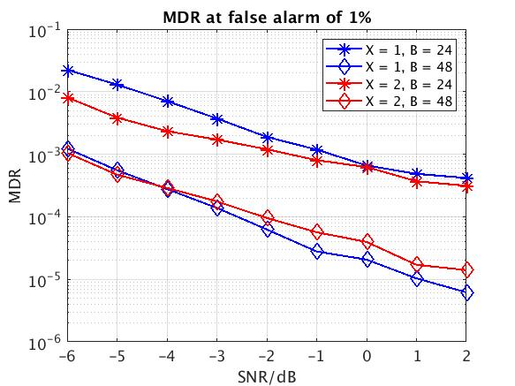  Figure 6: MDR at false alarm of 1% for TRS based I-WUS (residual CFO = 0.1ppm)  Observation #11: TRS based I-WUS can achieve MDR of 0.1% at false alarm of 1% for  - SNR >= -0.5dB with TRS duration X = 1 slot, and bandwidth of 10MHz  - SNR >= -6dB with TRS duration X = 1 or 2 slot, and bandwidth of 20MHz.  - SNR >= - 1.5dB with TRS duration X = 2 slot, and bandwidth of 10MHz.
MediaTek | 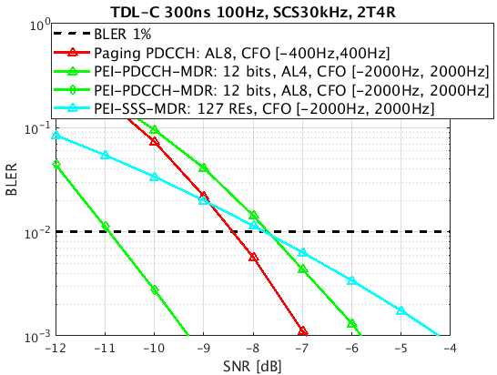  Figure 7: BLER performances of Paging PDCCH and PEI designs in the presence of residue frequency error  Observation 7: With 0.5 ppm residue frequency error range, PDCCH/DCI-based PEI and SSS-based PEI can achieve comparable performance as paging PDCCH with 0.1 ppm residue frequency error range, even subject to less or equal to half RE number of paging PDCCH.  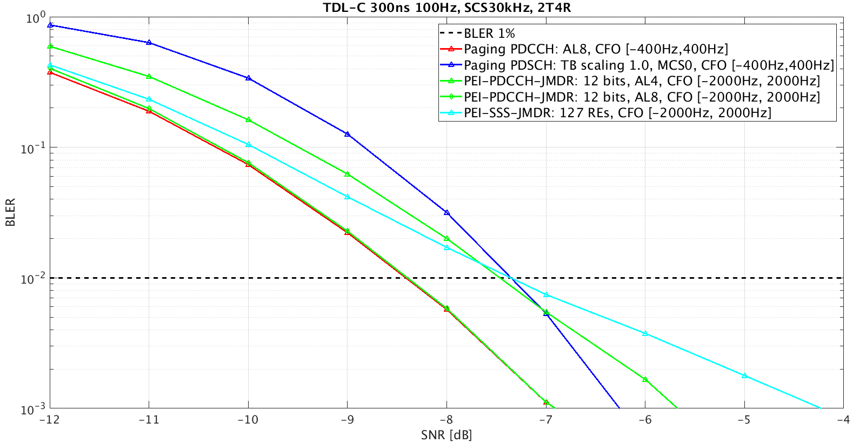  Figure 8: Comparison of overall paging indication performance and PDSCH performance  Observation 8: Considering BLER target down to 10-2, the combined performance of PEI and paging PDCCH is strictly lower than the BLER of PDSCH with residue frequency error range of 0.1 ppm, which is valid for both PDCCH/DCI-based PEI and SSS-based PEI designs.  Observation 9: Paging early indication can achieve no impact to paging detection performance.
Intel | Figure 4 shows miss-detection rate of TRS considering certain range of input CFO. CFO estimation and compensation is performed before detection of the TRS sequence. Figure 4 shows that TRS detection performance is very robust at low SNR. On the other hand, other channels such as PDCCH may not leverage CFO compensation unless multiple symbols are used in the CORESET.  In Figure 5, we consider miss-detection performance of SSS-like sequences. Two options are considered for duration such as 1 and 2 slots. In each slot, SSS sequence is repeated twice, i.e., each slot has two symbols containing SSS-like sequences and they are 4 symbols apart. Figure 5 shows miss-detection rate of SSS-like sequences considering certain range of input CFO. From the performance, it is observed that SSS detection is very robust at low SNR for a wide range of CFO at least up to 1ppm.  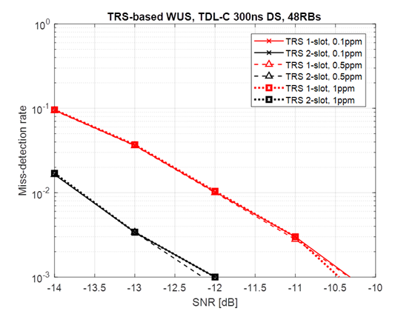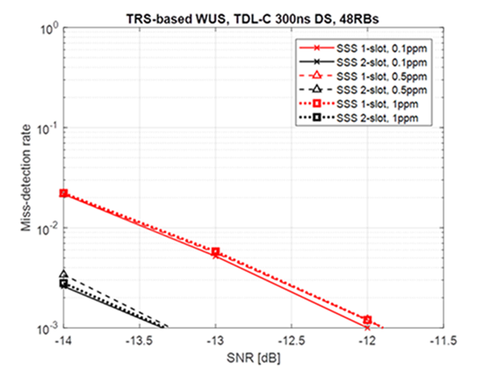  Figure 4: Miss-detection rate of TRS. Figure 5: Miss-detection rate of SSS.  Figure 6: PDCCH BLER for different CFO.
Qualcomm | Observation 4: Neither PDCCH based nor the RS/sequence-based paging early indication is sensitive to the maximum 0.1ppm frequency error.  Observation 5: RS/sequence-based paging early indication allows a tradeoff between false alarm rate and missed detection rate based on UE implementation.
CATT  R1-2007869 | DCI-based PEI  TRS-based PEI  Table 1: Residue frequency error performance with different SSB  Observation 1: PDCCH-based PEI and sequence-based PEI show good performance when there is enough CFO compensation.  Observation 2: sequence-based PEI show better performance gain than PDCH-based when there is no enough CFO compensation.  Observation 3: Three SSBs are required in the evaluation of IDLE mode UE power saving enhancement for coherent detection .
  1SSB | 2SSBs | 3 SSBs
  1ppm | 0.6ppm | 0.1ppm

Phase-1 Discussion
From the above results, the following topic is suggested:
Topic 4: Capture observation(s) on the detection performance of paging early indication. Potential observation(s) include
- Paging early indication design based on the following physical channels/signals can achieve comparable paging detection performance as Rel-15:
  - PDCCH/DCI-based design carrying 12-bit indication
  - SSS-based design carrying 1-bit indication
  - TRS-based design carrying 1-bit indication
- (TBD if any)

Please kindly provide your views for including Topic 4 for the email discussion in Table 6. Comments on (additional) observation are appreciated.

Table 8: Companies’ views on including Topic 4 for email discussion
Company name | Include Topic 4? (Y/N) | Comment(s) (including view(s) on observation(s))
Spreadtrum | Y
CATT | Y | We include CATT performance results in R1-2007869. However, we need to further discuss the payload size of DCI-based PEI since we believe that UE would increase the complexity in blind decoding when DCI size is assumed 12 bits.
Huawei, HiSilicon | Y | - Regarding CATT’s comments, 12 bits DCI payload has been already supported by Rel-15. The Rel-17 UE should be mandated to support PDCCH processing anyway. Therefore, there is no complexity increase for DCI based PEI design compared with Rel-15/16 UE. On the contrary, SSS-based and TRS-based design needs to implement new algorithm to detect the presence of SSS/TRS, which increases the complexity compared with Rel-15/16 UE. However, we don’t think the complexity is relevant with performance observation here, and it could be discussed in section 5.  - We assume that the simulated SSS performance is based on a SSS sequence. So, it would be good to revise ‘SSS-based design’ to ‘paging early indication implicitly carried by the detection of a given SSS’. SSS-based would be too general for the observation.  - Similarly, the ‘TRS-based design’ should be also updated to reflect what is simulated.
LG | Y
Intel | Y, but needs revision | We have added PDCCH result on the table  We do not agree that all the physical channels listed above can provide comparable performance. We need to consider SNR point, CFO, payload of DCI etc. for a more accurate observations. In our view, Sequence based PEI at least based on TRS and SSS seem to be more robust than PDCCH as CFO increases.  Additionally, we need to take into account that MDR target for PEI should be 0.1% so that SNR requirements for detecting paging DCI and paging PDSCH remain unimpacted.
DOCOMO | Y
OPPO | Y
CMCC | Y
Samsung | Y, with modifications | - For RS-based design, we suggest to replace “carrying” to “to indicate”. Because the 1-bit indication can be delivered by on-demand transmission of the sequence.  - Since TRS is one type of CSI-RS, we suggest to change “TRS-based design” to “TRS/CSI-RS based design”  - In addition, the resource overhead should be compared together.
Ericsson | N | The paging early indication design is not even discussed or finalized yet. Observation should be updated to reflect it and should provide a bit more detail about simulation assumption/resource usage relative to paging/etc.  Some sources have shown that the following example Paging early indications could achieve comparable paging detection performance as Rel-15.
Apple |  | A general comment to all the proposals for capturing observations: we are not against the discussion on observations. But if the discussion turns out to be difficult, it may not be worthwhile to spend too much effort trying to agree on the observations because this is not a study item.
Qualcomm | Y
ZTE, Sanechips | Y | We are okay with the Topic in general.  Regarding the complexity in blind decoding in DCI-based PEI, in our understanding, as long as there is no impact on the existing channel coding/decoding chain, UE can always reuse the polar code decoder, we don’t see any extra detection complexity with DCI-based PEI.
Vivo | Y | Generally OK. Not sure how TRS can provide PEI by considering reusing CONNECTED mode TRS. We think it need to be clarified.
Lenovo, Motorola Mobility | Y
Nokia | N | Performance is one important factor in choosing the PEI design, if agreed to be supported, but maybe we should then more holistically look at the pros and cons if we want to discuss this.
InterDigital | FFS | Some further clarification may be needed. Is the sequence carrying 1-bit per UE group (and so more sequences can be used for indicating to several UE groups); or is it that no sub-grouping is supported?
Panasonic | Y

Phase-2 Discussion
Proposal 3: For checking the impact to paging detection performance with a PEI design, companies to report the following values, targeting 1% detection error probability:
- A (dB): The required SINR value for the considered paging early indication design, assuming frequency error range of 0.5 ppm (1 ppm) with 1 (no) SSB burst for synchronization before the detection
- B (dB): The required SINR values for paging PDSCH, assuming frequency error range of 0.1 ppm
- B – A (dB): No impact to paging detection performance if the difference is larger than zero.

Companies please provide your comments/suggestions for Proposal 3 in the following Table:

Table 9: Companies’ views on Proposal 3
Company | Support (Y/N)? | Comment(s)/suggestion(s)
CATT | Yes and No | We agree to report SINR of miss detection at 1% with the following conditions  - UE can assume decoding of PDCCH for paging DCI and PDSCH for paging messages at 0.1 ppm (RAN4 requirements) with at least 3 SSBs for tuning and calibration.  - UE has no knowledge of frequency error caused by its local oscillator regardless the received signal SINR.
Qualcomm | Yes
Intel | Yes, with modifications | If No SSB is assumed before detection, initial CFO can be higher than 1ppm. We suggest to keep this at [2ppm], specially considering RedCap UEs.  Moreover, in our understanding 1% detection probability in main bullet seems to apply to paging PDCCH/PDSCH only. In order to make sure, paging PDCCH/PDSCH detection requirements at 1% MDR is not impacted, MDR target of 0.1% for PEI should be considered for collecting the required SINR.  From last meeting agreement, we should capture that 1% MDR for paging PDCCH/PDSCH is expected to be achieved at -6dB.
Samsung | Y with modifications | The reliability should be higher than paging PDCCH. We suggest 0.1% error detection error probability.  Also, for RS based solution, False alarm should also be considered. We can reuse the agreement from R16 power saving SI, i.e. 0.1% MDR at false alarm of 1%.  Proposal 3: For checking the impact to paging detection performance with a PEI design, companies to report the following values, targeting 1% 0.1% detection error probability for DCI based PEI, and 0.1% MDR with false alarm of 1% for RS based PEI :
InterDigital | Y | Agree with Samsung’s modifications.
LG |  | As pointed out by intel, it need to specify the CFO when no SSB is assumed before the PEI.  Also, to consider low SINR case, we prefer to consider (no)1~3 SSB burst for synchronization.
DOCOMO | Y | It is important to check not degrading the paging detection performance.
CMCC | Y | More than 1 SSB can be considered.
Huawei, HiSilicon | Y in principle | Agree the framework. Regarding A, we don’t think we need to report the case with no SSB burst for synchronization before the detection. 1 SSB burst is always needed for serving cell measurement.
Ericsson | Needs changes | For B, as we commented in 2.2, following values should be added: 0.2ppm, and [0.3ppm]  Agree with Samsung comment on detection probability. The detection error probability for PEI should be TBD as this affects the reliability of paging reception especially when a single PEI carries information for multiple POs.
ZTE,Sanechips | N | In our understanding, the above proposal implies that  - The initial frequency error is 1ppm and after 1 SSB processing, the residual frequency error is 0.5ppm, which is not acceptable to us. As we commented online, the frequency drift of NR UE should not be larger than NB-IoT UE(which is assumed to be 0.01ppm/s), assuming initial frequency error as 0.5ppm is already quite pessimistic and conservative. We don’t think the initial frequency error should be as large as 1ppm  - The residual frequency error depends on SNR, etc, the resource that provided the simulation results of 0.5ppm is quite limited. We think it is too rush to jump into the conclusion.  - As our reply to P1, the PDSCH decoding performance is closely related to UE implementation. If DMRS is used to correct the frequency error, the sensitivity of the PDSCH to the frequency error will be greatly reduced. Therefore, the residue frequency error should not be limited to 0.1 ppm.  Besides, we agree with Samsung that the MDR and FAR should be aligned and discussed to not impact the legacy PDCCH and PDSCH performance.  Moreover, the performance of PEI should evaluated when more than one bit is carried, such as sub-grouping information, SI notification,etc.
Apple | Y
MediaTek | Y | Ensuring no impact to paging detection performance is necessary to ensure paging coverage with paging early indication. In this regard, ensuring paging early indication can achieve better performance than paging data detection performance by checking the gap in the required SINR is a reasonable proposal. If there is no consensus on the frequency error assumed for paging early indication, it can be by company report. However, from companies’ contributions, it is reasonable to assume 0.5 ppm after synchronization with one SS burst.

From companies’ feedbacks, most companies are supportive to the proposal for further comparison of paging early indication performance. In general, the gap in the required SINR between paging early indication and paging PDSCH can be reported. Using the relative SINR gap instead of absolute required SINR can avoid the difficulty in comparing the results based on different simulation assumptions (including fading channel type, receiver algorithms, etc.). Since the SINR gap is a function of target miss detection probability, UE subgroup identification carried in paging early indication, and assumed frequency error, the following structure is suggested for companies’ report:
Proposal: For characterizing the impact to paging detection performance with a PEI design, companies are encouraged to report the following values w.r.t. the required SINR for paging PDSCH without frequency error:
- When the target miss detection probability is P (%):
  - V (dB) lower SINR is required for detecting PEI with indication for N UE sub-group(s) and subject to F ppm frequency error
  - … (result for another set of evaluated N and F values)
- Note: Considered values for P, N and F are by company report with justification.

Although there is no consensus on the values of the relevant parameters, the following candidate values can still be identified form companies’ contributions:
- Target miss detection probability P (%): 1%, 0.1%
- Number of UE subgroups: 2 to 16 (as noted in the agreed observations)
- Frequency error (before paging early indication detection): 0.5 ppm (after synchronization with 1 SS burst), 1 ppm or 2 ppm (no synchronization before the detection)

Characterization of System Impact and Design Criteria on Paging Enhancements
For system impact, Table 7 summarizes companies’ evaluation results and/or views. Since minimizing the system impacts can be mapped to design criteria, the related views are also included in the same table. There are 18 companies providing inputs.

Table 10: Companies’ views on system impact and design criteria on paging enhancements
Company | Views
Huawei, HiSilicon | Table 7: Analyses on system impact for proposed solutions  Proposal 1: Support Early paging indication (EPI) in Rel-17 to reduce the power consumption of IDLE more UE.  - FFS: DCI based EPI or RS based EPI  Proposal 2: Sub-grouping indication is indicated in the early paging indication and also paging DCI.  - FFS: How to group the UEs  Observation 8: The following information can be carried in an early transmitted paging DCI before the PO:  - There is paging or not in the following one or multiple POs  - SI change and/or ETWS information  - Availability of assistance RS
   | Resource overhead and its implications | Impact to legacy UEs | Impact to other functionalities
  DCI based EPI without sub-grouping (i.e. EPI-only) | For 2T4R: 4.91*10⁻⁴  For 2T2R: 19.6*10⁻⁴ | No impact to legacy UEs. | SI change and/or ETWS information and availability of assistance RS can be indicated in DCI based EPI.
  Sub-grouping indication in EPI(2 bits for each sub-group) | Similar overhead as that for EPI without sub-grouping.  For 12bits DCI payload, 2 bits indication can indicate 4 sub-groups for each PO and 6 POs can be indicated by one EPI. | No impact to legacy UEs. | SI change and/or ETWS information and availability of assistance RS can be indicated in DCI based EPI.
  Sub-grouping indication in legacy paging DCI | Little overhead when it is indicated by the reserved bits in paging DCI. | No impact to legacy UEs. | No impact to other functionalities.
vivo | Table 6: Comparison of different power saving signals/channels for PEI  Proposal 3: SSS-like sequence can be considered for PEI design.
  Schemes | Performance | Complexity | Overhead | Coexistence/  Multiplexing | Capacity (Number of bits delivered)
  SSS-like | Good | Low | Low | Good | Fewer
  CSI-RS-like | Bad | Low | Low | Good | Fewer
  PDCCH channel | Normal | High | Normal | No impact | More
CATT | Proposal 4: If PDCCH-based power saving signal/channel is considered for paging enhancement for UE in IDLE/Inactive mode, DCI format 2_6 with CRC scrambled by PS-RNTI could be reused for paging reception.  Proposal 5: The sequence-based paging indication should be supported in Rel-17 for UE in IDLE/Inactive mode for UE power saving.
Xiaomi | Observation 1: When SSB/CORESET#0 multiplexing is pattern #0, paging search space is Type #0 PDCCH CSS, which is over two consecutive slots, restrict paging search space to be in only certain one slot can reduce paging reception.  Observation 2: paging search space reducing scheme won’t cause impact on DCI blocking probabilities on Type #0 PDCCH CSS.  Proposal 1: Paging search space reducing scheme should be further studied.  Proposal 2: Power saving effect of DCI-based indication should be reconsidered with a more reasonable assumption, and RS-based or sequence-based paging early indication method is preferred.  Proposal 3: Sub-grouping methods by 1) reserved bits in legacy paging DCI and 2) RS-based or sequence-based paging early indication should be further studied.
ZTE | Observation 6: To save UE power consumption and alleviate the impact on the delivery of other information, the indication of other information in the paging DCI should be considered in the design of paging indication when UE does not need to monitor PO.  Observation 7: The DCI based indication can be used to carry UE sub-grouping information, SI change indication and other warning notifications.  Observation 8: If the paging indication scheme is supported, the DCI-based paging indication is a better choice from the perspective of performance, capacity, power saving gain, and standardization workload.
CMCC | Proposal 5. UE ID based sub-grouping can be supported and further to study how to guarantee uniform distribution of UE number in different sub-groups.  Proposal 6. Cross-slot scheduling for paging PDSCH should not be supported.
LG | Proposal 2: Early paging indication should at least convey the information on UE sub-group indication and short message (and/or short message indicator).  - FFS other power saving behavior (e.g. cross slot scheduling, TRS/CSI-RS indication)  Proposal 3: Use DCI based paging early indication before a target PO to indicate to a UE whether to monitor the PDCCH scrambled with P-RNTI at the PO.
Samsung | Table 1: Comparison on different I-WUS types  Observation #1: There is trade-off between detection performance and additional cost, including system overhead and power consumption on monitoring/reception for sequence based I-WUS and PDCCH based I-WUS.  Proposal #1: Support sequence based power saving signal for early paging indication in idle/inactive mode.  Observation #3: NR Rel-16 supports UE grouping or distribution for paging monitoring in the time domain, but not in the frequency domain.  Proposal #2: Support UE sub-grouping for paging monitoring in frequency domain.
  Types | Advantages | Disadvantages
  Sequence based I-WUS | - Low channel resource/signalling overhead  - Low power consumption to receive/monitor,  - Not sensitive to synchronization error | - Lower reliability
  PDCCH based I-WUS | - Higher reliability due to CRC check | - Larger channel resource/signalling overhead, especially considering multi-beam operation  - Higher power consumption or UE complexity to receive/monitor  - Higher requirement on synchronization error
OPPO | Observation 1: If DCI based paging early indication is considered for idle/inactive-mode UE, PDCCH CSS set can be used.  Proposal 1: The existing DCI format 2_6 is reused for paging early indication, if DCI-based indication is considered.  Observation 2: DCI based paging early indication for idle/inactive-mode UE has no backward compatibility issue.  Proposal 2: RS-based or sequence-based paging early indication can be considered. The issue of backward compatibility should be emphasized.  Observation 6: Power saving gain is an issue to be considered when designing paging early indication.  Proposal 3: Existing RS is reused for paging early indication, e.g. CSI-RS/TRS. Other existing RS are not excluded.  Proposal 4: The resource for paging early indication transmission is associated with the resource for SSB transmission.  Proposal 5: The sub-grouping for paging is based on paging early indication.
Panasonic | Proposal 2: Sub-grouping information could be carried in the RS-based paging early indication, which is associated with UE ID.  Proposal 3: sub-grouping information can also be carried in the paging DCI for more refined sub-grouping indication.  Proposal 4: Cross-slot scheduling for paging PDSCH should be supported together with paging early indication and sub-grouping.
Sony | Proposal 2 – Use sequence-based early paging indication as a paging enhancement scheme to reduce idle PO monitoring cost at the UE.  Proposal 3 – Use sequence-based early paging indicator with sub-grouping for paging enhancement and reducing unnecessary paging reception.  Proposal 4 - Use sequence-based early paging indicator with sub-grouping for paging enhancement for FR2 operation.
InterDigital | Table 1 Comparison of PDCCH-based and sequence-based paging indication  Observation 1: PDCCH-based paging indication can provide lower false alarm rate and higher flexibility/capacity over sequence-based paging indication.  Proposal 2: PDCCH-based paging indication is adopted.
   | Advantages | Disadvantages
  PDCCH-based | - Lower false alarm rate due to CRC  - Higher flexibility/capacity  (Separate paging indications can be transmitted for different UE groups and POs) | - Slightly more power needed to detect  - More sensitive to synchronization
  Sequence-based | - Slightly less power needed to detect  - Less sensitive to synchronization | - Less flexibility/capacity (Addition of more sequence resources are needed to target a larger number of UE groups/POs)  - Higher false alarm rate
MediaTek | Proposal 4: To avoid paging early indication to content resource with existing channels, UE is required to monitor legacy PO if PEI is not detected.  Observation 11: With Proposal 4, the resource occupation of paging early indication can be set to low priority, which then ensures no resource impact to existing channels and thus no impact to legacy idle/inactive mode and connected-mode UEs.  Observation 12: Legacy paging functionality of notifying SI change and ETWS indications can be maintained via either including the indications in PEI or indicating UEs to monitor legacy PO by PEI.  Proposal 5: Decide whether to include SI change and ETWS indications in paging early indication after the physical layer design is decided.  Proposal 6: For Rel-17 paging enhancement, UE-group paging early indication is supported.  - UE is required to monitor legacy PO if paging early indication is not detected.  - FFS: PDCCH/DCI-based or sequence-based physical layer design
Intel | 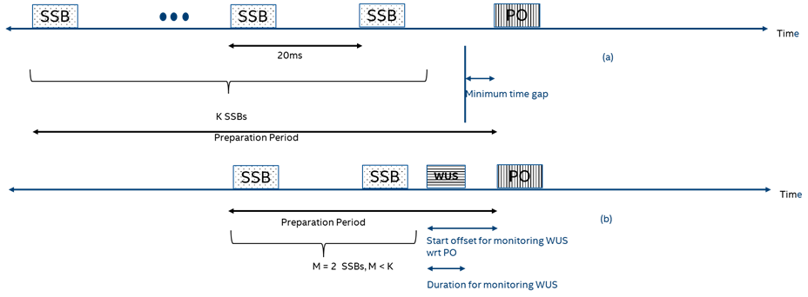  Figure 1: (a) K SSBs need to be monitored before PO so that paging DCI can be received with synchronization in place, (b) With PEI that can be used for tracking, M < K SSBs (2 in figure) need to be monitored.  Observations 3: One potential way to save power would be to reduce the number of SSBs necessary, if possible, that need to be processed before detecting the paging DCI, i.e., shorten the preparation time.  Observation 5: Monitoring a TRS after the closest SSB before PO could help UE save power as UE may not need to wake up long before PO to process a larger number of SSBs.  Observations 6: Sequence-based PEI can be designed with multiple non-contiguous symbols in a slot so that CFO can be compensated. For PDCCH-based PEI, such compensation may not be always feasible.  Proposal 3: Sequence-based paging early indication, that can be used for CFO-estimation purposes, are prioritized.  - Options include TRS and SSS.
Lenovo, Motorola | Observation 1: For an idle or inactive UE, before monitoring paging DCI, the UE may have to perform measurements on at least one SSB of a camped cell in order to select a suitable SSB and determine a paging DCI monitoring occasion corresponding to the selected SSB.  Observation 2: An indication from gNB to skip monitoring of paging DCI can reduce UE power consumption from unnecessary measurement and PDCCH decoding efforts.  Observation 3: For a UE with delay-tolerant application, a network can delay paging the UE and accordingly, the UE can skip monitoring paging DCI over a certain number of DRX cycles based on gNB’s indication for power saving.  Observation 4: Paging power saving (PPS)-PDCCH monitoring can be configured in a power efficient manner based on implementation and/or based on TRS/CSI-RS provision.  Proposal 1: Support indication from gNB to skip monitoring of paging DCI.  Observation 5: Sub-grouping of UEs of the same PO in a ‘skip monitoring of paging DCI’ indication channel (e.g. PPS-PDCCH) may degrade detection/decoding performance of the indication channel and/or may require higher power consumption for detection/decoding of the indication channel due to an increased signaling overhead.  Proposal 2: Sub-grouping of UEs of the same PO in a ‘skip monitoring of paging DCI’ indication channel is not supported.  Observation 6: A sub-group based indication from gNB in paging DCI to skip decoding of a paging message is beneficial for UE power saving (e.g. reduction of paging PDSCH decoding rate from 28% to 6%).  Proposal 3: Consider sub-group based indication in paging DCI to skip decoding of a paging PDSCH.  Proposal 4: Consider switching from RRC_INACTIVE to RRC_IDLE based on PPS-PDCCH without decoding a paging PDSCH.
DOCOMO | Proposal 1: DCI-based approach for paging early indication should be considered.  - FFS: Information in addition to whether UEs wake up or not  - FFS: Combination with other methods  Proposal 2: Following alternatives can be considered for time resource of paging early indication.  - Alt1: Paging early indication is located in front of PO  - Alt2: Paging early indication is located around SSB  - FFS: which SSB(s) are used for the location of paging early indication  Proposal 3: sub-grouping within a PO should be considered in addition to paging early indication.  Proposal 4: DCI-based paging early indication can indicate sub-grouping information.  Proposal 5: It is necessary to discuss and determine what to divide a group into sub-groups based on, e.g., UE id, and the number of sub-groups.  Proposal 6: Enhancements on cross-slot scheduling for paging is deprioritized compared with paging early indication and sub-grouping.
Ericsson | Observation 1: To maintain scheduling flexibility for the NW, PEI transmissions cannot be guaranteed to be in conjunction/adjacent to other transmission.  Observation 2: PEI transmissions lead to power increase in the NW due to their impact on transitions in/out of sleep state.  Observation 3: PEI transmissions double the amount of PDCCH resources dimensioned for paging.  Observation 4: Irrespective of an average assumed group paging rate, during periods of extensive paging load, the PEI transmissions lead to unacceptable blockage of control channel especially in multi-beam deployments where PEI needs to be swept.  Proposal 3: Study introduction of signaling in which the NW can guaranty entries of TimeDomainAllocationList with K0>0 for paging.
Qualcomm | Observation 6: Paging early indication may need to be transmitted at multiple locations for each PO to account for different SINR conditions for the UEs associated with the same PO.  Observation 7: Paging early indication based on legacy paging PDCCH with cross-slot scheduling of paging PDSCH has the least impact to Rel-17 NR standard.  Observation 8: DCI format 2_6 can be extended to carry the idle/inactive paging early indication and indication of availability of the additional CSI-RS/TRS.  Observation 9: Compared to existing RS (i.e., TRS/CSI-RS) and DCI (i.e., cross-slot scheduling paging DCI or DCI format 2_6) based paging early indication, new RS or sequence-based design has unnecessary impact to Rel-17 NR standard.  Proposal 1: For NR Rel-17, do not support new sequence or new DCI as paging early indication (PEI) design for idle/inactive mode UE.  Observation 10: Unused bits of the paging PDCCH can be used to indicate the paged UE groups. These include  - Reserved bits to indicate the paged UE groups in the PO  - Unused bits 4 to 8 in the Short Message field  - If Short Message Indicator is 01, the entire Short Message field  - If Short Message Indicator is 10, the scheduling field.  Observation 11: The multiple P-RNTI solution has the least impact to PHY standard. The set of P-RNTIs can be provided in a SIB or defined in specifications. The UE is associated with a group and the corresponding P-RNTI based on the UE’s ID.  Observation 12: If DCI format 2_6 is adopted as paging early indication, it can enable UE sub-grouping of idle/inactive mode UEs in the same PO.  Observation 13: For RS based PEI, subgrouping can be realized by associating the RS with a sub-group of UEs.  Observation 14: Additional PO in frequency domain has an impact to the minimum bandwidth to be monitored by idle/inactive mode UE. Additional PO in time domain is already implied by paging early indication design and hence no need to be separately discussed.  Proposal 2: Paging early indication, UE sub-grouping and availability indication of additional TRS/CSI-RS should be jointly designed if they are adopted by Rel-17.

Phase 1 Discussion
Based on the above summary, the following topics are suggested for the email discussion:

Topic 5: Capture design criteria for paging enhancement(s) for minimizing system impacts. Potential criteria include:
- Minimizing blockage to existing channels/signals
- Minimizing additional resource overhead per PO
- (TBD if any)

Topic 6: Way forward to conclude Rel-17 paging enhancement. Potential proposal is as follows:
RAN1 to decide paging early indication design capable of carrying UE sub-grouping information for Rel-17 paging enhancement from the following candidate design directions:
- DCI-based design by
  - Extending legacy DCI formats, e.g., DCI format 2_6 or DCI format 1_0
    - Note: If PS-RNTI is reused for DCI format 2_6 extension, how to multiplex idle-mode and connected-mode UEs should be clarified
  - New dedicated DCI format
- TRS-based design
- SSS-based design

Please kindly provide your views for including Topic 5 and Topic 6 for the email discussion in Table 8. Comments on the design criteria and proposed way forward are appreciated.
Table 11: Companies’ views on including Topic 5 and Topic 6 for email discussion
Company name | Include  Topic 5?  (Y/N) | Include  Topic 6?  (Y/N) | Comment(s) (including views on design criteria and the proposed way forward)
Xiaomi | Y | Y | For Topic 5,  Agree with the potential criterion as proposed by FL.  For Topic 6,  We prefer to separate the discussion of paging early discussion and UE sub-grouping. Still the same comment as listed in Table 4. For the potential proposal, our view is UE sub grouping can also be done in Paging DCI by some reserved bits, as revealed by many contributions. And when PEI is sequence-based, it will require more resources if it carry UE sub grouping information.
Spreadtrum | Y | Y | We suspect the some evaluation assumptions are too optimistic w.r.t. TRS and PEI overhead in network…
CATT | N | Y | We don’t think the criterial of PEI design being standalone as in Topic 5. The criterial should consider the tradeoff of both power saving gain, the system overhead and the complexity  For Topic 6, we suggest to conclude that paging early indication provides significant power saving gain for IDLE mode UE. The details of techniques of PEI would be determined during work.
Huawei, HiSilicon | Y | Y | For topic#5: We should also include the minimized impact on the specification considering we have limited time for the work.  For topic#6: agree with CATT that we should conclude that paging early indication provides significant power saving gain for IDLE mode UE. The details of techniques of PEI would be determined during work.  We also think the sub-grouping carried by paging DCI could be also used together with PEI solution, as Xiaomi mentioned. Therefore, we propose add one sub-bullet: other enhancements, e.g. jointly indicate sub-grouping information by PEI and paging DCI, is FFS.
LG | N | Y | For Topic 5  In the last meeting, we have an agreement as follow:  Agreements:  For the study on paging enhancements to reduce unnecessary paging reception, the following metrics are considered:  - UE power saving gain (relative to a given feature or overall)  - Impact to UE paging detection probability  - FFS: Link level simulation assumptions  - System impact, including  - Additional resource overhead and its implications  - Impact to Rel-15/Rel-16 idle/inactive-mode UEs and connected-mode UEs  - Impact to other legacy functionalities, including SI change and ETWS indication  - [Note: NW energy consumption evaluation is not precluded]  We already agreed to consider some system impacts as metrics. So we think proposal in Topic 5 is not necessary.  For Topic 6  Generally we are fine with the potential proposal. As commented in Topic 3, we would prefer to clarify that conveying additional information other than UE sub-grouping can be considered
Intel | N | Y | Further discussion point such as Topic 5 may not be needed, since we already have the agreement as captured by LG
DOCOMO | N | Y | For Topic 5, as LG mentions, we already have the aspects considered on system impact by paging enhancement solution. It should be clarified what needs to be discussed.  For Topic 6, similarly as our comment on topic 3, we are not sure how to indicate sub-grouping information by PEI in case of sequence/RS-based PEI. In case of DCI-based PEI, PEI and sub-grouping can be discussed jointly. Also, the details of DCI-based PEI should be considered taking into account how much information can be sent by DCI-based PEI.
OPPO | Y | Y | Agree with Topic 5 and 6. When we consider Topic 6, the principle in Topic 5 should be taken in to account. Besides, less spec impacts and standard efforts are also to be addressed.
CMCC | N | Y | For topic 5, similar view as LG.  For topic 6, we agree with this proposal.
Samsung | Y | Y, with modifications | For Topic 6, we think it’s too early to agree on UE sub-grouping carried by EPI. We prefer to handle the UE sub-grouping technique separately from EPI discussion at this stage. In addition, it would be better to remove the note describing details on RNTI.  We suggest following modification.  Topic 6: Way forward to conclude Rel-17 paging enhancement. Potential proposal is as follows:  RAN1 to decide paging early indication design capable of carrying UE sub-grouping information for Rel-17 paging enhancement from the following candidate design directions:  - DCI-based design by  - Extending legacy DCI formats for paging, i.e., DCI format with P-RNTI e.g., DCI format 2_6 or DCI format 1_0  - Note: If PS-RNTI is reused for DCI format 2_6 extension, how to multiplex idle-mode and connected-mode UEs should be clarified  - Extending legacy group common DCI formats, e.g., DCI format 2_6  - FFS for RNTI to be used  - New dedicated DCI format  - TRS/CSI-RS-based design  - SSS-based design
Ericsson | N | N | Prefer to first make a conclusion on the need or no need for PEI, and then discuss the remaining details.  For topic 5,  - Minimize NW impact including minimization of additional PDCCH resources and additional transmission occasions for paging indications  For topic 6,  We should first discuss the pros and cons including whether there are alternate light-weight mechanisms to address the core issue of reducing number of SSBs that a UE needs to process. There are several issues mentioned in R1-2009200 that need to be addressed related to the PEI.
Apple | N | Y | Minimizing the system impact should not be the only design criteria. In the previous meeting, we already agreed that system impact should be considered in the design, which should be sufficient already in our view.
Qualcomm | Y | Y | Topic 5 can be a broad topic. Topic 6 can be discussed first.
ZTE, Sanechips | Y | Y | For Topic 5, we think more discussion about the design criteria on the top of the agreements in the last meeting is helpful to have better comparison/ understanding of sequence/DCI-based PEI. Furthermore,  - The impact of sequence based PEI (like SSS-based PEI) on the detection performance of SSS should also be considered.  - The impact on delivery of the information, such as SI change and ETWS information, etc., should be considered.  - The performance of PEI if one or more bits to be carried.  Topic 5: Capture design criteria for paging enhancement(s) to minimize system impacts. Potential criteria include:  - Minimizing impact (blockage, MDR performance) on to existing channels/signals  - Minimizing additional resource overhead per PO  - Minimizing the impact on the delivery of the information, such as SI change and ETWS  - The MRD and performance of PEI when one or more bits to be carried  For Topic 6, it can be observed from companies’ simulation results, that PEI+sub-grouping provides more power saving gain than PEI-only. Hence, we think, we need to consider to use PEI to carry at least sub-grouping information, if PEI is supported.
Vivo | Y | Y | For topic 5,  Propose to adding the followings  Topic 5: Capture design criteria for paging enhancement(s) for minimizing system impacts. Potential criteria include:  - Minimizing blockage to existing channels/signals  - Minimizing additional resource overhead per PO  - Better performance w.r.t, BLER, CFO and etc.  - Power saving gain  We think for d) power saving gain is also important.  Comparing sequence –based and PDCCH-based PEI, sequence-based can relax the CFO requirement more so that even without SSB detection, sequence -based PEI may be correctly decoded. Additionally, for Low SINR UEs, sequence-based PEI could have more benefits than DCI-based PEI, if the sequence itself can be further used for measurement.  This benefit can be translated to power saving gain.
Lenovo, Motorola Mobility | N | Y | For topic 5, agree with LG’s view.
InterDigital | Y | Y | We think PEI should be capable of carrying UE sub-group information to attain higher power saving gain.
Panasonic | Y | Y

Phase-2 Discussion
Proposal 4: For checking the resource overhead with a PEI design, companies to report the following values with respect to a considered group paging rate R_{G} (including at least R_{G} = 10%):
- X (REs): The average RE number occupied by the considered PEI design, given by
(Required RE number for no paging detection performance impact) $×$ PEI transmission probability
- Y (REs): The average RE number of reference legacy PO, given by
( 72 REs $×$ AL + 12 REs $×$ 48 RPBs $×$ 12 symbols ) $× R_{G}$
- X / Y: Additional resource overhead per PO

Companies please provide your comments/suggestions for Proposal 4 in the following Table:

Table 12: Companies’ views on Proposal 4
Company | Support (Y/N)? | Comment(s)/suggestion(s)
Nokia |  | It would be good to clarify also what are the assumed rate matching mechanism applied to minimize the resource reservation from Connected mode UE perspective. We would recommend that only mandatory UE capabilities are assumed when determining the resource reservation.
CATT | Y | WE are OK to identify the additional resource for PEI. We also can consider 0 resource overhead if the TRS/CSI-RS resource using for PEI is introduced by channel tracking and AGC tuning.
Qualcomm | Y | Can you please clarify why the PEI transmission probability is not fixed at 1?
Intel | Y | One question: How R_{G} and PEI transmission probability are different? Assuming no sub-grouping indication.
Xiaomi | Y？ | In fact, we are not quite sure why the Y value is calculated by ( 72 REs $×$ AL + 12 REs $×$ 48 RPBs $×$ 12 symbols ) $× R_{G}$  In my understanding, for reference legacy PO, if we just count the RE occupied by paging DCI, 72 REs $×$ AL is OK. If we take all the t-f resource allocated to the PO into account, a reference resource allocation like 12 REs $×$ 48 RPBs $×$ 12 symbols will be OK. I don’t see why to add the two together. Hope to get clarified.
Samsung | Y with modification | PO consists of a number of PDCCH monitoring occasions. The resource overhead of paging PDSCH doesn’t have to be considered.  - Y (REs): The average RE number of reference legacy PO, given by  ( 72 REs $×$ AL + 12 REs $×$ 48 RPBs $×$ 12 symbols ) $× R_{G}$
InterDigital | Y | Our understanding is that PEI transmission probability can be 1 or less depending on the paging indication method.
LG | Y | Regarding Samsung’s comment, we prefer to keep overhead due to the PDSCH. It is common understanding that PEI would be used to indicate paging message for UE (sub-)group.
DOCOMO | Y | We are not sure what is the case that PEI transmission probability is less than 1.
CMCC | Y | Suggest keep the overhead of paging PDSCH.  The PEI transmission probability is related to the PEI design and also the indicating method.  e.g., if PEI is PDCCH based, and all UEs in the PO don’t need receive paging, one way is transmit the PEI carrying information bit “0”, another way is not transmit the PEI. These two different designs cause different PEI transmission probability.
Huawei, HiSilicon | Y with modifications | - X should consider the number of POs/sub-groups that share the same PEI channel/signal, thus this should be considered in the PEI transmission probability. PEI transmission probability should be the paging rate per indicated sub-group per PO corresponding to each individual PEI indication.  - Impact on legacy functionalities, e.g. ETWS and SI change notification. If ETWS and SI change notification cannot be indicated by the considered PEI design, X should include both the REs of PEI transmission and paging DCI transmission for indicating short message in legacy paging DCI;  - The resource overhead X should be based on the link level simulations that shall fulfill the requirement in section 4 if multiple signals would be transmitted simultaneously for indicating multiple PEI for different POs/sub-groups;
Ericsson | Needs change | Agree with Samsung’s proposed modification.  From NW perspective, the impact is more related to the time domain symbols rather than fraction of REs. So, propose to add the following in the observation:  Z : Number of OFDM symbols for PEI / Number OFDM symbols for PDCCH in corresponding PO.
ZTE,Sanechips | N | The resource overhead should also consider  - the PEI of all the sub-groups of the target PO.  - The number of bits carried by PEI.  The system impact includes many factors, such as impact (blockage, MDR performance) on to existing channels/signals, additional resource overhead, the impact on the delivery of the information, such as SI change and ETWS, the MRD and performance of PEI.  Besides, the factors listed in Question 5 should also be discussed all together.
Apple | Y | This looks fine to us for a basic PEI design.
MediaTek | Y | The resource overhead is an important consideration for a physical layer design. We are supportive to quantitative comparison. If the denominator calculation has no consensus, comparing the numerator resource element number is also useful for the comparison across different PEI designs.

Proposal 5: For characterizing a PEI design, companies to provide information (with justification) for the following questions:
- Feasibility and limitation(s) for carrying UE sub-group identification information?
- How to ensure legacy paging functionalities, including notification for SI update and/or ETWS?
- How to minimize impact to Rel-15/Rel-16 channels/signals and UEs?

Companies please provide your comments/suggestions for Proposal 5 in the following Table:

Table 13: Companies’ views on Proposal 5
Company | Support (Y/N)? | Comment(s)/suggestion(s)
CATT | N | - We need to show the benefit of UE sub-grouping including in the PEI comparing to without UE sub-grouping. If the PEI triggering whether UE to decode paging message at the subsequent PO, the power saving gain by UE sub-grouping is negligible.  - SI update and ETWS are included in paging messages. PEI is used to indicate whether UE needs to decode the paging message. If SI update or ETWS is included in the paging message, PEI should indicate UE to decode paging message. The message is too big to fit into any form of PEI.
Qualcomm | Y with clarification | For the second bullet, need to clarify that it does not assume PEI will carry the SI update and ETWS.
Samsung | N | The first two bullets are additional functionalities we haven’t agreed yet. It shouldn’t be mandatory.
DOCOMO | Y | For the first bullet, the feasibility of carrying UE sub-group information has impact on the additional power saving gain, and it is important.  For the second bullet, in our understanding, it means how to ensure legacy paging functionalities regardless of whether or not to carry notification for SI update and/or ETWS in PEI.
Huawei, HiSilicon | Y | It was already agreed in RAN1#102 that the second bullet needs to be considered.  For the third bullet, we can add, including the impact on detection of existing signals/channels.
ZTE,Sanechips | N | We agree that the second bullet was agreed and should be considered.  In addition, the impact of PEI on other legacy channel/signal should be considered.
Ericsson | N | Impact to other working groups especially RAN2 and RAN4 should also be added.  We prefer to update the last two bullets as below.  - How to ensure Impact, if any, on legacy paging functionalities, including notification for SI update and/or ETWS?  - How to minimize impact to Rel-15/Rel-16 channels/signals, resource overhead and UEs?
MediaTek | Y | For the first bullet, it is to support RAN2 work in UE grouping since carrying UE grouping information in paging early indication is discussed and considered.

If there is any other metric/information that companies should report for comparing PEI designs, please kindly provide your inputs to the following Table:
Table 14: Companies’ views on additional metric/info for comparing PEI designs
Company | Additional metric/info to compare PEI designs (Y/N)? | Comment(s)/suggestion(s)
Samsung | Y | Detection complexity. The computational complexity would be much different for DCI based and RS based PEI design.
Huawei, HiSilicon | Y | Detection complexity is not reasonable considering it was captured in R15 that DCI detection, SSS detection, and TRS detection have similar power consumption.  UE complexity should be considered, which means the additional implementation complexity due to the support of the UE.

For the comparison on resource overhead, most companies are supportive to the proposal. But, for calculating the ratio, there are different views on how to calculate the reference and the unit of symbol or RE. For the formal question, since the reference is the same for different paging early indication designs, it is sufficient for companies to provide the average occupied resource numbers instead of ratios. By “average”, companies can take into account whether paging early indication should be transmitted if there is no paging to the associated UE group(s). For the later question, whether the resource occupation is in unit of symbol or RE actually depends on how connected-mode UE can skip the occupied resources (as noted by Nokia). Therefore, if connected-mode UE needs to skip a while symbol even when part of the REs are occupied by a paging early indication, the RE number of a while symbol should be counted for resource occupation. With this note included, the following proposal is suggested:
Proposal: For characterizing the resource overhead with a PEI design, companies are encouraged to report the required averaged resource number per PO defined as below, assuming at least 10% group paging rate per PO:
- (Required RE number ensuring no paging detection performance impact) $×$ PEI transmission probability $÷$ Number of PO sharing the same PEI channel/signal
- When evaluating the needed resource overhead, only mandatory UE capabilities are assumed.

Regarding the justification for other aspects that cannot be quantified, the following proposal has been discussed during email discussion and can be referenced for the aspects companies think important in describing a paging early indication design:
Proposal: For describing a paging early indication (PEI) design, the following information should be provided:
- Assumption on PEI placement with justification on the feasibility.
- How to maintain the same level of synchronization performance as Rel-16 for PO reception when UE is indicated by PEI to receive paging?
- How to coexist with Rel-15/Rel-16 channels/signals and ensure no functional impact?
- How to maintain legacy paging functionalities, including notification for SI change and ETWS indication?
- Feasibility and limitation, if any, for carrying UE sub-group indication
  - Note: It is not yet decided whether to carry UE sub-group indication in PEI

Other Views/Proposals
In this section, Table 9 further summary companies’ views not included in the previous sections.

Table 15: Other companies' views/proposals
Company | Views
CATT | Proposal 1: For UE RRM measurement power consumption in IDLE mode, the scaling is similar to that of BWP switching. Remove the bracket of UE power model agreed in RAN1#102-e.  Proposal 2: The FR2 power consumption model and the scaling factor follows the same principle of that for FR1 with minimum BW of 50 MHz.  Table 2: FR2power consumption model for idle/inactive mode operations
  Power State | Relative Power  (FR2 reference from TR 38.840) | Relative Power  (Idle/inactive-mode operation with reception bandwidth 50 MHz)
  Deep Sleep (P_{DS}) | 1 | 1
  Light Sleep (P_{LS}) | 20 | 20
  Micro sleep (P_{MS}) | 45 | 45
  PDCCH-only (P_{PDCCH}) | 175 | 70
  PDCCH + PDSCH (P_{PDCCH+PDSCH}) | 350 | 140
  SSB/CSI-RS proc. (P_{SSB}) | 175 | 70
  Intra-frequency RRM measurement (P_{intra}) | • 225 (synchronous case, N=8, measurement only; P_{intra, meas-only})  • 320(combined search and measurement; P_{intra, search+meas}) | • 90 (synchronous case, N=8, measurement only; P_{intra, meas-only})  128 (combined search and measurement; P_{intra, search+meas})
  Inter-frequency RRM measurement (P_{inter}) | · 270(measurement only per freq. layer; P_{inter, meas-only})  · 270 (neighbor cell search power per freq. layer; P_{inter, search-only})  · Micro sleep power assumed for switch in/out a freq. layer | · 108 (measurement only per freq. layer; P_{inter, meas-only})  · 270 (neighbor cell search power per freq. layer; P_{inter, search-only})  · Micro sleep power assumed for switch in/out a freq. layer
TCL | Proposal 1: Consider a RS-based PI.  Proposal 2: Consider coexistence of both RS-based and DCI-based PI.  Proposal 3: Consider an RS-based PI followed by a DCI-based PI for group refinement.
OPPO | Observation 7: Paging procedure enhancements are mainly RAN2 issues. The power saving signal design may have impacts on the paging procedure enhancements.
Panasonic | Observation 4: For beam-sweeping operation, different PO monitoring durations could be different among different SINR conditions, which would impact on the baseline power consumption performance.  Observation 5: If beam-sweeping operation needs to be investigated for paging, the current power model needs to be clarified and updated.

By the above, the following are suggested for the email discussion:
Topic 7: For UE RRM measurement power consumption in IDLE mode, the scaling is similar to that of BWP switching. Remove the bracket of UE power model agreed in RAN1#102-e.

Topic 8: The FR2 power consumption model and the scaling factor follows the same principle of that for FR1 with minimum BW of 50 MHz.
Table 16: FR2 power consumption model for idle/inactive mode operations
Power State | Relative Power  (FR2 reference from TR 38.840) | Relative Power  (Idle/inactive-mode operation with reception bandwidth 50 MHz)
Deep Sleep (P_{DS}) | 1 | 1
Light Sleep (P_{LS}) | 20 | 20
Micro sleep (P_{MS}) | 45 | 45
PDCCH-only (P_{PDCCH}) | 175 | 70
PDCCH + PDSCH (P_{PDCCH+PDSCH}) | 350 | 140
SSB/CSI-RS proc. (P_{SSB}) | 175 | 70
Intra-frequency RRM measurement (P_{intra}) | • 225 (synchronous case, N=8, measurement only; P_{intra, meas-only})  • 320(combined search and measurement; P_{intra, search+meas}) | • 90 (synchronous case, N=8, measurement only; P_{intra, meas-only})  128 (combined search and measurement; P_{intra, search+meas})
Inter-frequency RRM measurement (P_{inter}) | · 270(measurement only per freq. layer; P_{inter, meas-only})  · 270 (neighbor cell search power per freq. layer; P_{inter, search-only})  · Micro sleep power assumed for switch in/out a freq. layer | · 108 (measurement only per freq. layer; P_{inter, meas-only})  · 270 (neighbor cell search power per freq. layer; P_{inter, search-only})  · Micro sleep power assumed for switch in/out a freq. layer

Please kindly provide your views for including Topic 7 and Topic 8 for the email discussion in Table 11.

Table 17: Companies’ views on including Topic 7 and Topic 8 for email discussion
Company name | Include  Topic 7?  (Y/N) | Include  Topic 8?  (Y/N) | Comment(s) (including views on the contents)
CATT | Y | Y
Samsung | Y | N | We expect similar or higher power saving gain for FR2. The power consumption difference between FR1 and FR2 is not very large for idle/inactive mode compared with connected mode. Due to time limit, it’s OK to skip the evaluation for FR2. The proposals/schemes can be common to FR1 and FR2.
Qualcomm | Y | Y | Agree with the principle. FR1 can be prioritized for now.
Vivo | Y | Y | We agree.
Nokia | Y | Y | Should be discussed to conclude the evaluation assumptions.

There is no discussion for the above topics due to limited time in this meeting. Since RAN1 has agreed to specify paging early indication design before paging occasion, we suggest to focus on comparing different physical layer designs in next meeting.

Summary
In this meeting, the study phase for paging enhancement is concluded with the following observations and proposal, and LS [26] is also sent for informing RAN2. It remains for RAN1 to further down-select and specify the physical layer design for early indication before paging occasion.
Agreements:
Observation: For NR idle/inactive-mode UEs with 10% group paging rate, paging early indication without UE sub-grouping can achieve the following power saving gains w.r.t. Rel-16:
- [0%] - [22.8%] where the baseline assumes 1 SS burst for synchronization before PO reception
  - Note: [0%] means UE can apply the baseline behavior if the time offset between the utilized SS burst and PO is small.
- [5.0%] - [32.0%] where the baseline assumes 2 SS bursts for synchronization before PO reception
- [10.2%] - [67.7%] where the baseline assumes 3 SS bursts for synchronization before PO reception
The power saving gains will become lower for higher group paging rate.
The power saving gains are dependent on the assumptions about placement of PEI and PO relative to SSB.
The power saving gains may vary with different paging early indication design.
Agreements:
Observation: For NR idle/inactive-mode UEs, UE sub-grouping indication within a PO can provide the following power saving gains w.r.t. Rel-16:
- If the original group paging rate is 10%:
  - [0.3%] - [1.1%] where the baseline assumes 1 SS burst for synchronization before PO reception
  - [0.4%] - [0.8%] where the baseline assumes 2 SS bursts for synchronization before PO reception
  - [0.3%] - [1.0%] where the baseline assumes 3 SS bursts for synchronization before PO reception
- Some sources also evaluated performance if the original group paging rate is in the range between 20% and 80% and showed following results:
  - [0.7%] - [7.6%] where the baseline assumes 1 SS burst for synchronization before PO reception
  - [0.8%] - [3.0%] where the baseline assumes 2 SS bursts for synchronization before PO reception
  - [0.5%] - [4.7%] where the baseline assumes 3 SS bursts for synchronization before PO reception
The number of UE sub-groups evaluated ranges from 2 to 16.
Some companies show concern on assuming group paging rate larger than 60%.
Note: It is FFS in RAN1 another group paging rate > 10% for the evaluation of Rel-17 paging enhancement.
Agreements:
Observation: For NR idle/inactive-mode UEs, UE sub-grouping indication carried in paging early indication can provide the following power saving gains w.r.t Rel-16:
- If the original group paging rate is 10%:
  - [10.6%] –[19.1%] where the baseline assumes 1 SS burst for synchronization before PO reception
  - [16.0%] –[36.0%] where the baseline assumes 2 SS bursts for synchronization before PO reception
  - [14.3%] –[46.0%] where the baseline assumes 3 SS bursts for synchronization before PO reception
- Some sources also evaluated performance if the original group paging rate is in the range between 20% and 60% and showed following results:
  - [8.0%] –[19.1%] where the baseline assumes 1 SS burst for synchronization before PO reception
  - [18.1%] –[34.0%] where the baseline assumes 2 SS bursts for synchronization before PO reception
  - [20.6%] –[42.0%] where the baseline assumes 3 SS bursts for synchronization before PO reception
The additional power saving gains w.r.t. paging early indication without UE sub-grouping are given as follows:
- If the original group paging rate is 10%:
  - [0.6%] –[2.7%] where the baseline assumes 1 SS burst for synchronization before PO reception
  - [0.6%] –[4.0%] where the baseline assumes 2 SS bursts for synchronization before PO reception
  - [0.6%] –[4.7%] where the baseline assumes 3 SS bursts for synchronization before PO reception
- Some sources also evaluated performance if the original group paging rate is in the range between 20% and 60% and showed following results:
  - [1.3%] –[8.0%] where the baseline assumes 1 SS burst for synchronization before PO reception
  - [2.1%] –[13.0%] where the baseline assumes 2 SS bursts for synchronization before PO reception
  - [3.3%] –[16.1%] where the baseline assumes 3 SS bursts for synchronization before PO reception
The number of UE sub-groups evaluated ranges from 2 to 16.
The power saving gains are dependent on the assumptions about placement of PEI and PO relative to SSB.
Note: It is FFS in RAN1 another group paging rate > 10% for the evaluation of Rel-17 paging enhancement.
Note: Not all sources providing results for paging early indication without UE sub-grouping also provide results for paging early indication with UE sub-grouping.
Agreements:
Observation: For NR idle/inactive-mode UEs with 10% group paging rate, cross-slot scheduling with K0 = 1, which can be supported by Rel-15/Rel-16 for Type 2 CSS, can provide the following power saving gains w.r.t. same-slot scheduling (K0 = 0):
- [<1%] –[2.5%] where the baseline assumes 1 SS burst for synchronization before PO reception
- [<1%] -[1.6%] where the baseline assumes 2 SS bursts for synchronization before PO reception
- [<1%] -[1.44%] where the baseline assumes 3 SS bursts for synchronization before PO reception
One source shows that cross-slot scheduling with K0 = 32, which cannot be supported by Rel-15/Rel-16 for Type 2 CSS, can provide the following power saving gains w.r.t. same-slot scheduling (K0 = 0):
- [0%] where the baseline assumes 1 SS burst for synchronization before PO reception
- [6.3%] where the baseline assumes 3 SS bursts for synchronization before PO reception
The power saving gain will become lower with higher group paging rate.

Agreements: For NR idle/inactive-mode paging enhancement, paging early indication before paging occasion is supported from RAN1 perspective
- FFS: Physical layer design based on DCI, SSS or TRS/CSI-RS
- Send LS to inform RAN2 and kindly ask RAN2 to inform RAN1 if there is anything that RAN1 should take into consideration in the physical layer design for this feature, including any other progress RAN2 has made in this WI which may has RAN1 impact

For further comparison of different physical layer designs for paging early indication, the following proposals are discussed in the email discussion and quoted below for reference of characterizing a physical layer design:
Proposal: For describing a paging early indication (PEI) design, the following information should be provided:
- Assumption on PEI placement with justification on the feasibility.
- How to maintain the same level of synchronization performance as Rel-16 for PO reception when UE is indicated by PEI to receive paging?
- How to coexist with Rel-15/Rel-16 channels/signals and ensure no functional impact?
- How to maintain legacy paging functionalities, including notification for SI change and ETWS indication?
- Feasibility and limitation, if any, for carrying UE sub-group indication
  - Note: It is not yet decided whether to carry UE sub-group indication in PEI
Proposal: For characterizing the power saving gains with a PEI design without UE sub-grouping, companies are encouraged to report the power saving gains w.r.t. Rel-16 for the following cases, assuming at least 10% group paging rate,
- When the time offset between PO and the start of the nearest SS burst is T (ms):
  - S1 (%) where the baseline assumes 1 SS burst for synchronization before PO reception
  - S2 (%) where the baseline assumes 2 SS bursts for synchronization before PO reception
  - S3 (%) where the baseline assumes 3 SS bursts for synchronization before PO reception
- Note: Considered value(s) for T is by company report.
Proposal: For characterizing the impact to paging detection performance with a PEI design, companies are encouraged to report the following values w.r.t. the required SINR for paging PDSCH without frequency error:
- When the target miss detection probability is P (%):
  - V (dB) lower SINR is required for detecting PEI with indication for N UE sub-group(s) and subject to F ppm frequency error
  - … (result for another set of evaluated N and F values)
- Note: Considered values for P, N and F are by company report with justification.
Proposal: For characterizing the resource overhead with a PEI design, companies are encouraged to report the required averaged resource number per PO defined as below, assuming at least 10% group paging rate per PO:
- (Required RE number ensuring no paging detection performance impact) $×$ PEI transmission probability $÷$ Number of PO sharing the same PEI channel/signal
- When evaluating the needed resource overhead, only mandatory UE capabilities are assumed.

References
- R1-2007600, “Paging enhancement(s) for UE power saving in IDLE/inactive mode”, Huawei, HiSilicon
- R1-2007673, “Paging enhancements for idle/inactive mode UE power saving”, vivo
- R1-2007867, “Paging enhancement for UE power saving”, CATT
- R1-2007890, “Potential paging enhancements”, TCL Communication Ltd.
- R1-2007898, “Paging enhancement for power saving”, Beijing Xiaomi Software Tech
- R1-2007971, “Discussion on power saving enhancements for paging”, ZTE
- R1-2008021, “Discussion on paging enhancement ”, CMCC
- R1-2008053, “Discussion on potential paging enhancements”, LG Electronics
- R1-2008103, “Discussion on potential paging enhancements”, Spreadtrum Communications
- R1-2008175, “Discussion on paging enhancements”, Samsung
- R1-2008265, “Further discussion on Paging enhancements for power saving”, OPPO
- R1-2008287, “Potential paging enhancements for idle/inactive-mode UE power saving”, Panasonic
- R1-2008368, “Paging enhancement for idle/inactive mode UE”, Sony
- R1-2008474, “Paging enhancements for idle/inactive-mode UE power saving”, Apple
- R1-2008689, “Paging enhancements for UE power saving”, InterDigital, Inc.
- R1-2008933, “On paging enhancements for UE power saving”, Nokia, Nokia Shanghai Bell
- R1-2008964, “Paging enhancements for idle/inactive-mode UE power saving”, MediaTek Inc.
- R1-2009488, “On paging enhancements for UE power saving”, Intel Corporation
- R1-2009105, “Paging enhancement for UE power saving”, Lenovo, Motorola Mobility
- R1-2009187, “Discussion on paging enhancements”, NTT DOCOMO, INC.
- R1-2009200, “Discussion on potential paging enhancements for UE power savings”, Ericsson
- R1-2009266, “Paging enhancements and evaluation methodology”, Qualcomm Incorporated
- R1-2007501, “Final Report of 3GPP TSG RAN WG1 #102-e v1.0.0”, MCC Support, RAN1 #102-e, online available @ https://www.3gpp.org/ftp/tsg_ran/WG1_RL1/TSGR1_102-e/Report
- RP-200938, “Revised WID: UE Power Saving Enhancements for NR”, MediaTek Inc., RAN#88-e
- TR 38.840, “Study on User Equipment (UE) power saving in NR”, online available @ https://portal.3gpp.org/desktopmodules/Specifications/SpecificationDetails.aspx?specificationId=3502
- R1-2009801, “LS on Paging Enhancement”, online available @ https://www.3gpp.org/ftp/tsg_ran/WG1_RL1/TSGR1_103-e/Inbox/R1-2009801.zip

