3GPP TSG-RAN WG1 Meeting #103-e R1-20xxxxx
e-Meeting, October 26th – November 13th, 2020

Agenda Item: 8.4.1
Source: Moderator (Ericsson)
Title: Feature lead summary#3 on timing relationship enhancements
Document for: Discussion

Introduction
A study item on solutions for NR to support non-terrestrial networks (NTN) was completed in Rel-16 [1]. The Rel-17 work item on solutions for NR to support NTN was approved at RAN#86 and the work item description is updated in [2]. One objective is to specify timing relationship enhancements for NTN.
In this contribution, we summarize the related issues and proposals based on the contributions submitted to RAN1#103-e under agenda item 8.4.1 [3] – [28].

1 Issue #1: Configuration of K_offset

1.1 Background
At RAN1#102-e, configuration of Koffset was heavily discussed. The discussion status was summarized in Feature Lead summary [3] and a high-level agreement was made.
RAN1#102-e:
Agreement:
For K_offset used in initial access, the information of K_offset is carried in system information.
- FFS implicit and/or explicit signaling of K_offset in system information.
- FFS a cell specific K_offset value used in all beams of a cell and/or each beam in a cell uses a beam-specific K_offset value.
- FFS whether/how to update K_offset after initial access.
Based on the submitted contributions at RAN1#103-e, there are diverse proposals on how to configure Koffset.

1.2 Company views

1.2.1 Implicit and/or explicit signaling of K_offset in system information
Many companies provide inputs on explicit and/or implicit signaling of Koffset, as summarized in the table below.
- It appears that the diverging situation does not change much compared to RAN1#102-e.
  - More companies prefer explicit signaling of Koffset, but there are also quite some companies supporting implicit signaling of Koffset.
- The pros and cons of both directions have become clearer.
In Moderator’s view, based on the current status, it is unlikely that the situation would change much at RAN1#103-e. Further, the discussion on implicit signaling would depend on progress on other topics such as TA in A.I. 8.4.2. Thus, it appears sensible that we leave this discussion FFS until more design aspects of NTN become clearer.
 | Explicit signaling of Koffset | Implicit signaling of Koffset
Pros | - Flexible for gNB to configure  - Clean and more forward compatible  - Not coupled with other parameters, e.g. unified signaling framework to support both full TA and partial TA | - Save signaling by deriving from e.g.  - Common TA  - Random access related parameters
Cons | - Potential signaling redundancy as dependency of different system parameters are not yet clear | - The parameter used to derive Koffset is mandatorily present  - Coupling of parameters  - E.g. for common TA, problematic when common TA < RTT  - E.g. if Koffset is beam specific, the parameter used to derive it needs to be beam specific as well
Support | [CAICT, Ericsson, MediaTek, Eutelsat, CMCC (if common TA is not present), Asia Pacific Telecom, OPPO, NTT DOCOMO, CATT, Lenovo, Motorola Mobility, Apple, InterDigital, LG, Spreadtrum, China Telecom, ETRI] | [ZTE, Fraunhofer IIS, Fraunhofer HHI, CMCC (if common TA is present), Huawei, HiSilicon, Intel, China Telecom, Sony]

Based on the above discussion, an initial proposal is made as follows. Companies are encouraged to provide views on the proposal.
Initial proposal 1.2-1 (Moderator):
Implicit and/or explicit signaling of K_offset in system information can be left as FFS until more design aspects of NTN become clearer.

Company | Comments
MediaTek | Agree with proposal. We have preference for explicit signaling, but this discussion on Explicit Vs implicit can be postponed.
Intel | Agree with the proposal. We expect that implicit signaling can be supported in case the round trip delay is indicated by another parameter, since round trip delay is parameter of the deployment. However, if there is no such parameter we are fine with explicit indication.
Panasonic | Agree.
OPPO | OK
CATT | Agree this proposal. Technically we prefer the explicit signaling, not coupled with other parameters since it is only related to TA alignment of service link.
Apple | We agree with the FL proposal to delay the discussion until more design aspects of NTN are clear. Among the two options, we prefer explicit signaling of Koffset, considering gNB flexible configuration and forward compatibility.
Ericsson | We support the proposal.
InterDigital | Ok with the proposal although we slightly prefer to downselect based on the majority support as we know what are the pros and cons of both methods.
Qualcomm | Agree with the proposal. Implicit signaling tends to complicate features and makes forward compatibility difficult.
Huawei | Fine with the proposal. For the pros and cons between the two options, we would like to understand the reasoning why explicit signaling is more forward compatible compared to implicit signaling.
Samsung | Agree
Xiaomi | Fine with the proposal, we prefer to have explicit signaling.
CMCC | We agree with the FL proposal to delay the discussion.  In our view, the working assumption of downlink and uplink frame timing aligned at gNB should at least be supported in NTN. In this case, Koffset has the same magnitude as full TA, i.e., the sum of service link RTD and feeder link RTD.  If there are some other parameters related to full TA to be explicitly signaled in some deployment scenario, implicit signaling of Koffset can be supported. Nevertheless, if there is no such parameter, we are fine with explicit signaling.
ZTE | Agree. If more detailed agreements can be achieved on related aspect (e.g., Synchronization), we can come back to this during this meeting.
Spreadtrum | Agree
NTT Docomo | Agree
LG | Agree. We prefer explicit signaling.
China Telecom | Agree. Implicit signaling can be a default or a fallback.
Lenovo/MM | Agree with proposal. We prefer explicit signaling, and we agree that this issue is couple with the TA related discussion in 8.4.2.
APT | Agree 1.2-1. However, prefer explicit signaling if an agreement must be made in RAN1#103-e for more flexibility.
CAICT | Agree with this proposal
ETRI | Agree with the proposal.
Nokia, Nokia Shanghai Bell | As already indicated in our contribution we have a preference for explicit indication. Using explicit indication will provide the full range of signaling, meaning that UE does not have to know anything about the network layout/architecture (LEO/GEO), and would only rely on the directly indicated value.
Thales | Agree with this proposal. We need first to make progress on TA related topics in A.I. 8.4.2 (Common TA indication). And make sure that there will be no redundancy/duplication in explicit signaling.  Although we think that deriving the Initial K_offset from common TA might not be enough. We prefer an explicit signaling.
Sony | Support the proposal.
Fraunhofer IIS, Fraunhofer HHI | Support initial proposal 1.2-1. We prefer implicit signaling.
Eutelsat | Agree with proposal

1.2.2 Cell specific and/or beam specific value of Koffset in initial access
Many companies provide inputs on cell specific and/or beam specific value of Koffset in initial access, as summarized in the table below.
- It appears that the diverging situation does not change much compared to RAN1#102-e.
  - The supporting companies are relatively equally split between the two options, cell specific and beam specific value of Koffset.
  - Several companies propose to support both options so that gNB could choose which option to use.
- The pros and cons of supporting either option or both have become clearer.
- Configuring a cell specific value of Koffset in system information is straightforward, while how to configure beam specific value of Koffset in system information would require more discussion.
In Moderator’s view, based on the current status, it appears difficult to reach a consensus to go for only one option. A potential common ground would be to support both options.
 | Cell specific | Beam specific | Both
Pros | - Less signaling overhead while providing enough granularity for initial access  - Simple and straightforward; less specification impact | - Finer granularity | - Flexible for gNB to control the performance
Cons | - Coarser granularity compared to beam specific | - Larger overhead: Based on current SI design principle, a list of $K_{offset}$ values need to be repeated across beams  - A different design for SIB needed to avoid repeating the list of $K_{offset}$ values across beams | - More spec impact
Support | [Ericsson, Fraunhofer IIS, Fraunhofer HHI, Huawei, HiSilicon, Nokia, Nokia Shanghai Bell, Panasonic, NTT DOCOMO, CATT, Apple] | [ZTE, MediaTek, Eutelsat, CMCC, Lenovo, Motorola Mobility, InterDigital, Intel, Xiaomi, LG, Spreadtrum, ETRI] | [CAICT, OPPO, VIVO, Samsung]

Based on the above discussion, an initial proposal is made as follows. Companies are encouraged to provide views on the proposal.
Initial proposal 1.2-2 (Moderator):
For K_offset configured in system information and used in initial access, the following two options are supported:
- Option 1: configure a cell specific K_offset value, which is used in all beams of a cell.
- Option 2: configure beam-specific K_offset value(s), each of which is used by one beam in a cell.

Company | Comments
MediaTek | Agree with proposal. Both options could be supported from device viewpoint. Option 1 is straightforward and has less signaling overhead. For initial cell access, Koffset should be based then on maximum cell RTD. In case of large cell with many beams, this maximum RTD could be very large and much larger than would be needed to ensure proper UL scheduling operations of Msg3. Option 2 would allow Koffset to be based on a smaller RTD.
Intel | Support the proposal. In our view it is beneficial to have an option to indicate beam-specific K_offset, especially for the case with very large cell coverage (e.g. GEO).
Panasonic | Support Option 1. Beam-specific Koffset can reduce the delay in operation with multiple beam per cell compared to cell-specific Koffset. But, considering Koffset value is UE specifically updated after initial access as discussed in section 1.2.3 below, the delay reduction effect of beam-specific K_offset is only limited to during initial access.
OPPO | Is the intention of the proposal to narrow down to one option or to agree supporting both options?
CATT | Agree, but we expect to have a complete comparison to make the progress. For K-offset configuration, if one beam/one initial BWP is linked to one cell for the initial access stage, then the motivation of configuring the K_offset with beam specific way will disappear. This issue is coupled with beam management, so we prefer simple design, not violating R15 framework.
Apple | It is unclear whether or not the two options will be further down selected.  We support Option 1. A single cell specific Koffset reduces the signaling overhead. Though it is not optimized, a single cell specific Koffset used in the initial access is an acceptable solution.
Ericsson | Our first preference is Option 1 only, but we could accept this compromise for progress.
InterDigital | Ok with the proposal. It is clear that there is a trade-off between overhead and latency based on which scheme to use. It can be just up to gNB’s choice which one to use based on the situation. If we need to down-select, we prefer the Option 2.
Qualcomm | Agree.
Huawei | Fine with the proposal. We have a preference to option 1 since it is feasible, simple and with less signaling overhead compared to Option 2. Option 2 can reduce the scheduling delay during initial access for UEs with a smaller RTD but this is achieved at the cost of additional signaling overhead in system information. In particular, one may need to carry a set of Koffset values for all beams following the existing SIB1 design. Note that the performance for UEs with a large RTD cannot be improved anyway.
Samsung | Agree
Xiaomi | Agree with the proposal, we prefer option 2 to reduce the delay.
CMCC | Agree with the proposal to compromise for progress. Nevertheless, if further down-selection is needed, we prefer the Option 2.
ZTE | Agree. But this proposal is also coupled with decision of Initial proposal 1.2-1. For example, for implicit way, if cell specific common TA is indicated, then, only option-1 is supported.  For explicit solution, both option-1 and Option-2 can be considered, but slightly prefer the Option-2 since it is more compatible for all cases, especially, one cell with multiple beams with larger coverage per beam.
Spreadtrum | Agree, we prefer option 2
NTT Docomo | Agree, but when considering beam-specific K_offset, it is necessary to clarify the relationship between the satellite beam and the terrestrial cell. In our observation, beam-specific K_offset can be achieved by mapping one satellite beam to one terrestrial cell by NW implementation.
LG | Agree
China Telecom | Agree with the proposal and prefer option 2.
Lenovo/MM | We agree that both option 1 and option 2 have their pros and cons, and it can leave to gNB to select whether to use cell specific or beam specific K_offset considering scheduling efficiency and signaling overhead.
APT | Disagree. Only Option 1. For initial access, we do not support multiple beams per cell (anchor beam shall be one beam per cell during initial access as well). As mentioned by the moderator, how to configure beam specific Koffset in system information is unclear. Also, finer granularity can be achieved by deploying a smaller cell size, e.g., a 50 km diameter beam, which is up to NW implementation.
CAICT | Agree with this proposal. Prefer support both of the two options. Down selection could be considered if needed for progress.
ETRI | Agree with the proposal.
Nokia, Nokia Shanghai Bell | Supporting cell-specific K_offset value. Providing cell specific values would be contradicting the normal procedure of having same configuration of beams. Further, if/when switching between beams, beam specific K_offset would create challenges for UE understanding of slot numbers
Thales | Having beam-specific K_offset (option 2) and thus multiple Koffset values to be broadcasted might cause quite an increase in signaling overhead. It can be left for implementation, considering the additional signalling.  Option 1 should be supported by default.
vivo | For Koffset used in initial access, beam-specific Koffset should be supported. The latency of RACH process for users in beam with smaller RTD will be significantly reduced. Thus, we prefer Option 2 in initial access.  For CSI-RS used to beam measurement and link failure recovery, UEs need to obtain the information of all beam-specific Koffset to perform beam measurement and reporting, which will lead to very large overhead, cell-specific Koffset could be considered.
Sony | Option 1 but in RRC connected, update to UE specific
Fraunhofer IIS, Fraunhofer HHI | We support the proposal to have progress. However, our preference is option 1.
Eutelsat | Agree with proposal

1.2.3 Whether to update K_offset after initial access
Many companies provide inputs on updating K_offset after initial access. Most of the companies support updating K_offset after initial access, while some companies propose restrictions.
- Companies supporting updating K_offset after initial access include [CAICT, Ericsson, Fraunhofer IIS, Fraunhofer HHI, CMCC, Huawei, HiSilicon, Nokia, Nokia Shanghai Bell, Panasonic, OPPO, NTT DOCOMO, Apple, InterDigital, Qualcomm, Xiaomi, LG, Spreadtrum, ETRI]
  - [Huawei, HiSilicon] hold the view that it is sufficient to update K_offset to be beam-specific after initial access.
- [VIVO] hold the view that there is no need to update K_offset if beam specific K_offset is used in initial access.
- [CATT] hold the view that K_offset update should be disabled for LEO.
In Moderator’s view, based on the current status, it is reasonable to support updating K_offset after initial access and make it configurable.
- To address [CATT]’s view about disabling the update for LEO, it is sensible to make the option of updating K_offset after initial access configurable by the network. Then for network that does not want to update K_offset after initial access, the network does not configure it.
- To address [Huawei, HiSilicon] and [VIVO]’s view about using beam specific K_offset after initial access:
  - According to TR 38.821, the maximum satellite beam size (edge-to-edge) can be up to 3500 km for GEO or 1000 km for LEO, resulting in maximum differential delay of up to 10.3 ms for GEO or 3.2 ms for LEO within a satellite beam. Therefore, the maximum satellite beam size is also the maximum cell size, regardless of whether a cell consists of a single beam or multiple beams. Thus, using only beam-specific K_offset after initial access does not resolve the issue.
  - Anyhow, how to update K_offset after initial access can be under network control. For network that does not want to use UE-specific K_offset but beam-specific K_offset after initial access:
    - If cell specific K_offset is used for initial access, the network can configure the same K_offset for all users in the same beam after initial access.
    - If beam specific K_offset is used for initial access, the network can continue to use beam specific K_offset for all users in the same beam after initial access.
Based on the above discussion, an initial proposal is made as follows. Companies are encouraged to provide views on the proposal.
Initial proposal 1.2-3 (Moderator):
K_offset update after initial access is configurable by gNB.

Company | Comments
MediaTek | Agree with proposal. Assuming both option 1 and 2 in proposal 1.2-3, it seems reasonable that before initial cell access cell-specific Koffset is configured, then after initial cell access beam-specific is configured depending on cell size and number of beams.
Intel | We are fine with the proposal as soon as reporting of TA applied by the UE is supported. Thus, K_offset may be determined at the gNB based on the TA value. If such reporting is not supported – UE-specific K_offset is not needed since it is not clear how to determine it.
Panasonic | Support proposal 1.2-3.
OPPO | support
CATT | For us, this proposal is unclear, not sure if it is UE specific updating or cell specific updating. Concrete design will impact the complexity of configuration and management.
Apple | Overall, we agree the specification should support the mechanism of updating Koffset after initial access.  Also, we do not think “configurable by gNB” is necessary in the proposal. gNB can optionally signal UE about the Koffset update, like in FL proposal 1.2-4. Maybe, we could simply propose:  “RAN1 supports Koffset update after initial access.”
Ericsson | We support this proposal.
InterDigital | Support the proposal. Especially in GEO, there is a huge difference between UEs in a same cell/beam in terms of the round trip delay. Using a common Koffset value seems increasing the latency for the UEs with lower round trip delay too much.
Qualcomm | Agree.
Huawei | Fine with the proposal. Not sure whether this proposal can be combined with proposal 1.2-4 since it is not clear from how the configurability is achieved with this proposal. A dedicated RRC signaling clearly has much more signaling overhead than group-common signaling.  We also share the same view with MTK that the initial K_offset value can be cell-specific while beam-specific K_offset values can be configured after initial access.
Samsung | Agree
Xiaomi | The proposal is not clear to us. The K_offset needs to be updated due to the large differential delay. However, the signaling overhead is a concern, and thus beam-specific update can be considered.
CMCC | Agree with the proposal to support updating Koffset after initial access.  Besides Koffset updating, it is also suggested to slightly extend K1/K2 value range (e.g., K1 value extend to 0..31) to reduce the potential RRC signaling overhead for frequently updating Koffset to capture rapidly changed RTT in LEO scenario.
ZTE | Disagree for this proposal. The definition of updates for K_offset is not clear. For example, in case of cell-specific K_offset for initial access, such updates per UE will be needed. But if explicit configuration is done per beam, no need to define the dedicated procedure for updates since all UEs under one beam will monitor the signalling for beam specific K_offset indication regardless UE status.
Spreadtrum | Agree with the proposal to support updating K_offset after initial access.
NTT Docomo | Support. In our observation, updating K_offset to UE-specific and/or extending K1/K2 are possible options to solve the issues (e.g. scheduling efficiency).
LG | Support
China Telecom | Support the proposal. Koffset should be updated along with TA.
Lenovo/MM | Agree that K_offset can be updated by gNB after initial access. Regarding what to update after initial access, it can be beam specific K_offset if there is only cell-specific K_offset in initial access, it can also be associated with feeder link switch or satellite switch, or it can also be address the large beam size.
APT | Agree 1.2-3.
CAICT | Agree with this proposal.
ETRI | Agree with the proposal.
Nokia, Nokia Shanghai Bell | Support
Thales | We support the proposal.  K_offset can be made configurable.  How to update K_offset after initial access can be under network control. But depending on the beam/cell size, it might not be optimal to configure a common K_offset of all users within the cell/beam.  Alternatively, K_offset can be equal to UE TA (UE specific TA + Common TA) but the UE needs to report its TA.
Sony | Support – if Koffset in SI is cell specific
Fraunhofer IIS,  Fraunhofer HHI | Support proposal 1.2-3
Eutelsat | Agree with proposal

1.2.4 How to update K_offset after initial access
Based on the submitted contributions at RAN1#103-e, there are diverse proposals on how to update K_offset after initial access, as summarized below.
- Option 1: RRC configuration
- Option 2: MAC CE
- Option 3: Group common DCI
- Option 4: Signaling multiple K_offset values in a non-UE specific way which are used to update the UE applied value over time
- Option 5: UE updates the value of K_offset based on predefined rules
There are also several companies proposing that UE reports TA, which can facilitate network updating K_offset after initial access. Besides, UE reporting TA may serve other purposes as well. But its discussion would depend on progress on other topics such as TA in A.I. 8.4.2. Thus, the following moderator recommendation from RAN1#102-e still holds.
[RAN1#102-e] Moderator recommendation on Issue #5:
- Handle TA focused proposals under A.I. 8.4.2, or treat them under A.I. 8.4.1 once sufficient progress has been made in A.I. 8.4.2.
Based on the above discussion, an initial proposal is made as follows. Companies are encouraged to provide views on the proposal.
Initial proposal 1.2-4 (Moderator):
Discuss how to update K_offset after initial access:
- Option 1: RRC configuration
- Option 2: MAC CE
- Option 3: Group common DCI
- Option 4: Signaling multiple K_offset values in a non-UE specific way which are used to update the UE applied value over time
- Option 5: UE updates the value of K_offset based on predefined rules

Company | Comments
MediaTek | We think discussions on the options to update Koffset after initial access could be postponed. We agree that UE autonomous TA report to gNB can wait until progress is made in AI 8.4.2. We also think it is needed to further discuss the trigger mechanisms to update Koffset and what the value of Koffset should be after initial cell access. Proposals 1.2-2 and 1.2-3 could be sufficient at least for FDD. For HD-FDD, further discussion seem needed to avoid UL-DL subframe collision issue.
Intel | If UE-specific K_offset is supported, we prefer RRC configuration or MAC CE signaling as it is more reliable.
Panasonic | We support option 1 for GEO and option 2 or option 3 for LEO. For GEO, Koffset would be update once after initial access via RRC configuration because satellite position is static. On the other hand, for LEO, in order to minimize the delay, Koffset should be frequently updated according to satellite movement in case of LEO. Relative value indication to the current value via MAC CE or Group common DCI would be desired.
OPPO | At least option1 should be supported so that the K offset can be UE-specifically configured. Option 2 and Option 3 are to be further considered.
CATT | In this stage, it is too early to make the agreement on detail design of K_offset updating. Whether to need the updating and how to trigger the updating are unclear totally. For example, if no TA reporting, how to update the K-offset?
Apple | Overall, we support the proposal.  In Option 4, it is unclear in which signal to “signaling multiple Koffset values”.
Ericsson | RRC configuration is the basic mechanism for reconfiguring parameters. Thus, at least Option 1 should be supported.
InterDigital | Agree with CATT that it is a little bit early to make an agreement on the signaling method for Koffset update since we don’t know yet whether the update of Koffset will be beam-specific value or UE-specific value at this point (if supported). This can be discussed after proposal 1.2-2 and 1.2-3 are agreed.
Huawei | We are fine to discuss this further but it seems that some of the options are not mutual exclusive. Option 1~3 are described in a way where Koffset values are carried while option 4 and option 5 are described in a way how a Koffset value is applied. In addition, it is clear how UE-specific K_offset is updated with time in option 4 and what is the predefined rules in option 5.
Samsung | We are okay to discuss with the above options.
Xiaomi | It is not clear to us what do option 4 and 5 mean. Anyway in our understanding, the frequency to update the K_offset depends on multiple factors such as the timing relationship option that is adopted and of course the granularity to update the K_offset value.
CMCC | Agree with Ericsson to at least support Option 1.  K1/K2 value range can be slightly extended (e.g., K1 value extend to 0..31) to reduce the potential RRC signaling overhead for frequently updating Koffset to capture rapidly changed RTT in LEO scenario.
ZTE | As commented in Initial proposal 1.2-3, since the definition for updates is not clear. The discussion for this proposal can be postponed once the basic framework for timing configuration is agreed.  Moreover, another option (Option 6) is that beam specific offset is indicated by SIB always. Then, no dedicated signalling is needed for “updates”.  For option-4: Not clear about the benefits to indicate the multiple value, which will be used over time. For simplicity, it can be updated as Option-4a: Signaling K_offset values (s) in a non-UE specific way.
Spreadtrum | We are okay to discuss with the above options.
NTT Docomo | We are okay to discuss with the above options.
LG | We agree with the proposal.
China Telecom | Support Opt 5 and Opt 1.
Lenovo/MM | We think firstly we should discuss whether option 4 is supported or only a single K_offset is indicated by signaling at a time. If option 4 is supported, we can further indicate which K_offset value to use, e.g. by option 1/2/3/5, otherwise, only option 1/2/3 can be considered to indicate a single K_offset value for one or multiple UEs.  Considering the signaling overhead, we prefer that option 4 is supported first, and option 1/2/3/5 is selected to select one K_offset value.
APT | Agree 1.2-4. Prefer option 1 because 1) If no extension for K1 and K2, K_offset shall be UE-specific; 2) K_offset may not update as often as timing advance.
CAICT | Agree to discuss these options after proposal 1.2-2 and 1.2-3 are agreed.
ETRI | RRC configuration and MAC-CE/DCI indication may also be considered. The meanings of options 4 and 5 are unclear.
Nokia, Nokia Shanghai Bell | OK to discuss further. Our starting point would be that the signaling of such K_offset values should be reliable and under gNB control, meaning that options 1 and potentially 2 would be preferable for us. To ensure common understanding of applied value of K_offset, the gNB need acknowledgement from UE of the applied value.
Thales | Updating K_offset after initial access via RRC configuration can be a straightforward option. But as we mentioned in our comment about Initial proposal 1.2-3, an alternative solution is to have K_offset equal to UE autonomous TA (UE specific TA + Common TA).  Further, If this alternative option is considered as valid option, we think that the reporting of TA should be discussed/handled within this AI 8.4.1 and not AI 8.4.2.
Sony | Option 2 – for UE-specific update
Fraunhofer IIS,  Fraunhofer HHI | We support the proposal 1.2-4. However, it is not clear how the update is triggered, e.g., at gNB side or at UE side. Some of the options (1-4) initiate the K_offset update at gNB, while option 5 initiate the update at UE side first. Also, it is not clear how K_offset can be updated without UE TA report?
Eutelsat | Further discussion will be necessary but this discussion could be postponed.

1.3 Updated proposal based on company views (1st round of email discussion)

1.3.1 Implicit and/or explicit signaling of K_offset in system information
In the first round of email discussion, 27 companies provided views:
- [MediaTek, Intel, Panasonic, OPPO, CATT, Apple, Ericsson, InterDigital, Qualcomm, Huawei, Samsung, Xiaomi, CMCC, ZTE, Spreadtrum, NTT Docomo, LG, China Telecom, Lenovo/MM, APT, CAICT, ETRI, Nokia/Nokia Shanghai Bell, Thales, Sony, Fraunhofer IIS/Fraunhofer HHI, Eutelsat] are all fine with the proposal.
So, the following Moderator recommendation is suggested. With this way forward, it is not necessary to discuss this issue further at this RAN1 meeting.
Moderator recommendation on Issue #1 – implicit and/or explicit signaling of K_offset:
Implicit and/or explicit signaling of K_offset in system information can be left as FFS until more design aspects of NTN become clearer.

1.3.2 Cell specific and/or beam specific value of Koffset in initial access
In the first round of email discussion, 27 companies provided views:
- [MediaTek, Intel, Panasonic, OPPO, CATT, Apple, Ericsson, InterDigital, Qualcomm, Huawei, Samsung, Xiaomi, CMCC, ZTE, Spreadtrum, NTT Docomo, LG, China Telecom, Lenovo/MM, APT, CAICT, ETRI, Nokia/Nokia Shanghai Bell, Thales, vivo, Sony, Fraunhofer IIS/Fraunhofer HHI, Eutelsat]
First, Moderator would like to clarify the intention of the proposal is to support both options, given the roughly equal split of the two options.
After this round of email discussion, it is clear the views are still split, despite the pros and cons are clear now. From Moderator’s perspective, the only possible common ground to move forward is to support both options. It is understood that this may not be a desirable outcome, but Moderator hope this is an acceptable compromise. For companies who cannot accept this compromise, please suggest a way forward that you believe can be RAN1 consensus.

Proposal 1.3-1 (based on 1st round of email discussion):
For K_offset configured in system information and used in initial access, the following two options are both supported:
- Option 1: configure a cell specific K_offset value, which is used in all beams of a cell.
- Option 2: configure beam-specific K_offset value(s), each of which is used by one beam in a cell.
[Moderator: For companies who cannot accept this compromise, please suggest a way forward that you believe can be the RAN1 consensus.]

Company | Comments
OPPO | Fine with the proposal
Samsung | Agree
Panasonic | Option 1 should be supported as a baseline as many companies commented. Beam specific Koffset can be supported either by configuring in system information to use initial access or by UE specific update of Koffset after initial access as commented by some companies. In our view, it would be unreasonable to burden significant spec impact and signaling overhead just to shorten the delay during initial access to some extent in multiple beams per cell scenario. Our proposed way forward is as follows.  Proposal:  - For K_offset configured in system information and used in initial access, at least a cell specific K_offset value, which is used in all beams of a cell, should be supported.  - For beam specific K_offset value(s), the following options should be discussed further.  - Option 1: configured in system information and used in initial access  Option 2: configured as UE specific update of K_offset
ZTE | Fine with moderator’s proposal since each of option can be used corresponding to different gNB implementation on the beam layout. Supportive on both options are flexible.
Huawei | Our understanding is that Option 1 is clearly the majority view. Option 2 is beneficial only for the case when there are multiple beams within one cell. As pointed out by APT, if initial access delay is indeed a concern which in our view it is not since the delay for the worst case UE cannot be improved, one can still resort to one beam per cell. We are supportive of the proposal from Panasonic.
CMCC | Fine with moderator’s proposal to support both options to make progress.

1.3.3 Whether to update K_offset after initial access
In the first round of email discussion, 27 companies provided views:
- 23 companies [MediaTek, Panasonic, OPPO, Apple, Ericsson, InterDigital, Qualcomm, Huawei, Samsung, CMCC, Spreadtrum, NTT Docomo, LG, China Telecom, Lenovo/MM, APT, CAICT, ETRI, Nokia/Nokia Shanghai Bell, Thales, Sony, Fraunhofer IIS/Fraunhofer HHI, Eutelsat] agree/support/are fine with the proposal that K_offset update after initial access is configurable by gNB.
- [Intel] is fine with the proposal as soon as TA reporting is supported.
  - Moderator: It is not necessary to couple the two discussions. Reporting TA is reasonable, but it is not the only way. Some other ways may include UE reporting position, network based position of UE location, network implementation based UE specific TA estimate, etc. Hope this follow-up addresses [Intel]’s concern.
- [CATT, Xiaomi, ZTE] comment that how to update K_offset is not clear.
  - Moderator: The detailed design can be further discussed. In fact, this is addressed in the proposal in Section 1.2.4. It is necessary to make small step for progress in RAN1. Hope this follow-up addresses [CATT, Xiaomi, ZTE]’s concern.

Proposal 1.3-3 (based on 1st round of email discussion):
K_offset update after initial access is configurable by gNB.
[Moderator]: Given the support from the large number of companies already, it is not necessary to collect companies’ comments for another round. If some company still has concern on this proposal, the discussion can be taken directly over reflector emails and/or GTW session.

1.3.4 How to update K_offset after initial access
In the first round of email discussion, 26 companies provided views:
- [MediaTek, Intel, Panasonic, OPPO, CATT, Apple, Ericsson, InterDigital, Huawei, Samsung, Xiaomi, CMCC, ZTE, Spreadtrum, NTT Docomo, LG, China Telecom, Lenovo/MM, APT, CAICT, ETRI, Nokia/Nokia Shanghai Bell, Thales, Sony, Fraunhofer IIS/Fraunhofer HHI, Eutelsat]
The views are quite diverse, as this issue is being discussed for the first time. It’s Moderator’s view that companies may need more time to analyze it. So, it is recommended that we revisit this issue at the next RAN1 meeting. With this way forward, it is not necessary to discuss this issue further at this RAN1 meeting.
Moderator recommendation on Issue #1 – how to update K_offset after initial access:
On how to update K_offset after initial access, companies are encouraged to review views collected in Section 1.2.4 and provide input to RAN1#104-e.

2 Issue #2: MAC CE command timing relationship

2.1 Background
At RAN1#102-e, MAC CE command timing relationship was heavily discussed. The discussion status was summarized in Feature Lead summary [3] and the following Moderator recommendation was made.
RAN1#102-e:
Moderator recommendation on Issue #3:
On MAC CE timing relationship, companies are encouraged to conduct more investigations and provide input to RAN1#103-e.
When conducting the analysis, companies may consider the following understanding as a starting point:
- [UL MAC CE] For a MAC CE command received in DL slot n, where the command is used to indicate to the UE about an action in the UL or an assumption on the uplink configuration, the UE assumes the command is activated in the UL slot (at UE side) $n+k_{1}+{3N}_{slot}^{subframe,µ}+1$, where TA is assumed to be zero and the UL slot indexed by $n+k_{1}$ is the UL slot where UE transmits HARQ-ACK corresponding to the received PDSCH carrying the MAC CE command.
- [DL MAC CE] For a MAC CE command received in DL slot n, where the command is used to indicate to the UE about an action in the DL or an assumption on the downlink configuration, the UE assumes the command is activated in the DL slot (at UE side) which is the first DL slot after the UL slot $n+k_{1}+{3N}_{slot}^{subframe,µ}$, where TA is assumed to be zero and the UL slot indexed by $n+k_{1}$ is the UL slot where UE transmits HARQ-ACK corresponding to the received PDSCH carrying the MAC CE command.
Companies are encouraged to analyze the above further with a focus on the following aspects:
- Whether the principle described above applies to all MAC CE’s in existing NR.
- When TA becomes large in NTN, and DL timing and UL timing are aligned at gNB:
  - How to modify the timing relationship?
  - Does the modification need to be different depending on the type of MAC CE?
- When DL timing and UL timing are not aligned at gNB.

Many companies provide inputs on MAC timing relationship for RAN1#103-e, several of which provide good analysis.
- [CAICT, Ericsson, ZTE, MediaTek, Eutelsat, CMCC, Asia Pacific Telecom, Nokia, Nokia Shanghai Bell, Panasonic, OPPO, CATT, vivo, Lenovo, Motorola Mobility, Apple, InterDigital, Samsung, Qualcomm, Intel, Xiaomi, LG]
Based on the submitted contributions, it is clear that the issue is complicated and requires step-by-step discussion, which is especially needed during the current e-meeting way of discussion in RAN1.
[Asia Pacific Telecom] provides good categorization of MAC CE timing in existing spec:
[Asia Pacific Telecom] - Action time on Rel-16 spec:

Note that there exist four different wordings (and three different timing) in Rel-16 for the action time
- given a specific slot number with no TA, e.g., slot $p=n+k'+1$; or
- timing after a given slot, e.g., the first slot that is after slot $q=n+k'$; or
- given a specific UL slot number, e.g., UL slot $r=m+k+1$; or
- given a specific processing time in absolute time, e.g., $s=m+4ms$ (after 4ms),
where $n$ refers to a slot for HARQ-ACK, $m$ refers to a slot for a timing advance command reception, and k and k’ are related to UE processing time.
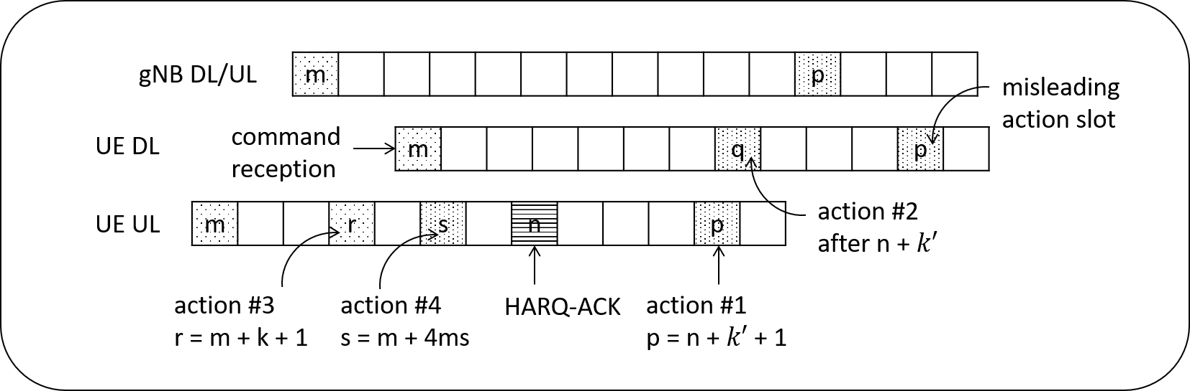
Figure 1: MAC CE activation timing in Rel-16
Figure 1 shows different MAC CE action time supported in Rel-16, where
- action #1: MAC CE action time for SCell, PUCCH spatial relation, SP CSI reporting, and SP SRS
- action #2: MAC CE action time for SP ZP CSI-RS, TCI States, Aperiodic CSI, SP CSI-RS/CSI-IM
- action #3: MAC CE action time for Timing Advance Command
- action #4: MAC CE action time for DRX Command
Based on our understanding, the UE DL slot p shall not be a correct MAC CE action time, wrong interpretation to us.
[Asia Pacific Telecom] further reviews interpretation of MAC CE timing in existing spec:
[Asia Pacific Telecom] - Action time interpretation:
Rel-16 spec text is not crystal clear about the MAC CE action timing. The ambiguity comes from whether UE shall determine the action time before or after timing advance is applied. To handle this, the terms Logical Time and Actual Time are introduced based on RAN1#98-Bis consensus, where
- Logical Time means that all the following is assumed to be zero
  - DL-to-DL timing differences between CCs
  - UL-to-UL timing differences across different TAGs
  - UL timing advance
- Actual Time means that values observed by the UE are assumed for
  - DL-to-DL timing differences between CCs
  - UL-to-UL timing differences across different TAGs
  - UL timing advance
In the consensus, MAC CE action time was categorized into Logical Time. That means UE shall make a logical MAC CE action in a slot number based on the spec text and then actually apply the MAC CE after UL timing advance.
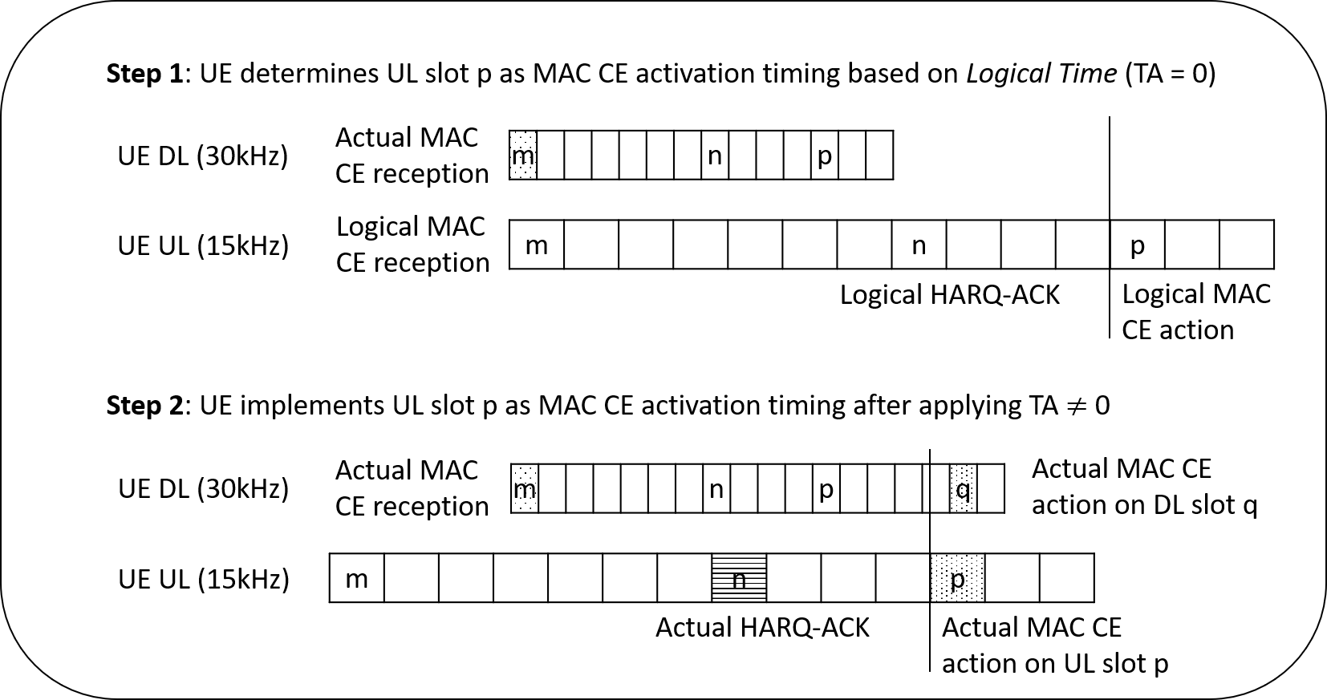
Figure 2: Consensus made after RAN1#98-Bis for MAC action time

In short:
- There are various types of MAC CEs in NR, which can be found in TS 38.821. Some of these MAC CEs (e.g. the Recommended Bit Rate MAC CE) do not involve timing relationships defined in the physical layer specifications. Clearly, RAN1 discussion on MAC CE timing relationships is only relevant for those MAC CEs that involve timing relationships defined in the physical layer specifications.
- In general, for MAC CE timing relationships defined in the physical layer specification, the MAC CE command becomes activated 3 ms after UE transmits HARQ-ACK corresponding to the received PDSCH carrying the MAC CE command. However, there are exception(s). For example, the adjustment of the uplink transmission timing corresponding to a timing advance command MAC CE is one such exception:
Section 4.2, TS 38.213:

For a timing advance command received on uplink slot and for a transmission other than a PUSCH scheduled by a RAR UL grant as described in Subclause 8.3, the corresponding adjustment of the uplink transmission timing applies from the beginning of uplink slot where ,…
To facilitate RAN1 discussion, we could proceed as follows:
- General MAC CE timing relationship discussions are assumed to be applicable to those MAC CEs that involve “3 ms application delay” defined in the physical layer specifications.
- Exceptional MAC CE timing relationships where the general discussion is not applicable may be discussed case by case based on company input.
The first part of the below table attempts to categorize companies’ views along this line of thinking. The second part of the below table collects general companies’ views.
 | General MAC CE with aligned UL-DL frame timing | General MAC CE with unaligned UL-DL frame timing | Exceptional MAC CE timing
Ericsson | Koffset is not needed for DL MAC CE  Koffset is not needed for UL MAC CE | Offset is needed for DL MAC CE (but not called Koffset)  Koffset is not needed for UL MAC CE | MAC CE action time for Timing Advance Command
ZTE | Koffset is not needed for DL MAC CE  Koffset is not needed for UL MAC CE |  | MAC CE action time for Timing Advance Command
Asia Pacific Telecom | Koffset is not needed for DL MAC CE  Koffset is not needed for UL MAC CE |  | - MAC CE action time for Timing Advance Command  - MAC CE action time for DRX Command
Intel | Koffset is not needed for DL MAC CE | Offset is needed for DL MAC CE (but not called Koffset)
VIVO | Koffset is not needed for DL MAC CE (?)  Koffset is not needed for UL MAC CE (?)  (this is moderator’s understanding of the figures, but the formulated proposal indicated the converse) | Offset is needed for DL MAC CE (but not called Koffset) (?)  Koffset is not needed for UL MAC CE (?)  (this is moderator’s understanding of the figures, but the formulated proposal indicated the converse)
 | General views
CAICT | Koffset is needed for DL MAC CE. Its necessity for UL MAC CE depends on whether or not the command is dependent on DL scheduling.
Lenovo, Motorola Mobility | MAC CE activation delay is determined by the gNB UL-DL timing shift
Meditatek, Eutelsat | Koffset is needed for MAC CE
CMCC | Discussion should be based on the assumption for aligned DL-UL timing at gNB side
Nokia, Nokia Shanghai Bell | Discuss the understanding of MAC-CE action timing for both the long TA and short TA
PANASONIC | - Koffset not needed for UL MAC CE  - DL status should be defined based on an offset from the reception timing of PDSCH containing the MAC CE
OPPO | Koffset is needed to absorb further the propagation delay
CATT | RTD needs to be considered in MAC CE
Apple | Koffset is not needed for UL MAC CE, but is needed for DL MAC CE
Interdigital | Support Koffset for MAC-CE action timing
Samsung | - The range of Koffset should depend on the maximum round trip propagation delay Trt and the maximum hop number L as Koffset ≥ L×Trt  - Koffset is applied to the determination of MAC CE activation timing
Qualcomm | Introduce Koffset for MAC CE
Xiaomi | Different Koffset value is applied to the activation of MAC CE.
LG | At least for MAC-CE associated with DL transmission, K_offset is needed.

2.2 Company views
To start the discussion, it is recommended to focus on the simpler case, where downlink and uplink frame timing are aligned at gNB. When consensus is achieved for this case, we could move on to discuss the more complicated case, where downlink and uplink frame timing are not aligned at gNB.
Understanding of existing MAC CE timing relationships was heavily discussed in Rel-15 maintenance. Common understanding, based on the conclusion at RAN1#98bis, can be found in R1-1911583. Note that Koffset for MAC CE in Rel-16 NTN SI was identified at RAN1#98bis as well, so the thinking at that time for Koffset would need to be updated based on the common understanding of the specification.

In short, the discussion in R1-1911583 indicates that UE assumes MAC CE command is active 3 ms after it transmits HARQ ACK corresponding to a received PDSCH carrying the MAC CE command.
The figure below illustrates if TA = 0, gNB and UE would have the same understanding that MAC CE command is activated in slot m.
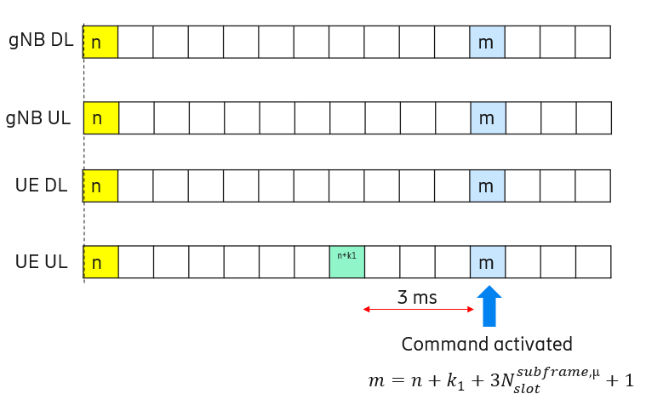
The figure below illustrates if TA > 0 but not too large, gNB and UE would have the same understanding that MAC CE command is activated in slot m.
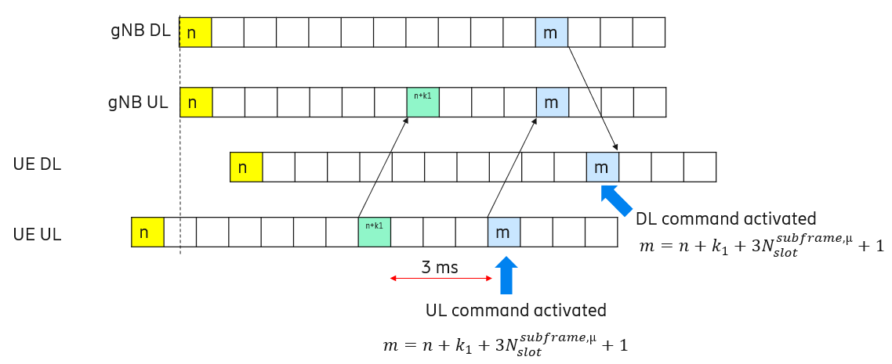
The main difference between NTN and terrestrial networks is that large TA value may need to be applied in NTN. Let’s start the analysis with the assumption that downlink and uplink frame timing are aligned at gNB.
The figure below illustrates the case in question. In this figure, UE applies a large TA. Due to this, gNB uses Koffset and k1 together to indicate the slot where the UE is scheduled to transmit HARQ-ACK. As shown in this figure, with the existing MAC CE timing relationship, gNB and UE would have the same understanding that MAC CE command is activated in slot m. So, there is no need to introduce additional Koffset for MAC CE timing relationship in this case.
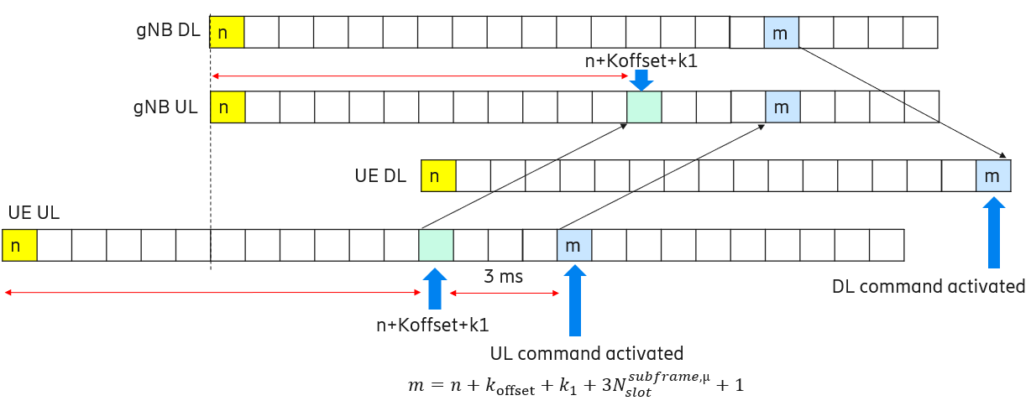
Based on the above discussion, an initial proposal is made as follows. Companies are encouraged to provide views on the proposal.
Initial proposal 2.2-1 (Moderator):
- RAN1 to conclude that when downlink and uplink frame timing are aligned at gNB:
  - For DL MAC CE timing relationship, K_offset is not needed
  - For UL MAC CE timing relationship, K_offset is not needed
- FFS when downlink and uplink frame timing are not aligned at gNB.
- Note: This does not preclude identifying exceptional MAC CE timing relationship(s) that may or may not require K_offset.

Company | Comments
MediaTek | There could be error case where the UL HARQ feedback on a DL MAC CE is not received at the gNB. It is not clear what happens with UE for example receiving TCI state indication for UE-specific MAC CE but gNB assumes UE has not done switching TCI because it did not receive UL HARQ feedback. Because of satellite RTD, it could take a long time for UE and gNB to realise something went wrong – i.e. at least satellite RTD. The error case could be avoided if Koffset is included in time when UE assumes MAC CE is activated.
Intel | Support the proposal 2.2-1
Panasonic | Support proposal 2.2-1 when DL and UL timing are aligned at gNB. On the other hand, in terrestrial operation, UE doesn't know whether DL and UL timing are aligned at gNB. In case of LEO, our view is that DL and UL timing would not be aligned at gNB because of the feeder link delay varying according to the satellite movement. Therefore, an offset is needed for DL MAC CE reflection timing.
OPPO | Agree with the proposal and regarding MTK’s comment, how adding K offset would resolve the issue of miss-detecting UL HARQ-ACK?
CATT | In principle, we are ok for this proposal. But since transparent payload is the main assumption for this WI, the case that downlink and uplink frame timing are not aligned at gNB should be prioritized, because feeder link delay can be compensated by the gNB.
Apple | For UL MAC CE timing relationship, we think that Koffset is not needed, no matter whether DL and UL frame timing is aligned at gNB.  For DL MAC CE timing relationship, we think Koffset is needed for DL MAC CE timing relationship when gNB has unaligned DL and UL frame timing. Similar to CATT, we think the case that DL and UL frame timing unaligned at gNB should be prioritized.
Ericsson | We support the proposal.
InterDigital | Agree with CATT and Apple
Qualcomm | Given that we don’t think it’s feasible to have DL and UL frame aligned at gNB with sufficient accuracy like in terrestrial network, we don’t see the value of the proposal.
Huawei | We support the proposal.
Samsung | The proposal is a little bit confusing. Does the proposal mean that K_offset is not applied to the MAC CE timing?  We interpret m = n+k_offset+k_1 + 3N + 1 as K_offset is applied to MAC CE. If this equation would be used, then we believe that the proposal needs to be revised as below.  For DL/UL MAC CE timing, the same value of K_offset is applied to MAC CE as DL HARQ-ACK timing.
Xiaomi | We don’t get the point why the MAC CE timing relationship have dependence on the timing relationship options. For us, K_offset can be a different value for the activation of DL/UL MAC CE command.
CMCC | Agree with the proposal.  In our view, the working assumption of downlink and uplink frame timing aligned at gNB should at least be supported in NTN. In this case, Koffset has the same magnitude as full TA, i.e., the sum of service link RTD and feeder link RTD.  In the above working assumption, the FL’s proposal can guarantee that gNB and UE should have the same understanding on in which slot MAC CE command is activated, at least in the case of the UL HARQ feedback on a DL MAC CE being correctly received at the gNB.  The error case when the UL HARQ feedback on a DL MAC CE is not received at the gNB is traditional problem which is also encountered in terrestrial network. The necessity for specification enhancement to address above problem needs more clarification.  Furthermore, for any potential specification enhancement, the common understanding on in which slot MAC CE command is activated in the case of the UL HARQ feedback on a DL MAC CE being correctly received at the gNB should at least be guaranteed.
ZTE | We support the proposal.
Spreadtrum | Agree with the proposal.
NTT Docomo | We support the proposal
LG | Support
Lenovo/MM | Agree with the proposal.
APT | Agree 2.2-1. Thanks for mentioning our contribution.
Nokia, Nokia Shanghai Bell | In the discussion it is important to recall that the DL and UL frame timing alignment at gNB may be attractive, but in reality it might be impossible to implement. With the above proposals, we get rid of the dependency of the K_offset for the MAC CE timing relationships, but on the other hand we create an impossible situation for the UE. Consider the case of TCI state change. Here, the gNB will give indication, which will not be acknowledged, which would create risk of UE and gNB not having same understanding of the configuration.
Thales | K_offset for MAC CE action time is not needed. We agree with the proposal.  The MAC CE command is active only after applying TA (to the logical MAC CE Action)  In this case, the UL HARQ feedback should be received before the MAC CE CMD is active. gNB and UE would have the same understanding that MAC CE command is active. Therefore, the error case mentioned by MediaTek should not happen.  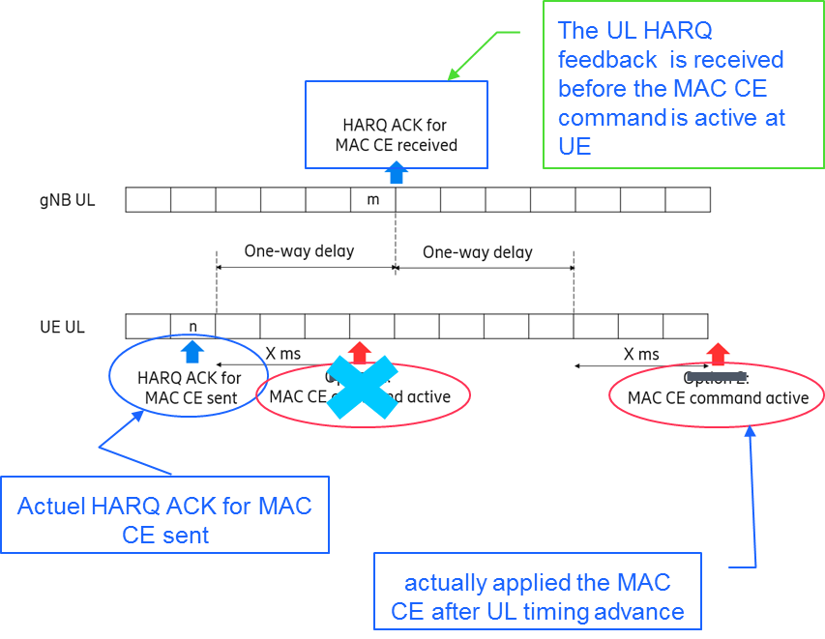
vivo | When downlink and uplink frame timing are aligned at gNB, we support that K_offset is not needed for both of UL and DL MAC CE timing relationship.  However, when downlink and uplink frame timing are unaligned at gNB, another offset is needed for DL MAC CE timing relationship. And the value of the offset is based on the common TA offset in the gNB's DL and UL frame timing.
Fraunhofer IIS, Fraunhofer HHI | Support proposal 2.2-1
Eutelsat | In the case where UL and DL are aligned the proposal is sound, however, in the case of unaligned UL and DL some offset to adjust the MAC CE timing relationship is required. MediaTek’s comment should also be taken into account.

2.3 Updated proposal based on company views (1st round of email discussion)
In the first round of email discussion, 27 companies provided views:
- 18 companies [Intel, OPPO, CATT, Apple, Ericsson, InterDigital, Huawei, CMCC, ZTE, Spreadtrum, NTT Docomo, LG, Lenovo/MM, APT, Thales, vivo, Fraunhofer IIS/Fraunhofer HHI, Eutelsat] agree/support/are fine with the proposal.
- [Panasonic, CATT, Apple, InterDigital, Qualcomm, Nokia/Nokia Shanghai Bell, vivo] point out that the case the case, where downlink and uplink frame timing are not aligned at gNB, also needs to be addressed.
  - Moderator: The intention is to make step-by-step analysis because this is a complicated issue. It is good to see that companies now have aligned understanding for the case where downlink and uplink frame timing are aligned at gNB. For the 2nd round of discussion, I update the proposal by including the case where downlink and uplink frame timing are not aligned at gNB.
- [MediaTek]’s comment was answered by [OPPO, CMCC].
- [Samsung] asked for clarification: Does the proposal mean that K_offset is not applied to the MAC CE timing?
  - Moderator: The Koffset in your example is already part of enhancing the transmission timing of HARQ-ACK on PUCCH (i.e., K1 already). The discussion/proposal here is about whether a second K_offset (which may take a different value) is needed. If [Samsung] think the wording is not clear, please suggest alternative wording that can be RAN1 consensus.
- [Xiaomi] said “We don’t get the point why the MAC CE timing relationship have dependence on the timing relationship options.”
  - Moderator: Please find detailed analysis in e.g. R1-2009091.

An updated proposal is made to make further progress on the case where downlink and uplink frame timing are not aligned at gNB.
Proposal 2.3-1 (based on 1st round of email discussion):
- When downlink and uplink frame timing are aligned at gNB:
  - For DL MAC CE timing relationship, K_offset is not needed
  - For UL MAC CE timing relationship, K_offset is not needed
- When downlink and uplink frame timing are not aligned at gNB:
  - For DL MAC CE timing relationship, K_offset is needed
  - For UL MAC CE timing relationship, K_offset is not needed
- Note: This does not preclude identifying exceptional MAC CE timing relationship(s) that may or may not require K_offset.

Moderator: In the second round of email discussion, please focus on commenting on the case where downlink and uplink frame timing are not aligned at gNB.
Company | Comments
OPPO | Fine with the proposal, but need to make it clear what the definition is for DL MAC CE and UL MAC CE.
Samsung | Following the FL's explanation "Due to this, gNB uses Koffset and k1 together to indicate the slot where the UE is scheduled to transmit HARQ-ACK. As shown in this figure, with the existing MAC CE timing relationship, gNB and UE would have the same understanding that MAC CE command is activated in slot m. So, there is no need to introduce additional Koffset for MAC CE timing relationship in this case.", we need to add "a new additional" before "K_offset" in four sub-bullets for clarification.  Also, it would be better to change "When" to "if" because we do not decide yet how to handle the timing alignment, i.e., whether DL/UL frame timing would be aligned or not at gNB. Similar to OPPO, we also think we need to clarify what's "UL" MAC CE timing.
Panasonic | Support proposal 2.3-1.
ZTE | Fine to take both cases (i.e., aligned and unaligned) for discussion.  Following the same principle as clarified in the discussion on the first bullet, the DL MAC CE will apply at gNB side after the HARQ-ACK signaling received at gNB UL slot m. And with consideration in this non-aligned case, the gNB UL slot m have a delay relative to the gNB DL slot m. So in fact, DL MAC CE can’t apply at gNB side at DL slot m. Instead, it should take the delay into account. That is, it should apply at ‘DL slot m + delay of gNB UL’.  Moreover, the delay of gNB UL is different from previous K_offset(including the K_offset in the first bullet) which was used to handle the TA value. While the delay of gNB UL may be a value relate to the feeder link delay. So we suggest to use another terminology in this case to clarify and avoid any misunderstanding.  W.r.t the UL MAC CE timing relationship, since the gNB DL timeline is not involved at all, no additional offset is needed for this case.
CMCC | W.r.t. 1st bullet: Agree.  W.r.t. 2nd bullet: We do not see the benefit for supporting unaligned downlink and uplink frame timing at gNB.  In our view, one possible motivation to support unaligned downlink and uplink frame timing at gNB is to support “RP OPTION 2: The RP is located at the satellite” as discussed in Issue#1-1 in AI 8.4.2. In this case, only UE specific TA (i.e., service link RTD) is pre-compensated, which results in unaligned downlink and uplink frame timing at gNB. The potential benefit is signaling overhead reduction due to avoiding Common TA indication.  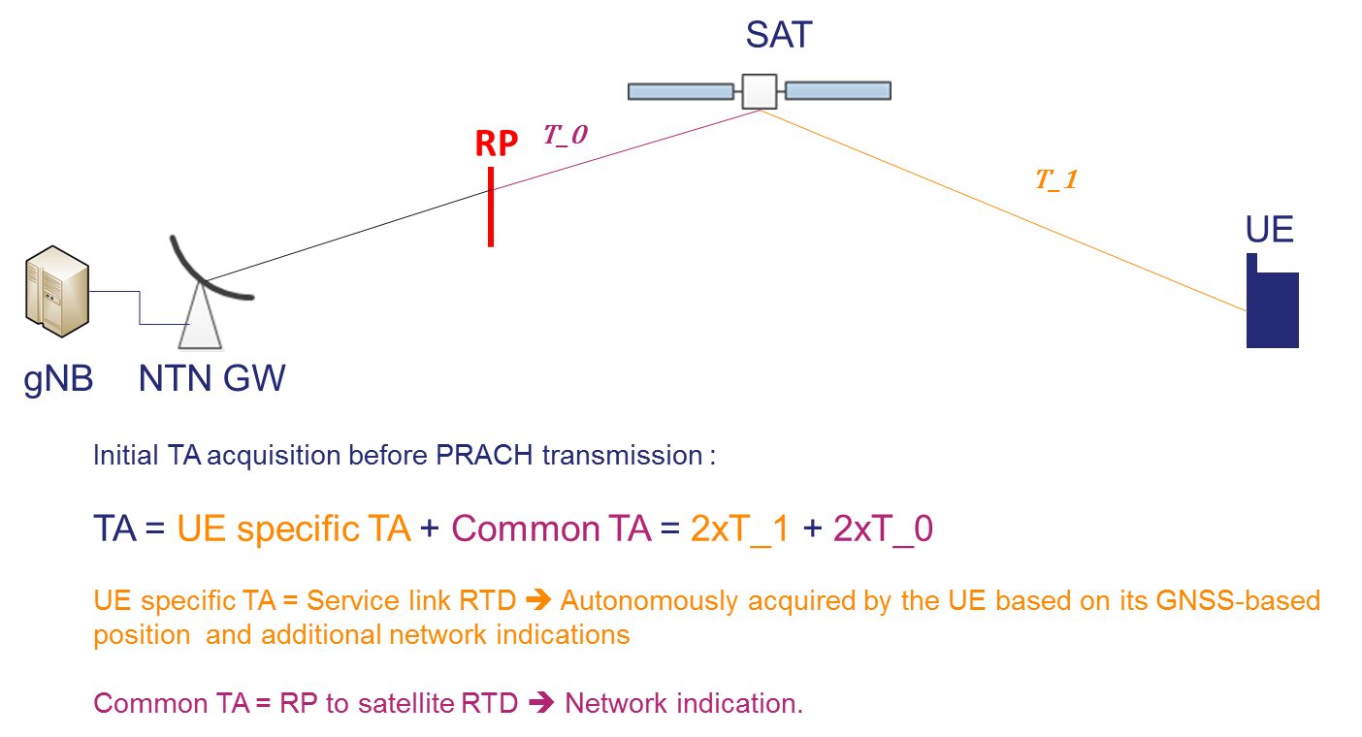  Nevertheless, as discussed in Ericsson’s contribution (R1-2009091), when downlink and uplink frame timing are not aligned at gNB, an additional Koffset (termed as Y in the below figure) is needed for DL MAC CE timing relationship.  The value of Y has the same magnitude of feeder link RTD, which needs to be indicated to the UE.  Therefore, for RP OPTION 2, Common TA indication is avoided, while an additional indication of Y for DL MAC CE timing relationship is needed.  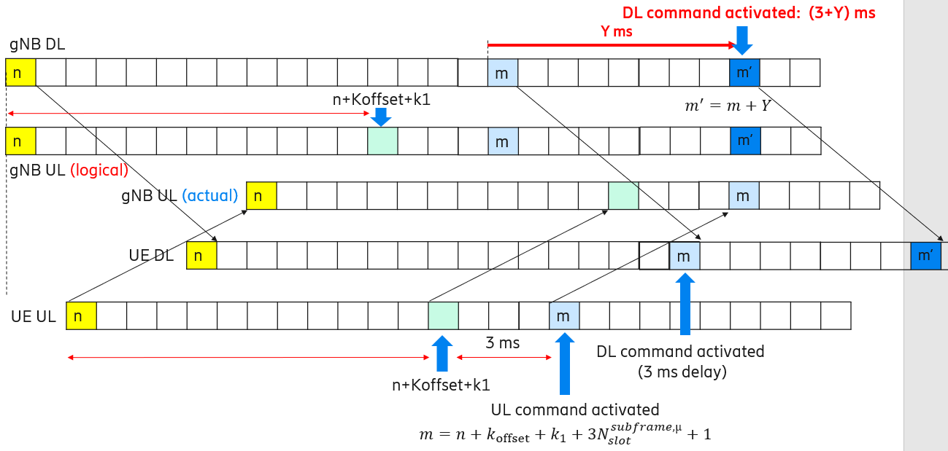  On the contrary, if supporting “RP OPTION 1: The RP is located at the gNB” as discussed in Issue#1-1 in AI 8.4.2, downlink and uplink frame timing can keep aligned at gNB. Common TA indication shall be introduced, while there is no need for additional Koffset indication for MAC CE timing relationship.  In summary, compared with RP OPTION 1 and RP OPTION 2, similar signaling overhead for indicating Common TA or additional Koffset is needed, while RP OPTION 1 is more typical/easy for implementation without additional cost. And it’s also aligned with existing NR with less spec impact.  Therefore, the benefit of supporting RP OPTION 2, as well as supporting unaligned downlink and uplink frame timing at gNB, is unclear to us.  W.r.t. 3th bullet: Agree.

3 Issue #3: On K1/K2 range extension

3.1 Background
At RAN1#102-e, K1/K2 range extension was discussed. The discussion status was summarized in Feature Lead summary [3]. After 2 rounds of email discussions at RAN1#102-e, it became clear that it is better to separate the discussion of updating Koffset from the discussion of extending value ranges of K1 and/or K2, as preferred by many companies.
At RAN1#103-e, several companies provide proposals on this topic. It appears that the input to this topic is not many. That said, it is unclear if companies change their mind after reading the newly submitted contributions at RAN1#103-e. So, in Moderator’s view, it may be beneficial to collect companies’ views again and check the necessity of K1/K2 range extension for NTN.
[CAICT]:
Proposal 6: To enhance K1/K2 indication with explicit or implicit way in TDD system which is with more contiguous DL slots.
[Lenovo, Motorola Mobility]:
Proposal 5: Support extending the range of K1 value.
[ZTE]:
Proposal 4: Extension of existing offset (i.e., k, K1, K2) should be supported.
[MTK, Eutelsat]:
Proposal 4: K1 range are increased to 32 with indication of INTEGER (0..31) in dl-DataToUL-ACK field in PUCCH-Config.
Proposal 5: K2 range are increased to 64 with indication of INTEGER (0..63) in PUSCH-TimeDomainResourceAllocation field in DCI .
[CMCC]:
Proposal 8: Extend the value range of K1 to larger than 15, e.g., 31.
[CATT]:
Proposal 5: Expanding K1/K2 is not necessary.

3.2 Company views
Based on the above discussion, an initial proposal is made as follows. Companies are encouraged to provide views on the proposal.
Initial proposal 3.2-1 (Moderator):
Discuss whether to extend value ranges of K1 and/or K2.

Company | Comments
MediaTek | At least K1 could be increased following RAN1 agreement on supporting 32 HARQ processes.
Intel | It is not clear if it is needed since K_offset is added to both K1 and K2. Moreover, if UE-specific K_offset is supported it will have similar functionality as K1 and K2 except that it is same for HARQ and PUSCH transmissions.
Panasonic | We don’t see the need of extending K1 and/or K2 values so far.
OPPO | Could we discuss if the extension would change the DCI size or not?
Apple | We may hold this discussion after the discussion of Koffset in or after initial access. Depending on the accuracy of Koffset, we may then know whether the ranges of K1 and K2 need to be extended.
Ericsson | We are fine to discuss.
InterDigital | Not sure if extended value range is needed for K1 and/or K2 but we are open to discuss
Qualcomm | Don’t see reasons for extending K1 and K2 so far. We are open to the discussion.
Huawei | Okay to discuss this further.
Samsung | Further discussion is fine to us, but, if K_offset value is introduced, we don’t think the extension of K1/K2 candidate values.
Xiaomi | Fine to discuss further. Whether to extend the K1/K2 value depends on multiple factors which can be decided in the later phase.
CMCC | At least K1 could be increased following RAN1 agreement on supporting 32 HARQ processes.  Furthermore, even if UE-specific Koffset updating via high level signaling is supported, slightly extending K1/K2 value range (e.g., K1 value extend to 0..31) is also beneficial to significantly reduce the potential high level signaling overhead for frequently updating Koffset to capture rapidly changed RTT in LEO scenario.  Regarding OPPO’s comments, we think there is no need to extend the bit size of PDSCH-to-HARQ_feedback timing indicator and/or TDRA (Time domain resource assignment) field in DCI.
ZTE | Fine to discuss it. And extension of these values are preferred.
Spreadtrum | We are fine to discuss.
NTT Docomo | We are fine to discuss. Not only updating K_offset but also extending K1/K2 are possible options to improve scheduling efficiency, latency performance, and HARQ process management.
LG | Agree with Intel.
Lenovo/MM | Agree with the proposal.
APT | Not necessary for FDD. The possible benefit to support K1 >15 is all 32 HARQ processes’ feedback can be multiplexed in a HARQ-ACK codebook. But it might be good for TDD or half-duplex FDD.
CAICT | With UE-specific $K_{offset}$ updating is supported, the need of extending the value range of K1/K2 would be marginal. For supporting 32 HARQ processes and supporting TDD system with more contiguous DL slots, the value of K1/K2 should be extended. However, implicit indication should be considered to avoid changing the DCI size while keep the comparative flexibility with TN.
ETRI | Agree with the proposal.
Nokia, Nokia Shanghai Bell | If we consider the values of K1 and/or K2 as the relative delay from reception of PDCCH/PDSCH until associated UL transmission, we do not see any reason to extend the value range of these.
Thales | K1 and K2 could be extended
vivo | We support further discussion to extend value ranges of K1, to fit some frame structure with multiple consecutive DL slots.
Fraunhofer IIS, Fraunhofer HHI | Extension of K1 and K2 is not needed if UE specific K_offset is considered. We are open to discussion.
Eutelsat | K1 could be increased following RAN1 agreement on supporting 32 HARQ processes. Further discussion acceptable.

3.3 Updated proposal based on company views (1st round of email discussion)
In the first round of email discussion, 25 companies provided views:
- [MediaTek, CMCC, ZTE, CAICT, Thales, VIVO, Eutelsat] support extending K1/K2 range.
  - [APT] think extending K1/K2 range might be good for TDD and HD FDD.
  - [NTT Docomo] consider extending K1/K2 range a beneficial option.
- [Intel, Panasonic, InterDigital, Qualcomm, Samsung, LG, Nokia/Nokia Shanghai Bell, Fraunhofer IIS/Fraunhofer HHI] do not see/are not sure about the need of extending K1/K2 value range.
  - [Ericsson, InterDigital, Qualcomm, Huawei, Samsung, Xiaomi, Spreadtrum, Lenovo/MM, ETRI, Fraunhofer IIS/Fraunhofer HHI] are open to discuss.
- [Apple] suggest holding off the discussion until Koffset design is settled.
- [OPPO] suggest discussing if extending K1/K2 value range affects DCI size, to which [CMCC] provide a response.

Given the views expressed so far, the situation does not change much compared to RAN1#102-e. From Moderator’s perspective, it is not appropriate to propose to extend K1/K2 value nor to conclude extension of K1/K2 value is not needed. It is recommended that the proponents to offline discuss with other companies to make progress and let Moderator know if there is a possibility for potential consensus.
Moderator recommendation on Issue #3:
On K1/K2 range extension, proponents are encouraged to have offline discussions with other companies.

4 Issue #4: Configured grant timing relationships

4.1 Background
At RAN1#103-e, a few companies provide proposals on this topic:
[Apple]:
Proposal 6: Introduce $K_{offset}$ to the timing relationship for type 1 configured grant.
[Samsung]:
Proposal 4: The timing relationship for Configured Grant Type 1 should be left to Network implementation.
Proposal 5: The timing relationship for Configured Grant Type 2 can follow the timing relationship for DCI scheduled PUSCH.

At RAN1#102-e, configured grant timing relationship was discussed. The discussion status was summarized in Feature Lead summary [3]. Based on the submitted contributions at RAN1#103-e, it appears that the input to this topic is limited. That said, it is unclear if companies change their mind after reading the newly submitted contributions at RAN1#103-e. So, in Moderator’s view, it may be beneficial to collect companies’ views again and check the necessity of enhancing configured grant timing relationships for NTN.

4.2 Company views
Based on the above discussion, an initial proposal is made as follows. Companies are encouraged to provide views on the proposal.
Initial proposal 4.2-1 (Moderator):
Discuss which direction to take for the timing relationship of type 1 configured grant:
- Option 1: [Apple] Introduce K_offset to the timing relationship for type 1 configured grant.
- Option 2: [Samsung] The timing relationship for Configured Grant Type 1 should be left to Network implementation.

Company | Comments
Panasonic | Support Option 2.
Apple | We support Option 1. Configured grant type 1 involves the DL-UL timing interaction, and hence, it is natural to introduce Koffset to it, just like the other timing relationship enhancement cases.  If we leave the timing relationship for configured grant type 1 to network implementation, then the network may have to modify configured grant type 1 based on a new Koffset at every Koffset update. This is not preferred.
Ericsson | We feel Option 2 is sufficient.
Qualcomm | Option2 is preferred.
Huawei | We are fine with option 2.
Samsung | Option 2.  We can follow the same principles of NR CG type 1 as Rel-15/16.
ZTE | We are fine with option 2.
Spreadtrum | We are fine with option 2.
LG | Support option 2
Lenovo/MM | Slightly prefer option 2. For the first type 1 configured grant PUSCH transmission after RRC configuration, K_offset may be necessary, while for others not. If there is no enough time between the RRC activation and the UL slot for the first PUSCH transmission, the first PUSCH can be omitted.
APT | Option 3: Up to UE implementation, e.g.,  “UE is not expected to send a Type1 PUSCH transmission prior to the received RRC message of configuredGrantConfig is applied by the UE”
CAICT | In our observation, the main problem is how to align the first available resource in NR CG type1 at both gNB and UE side. If gNB doesn’t know the pre-compensated TA at UE side or there is no HARQ-ACK for the PDSCH carrying NR CG type1, we think there is a necessity of introducing K_offset in the timing relationship of NR CG type1.
Nokia, Nokia Shanghai Bell | At present, we find this discussion dependent on the general system design, so other agreements need to settle first.

Initial proposal 4.2-2 (Moderator):
Discuss the following proposal for the timing relationship of type 2 configured grant:
[Samsung] The timing relationship for Configured Grant Type 2 can follow the timing relationship for DCI scheduled PUSCH.

Company | Comments
Panasonic | We agree that the timing relationship for Configured Grant Type 2 can follow the timing relationship for DCI scheduled PUSCH.
Ericsson | It should be clarified that the timing relationship here for CG type 2 refers to the activation timing.
Huawei | Support in principle but may need to refine the wording.
Samsung | K_offset is already introduced for PUSCH timing. So, CG type 2 can also use this timing relationship with K_offset.
ZTE | Supportive.
Spreadtrum | Supportive
LG | Agree
Lenovo/MM | Agree with Samsung on the necessity of K_offset for type 2 configured grant PUSCH due to activation by DCI.
APT | Agree. No enhancement is needed.
CAICT | Supportive
Nokia, Nokia Shanghai Bell | At present, we find this discussion dependent on the general system design, so other agreements need to settle first.

4.3 Updated proposal based on company views (1st round of email discussion)

4.3.1 Configured grant type 1
In the first round of email discussion, 13 companies provided views:
- [Panasonic, Ericsson, Qualcomm, Huawei, Samsung, ZTE, Spreadtrum, LG] are fine/supportive of Option 2: The timing relationship for Configured Grant Type 1 should be left to Network implementation.
- [Lenovo/MM] have slight preference on Option 2, but point out K_offset may be needed in some case. [CAICT] also point out K_offset is needed in some cases. [Apple] hold the view that K_offset is needed in the timing relationship for Configured Grant Type 1.
- [APT] propose Option 3: Up to UE implementation, e.g., “UE is not expected to send a Type1 PUSCH transmission prior to the received RRC message of configuredGrantConfig is applied by the UE”
  - Moderator: The “e.g.” feels a bit strange. It is by default that UE should follow the RRC configuration.
- [Nokia/Nokia Shanghai Bell] make a general comment that “At present, we find this discussion dependent on the general system design, so other agreements need to settle first.”
Given the different views expressed so far, it is worthwhile to continue discussing this issue. Since this issue is brought up for the first time, companies may need more time to analyze it. So, it is recommended that we revisit this issue at the next RAN1 meeting. With this way forward, it is not necessary to discuss this issue further at this RAN1 meeting.
Moderator recommendation on Issue #4 – CG Type 1:
On Configured Grant Type 1 timing relationship, interested companies are encouraged to provide input to RAN1#104-e.

4.3.2 Configured grant type 2
In the first round of email discussion, 11 companies provided views:
- [Panasonic, Ericsson, Huawei, Samsung, ZTE, Spreadtrum, LG, Lenovo/MM, APT, CAICT] are fine/supportive of Samsung’s proposal.
  - [Ericsson, Huawei] suggest the wording need to be refined.
- [Nokia/Nokia Shanghai Bell] make a general comment that “At present, we find this discussion dependent on the general system design, so other agreements need to settle first.”
There is only one company expressing non-supportive. From Moderator’s perspective, it would be more constructive and fairer to the proponent, if [Nokia/Nokia Shanghai Bell] can provide detailed arguments why there is a concern, e.g. describing what the dependency is.
To accommodate [Nokia/Nokia Shanghai Bell]’s comment, it is suggested that we take the following as a work assumption.
Proposal 4.3-2 (based on 1st round of email discussion):
Take the following as a work assumption:
K_offset can be applied to the activation timing of PUSCH transmission in Configured Grant Type 2 in the same way as K_offset is applied to the transmission timing of DCI scheduled PUSCH.

Company | Comments
OPPO | Sorry for our late comment. We would like to ask what the activation timing is for PUSCH transmission in CG type 2. The concept of CG type 2 activation timing is not discussed in NR of R15/R16. If the activation time is related to UE processing time for the UE to determine the earliest valid CG resource for PUSCH transmission, our view is that when a UE receives a triggering DCI for CG type 2, the UE will select a CG resource that satisfies a UE processing time after the DCI reception. Thus, thus what the UE needs to determine the CG transmission are 1) periodic CG resources; 2) last symbol of PDCCH position; 3) UE processing time. With these three information, the UE can determine which CG resource can be used and which are not. We fail to see how K offset is intervening here.
Samsung | Agree to FL’s proposal above.
Panasonic | Support proposal 4.3-2.  Response to Oppo’s comment. As described in TS38.321 section 5.8.2 (copied below), CG resource is defined based on the first transmission opportunity of PUSCH which is scheduled by DCI for activation. In order to determine the “first transmission opportunity of PUSCH”, use of K_offset is proposed in our understanding.
  After an uplink grant is configured for a configured grant Type 2, the MAC entity shall consider that the uplink grant recurs associated with each symbol for which:
  [(SFN × numberOfSlotsPerFrame × numberOfSymbolsPerSlot) + (slot number in the frame × numberOfSymbolsPerSlot) + symbol number in the slot] =
  [(SFN_{start time} × numberOfSlotsPerFrame × numberOfSymbolsPerSlot + slot_{start time} × numberOfSymbolsPerSlot + symbol_{start time}) + N × periodicity] modulo (1024 × numberOfSlotsPerFrame × numberOfSymbolsPerSlot), for all N >= 0.
  where SFN_{start time}, slot_{start time}, and symbol_{start time} are the SFN, slot, and symbol, respectively, of the first transmission opportunity of PUSCH where the configured uplink grant was (re-)initialised.
ZTE | Agree to FL’s proposal above.
Huawei | Fine with the proposal. Agree with Panasonic, suggest the following wording  K_offset can be applied to the activation timing of first PUSCH transmission occasion in Configured Grant Type 2 in the same way as K_offset is applied to the transmission timing of DCI scheduled PUSCH.

5 Issue #5: 2-Step RACH timing relationships

5.1 Background
At RAN1#103-e, a few companies provide proposals on this topic:
[Asia Pacific Telecom co. Ltd]:
Proposal 5: Timing enhancement on 2-step RACH shall start in RAN1#103-e.
[ZTE]:
Proposal 7: For the 2-step RACH, introduce K_offset for the transmission timing of fallback random-access response (RAR) scheduled PUSCH and HARQ-ACK feedback for Msg-B.
[Fraunhofer IIS, Fraunhofer HHI]:
Proposal 10: RAN1 to further study the enhancement of 2-step RACH timing relationship for NTN.

At RAN1#102-e, 2-Step RACH timing relationship was discussed. Based on the discussion as summarized in Feature Lead summary [3], Moderator recommended that RAN1 wait for RAN2 decision on whether to support 2-step RACH for NTN or not, before discussing 2-step RACH timing relationship.
RAN2 now has agreed to support both 2-step and 4-step RACH in Rel-17 NTN. So, it is reasonable to start discussing 2-step RACH timing relationship in RAN1.
[RAN2#111-e agreement] Both 2-step and 4-step RACH are supported in Rel-17 NTN. FFS enhancements to RACH to accommodate the NTN environment.
[Asia Pacific Telecom co. Ltd] provide good figures to illustrate timing relationships that should be discussed in RAN1.
[Asia Pacific Telecom co. Ltd]:
Figure 4 shows an example when UE receives a fallbackRAR within the MsgB-RAR window, where 1st offset and 3rd offset might be derived by UE, and 2nd offset and 4th could be provided by NW. In our example, C-RNTI is provided for PDCCH monitoring, the UE may transmit HARQ-ACK information for the received Msg4, meanwhile, NW shall guarantee proper scheduling regarding required TA and UE processing time.
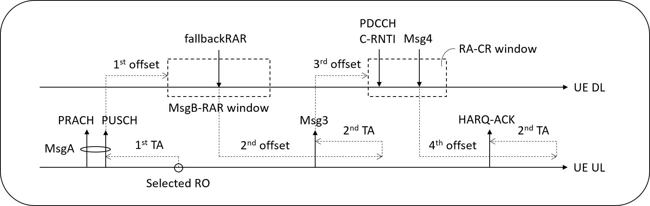
Figure 4: Example of a fallbackRAR reception within the MsgB-RAR window
However, detail on 1st offset, 3rd offset, and 4th offset is unclear. More discussion shall be needed in RAN1.
Figure 5 shows another example when UE receives a successRAR within the MsgB-RAR window. Note the HARQ-ACK information shall be ACK value only. Timing enhancement on 2nd offset might need some discussion in RAN1.
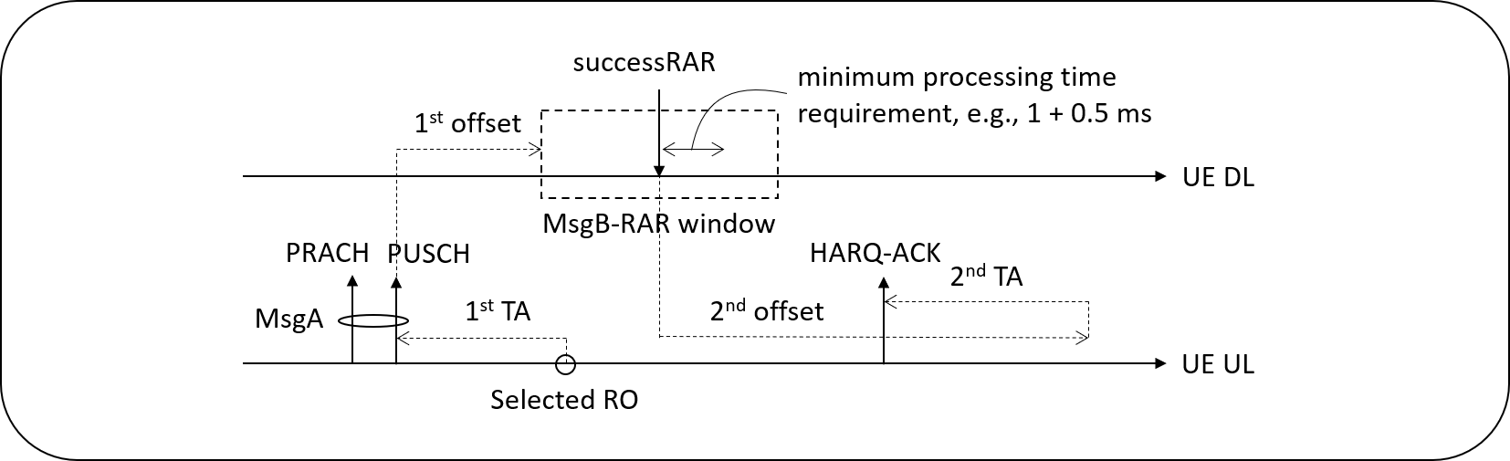
Figure 5: Example of a successRAR reception within the MsgB-RAR window
Figure 6 shows another example when the MSGA includes the C-RNTI MAC CE. In this case, UE may receive a DCI format in the PDCCH within the MsgB-RAR window. The DCI format in PDCCH shall provide the 2nd offset for HARQ-ACK information, either ACK or NACK values, for the received PDSCH, and NW shall guarantee that the 2nd offset is long enough to cover the 2nd TA value required for the PUCCH transmission. Details shall be discussed further.
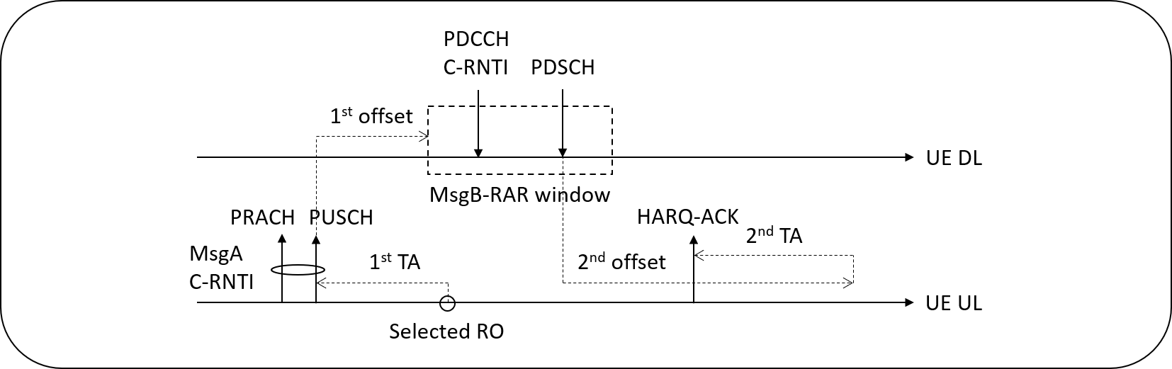
Figure 6: Example of C-RNTI MAC CE included in the MSGA transmission

In summary, as illustrated by the above figures from [Asia Pacific Telecom co. Ltd], there are 3 types of timing relationships.
- Transmission timing of fallback RAR scheduled PUSCH
- Reception timing of HARQ-ACK feedback for MsgB
- Offset to the start of MsgB-RAR window (similar discussion is applicable to the start of Msg2-RAR window) and offset to the start of ra-ContentionResolutionTimer window

5.2 Company views

5.2.1 FallbackRAR scheduled PUSCH
The FallbackRAR scheduled PUSCH is similar to the Msg2 RAR scheduled PUSCH. Given that RAN1 has agreed to introduce K_offset in the transmission timing of Msg2 RAR grant scheduled PUSCH, it is natural to apply the same design to FallbackRAR scheduled PUSCH.
Based on the above discussion, an initial proposal is made as follows. Companies are encouraged to provide views on the proposal.

Initial proposal 5.2-1 (Moderator):
Introduce K_offset to enhance the timing relationship of fallbackRAR scheduled PUSCH.

Company | Comments
Intel | Support the proposal 5.2-1
Panasonic | Support proposal 5.2-1.
OPPO | support
Apple | Agree
Ericsson | This is reasonable.
Qualcomm | We believe this is already supported in the existing agreement.
Huawei | Support
Samsung | Agree
ZTE | Support
Spreadtrum | Agree
LG | Support
Lenovo/MM | Support the proposal.
APT | Agree. Thanks for mentioning our contribution.
CAICT | Agree
ETRI | Support
Nokia, Nokia Shanghai Bell | Tentatively, we would be supportive of this proposal, but further discussions may be needed – potentially, this need discussion in RAN2 as well.
Thales | We support the proposal
Fraunhofer IIS,  Fraunhofer HHI | Support proposal 5.2-1.

5.2.2 HARQ-ACK to MsgB
[Asia Pacific Telecom co. Ltd] describe two cases of HARQ feedback to MsgB (see Figures 5 and 6 in [Asia Pacific Telecom co. Ltd]’s contribution, which are also cited in Section 5.1 in the above).
In either case, the HARQ-ACK to MsgB is similar to the case of HARQ-ACK on PUCCH to a normal PDSCH. Given that RAN1 has agreed to introduce K_offset in the transmission timing of HARQ-ACK on PUCCH, it is natural to apply the same design to HARQ-ACK to MsgB.

Based on the above discussion, an initial proposal is made as follows. Companies are encouraged to provide views on the proposal.

Initial proposal 5.2-2 (Moderator):
Introduce K_offset to enhance the timing relationship of HARQ-ACK on PUCCH to MsgB.

Company | Comments
Intel | Support the proposal 5.2-2
Panasonic | Support proposal5.2-2.
OPPO | support
Apple | Agree
Ericsson | This is reasonable.
Qualcomm | Agree
Huawei | Support
Samsung | Agree
ZTE | Support
Spreadtrum | Agree
LG | Support
Lenovo/MM | Agree with the proposal.
APT | Agree. Thanks for mentioning our contribution.
CAICT | Agree
ETRI | Support
Nokia, Nokia Shanghai Bell | Tentatively, we would be supportive of this proposal, but further discussions may be needed.
Thales | We support the proposal
Fraunhofer IIS,  Fraunhofer HHI | Support proposal 5.2-2

5.2.3 Start of Msg2/MsgB RAR window
At RAN2#111, the following agreement was made about adding offset to the starts of ra-ResponseWindow and ra-ContentionResolutionTimer.
[RAN2#111-e agreement]
1. From RAN2 perspective, an offset is applied to the start of ra-ResponseWindow in NTN for both LEO and GEO scenarios.
2. An offset to the start of the ra-ContentionResolutionTimer is introduced for both LEO and GEO scenarios.
The start of ra-ResponseWindow is defined in RAN2 spec TS 38.321 and its discussion can be up to RAN2, and thus there is no highlight of “From RAN2 perspective” in the RAN2 agreement.
The first bullet in the RAN2 agreement however highlights that the offset to the start of ra-ResponseWindow can be added “from RAN2 perspective”, because the start of ra-ResponseWindow is specified in RAN1 spec TS 38.213 and thus RAN2 expects coordination with RAN1 is needed.
Section 8.2, TS 38.213 – 4-step RACH:
… The window starts at the first symbol of the earliest CORESET the UE is configured to receive PDCCH for Type1-PDCCH CSS set, as defined in Clause 10.1, that is at least one symbol, after the last symbol of the PRACH occasion corresponding to the PRACH transmission, where the symbol duration corresponds to the SCS for Type1-PDCCH CSS set as defined in Clause 10.1. …
Section 8.2A, TS 38.213 – 2-step RACH:
… The window starts at the first symbol of the earliest CORESET the UE is configured to receive PDCCH for Type1-PDCCH CSS set, as defined in Clause 10.1, that is at least one symbol, after the last symbol of the PUSCH occasion corresponding to the PRACH transmission, where the symbol duration corresponds to the SCS for Type1-PDCCH CSS set. …
During the Rel-15 maintenance at RAN1#98bis, many timing relationships were clarified with respect to whether TA is considered or not in the corresponding timing relationship (see R1-1911583). But whether TA is considered or not for defining the start of Msg2/MsgB RAR window was not discussed and appears to be not clear.
The following figure provides an illustration.
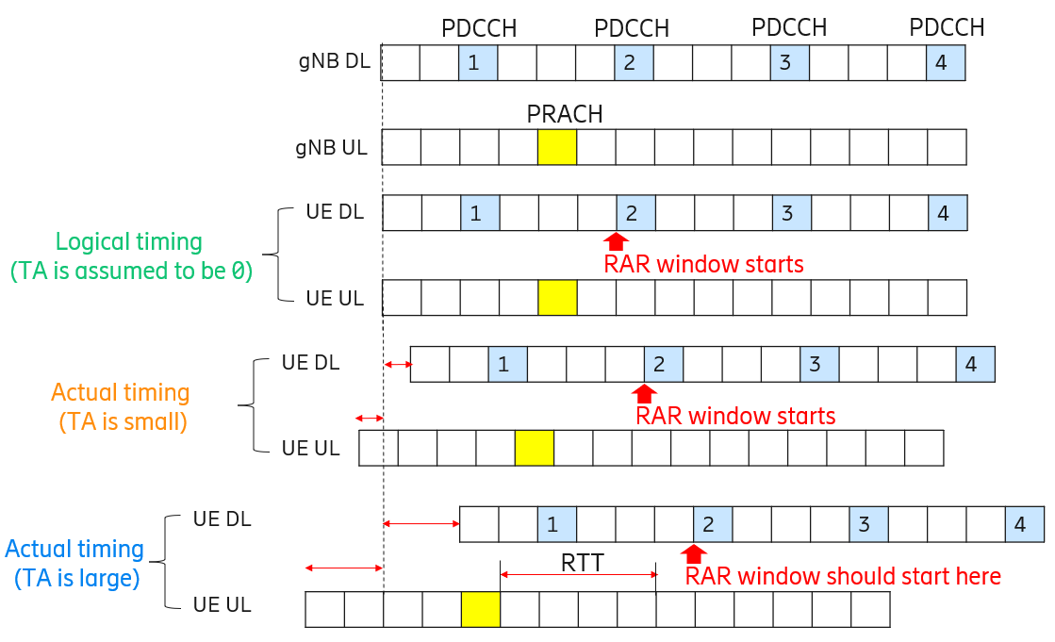
For PRACH transmission in the slot indicated in yellow:
- If TA is assumed to be zero, the RAR window should start at PDCCH monitoring occasion 2.
- When TA is not large as in terrestrial case (TA is small), it does not matter whether TA is assumed to be zero or not, the RAR window would start at PDCCH monitoring occasion 2.
- When TA is large as in NTN case, it matters whether TA is assumed to be zero or not
  - If logical timing is used (TA is assumed to be 0), the RAR window starts at PDCCH monitoring occasion 2. In this case, UE implicitly adds an offset already to the start of the RAR window when it comes to the actual timing.
  - If actual timing is used, the RAR window starts at PDCCH monitoring occasion 1 according to current spec text. In this case, UE would need to add an explicit offset (e.g. equal to RTT) to the start of the RAR window so that the UE starts the RAR window at PDCCH monitoring occasion 2 (instead of 1).
Therefore, it is necessary to first clarify the interpretation of the existing RAN1 specification about the start of the Msg2/MsgB RAR window, particularly whether or not TA is considered.
Based on the above discussion, an initial proposal is made as follows. Companies are encouraged to provide views on the proposal.

Initial proposal 5.2-3 (Moderator):
Discuss the interpretation of the existing TS 38.213 spec text on the start of Msg2/MsgB RAR window:
- Interpretation 1: Logical timing, i.e., TA is not considered and assumed to be zero
- Interpretation 2: Actual timing, i.e., TA is considered.

Company | Comments
Intel | The same solution as for 4-step RACH RAR window can be considered
Panasonic | Existing text seems not consider TA, but for NTN it should be explicitly described that TA is not considered and assumed to be zero.
OPPO | Interpretation 2
Ericsson | We are open to discuss how to interpret it for NTN. Interpretation 1 appears simpler for NTN.
Huawei | Our understanding of the current specification is that the N_TA for PRACH is 0 hence it does not really matter whether it is interpretation 1 or 2. For NTN, more discussion is needed since N_TA is not 0.
Samsung | We are also open to discuss.  In current NR, the RAR window starts after the last symbol of RO for the PRACH transmission, NOT after the end of PRACH transmission. In this sense, interpretation 1 is better.
ZTE | This issue should be discussed. We share the same view as HW for current specification since no pre-compensation action is conducted. For NTN with defined operation, more discussion is needed. Option-2 seems to be reasonable since the UE will start to monitor the RAR after the Msg-1/Msg-A reception.
Spreadtrum | Open to discuss.
LG | Our understanding is current spec assumes TA=0. For NTN, we are open for the discussion.
Lenovo/MM | If 2-step RACH is used in RRC idle state without effective TA, Interpretation 2 is supported to add an explicit offset. And we want to mention that there are other cases to apply Interpretation 1 without explicit offset, such as the time domain difference between PRACH transmission and PDCCH monitoring for BFR, and the time domain different between configured grant PUSCH transmission and PDCCH monitoring.
APT | The current RAR window text was written by assuming TA = 0 only. Therefore, both interpretations 1 and 2 are correct for Rel-16 NR. However, if a new offset is needed in NTN, we can make it clear by adding “assuming TA = 0” in the end of the sentence, e.g.,  [TS 38.213] The uplink slot n is the last slot among uplink slot(s) overlapping with the slot(s) of PDSCH reception assuming $T_{TA}=0$.  Another good solution is the use of UE DL timeline, e.g.,  [R2-2010169, Ericsson] proposal 3: From RAN2 perspective, the start of ra-ResponseWindow can be made in the first PDCCH occasion after the downlink symbol that has the same symbol number, slot number, and system frame number as the last uplink symbol of the PRACH occasion where msg1 was transmitted.
CAICT | We think there should be an interpretation 3:  Actual DL timing before TA is applied.
ETRI | We are open to discuss. Based on 38.211, uplink frame number for transmission from the UE shall start $T_{TA}=\left(N_{TA}+N_{TA offset}\right)T_{C}$ before the start of the corresponding downlink frame at the UE where $N_{TA offset}$ is given by 38.213, except for msgA transmission on PUSCH where $N_{TA}=0$ shall be used.
Nokia, Nokia Shanghai Bell | If UE is provided a value that represents “non-availability” of response from the gNB, it would be natural that the UE does not monitor for the response during this time. Hence, we would be supportive of specifications operating according to interpretation 2. However, according to our reading of specifications in 38.213, the text refers to logical timing, that is, current specifications are defined in view of interpretation 1 (which is also supported by description in 38.211, where TA is explicitly expected to be 0).
Thales | In 5G NR TN, for PRACH N_TA =0, so Actual timing = Logical timing. But in NTN with the autonomous TA acquisition maybe an enhancement would be to consider the TA
Fraunhofer IIS,  Fraunhofer HHI | Interpretation 1

5.3 Updated proposal based on company views (1st round of email discussion)

5.3.1 FallbackRAR scheduled PUSCH
In the first round of email discussion, 18 companies provided views:
- [Intel, Panasonic, OPPO, Apple, Ericsson, Huawei, Samsung, ZTE, Spreadtrum, LG, Lenovo/MM APT, CAICT, ETRI, Thales Fraunhofer IIS/Fraunhofer HHI] support/agree with the proposal 5.2-1. [Nokia/Nokia Shanghai Bell] tentatively support the proposal.
- Qualcomm hold the view that K_offset for the timing relationship of fallbackRAR scheduled PUSCH is already covered by the previous agreement on RAR grant scheduled PUSCH.
In Moderator’s view, when RAN1 made the agreement on introducing K_offset for the timing relationship of RAR grant scheduled PUSCH, 2-step RACH was not yet agreed to be supported. So, strictly speaking, the previous agreement does not cover fallbackRAR grant scheduled PUSCH.
So, either we could make a new agreement or conclude that the previous agreement covers fallbackRAR grant scheduled PUSCH. Companies are encouraged to provide views on their preference.

Proposal 5.3-1 (based on 1st round of email discussion):
On the timing relationship of fallbackRAR scheduled PUSCH, choose one option from below:
- Option 1: Make a new agreement:
  - Introduce K_offset (may or may not have the same K_offset value in other timing relationships) to enhance the timing relationship of fallbackRAR scheduled PUSCH.
- Option 2: Make a conclusion:
  - It is common RAN1 understanding that the agreement made at RAN1#102-e about introducing K_offset in the transmission timing of RAR grant scheduled PUSCH is also applicable to fallbackRAR scheduled PUSCH.

Company | Comments
OPPO | We are open for either option. If we go with option 1 and at the end, it turns out that a same offset can be applied for both RAR grant scheduled PUSCH and fallbackRAR grant scheduled PUSCH, it will be captured by the design.
Samsung | We prefer Option 1. It’s not clear what’s the motivation for Option 2.
Panasonic | Slightly prefer option 2.
ZTE | We slightly prefer the Opiton-1 since it’s more general as discussed for other timing issue. Whether to couple the configuration for each timing issue can be discussed later during the signaling design.
Huawei | Slightly prefer Option 2. Alternatively, one can update the agreement in RAN1#102-e.  Agreement:  - Introduce K_offset to enhance the following timing relationships:  - The transmission timing of DCI scheduled PUSCH (including CSI on PUSCH).  - The transmission timing of RAR/fallbackRAR grant scheduled PUSCH.  - …

5.3.2 HARQ-ACK to MsgB
In the first round of email discussion, 18 companies provided views, which are positive. Accordingly, an agreement was endorsed at the GTW session on Wed, Nov 4, 2020. So, this issue is considered closed.

5.3.3 Start of Msg2/MsgB RAR window
In the first round of email discussion, 16 companies provided views:
- [Panasonic, Ericsson, Huawei, Samsung, ZTE, LG, Nokia/Nokia Shanghai Bell, Fraunhofer IIS/Fraunhofer HHI] tend to think existing spec is along the line of Interpretation 1: Logical timing, i.e., TA is not considered and assumed to be zero.
- [OPPO] tend to think existing spec is along the line of Interpretation 2: Actual timing, i.e., TA is considered.
- [CAICT] provide one more interpretation on using DL timing before TA is applied. This appears to be in line with what [APT] commented
- [ETRI] made a good comment that even in existing NR, the TA is not necessarily zero: “Based on 38.211, uplink frame number for transmission from the UE shall start $T_{TA}=\left(N_{TA}+N_{TA offset}\right)T_{C}$ before the start of the corresponding downlink frame at the UE where $N_{TA offset}$ is given by 38.213, except for msgA transmission on PUSCH where $N_{TA}=0$ shall be used.” Here, $N_{TA offset}$ can be configured by gNB. In other words, even in terrestrial NR, there is some flavor of UE pre-compensation of TA for PRACH transmission.
- [Lenovo/MM] further point out that there are other cases where implicit offset is needed (along the line of Interpretation 1).
- [Intel] point out same solution should be used for 4-step RACH and 2-step RACH.
- [Spreadtrum, Thales] are open to discuss.

In Moderator’s view, this appears to be a valid issue that requires more discussion. The interpretation matters to some extent even in terrestrial NR, because as [ETRI] pointed out, even in existing NR, the TA is not necessarily zero, i.e., logical TA may or may not be the same as actual TA in terrestrial NR.
Since this issue is discussed for the first time, companies may need more time to analyze it. So, it is recommended that we revisit this issue at the next RAN1 meeting. With this way forward, it is not necessary to discuss this issue further at this RAN1 meeting.
Moderator recommendation on Issue #5 – start of Msg2/MsgB RAR window:
On the start of Msg2/MsgB RAR window, companies are encouraged to conduct more investigations and provide input to RAN1#104-e on the interpretation of existing spec text:
- Interpretation 1: Logical UL timing, i.e., TA is not considered and assumed to be zero.
- Interpretation 2: Actual UL timing, i.e., TA is considered.
- Interpretation 3: Actual DL timing before TA is applied.
- More interpretations?

6 Issue #6: SFI timing relationship

6.1 Background
At RAN1#103-e, a few companies provide proposals on this topic:
[CAICT]:
Proposal 1: In NTN, SFI-index field value in a DCI format 2_0 indicates slot format for a number of slots starting from the slot which is at least $K_{offset}$ slots after the UE detects the DCI format 2_0.
[Lenovo, Motorola Mobility]:
Proposal 2: DCI 2-0 application delay should be determined by twice the propagation delay between gNB and UE if uplink slot/symbol is indicated by DCI 2-0.
Proposal 3: Consider slot format ending with several F slot/symbols.
[OPPO]:
Proposal 6: K_offset should be introduced for SFI interpretation for an uplink BWP.
[MediaTek, Eutelsat]:
Proposal 7: The SFI-index field value in a DCI format 2_0 is delayed by K_{offset} corresponding to maximum RTD in the beam.

At RAN1#102-e, SFI timing relationship was discussed. The discussion status was summarized in Feature Lead summary [3] as follows. Based on the submitted contributions at RAN1#103-e, it appears that the interest in this topic is still not high. That said, it is unclear if companies change their mind after reading the newly submitted contributions at RAN1#103-e. So, in Moderator’s view, it may be beneficial to collect companies’ views again and check the necessity of introducing Koffset to enhance the DCI 2_0 scheduled SFI timing relationship for NTN.
Feature lead summary on SFI timing relationship from RAN1#102-e:
In the second round of email discussion, 17 companies provided views regarding DCI 2_0 scheduled SFI timing relationship. The majority, 13 companies (Intel, CATT, Panasonic, Huawei, APT, ZTE, Xiaomi, LG, Ericsson, Thales, Nokia, Fraunhofer IIS/ Fraunhofer HHI, Apple), do not see the need of using DCI 2_0 for NTN or do not think it is urgent to resolve this at this RAN1 meeting (i.e., FFS).
Considering the views expressed by companies, we can see that there is no strong support for this issue. In contrast, many companies are questioning the necessity. A recommended way forward is provided as follows.
Moderator recommendation on Issue #4 – DCI 2_0 scheduled SFI:
On DCI 2_0 scheduled SFI timing relationship, interested companies are encouraged to justify the need and submit concrete proposals to RAN1#103-e.

6.2 Company views
Based on the above discussion, an initial proposal is made as follows. Companies are encouraged to provide views on the proposal.
Initial proposal 6.2-1 (Moderator):
Discuss the necessity of introducing K_offset to enhance the DCI 2_0 scheduled SFI timing relationship for NTN.

Company | Comments
MediaTek | DCI Format 2_0 is used to provide the Slot Format Indicator (SFI) that defines a pointer towards a specific Slot Format Combination used for UE transmission pattern. The Slot Format Configuration starts at the UE side will be delayed by at least the satellite propagation delay. Each UE in a UE group may experience different RTDs over the access link. This may be issue for HD-FDD and can be avoided if Koffset based on maximum RTD is used.
Panasonic | The main use case of DCI 2_0 is dynamic change of uplink and downlink in TDD. Such operation is not efficient for larger cell because of the possible collision between uplink and downlink from different cells suffers more. Therefore, our view is DCI 2_0 is not required to be optimized in NTN.
OPPO | Maybe what we have to first agree on is whether we need to support the SFI function in NTN.
Ericsson | We’re open to discuss, though we don’t think it’s essential to use DCI 2_0 in NTN.
Huawei | We think it is not critical to enhance DCI format 2_0 for NTN. The Rel-17 NTN WI should focus on basic functionalities that are absolutely necessary.
Samsung | Ok for further discussion. We think the same value for K_offset configured for DL HARQ-ACK or PUSCH can be reused for SFI timing.
Xiaomi | We think this is a low priority issue. The use of dynamic SFI may leads to complex design on the cross-link interference avoidance in NTN scenarios.
ZTE | Fine to discuss it with lower priority.
Spreadtrum | Fine to discuss it with lower priority.
LG | Agree with Panasonic and Ericsson, it is not essential issue in NTN, but open for further discussion.
Lenovo/MM | Support to introduce K_offset for DCI 2-0 when the slot format contains uplink symbols. As semi-static uplink channel/RS may be transmitted in the uplink symbols indicated by DCI 2-0. This is similar to the case with PDCCH scheduling PUSCH/SRS. And we want to mention that if there is misalignment between DL Tx and UL Rx at gNB side due to partial TA indication, uplink transmission at the ending symbols may fall into the next slot, which will decrease the scheduling efficiency for HD-FDD system. So it is preferred to define some slot format ending with F to avoid uplink transmission at the ending of a slot.
APT | For FDD, we do not see the need. It might be good for TDD and HD-FDD.
CAICT | Agree with this proposal.  It is observed that DCI format 2_0 is not only used to change UL/DL in TDD. In FDD and TDD, DCI format 2_0 is used to dynamically enable/disable semi-static configured UL transmission.  In NTN, It is unreasonable to exempt DCI format 2_0 from enabling/disabling semi-static configured UL transmission.  We think it is necessary to introduce K_offset (to be clarified once proposal 1.2-1/1.2-2 is determined) to enhance the DCI 2_0 scheduled SFI timing relationship for NTN.
Nokia, Nokia Shanghai Bell | This proposal is related to TDD operation, and main priority should be on FDD operation. Suggest to not consider SFI timing relationship for NTN at present stage.
Thales | DCI format 2_0 is notifying the slot format and the SFI message will be received by a configured group of one or more UEs. SFI timing relationship should consider the maximum round trip delay within the cell coverage. Upon receiving the SFI the slot format configuration should take place at the UE after K_offset

6.3 Updated proposal based on company views (1st round of email discussion)
In the first round of email discussion, 15 companies provided views:
- [MediaTek, Lenovo/MM] pointed out that SFI could be useful for HD-FDD. [APT] commented it might be useful for TDD and HD-FDD. [CAICT] also think SFI is needed for NTN.
  - Moderator: The Rel-17 NR NTN WI focuses on FDD. It’s Moderator’s understanding that there is no HD-FDD UE support for non-CA case in NR Rel-15/16. It’s unclear whether it’s necessary to consider HD FDD in NTN.
- [Samsung, Thales] pointed out K_offset value can be used for SFI.
- [OPPO] commented the necessity of SFI in NTN may be discussed first.
- [Panasonic, Ericsson, Huawei, Xiaomi, ZTE, Spreatrum, LG, Nokia/Nokia Shanghai Bell] hold the view that it is not critical to use DCI 2_0 or not necessary to optimize DCI 2_0 timing for NTN or it is a low-priority issue
Given the views expressed so far, it is clear that many companies are still not convinced about the necessity of SFI in NTN. In Moderator’s view, SFI is not critical for NTN operation and is a low priority issue. We should focus our efforts on more critical issues first. It is recommended that the proponents to offline discuss with other companies to make progress. With this way forward, it is not necessary to discuss issue #6 further at this RAN1 meeting.
Moderator recommendation on Issue #6:
On DCI 2_0 scheduled SFI timing relationship, proponents are encouraged to have offline discussions with other companies.

7 Issue #7: PDCCH ordered PRACH

7.1 Background
[CAICT] make the following observation on PDCCH ordered PRACH:
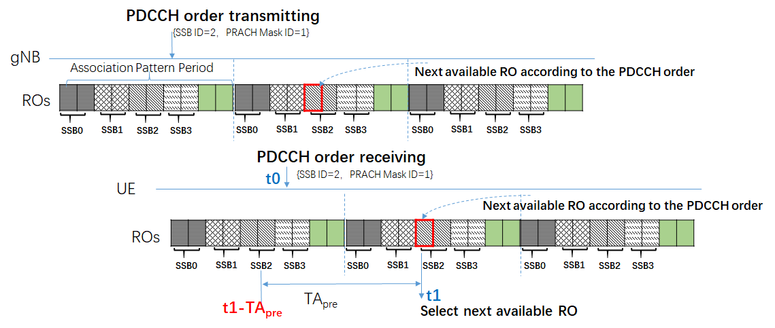
Fig. 2 The illustration of RO selection in the RACH procedure triggered by PDCCH order.
Observation 3: If a TA is pre-compensated to the PRACH transmission, current PRACH occasion determination manner in the RACH procedure triggered by PDCCH order will not work, since the timing-gap between the time of receiving PDCCH order and the time of selected RO might be smaller than the necessary pre-compensated TA.

Based on the observation, [CAICT] propose the following:
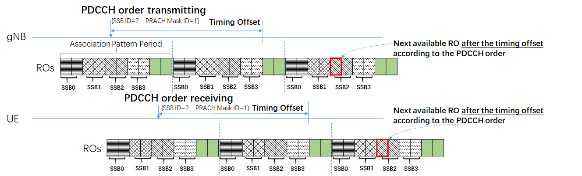
Fig. 3 The illustration of RO selection after a timing offset in the RACH procedure triggered by PDCCH order.
Proposal 2: When a RACH procedure is trigged by PDCCH order, UE shall select the next available RO after a timing offset according to the indication of PDCCH order, where the timing offset can use the $K_{offset}$ explicitly indicated by gNB or implicitly related to the TA reported by UE.

In Moderator’s view, this appears to be a valid issue that requires discussion. Before discussing potential solutions, it should be first discussed whether the observation is correct to see if there is any issue with the timing of the PDCCH ordered PRACH.

7.2 Company views
Based on the above discussion, an initial proposal is made as follows. Companies are encouraged to provide views on the proposal.
Initial proposal 7.2-1 (Moderator):
Discuss whether the following observation on PDCCH ordered PRACH is correct or not:
[CAICT] If a TA is pre-compensated to the PRACH transmission, current PRACH occasion determination manner in the RACH procedure triggered by PDCCH order will not work, since the timing-gap between the time of receiving PDCCH order and the time of selected RO might be smaller than the necessary pre-compensated TA.

Company | Comments
Panasonic | UE would transmit PRACH in the next available RACH occasion after reception of PDCCH order. Because gNB would have a rough knowledge of RTT, gNB can detect the PRACH in the candidate ROs. Therefore, PDCCH order PRACH can work without Koffset. On the other hand, it might not be harmful to use Koffset to alleviate potential gNB complexity because Koffset is already available.
OPPO | We have a different understanding. When a UE receives a PDCCH order, the indicated ROs are periodic, the spec does not seem to mandate the UE to select only one RO.
Ericsson | This appears to be a valid issue that requires discussion.
Huawei | We agree this should be discussed further.
Samsung | When the UE is triggered for RACH by PDCCH order, the TA value may be mis-aligned between the UE and gNB. Then, this solution does not work.  If the TA value is aligned in this case, this solution is not needed and the network can manage that since the gNB already is aware of the TA.
ZTE | Valid issue and fine to discuss it.
Spreadtrum | We agree this should be discussed further.
Lenovo/MM | We agree with CAICT that an offset should be added for the time domain difference between PDCCH order and corresponding PRACH transmission.
APT | In Rel-16, the RACH occasion (RO) validity is determined by UE, corresponding to paired or unpaired spectrum operation, the selected SSB, and NW configuration if any. For NTN, if one selected RO cannot satisfy the initial TA requirement, UE may select another available PRACH occasion.  Some specifications are given below.  3GPP TS 38.321 V16.0.0 (2020-03)  1> else if an SSB is selected above:  2> determine the next available PRACH occasion from the PRACH occasions corresponding to the selected SSB permitted by the restrictions given by the ra-ssb-OccasionMaskIndex if configured or indicated by PDCCH (the MAC entity shall select a PRACH occasion randomly with equal probability amongst the consecutive PRACH occasions according to clause 8.1 of TS 38.213 [6], corresponding to the selected SSB; the MAC entity may take into account the possible occurrence of measurement gaps when determining the next available PRACH occasion corresponding to the selected SSB).  If RAN1 spec change is needed, we may add some guidelines, e.g., UE is not expected to send a PRACH transmission prior to the selected SSB.
CAICT | We agree this is a valid issue and requires a solution for it.  According to the following description in the current specification in 38.213:  “The UE selects for a PRACH transmission the PRACH occasion indicated by PRACH mask index value for the indicated SS/PBCH block index in the first available mapping cycle.”  a UE will select the RO associated to the indicated PRACH mask index and the indicated SSB index in the first available mapping cycle after the PDCCH order. The PRACH mask index indicates one RO in the mapping cycle between the indicated SSB index and ROs. A SSB can map to eight ROs at most. PRACH mask index (1~8) indicates which RO in the eight ROs to be selected.  The timing gap between PDCCH order and the selected RO might be insufficient to cover the pre-compensated TA. Besides, if the timing gap is not aligned between gNB and UE, then the PDCCH ordered PRACH procedure cannot be carried out correctly.  Therefore, a solution to align the timing gap between PDCCH order and the selected RO between gNB and UE is necessary.
Nokia, Nokia Shanghai Bell | Agree that there may be problems in having the correct timing between PDCCH order and the associated RO to use. Would need further discussion.
Fraunhofer IIS, Fraunhofer HHI | This seems to be a valid observation.

7.3 Updated proposal based on company views (1st round of email discussion)
In the first round of email discussion, 12 companies provided views:
- [Panasonic] pointed out that it can work without K_offset but K_offset could help.
- [Lenovo/MM] agreed with the proponent [CAICT] that an offset is needed.
- [OPPO, Samsung] have different understandings compared to the proponent [CAICT]’s observation.
- [Ericsson, Huawei, ZTE, Spreadtrum, APT, Nokia/Nokia Shanghai Bell, Fraunhofer IIS/Fraunhofer HHI] are open to discuss the issue further.
Given the views expressed so far, it is worthwhile to continue discussing this issue. The issue is however not urgent to solve. Since this issue is brought up for the first time, companies may need more time to analyze it. So, it is recommended that we revisit this issue at the next RAN1 meeting. With this way forward, it is not necessary to discuss issue #7 further at this RAN1 meeting.
Moderator recommendation on Issue #7:
On PDCCH ordered PRACH timing relationship, interested companies are encouraged to provide input to RAN1#104-e.

8 Issue #8: RRC procedure delay

8.1 Background
[Oppo] propose to introduce Koffset to enhance the RRC procedure delay.
The motivation of introducing K_offset for MAC-CE activation time is to increase the buffer time for the gNB to receive the HARQ-ACK information from the UE. A similar reason can be considered for the RRC procedure delay. In TN system, the RRC procedure delay is a fixed duration, e.g. for RRC reconfiguration the delay is 10 ms, which is long enough for HARQ-ACK feedback in TN network. But the configured delay value in current spec cannot cover the propagation delay in NTN system such as for GEO. For this reason, the RRC procedure delay should also be revisited, e.g., K_offset should be introduced to the configuration of RRC procedure delay.
Proposal 5: K_offset should be introduced to enhance the RRC procedure delay.

In Moderator’s view, RRC procedure delay, as defined in TS 38.331, is a RAN2 topic and should be discussed in RAN2.

8.2 Company views
Based on the above discussion, an initial proposal is made as follows. Companies are encouraged to provide views on the proposal.
Initial proposal 8.2-1 (Moderator):
It is recommended that the proponent bring up the following proposal in RAN2:
[OPPO] K_offset should be introduced to enhance the RRC procedure delay.

Company | Comments
Panasonic | We agree this is RAN2 topic.
OPPO | We think even though the corresponding spec is in RAN2, RAN1 would need to discuss this issue to have a common understanding.
Ericsson | It is not needed in our view, as RRC procedure delay is about UE processing time at the UE side. Anyway, this is a topic for RAN2 not for RAN1.
Huawei | Our understanding is a bit different from OPPO. According to TS 38.331, the RRC procedure delay includes the time for PDSCH decoding, the time to apply the RRC configuration and the time for UL response preparation, which does not include time for the gNB to receive HARQ-ACK feedback for the RRC message.  The UE performance requirements for RRC procedures are specified in the following tables. The performance requirement is expressed as the time in [ms] from the end of reception of the network -> UE message on the UE physical layer up to when the UE shall be ready for the reception of uplink grant for the UE -> network response message with no access delay other than the TTI-alignment (e.g. excluding delays caused by scheduling, the random access procedure or physical layer synchronisation). In case the RRC procedure triggers BWP switching, the RRC procedure delay is the value defined in the following table plus the BWP switching delay defined in TS 38.133 [14], clause 8.6.3.  Anyway, we agree with the moderator recommendation that this can be further discussed in RAN2.
Samsung | Agree to Moderator’s recommendation. This is up to RAN2.
ZTE | Fine to take it in RAN2
LG | Agree, this is RAN2 topic.
Lenovo/MM | Generally agree with OPPO on introduction of K_offset for RRC procedure delay and also agree with Moderator that it should be discussed in RAN2.
APT | Agree
CAICT | We generally agree the idea that K_offset should be introduced to enhance the RRC procedure delay. Timing relationship of RAN1 related procedure in the RRC procedure, such as impact on the RACH timing relationship due to PRACH resource reconfiguration can be further detailed.
Nokia, Nokia Shanghai Bell | Agree that we may need an additional delay to handle RRC procedure delay(s). However, we are not sure whether or not this need to be equal to the K_offset. We would prefer that this discussion is taken at RAN2 level.
Thales | This issue should be discussed in RAN2
Fraunhofer IIS, Fraunhofer HHI | Agree with moderator’s response.

8.3 Updated proposal based on company views (1st round of email discussion)
In the first round of email discussion, 13 companies provided views:
- [Panasonic, Ericsson, Huawei, Samsung, ZTE, LG, APT, Nokia/Nokia Shanghai Bell, Thales, Fraunhofer IIS/Fraunhofer HHI] agreed that the issue should be discussed in RAN2.
- [OPPO] hold the view that it should be discussed in RAN1.
- [OPPO, Lenovo/MM, CAICT] hold the view that K_offset is needed for RRC procedure delay.
- [Nokia/Nokia Shanghai Bell] pointed out additional delay may be needed but not sure if it needs to be K_offset
- [Ericsson, Huawei] tend to think additional delay is not needed.
Given the views expressed so far, it is clear that the majority hold the view that the discussion should be taken in RAN2. With this way forward, it is not necessary to discuss issue #8 further at this RAN1 meeting.
Moderator recommendation on Issue #8:
It is recommended that the proponent bring up the following proposal in RAN2:
[OPPO] K_offset should be introduced to enhance the RRC procedure delay.

9 Issue #9: Timing relationship upon feeder link switch

9.1 Background
[Nokia, Nokia Shanghai Bell] propose to define timing relationships such that a feeder link switch does not cause a large jump in the common delay value used by the UE.
One item that needs further discussion is the impact of any feeder link switches on the timing relationships for NTN. Related topics have been proposed in [4]. As a guiding principle the reference point used for timing must not change as a consequence of the FL switch and as such it should not cause a jump in the common delay.
Proposal 7: RAN1 to define timing relationships such that a feeder link switch does not cause a large jump in the common delay value used by the UE.

In Moderator’s view, it is not clear how this can be achieved. The degree of common delay variation upon feeder link switch depends on the length difference of the first feeder link and the second feeder link, which in turn depends on the actual deployment of gateways and satellite constellation.
Further, it appears not an issue to have different delays before and after feeder link switch. For example, the network can configure UE to use different Koffset values for use before and after feeder link switch.

9.2 Company views
Based on the above discussion, an initial proposal is made as follows. Companies are encouraged to provide views on the proposal.
Initial proposal 9.2-1 (Moderator):
Discuss the necessity of the following proposal:
[Nokia, Nokia Shanghai Bell] RAN1 to define timing relationships such that a feeder link switch does not cause a large jump in the common delay value used by the UE.

Company | Comments
Panasonic | The issue is not clear. Might be solved by gNB implementation as commented by the moderator above.
Ericsson | It would be better if proponent could clarify the proposal.
Huawei | We see some benefit of this proposal that the TA adopted at the UE does not need to jump due to a feeder link switch.
Samsung | It is not clear yet whether/which issue would happen. We suggest to deprioritize this issue.
Xiaomi | We agree that the impact due to the feeder-link switch should be minimized.
ZTE | Intention is not clear and it’s also up to the whole framework of feeder link switching defined in RAN2. If the continuous transmission cannot be guaranteed by the defined solution, no need to touch the timing issue in RAN1.
Lenovo/MM | Agree with Moderator’s view.
APT | Feeder link switch might go with conditional handover (CHO) or handover (RRCReconfiguration), which involves a RA procedure. UE would recalculate an initial TA and report the initial TA to NW during the RA procedure. Before the TA report, NW may not have any UE’s RTT after a feeder link switch.
CAICT | We need to give a clear definition of the common delay used at UE first. If the feeder link delay is applied at gNB, the issue might be solved by gNB implementation.
Nokia, Nokia Shanghai Bell | In response to moderator comment, we would like to highlight that a UE being connected to one gNB served cell through a satellite should not have its timing changed when/if the feeder link is switched. That is, in case of longer or shorter propagation distance (which would result in different K_offset value), the overall timing of the UE’s operation should not change. If the timing will change, the UE would need to drop the cell or make a handover.
Fraunhofer IIS, Fraunhofer HHI | As mentioned by the moderator, it is not clear how this can be achieved. One potential solution would be to adopt the time reference point (RP) for TA calculation at satellite. Then, according to the definition of common TA based on AI 8.4.2, common TA would be equal to zero and it does not change by feeder link switch. However, this solution increases the complexity at the network side to handle feeder link delay and feeder link switch at the same time.

9.3 Updated proposal based on company views (1st round of email discussion)
In the first round of email discussion, 11 companies provided views:
- [Panasonic, Ericsson, Samsung, Lenovo/MM] pointed out that the proposal is not clear.
- [CAICT, Fraunhofer IIS/Fraunhofer HHI] pointed out the discussion may be coupled with TA discussion in AI 8.4.2.
- [Huawei, Xiaomi] pointed out the proposal may worth consideration.
- The proponent [Nokia, Nokia Shanghai Bell] clarified the intention is to avoid the case “If the timing will change, the UE would need to drop the cell or make a handover.”
- However, as pointed out by [ZTE, APT], this is in fact part of the overall feeder link switch topic that is being discussed in RAN2.
Given the views expressed so far, it is reasonable that RAN1 wait for RAN2 progress on feeder link switch before discussing its impact on timing relationship. Note that the same approach is taken in AI 8.4.4 about feeder link switch in general. With this way forward, it is not necessary to discuss issue #9 further at this RAN1 meeting.
Moderator recommendation on Issue #9:
RAN1 to wait for RAN2 progress on feeder link switch before discussing its impact on timing relationship.

References
- TR 38.821, Solutions for NR to support non-terrestrial networks
- RP-201256, Solutions for NR to support non-terrestrial networks (NTN), 3GPP TSG RAN #88e, June 2020
- R1-2007323, Feature lead summary#4 on timing relationship enhancements, Moderator (Ericsson), 3GPP TSG RAN1 #102e, August 2020
- R1-2007569, Discussion on timing relationship enhancements for NTN, Huawei, HiSilicon
- R1-2007660, Discussion on timing relationship enhancements for NR-NTN, vivo
- R1-2007854, Timing relationship discussion for NTN, CATT
- R1-2007991, Discussion on timing relationship enhancements for NR NTN, China Telecom
- R1-2008010, Discussion on timing relationship enhancements for NTN, CMCC
- R1-2008164, Timing relationship enhancements for NTN, Samsung
- R1-2008253, Discusson on timing relationship enhancement, OPPO
- R1-2008359, Calculation of timing relationship offsets, Sony
- R1-2008410, Discussions on timing relationship enhancements in NTN, LG Electronics
- R1-2008465, Timing Relationship Enhancement in NTN, Apple
- R1-2008722, Discussion on timing relationship enhancements for NTN, Fraunhofer IIS, Fraunhofer HHI
- R1-2008808, Timing relationship enhancements for NR-NTN, MediaTek Inc., Eutelsat
- R1-2008850, Discussion on timing relationship for NTN, ZTE
- R1-2008922, Discussion on NTN timing relationship, Lenovo, Motorola Mobility
- R1-2008989, On timing relationship enhancements for NTN, Intel Corporation
- R1-2009015, Discussion on timing relationship enhancement for NTN, ETRI
- R1-2009032, Discussion on the timing relationship enhancement for NTN, Xiaomi
- R1-2009049, Timing relationship enhancement for NTN, Panasonic Corporation
- R1-2009057, Timing relationship enhancements in NTN, Asia Pacific Telecom co. Ltd
- R1-2009076, Timing relationship enhancements to support NTN , CAICT
- R1-2009091, On timing relationship enhancements for NTN, Ericsson
- R1-2009116, On timing relationship for NTN, InterDigital, Inc.
- R1-2009152, Consideration on timing relationship enhancements, Spreadtrum Communications
- R1-2009186, Discussion on timing relationship enhancements for NTN, NTT DOCOMO, INC.
- R1-2009242, Views on DL-UL timing relationship for NTN operation, Nokia, Nokia Shanghai Bell
- R1-2009262, Enhancements on Timing Relationship for NTN, Qualcomm Incorporated

Appendix I: RAN1 agreements on timing relationship
RAN1#102-e:
Agreement:
- Introduce K_offset to enhance the following timing relationships:
  - The transmission timing of DCI scheduled PUSCH (including CSI on PUSCH).
  - The transmission timing of RAR grant scheduled PUSCH.
  - The transmission timing of HARQ-ACK on PUCCH.
  - The CSI reference resource timing.
  - The transmission timing of aperiodic SRS.
- Note: Additional timing relationships that require K_offset of the same or different values can be further identified.

Agreement:
For K_offset used in initial access, the information of K_offset is carried in system information.
- FFS implicit and/or explicit signaling of K_offset in system information.
- FFS a cell specific K_offset value used in all beams of a cell and/or each beam in a cell uses a beam-specific K_offset value.
- FFS whether/how to update K_offset after initial access.

Appendix II: Summary of proposals
Tdoc | Source | Proposals
R1-2007569 | Huawei, HiSilicon | Proposal 1: Support implicit signaling of Koffset in system information.  Proposal 2: A cell specific Koffset value is used for initial access.  Proposal 3: Derive the initial Koffset from ra-ResponseWindow and an offset for the start of the ra-ResponseWindow.  Proposal 4: Support updating of the Koffset from cell-specific to beam-specific after initial access.
R1-2007660 | vivo | Proposal 1: For a MAC CE command indicates to the UE about an action in DL or an assumption on the downlink configuration, the UE assumes the command is activated in the DL slot (at UE side) which is the first DL slot after the UL slot$n+{XN}_{slot}^{subframe,µ}+YN_{slot}^{subframe,µ}$ , where the UL slot indexed by $n$ is the UL slot where UE transmits HARQ-ACK corresponding to the received PDSCH carrying the MAC CE command, and the value of Y is the common TA offset in the gNB's DL and UL frame timing.  Proposal 2: For a MAC CE command indicates to the UE about an action in UL or an assumption on the uplink configuration, the UE assumes the command is activated in the UL slot (at UE side) $n+{XN}_{slot}^{subframe,µ}+1$, where the UL slot indexed by $n$ is the UL slot where UE transmits HARQ-ACK corresponding to the received PDSCH carrying the MAC CE command.  Proposal 3: For K_{offset} used in initial access, beam-specific K_{offset} is supported.  Proposal 4: In NTN, cell-specific K_{offset} should also be supported.  Proposal 5: After initial access procedure, there is no need to update K_{offset} if beam-specific K_{offset} is used in initial access procedure.
R1-2007854 | CATT | Proposal 1: K_offset should be linked to TA compensation offset, rather than the whole RTD length.  Proposal 2: The K_offset should be explicit signaled in system information according to different scenarios.  Proposal 3: The values of K_offset can be notified within per-cell based on the SIB.  Proposal 4: There is no need to update the K_offset after initial access.  Proposal 5: Expanding K1/K2 is not necessary.  Proposal 6: For the MAC CE action timing, the parameter T should be equal to 3+RTD in NTN.
R1-2007991 | China Telecom | Proposal 1: The value of $K_{offset}$ before random access is directly proportional to the maximum RTT of a beam, which is calculated based on the satellite’s ephemeris and the scope of the beam.  Proposal 2: The value of $K_{offset}$ is configured by the following two methods depending on the deployment,  - The gNodeB calculates the value of $K_{offset}$ based on the maximum RTT and inform it to the UE through additional signaling, or,  - The UE calculates the value of $K_{offset}$ itself based on the TA value as a default configuration when the gNodeB does not inform it.
R1-2008010 | CMCC | Proposal 1: RAR windows related parameters can be derived from Koffset.  Proposal 2: For Common TA based TA determining solution, only one of Common TA and Initial Koffset is explicitly indicated in system information. The following alternatives for further study  - Alt 1 (i.e., Option 4b): Common TA is explicitly indicated in system information, while Initial Koffset is derived from Common TA as following  - Initial Koffset (in slot) = ⌈Common TA + maximum TA adjust range indicated by RAR⌉  - Alt 2: Initial Koffset is explicitly indicated in system information, while Common TA is derived from Initial Koffset as following  - Common TA = Initial Koffset - maximum TA adjust range indicated by RAR  Proposal 3: For TA determining solutions except for Common TA based one, Initial Koffset can be explicitly indicated in system information.  Proposal 4: Beam specific indication for Initial Koffset and/or Common TA (i.e., each beam in a cell uses a beam-specific value) is supported.  Proposal 5: For beam specific indication, cell specific system information with a list of beam-specific value to be repeated across beams as a baseline.  Proposal 6: Further study beam specific system information, where each SI carries different beam-specific value.  Proposal 7: Support Koffset update after initial access with extended K1/K2 value range.  Proposal 8: Extend the value range of K1 to larger than 15, e.g., 31.  Proposal 9: Discussion should be based on the assumption for aligned DL-UL timing at gNB side.  Proposal 10: For aligned DL-UL timing at gNB side, conform the following understanding achieved in last meeting.  - [UL MAC CE] For a MAC CE command received in DL slot n, where the command is used to indicate to the UE about an action in the UL or an assumption on the uplink configuration, the UE assumes the command is activated in the UL slot (at UE side) $n+k_{1}+{3N}_{slot}^{subframe,µ}+1$, where TA is assumed to be zero and the UL slot indexed by $n+k_{1}$ is the UL slot where UE transmits HARQ-ACK corresponding to the received PDSCH carrying the MAC CE command.  - [DL MAC CE] For a MAC CE command received in DL slot n, where the command is used to indicate to the UE about an action in the DL or an assumption on the downlink configuration, the UE assumes the command is activated in the DL slot (at UE side) which is the first DL slot after the UL slot $n+k_{1}+{3N}_{slot}^{subframe,µ}$, where TA is assumed to be zero and the UL slot indexed by $n+k_{1}$ is the UL slot where UE transmits HARQ-ACK corresponding to the received PDSCH carrying the MAC CE command.
R1-2008164 | Samsung | Proposal 1: The range of K_{offset} should depend on the maximum round trip propagation delay T_{rt} and the maximum hop number L as  Koffset ≥ L×T_{rt}  where T_{rt} can be inferred from the broadcasting information.  Proposal 2: K_{offset} is also applied to the determination of MAC CE activation timing.  Proposal 3: More than one of above K_{offset} configurations can be supported, and using which one is dependent on gNB configuration.  Proposal 4: The timing relationship for Configured Grant Type 1 should be left to Network implementation.  Proposal 5: The timing relationship for Configured Grant Type 2 can follow the timing relationship for DCI scheduled PUSCH.
R1-2008253 | OPPO | Proposal 1: Support explicit configuration of cell-specific/beam-specific K_offset in system information.  Proposal 2: UE-triggered and gNB-controlled K_offset updating can be considered.  Proposal 3: K_offset can be updated via RRC configuration or group-common DCI after initial access procedure.  Proposal 4: For MAC-CE activation timing, X = max(3,K_offset) ms.  Proposal 5: K_offset should be introduced to enhance the RRC procedure delay.  Proposal 6: K_offset should be introduced for SFI interpretation for an uplink BWP.
R1-2008359 | Sony | Proposal 1: When the common TA is configured by gNB, the K_{offset} values should be implicitly defined by calculation at the UE from the common TA.  Proposal 2: When the common TA is not configured by gNB in transparent payload case, the network should signal additional information such as gNB position or distance from the satellite to the UE.
R1-2008410 | LG Electronics | Proposal 1: Support explicit signaling of K_offset in system information.  Proposal 2: Beam-specific K_offset signaling is preferred.  Proposal 3: Discuss whether and how to updated K_offset value after initial access.  Proposal 4: For the MAC-CE action timing, the corresponding action and the UE assumption on the downlink configuration indicated by the MAC-CE command shall be applied starting from the first slot that is after slot $n+{XN}_{slot}^{subframe,µ}+K_{offset}$ where X can be smaller than 3.
R1-2008465 | Apple | Proposal 1: A cell specific $K_{offset}$ is used in initial access. This cell specific $K_{offset}$is explicitly indicated in system information.  Proposal 2: A UE specific or a beam specific $K_{offset}$ is used after initial access.  Proposal 3: RAN1 strives to reduce the signaling overhead of updating $K_{offset}$.  Proposal 4: On MAC CE timing relationship, UE assumes UL MAC CE command is activated 3 ms after it transmits HARQ-ACK corresponding to a received PDSCH carrying the UL MAC CE command.  Proposal 5: On MAC CE timing relationship, UE assumes DL MAC CE command is activated Y ms after it transmits HARQ-ACK corresponding to a received PDSCH carrying the DL MAC CE command. The value Y is equal to${ K}_{offset}^{'}+X$, where ${K'}_{offset}$ is the absolute time converted from $K_{offset}$ and X is less than 3 ms.  Proposal 6: Introduce $K_{offset}$ to the timing relationship for type 1 configured grant.
R1-2008722 | Fraunhofer IIS, Fraunhofer HHI | Proposal 1: It must be left to gNB/network to select a value of $K_{offset}$ greater than or equal to the maximum RTD of cell or beam depending on cell specific or beam specific signaling.  Proposal 2: RAN1 to adopt millisecond as the unit of the $K_{offset}$.  Proposal 3: NTN UE should derive the initial value of $K_{offset}$ from the broadcast system information, e.g., ra-ContentionResolutionTimer and an offset to the start of ra-ContentionResolutionTimer or common/minimum delay.  Proposal 4: NTN UE should derive the initial value of $K_{offset}$ from the broadcast system information, e.g., RRC timers T300, T301, T319, and T310.  Proposal 5: RAN1 to consider cell specific signaling of initial $K_{offset}$.  Proposal 6: The value of $K_{offset}$ should be updated/reconfigure after RRC connection in UE specific manner.  Proposal 7: For UE specific update of $K_{offset}$, NTN UE should report its acquired TA to gNB.  Proposal 8: NTN UE should report its first TA report as part of MSG3.  Proposal 9: RAN1 to further study the details of NTN UE TA report.  Proposal 10: RAN1 to further study the enhancement of 2-step RACH timing relationship for NTN.
R1-2008808 | MediaTek Inc., Eutelsat | Proposal 1: Beam-specific K_{offset} corresponding to maximum RTD is broadcast on SIB for initial cell access. Whether Koffset is broadcast on SIB1 or on NTN-specific SIB is FFS.  Proposal 2: UE reports its autonomously determined TA to the gNB.  Proposal 3: Guard Period Around the start / end of UL transmission is configured.  Proposal 4: K1 range are increased to 32 with indication of INTEGER (0..31) in dl-DataToUL-ACK field in PUCCH-Config.  Proposal 5: K2 range are increased to 64 with indication of INTEGER (0..63) in PUSCH-TimeDomainResourceAllocation field in DCI .  Proposal 6: For the MAC CE activation timing, MAC CE command is active Y ms after it transmits HARQ ACK corresponding to a received PDSCH carrying the MAC CE command, where Y = X + $K_{offset}$ and X = 3.  Proposal 7: The SFI-index field value in a DCI format 2_0 is delayed by K_{offset} corresponding to maximum RTD in the beam.
R1-2008850 | ZTE | Proposal 1: The K_offset derived from corresponding common TA value should be supported.  Proposal 2: Beam-specific K_offset configuration can be supported via common SIB or beam-specific SIB with following considerations:  - Multiple beam-specific values of K_offset in single SIB.  - Different single value of K_offset per beam in dedicated SIB.  Proposal 3: In case of indication of K_offset, adaptive unit should be considered to support all scenarios with lower overhead.  Proposal 4: Extension of existing offset (i.e., k, K₁, K₂) should be supported.  Proposal 5: Taking following principles as the basis for MAC CE timing relationship discussion:  - The MAC CE (except for the TA command)can only be applied once the ACK/NACK is received at gNB side  - Slot n for ACK/NACK transmission at UE side is determined by previous scheduling instead of real time instant for transmission with applied TA.  Proposal 6: For the MAC CE action timing, the existing value of X, i.e., X = 3, can be reused in NTN.  Proposal 7: For the 2-step RACH, introduce K_offset for the transmission timing of fallback random-access response (RAR) scheduled PUSCH and HARQ-ACK feedback for Msg-B.
R1-2008922 | Lenovo, Motorola Mobility | Proposal 1: MAC CE activation delay is determined by the gNB UL-DL timing shift.  Proposal 2: DCI 2-0 application delay should be determined by twice the propagation delay between gNB and UE if uplink slot/symbol is indicated by DCI 2-0.  Proposal 3: Consider slot format ending with several F slot/symbols.  Proposal 4: Support per beam indication of K_{offset}.  Proposal 5: Support extending the range of K₁ value.  Proposal 6: The K_{offset} indication in broadcast signaling or RRC signaling depends on the UE status and scenarios.
R1-2008989 | Intel Corporation | Proposal 1:  - If TA corresponds to UE-gNB round trip delay  - For the MAC CE action timing, the corresponding action and the UE assumption on the downlink configuration indicated by the MAC-CE command shall be applied starting from the first slot that is after slot $n+{3N}_{slot}^{subframe,µ}$, where n is target slot for the HARQ-ACK transmission (without TA)  - If TA corresponds to service link round trip delay (feeder link delay is not considered for TA)  - For the MAC CE action timing, the corresponding action and the UE assumption on the downlink configuration indicated by the MAC-CE command shall be applied starting from the first slot that is after slot $n+{3N}_{slot}^{subframe,µ}+K_{MAC CE}$, where n is target slot for the HARQ-ACK transmission (without TA), $K_{MAC CE}$ is configured by higher layers  Proposal 2:  - Common timing advance (TA) value can be used to determine common slot offset (Koffset) if common TA indication is supported  - Beam-specific indication of Koffset value should be supported  - Koffset value should be common for all applicable physical layer procedures
R1-2009015 | ETRI | Proposal 1: In the initial access, Koffset can be configured regardless of the configuration of the common TA. Koffset can be the maximum value of the RTT of the service link.  Proposal 2: In the initial access, Koffset can be broadcast through SIB as a beam-specific parameter.  Proposal 3: A UE-specific parameter can be configured for Koffset update. In order to adjust Koffset for the UE, a difference value between the beam-specific Koffset configured for initial access and the value reflecting the UE-specific TA can be transmitted to the UE.
R1-2009032 | Xiaomi | Proposal 1: Different Koffset value is applied to the activation of MAC CE.  Proposal 2: Koffset is configured on a per beam basis.  Proposal 3: It is preferred to have common signaling to update the Koffset.  Proposal 4: The Koffset is configured with a unit of millisecond.
R1-2009049 | Panasonic Corporation | Proposal 1: UE-specifically update Koffset after initial access.  Proposal 2: Support indication of relative Koffset value via MAC CE or group common DCI.  Proposal 3: Beam specific Koffset is not supported.  Proposal 4:  - MAC CE action timing related to UL transmission should be 3 slots after HARQ-ACK transmission slot for the PDSCH containing the MAC CE.  - MAC CE action timing related to DL status should be defined based on an offset from the reception timing of PDSCH containing the MAC CE.
R1-2009057 | Asia Pacific Telecom co. Ltd | Proposal 1 Different MAC CE action time based on MAC CE types shall be supported in NTN  Proposal 2 Do not introduce K_offset for MAC CE action time.  Proposal 3 To prevent the MAC CE action time before the HARQ-ACK that NW receives, MAC CE action time based on the NW timeline shall be considered.  Proposal 4 The term of $NTA,max$used for TA command MAC CE shall be further enhanced.  Proposal 5 Timing enhancement on 2-step RACH shall start in RAN1#103-e.  Proposal 6 Signaling on K_offset in initial access shall be explicit or RAN1 shall wait for more progress on Msg3 scheduling in RAN2.
R1-2009076 | CAICT | Proposal 1: In NTN, SFI-index field value in a DCI format 2_0 indicates slot format for a number of slots starting from the slot which is at least $K_{offset}$ slots after the UE detects the DCI format 2_0.  Proposal 2: When a RACH procedure is trigged by PDCCH order, UE shall select the next available RO after a timing offset according to the indication of PDCCH order, where the timing offset can be indicated explicitly or implicitly.  Proposal 3: Explicit signal of $K_{offset}$ in the system information. gNB has the flexibility of configuring cell-specific or beam specific value of $K_{offset}$.  Proposal 4: To support updating $K_{offset}$ after initial access. The value of $K_{offset}$ corresponds to UE-specific TA.  Proposal 5: UE reports its autonomous TA to the gNB when the corresponding value of $K_{offset}$ is to be changed at the UE side.  Proposal 6: To enhance K1/K2 indication with explicit or implicit way in TDD system which is with more contiguous DL slots.  Proposal 7: Confirm the previous understanding of existing MAC CE timing.  Proposal 8: Have the following enhancements on the MAC CE timing in NTN：  - [UL MAC CE] For a MAC CE command received in DL slot n, where the command is used to indicate to the UE about an action in the UL or an assumption on the uplink configuration,  - If UL transmission corresponding to the MAC CE command is independent of instantons DL scheduling, the UE assumes the command is activated in the UL slot (at UE side) $n+k_{1}+{3N}_{slot}^{subframe,µ}+1$, where TA is assumed to be zero and the UL slot indexed by $n+k_{1}$ is the UL slot where UE transmits HARQ-ACK corresponding to the received PDSCH carrying the MAC CE command.  - If UL transmission corresponding to the MAC CE command depends on instantons DL scheduling, the UE assumes the command is activated in the UL slot (at UE side) $n+k_{1}+K_{offset}+{XN}_{slot}^{subframe,µ}+1$, where TA is applied and the UL slot indexed by $n+k_{1}$ is the UL slot where UE transmits HARQ-ACK and the corresponding to the received PDSCH carrying the MAC CE command.  - [DL MAC CE] For a MAC CE command received in DL slot n, where the command is used to indicate to the UE about an action in the DL or an assumption on the downlink configuration, the UE assumes the command is activated in the DL slot (at UE side) which is the first DL slot after the UL $n+k_{1}+K_{offset}+{XN}_{slot}^{subframe,µ}+1$,, where TA is applied and the UL slot indexed by $n+k_{1}$ is the UL slot where UE transmits HARQ-ACK corresponding to the received PDSCH carrying the MAC CE command.
R1-2009091 | Ericsson | Proposal 1 The value of $K_{offset}$ used in initial access is signaled explicitly in system information.  Proposal 2 The value of $K_{offset}$ used in initial access is cell specific.  Proposal 3 The value of $K_{offset}$ can be reconfigured after RRC connection setup to be UE specific for unicast scheduling.  Proposal 4 RAN1 discussion on MAC CE timing relationships is only relevant for those MAC CEs that involve timing relationships defined in the physical layer specifications.  Proposal 5 General MAC CE timing relationship discussions are assumed to be applicable to those MAC CEs that involve “3 ms application delay” defined in the physical layer specifications.  Proposal 6 Exceptional MAC CE timing relationships where the general discussion is not applicable may be discussed case by case based on company input.  Proposal 7 RAN1 should determine suitable MAC CE activation times for e.g. TCI states and spatial relations to support beam change.  Proposal 8 Downlink and uplink frame timing are assumed to be aligned at gNB in Rel-17 NTN. In other words, downlink and uplink frame timing are offset by no more than a small fraction of a slot.  Proposal 9 If Proposal 8 is not agreeable: [DL MAC CE] When the gNB UL timing is delayed by an offset of Y ms relative to its DL timing, for a MAC CE command received in DL slot n, where the command is used to indicate to the UE about an action in the DL or an assumption on the downlink configuration, the UE assumes the command is activated in the DL slot (at UE side) which is the first DL slot after the UL slot $n+k_{1}+{(3+Y)N}_{slot}^{subframe,µ}$, where TA is assumed to be zero and the UL slot indexed by $n+k_{1}$ is the UL slot where UE transmits HARQ-ACK corresponding to the received PDSCH carrying the MAC CE command.
R1-2009116 | InterDigital, Inc. | Proposal 1: support K-offset for MAC-CE action timing  Proposal-2: K-offset value is independently determined/indicated from common TA in the system information (Alt-1)  Proposal-3: support explicit indication of K-offset and beam-specific K-offset indication  Proposal-4: support to update the K-offset to a UE-specific delay after initial access and it is up to the network to use UE-specific K-offset
R1-2009152 | Spreadtrum Communications | Proposal 1: Explicit signaling of K_offset used in initial access in system information should be considered.  Proposal 2: Beam-specific values of K_offset configuration for initial access should be supported.  Proposal 3: UE updates the value of K_offset based on predefined rules should be considered.
R1-2009186 | NTT DOCOMO, INC. | Proposal 1: $K_{offset}$ is signaled in SIB1 or in SIB following SIB1.  Proposal 2: $K_{offset}$ in initial access is a cell-specific parameter.  Proposal 3: Support the value of $K_{offset}$ in initial access which corresponds to the largest delay in the cell.
R1-2009242 | Nokia, Nokia Shanghai Bell | Proposal 1: In order to minimize specification efforts, RAN1 to decide a single combination option for synchronization reference point and long/short TA.  Proposal 2: RAN1 to discuss the understanding of MAC-CE action timing for both the long TA and short TA cases to identify which scenario requires changes to specifications (if any).  Proposal 3: The UL-DL timing relationships adjustments should be dynamic to follow the propagation variation over time.  Proposal 4: RAN1 to discuss if UE-specific values for $K_{NTN}$ can be specified in complement to the cell base $K_{NTN}.$  Proposal 5: K_offset applied by the UE to the timing relationships can be updated after initial access.  Proposal 6: RAN1 to discuss signalling multiple K_offset or $K_{NTN}$ values in a non-UE specific way which are used to update the UE applied value over time.  Proposal 7: RAN1 to define timing relationships such that a feeder link switch does not cause a large jump in the common delay value used by the UE.
R1-2009262 | Qualcomm Incorporated | Proposal 1:  - Introduce Koffset for the following timing relationship:  - When the HARQ-ACK corresponding to a PDSCH carrying a MAC-CE command is transmitted in slot $n$, the corresponding action and the UE assumption on the downlink configuration indicated by the MAC-CE command shall be applied starting from the first slot that is after slot $n+{XN}_{slot}^{subframe,µ}+K_{offset}$ (the value of X is FFS), where $N_{slot}^{subframe,µ}$ denotes the number of slots per subframe for subcarrier spacing configuration $μ$.  - FFS if the above Koffset is applied to PRACH transmission.  - Note that the above does not preclude the use of the same Koffset value as that for DCI scheduled PUSCH.  Proposal 2: Support UE specific K_{offset} based on UE TA report(s).  - Exact mechanisms for UE TA report and associated signalling of K_{offset} are FFS.

